Unión Internacional de Telecomunicaciones
Oficina de Normalización de las Telecomunicaciones

Ginebra, 16 de abril de 2011

Ref:  Tel:  Fax:  Correo-e: | TSB AAP-57  AAP/MJ  +41 22 730 5860  +41 22 730 5853  tsbdir@itu.int | – A las Administraciones de los Estados Miembros de la Unión;  – A los Miembros del Sector UIT-T;  – A los Asociados del UIT-T  Copia:  – A los Presidentes y a los Vicepresidentes de las Comisiones de Estudio del UIT-T;  – Al Director de la Oficina de Desarrollo de las Telecomunicaciones;  – Al Director de la Oficina de Radiocomunicaciones

Asunto: | Situación de las Recomendaciones sometidas al proceso de aprobación alternativo (AAP)

Muy señora mía/Muy señor mío:

El proceso de aprobación alternativo (AAP) definido en la Recomendación A.8 del UIT-T se aplica a las Recomendaciones que no tienen consecuencias en materia de política o reglamentación y que no requieren, por lo tanto, la consulta formal de los Estados Miembros (véase el número 246B del Convenio de la UIT).
En el anexo 1 se enumera la lista de los textos cuyo estado ha cambiado con respecto a los anuncios TSB AAP precedentes.
Si desea formular un comentario en relación con una Recomendación sometida al AAP, le alentamos a utilizar el formulario de presentación de comentarios disponible en la página de la Recomendación que figura en el área AAP del sitio web del UIT-T, en la dirección http://www.itu.int/ITU-T/aap/ (véase también el anexo 2). Alternativamente, pueden presentarse comentarios completando el formulario del anexo 3 y remitiéndolo a la secretaría de la Comisión de Estudio correspondiente.
Le rogamos tenga en cuenta que no se alientan comentarios que se limiten a apoyar la adopción del texto en cuestión.
Le saluda atentamente,

Malcolm Johnson
Director de la Oficina de
Normalización de las Telecomunicaciones
Anexos: 3

Annex 1
(to TSB AAP-57)

Status codes used in the AAP announcements:
LC = Last Call
LJ = Last Call Judgment (includes comment resolution)
AR = Additional Review
AJ = Additional Review Judgment (includes comment resolution)
SG = For Study Group approval
A = Approved
AT = Approved with typographic corrections
AC = Approved after Additional Review of Comments
NA = Not approved
TAP = Moved to TAP (ITU-T A.8 / § 5.2)
ITU-T website entry page:
http://www.itu.int/ITU-T
Alternative approval process (AAP) welcome page:
http://www.itu.int/ITU-T/aapinfo
Note – A tutorial on the ITU-T AAP application is available under the AAP welcome page
ITU-T website AAP Recommendation search page:
http://www.itu.int/ITU-T/aap/
Study Group web pages and contacts:
SG 2 | http://www.itu.int/ITU-T/studygroups/com02 | tsbsg2@itu.int
SG 3 | http://www.itu.int/ITU-T/studygroups/com03 | tsbsg3@itu.int
SG 5 | http://www.itu.int/ITU-T/studygroups/com05 | tsbsg5@itu.int
SG 9 | http://www.itu.int/ITU-T/studygroups/com09 | tsbsg9@itu.int
SG 11 | http://www.itu.int/ITU-T/studygroups/com11 | tsbsg11@itu.int
SG 12 | http://www.itu.int/ITU-T/studygroups/com12 | tsbsg12@itu.int
SG 13 | http://www.itu.int/ITU-T/studygroups/com13 | tsbsg13@itu.int
SG 15 | http://www.itu.int/ITU-T/studygroups/com15 | tsbsg15@itu.int
SG 16 | http://www.itu.int/ITU-T/studygroups/com16 | tsbsg16@itu.int
SG 17 | http://www.itu.int/ITU-T/studygroups/com17 | tsbsg17@itu.int

Situation concerning Study Group 15 Recommendations under AAP
Rec # | Title | Last Call (LC) Period |  |  |  | Additional Review (AR) Period |  |  |  | Status
 |  | LC Start | LC End | LC  Result | LJ  Result | AR Start | AR End | AR  Result | AJ  Result
G.663 | Application related aspects of optical amplifier devices and subsystems | 2011-03-16 | 2011-04-12 | A |  |  |  |  |  | A
G.709/Y.1331 (2009) Amd.2 | Interfaces for the Optical Transport Network (OTN): Amendment 2 | 2011-03-16 | 2011-04-12 | A |  |  |  |  |  | A
G.798 (2010) Amd.1 | Characteristics of optical transport network hierarchy equipment functional blocks: Amendment 1 | 2011-03-16 | 2011-04-12 | LJ |  |  |  |  |  | LJ
G.798 (2010) Cor.1 | Characteristics of optical transport network hierarchy equipment functional blocks: Corrigendum 1 | 2011-03-16 | 2011-04-12 | A |  |  |  |  |  | A
G.798.1 | Types and characteristics of Optical Transport Network (OTN) equipment | 2011-03-16 | 2011-04-12 | A |  |  |  |  |  | A
G.806 (2009) Amd.1 | Characteristics of transport equipment – Description methodology and generic functionality: Amendment 1 | 2011-03-16 | 2011-04-12 | LJ |  |  |  |  |  | LJ
G.873.1 | Optical Transport Network (OTN): Linear protection | 2011-03-16 | 2011-04-12 | LJ |  |  |  |  |  | LJ
G.874 (2010) Cor.1 | Management aspects of optical transport network elements: Corrigendum 1 | 2011-03-16 | 2011-04-12 | LJ |  |  |  |  |  | LJ
G.959.1 (2009) Amd.1 | Optical transport networks physical layer interfaces: Amendment 1 | 2011-03-16 | 2011-04-12 | A |  |  |  |  |  | A
G.972 | Definition of terms relevant to optical fibre submarine cable systems | 2011-03-16 | 2011-04-12 | LJ |  |  |  |  |  | LJ
G.973.2 (G.mdasub) | Multichannel DWDM applications with single channel optical interfaces for repeaterless optical fibre submarine cable systems | 2011-03-16 | 2011-04-12 | A |  |  |  |  |  | A
G.977 | Characteristics of optically amplified optical fibre submarine cable systems | 2011-03-16 | 2011-04-12 | A |  |  |  |  |  | A
G.988 (2010-10) Amd.1 | ONU management and control interface (OMCI) specification: Amendment 1 - Maintenance | 2011-03-16 | 2011-04-12 | A |  |  |  |  |  | A
G.992.3 (2009) Cor.2 | Asymmetric digital subscriber line transceivers 2 (ADSL2): Corrigendum 2 | 2011-03-16 | 2011-04-12 | LJ |  |  |  |  |  | LJ
G.993.2 (2006) Amd.7 | Very high speed digital subscriber line transceivers 2 (VDSL2): Amendment 7 | 2011-03-16 | 2011-04-12 | LJ |  |  |  |  |  | LJ
G.993.2 (2006) Cor.4 | Very high speed digital subscriber line transceivers 2 (VDSL2): Corrigendum 4 | 2011-03-16 | 2011-04-12 | A |  |  |  |  |  | A
G.993.5 (2010) Cor.1 (G.vector) | Self-FEXT cancellation (vectoring) for use with VDSL2 transceivers: Corrigendum 1 | 2011-03-16 | 2011-04-12 | LJ |  |  |  |  |  | LJ
G.994.1 (2007) Amd.7 | Handshake procedures for digital subscriber line (DSL) transceivers: Amendment 7 | 2011-03-16 | 2011-04-12 | AT |  |  |  |  |  | AT
G.997.1 (2009) Amd.3 | Physical layer management for digital subscriber line (DSL) transceivers: Amendment 3 | 2011-03-16 | 2011-04-12 | LJ |  |  |  |  |  | LJ
G.998.4 (2010) Amd.1 | Improved impulse noise protection for DSL transceivers: Amendment 1 | 2011-03-16 | 2011-04-12 | LJ |  |  |  |  |  | LJ
G.998.4 (2010) Cor.2 | Improved impulse noise protection for DSL transceivers: Corrigendum 2 | 2011-03-16 | 2011-04-12 | A |  |  |  |  |  | A
G.7041/Y.1303 | Generic framing procedure (GFP) | 2011-03-16 | 2011-04-12 | A |  |  |  |  |  | A
G.7710/Y.1701 (2007) Cor.2 | Common equipment management function requirements: Corrigendum 2 | 2011-03-16 | 2011-04-12 | A |  |  |  |  |  | A
G.8001/Y.1354 | Terms and definitions for Ethernet frames over Transport | 2011-03-16 | 2011-04-12 | LJ |  |  |  |  |  | LJ
G.8013/Y.1731 (Y.1731) | OAM functions and mechanisms for Ethernet based networks | 2011-03-16 | 2011-04-12 | LJ |  |  |  |  |  | LJ
G.8021/Y.1341 (2010) Amd.1 | Characteristics of Ethernet transport network equipment functional blocks: Amendment 1 | 2011-03-16 | 2011-04-12 | LJ |  |  |  |  |  | LJ
G.8031/Y.1342 | Ethernet linear protection switching | 2011-03-16 | 2011-04-12 | LJ |  |  |  |  |  | LJ
G.8051/Y.1345 (2009) Amd.1 (G.eot-mgmt) | Management aspects of the Ethernet-over-Transport (EoT) capable network element: Amendment 1 | 2011-03-16 | 2011-04-12 | LJ |  |  |  |  |  | LJ
G.8201 | Error performance parameters and objectives for multi-operator international paths within the Optical Transport Network (OTN) | 2011-03-16 | 2011-04-12 | A |  |  |  |  |  | A
G.8251 (2010) Amd.1 | The control of jitter and wander within the optical transport network (OTN): Amendment 1 | 2011-03-16 | 2011-04-12 | A |  |  |  |  |  | A
G.8265.1/Y.1365.1 (2010) Amd.1 | Precision time protocol telecom profile for frequency synchronization: Amendment 1 | 2011-03-16 | 2011-04-12 | AT |  |  |  |  |  | AT
G.9956 (G.hnem) | Narrow-band OFDM power line communication transceivers - Data link layer specification | 2011-03-16 | 2011-04-12 | LJ |  |  |  |  |  | LJ
G.9961 (2010) Amd.1 | Data link layer (DLL) for unified high-speed wire-line based home networking transceivers: Amendment 1 | 2011-03-16 | 2011-04-12 | LJ |  |  |  |  |  | LJ
G.9961 (2010) Cor.1 | Data link layer (DLL) for unified high-speed wire-line based home networking transceivers: Corrigendum 1 | 2011-03-16 | 2011-04-12 | LJ |  |  |  |  |  | LJ
O.174 (2009) Amd.1 | Jitter and wander measuring equipment for digital systems which are based on synchronous Ethernet technology: Amendment 1 | 2011-03-16 | 2011-04-12 | A |  |  |  |  |  | A
Situation concerning Study Group 16 Recommendations under AAP
Rec # | Title | Last Call (LC) Period |  |  |  | Additional Review (AR) Period |  |  |  | Status
 |  | LC Start | LC End | LC  Result | LJ  Result | AR Start | AR End | AR  Result | AJ  Result
G.169 (V2) | Automatic level control devices | 2011-04-16 | 2011-05-13 |  |  |  |  |  |  | LC
G.799.3 (G.IP2IP) | Signal processing functionality and performance of an IP-to-IP voice gateway optimised for the transport of voice and voiceband data | 2011-04-16 | 2011-05-13 |  |  |  |  |  |  | LC
H.222.0 (2006) Amd.5 (H.222.0-J2k-video) | Information technology - Generic coding of moving pictures and associated audio information: Systems: Transport of JPEG 2000 Part 1 (ITU-T T.800 | ISO/IEC 15444-1) video over ITU-T H.222.0 | ISO/IEC 13818-1 | 2011-04-16 | 2011-05-13 |  |  |  |  |  |  | LC
H.222.0 (2006) Amd.6 (H.222.0-MVC-ext) | Information technology - Generic coding of moving pictures and associated audio information: Systems: Extension to AVC video descriptor and signaling of operation points for MVC | 2011-04-16 | 2011-05-13 |  |  |  |  |  |  | LC
H.241 (2006) Cor.1 | Extended video procedures and control signals for H.300-series terminals: Corrections to CustomMaxDPB capability parameter | 2011-04-16 | 2011-05-13 |  |  |  |  |  |  | LC
H.245 (V16) | Control protocol for multimedia communication | 2011-04-16 | 2011-05-13 |  |  |  |  |  |  | LC
H.248.75 (H.248.PIPA) | Gateway control protocol: Package identifier publishing and application package | 2011-04-16 | 2011-05-13 |  |  |  |  |  |  | LC
H.248.81 (H.248.ETS) | Gateway Control Protocol: Guidelines on the Use of the International Emergency Preference Scheme (IEPS) Call Indicator and Priority Indicator in H.248 Profiles | 2011-04-16 | 2011-05-13 |  |  |  |  |  |  | LC
H.350 | Directory services architecture for multimedia conferencing | 2011-04-16 | 2011-05-13 |  |  |  |  |  |  | LC
H.350.1 | Directory services architecture for H.323 | 2011-04-16 | 2011-05-13 |  |  |  |  |  |  | LC
H.350.2 | Directory services architecture for H.235 | 2011-04-16 | 2011-05-13 |  |  |  |  |  |  | LC
H.350.3 | Directory services architecture for H.320 | 2011-04-16 | 2011-05-13 |  |  |  |  |  |  | LC
H.350.4 | Directory services architecture for SIP | 2011-04-16 | 2011-05-13 |  |  |  |  |  |  | LC
H.350.5 | Directory services architecture for non-standard protocols | 2011-04-16 | 2011-05-13 |  |  |  |  |  |  | LC
H.350.6 | Directory services architecture for call forwarding and preferences | 2011-04-16 | 2011-05-13 |  |  |  |  |  |  | LC
H.450.1 | Generic functional protocol for the support of supplementary services in H.323 | 2011-04-16 | 2011-05-13 |  |  |  |  |  |  | LC
H.450.2 | Call transfer supplementary service for H.323 | 2011-04-16 | 2011-05-13 |  |  |  |  |  |  | LC
H.450.3 | Call diversion supplementary service for H.323 | 2011-04-16 | 2011-05-13 |  |  |  |  |  |  | LC
H.460.23 (2009) Amd.1 | Network address translator and firewall device determination in H.323 systems: Support for ITU-T H.460.24 Annex B | 2011-04-16 | 2011-05-13 |  |  |  |  |  |  | LC
H.460.24 (2009) Amd.1 | Point to point media through network address translators and firewalls within H.323 systems: Improvements for NAT traversal without intermediary entities | 2011-04-16 | 2011-05-13 |  |  |  |  |  |  | LC
H.626 (H.VSarch) | Architectural requirements for visual surveillance | 2011-04-16 | 2011-05-13 |  |  |  |  |  |  | LC
H.762 | Lightweight interactive multimedia environment (LIME) for IPTV services | 2011-04-16 | 2011-05-13 |  |  |  |  |  |  | LC
H.771  (H.IPTV-SBSD) | SIP-based IPTV Service Discovery | 2011-04-16 | 2011-05-13 |  |  |  |  |  |  | LC
T.88 (2000) Amd.3 | Information technology - Lossy/lossless coding of bi-level images: Extension to color coding | 2011-04-16 | 2011-05-13 |  |  |  |  |  |  | LC
T.800 (2002) Amd.3 | Information technology - JPEG 2000 image coding system: Core coding system: Guidelines for digital cinema applications | 2011-04-16 | 2011-05-13 |  |  |  |  |  |  | LC
T.808 (2005) Cor.3 | Information technology - JPEG 2000 image coding system: Interactivity tools, APIs and protocols: Corrections to clause J.4.3.4 | 2011-04-16 | 2011-05-13 |  |  |  |  |  |  | LC
T.809 (2007) Cor.1 | Information technology - JPEG 2000 image coding system: Extensions for three-dimensional data: Minor corrections plus clarifications on code stream CAP marker segments and quantization of JP3D images | 2011-04-16 | 2011-05-13 |  |  |  |  |  |  | LC
T.832 (2009) Cor.2 | JPEG XR image coding system - Image coding specification: Corrections and clarifications | 2011-04-16 | 2011-05-13 |  |  |  |  |  |  | LC
T.871 (T.JFIF) | Information technology - Digital compression and coding of continuous-tone still images: JPEG File Interchange Format (JFIF) | 2011-04-16 | 2011-05-13 |  |  |  |  |  |  | LC

Annex 2
(to TSB AAP-57)
Using the on-line comment submission form
Comment submission
1) Go to AAP search Web page at http://www.itu.int/ITU-T/aap/
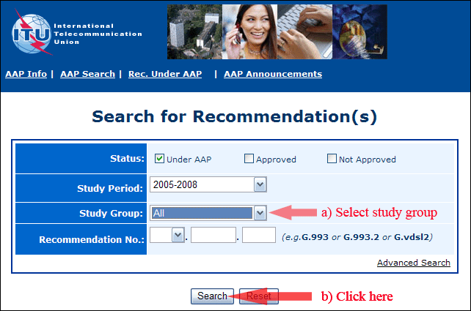
2) Select your Recommendation
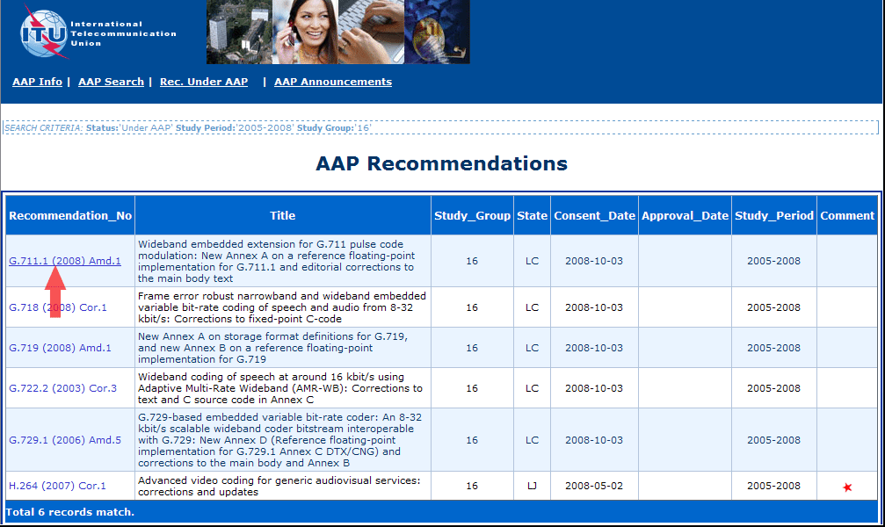
3) Click the "Submit Comment" button
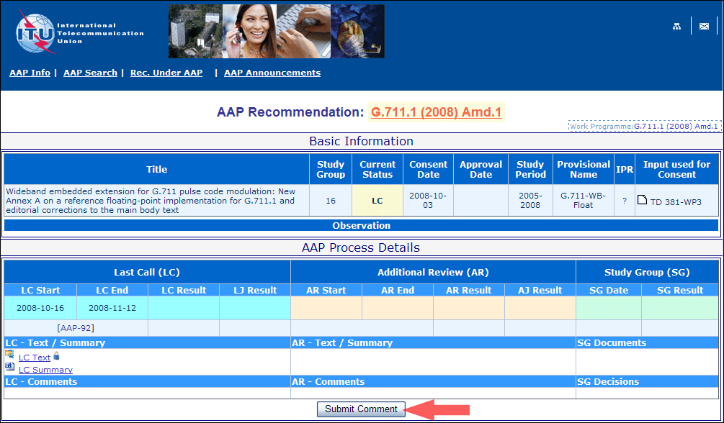
4) Complete the on-line form and click on "Submit"
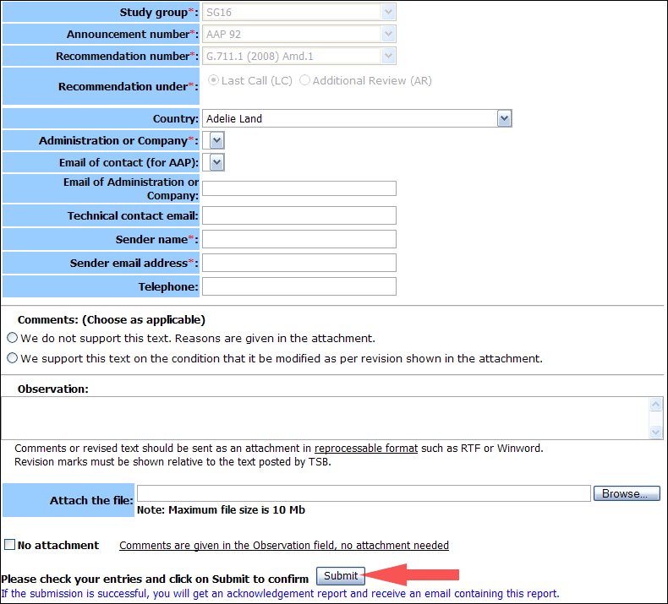
For more information, read the AAP tutorial on:
http://www.itu.int/ITU-T/aapinfo/files/AAPTutorial.pdf
Annex 3
(to TSB AAP-57)
Recommendations under LC/AR – Comment submission form
(Separate form for each Recommendation being commented upon)
ITU-T AAP comment submission form for the period 2009-2012
Study Group:
Announcement number:
Recommendation number:
Recommendation under: | Last call (LC)  Additional Review (AR)
Country:
Administration/Company:
Name of AAP Contact Person:
Email of AAP Contact Person:
Sender name:
(if different from AAP Contact Person)
Sender email address:
Telephone:
Comments:  (Choose as applicable) | We do not support this text. Reasons are given in the attachment.  We support this text on the condition that it be modified as per revision shown in the attachment.
Observations:
No attachment: Comments are given in the Observation field, no attachment needed
To be returned to: email: tsbsg....@itu.int
[or fax +41 22 730 5853]
Comments or revised text should be sent as an attachment in RTF or WinWord format.
Revision marks must be shown relative to the text posted by TSB.

