International Telecommunication Union
Telecommunication Standardization Bureau

Geneva, 16 April 2011

Ref:  Tel:  Fax:  E-mail: | TSB AAP-57  AAP/MJ  +41 22 730 5860  +41 22 730 5853  tsbdir@itu.int | – To Administrations of Member States of the Union;  – To ITU-T Sector Members;  – To ITU-T Associates  Copy:  – To the ITU-T Study Group Chairmen and Vice-Chairmen;  – To the Director of the Telecommunication Development Bureau;  – To the Director of the Radiocommunication Bureau

Subject: | Situation concerning Recommendations under the Alternative Approval Process (AAP)

Dear Sir/Madam,
The Alternative Approval Process (AAP) defined in Rec. ITU-T A.8 applies to Recommendations which do not have policy or regulatory implications and which, therefore, do not require formal consultation of Member States (see ITU Convention 246B).
Annex 1 lists those texts whose status has changed compared with previous TSB AAP Announcements.
If you wish to submit a comment relative to a Recommendation under AAP, you are encouraged to use the on-line AAP comment submission form available on the page of the Recommendation in the AAP area of the ITU-T website at http://www.itu.int/ITU-T/aap (see Annex 2). Alternatively, comments can be submitted by completing the form in Annex 3 and sending it to the secretariat of the concerned study group.
Please note that comments that simply support adoption of the text in question are not encouraged.
Yours faithfully,
Malcolm Johnson
Director of the Telecommunication Standardization Bureau
Annexes: 3

Annex 1
(to TSB AAP-57)

Status codes used in the AAP announcements:
LC = Last Call
LJ = Last Call Judgment (includes comment resolution)
AR = Additional Review
AJ = Additional Review Judgment (includes comment resolution)
SG = For Study Group approval
A = Approved
AT = Approved with typographic corrections
AC = Approved after Additional Review of Comments
NA = Not approved
TAP = Moved to TAP (ITU-T A.8 / § 5.2)
ITU-T website entry page:
http://www.itu.int/ITU-T
Alternative approval process (AAP) welcome page:
http://www.itu.int/ITU-T/aapinfo
Note – A tutorial on the ITU-T AAP application is available under the AAP welcome page
ITU-T website AAP Recommendation search page:
http://www.itu.int/ITU-T/aap/
Study Group web pages and contacts:
SG 2 | http://www.itu.int/ITU-T/studygroups/com02 | tsbsg2@itu.int
SG 3 | http://www.itu.int/ITU-T/studygroups/com03 | tsbsg3@itu.int
SG 5 | http://www.itu.int/ITU-T/studygroups/com05 | tsbsg5@itu.int
SG 9 | http://www.itu.int/ITU-T/studygroups/com09 | tsbsg9@itu.int
SG 11 | http://www.itu.int/ITU-T/studygroups/com11 | tsbsg11@itu.int
SG 12 | http://www.itu.int/ITU-T/studygroups/com12 | tsbsg12@itu.int
SG 13 | http://www.itu.int/ITU-T/studygroups/com13 | tsbsg13@itu.int
SG 15 | http://www.itu.int/ITU-T/studygroups/com15 | tsbsg15@itu.int
SG 16 | http://www.itu.int/ITU-T/studygroups/com16 | tsbsg16@itu.int
SG 17 | http://www.itu.int/ITU-T/studygroups/com17 | tsbsg17@itu.int

Situation concerning Study Group 15 Recommendations under AAP
Rec # | Title | Last Call (LC) Period |  |  |  | Additional Review (AR) Period |  |  |  | Status
 |  | LC Start | LC End | LC  Result | LJ  Result | AR Start | AR End | AR  Result | AJ  Result
G.663 | Application related aspects of optical amplifier devices and subsystems | 2011-03-16 | 2011-04-12 | A |  |  |  |  |  | A
G.709/Y.1331 (2009) Amd.2 | Interfaces for the Optical Transport Network (OTN): Amendment 2 | 2011-03-16 | 2011-04-12 | A |  |  |  |  |  | A
G.798 (2010) Amd.1 | Characteristics of optical transport network hierarchy equipment functional blocks: Amendment 1 | 2011-03-16 | 2011-04-12 | LJ |  |  |  |  |  | LJ
G.798 (2010) Cor.1 | Characteristics of optical transport network hierarchy equipment functional blocks: Corrigendum 1 | 2011-03-16 | 2011-04-12 | A |  |  |  |  |  | A
G.798.1 | Types and characteristics of Optical Transport Network (OTN) equipment | 2011-03-16 | 2011-04-12 | A |  |  |  |  |  | A
G.806 (2009) Amd.1 | Characteristics of transport equipment – Description methodology and generic functionality: Amendment 1 | 2011-03-16 | 2011-04-12 | LJ |  |  |  |  |  | LJ
G.873.1 | Optical Transport Network (OTN): Linear protection | 2011-03-16 | 2011-04-12 | LJ |  |  |  |  |  | LJ
G.874 (2010) Cor.1 | Management aspects of optical transport network elements: Corrigendum 1 | 2011-03-16 | 2011-04-12 | LJ |  |  |  |  |  | LJ
G.959.1 (2009) Amd.1 | Optical transport networks physical layer interfaces: Amendment 1 | 2011-03-16 | 2011-04-12 | A |  |  |  |  |  | A
G.972 | Definition of terms relevant to optical fibre submarine cable systems | 2011-03-16 | 2011-04-12 | LJ |  |  |  |  |  | LJ
G.973.2 (G.mdasub) | Multichannel DWDM applications with single channel optical interfaces for repeaterless optical fibre submarine cable systems | 2011-03-16 | 2011-04-12 | A |  |  |  |  |  | A
G.977 | Characteristics of optically amplified optical fibre submarine cable systems | 2011-03-16 | 2011-04-12 | A |  |  |  |  |  | A
G.988 (2010-10) Amd.1 | ONU management and control interface (OMCI) specification: Amendment 1 - Maintenance | 2011-03-16 | 2011-04-12 | A |  |  |  |  |  | A
G.992.3 (2009) Cor.2 | Asymmetric digital subscriber line transceivers 2 (ADSL2): Corrigendum 2 | 2011-03-16 | 2011-04-12 | LJ |  |  |  |  |  | LJ
G.993.2 (2006) Amd.7 | Very high speed digital subscriber line transceivers 2 (VDSL2): Amendment 7 | 2011-03-16 | 2011-04-12 | LJ |  |  |  |  |  | LJ
G.993.2 (2006) Cor.4 | Very high speed digital subscriber line transceivers 2 (VDSL2): Corrigendum 4 | 2011-03-16 | 2011-04-12 | A |  |  |  |  |  | A
G.993.5 (2010) Cor.1 (G.vector) | Self-FEXT cancellation (vectoring) for use with VDSL2 transceivers: Corrigendum 1 | 2011-03-16 | 2011-04-12 | LJ |  |  |  |  |  | LJ
G.994.1 (2007) Amd.7 | Handshake procedures for digital subscriber line (DSL) transceivers: Amendment 7 | 2011-03-16 | 2011-04-12 | AT |  |  |  |  |  | AT
G.997.1 (2009) Amd.3 | Physical layer management for digital subscriber line (DSL) transceivers: Amendment 3 | 2011-03-16 | 2011-04-12 | LJ |  |  |  |  |  | LJ
G.998.4 (2010) Amd.1 | Improved impulse noise protection for DSL transceivers: Amendment 1 | 2011-03-16 | 2011-04-12 | LJ |  |  |  |  |  | LJ
G.998.4 (2010) Cor.2 | Improved impulse noise protection for DSL transceivers: Corrigendum 2 | 2011-03-16 | 2011-04-12 | A |  |  |  |  |  | A
G.7041/Y.1303 | Generic framing procedure (GFP) | 2011-03-16 | 2011-04-12 | A |  |  |  |  |  | A
G.7710/Y.1701 (2007) Cor.2 | Common equipment management function requirements: Corrigendum 2 | 2011-03-16 | 2011-04-12 | A |  |  |  |  |  | A
G.8001/Y.1354 | Terms and definitions for Ethernet frames over Transport | 2011-03-16 | 2011-04-12 | LJ |  |  |  |  |  | LJ
G.8013/Y.1731 (Y.1731) | OAM functions and mechanisms for Ethernet based networks | 2011-03-16 | 2011-04-12 | LJ |  |  |  |  |  | LJ
G.8021/Y.1341 (2010) Amd.1 | Characteristics of Ethernet transport network equipment functional blocks: Amendment 1 | 2011-03-16 | 2011-04-12 | LJ |  |  |  |  |  | LJ
G.8031/Y.1342 | Ethernet linear protection switching | 2011-03-16 | 2011-04-12 | LJ |  |  |  |  |  | LJ
G.8051/Y.1345 (2009) Amd.1 (G.eot-mgmt) | Management aspects of the Ethernet-over-Transport (EoT) capable network element: Amendment 1 | 2011-03-16 | 2011-04-12 | LJ |  |  |  |  |  | LJ
G.8201 | Error performance parameters and objectives for multi-operator international paths within the Optical Transport Network (OTN) | 2011-03-16 | 2011-04-12 | A |  |  |  |  |  | A
G.8251 (2010) Amd.1 | The control of jitter and wander within the optical transport network (OTN): Amendment 1 | 2011-03-16 | 2011-04-12 | A |  |  |  |  |  | A
G.8265.1/Y.1365.1 (2010) Amd.1 | Precision time protocol telecom profile for frequency synchronization: Amendment 1 | 2011-03-16 | 2011-04-12 | AT |  |  |  |  |  | AT
G.9956 (G.hnem) | Narrow-band OFDM power line communication transceivers - Data link layer specification | 2011-03-16 | 2011-04-12 | LJ |  |  |  |  |  | LJ
G.9961 (2010) Amd.1 | Data link layer (DLL) for unified high-speed wire-line based home networking transceivers: Amendment 1 | 2011-03-16 | 2011-04-12 | LJ |  |  |  |  |  | LJ
G.9961 (2010) Cor.1 | Data link layer (DLL) for unified high-speed wire-line based home networking transceivers: Corrigendum 1 | 2011-03-16 | 2011-04-12 | LJ |  |  |  |  |  | LJ
O.174 (2009) Amd.1 | Jitter and wander measuring equipment for digital systems which are based on synchronous Ethernet technology: Amendment 1 | 2011-03-16 | 2011-04-12 | A |  |  |  |  |  | A
Situation concerning Study Group 16 Recommendations under AAP
Rec # | Title | Last Call (LC) Period |  |  |  | Additional Review (AR) Period |  |  |  | Status
 |  | LC Start | LC End | LC  Result | LJ  Result | AR Start | AR End | AR  Result | AJ  Result
G.169 (V2) | Automatic level control devices | 2011-04-16 | 2011-05-13 |  |  |  |  |  |  | LC
G.799.3 (G.IP2IP) | Signal processing functionality and performance of an IP-to-IP voice gateway optimised for the transport of voice and voiceband data | 2011-04-16 | 2011-05-13 |  |  |  |  |  |  | LC
H.222.0 (2006) Amd.5 (H.222.0-J2k-video) | Information technology - Generic coding of moving pictures and associated audio information: Systems: Transport of JPEG 2000 Part 1 (ITU-T T.800 | ISO/IEC 15444-1) video over ITU-T H.222.0 | ISO/IEC 13818-1 | 2011-04-16 | 2011-05-13 |  |  |  |  |  |  | LC
H.222.0 (2006) Amd.6 (H.222.0-MVC-ext) | Information technology - Generic coding of moving pictures and associated audio information: Systems: Extension to AVC video descriptor and signaling of operation points for MVC | 2011-04-16 | 2011-05-13 |  |  |  |  |  |  | LC
H.241 (2006) Cor.1 | Extended video procedures and control signals for H.300-series terminals: Corrections to CustomMaxDPB capability parameter | 2011-04-16 | 2011-05-13 |  |  |  |  |  |  | LC
H.245 (V16) | Control protocol for multimedia communication | 2011-04-16 | 2011-05-13 |  |  |  |  |  |  | LC
H.248.75 (H.248.PIPA) | Gateway control protocol: Package identifier publishing and application package | 2011-04-16 | 2011-05-13 |  |  |  |  |  |  | LC
H.248.81 (H.248.ETS) | Gateway Control Protocol: Guidelines on the Use of the International Emergency Preference Scheme (IEPS) Call Indicator and Priority Indicator in H.248 Profiles | 2011-04-16 | 2011-05-13 |  |  |  |  |  |  | LC
H.350 | Directory services architecture for multimedia conferencing | 2011-04-16 | 2011-05-13 |  |  |  |  |  |  | LC
H.350.1 | Directory services architecture for H.323 | 2011-04-16 | 2011-05-13 |  |  |  |  |  |  | LC
H.350.2 | Directory services architecture for H.235 | 2011-04-16 | 2011-05-13 |  |  |  |  |  |  | LC
H.350.3 | Directory services architecture for H.320 | 2011-04-16 | 2011-05-13 |  |  |  |  |  |  | LC
H.350.4 | Directory services architecture for SIP | 2011-04-16 | 2011-05-13 |  |  |  |  |  |  | LC
H.350.5 | Directory services architecture for non-standard protocols | 2011-04-16 | 2011-05-13 |  |  |  |  |  |  | LC
H.350.6 | Directory services architecture for call forwarding and preferences | 2011-04-16 | 2011-05-13 |  |  |  |  |  |  | LC
H.450.1 | Generic functional protocol for the support of supplementary services in H.323 | 2011-04-16 | 2011-05-13 |  |  |  |  |  |  | LC
H.450.2 | Call transfer supplementary service for H.323 | 2011-04-16 | 2011-05-13 |  |  |  |  |  |  | LC
H.450.3 | Call diversion supplementary service for H.323 | 2011-04-16 | 2011-05-13 |  |  |  |  |  |  | LC
H.460.23 (2009) Amd.1 | Network address translator and firewall device determination in H.323 systems: Support for ITU-T H.460.24 Annex B | 2011-04-16 | 2011-05-13 |  |  |  |  |  |  | LC
H.460.24 (2009) Amd.1 | Point to point media through network address translators and firewalls within H.323 systems: Improvements for NAT traversal without intermediary entities | 2011-04-16 | 2011-05-13 |  |  |  |  |  |  | LC
H.626 (H.VSarch) | Architectural requirements for visual surveillance | 2011-04-16 | 2011-05-13 |  |  |  |  |  |  | LC
H.762 | Lightweight interactive multimedia environment (LIME) for IPTV services | 2011-04-16 | 2011-05-13 |  |  |  |  |  |  | LC
H.771  (H.IPTV-SBSD) | SIP-based IPTV Service Discovery | 2011-04-16 | 2011-05-13 |  |  |  |  |  |  | LC
T.88 (2000) Amd.3 | Information technology - Lossy/lossless coding of bi-level images: Extension to color coding | 2011-04-16 | 2011-05-13 |  |  |  |  |  |  | LC
T.800 (2002) Amd.3 | Information technology - JPEG 2000 image coding system: Core coding system: Guidelines for digital cinema applications | 2011-04-16 | 2011-05-13 |  |  |  |  |  |  | LC
T.808 (2005) Cor.3 | Information technology - JPEG 2000 image coding system: Interactivity tools, APIs and protocols: Corrections to clause J.4.3.4 | 2011-04-16 | 2011-05-13 |  |  |  |  |  |  | LC
T.809 (2007) Cor.1 | Information technology - JPEG 2000 image coding system: Extensions for three-dimensional data: Minor corrections plus clarifications on code stream CAP marker segments and quantization of JP3D images | 2011-04-16 | 2011-05-13 |  |  |  |  |  |  | LC
T.832 (2009) Cor.2 | JPEG XR image coding system - Image coding specification: Corrections and clarifications | 2011-04-16 | 2011-05-13 |  |  |  |  |  |  | LC
T.871 (T.JFIF) | Information technology - Digital compression and coding of continuous-tone still images: JPEG File Interchange Format (JFIF) | 2011-04-16 | 2011-05-13 |  |  |  |  |  |  | LC

Annex 2
(to TSB AAP-57)
Using the on-line comment submission form
Comment submission
1) Go to AAP search Web page at http://www.itu.int/ITU-T/aap/
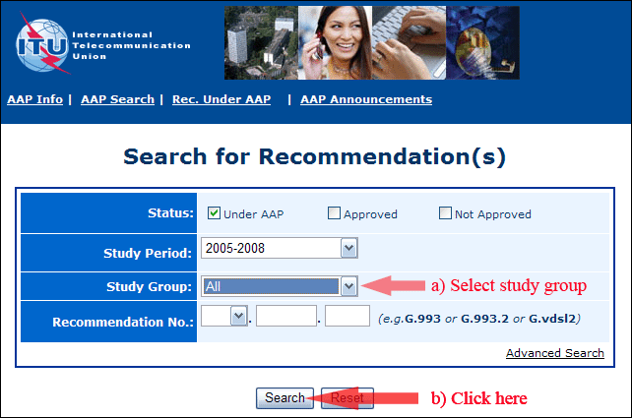
2) Select your Recommendation
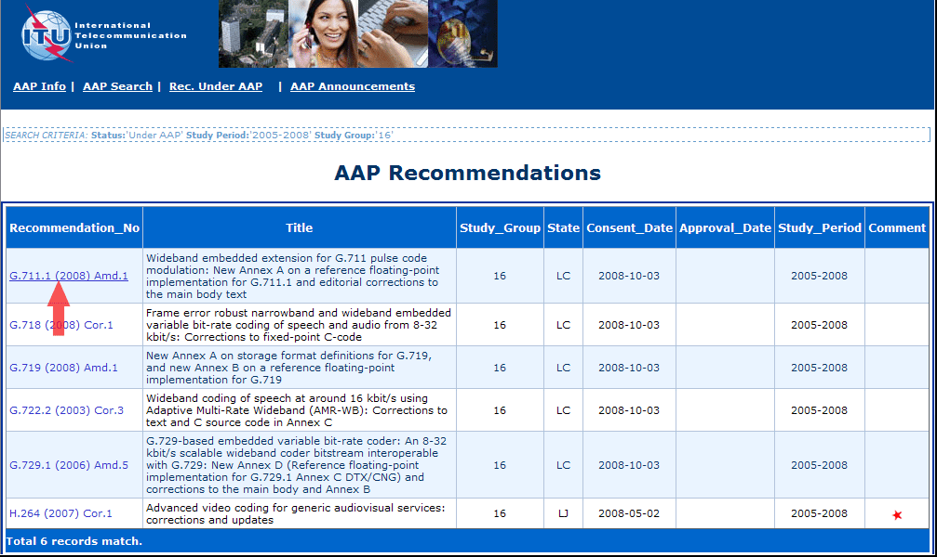
3) Click the "Submit Comment" button
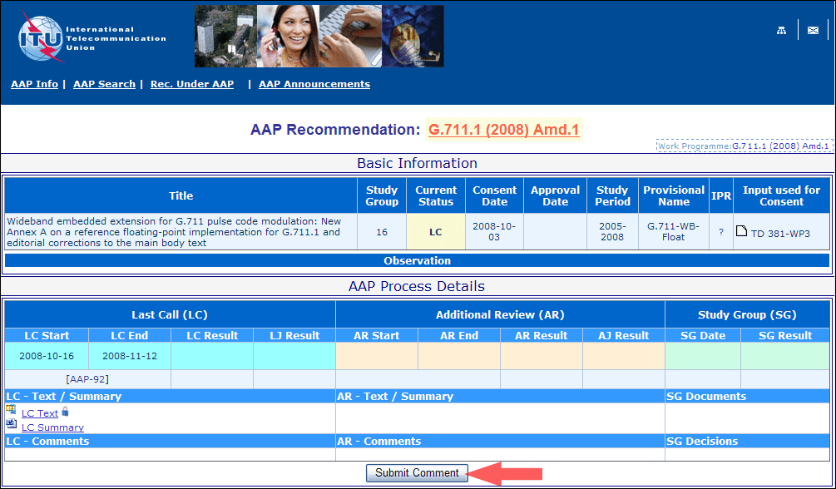
4) Complete the on-line form and click on "Submit"
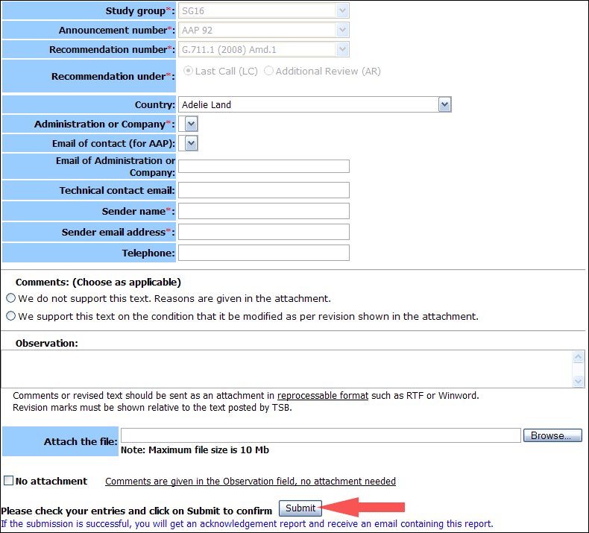
For more information, read the AAP tutorial on:
http://www.itu.int/ITU-T/aapinfo/files/AAPTutorial.pdf
Annex 3
(to TSB AAP-57)
Recommendations under LC/AR – Comment submission form
(Separate form for each Recommendation being commented upon)
ITU-T AAP comment submission form for the period 2009-2012
Study Group:
Announcement number:
Recommendation number:
Recommendation under: | Last call (LC)  Additional Review (AR)
Country:
Administration/Company:
Name of AAP Contact Person:
Email of AAP Contact Person:
Sender name:
(if different from AAP Contact Person)
Sender email address:
Telephone:
Comments:  (Choose as applicable) | We do not support this text. Reasons are given in the attachment.  We support this text on the condition that it be modified as per revision shown in the attachment.
Observations:
No attachment: Comments are given in the Observation field, no attachment needed
To be returned to: email: tsbsg....@itu.int
[or fax +41 22 730 5853]
Comments or revised text should be sent as an attachment in RTF or WinWord format.
Revision marks must be shown relative to the text posted by TSB.

