|  |  |
| --- | --- |
|  | الا تحــاد الــدولي للاتصــالات  *مكتب تقييس الاتصالات* |

|  |  |  |
| --- | --- | --- |
|  |  | جنيف، 16 مارس 2011 |
| المرجع:    الهاتف:  الفاكس:  البريد الإلكتروني: | **TSB AAP-55**  AAP/MJ  +41 22 730 5860  +41 22 730 5853  tsbdir@itu.int | - إلى إدارات الدول الأعضاء في الاتحاد؛  - إلى أعضاء قطاع تقييس الاتصالات؛  - إلى المنتسبين إلى قطاع تقييس الاتصالات  **نسخة إلى:**  - رؤساء لجان الدراسات في قطاع تقييس الاتصالات ونوابهم؛  - مدير مكتب تنمية الاتصالات؛  - مدير مكتب الاتصالات الراديوية |

الموضوع: **حالة التوصيات الخاضعة لعملية الموافقة البديلة (AAP)**

حضرات السادة والسيدات،

تحية طيبة وبعد،

تنطبق عملية الموافقة البديلة (AAP) المعرفة في التوصية ITU‑T A.8 على التوصيات التي لا تنطوي على بعد سياسي أوتنظيمي ولا تتطلب بالتالي استشارة الدول الأعضاء رسمياً (انظر الرقم 246B من اتفاقية الاتحاد).

ويتضمن **الملحق 1** لائحة بالنصوص التي تغيرت حالتها مقارنة بما جاء في إعلانات عملية الموافقة البديلة السابقة.

إذا رغبتم في تقديم تعليق بشأن توصية ما خاضعة لعملية الموافقة البديلة، فنرجو منكم استعمال استمارة التعليق على الخط المتوفّرة على موقع قطاع تقييس الاتصالات على صفحة عملية الموافقة البديلة [http://www.itu.int/ITU-T/aap](http://www.itu.int/ITU-T/aap/) على المدخل الخاص بالتوصية المعنية (انظر **الملحق** (**2**. وبديلاً من ذلك، يمكنكم تقديم التعليقات باستكمال الاستمارة الواردة في **الملحق 3** وإرسالها إلى أمانة لجنة الدراسات المعنية بالأمر.

وتجدر الإشارة إلى أنه يفضّل عدم إرسال تعليقات تقتصر على تأييد اعتماد النص قيد النظر.

وتفضلوا بقبول فائق الاحترام والتقدير.

مالكولم جونسون  
مدير مكتب تقييس الاتصالات

**الملحقات:** 3

Annex 1

(to TSB AAP-55)

Status codes used in the AAP announcements:

LC = Last Call

LJ = Last Call Judgment (includes comment resolution)

AR = Additional Review

AJ = Additional Review Judgment (includes comment resolution)

SG = For Study Group approval

A = Approved

AT = Approved with typographic corrections

AC = Approved after Additional Review of Comments

NA = Not approved

TAP = Moved to TAP (ITU-T A.8 / § 5.2)

ITU-T website entry page:

[http://www.itu.int/ITU-T](http://www.itu.int/ITU-T/)

Alternative approval process (AAP) welcome page:

[http://www.itu.int/ITU-T/aapinfo](http://www.itu.int/ITU-T/aapinfo/)

Note – A tutorial on the ITU-T AAP application is available under the AAP welcome page

ITU-T website AAP Recommendation search page:

<http://www.itu.int/ITU-T/aap/>

Study Group web pages and contacts:

|  |  |  |
| --- | --- | --- |
| SG 2 | <http://www.itu.int/ITU-T/studygroups/com02> | [tsbsg2@itu.int](mailto:tsbsg2@itu.int) |
| SG 3 | <http://www.itu.int/ITU-T/studygroups/com03> | [tsbsg3@itu.int](mailto:tsbsg3@itu.int) |
| SG 5 | <http://www.itu.int/ITU-T/studygroups/com05> | [tsbsg5@itu.int](mailto:tsbsg5@itu.int) |
| SG 9 | <http://www.itu.int/ITU-T/studygroups/com09> | [tsbsg9@itu.int](mailto:tsbsg9@itu.int) |
| SG 11 | <http://www.itu.int/ITU-T/studygroups/com11> | [tsbsg11@itu.int](mailto:tsbsg11@itu.int) |
| SG 12 | <http://www.itu.int/ITU-T/studygroups/com12> | [tsbsg12@itu.int](mailto:tsbsg12@itu.int) |
| SG 13 | <http://www.itu.int/ITU-T/studygroups/com13> | [tsbsg13@itu.int](mailto:tsbsg13@itu.int) |
| SG 15 | <http://www.itu.int/ITU-T/studygroups/com15> | [tsbsg15@itu.int](mailto:tsbsg15@itu.int) |
| SG 16 | <http://www.itu.int/ITU-T/studygroups/com16> | [tsbsg16@itu.int](mailto:tsbsg16@itu.int) |
| SG 17 | <http://www.itu.int/ITU-T/studygroups/com17> | [tsbsg17@itu.int](mailto:tsbsg17@itu.int) |

Situation concerning Study Group 2 Recommendations under AAP

| **Rec #** | **Title** | **Last Call (LC) Period** | | | | **Additional Review (AR) Period** | | | | Status |
| --- | --- | --- | --- | --- | --- | --- | --- | --- | --- | --- |
| **LC Start** | **LC End** | **LC Result** | **LJ Result** | **AR Start** | **AR End** | **AR Result** | **AJ Result** |
| [M.727 (M.7pnop)](http://www.itu.int/itu-t/aap/AAPRecDetails.aspx?AAPSeqNo=2193) | Planned Outage Notification Point | 2010-12-01 | 2011-01-12 | A |  |  |  |  |  | A |

Situation concerning Study Group 5 Recommendations under AAP

| **Rec #** | **Title** | **Last Call (LC) Period** | | | | **Additional Review (AR) Period** | | | | Status |
| --- | --- | --- | --- | --- | --- | --- | --- | --- | --- | --- |
| **LC Start** | **LC End** | **LC Result** | **LJ Result** | **AR Start** | **AR End** | **AR Result** | **AJ Result** |
| [K.83 (K.monitor)](http://www.itu.int/itu-t/aap/AAPRecDetails.aspx?AAPSeqNo=2203) | Monitoring of EMF levels | 2010-12-16 | 2011-01-12 | LJ | AR | 2011-02-16 | 2011-03-08 | AC |  | AC |
| [L.1400 (L.methodology_umbrella)](http://www.itu.int/itu-t/aap/AAPRecDetails.aspx?AAPSeqNo=2185) | Overview and general principles of methodologies for assessing the environmental impact of ICT | 2010-10-16 | 2010-11-12 | LJ | AR | 2011-02-01 | 2011-02-21 | AJ | AC | AC |

Situation concerning Study Group 12 Recommendations under AAP

| **Rec #** | **Title** | **Last Call (LC) Period** | | | | **Additional Review (AR) Period** | | | | Status |
| --- | --- | --- | --- | --- | --- | --- | --- | --- | --- | --- |
| **LC Start** | **LC End** | **LC Result** | **LJ Result** | **AR Start** | **AR End** | **AR Result** | **AJ Result** |
| [G.1050](http://www.itu.int/itu-t/aap/AAPRecDetails.aspx?AAPSeqNo=2237) | Network model for evaluating multimedia transmission performance over Internet Protocol | 2011-02-01 | 2011-02-28 | A |  |  |  |  |  | A |
| [P.56](http://www.itu.int/itu-t/aap/AAPRecDetails.aspx?AAPSeqNo=2240) | Objective measurement of active speech level | 2011-02-01 | 2011-02-28 | A |  |  |  |  |  | A |
| [P.311](http://www.itu.int/itu-t/aap/AAPRecDetails.aspx?AAPSeqNo=2235) | Transmission characteristics for wideband digital handset and headset telephones | 2011-02-01 | 2011-02-28 | A |  |  |  |  |  | A |
| [P.341](http://www.itu.int/itu-t/aap/AAPRecDetails.aspx?AAPSeqNo=2236) | Transmission characteristics for wideband digital loudspeaking and hands-free telephony terminals | 2011-02-01 | 2011-02-28 | A |  |  |  |  |  | A |
| [P.1100](http://www.itu.int/itu-t/aap/AAPRecDetails.aspx?AAPSeqNo=2241) | Narrowband hands-free communication in motor vehicles | 2011-02-01 | 2011-02-28 | A |  |  |  |  |  | A |
| [Y.1540](http://www.itu.int/itu-t/aap/AAPRecDetails.aspx?AAPSeqNo=2238) | Internet protocol data communication service – IP packet transfer and availability performance parameters | 2011-02-01 | 2011-02-28 | A |  |  |  |  |  | A |
| [Y.1564 (Y.156sam)](http://www.itu.int/itu-t/aap/AAPRecDetails.aspx?AAPSeqNo=2239) | Ethernet service activation test methodology | 2011-02-01 | 2011-02-28 | AT |  |  |  |  |  | AT |

Situation concerning Study Group 15 Recommendations under AAP

| **Rec #** | **Title** | **Last Call (LC) Period** | | | | **Additional Review (AR) Period** | | | | Status |
| --- | --- | --- | --- | --- | --- | --- | --- | --- | --- | --- |
| **LC Start** | **LC End** | **LC Result** | **LJ Result** | **AR Start** | **AR End** | **AR Result** | **AJ Result** |
| [G.663](http://www.itu.int/itu-t/aap/AAPRecDetails.aspx?AAPSeqNo=2265) | Application related aspects of optical amplifier devices and subsystems | 2011-03-16 | 2011-04-12 |  |  |  |  |  |  | LC |
| [G.709/Y.1331 (2009) Amd.2](http://www.itu.int/itu-t/aap/AAPRecDetails.aspx?AAPSeqNo=2279) | Interfaces for the Optical Transport Network (OTN): Amendment 2 | 2011-03-16 | 2011-04-12 |  |  |  |  |  |  | LC |
| [G.798 (2010) Amd.1](http://www.itu.int/itu-t/aap/AAPRecDetails.aspx?AAPSeqNo=2270) | Characteristics of optical transport network hierarchy equipment functional blocks: Amendment 1 | 2011-03-16 | 2011-04-12 |  |  |  |  |  |  | LC |
| [G.798 (2010) Cor.1](http://www.itu.int/itu-t/aap/AAPRecDetails.aspx?AAPSeqNo=2271) | Characteristics of optical transport network hierarchy equipment functional blocks: Corrigendum 1 | 2011-03-16 | 2011-04-12 |  |  |  |  |  |  | LC |
| [G.798.1](http://www.itu.int/itu-t/aap/AAPRecDetails.aspx?AAPSeqNo=2272) | Types and characteristics of Optical Transport Network (OTN) equipment | 2011-03-16 | 2011-04-12 |  |  |  |  |  |  | LC |
| [G.806 (2009) Amd.1](http://www.itu.int/itu-t/aap/AAPRecDetails.aspx?AAPSeqNo=2273) | Characteristics of transport equipment – Description methodology and generic functionality: Amendment 1 | 2011-03-16 | 2011-04-12 |  |  |  |  |  |  | LC |
| [G.873.1](http://www.itu.int/itu-t/aap/AAPRecDetails.aspx?AAPSeqNo=2274) | Optical Transport Network (OTN): Linear protection | 2011-03-16 | 2011-04-12 |  |  |  |  |  |  | LC |
| [G.874 (2010) Cor.1](http://www.itu.int/itu-t/aap/AAPRecDetails.aspx?AAPSeqNo=2284) | Management aspects of optical transport network elements: Corrigendum 1 | 2011-03-16 | 2011-04-12 |  |  |  |  |  |  | LC |
| [G.959.1 (2009) Amd.1](http://www.itu.int/itu-t/aap/AAPRecDetails.aspx?AAPSeqNo=2264) | Optical transport networks physical layer interfaces: Amendment 1 | 2011-03-16 | 2011-04-12 |  |  |  |  |  |  | LC |
| [G.972](http://www.itu.int/itu-t/aap/AAPRecDetails.aspx?AAPSeqNo=2266) | Definition of terms relevant to optical fibre submarine cable systems | 2011-03-16 | 2011-04-12 |  |  |  |  |  |  | LC |
| [G.973.2 (G.mdasub)](http://www.itu.int/itu-t/aap/AAPRecDetails.aspx?AAPSeqNo=2268) | Multichannel DWDM applications with single channel optical interfaces for repeaterless optical fibre submarine cable systems | 2011-03-16 | 2011-04-12 |  |  |  |  |  |  | LC |
| [G.977](http://www.itu.int/itu-t/aap/AAPRecDetails.aspx?AAPSeqNo=2267) | Characteristics of optically amplified optical fibre submarine cable systems | 2011-03-16 | 2011-04-12 |  |  |  |  |  |  | LC |
| [G.988 (2010-10) Amd.1](http://www.itu.int/itu-t/aap/AAPRecDetails.aspx?AAPSeqNo=2252) | ONU management and control interface (OMCI) specification: Amendment 1 - Maintenance | 2011-03-16 | 2011-04-12 |  |  |  |  |  |  | LC |
| [G.992.3 (2009) Cor.2](http://www.itu.int/itu-t/aap/AAPRecDetails.aspx?AAPSeqNo=2253) | Asymmetric digital subscriber line transceivers 2 (ADSL2): Corrigendum 2 | 2011-03-16 | 2011-04-12 |  |  |  |  |  |  | LC |
| [G.993.2 (2006) Amd.7](http://www.itu.int/itu-t/aap/AAPRecDetails.aspx?AAPSeqNo=2254) | Very high speed digital subscriber line transceivers 2 (VDSL2): Amendment 7 | 2011-03-16 | 2011-04-12 |  |  |  |  |  |  | LC |
| [G.993.2 (2006) Cor.4](http://www.itu.int/itu-t/aap/AAPRecDetails.aspx?AAPSeqNo=2255) | Very high speed digital subscriber line transceivers 2 (VDSL2): Corrigendum 4 | 2011-03-16 | 2011-04-12 |  |  |  |  |  |  | LC |
| [G.993.5 (2010) Cor.1 (G.vector)](http://www.itu.int/itu-t/aap/AAPRecDetails.aspx?AAPSeqNo=2256) | Self-FEXT cancellation (vectoring) for use with VDSL2 transceivers: Corrigendum 1 | 2011-03-16 | 2011-04-12 |  |  |  |  |  |  | LC |
| [G.994.1 (2007) Amd.7](http://www.itu.int/itu-t/aap/AAPRecDetails.aspx?AAPSeqNo=2257) | Handshake procedures for digital subscriber line (DSL) transceivers: Amendment 7 | 2011-03-16 | 2011-04-12 |  |  |  |  |  |  | LC |
| [G.997.1 (2009) Amd.3](http://www.itu.int/itu-t/aap/AAPRecDetails.aspx?AAPSeqNo=2258) | Physical layer management for digital subscriber line (DSL) transceivers: Amendment 3 | 2011-03-16 | 2011-04-12 |  |  |  |  |  |  | LC |
| [G.998.4 (2010) Amd.1](http://www.itu.int/itu-t/aap/AAPRecDetails.aspx?AAPSeqNo=2259) | Improved impulse noise protection for DSL transceivers: Amendment 1 | 2011-03-16 | 2011-04-12 |  |  |  |  |  |  | LC |
| [G.998.4 (2010) Cor.2](http://www.itu.int/itu-t/aap/AAPRecDetails.aspx?AAPSeqNo=2260) | Improved impulse noise protection for DSL transceivers: Corrigendum 2 | 2011-03-16 | 2011-04-12 |  |  |  |  |  |  | LC |
| [G.7041/Y.1303](http://www.itu.int/itu-t/aap/AAPRecDetails.aspx?AAPSeqNo=2280) | Generic framing procedure (GFP) | 2011-03-16 | 2011-04-12 |  |  |  |  |  |  | LC |
| [G.7710/Y.1701 (2007) Cor.2](http://www.itu.int/itu-t/aap/AAPRecDetails.aspx?AAPSeqNo=2285) | Common equipment management function requirements: Corrigendum 2 | 2011-03-16 | 2011-04-12 |  |  |  |  |  |  | LC |
| [G.8001/Y.1354](http://www.itu.int/itu-t/aap/AAPRecDetails.aspx?AAPSeqNo=2269) | Terms and definitions for Ethernet frames over Transport | 2011-03-16 | 2011-04-12 |  |  |  |  |  |  | LC |
| [G.8013/Y.1731 (Y.1731)](http://www.itu.int/itu-t/aap/AAPRecDetails.aspx?AAPSeqNo=2278) | OAM functions and mechanisms for Ethernet based networks | 2011-03-16 | 2011-04-12 |  |  |  |  |  |  | LC |
| [G.8021/Y.1341 (2010) Amd.1](http://www.itu.int/itu-t/aap/AAPRecDetails.aspx?AAPSeqNo=2275) | Characteristics of Ethernet transport network equipment functional blocks: Amendment 1 | 2011-03-16 | 2011-04-12 |  |  |  |  |  |  | LC |
| [G.8031/Y.1342](http://www.itu.int/itu-t/aap/AAPRecDetails.aspx?AAPSeqNo=2276) | Ethernet linear protection switching | 2011-03-16 | 2011-04-12 |  |  |  |  |  |  | LC |
| [G.8051/Y.1345 (2009) Amd.1 (G.eot-mgmt)](http://www.itu.int/itu-t/aap/AAPRecDetails.aspx?AAPSeqNo=2286) | Management aspects of the Ethernet-over-Transport (EoT) capable network element: Amendment 1 | 2011-03-16 | 2011-04-12 |  |  |  |  |  |  | LC |
| [G.8110.1/Y.1370.1](http://www.itu.int/itu-t/aap/AAPRecDetails.aspx?AAPSeqNo=2281) | Architecture of MPLS Transport Profile (MPLS-TP) layer network | 2011-03-16 | 2011-04-12 |  |  |  |  |  |  | LC |
| [G.8201](http://www.itu.int/itu-t/aap/AAPRecDetails.aspx?AAPSeqNo=2277) | Error performance parameters and objectives for multi-operator international paths within the Optical Transport Network (OTN) | 2011-03-16 | 2011-04-12 |  |  |  |  |  |  | LC |
| [G.8251 (2010) Amd.1](http://www.itu.int/itu-t/aap/AAPRecDetails.aspx?AAPSeqNo=2282) | The control of jitter and wander within the optical transport network (OTN): Amendment 1 | 2011-03-16 | 2011-04-12 |  |  |  |  |  |  | LC |
| [G.8265.1/Y.1365.1 (2010) Amd.1](http://www.itu.int/itu-t/aap/AAPRecDetails.aspx?AAPSeqNo=2283) | Precision time protocol telecom profile for frequency synchronization: Amendment 1 | 2011-03-16 | 2011-04-12 |  |  |  |  |  |  | LC |
| [G.9956 (G.hnem)](http://www.itu.int/itu-t/aap/AAPRecDetails.aspx?AAPSeqNo=2261) | Narrow-band OFDM power line communication transceivers - Data link layer specification | 2011-03-16 | 2011-04-12 |  |  |  |  |  |  | LC |
| [G.9961 (2010) Amd.1](http://www.itu.int/itu-t/aap/AAPRecDetails.aspx?AAPSeqNo=2262) | Data link layer (DLL) for unified high-speed wire-line based home networking transceivers: Amendment 1 | 2011-03-16 | 2011-04-12 |  |  |  |  |  |  | LC |
| [G.9961 (2010) Cor.1](http://www.itu.int/itu-t/aap/AAPRecDetails.aspx?AAPSeqNo=2263) | Data link layer (DLL) for unified high-speed wire-line based home networking transceivers: Corrigendum 1 | 2011-03-16 | 2011-04-12 |  |  |  |  |  |  | LC |
| [O.174 (2009) Amd.1](http://www.itu.int/itu-t/aap/AAPRecDetails.aspx?AAPSeqNo=2287) | Jitter and wander measuring equipment for digital systems which are based on synchronous Ethernet technology: Amendment 1 | 2011-03-16 | 2011-04-12 |  |  |  |  |  |  | LC |

Annex 2

(to TSB AAP-55)

Using the on-line comment submission form

Comment submission

1) Go to AAP search Web page at <http://www.itu.int/ITU-T/aap/>

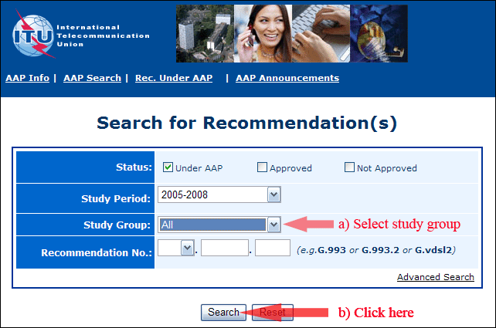

2) Select your Recommendation

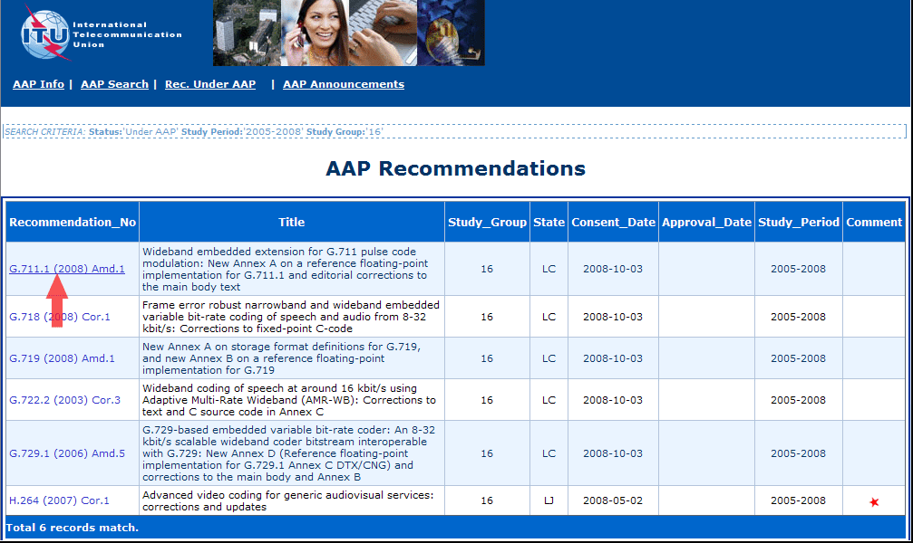

3) Click the "Submit Comment" button

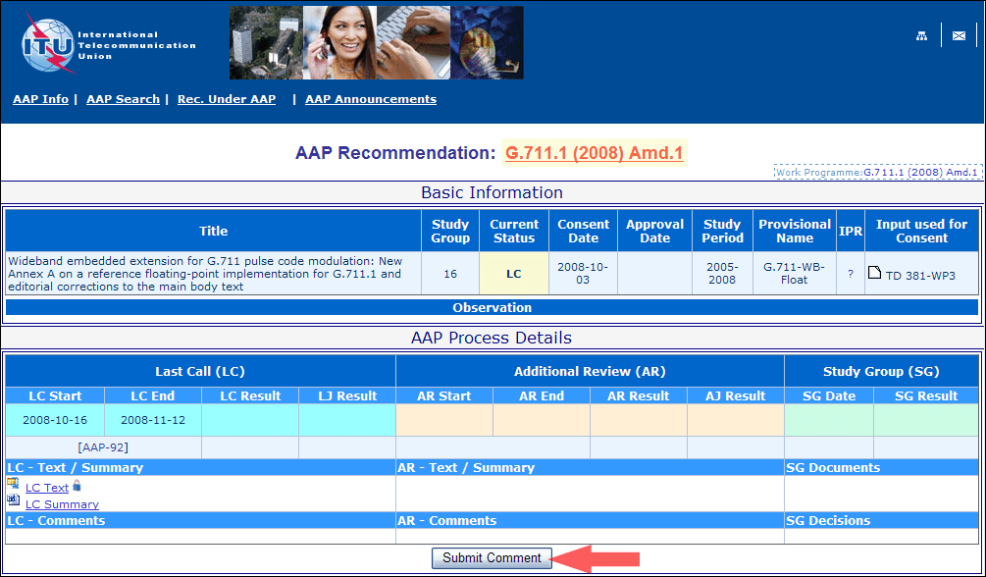

4) Complete the on-line form and click on "Submit"

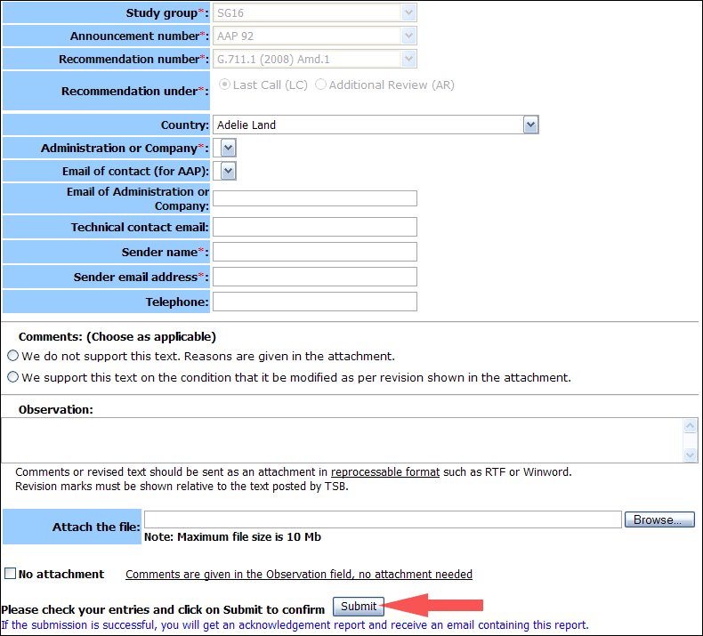

For more information, read the AAP tutorial on:   
<http://www.itu.int/ITU-T/aapinfo/files/AAPTutorial.pdf>

Annex 3

(to TSB AAP-55)

Recommendations under LC/AR – Comment submission form

*(Separate form for each Recommendation being commented upon)*

|  |  |
| --- | --- |
| ITU-T AAP comment submission form for the period 2009-2012 | |
| **Study Group:** |  |
| **Announcement number:** |  |
| **Recommendation number:** |  |
| **Recommendation under:** | Last call (LC)   Additional Review (AR) |
| **Country:** |  |
| **Administration/Company:** |  |
| **Name of AAP Contact Person:** |  |
| **Email of AAP Contact Person:** |  |
| **Sender name: (if different from AAP Contact Person)** |  |
| **Sender email address:** |  |
| **Telephone:** |  |
| **Comments: (Choose as applicable)** | We do not support this text. Reasons are given in the attachment.   We support this text on the condition that it be modified as per revision shown in the attachment. |
| **Observations:** |  |

**No attachment:** Comments are given in the Observation field, no attachment needed

*To be returned to: email:* [*tsbsg....@itu.int*](mailto:tsbsg....@itu.int) *[or fax +41 22 730 5853]  
Comments or revised text should be sent as an attachment in RTF or WinWord format.  
Revision marks must be shown relative to the text posted by TSB.*