International Telecommunication Union
Telecommunication Standardization Bureau

Geneva, 16 February 2011

Ref:  Tel:  Fax:  E-mail: | TSB AAP-53  AAP/MJ  +41 22 730 5860  +41 22 730 5853  tsbdir@itu.int | – To Administrations of Member States of the Union;  – To ITU-T Sector Members;  – To ITU-T Associates  Copy:  – To the ITU-T Study Group Chairmen and Vice-Chairmen;  – To the Director of the Telecommunication Development Bureau;  – To the Director of the Radiocommunication Bureau

Subject: | Situation concerning Recommendations under the Alternative Approval Process (AAP)

Dear Sir/Madam,
The Alternative Approval Process (AAP) defined in Rec. ITU-T A.8 applies to Recommendations which do not have policy or regulatory implications and which, therefore, do not require formal consultation of Member States (see ITU Convention 246B).
Annex 1 lists those texts whose status has changed compared with previous TSB AAP Announcements.
If you wish to submit a comment relative to a Recommendation under AAP, you are encouraged to use the on-line AAP comment submission form available on the page of the Recommendation in the AAP area of the ITU-T website at http://www.itu.int/ITU-T/aap (see Annex 2). Alternatively, comments can be submitted by completing the form in Annex 3 and sending it to the secretariat of the concerned study group.
Please note that comments that simply support adoption of the text in question are not encouraged.
Yours faithfully,
Malcolm Johnson
Director of the Telecommunication Standardization Bureau
Annexes: 3

Annex 1
(to TSB AAP-53)

Status codes used in the AAP announcements:
LC = Last Call
LJ = Last Call Judgment (includes comment resolution)
AR = Additional Review
AJ = Additional Review Judgment (includes comment resolution)
SG = For Study Group approval
A = Approved
AT = Approved with typographic corrections
AC = Approved after Additional Review of Comments
NA = Not approved
TAP = Moved to TAP (ITU-T A.8 / § 5.2)
ITU-T website entry page:
http://www.itu.int/ITU-T
Alternative approval process (AAP) welcome page:
http://www.itu.int/ITU-T/aapinfo
Note – A tutorial on the ITU-T AAP application is available under the AAP welcome page
ITU-T website AAP Recommendation search page:
http://www.itu.int/ITU-T/aap/
Study Group web pages and contacts:
SG 2 | http://www.itu.int/ITU-T/studygroups/com02 | tsbsg2@itu.int
SG 3 | http://www.itu.int/ITU-T/studygroups/com03 | tsbsg3@itu.int
SG 5 | http://www.itu.int/ITU-T/studygroups/com05 | tsbsg5@itu.int
SG 9 | http://www.itu.int/ITU-T/studygroups/com09 | tsbsg9@itu.int
SG 11 | http://www.itu.int/ITU-T/studygroups/com11 | tsbsg11@itu.int
SG 12 | http://www.itu.int/ITU-T/studygroups/com12 | tsbsg12@itu.int
SG 13 | http://www.itu.int/ITU-T/studygroups/com13 | tsbsg13@itu.int
SG 15 | http://www.itu.int/ITU-T/studygroups/com15 | tsbsg15@itu.int
SG 16 | http://www.itu.int/ITU-T/studygroups/com16 | tsbsg16@itu.int
SG 17 | http://www.itu.int/ITU-T/studygroups/com17 | tsbsg17@itu.int

Situation concerning Study Group 5 Recommendations under AAP
Rec # | Title | Last Call (LC) Period |  |  |  | Additional Review (AR) Period |  |  |  | Status
 |  | LC Start | LC End | LC  Result | LJ  Result | AR Start | AR End | AR  Result | AJ  Result
K.83 (K.monitor) | Monitoring of EMF levels | 2010-12-16 | 2011-01-12 | LJ | AR | 2011-02-16 | 2011-03-08 |  |  | AR
Situation concerning Study Group 11 Recommendations under AAP
Rec # | Title | Last Call (LC) Period |  |  |  | Additional Review (AR) Period |  |  |  | Status
 |  | LC Start | LC End | LC  Result | LJ  Result | AR Start | AR End | AR  Result | AJ  Result
Q.1912.5 F | Interworking between Session Initiation Protocol (SIP) and Bearer Independent Call Control Protocol (BICC) or ISDN User Part (ISUP); Part 5: Abstract Test Suite (ATS) and partial Protocol Implementation eXtra Information for Testing (PIXIT) for Profile C | 2011-02-16 | 2011-03-15 |  |  |  |  |  |  | LC
Q.3931.1  (Q.Bench-IMS-PES A) | IMS/PES Performance Benchmark Part 1: Core concepts | 2011-02-16 | 2011-03-15 |  |  |  |  |  |  | LC
Q.3931.2  (Q.Bench-IMS-PES B) | IMS/PES Performance Benchmark Part 2: Subsystem configurations and benchmarks | 2011-02-16 | 2011-03-15 |  |  |  |  |  |  | LC
Situation concerning Study Group 13 Recommendations under AAP
Rec # | Title | Last Call (LC) Period |  |  |  | Additional Review (AR) Period |  |  |  | Status
 |  | LC Start | LC End | LC  Result | LJ  Result | AR Start | AR End | AR  Result | AJ  Result
Y.1902  (Y.iptv-netcontrol-fw) | Framework for multicast based IPTV content delivery | 2011-02-16 | 2011-03-15 |  |  |  |  |  |  | LC
Y.2020 (Y.OSE-arch) | Open Service Environment Functional Architecture for NGN | 2011-02-16 | 2011-03-15 |  |  |  |  |  |  | LC
Y.2055  (Y.ipv6-object) | Framework of object mapping using IPv6 in NGN | 2011-02-16 | 2011-03-15 |  |  |  |  |  |  | LC
Y.2091 | Terms and definitions for Next Generation Networks | 2011-02-16 | 2011-03-15 |  |  |  |  |  |  | LC
Y.2240  (Y.NGN-SIDE-Req) | Requirements and capabilities for NGN service integration and delivery environment | 2011-02-16 | 2011-03-15 |  |  |  |  |  |  | LC
Y.2251 (Y.MC-REQ) | Multi-connection Requirements | 2011-02-16 | 2011-03-15 |  |  |  |  |  |  | LC
Situation concerning Study Group 17 Recommendations under AAP
Rec # | Title | Last Call (LC) Period |  |  |  | Additional Review (AR) Period |  |  |  | Status
 |  | LC Start | LC End | LC  Result | LJ  Result | AR Start | AR End | AR  Result | AJ  Result
X.501 (2005) Cor.3 | Technical Corrigendum 3 to ITU-T X.501 (2005) | ISO/IEC 9594-2:2005 | 2011-01-16 | 2011-02-12 | A |  |  |  |  |  | A
X.501 (2008) Cor.1 | Technical Corrigendum 1 to ITU-T X.501 (2008) | ISO/IEC 9594-2:2008 | 2011-01-16 | 2011-02-12 | A |  |  |  |  |  | A
X.509 (2005) Cor. 3 | Technical Corrigendum 3 to ITU-T X.509 (2005) | ISO/IEC 9594-8:2005 | 2011-01-16 | 2011-02-12 | A |  |  |  |  |  | A
X.509 (2008) Cor.1 | Technical Corrigendum 1 to ITU-T X.509 (2008) | ISO/IEC 9594-8:2008 | 2011-01-16 | 2011-02-12 | A |  |  |  |  |  | A
X.511 (2005) Cor.3 | Technical Corrigendum 3 to ITU-T X.511 (2005) | ISO/IEC 9594-3:2005 | 2011-01-16 | 2011-02-12 | A |  |  |  |  |  | A
X.511 (2008) Cor.1 | Technical Corrigendum 1 to ITU-T X.511 (2008) | ISO/IEC 9594-3:2008 | 2011-01-16 | 2011-02-12 | A |  |  |  |  |  | A
X.518 (2005) Cor.2 | Technical Corrigendum 2 to ITU-T X.518 (2005) | ISO/IEC 9594-4:2005 | 2011-01-16 | 2011-02-12 | A |  |  |  |  |  | A
X.518 (2008) Cor.1 | Technical Corrigendum 1 to ITU-T X.518 (2008) | ISO/IEC 9594-4:2008 | 2011-01-16 | 2011-02-12 | A |  |  |  |  |  | A
X.519 (2005) Cor.2 | Technical Corrigendum 2 to ITU-T X.519 (2005) | ISO/IEC 9594-5:2005 | 2011-01-16 | 2011-02-12 | A |  |  |  |  |  | A
X.519 (2008) Cor.1 | Technical Corrigendum 1 to ITU-T X.519 (2008) | ISO/IEC 9594-5:2008 | 2011-01-16 | 2011-02-12 | A |  |  |  |  |  | A
X.520 (2005) Cor.3 | Technical Corrigendum 3 to ITU-T X.520 (2005) | ISO/IEC 9594-6:2005 | 2011-01-16 | 2011-02-12 | A |  |  |  |  |  | A
X.520 (2008) Cor.1 | Technical Corrigendum 1 to ITU-T X.520 (2008) | ISO/IEC 9594-6:2008 | 2011-01-16 | 2011-02-12 | A |  |  |  |  |  | A
X.525 (2005) Cor.1 | Technical Corrigendum 1 to ITU-T X.525 (2005) | ISO/IEC 9594-9:2005 | 2011-01-16 | 2011-02-12 | A |  |  |  |  |  | A
X.525 (2008) Cor.1 | Technical Corrigendum 1 to ITU-T X.525 (2008) | ISO/IEC 9594-9:2008 | 2011-01-16 | 2011-02-12 | A |  |  |  |  |  | A
X.674 (X.alerting) | Procedures for the registration of arcs under the alerting object identifier arc | 2011-01-16 | 2011-02-12 | A |  |  |  |  |  | A
X.1034 | Guideline on extensible authentication protocol based authentication and key management in a data communication network | 2011-01-16 | 2011-02-12 | A |  |  |  |  |  | A
X.1153 (X.sap-3) | A management framework of an one time password-based authentication service | 2011-01-16 | 2011-02-12 | A |  |  |  |  |  | A
X.1195 (X.iptvsec-5) | Service and content protection (SCP) interoperability scheme | 2011-01-16 | 2011-02-12 | A |  |  |  |  |  | A
X.1311 (X.usnsec-1) | Security framework for ubiquitous sensor network | 2011-01-16 | 2011-02-12 | A |  |  |  |  |  | A
X.1312 (X.usnsec-2) | Ubiquitous sensor network (USN) middleware security guidelines | 2011-01-16 | 2011-02-12 | A |  |  |  |  |  | A
Z.120 | Message sequence chart (MSC) | 2011-01-16 | 2011-02-12 | A |  |  |  |  |  | A
Z.150 | User Requirements Notation (URN) - Language requirements and framework | 2011-01-16 | 2011-02-12 | A |  |  |  |  |  | A
Z.161 | Testing and Test Control Notation version 3: TTCN-3 core language | 2011-02-16 | 2011-03-15 |  |  |  |  |  |  | LC
Z.164 | Testing and Test Control Notation version 3: TTCN-3 operational semantics | 2011-02-16 | 2011-03-15 |  |  |  |  |  |  | LC
Z.165 | Testing and Test Control Notation version 3: TTCN-3 runtime interface (TRI) | 2011-02-16 | 2011-03-15 |  |  |  |  |  |  | LC
Z.166 | Testing and Test Control Notation version 3: TTCN-3 control interface (TCI) | 2011-02-16 | 2011-03-15 |  |  |  |  |  |  | LC
Z.167 | Testing and Test Control Notation version 3: TTCN-3 mapping from ASN.1 | 2011-02-16 | 2011-03-15 |  |  |  |  |  |  | LC
Z.168 | Testing and Test Control Notation version 3: TTCN-3 mapping from CORBA IDL | 2011-02-16 | 2011-03-15 |  |  |  |  |  |  | LC
Z.169 | Testing and Test Control Notation version 3: TTCN-3 mapping from XML data definition | 2011-02-16 | 2011-03-15 |  |  |  |  |  |  | LC
Z.170 | The testing and test control notation version 3: TTCN-3 documentation comment specification | 2011-02-16 | 2011-03-15 |  |  |  |  |  |  | LC

Annex 2
(to TSB AAP-53)
Using the on-line comment submission form
Comment submission
1) Go to AAP search Web page at http://www.itu.int/ITU-T/aap/
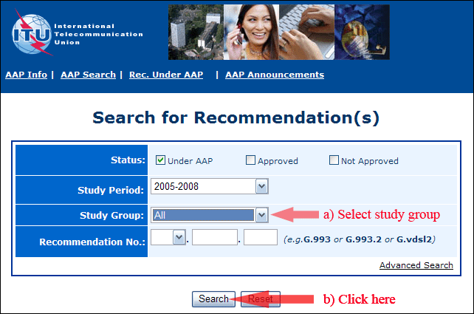
2) Select your Recommendation
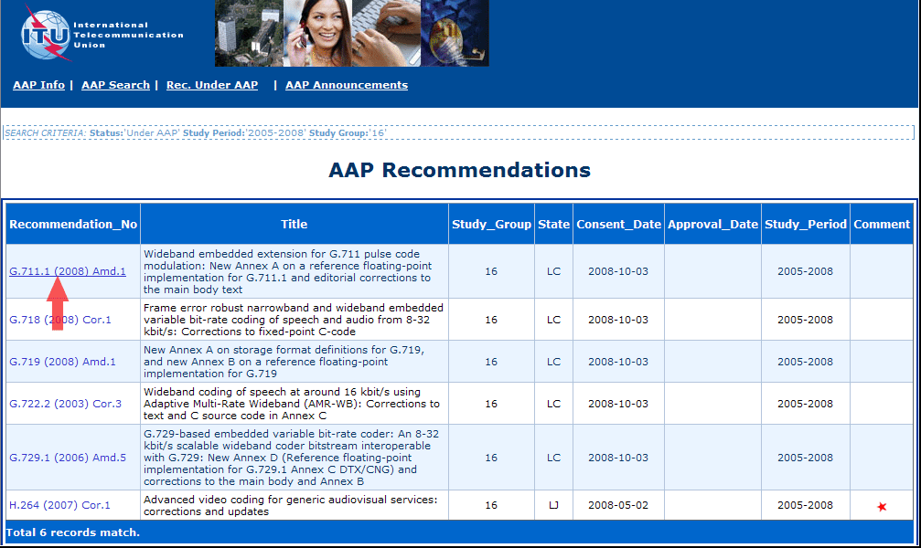
3) Click the "Submit Comment" button
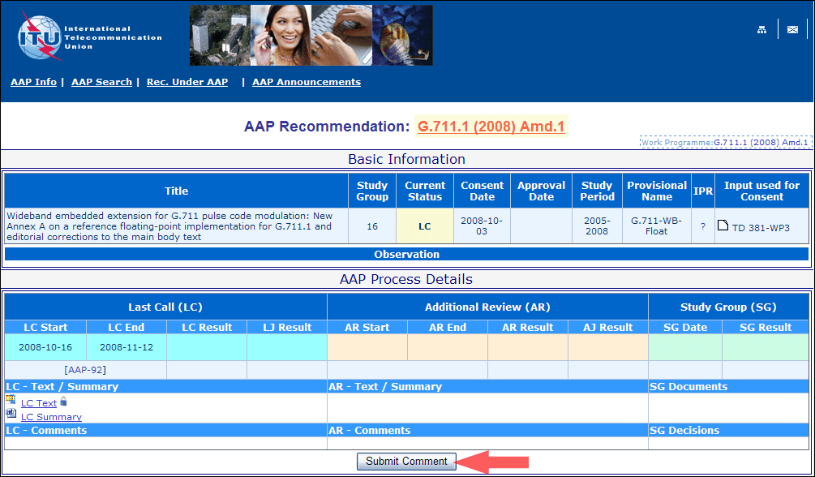
4) Complete the on-line form and click on "Submit"
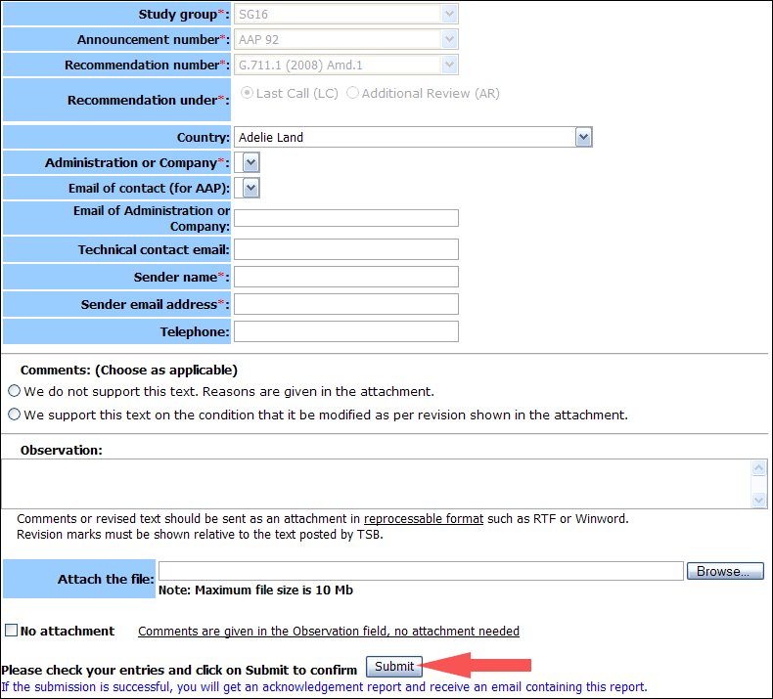
For more information, read the AAP tutorial on:
http://www.itu.int/ITU-T/aapinfo/files/AAPTutorial.pdf
Annex 3
(to TSB AAP-53)
Recommendations under LC/AR – Comment submission form
(Separate form for each Recommendation being commented upon)
ITU-T AAP comment submission form for the period 2009-2012
Study Group:
Announcement number:
Recommendation number:
Recommendation under: | Last call (LC)  Additional Review (AR)
Country:
Administration/Company:
Name of AAP Contact Person:
Email of AAP Contact Person:
Sender name:
(if different from AAP Contact Person)
Sender email address:
Telephone:
Comments:  (Choose as applicable) | We do not support this text. Reasons are given in the attachment.  We support this text on the condition that it be modified as per revision shown in the attachment.
Observations:
No attachment: Comments are given in the Observation field, no attachment needed
To be returned to: email: tsbsg....@itu.int
[or fax +41 22 730 5853]
Comments or revised text should be sent as an attachment in RTF or WinWord format.
Revision marks must be shown relative to the text posted by TSB.

