|  |  |
| --- | --- |
|  | الا تحــاد الــدولي للاتصــالات  *مكتب تقييس الاتصالات* |

|  |  |  |
| --- | --- | --- |
|  |  | جنيف، 16 فبراير 2011 |
| المرجع:    الهاتف:  الفاكس:  البريد الإلكتروني: | **TSB AAP-53**  AAP/MJ  +41 22 730 5860  +41 22 730 5853  tsbdir@itu.int | - إلى إدارات الدول الأعضاء في الاتحاد؛  - إلى أعضاء قطاع تقييس الاتصالات؛  - إلى المنتسبين إلى قطاع تقييس الاتصالات  **نسخة إلى:**  - رؤساء لجان الدراسات في قطاع تقييس الاتصالات ونوابهم؛  - مدير مكتب تنمية الاتصالات؛  - مدير مكتب الاتصالات الراديوية |

الموضوع: **حالة التوصيات الخاضعة لعملية الموافقة البديلة (AAP)**

حضرات السادة والسيدات،

تحية طيبة وبعد،

تنطبق عملية الموافقة البديلة (AAP) المعرفة في التوصية ITU‑T A.8 على التوصيات التي لا تنطوي على بعد سياسي أوتنظيمي ولا تتطلب بالتالي استشارة الدول الأعضاء رسمياً (انظر الرقم 246B من اتفاقية الاتحاد).

ويتضمن **الملحق 1** لائحة بالنصوص التي تغيرت حالتها مقارنة بما جاء في إعلانات عملية الموافقة البديلة السابقة.

إذا رغبتم في تقديم تعليق بشأن توصية ما خاضعة لعملية الموافقة البديلة، فنرجو منكم استعمال استمارة التعليق على الخط المتوفّرة على موقع قطاع تقييس الاتصالات على صفحة عملية الموافقة البديلة [http://www.itu.int/ITU-T/aap](http://www.itu.int/ITU-T/aap/) على المدخل الخاص بالتوصية المعنية (انظر **الملحق** (**2**. وبديلاً من ذلك، يمكنكم تقديم التعليقات باستكمال الاستمارة الواردة في **الملحق 3** وإرسالها إلى أمانة لجنة الدراسات المعنية بالأمر.

وتجدر الإشارة إلى أنه يفضّل عدم إرسال تعليقات تقتصر على تأييد اعتماد النص قيد النظر.

وتفضلوا بقبول فائق الاحترام والتقدير.

مالكولم جونسون  
مدير مكتب تقييس الاتصالات

**الملحقات:** 3

Annex 1

(to TSB AAP-53)

Status codes used in the AAP announcements:

LC = Last Call

LJ = Last Call Judgment (includes comment resolution)

AR = Additional Review

AJ = Additional Review Judgment (includes comment resolution)

SG = For Study Group approval

A = Approved

AT = Approved with typographic corrections

AC = Approved after Additional Review of Comments

NA = Not approved

TAP = Moved to TAP (ITU-T A.8 / § 5.2)

ITU-T website entry page:

[http://www.itu.int/ITU-T](http://www.itu.int/ITU-T/)

Alternative approval process (AAP) welcome page:

[http://www.itu.int/ITU-T/aapinfo](http://www.itu.int/ITU-T/aapinfo/)

Note – A tutorial on the ITU-T AAP application is available under the AAP welcome page

ITU-T website AAP Recommendation search page:

<http://www.itu.int/ITU-T/aap/>

Study Group web pages and contacts:

|  |  |  |
| --- | --- | --- |
| SG 2 | <http://www.itu.int/ITU-T/studygroups/com02> | [tsbsg2@itu.int](mailto:tsbsg2@itu.int) |
| SG 3 | <http://www.itu.int/ITU-T/studygroups/com03> | [tsbsg3@itu.int](mailto:tsbsg3@itu.int) |
| SG 5 | <http://www.itu.int/ITU-T/studygroups/com05> | [tsbsg5@itu.int](mailto:tsbsg5@itu.int) |
| SG 9 | <http://www.itu.int/ITU-T/studygroups/com09> | [tsbsg9@itu.int](mailto:tsbsg9@itu.int) |
| SG 11 | <http://www.itu.int/ITU-T/studygroups/com11> | [tsbsg11@itu.int](mailto:tsbsg11@itu.int) |
| SG 12 | <http://www.itu.int/ITU-T/studygroups/com12> | [tsbsg12@itu.int](mailto:tsbsg12@itu.int) |
| SG 13 | <http://www.itu.int/ITU-T/studygroups/com13> | [tsbsg13@itu.int](mailto:tsbsg13@itu.int) |
| SG 15 | <http://www.itu.int/ITU-T/studygroups/com15> | [tsbsg15@itu.int](mailto:tsbsg15@itu.int) |
| SG 16 | <http://www.itu.int/ITU-T/studygroups/com16> | [tsbsg16@itu.int](mailto:tsbsg16@itu.int) |
| SG 17 | <http://www.itu.int/ITU-T/studygroups/com17> | [tsbsg17@itu.int](mailto:tsbsg17@itu.int) |

Situation concerning Study Group 5 Recommendations under AAP

| **Rec #** | **Title** | **Last Call (LC) Period** | | | | **Additional Review (AR) Period** | | | | Status |
| --- | --- | --- | --- | --- | --- | --- | --- | --- | --- | --- |
| **LC Start** | **LC End** | **LC Result** | **LJ Result** | **AR Start** | **AR End** | **AR Result** | **AJ Result** |
| [K.83 (K.monitor)](http://www.itu.int/itu-t/aap/AAPRecDetails.aspx?AAPSeqNo=2203) | Monitoring of EMF levels | 2010-12-16 | 2011-01-12 | LJ | AR | 2011-02-16 | 2011-03-08 |  |  | AR |

Situation concerning Study Group 11 Recommendations under AAP

| **Rec #** | **Title** | **Last Call (LC) Period** | | | | **Additional Review (AR) Period** | | | | Status |
| --- | --- | --- | --- | --- | --- | --- | --- | --- | --- | --- |
| **LC Start** | **LC End** | **LC Result** | **LJ Result** | **AR Start** | **AR End** | **AR Result** | **AJ Result** |
| [Q.1912.5 F](http://www.itu.int/itu-t/aap/AAPRecDetails.aspx?AAPSeqNo=2243) | Interworking between Session Initiation Protocol (SIP) and Bearer Independent Call Control Protocol (BICC) or ISDN User Part (ISUP); Part 5: Abstract Test Suite (ATS) and partial Protocol Implementation eXtra Information for Testing (PIXIT) for Profile C | 2011-02-16 | 2011-03-15 |  |  |  |  |  |  | LC |
| [Q.3931.1  (Q.Bench-IMS-PES A)](http://www.itu.int/itu-t/aap/AAPRecDetails.aspx?AAPSeqNo=2245) | IMS/PES Performance Benchmark Part 1: Core concepts | 2011-02-16 | 2011-03-15 |  |  |  |  |  |  | LC |
| [Q.3931.2  (Q.Bench-IMS-PES B)](http://www.itu.int/itu-t/aap/AAPRecDetails.aspx?AAPSeqNo=2244) | IMS/PES Performance Benchmark Part 2: Subsystem configurations and benchmarks | 2011-02-16 | 2011-03-15 |  |  |  |  |  |  | LC |

Situation concerning Study Group 13 Recommendations under AAP

| **Rec #** | **Title** | **Last Call (LC) Period** | | | | **Additional Review (AR) Period** | | | | Status |
| --- | --- | --- | --- | --- | --- | --- | --- | --- | --- | --- |
| **LC Start** | **LC End** | **LC Result** | **LJ Result** | **AR Start** | **AR End** | **AR Result** | **AJ Result** |
| [Y.1902  (Y.iptv-netcontrol-fw)](http://www.itu.int/itu-t/aap/AAPRecDetails.aspx?AAPSeqNo=2247) | Framework for multicast based IPTV content delivery | 2011-02-16 | 2011-03-15 |  |  |  |  |  |  | LC |
| [Y.2020 (Y.OSE-arch)](http://www.itu.int/itu-t/aap/AAPRecDetails.aspx?AAPSeqNo=2249) | Open Service Environment Functional Architecture for NGN | 2011-02-16 | 2011-03-15 |  |  |  |  |  |  | LC |
| [Y.2055  (Y.ipv6-object)](http://www.itu.int/itu-t/aap/AAPRecDetails.aspx?AAPSeqNo=2250) | Framework of object mapping using IPv6 in NGN | 2011-02-16 | 2011-03-15 |  |  |  |  |  |  | LC |
| [Y.2091](http://www.itu.int/itu-t/aap/AAPRecDetails.aspx?AAPSeqNo=2246) | Terms and definitions for Next Generation Networks | 2011-02-16 | 2011-03-15 |  |  |  |  |  |  | LC |
| [Y.2240  (Y.NGN-SIDE-Req)](http://www.itu.int/itu-t/aap/AAPRecDetails.aspx?AAPSeqNo=2248) | Requirements and capabilities for NGN service integration and delivery environment | 2011-02-16 | 2011-03-15 |  |  |  |  |  |  | LC |
| [Y.2251 (Y.MC-REQ)](http://www.itu.int/itu-t/aap/AAPRecDetails.aspx?AAPSeqNo=2251) | Multi-connection Requirements | 2011-02-16 | 2011-03-15 |  |  |  |  |  |  | LC |

Situation concerning Study Group 17 Recommendations under AAP

| **Rec #** | **Title** | **Last Call (LC) Period** | | | | **Additional Review (AR) Period** | | | | Status |
| --- | --- | --- | --- | --- | --- | --- | --- | --- | --- | --- |
| **LC Start** | **LC End** | **LC Result** | **LJ Result** | **AR Start** | **AR End** | **AR Result** | **AJ Result** |
| [X.501 (2005) Cor.3](http://www.itu.int/itu-t/aap/AAPRecDetails.aspx?AAPSeqNo=2205) | Technical Corrigendum 3 to ITU-T X.501 (2005) | ISO/IEC 9594-2:2005 | 2011-01-16 | 2011-02-12 | A |  |  |  |  |  | A |
| [X.501 (2008) Cor.1](http://www.itu.int/itu-t/aap/AAPRecDetails.aspx?AAPSeqNo=2206) | Technical Corrigendum 1 to ITU-T X.501 (2008) | ISO/IEC 9594-2:2008 | 2011-01-16 | 2011-02-12 | A |  |  |  |  |  | A |
| [X.509 (2005) Cor. 3](http://www.itu.int/itu-t/aap/AAPRecDetails.aspx?AAPSeqNo=2207) | Technical Corrigendum 3 to ITU-T X.509 (2005) | ISO/IEC 9594-8:2005 | 2011-01-16 | 2011-02-12 | A |  |  |  |  |  | A |
| [X.509 (2008) Cor.1](http://www.itu.int/itu-t/aap/AAPRecDetails.aspx?AAPSeqNo=2208) | Technical Corrigendum 1 to ITU-T X.509 (2008) | ISO/IEC 9594-8:2008 | 2011-01-16 | 2011-02-12 | A |  |  |  |  |  | A |
| [X.511 (2005) Cor.3](http://www.itu.int/itu-t/aap/AAPRecDetails.aspx?AAPSeqNo=2209) | Technical Corrigendum 3 to ITU-T X.511 (2005) | ISO/IEC 9594-3:2005 | 2011-01-16 | 2011-02-12 | A |  |  |  |  |  | A |
| [X.511 (2008) Cor.1](http://www.itu.int/itu-t/aap/AAPRecDetails.aspx?AAPSeqNo=2210) | Technical Corrigendum 1 to ITU-T X.511 (2008) | ISO/IEC 9594-3:2008 | 2011-01-16 | 2011-02-12 | A |  |  |  |  |  | A |
| [X.518 (2005) Cor.2](http://www.itu.int/itu-t/aap/AAPRecDetails.aspx?AAPSeqNo=2211) | Technical Corrigendum 2 to ITU-T X.518 (2005) | ISO/IEC 9594-4:2005 | 2011-01-16 | 2011-02-12 | A |  |  |  |  |  | A |
| [X.518 (2008) Cor.1](http://www.itu.int/itu-t/aap/AAPRecDetails.aspx?AAPSeqNo=2212) | Technical Corrigendum 1 to ITU-T X.518 (2008) | ISO/IEC 9594-4:2008 | 2011-01-16 | 2011-02-12 | A |  |  |  |  |  | A |
| [X.519 (2005) Cor.2](http://www.itu.int/itu-t/aap/AAPRecDetails.aspx?AAPSeqNo=2213) | Technical Corrigendum 2 to ITU-T X.519 (2005) | ISO/IEC 9594-5:2005 | 2011-01-16 | 2011-02-12 | A |  |  |  |  |  | A |
| [X.519 (2008) Cor.1](http://www.itu.int/itu-t/aap/AAPRecDetails.aspx?AAPSeqNo=2214) | Technical Corrigendum 1 to ITU-T X.519 (2008) | ISO/IEC 9594-5:2008 | 2011-01-16 | 2011-02-12 | A |  |  |  |  |  | A |
| [X.520 (2005) Cor.3](http://www.itu.int/itu-t/aap/AAPRecDetails.aspx?AAPSeqNo=2215) | Technical Corrigendum 3 to ITU-T X.520 (2005) | ISO/IEC 9594-6:2005 | 2011-01-16 | 2011-02-12 | A |  |  |  |  |  | A |
| [X.520 (2008) Cor.1](http://www.itu.int/itu-t/aap/AAPRecDetails.aspx?AAPSeqNo=2216) | Technical Corrigendum 1 to ITU-T X.520 (2008) | ISO/IEC 9594-6:2008 | 2011-01-16 | 2011-02-12 | A |  |  |  |  |  | A |
| [X.525 (2005) Cor.1](http://www.itu.int/itu-t/aap/AAPRecDetails.aspx?AAPSeqNo=2217) | Technical Corrigendum 1 to ITU-T X.525 (2005) | ISO/IEC 9594-9:2005 | 2011-01-16 | 2011-02-12 | A |  |  |  |  |  | A |
| [X.525 (2008) Cor.1](http://www.itu.int/itu-t/aap/AAPRecDetails.aspx?AAPSeqNo=2218) | Technical Corrigendum 1 to ITU-T X.525 (2008) | ISO/IEC 9594-9:2008 | 2011-01-16 | 2011-02-12 | A |  |  |  |  |  | A |
| [X.674 (X.alerting)](http://www.itu.int/itu-t/aap/AAPRecDetails.aspx?AAPSeqNo=2219) | Procedures for the registration of arcs under the alerting object identifier arc | 2011-01-16 | 2011-02-12 | A |  |  |  |  |  | A |
| [X.1034](http://www.itu.int/itu-t/aap/AAPRecDetails.aspx?AAPSeqNo=2220) | Guideline on extensible authentication protocol based authentication and key management in a data communication network | 2011-01-16 | 2011-02-12 | A |  |  |  |  |  | A |
| [X.1153 (X.sap-3)](http://www.itu.int/itu-t/aap/AAPRecDetails.aspx?AAPSeqNo=2221) | A management framework of an one time password-based authentication service | 2011-01-16 | 2011-02-12 | A |  |  |  |  |  | A |
| [X.1195 (X.iptvsec-5)](http://www.itu.int/itu-t/aap/AAPRecDetails.aspx?AAPSeqNo=2222) | Service and content protection (SCP) interoperability scheme | 2011-01-16 | 2011-02-12 | A |  |  |  |  |  | A |
| [X.1311 (X.usnsec-1)](http://www.itu.int/itu-t/aap/AAPRecDetails.aspx?AAPSeqNo=2223) | Security framework for ubiquitous sensor network | 2011-01-16 | 2011-02-12 | A |  |  |  |  |  | A |
| [X.1312 (X.usnsec-2)](http://www.itu.int/itu-t/aap/AAPRecDetails.aspx?AAPSeqNo=2224) | Ubiquitous sensor network (USN) middleware security guidelines | 2011-01-16 | 2011-02-12 | A |  |  |  |  |  | A |
| [Z.120](http://www.itu.int/itu-t/aap/AAPRecDetails.aspx?AAPSeqNo=2225) | Message sequence chart (MSC) | 2011-01-16 | 2011-02-12 | A |  |  |  |  |  | A |
| [Z.150](http://www.itu.int/itu-t/aap/AAPRecDetails.aspx?AAPSeqNo=2226) | User Requirements Notation (URN) - Language requirements and framework | 2011-01-16 | 2011-02-12 | A |  |  |  |  |  | A |
| [Z.161](http://www.itu.int/itu-t/aap/AAPRecDetails.aspx?AAPSeqNo=2227) | Testing and Test Control Notation version 3: TTCN-3 core language | 2011-02-16 | 2011-03-15 |  |  |  |  |  |  | LC |
| [Z.164](http://www.itu.int/itu-t/aap/AAPRecDetails.aspx?AAPSeqNo=2228) | Testing and Test Control Notation version 3: TTCN-3 operational semantics | 2011-02-16 | 2011-03-15 |  |  |  |  |  |  | LC |
| [Z.165](http://www.itu.int/itu-t/aap/AAPRecDetails.aspx?AAPSeqNo=2229) | Testing and Test Control Notation version 3: TTCN-3 runtime interface (TRI) | 2011-02-16 | 2011-03-15 |  |  |  |  |  |  | LC |
| [Z.166](http://www.itu.int/itu-t/aap/AAPRecDetails.aspx?AAPSeqNo=2230) | Testing and Test Control Notation version 3: TTCN-3 control interface (TCI) | 2011-02-16 | 2011-03-15 |  |  |  |  |  |  | LC |
| [Z.167](http://www.itu.int/itu-t/aap/AAPRecDetails.aspx?AAPSeqNo=2231) | Testing and Test Control Notation version 3: TTCN-3 mapping from ASN.1 | 2011-02-16 | 2011-03-15 |  |  |  |  |  |  | LC |
| [Z.168](http://www.itu.int/itu-t/aap/AAPRecDetails.aspx?AAPSeqNo=2232) | Testing and Test Control Notation version 3: TTCN-3 mapping from CORBA IDL | 2011-02-16 | 2011-03-15 |  |  |  |  |  |  | LC |
| [Z.169](http://www.itu.int/itu-t/aap/AAPRecDetails.aspx?AAPSeqNo=2233) | Testing and Test Control Notation version 3: TTCN-3 mapping from XML data definition | 2011-02-16 | 2011-03-15 |  |  |  |  |  |  | LC |
| [Z.170](http://www.itu.int/itu-t/aap/AAPRecDetails.aspx?AAPSeqNo=2234) | The testing and test control notation version 3: TTCN-3 documentation comment specification | 2011-02-16 | 2011-03-15 |  |  |  |  |  |  | LC |

Annex 2

(to TSB AAP-53)

Using the on-line comment submission form

Comment submission

1) Go to AAP search Web page at <http://www.itu.int/ITU-T/aap/>

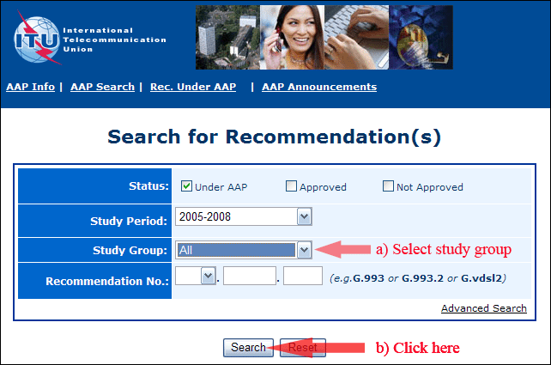

2) Select your Recommendation

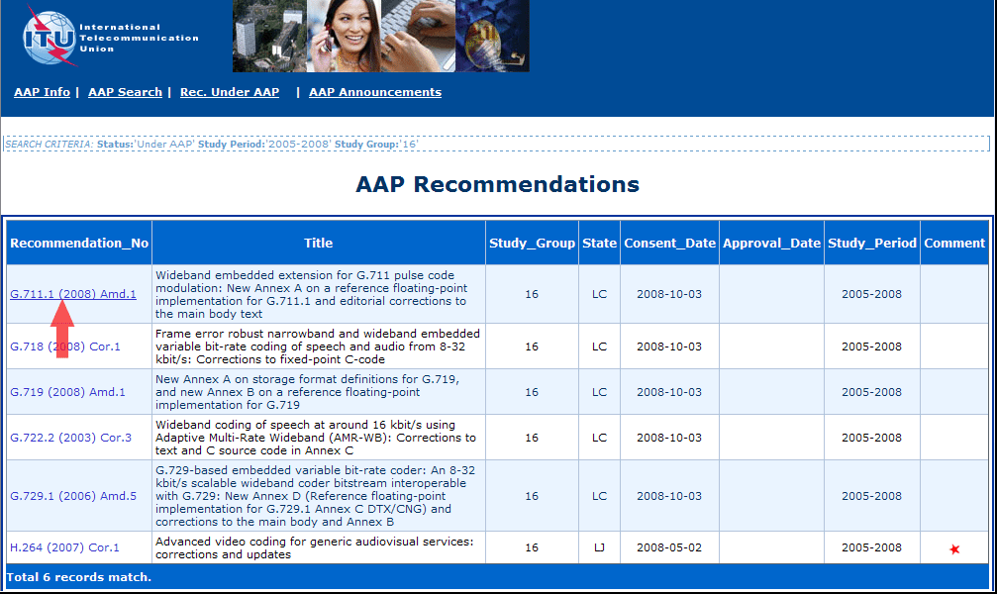

3) Click the "Submit Comment" button

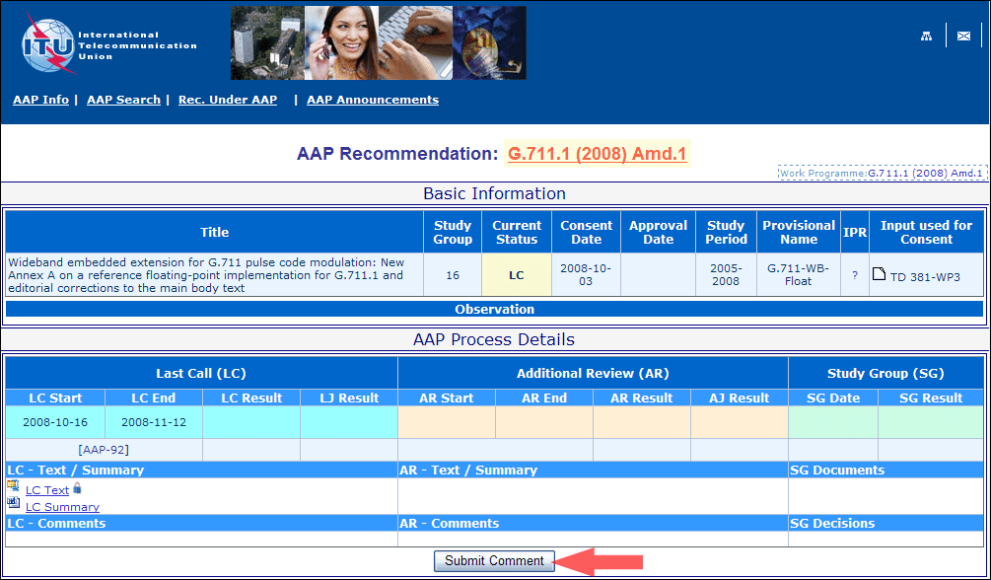

4) Complete the on-line form and click on "Submit"

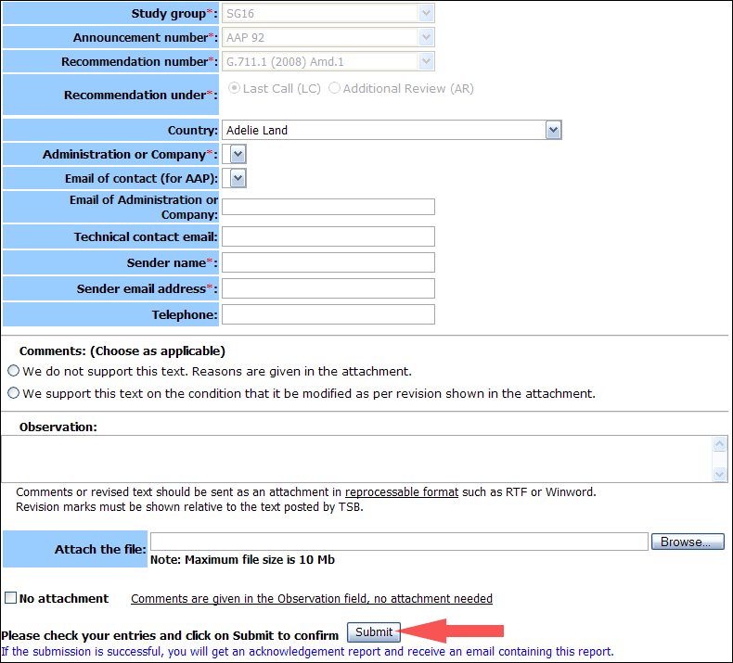

For more information, read the AAP tutorial on:   
<http://www.itu.int/ITU-T/aapinfo/files/AAPTutorial.pdf>

Annex 3

(to TSB AAP-53)

Recommendations under LC/AR – Comment submission form

*(Separate form for each Recommendation being commented upon)*

|  |  |
| --- | --- |
| ITU-T AAP comment submission form for the period 2009-2012 | |
| **Study Group:** |  |
| **Announcement number:** |  |
| **Recommendation number:** |  |
| **Recommendation under:** | Last call (LC)   Additional Review (AR) |
| **Country:** |  |
| **Administration/Company:** |  |
| **Name of AAP Contact Person:** |  |
| **Email of AAP Contact Person:** |  |
| **Sender name: (if different from AAP Contact Person)** |  |
| **Sender email address:** |  |
| **Telephone:** |  |
| **Comments: (Choose as applicable)** | We do not support this text. Reasons are given in the attachment.   We support this text on the condition that it be modified as per revision shown in the attachment. |
| **Observations:** |  |

**No attachment:** Comments are given in the Observation field, no attachment needed

*To be returned to: email:* [*tsbsg....@itu.int*](mailto:tsbsg....@itu.int) *[or fax +41 22 730 5853]  
Comments or revised text should be sent as an attachment in RTF or WinWord format.  
Revision marks must be shown relative to the text posted by TSB.*