Union Internationale des Telecommunications
Bureau de la normalisation des télécommunications

Genève, le 16 septembre 2010

Réf:  Tél:  Fax:  E-mail: | TSB AAP-44  AAP/MJ  +41 22 730 5860  +41 22 730 5853  tsbdir@itu.int | – Aux administrations des Etats Membres de l'Union;  – Aux Membres du Secteur UIT-T;  – Aux Associés de l'UIT-T  Copie:  – Aux Présidents et Vice-Présidents des Commissions d'études de l'UIT-T;  – Au Directeur du Bureau de développement des télécommunications;  – Au Directeur du Bureau des radiocommunications

Objet: | Etat des Recommandations auxquelles s'applique la variante de la procédure d'approbation (AAP)

Madame, Monsieur,

La variante de la procédure d'approbation (AAP), définie dans la Recommandation UIT-T A.8, s'applique aux Recommandations qui n'ont pas d'incidence politique ou réglementaire et ne nécessitent donc pas une consultation formelle des Etats Membres (voir le numéro 246B de la Convention de l'UIT).
L'Annexe 1 énumère les textes dont le statut a changé par rapport aux annonces TSB AAP antérieures.
Si vous souhaitez soumettre des observations sur une Recommandation ayant fait l'objet de la procédure AAP, vous êtes encouragés à utiliser le formulaire en ligne de soumission des observations AAP, disponible dans l'espace AAP du site web de l'UIT-T à l'adresse http://www.itu.int/ITU-T/aap/, à la page de la Recommandation concernée (voir l'Annexe 2). Vous pouvez aussi soumettre vos observations en remplissant le formulaire figurant à l'Annexe 3 et en l'envoyant au secrétariat de la Commission d'études concernée.
Veuillez noter que les observations ayant simplement pour objet d'appuyer l'adoption du texte en question ne sont pas encouragées.
Veuillez agréer, Madame, Monsieur, l'assurance de ma considération distinguée.
Malcolm Johnson
Directeur du Bureau de la normalisation des télécommunications

Annexes: 3

Annex 1
(to TSB AAP-44)

Status codes used in the AAP announcements:
LC = Last Call
LJ = Last Call Judgment (includes comment resolution)
AR = Additional Review
AJ = Additional Review Judgment (includes comment resolution)
SG = For Study Group approval
A = Approved
AT = Approved with typographic corrections
AC = Approved after Additional Review of Comments
NA = Not approved
TAP = Moved to TAP (ITU-T A.8 / § 5.2)
ITU-T website entry page:
http://www.itu.int/ITU-T
Alternative approval process (AAP) welcome page:
http://www.itu.int/ITU-T/aapinfo
Note – A tutorial on the ITU-T AAP application is available under the AAP welcome page
ITU-T website AAP Recommendation search page:
http://www.itu.int/ITU-T/aap/
Study Group web pages and contacts:
SG 2 | http://www.itu.int/ITU-T/studygroups/com02 | tsbsg2@itu.int
SG 3 | http://www.itu.int/ITU-T/studygroups/com03 | tsbsg3@itu.int
SG 5 | http://www.itu.int/ITU-T/studygroups/com05 | tsbsg5@itu.int
SG 9 | http://www.itu.int/ITU-T/studygroups/com09 | tsbsg9@itu.int
SG 11 | http://www.itu.int/ITU-T/studygroups/com11 | tsbsg11@itu.int
SG 12 | http://www.itu.int/ITU-T/studygroups/com12 | tsbsg12@itu.int
SG 13 | http://www.itu.int/ITU-T/studygroups/com13 | tsbsg13@itu.int
SG 15 | http://www.itu.int/ITU-T/studygroups/com15 | tsbsg15@itu.int
SG 16 | http://www.itu.int/ITU-T/studygroups/com16 | tsbsg16@itu.int
SG 17 | http://www.itu.int/ITU-T/studygroups/com17 | tsbsg17@itu.int

Situation concerning Study Group 2 Recommendations under AAP
Rec # | Title | Last Call (LC) Period |  |  |  | Additional Review (AR) Period |  |  |  | Status
 |  | LC Start | LC End | LC  Result | LJ  Result | AR Start | AR End | AR  Result | AJ  Result
M.3020 | Management interface specification methodology | 2010-06-16 | 2010-07-13 | LJ | AR | 2010-08-16 | 2010-09-05 | AC |  | AC
Situation concerning Study Group 9 Recommendations under AAP
Rec # | Title | Last Call (LC) Period |  |  |  | Additional Review (AR) Period |  |  |  | Status
 |  | LC Start | LC End | LC  Result | LJ  Result | AR Start | AR End | AR  Result | AJ  Result
J.294 (J.rg-req) | A Residential Gateway Requirement to support broadcast and IP-based interactive services over Cable Television Networks | 2010-08-16 | 2010-09-12 | A |  |  |  |  |  | A
Situation concerning Study Group 11 Recommendations under AAP
Rec # | Title | Last Call (LC) Period |  |  |  | Additional Review (AR) Period |  |  |  | Status
 |  | LC Start | LC End | LC  Result | LJ  Result | AR Start | AR End | AR  Result | AJ  Result
Q.3311 (Q.PCN App) | Enhancement of resource and admission control protocols to use pre-congestion notification (PCN) | 2010-09-16 | 2010-10-13 |  |  |  |  |  |  | LC
Q.3312 (Q.ANCP) | Use of the Access Node Control Protocol (ANCP) on the Rp interface | 2010-09-16 | 2010-10-13 |  |  |  |  |  |  | LC
Q.3322 (Q.3322.1) | Resource control protocol no.2 (rcp2)Protocol at the interface between Transport Resource Control Physical Entities (TRC-PEs) (Rp interface) | 2010-09-16 | 2010-10-13 |  |  |  |  |  |  | LC
Q.3906.1 | The scenarios, list and types of tests for fixed Broadband NUT testing on the Model networks. Part I | 2010-09-16 | 2010-10-13 |  |  |  |  |  |  | LC
X.603.2 | Information technology - Relayed multicast protocol: Specification for N-plex group applications | 2010-09-16 | 2010-10-13 |  |  |  |  |  |  | LC
X.604.2 | Information technology - Mobile multicast communications: Protocol over overlay multicast networks | 2010-09-16 | 2010-10-13 |  |  |  |  |  |  | LC
Situation concerning Study Group 13 Recommendations under AAP
Rec # | Title | Last Call (LC) Period |  |  |  | Additional Review (AR) Period |  |  |  | Status
 |  | LC Start | LC End | LC  Result | LJ  Result | AR Start | AR End | AR  Result | AJ  Result
Y.2019 (Y.CD&S) | Content Delivery and Storage Architecture in NGN | 2010-05-16 | 2010-06-12 | LJ | AR | 2010-08-16 | 2010-09-05 | AC |  | AC
Situation concerning Study Group 15 Recommendations under AAP
Rec # | Title | Last Call (LC) Period |  |  |  | Additional Review (AR) Period |  |  |  | Status
 |  | LC Start | LC End | LC  Result | LJ  Result | AR Start | AR End | AR  Result | AJ  Result
G.800 (2007) Amd.2 | Unified framework for the architecture of transport networks: Amendment 2 | 2010-07-01 | 2010-07-28 | LJ | AR | 2010-08-16 | 2010-09-05 | AC |  | AC
G.987 | 10-Gigabit-capable passive optical network (XG-PON) systems: Definitions, abbreviations and acronyms | 2010-07-01 | 2010-07-28 | LJ | AR | 2010-09-16 | 2010-10-06 |  |  | AR
G.987.2 | 10-Gigabit-capable passive optical networks (XG-PON): Physical media dependent (PMD) layer specification | 2010-07-01 | 2010-07-28 | LJ | AR | 2010-09-16 | 2010-10-06 |  |  | AR
G.987.3 (G.xgpon.3) | 10-Gigabit-capable passive optical networks (XG-PON): Transmission convergence (TC) specifications | 2010-07-01 | 2010-07-28 | LJ | AR | 2010-09-16 | 2010-10-06 |  |  | AR
G.988 (G.omci) | ONU management and control interface (OMCI) specification | 2010-07-01 | 2010-07-28 | LJ | AR | 2010-09-16 | 2010-10-06 |  |  | AR
G.7712/Y.1703 | Architecture and specification of data communication network | 2010-07-01 | 2010-07-28 | LJ | AR | 2010-08-16 | 2010-09-05 | AC |  | AC
G.7714.1/Y.1705.1 | Protocol for automatic discovery in SDH and OTN networks | 2010-07-01 | 2010-07-28 | LJ | AR | 2010-08-16 | 2010-09-05 | AC |  | AC
G.8031/Y.1342 (2009) Cor.1 | Ethernet linear protection switching: Corrigendum 1 | 2010-07-01 | 2010-07-28 | LJ | AR | 2010-08-16 | 2010-09-05 | AC |  | AC
G.8032/Y.1344 (2010) Cor.1 | Ethernet Ring Protection Switching: Corrigendum 1 | 2010-07-01 | 2010-07-28 | LJ | AR | 2010-09-16 | 2010-10-06 |  |  | AR
G.8080/Y.1304 (2006) Amd.2 (G.ason) | Architecture for the automatically switched optical network (ASON): Amendment 2 | 2010-07-01 | 2010-07-28 | LJ | AR | 2010-08-16 | 2010-09-05 | AC |  | AC
G.8265.1/Y.1365.1 | Precision time protocol telecom profile for frequency synchronization | 2010-07-16 | 2010-08-12 | LJ | AR | 2010-09-16 | 2010-10-06 |  |  | AR
G.8265/Y.1365 (G.pacmod-bis) | Architecture and requirements for packet based frequency delivery | 2010-07-16 | 2010-08-12 | LJ | AR | 2010-09-16 | 2010-10-06 |  |  | AR
Situation concerning Study Group 16 Recommendations under AAP
Rec # | Title | Last Call (LC) Period |  |  |  | Additional Review (AR) Period |  |  |  | Status
 |  | LC Start | LC End | LC  Result | LJ  Result | AR Start | AR End | AR  Result | AJ  Result
F.745 (F.S2STreqs) | Functional requirements for network-based speech-to-speech translation services | 2010-09-16 | 2010-10-13 |  |  |  |  |  |  | LC
G.711.1 (2008) Amd.3 (G.711.1-LLC) | Wideband embedded extension for G.711 PCM: Lossless compression of G.711 bitstreams in G.711.1 | 2010-09-16 | 2010-10-13 |  |  |  |  |  |  | LC
H.248.50 (H.248.NATTT) | Gateway control protocol: NAT traversal toolkit packages | 2010-08-16 | 2010-09-12 | A |  |  |  |  |  | A
H.248.73 (H.248.MSCML) | Gateway control protocol: Packages for MSCML and H.248 Interworking | 2010-08-16 | 2010-09-12 | A |  |  |  |  |  | A
H.248.76 (H.248.FILTER) | Gateway control protocol: Filter group package and guidelines | 2010-08-16 | 2010-09-12 | A |  |  |  |  |  | A
H.248.77 (H.248.SRTP) | Gateway control protocol: SRTP package and procedures | 2010-08-16 | 2010-09-12 | A |  |  |  |  |  | A
H.248.78 (H.248.ALG) | Gateway control protocol: Bearer-level application level gateway | 2010-08-16 | 2010-09-12 | A |  |  |  |  |  | A
H.362 (H.codec.qoe) | A framework for adaptive end-to-end QoS control based on variable bit-rate codecs in wireless networks | 2010-08-16 | 2010-09-12 | A |  |  |  |  |  | A
H.460.25 (H.460.geo) | Transport of geographic information in H.323 systems | 2010-08-16 | 2010-09-12 | A |  |  |  |  |  | A
H.625 (H.S2STarch) | Architecture for network-based speech-to-speech translation services | 2010-09-16 | 2010-10-13 |  |  |  |  |  |  | LC
H.763.1 (H.IPTV-MAFR.4) | Cascading style sheets for IPTV services | 2010-08-16 | 2010-09-12 | A |  |  |  |  |  | A
H.770 (2009) Amd.2 | Mechanisms for service discovery and selection for IPTV services: Support of service discovery using Broadband Forum TR-069 | 2010-08-16 | 2010-09-12 | A |  |  |  |  |  | A
T.38 (V6) | Procedures for real-time Group 3 facsimile communication over IP networks | 2010-08-16 | 2010-09-12 | LJ |  |  |  |  |  | LJ
T.833 (T.JXR-3) | Information technology - JPEG XR image coding system - Motion JPEG XR | 2010-08-16 | 2010-09-12 | A |  |  |  |  |  | A
V.152 | Procedures for supporting voice-band data over IP networks | 2010-08-16 | 2010-09-12 | A |  |  |  |  |  | A
V.254 (V.AMAT) | Asynchronous serial command interface for assistive and multi-functional communication devices | 2010-08-16 | 2010-09-12 | A |  |  |  |  |  | A

Annex 2
(to TSB AAP-44)
Using the on-line comment submission form
Comment submission
1) Go to AAP search Web page at http://www.itu.int/ITU-T/aap/
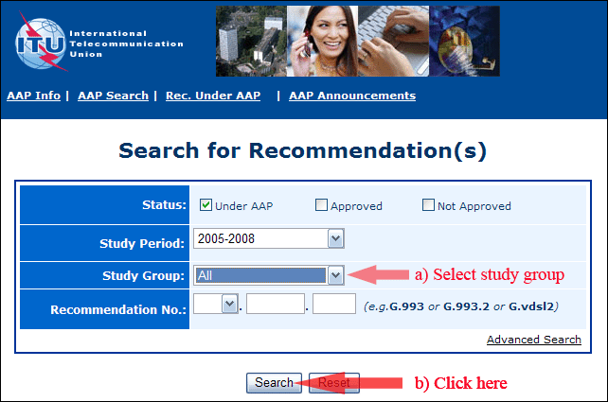
2) Select your Recommendation
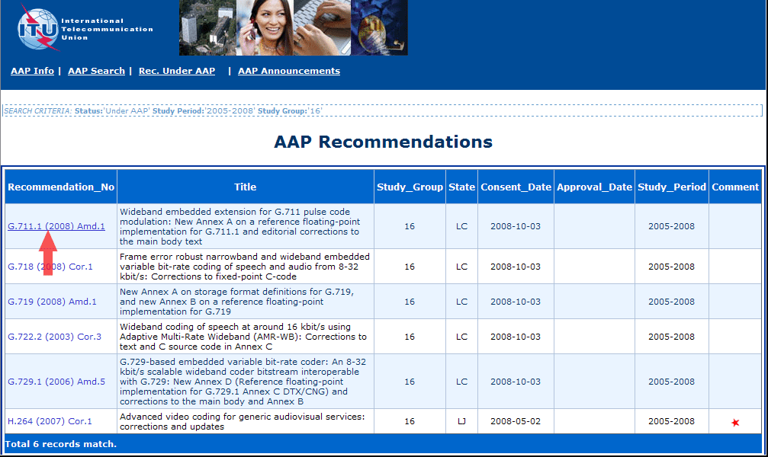
3) Click the "Submit Comment" button
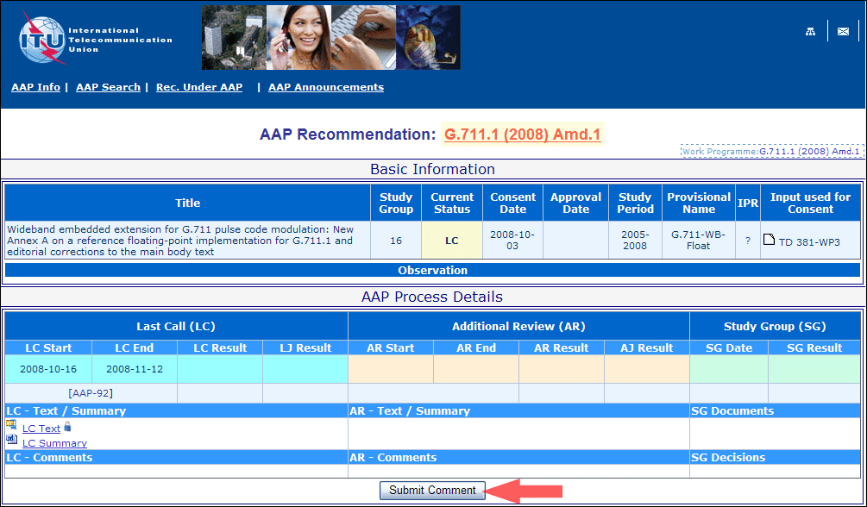
4) Complete the on-line form and click on "Submit"
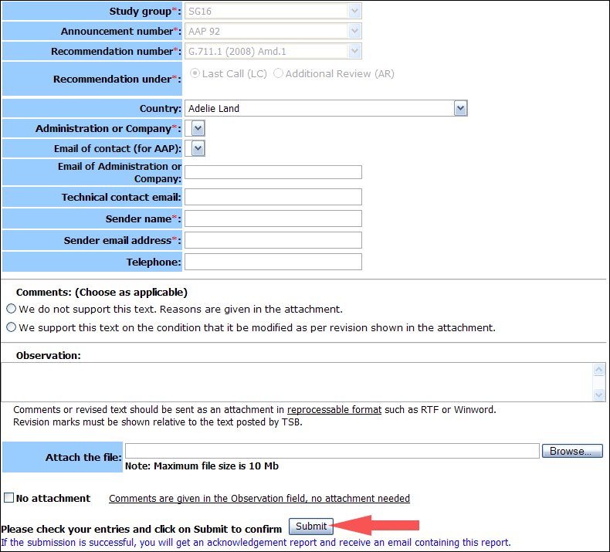
For more information, read the AAP tutorial on:
http://www.itu.int/ITU-T/aapinfo/files/AAPTutorial.pdf
Annex 3
(to TSB AAP-44)
Recommendations under LC/AR – Comment submission form
(Separate form for each Recommendation being commented upon)
ITU-T AAP comment submission form for the period 2009-2012
Study Group:
Announcement number:
Recommendation number:
Recommendation under: | Last call (LC)  Additional Review (AR)
Country:
Administration/Company:
Name of AAP Contact Person:
Email of AAP Contact Person:
Sender name:
(if different from AAP Contact Person)
Sender email address:
Telephone:
Comments:  (Choose as applicable) | We do not support this text. Reasons are given in the attachment.  We support this text on the condition that it be modified as per revision shown in the attachment.
Observations:
No attachment: Comments are given in the Observation field, no attachment needed
To be returned to: email: tsbsg....@itu.int
[or fax +41 22 730 5853]
Comments or revised text should be sent as an attachment in RTF or WinWord format.
Revision marks must be shown relative to the text posted by TSB.

