Unión Internacional de Telecomunicaciones
Oficina de Normalización de las Telecomunicaciones

Ginebra, 16 de septiembre de 2010

Ref:  Tel:  Fax:  Correo-e: | TSB AAP-44  AAP/MJ  +41 22 730 5860  +41 22 730 5853  tsbdir@itu.int | – A las Administraciones de los Estados Miembros de la Unión;  – A los Miembros del Sector UIT-T;  – A los Asociados del UIT-T  Copia:  – A los Presidentes y a los Vicepresidentes de las Comisiones de Estudio del UIT-T;  – Al Director de la Oficina de Desarrollo de las Telecomunicaciones;  – Al Director de la Oficina de Radiocomunicaciones

Asunto: | Situación de las Recomendaciones sometidas al proceso de aprobación alternativo (AAP)

Muy señora mía/Muy señor mío:

El proceso de aprobación alternativo (AAP) definido en la Recomendación A.8 del UIT-T se aplica a las Recomendaciones que no tienen consecuencias en materia de política o reglamentación y que no requieren, por lo tanto, la consulta formal de los Estados Miembros (véase el número 246B del Convenio de la UIT).
En el anexo 1 se enumera la lista de los textos cuyo estado ha cambiado con respecto a los anuncios TSB AAP precedentes.
Si desea formular un comentario en relación con una Recomendación sometida al AAP, le alentamos a utilizar el formulario de presentación de comentarios disponible en la página de la Recomendación que figura en el área AAP del sitio web del UIT-T, en la dirección http://www.itu.int/ITU-T/aap/ (véase también el anexo 2). Alternativamente, pueden presentarse comentarios completando el formulario del anexo 3 y remitiéndolo a la secretaría de la Comisión de Estudio correspondiente.
Le rogamos tenga en cuenta que no se alientan comentarios que se limiten a apoyar la adopción del texto en cuestión.
Le saluda atentamente,

Malcolm Johnson
Director de la Oficina de
Normalización de las Telecomunicaciones
Anexos: 3

Annex 1
(to TSB AAP-44)

Status codes used in the AAP announcements:
LC = Last Call
LJ = Last Call Judgment (includes comment resolution)
AR = Additional Review
AJ = Additional Review Judgment (includes comment resolution)
SG = For Study Group approval
A = Approved
AT = Approved with typographic corrections
AC = Approved after Additional Review of Comments
NA = Not approved
TAP = Moved to TAP (ITU-T A.8 / § 5.2)
ITU-T website entry page:
http://www.itu.int/ITU-T
Alternative approval process (AAP) welcome page:
http://www.itu.int/ITU-T/aapinfo
Note – A tutorial on the ITU-T AAP application is available under the AAP welcome page
ITU-T website AAP Recommendation search page:
http://www.itu.int/ITU-T/aap/
Study Group web pages and contacts:
SG 2 | http://www.itu.int/ITU-T/studygroups/com02 | tsbsg2@itu.int
SG 3 | http://www.itu.int/ITU-T/studygroups/com03 | tsbsg3@itu.int
SG 5 | http://www.itu.int/ITU-T/studygroups/com05 | tsbsg5@itu.int
SG 9 | http://www.itu.int/ITU-T/studygroups/com09 | tsbsg9@itu.int
SG 11 | http://www.itu.int/ITU-T/studygroups/com11 | tsbsg11@itu.int
SG 12 | http://www.itu.int/ITU-T/studygroups/com12 | tsbsg12@itu.int
SG 13 | http://www.itu.int/ITU-T/studygroups/com13 | tsbsg13@itu.int
SG 15 | http://www.itu.int/ITU-T/studygroups/com15 | tsbsg15@itu.int
SG 16 | http://www.itu.int/ITU-T/studygroups/com16 | tsbsg16@itu.int
SG 17 | http://www.itu.int/ITU-T/studygroups/com17 | tsbsg17@itu.int

Situation concerning Study Group 2 Recommendations under AAP
Rec # | Title | Last Call (LC) Period |  |  |  | Additional Review (AR) Period |  |  |  | Status
 |  | LC Start | LC End | LC  Result | LJ  Result | AR Start | AR End | AR  Result | AJ  Result
M.3020 | Management interface specification methodology | 2010-06-16 | 2010-07-13 | LJ | AR | 2010-08-16 | 2010-09-05 | AC |  | AC
Situation concerning Study Group 9 Recommendations under AAP
Rec # | Title | Last Call (LC) Period |  |  |  | Additional Review (AR) Period |  |  |  | Status
 |  | LC Start | LC End | LC  Result | LJ  Result | AR Start | AR End | AR  Result | AJ  Result
J.294 (J.rg-req) | A Residential Gateway Requirement to support broadcast and IP-based interactive services over Cable Television Networks | 2010-08-16 | 2010-09-12 | A |  |  |  |  |  | A
Situation concerning Study Group 11 Recommendations under AAP
Rec # | Title | Last Call (LC) Period |  |  |  | Additional Review (AR) Period |  |  |  | Status
 |  | LC Start | LC End | LC  Result | LJ  Result | AR Start | AR End | AR  Result | AJ  Result
Q.3311 (Q.PCN App) | Enhancement of resource and admission control protocols to use pre-congestion notification (PCN) | 2010-09-16 | 2010-10-13 |  |  |  |  |  |  | LC
Q.3312 (Q.ANCP) | Use of the Access Node Control Protocol (ANCP) on the Rp interface | 2010-09-16 | 2010-10-13 |  |  |  |  |  |  | LC
Q.3322 (Q.3322.1) | Resource control protocol no.2 (rcp2)Protocol at the interface between Transport Resource Control Physical Entities (TRC-PEs) (Rp interface) | 2010-09-16 | 2010-10-13 |  |  |  |  |  |  | LC
Q.3906.1 | The scenarios, list and types of tests for fixed Broadband NUT testing on the Model networks. Part I | 2010-09-16 | 2010-10-13 |  |  |  |  |  |  | LC
X.603.2 | Information technology - Relayed multicast protocol: Specification for N-plex group applications | 2010-09-16 | 2010-10-13 |  |  |  |  |  |  | LC
X.604.2 | Information technology - Mobile multicast communications: Protocol over overlay multicast networks | 2010-09-16 | 2010-10-13 |  |  |  |  |  |  | LC
Situation concerning Study Group 13 Recommendations under AAP
Rec # | Title | Last Call (LC) Period |  |  |  | Additional Review (AR) Period |  |  |  | Status
 |  | LC Start | LC End | LC  Result | LJ  Result | AR Start | AR End | AR  Result | AJ  Result
Y.2019 (Y.CD&S) | Content Delivery and Storage Architecture in NGN | 2010-05-16 | 2010-06-12 | LJ | AR | 2010-08-16 | 2010-09-05 | AC |  | AC
Situation concerning Study Group 15 Recommendations under AAP
Rec # | Title | Last Call (LC) Period |  |  |  | Additional Review (AR) Period |  |  |  | Status
 |  | LC Start | LC End | LC  Result | LJ  Result | AR Start | AR End | AR  Result | AJ  Result
G.800 (2007) Amd.2 | Unified framework for the architecture of transport networks: Amendment 2 | 2010-07-01 | 2010-07-28 | LJ | AR | 2010-08-16 | 2010-09-05 | AC |  | AC
G.987 | 10-Gigabit-capable passive optical network (XG-PON) systems: Definitions, abbreviations and acronyms | 2010-07-01 | 2010-07-28 | LJ | AR | 2010-09-16 | 2010-10-06 |  |  | AR
G.987.2 | 10-Gigabit-capable passive optical networks (XG-PON): Physical media dependent (PMD) layer specification | 2010-07-01 | 2010-07-28 | LJ | AR | 2010-09-16 | 2010-10-06 |  |  | AR
G.987.3 (G.xgpon.3) | 10-Gigabit-capable passive optical networks (XG-PON): Transmission convergence (TC) specifications | 2010-07-01 | 2010-07-28 | LJ | AR | 2010-09-16 | 2010-10-06 |  |  | AR
G.988 (G.omci) | ONU management and control interface (OMCI) specification | 2010-07-01 | 2010-07-28 | LJ | AR | 2010-09-16 | 2010-10-06 |  |  | AR
G.7712/Y.1703 | Architecture and specification of data communication network | 2010-07-01 | 2010-07-28 | LJ | AR | 2010-08-16 | 2010-09-05 | AC |  | AC
G.7714.1/Y.1705.1 | Protocol for automatic discovery in SDH and OTN networks | 2010-07-01 | 2010-07-28 | LJ | AR | 2010-08-16 | 2010-09-05 | AC |  | AC
G.8031/Y.1342 (2009) Cor.1 | Ethernet linear protection switching: Corrigendum 1 | 2010-07-01 | 2010-07-28 | LJ | AR | 2010-08-16 | 2010-09-05 | AC |  | AC
G.8032/Y.1344 (2010) Cor.1 | Ethernet Ring Protection Switching: Corrigendum 1 | 2010-07-01 | 2010-07-28 | LJ | AR | 2010-09-16 | 2010-10-06 |  |  | AR
G.8080/Y.1304 (2006) Amd.2 (G.ason) | Architecture for the automatically switched optical network (ASON): Amendment 2 | 2010-07-01 | 2010-07-28 | LJ | AR | 2010-08-16 | 2010-09-05 | AC |  | AC
G.8265.1/Y.1365.1 | Precision time protocol telecom profile for frequency synchronization | 2010-07-16 | 2010-08-12 | LJ | AR | 2010-09-16 | 2010-10-06 |  |  | AR
G.8265/Y.1365 (G.pacmod-bis) | Architecture and requirements for packet based frequency delivery | 2010-07-16 | 2010-08-12 | LJ | AR | 2010-09-16 | 2010-10-06 |  |  | AR
Situation concerning Study Group 16 Recommendations under AAP
Rec # | Title | Last Call (LC) Period |  |  |  | Additional Review (AR) Period |  |  |  | Status
 |  | LC Start | LC End | LC  Result | LJ  Result | AR Start | AR End | AR  Result | AJ  Result
F.745 (F.S2STreqs) | Functional requirements for network-based speech-to-speech translation services | 2010-09-16 | 2010-10-13 |  |  |  |  |  |  | LC
G.711.1 (2008) Amd.3 (G.711.1-LLC) | Wideband embedded extension for G.711 PCM: Lossless compression of G.711 bitstreams in G.711.1 | 2010-09-16 | 2010-10-13 |  |  |  |  |  |  | LC
H.248.50 (H.248.NATTT) | Gateway control protocol: NAT traversal toolkit packages | 2010-08-16 | 2010-09-12 | A |  |  |  |  |  | A
H.248.73 (H.248.MSCML) | Gateway control protocol: Packages for MSCML and H.248 Interworking | 2010-08-16 | 2010-09-12 | A |  |  |  |  |  | A
H.248.76 (H.248.FILTER) | Gateway control protocol: Filter group package and guidelines | 2010-08-16 | 2010-09-12 | A |  |  |  |  |  | A
H.248.77 (H.248.SRTP) | Gateway control protocol: SRTP package and procedures | 2010-08-16 | 2010-09-12 | A |  |  |  |  |  | A
H.248.78 (H.248.ALG) | Gateway control protocol: Bearer-level application level gateway | 2010-08-16 | 2010-09-12 | A |  |  |  |  |  | A
H.362 (H.codec.qoe) | A framework for adaptive end-to-end QoS control based on variable bit-rate codecs in wireless networks | 2010-08-16 | 2010-09-12 | A |  |  |  |  |  | A
H.460.25 (H.460.geo) | Transport of geographic information in H.323 systems | 2010-08-16 | 2010-09-12 | A |  |  |  |  |  | A
H.625 (H.S2STarch) | Architecture for network-based speech-to-speech translation services | 2010-09-16 | 2010-10-13 |  |  |  |  |  |  | LC
H.763.1 (H.IPTV-MAFR.4) | Cascading style sheets for IPTV services | 2010-08-16 | 2010-09-12 | A |  |  |  |  |  | A
H.770 (2009) Amd.2 | Mechanisms for service discovery and selection for IPTV services: Support of service discovery using Broadband Forum TR-069 | 2010-08-16 | 2010-09-12 | A |  |  |  |  |  | A
T.38 (V6) | Procedures for real-time Group 3 facsimile communication over IP networks | 2010-08-16 | 2010-09-12 | LJ |  |  |  |  |  | LJ
T.833 (T.JXR-3) | Information technology - JPEG XR image coding system - Motion JPEG XR | 2010-08-16 | 2010-09-12 | A |  |  |  |  |  | A
V.152 | Procedures for supporting voice-band data over IP networks | 2010-08-16 | 2010-09-12 | A |  |  |  |  |  | A
V.254 (V.AMAT) | Asynchronous serial command interface for assistive and multi-functional communication devices | 2010-08-16 | 2010-09-12 | A |  |  |  |  |  | A

Annex 2
(to TSB AAP-44)
Using the on-line comment submission form
Comment submission
1) Go to AAP search Web page at http://www.itu.int/ITU-T/aap/
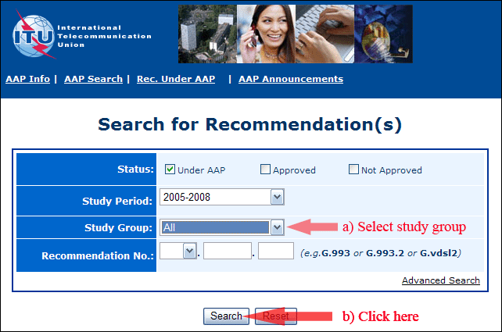
2) Select your Recommendation
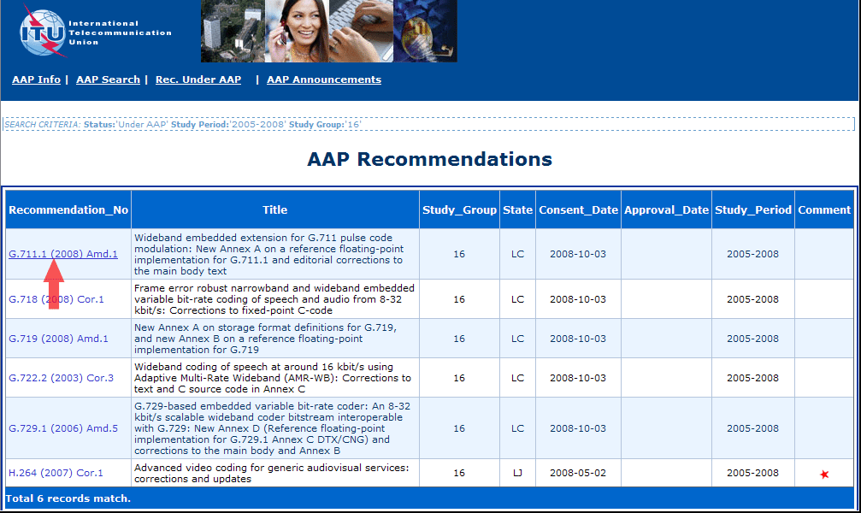
3) Click the "Submit Comment" button
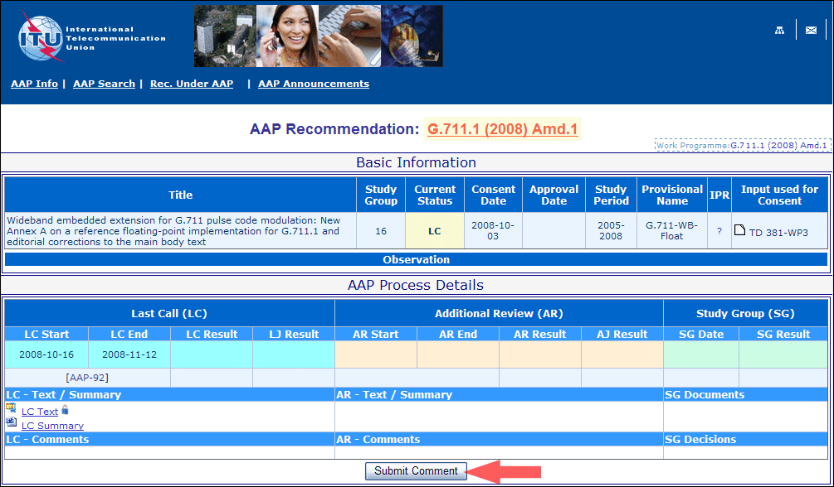
4) Complete the on-line form and click on "Submit"
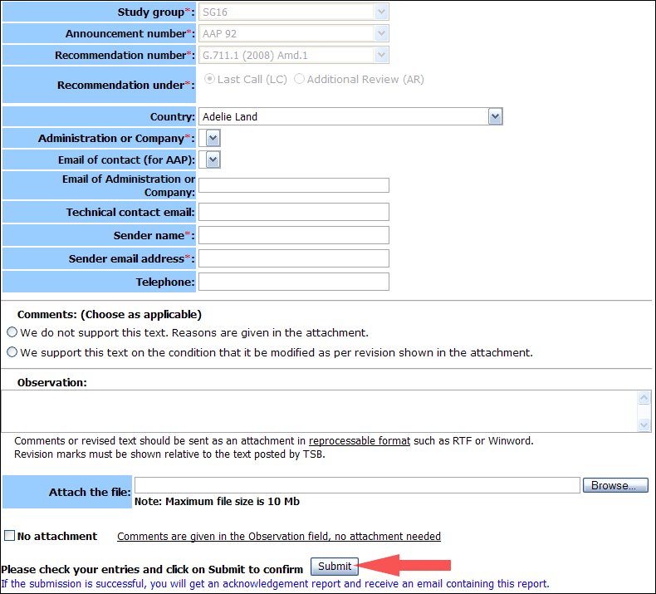
For more information, read the AAP tutorial on:
http://www.itu.int/ITU-T/aapinfo/files/AAPTutorial.pdf
Annex 3
(to TSB AAP-44)
Recommendations under LC/AR – Comment submission form
(Separate form for each Recommendation being commented upon)
ITU-T AAP comment submission form for the period 2009-2012
Study Group:
Announcement number:
Recommendation number:
Recommendation under: | Last call (LC)  Additional Review (AR)
Country:
Administration/Company:
Name of AAP Contact Person:
Email of AAP Contact Person:
Sender name:
(if different from AAP Contact Person)
Sender email address:
Telephone:
Comments:  (Choose as applicable) | We do not support this text. Reasons are given in the attachment.  We support this text on the condition that it be modified as per revision shown in the attachment.
Observations:
No attachment: Comments are given in the Observation field, no attachment needed
To be returned to: email: tsbsg....@itu.int
[or fax +41 22 730 5853]
Comments or revised text should be sent as an attachment in RTF or WinWord format.
Revision marks must be shown relative to the text posted by TSB.

