|  |  |
| --- | --- |
| Международный союз электросвязи  *Бюро стандартизации электросвязи* | ITU-COLOR |

Женева, 1 августа 2010

|  |  |  |
| --- | --- | --- |
| Осн.:  Тел.:  Факс:  Эл. почта: | **TSB AAP-41**  AAP/MJ  +41 22 730 5860  +41 22 730 5853  [tsbdir@itu.int](mailto:tsbdir@itu.int) | – Администрациям Государств – Членов Союза;  – Членам Сектора МСЭ-Т;  – Ассоциированным членам МСЭ-Т  **Копии:**  – Председателям и заместителям председателей Исследовательских комиссий МСЭ-Т;  – Директору Бюро Развития Электросвязи;  – Директору Бюро Радиосвязи |

|  |  |
| --- | --- |
| Предмет: | **Положение относительно Рекомендаций, рассматриваемых в соответствии с альтернативным процессом утверждения (АПУ)** |

Уважаемая госпожа,  
уважаемый господин,

Альтернативный процесс утверждения (АПУ), определенный в Рекомендации МСЭ-Т А.8, распространяется на Рекомендации, которые не имеют политических или регламентарных последствий и которые поэтому не требуют официальных консультаций с Государствами-Членами (см. п. 246B Конвенции МСЭ).

В **Приложении 1** содержится перечень текстов, статус которых изменился по сравнению с предыдущими объявлениями об АПУ БСЭ.

Если вы желаете представить замечания относительно какой-либо Рекомендации, рассматриваемой в соответствии с АПУ, рекомендуем Вам использовать онлайновую форму для представления замечаний по АПУ, которая размещена на странице этой Рекомендации в разделе веб-сайта МСЭ-Т, посвященном АПУ, по адресу: <http://www.itu.int/ITU-T/aap/> (см. **Приложение 2**). Замечания можно представить иным способом, заполнив приведенную в **Приложении 3** форму и направив ее в секретариат заинтересованной исследовательской комиссии.

Просим принять к сведению, что не рекомендуется представлять замечания, являющиеся не чем иным, как поддержкой рассматриваемого текста.

С уважением,

Малколм Джонсон  
Директор Бюро   
стандартизации электросвязи

**Приложения**: 3

Annex 1

(to TSB AAP-41)

Status codes used in the AAP announcements:

LC = Last Call

LJ = Last Call Judgment (includes comment resolution)

AR = Additional Review

AJ = Additional Review Judgment (includes comment resolution)

SG = For Study Group approval

A = Approved

AT = Approved with typographic corrections

AC = Approved after Additional Review of Comments

NA = Not approved

TAP = Moved to TAP (ITU-T A.8 / § 5.2)

ITU-T website entry page:

[http://www.itu.int/ITU-T](http://www.itu.int/ITU-T/)

Alternative approval process (AAP) welcome page:

[http://www.itu.int/ITU-T/aapinfo](http://www.itu.int/ITU-T/aapinfo/)

Note – A tutorial on the ITU-T AAP application is available under the AAP welcome page

ITU-T website AAP Recommendation search page:

<http://www.itu.int/ITU-T/aap/>

Study Group web pages and contacts:

|  |  |  |
| --- | --- | --- |
| SG 2 | <http://www.itu.int/ITU-T/studygroups/com02> | [tsbsg2@itu.int](mailto:tsbsg2@itu.int) |
| SG 3 | <http://www.itu.int/ITU-T/studygroups/com03> | [tsbsg3@itu.int](mailto:tsbsg3@itu.int) |
| SG 5 | <http://www.itu.int/ITU-T/studygroups/com05> | [tsbsg5@itu.int](mailto:tsbsg5@itu.int) |
| SG 9 | <http://www.itu.int/ITU-T/studygroups/com09> | [tsbsg9@itu.int](mailto:tsbsg9@itu.int) |
| SG 11 | <http://www.itu.int/ITU-T/studygroups/com11> | [tsbsg11@itu.int](mailto:tsbsg11@itu.int) |
| SG 12 | <http://www.itu.int/ITU-T/studygroups/com12> | [tsbsg12@itu.int](mailto:tsbsg12@itu.int) |
| SG 13 | <http://www.itu.int/ITU-T/studygroups/com13> | [tsbsg13@itu.int](mailto:tsbsg13@itu.int) |
| SG 15 | <http://www.itu.int/ITU-T/studygroups/com15> | [tsbsg15@itu.int](mailto:tsbsg15@itu.int) |
| SG 16 | <http://www.itu.int/ITU-T/studygroups/com16> | [tsbsg16@itu.int](mailto:tsbsg16@itu.int) |
| SG 17 | <http://www.itu.int/ITU-T/studygroups/com17> | [tsbsg17@itu.int](mailto:tsbsg17@itu.int) |

Situation concerning Study Group 9 Recommendations under AAP

| **Rec #** | **Title** | **Last Call (LC) Period** | | | | **Additional Review (AR) Period** | | | | Status |
| --- | --- | --- | --- | --- | --- | --- | --- | --- | --- | --- |
| **LC Start** | **LC End** | **LC Result** | **LJ Result** | **AR Start** | **AR End** | **AR Result** | **AJ Result** |
| [J.366.2 (J.ims.2)](http://www.itu.int/itu-t/aap/AAPRecDetails.aspx?AAPSeqNo=1230) | IPCablecom2 IP Multimedia (IM) session handling: IM call model: Stage 2 Specification | 2010-08-01 | 2010-08-28 |  |  |  |  |  |  | LC |
| [J.366.3 (J.ims3)](http://www.itu.int/itu-t/aap/AAPRecDetails.aspx?AAPSeqNo=1231) | IPCablecom2 IP Multimdia Subsystem (IMS); Stage 2 Specification | 2010-08-01 | 2010-08-28 |  |  |  |  |  |  | LC |
| [J.366.4 (J.ims4)](http://www.itu.int/itu-t/aap/AAPRecDetails.aspx?AAPSeqNo=1232) | IPCablecom2 IP Multimedia Session Initiation Protocol (SIP) and Session Descripton Protocol (SDP); Stage 3 Specification | 2010-08-01 | 2010-08-28 |  |  |  |  |  |  | LC |
| [J.366.7 (J.ims7)](http://www.itu.int/itu-t/aap/AAPRecDetails.aspx?AAPSeqNo=1233) | IPCablecom2 Access Security for IP-Based Services | 2010-08-01 | 2010-08-28 |  |  |  |  |  |  | LC |
| [J.388 (J.rtav)](http://www.itu.int/itu-t/aap/AAPRecDetails.aspx?AAPSeqNo=1236) | Real-time video and audio transmission system over IP network | 2010-08-01 | 2010-08-28 |  |  |  |  |  |  | LC |

Situation concerning Study Group 15 Recommendations under AAP

| **Rec #** | **Title** | **Last Call (LC) Period** | | | | **Additional Review (AR) Period** | | | | Status |
| --- | --- | --- | --- | --- | --- | --- | --- | --- | --- | --- |
| **LC Start** | **LC End** | **LC Result** | **LJ Result** | **AR Start** | **AR End** | **AR Result** | **AJ Result** |
| [G.650.1](http://www.itu.int/itu-t/aap/AAPRecDetails.aspx?AAPSeqNo=2105) | Definitions and test methods for linear, deterministic attributes of single-mode fibre and cable | 2010-07-01 | 2010-07-28 | A |  |  |  |  |  | A |
| [G.653](http://www.itu.int/itu-t/aap/AAPRecDetails.aspx?AAPSeqNo=2106) | Characteristics of a dispersion-shifted single-mode optical fibre and cable | 2010-07-01 | 2010-07-28 | A |  |  |  |  |  | A |
| [G.654](http://www.itu.int/itu-t/aap/AAPRecDetails.aspx?AAPSeqNo=2107) | Characteristics of a cut-off shifted single-mode optical fibre and cable | 2010-07-01 | 2010-07-28 | A |  |  |  |  |  | A |
| [G.656](http://www.itu.int/itu-t/aap/AAPRecDetails.aspx?AAPSeqNo=2108) | Characteristics of a fibre and cable with non-zero dispersion for wideband optical transport | 2010-07-01 | 2010-07-28 | A |  |  |  |  |  | A |
| [G.695](http://www.itu.int/itu-t/aap/AAPRecDetails.aspx?AAPSeqNo=2109) | Optical interfaces for coarse wavelength division multiplexing (CWDM) applications | 2010-07-01 | 2010-07-28 | LJ |  |  |  |  |  | LJ |
| [G.696.1](http://www.itu.int/itu-t/aap/AAPRecDetails.aspx?AAPSeqNo=2110) | Longitudinally compatible intra-domain DWDM applications | 2010-07-01 | 2010-07-28 | A |  |  |  |  |  | A |
| [G.709/Y.1322 (2009) Amd.1](http://www.itu.int/itu-t/aap/AAPRecDetails.aspx?AAPSeqNo=2133) | Interfaces for the Optical Transport Network (OTN): Amendment 1 | 2010-07-01 | 2010-07-28 | LJ |  |  |  |  |  | LJ |
| [G.709/Y.1331 (2009) Cor.1](http://www.itu.int/itu-t/aap/AAPRecDetails.aspx?AAPSeqNo=2134) | Interfaces for the Optical Transport Network (OTN): Corrigendum 1 | 2010-07-01 | 2010-07-28 | LJ |  |  |  |  |  | LJ |
| [G.780/Y.1351](http://www.itu.int/itu-t/aap/AAPRecDetails.aspx?AAPSeqNo=2123) | Terms and definitions for synchronous digital hierarchy (SDH) networks | 2010-07-01 | 2010-07-28 | A |  |  |  |  |  | A |
| [G.798](http://www.itu.int/itu-t/aap/AAPRecDetails.aspx?AAPSeqNo=2128) | Characteristics of optical transport network hierarchy equipment functional blocks | 2010-07-01 | 2010-07-28 | LJ |  |  |  |  |  | LJ |
| [G.800 (2007) Amd.2](http://www.itu.int/itu-t/aap/AAPRecDetails.aspx?AAPSeqNo=2136) | Unified framework for the architecture of transport networks: Amendment 2 | 2010-07-01 | 2010-07-28 | LJ |  |  |  |  |  | LJ |
| [G.870/Y.1352](http://www.itu.int/itu-t/aap/AAPRecDetails.aspx?AAPSeqNo=2124) | Terms and definitions for optical transport networks (OTN) | 2010-07-01 | 2010-07-28 | A |  |  |  |  |  | A |
| [G.872 (2001) Amd.2](http://www.itu.int/itu-t/aap/AAPRecDetails.aspx?AAPSeqNo=2137) | Architecture of optical transport networks: Amendment 2 | 2010-07-01 | 2010-07-28 | A |  |  |  |  |  | A |
| [G.874](http://www.itu.int/itu-t/aap/AAPRecDetails.aspx?AAPSeqNo=2147) | Management aspects of optical transport network elements | 2010-07-01 | 2010-07-28 | A |  |  |  |  |  | A |
| [G.971](http://www.itu.int/itu-t/aap/AAPRecDetails.aspx?AAPSeqNo=2112) | General features of optical fibre submarine cable systems | 2010-07-01 | 2010-07-28 | A |  |  |  |  |  | A |
| [G.973](http://www.itu.int/itu-t/aap/AAPRecDetails.aspx?AAPSeqNo=2113) | Characteristics of repeaterless optical fibre submarine cable systems | 2010-07-01 | 2010-07-28 | A |  |  |  |  |  | A |
| [G.976](http://www.itu.int/itu-t/aap/AAPRecDetails.aspx?AAPSeqNo=2114) | Test methods applicable to optical fibre submarine cable systems | 2010-07-01 | 2010-07-28 | A |  |  |  |  |  | A |
| [G.978](http://www.itu.int/itu-t/aap/AAPRecDetails.aspx?AAPSeqNo=2115) | Characteristics of optical fibre submarine cables | 2010-07-01 | 2010-07-28 | A |  |  |  |  |  | A |
| [G.984.4 (2008) Amd.3](http://www.itu.int/itu-t/aap/AAPRecDetails.aspx?AAPSeqNo=2102) | Gigabit-capable Passive Optical Networks (GPON): ONT management and control interface (OMCI) specification: Amendment 3 | 2010-07-01 | 2010-07-28 | A |  |  |  |  |  | A |
| [G.984.7 (G.984.lr)](http://www.itu.int/itu-t/aap/AAPRecDetails.aspx?AAPSeqNo=2103) | Gigabit-capable Passive Optical Networks (GPON): Long reach | 2010-07-01 | 2010-07-28 | A |  |  |  |  |  | A |
| [G.987](http://www.itu.int/itu-t/aap/AAPRecDetails.aspx?AAPSeqNo=2098) | 10-Gigabit-capable passive optical network (XG-PON) systems: Definitions, abbreviations and acronyms | 2010-07-01 | 2010-07-28 | LJ |  |  |  |  |  | LJ |
| [G.987.2](http://www.itu.int/itu-t/aap/AAPRecDetails.aspx?AAPSeqNo=2100) | 10-Gigabit-capable passive optical networks (XG-PON): Physical media dependent (PMD) layer specification | 2010-07-01 | 2010-07-28 | LJ |  |  |  |  |  | LJ |
| [G.987.3 (G.xgpon.3)](http://www.itu.int/itu-t/aap/AAPRecDetails.aspx?AAPSeqNo=2099) | 10-Gigabit-capable passive optical networks (XG-PON): Transmission convergence (TC) specifications | 2010-07-01 | 2010-07-28 | LJ |  |  |  |  |  | LJ |
| [G.988 (G.omci)](http://www.itu.int/itu-t/aap/AAPRecDetails.aspx?AAPSeqNo=2101) | ONU management and control interface (OMCI) specification | 2010-07-01 | 2010-07-28 | LJ |  |  |  |  |  | LJ |
| [G.992.3 (2009) Amd.2](http://www.itu.int/itu-t/aap/AAPRecDetails.aspx?AAPSeqNo=2104) | Asymmetric digital subscriber line transceivers 2 (ADSL2): Amendment 2 - Retrain on eoc protocol timeout | 2010-07-01 | 2010-07-28 | A |  |  |  |  |  | A |
| [G.7041/Y.1303 (2008) Amd.2](http://www.itu.int/itu-t/aap/AAPRecDetails.aspx?AAPSeqNo=2135) | Generic framing procedure (GFP) | 2010-07-01 | 2010-07-28 | A |  |  |  |  |  | A |
| [G.7710/Y.1701 (2007) Amd.1](http://www.itu.int/itu-t/aap/AAPRecDetails.aspx?AAPSeqNo=2148) | Common equipment management function requirements: Amendment 1 | 2010-07-01 | 2010-07-28 | A |  |  |  |  |  | A |
| [G.7712/Y.1703](http://www.itu.int/itu-t/aap/AAPRecDetails.aspx?AAPSeqNo=2149) | Architecture and specification of data communication network | 2010-07-01 | 2010-07-28 | LJ |  |  |  |  |  | LJ |
| [G.7714.1/Y.1705.1](http://www.itu.int/itu-t/aap/AAPRecDetails.aspx?AAPSeqNo=2150) | Protocol for automatic discovery in SDH and OTN networks | 2010-07-01 | 2010-07-28 | LJ |  |  |  |  |  | LJ |
| [G.7718/Y.1709](http://www.itu.int/itu-t/aap/AAPRecDetails.aspx?AAPSeqNo=2151) | Framework for ASON management | 2010-07-01 | 2010-07-28 | A |  |  |  |  |  | A |
| [G.8001/Y.1354](http://www.itu.int/itu-t/aap/AAPRecDetails.aspx?AAPSeqNo=2125) | Terms and definitions for Ethernet frames over Transport | 2010-07-01 | 2010-07-28 | A |  |  |  |  |  | A |
| [G.8010/Y.1306 (2004) Amd.2](http://www.itu.int/itu-t/aap/AAPRecDetails.aspx?AAPSeqNo=2138) | Architecture of Ethernet layer networks: Amendment 2 | 2010-07-01 | 2010-07-28 | A |  |  |  |  |  | A |
| [G.8031/Y.1342 (2009) Cor.1](http://www.itu.int/itu-t/aap/AAPRecDetails.aspx?AAPSeqNo=2130) | Ethernet linear protection switching: Corrigendum 1 | 2010-07-01 | 2010-07-28 | LJ |  |  |  |  |  | LJ |
| [G.8032/Y.1344 (2010) Cor.1](http://www.itu.int/itu-t/aap/AAPRecDetails.aspx?AAPSeqNo=2131) | Ethernet Ring Protection Switching: Corrigendum 1 | 2010-07-01 | 2010-07-28 | LJ |  |  |  |  |  | LJ |
| [G.8080/Y.1304 (2006) Amd.2 (G.ason)](http://www.itu.int/itu-t/aap/AAPRecDetails.aspx?AAPSeqNo=2139) | Architecture for the automatically switched optical network (ASON): Amendment 2 | 2010-07-01 | 2010-07-28 | LJ |  |  |  |  |  | LJ |
| [G.8081/Y.1353](http://www.itu.int/itu-t/aap/AAPRecDetails.aspx?AAPSeqNo=2126) | Terms and definitions for Automatically Switched Optical Networks (ASON) | 2010-07-01 | 2010-07-28 | LJ |  |  |  |  |  | LJ |
| [G.8101/Y.1355](http://www.itu.int/itu-t/aap/AAPRecDetails.aspx?AAPSeqNo=2127) | Terms and definitions for MPLS Transport Profile (MPLS-TP) | 2010-07-01 | 2010-07-28 | A |  |  |  |  |  | A |
| [G.8251](http://www.itu.int/itu-t/aap/AAPRecDetails.aspx?AAPSeqNo=2140) | The control of jitter and wander within the optical transport network (OTN) | 2010-07-01 | 2010-07-28 | LJ |  |  |  |  |  | LJ |
| [G.8261/Y.1361 (2008) Amd.1 (G.pactiming)](http://www.itu.int/itu-t/aap/AAPRecDetails.aspx?AAPSeqNo=2142) | Timing and synchronization aspects in packet networks: Amendment 1 | 2010-07-01 | 2010-07-28 | AT |  |  |  |  |  | AT |
| [G.8262/Y.1362 (G.paclock)](http://www.itu.int/itu-t/aap/AAPRecDetails.aspx?AAPSeqNo=2143) | Timing characteristics of a synchronous Ethernet equipment slave clock (EEC) | 2010-07-01 | 2010-07-28 | LJ |  |  |  |  |  | LJ |
| [G.8264/Y.1364 (2008) Amd.1 (G.pacmod)](http://www.itu.int/itu-t/aap/AAPRecDetails.aspx?AAPSeqNo=2144) | Distribution of timing information through packet networks: Amendment 1 | 2010-07-01 | 2010-07-28 | LJ |  |  |  |  |  | LJ |
| [G.9971 (G.hntreq)](http://www.itu.int/itu-t/aap/AAPRecDetails.aspx?AAPSeqNo=2097) | Requirements of transport functions in IP home networks | 2010-07-01 | 2010-07-28 | A |  |  |  |  |  | A |
| [L.50](http://www.itu.int/itu-t/aap/AAPRecDetails.aspx?AAPSeqNo=2111) | Requirements for passive optical nodes: Optical distribution frames for central office environments | 2010-07-01 | 2010-07-28 | A |  |  |  |  |  | A |
| [L.82 (L.teib)](http://www.itu.int/itu-t/aap/AAPRecDetails.aspx?AAPSeqNo=2116) | Optical cabling shared with multiple operators in buildings | 2010-07-01 | 2010-07-28 | A |  |  |  |  |  | A |
| [L.83 (L.limt)](http://www.itu.int/itu-t/aap/AAPRecDetails.aspx?AAPSeqNo=2117) | Low impact trenching technique for FTTx networks | 2010-07-01 | 2010-07-28 | A |  |  |  |  |  | A |
| [L.84 (L.fmun)](http://www.itu.int/itu-t/aap/AAPRecDetails.aspx?AAPSeqNo=2118) | Fast mapping of underground networks | 2010-07-01 | 2010-07-28 | A |  |  |  |  |  | A |
| [L.85 (L.ofid)](http://www.itu.int/itu-t/aap/AAPRecDetails.aspx?AAPSeqNo=2119) | Optical fibre identification for the maintenance of optical access networks | 2010-07-01 | 2010-07-28 | A |  |  |  |  |  | A |
| [L.86 (L.pon)](http://www.itu.int/itu-t/aap/AAPRecDetails.aspx?AAPSeqNo=2120) | Considerations on the installation site of branching components in PONs for FTTH | 2010-07-01 | 2010-07-28 | A |  |  |  |  |  | A |
| [L.87 (L.cda)](http://www.itu.int/itu-t/aap/AAPRecDetails.aspx?AAPSeqNo=2121) | Optical fibre cables for drop applications | 2010-07-01 | 2010-07-28 | A |  |  |  |  |  | A |
| [L.88 (L.mpot)](http://www.itu.int/itu-t/aap/AAPRecDetails.aspx?AAPSeqNo=2122) | Management of poles carrying overhead telecommunication lines | 2010-07-01 | 2010-07-28 | A |  |  |  |  |  | A |
| [O.172 (2005) Amd.2](http://www.itu.int/itu-t/aap/AAPRecDetails.aspx?AAPSeqNo=2152) | Jitter and wander measuring equipment for digital systems which are based on the synchronous digital hierarchy (SDH): Amendment 2 | 2010-07-01 | 2010-07-28 | A |  |  |  |  |  | A |
| [O.173 (2007) Amd.1](http://www.itu.int/itu-t/aap/AAPRecDetails.aspx?AAPSeqNo=2153) | Jitter measuring equipment for digital systems which are based on the Optical Transport Network (OTN): Amendment 1 | 2010-07-01 | 2010-07-28 | A |  |  |  |  |  | A |
| [O.174 (2009) Cor.1](http://www.itu.int/itu-t/aap/AAPRecDetails.aspx?AAPSeqNo=2154) | Jitter and wander measuring equipment for digital systems which are based on synchronous Ethernet technology: Corrigendum 1 | 2010-07-01 | 2010-07-28 | LJ |  |  |  |  |  | LJ |
| [Y.1731 (2008) Amd.1](http://www.itu.int/itu-t/aap/AAPRecDetails.aspx?AAPSeqNo=2132) | OAM functions and mechanisms for Ethernet based networks: Amendment 1 | 2010-07-01 | 2010-07-28 | A |  |  |  |  |  | A |

Situation concerning Study Group 17 Recommendations under AAP

| **Rec #** | **Title** | **Last Call (LC) Period** | | | | **Additional Review (AR) Period** | | | | Status |
| --- | --- | --- | --- | --- | --- | --- | --- | --- | --- | --- |
| **LC Start** | **LC End** | **LC Result** | **LJ Result** | **AR Start** | **AR End** | **AR Result** | **AJ Result** |
| [X.672 (X.oid-res)](http://www.itu.int/itu-t/aap/AAPRecDetails.aspx?AAPSeqNo=2082) | Information technology - Open systems interconnection - Object identifier resolution system (ORS) | 2010-08-01 | 2010-08-28 |  |  |  |  |  |  | LC |

Annex 2

(to TSB AAP-41)

Using the on-line comment submission form

Comment submission

1) Go to AAP search Web page at <http://www.itu.int/ITU-T/aap/>

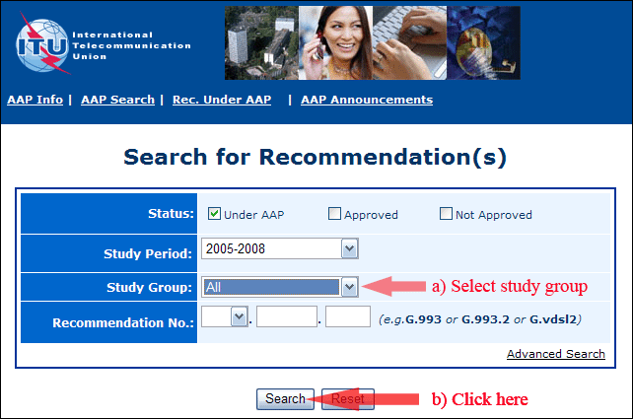

2) Select your Recommendation

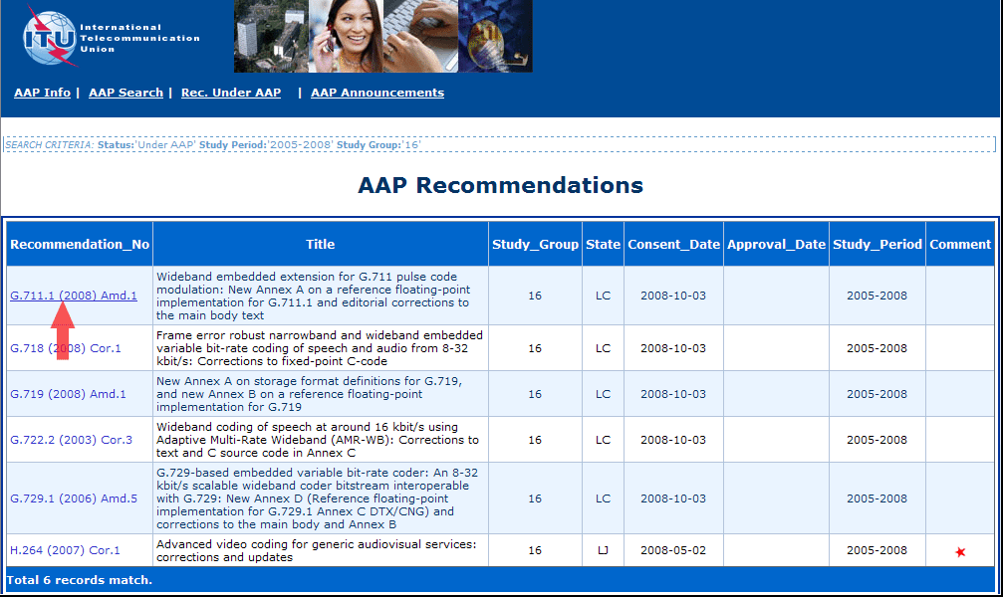

3) Click the "Submit Comment" button

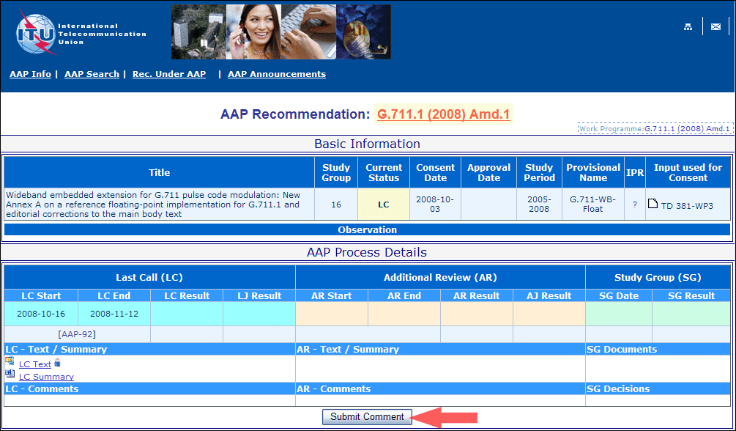

4) Complete the on-line form and click on "Submit"

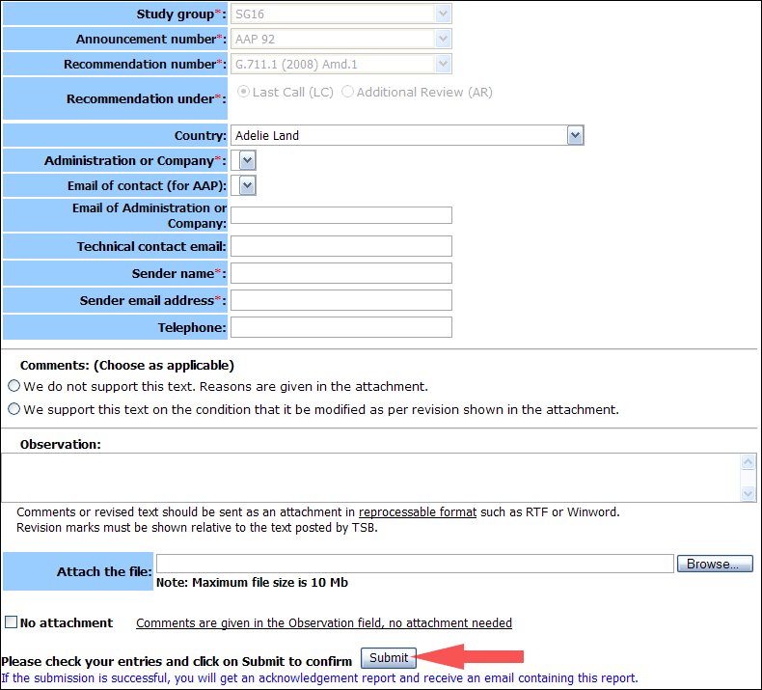

For more information, read the AAP tutorial on:   
<http://www.itu.int/ITU-T/aapinfo/files/AAPTutorial.pdf>

Annex 3

(to TSB AAP-41)

Recommendations under LC/AR – Comment submission form

*(Separate form for each Recommendation being commented upon)*

|  |  |
| --- | --- |
| ITU-T AAP comment submission form for the period 2009-2012 | |
| **Study Group:** |  |
| **Announcement number:** |  |
| **Recommendation number:** |  |
| **Recommendation under:** | Last call (LC)   Additional Review (AR) |
| **Country:** |  |
| **Administration/Company:** |  |
| **Name of AAP Contact Person:** |  |
| **Email of AAP Contact Person:** |  |
| **Sender name: (if different from AAP Contact Person)** |  |
| **Sender email address:** |  |
| **Telephone:** |  |
| **Comments: (Choose as applicable)** | We do not support this text. Reasons are given in the attachment.   We support this text on the condition that it be modified as per revision shown in the attachment. |
| **Observations:** |  |

**No attachment:** Comments are given in the Observation field, no attachment needed

*To be returned to: email:* [*tsbsg....@itu.int*](mailto:tsbsg....@itu.int) *[or fax +41 22 730 5853]  
Comments or revised text should be sent as an attachment in RTF or WinWord format.  
Revision marks must be shown relative to the text posted by TSB.*