|  |  |
| --- | --- |
|  | الا تحــاد الــدولي للاتصــالات  *مكتب تقييس الاتصالات* |

|  |  |  |
| --- | --- | --- |
|  |  | جنيف، 1 اغسطس 2010 |
| المرجع:    الهاتف:  الفاكس:  البريد الإلكتروني: | **TSB AAP-41**  AAP/MJ  +41 22 730 5860  +41 22 730 5853  tsbdir@itu.int | - إلى إدارات الدول الأعضاء في الاتحاد؛  - إلى أعضاء قطاع تقييس الاتصالات؛  - إلى المنتسبين إلى قطاع تقييس الاتصالات  **نسخة إلى:**  - رؤساء لجان الدراسات في قطاع تقييس الاتصالات ونوابهم؛  - مدير مكتب تنمية الاتصالات؛  - مدير مكتب الاتصالات الراديوية |

الموضوع: **حالة التوصيات الخاضعة لعملية الموافقة البديلة (AAP)**

حضرات السادة والسيدات،

تحية طيبة وبعد،

تنطبق عملية الموافقة البديلة (AAP) المعرفة في التوصية ITU‑T A.8 على التوصيات التي لا تنطوي على بعد سياسي أوتنظيمي ولا تتطلب بالتالي استشارة الدول الأعضاء رسمياً (انظر الرقم 246B من اتفاقية الاتحاد).

ويتضمن **الملحق 1** لائحة بالنصوص التي تغيرت حالتها مقارنة بما جاء في إعلانات عملية الموافقة البديلة السابقة.

إذا رغبتم في تقديم تعليق بشأن توصية ما خاضعة لعملية الموافقة البديلة، فنرجو منكم استعمال استمارة التعليق على الخط المتوفّرة على موقع قطاع تقييس الاتصالات على صفحة عملية الموافقة البديلة [http://www.itu.int/ITU-T/aap](http://www.itu.int/ITU-T/aap/) على المدخل الخاص بالتوصية المعنية (انظر **الملحق** (**2**. وبديلاً من ذلك، يمكنكم تقديم التعليقات باستكمال الاستمارة الواردة في **الملحق 3** وإرسالها إلى أمانة لجنة الدراسات المعنية بالأمر.

وتجدر الإشارة إلى أنه يفضّل عدم إرسال تعليقات تقتصر على تأييد اعتماد النص قيد النظر.

وتفضلوا بقبول فائق الاحترام والتقدير.

مالكولم جونسون  
مدير مكتب تقييس الاتصالات

**الملحقات:** 3

Annex 1

(to TSB AAP-41)

Status codes used in the AAP announcements:

LC = Last Call

LJ = Last Call Judgment (includes comment resolution)

AR = Additional Review

AJ = Additional Review Judgment (includes comment resolution)

SG = For Study Group approval

A = Approved

AT = Approved with typographic corrections

AC = Approved after Additional Review of Comments

NA = Not approved

TAP = Moved to TAP (ITU-T A.8 / § 5.2)

ITU-T website entry page:

[http://www.itu.int/ITU-T](http://www.itu.int/ITU-T/)

Alternative approval process (AAP) welcome page:

[http://www.itu.int/ITU-T/aapinfo](http://www.itu.int/ITU-T/aapinfo/)

Note – A tutorial on the ITU-T AAP application is available under the AAP welcome page

ITU-T website AAP Recommendation search page:

<http://www.itu.int/ITU-T/aap/>

Study Group web pages and contacts:

|  |  |  |
| --- | --- | --- |
| SG 2 | <http://www.itu.int/ITU-T/studygroups/com02> | [tsbsg2@itu.int](mailto:tsbsg2@itu.int) |
| SG 3 | <http://www.itu.int/ITU-T/studygroups/com03> | [tsbsg3@itu.int](mailto:tsbsg3@itu.int) |
| SG 5 | <http://www.itu.int/ITU-T/studygroups/com05> | [tsbsg5@itu.int](mailto:tsbsg5@itu.int) |
| SG 9 | <http://www.itu.int/ITU-T/studygroups/com09> | [tsbsg9@itu.int](mailto:tsbsg9@itu.int) |
| SG 11 | <http://www.itu.int/ITU-T/studygroups/com11> | [tsbsg11@itu.int](mailto:tsbsg11@itu.int) |
| SG 12 | <http://www.itu.int/ITU-T/studygroups/com12> | [tsbsg12@itu.int](mailto:tsbsg12@itu.int) |
| SG 13 | <http://www.itu.int/ITU-T/studygroups/com13> | [tsbsg13@itu.int](mailto:tsbsg13@itu.int) |
| SG 15 | <http://www.itu.int/ITU-T/studygroups/com15> | [tsbsg15@itu.int](mailto:tsbsg15@itu.int) |
| SG 16 | <http://www.itu.int/ITU-T/studygroups/com16> | [tsbsg16@itu.int](mailto:tsbsg16@itu.int) |
| SG 17 | <http://www.itu.int/ITU-T/studygroups/com17> | [tsbsg17@itu.int](mailto:tsbsg17@itu.int) |

Situation concerning Study Group 9 Recommendations under AAP

| **Rec #** | **Title** | **Last Call (LC) Period** | | | | **Additional Review (AR) Period** | | | | Status |
| --- | --- | --- | --- | --- | --- | --- | --- | --- | --- | --- |
| **LC Start** | **LC End** | **LC Result** | **LJ Result** | **AR Start** | **AR End** | **AR Result** | **AJ Result** |
| [J.366.2 (J.ims.2)](http://www.itu.int/itu-t/aap/AAPRecDetails.aspx?AAPSeqNo=1230) | IPCablecom2 IP Multimedia (IM) session handling: IM call model: Stage 2 Specification | 2010-08-01 | 2010-08-28 |  |  |  |  |  |  | LC |
| [J.366.3 (J.ims3)](http://www.itu.int/itu-t/aap/AAPRecDetails.aspx?AAPSeqNo=1231) | IPCablecom2 IP Multimdia Subsystem (IMS); Stage 2 Specification | 2010-08-01 | 2010-08-28 |  |  |  |  |  |  | LC |
| [J.366.4 (J.ims4)](http://www.itu.int/itu-t/aap/AAPRecDetails.aspx?AAPSeqNo=1232) | IPCablecom2 IP Multimedia Session Initiation Protocol (SIP) and Session Descripton Protocol (SDP); Stage 3 Specification | 2010-08-01 | 2010-08-28 |  |  |  |  |  |  | LC |
| [J.366.7 (J.ims7)](http://www.itu.int/itu-t/aap/AAPRecDetails.aspx?AAPSeqNo=1233) | IPCablecom2 Access Security for IP-Based Services | 2010-08-01 | 2010-08-28 |  |  |  |  |  |  | LC |
| [J.388 (J.rtav)](http://www.itu.int/itu-t/aap/AAPRecDetails.aspx?AAPSeqNo=1236) | Real-time video and audio transmission system over IP network | 2010-08-01 | 2010-08-28 |  |  |  |  |  |  | LC |

Situation concerning Study Group 15 Recommendations under AAP

| **Rec #** | **Title** | **Last Call (LC) Period** | | | | **Additional Review (AR) Period** | | | | Status |
| --- | --- | --- | --- | --- | --- | --- | --- | --- | --- | --- |
| **LC Start** | **LC End** | **LC Result** | **LJ Result** | **AR Start** | **AR End** | **AR Result** | **AJ Result** |
| [G.650.1](http://www.itu.int/itu-t/aap/AAPRecDetails.aspx?AAPSeqNo=2105) | Definitions and test methods for linear, deterministic attributes of single-mode fibre and cable | 2010-07-01 | 2010-07-28 | A |  |  |  |  |  | A |
| [G.653](http://www.itu.int/itu-t/aap/AAPRecDetails.aspx?AAPSeqNo=2106) | Characteristics of a dispersion-shifted single-mode optical fibre and cable | 2010-07-01 | 2010-07-28 | A |  |  |  |  |  | A |
| [G.654](http://www.itu.int/itu-t/aap/AAPRecDetails.aspx?AAPSeqNo=2107) | Characteristics of a cut-off shifted single-mode optical fibre and cable | 2010-07-01 | 2010-07-28 | A |  |  |  |  |  | A |
| [G.656](http://www.itu.int/itu-t/aap/AAPRecDetails.aspx?AAPSeqNo=2108) | Characteristics of a fibre and cable with non-zero dispersion for wideband optical transport | 2010-07-01 | 2010-07-28 | A |  |  |  |  |  | A |
| [G.695](http://www.itu.int/itu-t/aap/AAPRecDetails.aspx?AAPSeqNo=2109) | Optical interfaces for coarse wavelength division multiplexing (CWDM) applications | 2010-07-01 | 2010-07-28 | LJ |  |  |  |  |  | LJ |
| [G.696.1](http://www.itu.int/itu-t/aap/AAPRecDetails.aspx?AAPSeqNo=2110) | Longitudinally compatible intra-domain DWDM applications | 2010-07-01 | 2010-07-28 | A |  |  |  |  |  | A |
| [G.709/Y.1322 (2009) Amd.1](http://www.itu.int/itu-t/aap/AAPRecDetails.aspx?AAPSeqNo=2133) | Interfaces for the Optical Transport Network (OTN): Amendment 1 | 2010-07-01 | 2010-07-28 | LJ |  |  |  |  |  | LJ |
| [G.709/Y.1331 (2009) Cor.1](http://www.itu.int/itu-t/aap/AAPRecDetails.aspx?AAPSeqNo=2134) | Interfaces for the Optical Transport Network (OTN): Corrigendum 1 | 2010-07-01 | 2010-07-28 | LJ |  |  |  |  |  | LJ |
| [G.780/Y.1351](http://www.itu.int/itu-t/aap/AAPRecDetails.aspx?AAPSeqNo=2123) | Terms and definitions for synchronous digital hierarchy (SDH) networks | 2010-07-01 | 2010-07-28 | A |  |  |  |  |  | A |
| [G.798](http://www.itu.int/itu-t/aap/AAPRecDetails.aspx?AAPSeqNo=2128) | Characteristics of optical transport network hierarchy equipment functional blocks | 2010-07-01 | 2010-07-28 | LJ |  |  |  |  |  | LJ |
| [G.800 (2007) Amd.2](http://www.itu.int/itu-t/aap/AAPRecDetails.aspx?AAPSeqNo=2136) | Unified framework for the architecture of transport networks: Amendment 2 | 2010-07-01 | 2010-07-28 | LJ |  |  |  |  |  | LJ |
| [G.870/Y.1352](http://www.itu.int/itu-t/aap/AAPRecDetails.aspx?AAPSeqNo=2124) | Terms and definitions for optical transport networks (OTN) | 2010-07-01 | 2010-07-28 | A |  |  |  |  |  | A |
| [G.872 (2001) Amd.2](http://www.itu.int/itu-t/aap/AAPRecDetails.aspx?AAPSeqNo=2137) | Architecture of optical transport networks: Amendment 2 | 2010-07-01 | 2010-07-28 | A |  |  |  |  |  | A |
| [G.874](http://www.itu.int/itu-t/aap/AAPRecDetails.aspx?AAPSeqNo=2147) | Management aspects of optical transport network elements | 2010-07-01 | 2010-07-28 | A |  |  |  |  |  | A |
| [G.971](http://www.itu.int/itu-t/aap/AAPRecDetails.aspx?AAPSeqNo=2112) | General features of optical fibre submarine cable systems | 2010-07-01 | 2010-07-28 | A |  |  |  |  |  | A |
| [G.973](http://www.itu.int/itu-t/aap/AAPRecDetails.aspx?AAPSeqNo=2113) | Characteristics of repeaterless optical fibre submarine cable systems | 2010-07-01 | 2010-07-28 | A |  |  |  |  |  | A |
| [G.976](http://www.itu.int/itu-t/aap/AAPRecDetails.aspx?AAPSeqNo=2114) | Test methods applicable to optical fibre submarine cable systems | 2010-07-01 | 2010-07-28 | A |  |  |  |  |  | A |
| [G.978](http://www.itu.int/itu-t/aap/AAPRecDetails.aspx?AAPSeqNo=2115) | Characteristics of optical fibre submarine cables | 2010-07-01 | 2010-07-28 | A |  |  |  |  |  | A |
| [G.984.4 (2008) Amd.3](http://www.itu.int/itu-t/aap/AAPRecDetails.aspx?AAPSeqNo=2102) | Gigabit-capable Passive Optical Networks (GPON): ONT management and control interface (OMCI) specification: Amendment 3 | 2010-07-01 | 2010-07-28 | A |  |  |  |  |  | A |
| [G.984.7 (G.984.lr)](http://www.itu.int/itu-t/aap/AAPRecDetails.aspx?AAPSeqNo=2103) | Gigabit-capable Passive Optical Networks (GPON): Long reach | 2010-07-01 | 2010-07-28 | A |  |  |  |  |  | A |
| [G.987](http://www.itu.int/itu-t/aap/AAPRecDetails.aspx?AAPSeqNo=2098) | 10-Gigabit-capable passive optical network (XG-PON) systems: Definitions, abbreviations and acronyms | 2010-07-01 | 2010-07-28 | LJ |  |  |  |  |  | LJ |
| [G.987.2](http://www.itu.int/itu-t/aap/AAPRecDetails.aspx?AAPSeqNo=2100) | 10-Gigabit-capable passive optical networks (XG-PON): Physical media dependent (PMD) layer specification | 2010-07-01 | 2010-07-28 | LJ |  |  |  |  |  | LJ |
| [G.987.3 (G.xgpon.3)](http://www.itu.int/itu-t/aap/AAPRecDetails.aspx?AAPSeqNo=2099) | 10-Gigabit-capable passive optical networks (XG-PON): Transmission convergence (TC) specifications | 2010-07-01 | 2010-07-28 | LJ |  |  |  |  |  | LJ |
| [G.988 (G.omci)](http://www.itu.int/itu-t/aap/AAPRecDetails.aspx?AAPSeqNo=2101) | ONU management and control interface (OMCI) specification | 2010-07-01 | 2010-07-28 | LJ |  |  |  |  |  | LJ |
| [G.992.3 (2009) Amd.2](http://www.itu.int/itu-t/aap/AAPRecDetails.aspx?AAPSeqNo=2104) | Asymmetric digital subscriber line transceivers 2 (ADSL2): Amendment 2 - Retrain on eoc protocol timeout | 2010-07-01 | 2010-07-28 | A |  |  |  |  |  | A |
| [G.7041/Y.1303 (2008) Amd.2](http://www.itu.int/itu-t/aap/AAPRecDetails.aspx?AAPSeqNo=2135) | Generic framing procedure (GFP) | 2010-07-01 | 2010-07-28 | A |  |  |  |  |  | A |
| [G.7710/Y.1701 (2007) Amd.1](http://www.itu.int/itu-t/aap/AAPRecDetails.aspx?AAPSeqNo=2148) | Common equipment management function requirements: Amendment 1 | 2010-07-01 | 2010-07-28 | A |  |  |  |  |  | A |
| [G.7712/Y.1703](http://www.itu.int/itu-t/aap/AAPRecDetails.aspx?AAPSeqNo=2149) | Architecture and specification of data communication network | 2010-07-01 | 2010-07-28 | LJ |  |  |  |  |  | LJ |
| [G.7714.1/Y.1705.1](http://www.itu.int/itu-t/aap/AAPRecDetails.aspx?AAPSeqNo=2150) | Protocol for automatic discovery in SDH and OTN networks | 2010-07-01 | 2010-07-28 | LJ |  |  |  |  |  | LJ |
| [G.7718/Y.1709](http://www.itu.int/itu-t/aap/AAPRecDetails.aspx?AAPSeqNo=2151) | Framework for ASON management | 2010-07-01 | 2010-07-28 | A |  |  |  |  |  | A |
| [G.8001/Y.1354](http://www.itu.int/itu-t/aap/AAPRecDetails.aspx?AAPSeqNo=2125) | Terms and definitions for Ethernet frames over Transport | 2010-07-01 | 2010-07-28 | A |  |  |  |  |  | A |
| [G.8010/Y.1306 (2004) Amd.2](http://www.itu.int/itu-t/aap/AAPRecDetails.aspx?AAPSeqNo=2138) | Architecture of Ethernet layer networks: Amendment 2 | 2010-07-01 | 2010-07-28 | A |  |  |  |  |  | A |
| [G.8031/Y.1342 (2009) Cor.1](http://www.itu.int/itu-t/aap/AAPRecDetails.aspx?AAPSeqNo=2130) | Ethernet linear protection switching: Corrigendum 1 | 2010-07-01 | 2010-07-28 | LJ |  |  |  |  |  | LJ |
| [G.8032/Y.1344 (2010) Cor.1](http://www.itu.int/itu-t/aap/AAPRecDetails.aspx?AAPSeqNo=2131) | Ethernet Ring Protection Switching: Corrigendum 1 | 2010-07-01 | 2010-07-28 | LJ |  |  |  |  |  | LJ |
| [G.8080/Y.1304 (2006) Amd.2 (G.ason)](http://www.itu.int/itu-t/aap/AAPRecDetails.aspx?AAPSeqNo=2139) | Architecture for the automatically switched optical network (ASON): Amendment 2 | 2010-07-01 | 2010-07-28 | LJ |  |  |  |  |  | LJ |
| [G.8081/Y.1353](http://www.itu.int/itu-t/aap/AAPRecDetails.aspx?AAPSeqNo=2126) | Terms and definitions for Automatically Switched Optical Networks (ASON) | 2010-07-01 | 2010-07-28 | LJ |  |  |  |  |  | LJ |
| [G.8101/Y.1355](http://www.itu.int/itu-t/aap/AAPRecDetails.aspx?AAPSeqNo=2127) | Terms and definitions for MPLS Transport Profile (MPLS-TP) | 2010-07-01 | 2010-07-28 | A |  |  |  |  |  | A |
| [G.8251](http://www.itu.int/itu-t/aap/AAPRecDetails.aspx?AAPSeqNo=2140) | The control of jitter and wander within the optical transport network (OTN) | 2010-07-01 | 2010-07-28 | LJ |  |  |  |  |  | LJ |
| [G.8261/Y.1361 (2008) Amd.1 (G.pactiming)](http://www.itu.int/itu-t/aap/AAPRecDetails.aspx?AAPSeqNo=2142) | Timing and synchronization aspects in packet networks: Amendment 1 | 2010-07-01 | 2010-07-28 | AT |  |  |  |  |  | AT |
| [G.8262/Y.1362 (G.paclock)](http://www.itu.int/itu-t/aap/AAPRecDetails.aspx?AAPSeqNo=2143) | Timing characteristics of a synchronous Ethernet equipment slave clock (EEC) | 2010-07-01 | 2010-07-28 | LJ |  |  |  |  |  | LJ |
| [G.8264/Y.1364 (2008) Amd.1 (G.pacmod)](http://www.itu.int/itu-t/aap/AAPRecDetails.aspx?AAPSeqNo=2144) | Distribution of timing information through packet networks: Amendment 1 | 2010-07-01 | 2010-07-28 | LJ |  |  |  |  |  | LJ |
| [G.9971 (G.hntreq)](http://www.itu.int/itu-t/aap/AAPRecDetails.aspx?AAPSeqNo=2097) | Requirements of transport functions in IP home networks | 2010-07-01 | 2010-07-28 | A |  |  |  |  |  | A |
| [L.50](http://www.itu.int/itu-t/aap/AAPRecDetails.aspx?AAPSeqNo=2111) | Requirements for passive optical nodes: Optical distribution frames for central office environments | 2010-07-01 | 2010-07-28 | A |  |  |  |  |  | A |
| [L.82 (L.teib)](http://www.itu.int/itu-t/aap/AAPRecDetails.aspx?AAPSeqNo=2116) | Optical cabling shared with multiple operators in buildings | 2010-07-01 | 2010-07-28 | A |  |  |  |  |  | A |
| [L.83 (L.limt)](http://www.itu.int/itu-t/aap/AAPRecDetails.aspx?AAPSeqNo=2117) | Low impact trenching technique for FTTx networks | 2010-07-01 | 2010-07-28 | A |  |  |  |  |  | A |
| [L.84 (L.fmun)](http://www.itu.int/itu-t/aap/AAPRecDetails.aspx?AAPSeqNo=2118) | Fast mapping of underground networks | 2010-07-01 | 2010-07-28 | A |  |  |  |  |  | A |
| [L.85 (L.ofid)](http://www.itu.int/itu-t/aap/AAPRecDetails.aspx?AAPSeqNo=2119) | Optical fibre identification for the maintenance of optical access networks | 2010-07-01 | 2010-07-28 | A |  |  |  |  |  | A |
| [L.86 (L.pon)](http://www.itu.int/itu-t/aap/AAPRecDetails.aspx?AAPSeqNo=2120) | Considerations on the installation site of branching components in PONs for FTTH | 2010-07-01 | 2010-07-28 | A |  |  |  |  |  | A |
| [L.87 (L.cda)](http://www.itu.int/itu-t/aap/AAPRecDetails.aspx?AAPSeqNo=2121) | Optical fibre cables for drop applications | 2010-07-01 | 2010-07-28 | A |  |  |  |  |  | A |
| [L.88 (L.mpot)](http://www.itu.int/itu-t/aap/AAPRecDetails.aspx?AAPSeqNo=2122) | Management of poles carrying overhead telecommunication lines | 2010-07-01 | 2010-07-28 | A |  |  |  |  |  | A |
| [O.172 (2005) Amd.2](http://www.itu.int/itu-t/aap/AAPRecDetails.aspx?AAPSeqNo=2152) | Jitter and wander measuring equipment for digital systems which are based on the synchronous digital hierarchy (SDH): Amendment 2 | 2010-07-01 | 2010-07-28 | A |  |  |  |  |  | A |
| [O.173 (2007) Amd.1](http://www.itu.int/itu-t/aap/AAPRecDetails.aspx?AAPSeqNo=2153) | Jitter measuring equipment for digital systems which are based on the Optical Transport Network (OTN): Amendment 1 | 2010-07-01 | 2010-07-28 | A |  |  |  |  |  | A |
| [O.174 (2009) Cor.1](http://www.itu.int/itu-t/aap/AAPRecDetails.aspx?AAPSeqNo=2154) | Jitter and wander measuring equipment for digital systems which are based on synchronous Ethernet technology: Corrigendum 1 | 2010-07-01 | 2010-07-28 | LJ |  |  |  |  |  | LJ |
| [Y.1731 (2008) Amd.1](http://www.itu.int/itu-t/aap/AAPRecDetails.aspx?AAPSeqNo=2132) | OAM functions and mechanisms for Ethernet based networks: Amendment 1 | 2010-07-01 | 2010-07-28 | A |  |  |  |  |  | A |

Situation concerning Study Group 17 Recommendations under AAP

| **Rec #** | **Title** | **Last Call (LC) Period** | | | | **Additional Review (AR) Period** | | | | Status |
| --- | --- | --- | --- | --- | --- | --- | --- | --- | --- | --- |
| **LC Start** | **LC End** | **LC Result** | **LJ Result** | **AR Start** | **AR End** | **AR Result** | **AJ Result** |
| [X.672 (X.oid-res)](http://www.itu.int/itu-t/aap/AAPRecDetails.aspx?AAPSeqNo=2082) | Information technology - Open systems interconnection - Object identifier resolution system (ORS) | 2010-08-01 | 2010-08-28 |  |  |  |  |  |  | LC |

Annex 2

(to TSB AAP-41)

Using the on-line comment submission form

Comment submission

1) Go to AAP search Web page at <http://www.itu.int/ITU-T/aap/>

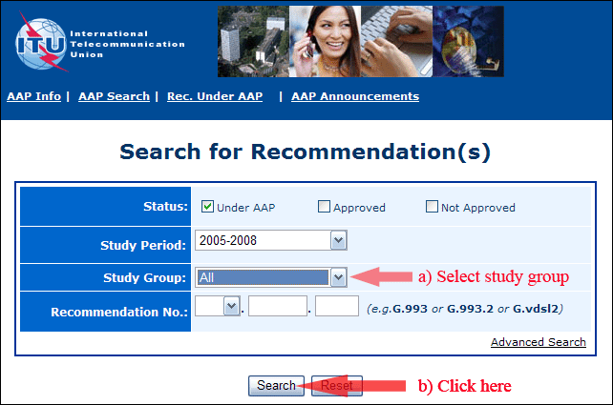

2) Select your Recommendation

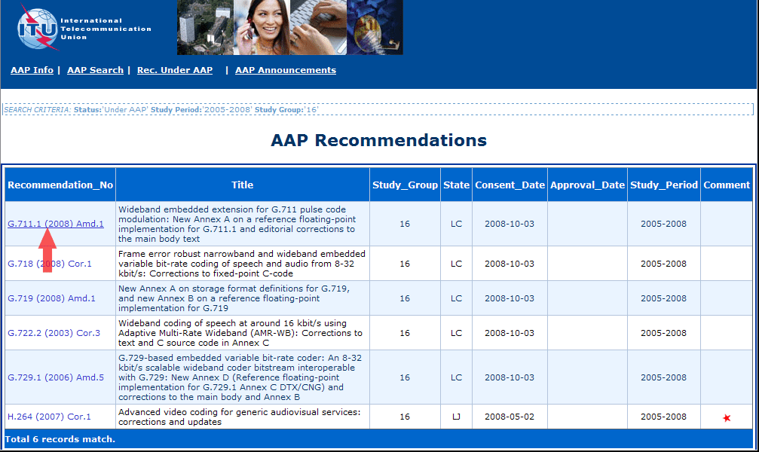

3) Click the "Submit Comment" button

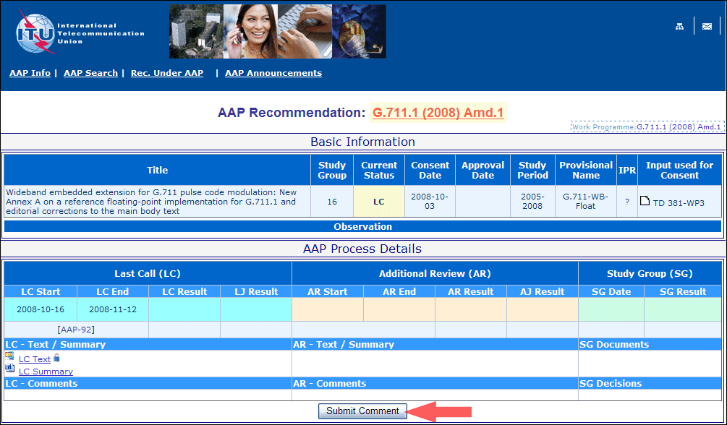

4) Complete the on-line form and click on "Submit"

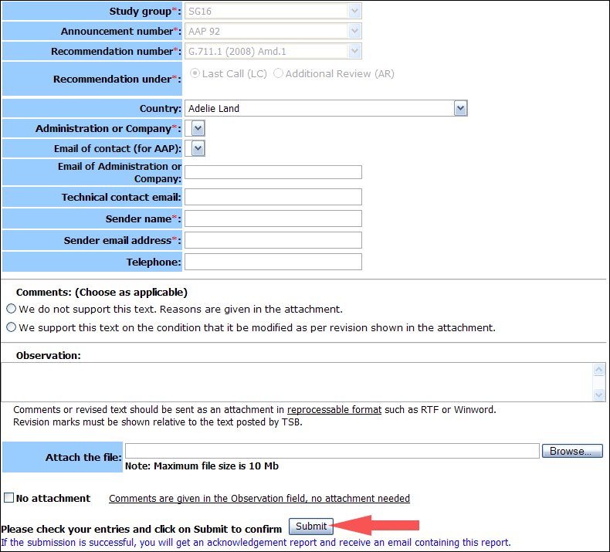

For more information, read the AAP tutorial on:   
<http://www.itu.int/ITU-T/aapinfo/files/AAPTutorial.pdf>

Annex 3

(to TSB AAP-41)

Recommendations under LC/AR – Comment submission form

*(Separate form for each Recommendation being commented upon)*

|  |  |
| --- | --- |
| ITU-T AAP comment submission form for the period 2009-2012 | |
| **Study Group:** |  |
| **Announcement number:** |  |
| **Recommendation number:** |  |
| **Recommendation under:** | Last call (LC)   Additional Review (AR) |
| **Country:** |  |
| **Administration/Company:** |  |
| **Name of AAP Contact Person:** |  |
| **Email of AAP Contact Person:** |  |
| **Sender name: (if different from AAP Contact Person)** |  |
| **Sender email address:** |  |
| **Telephone:** |  |
| **Comments: (Choose as applicable)** | We do not support this text. Reasons are given in the attachment.   We support this text on the condition that it be modified as per revision shown in the attachment. |
| **Observations:** |  |

**No attachment:** Comments are given in the Observation field, no attachment needed

*To be returned to: email:* [*tsbsg....@itu.int*](mailto:tsbsg....@itu.int) *[or fax +41 22 730 5853]  
Comments or revised text should be sent as an attachment in RTF or WinWord format.  
Revision marks must be shown relative to the text posted by TSB.*