Unión Internacional de Telecomunicaciones
Oficina de Normalización de las Telecomunicaciones

Ginebra, 01 de julio de 2010

Ref:  Tel:  Fax:  Correo-e: | TSB AAP-39  AAP/MJ  +41 22 730 5860  +41 22 730 5853  tsbdir@itu.int | – A las Administraciones de los Estados Miembros de la Unión;  – A los Miembros del Sector UIT-T;  – A los Asociados del UIT-T  Copia:  – A los Presidentes y a los Vicepresidentes de las Comisiones de Estudio del UIT-T;  – Al Director de la Oficina de Desarrollo de las Telecomunicaciones;  – Al Director de la Oficina de Radiocomunicaciones

Asunto: | Situación de las Recomendaciones sometidas al proceso de aprobación alternativo (AAP)

Muy señora mía/Muy señor mío:

El proceso de aprobación alternativo (AAP) definido en la Recomendación A.8 del UIT-T se aplica a las Recomendaciones que no tienen consecuencias en materia de política o reglamentación y que no requieren, por lo tanto, la consulta formal de los Estados Miembros (véase el número 246B del Convenio de la UIT).
En el anexo 1 se enumera la lista de los textos cuyo estado ha cambiado con respecto a los anuncios TSB AAP precedentes.
Si desea formular un comentario en relación con una Recomendación sometida al AAP, le alentamos a utilizar el formulario de presentación de comentarios disponible en la página de la Recomendación que figura en el área AAP del sitio web del UIT-T, en la dirección http://www.itu.int/ITU-T/aap/ (véase también el anexo 2). Alternativamente, pueden presentarse comentarios completando el formulario del anexo 3 y remitiéndolo a la secretaría de la Comisión de Estudio correspondiente.
Le rogamos tenga en cuenta que no se alientan comentarios que se limiten a apoyar la adopción del texto en cuestión.
Le saluda atentamente,

Malcolm Johnson
Director de la Oficina de
Normalización de las Telecomunicaciones
Anexos: 3

Annex 1
(to TSB AAP-39)

Status codes used in the AAP announcements:
LC = Last Call
LJ = Last Call Judgment (includes comment resolution)
AR = Additional Review
AJ = Additional Review Judgment (includes comment resolution)
SG = For Study Group approval
A = Approved
AT = Approved with typographic corrections
AC = Approved after Additional Review of Comments
NA = Not approved
TAP = Moved to TAP (ITU-T A.8 / § 5.2)
ITU-T website entry page:
http://www.itu.int/ITU-T
Alternative approval process (AAP) welcome page:
http://www.itu.int/ITU-T/aapinfo
Note – A tutorial on the ITU-T AAP application is available under the AAP welcome page
ITU-T website AAP Recommendation search page:
http://www.itu.int/ITU-T/aap/
Study Group web pages and contacts:
SG 2 | http://www.itu.int/ITU-T/studygroups/com02 | tsbsg2@itu.int
SG 3 | http://www.itu.int/ITU-T/studygroups/com03 | tsbsg3@itu.int
SG 5 | http://www.itu.int/ITU-T/studygroups/com05 | tsbsg5@itu.int
SG 9 | http://www.itu.int/ITU-T/studygroups/com09 | tsbsg9@itu.int
SG 11 | http://www.itu.int/ITU-T/studygroups/com11 | tsbsg11@itu.int
SG 12 | http://www.itu.int/ITU-T/studygroups/com12 | tsbsg12@itu.int
SG 13 | http://www.itu.int/ITU-T/studygroups/com13 | tsbsg13@itu.int
SG 15 | http://www.itu.int/ITU-T/studygroups/com15 | tsbsg15@itu.int
SG 16 | http://www.itu.int/ITU-T/studygroups/com16 | tsbsg16@itu.int
SG 17 | http://www.itu.int/ITU-T/studygroups/com17 | tsbsg17@itu.int

Situation concerning Study Group 2 Recommendations under AAP
Rec # | Title | Last Call (LC) Period |  |  |  | Additional Review (AR) Period |  |  |  | Status
 |  | LC Start | LC End | LC  Result | LJ  Result | AR Start | AR End | AR  Result | AJ  Result
M.3703  (X.alarm-neutral) | Common Management Service – Alarm Management - Requirements and analysis - Protocol neutral | 2010-06-01 | 2010-06-28 | A |  |  |  |  |  | A
Situation concerning Study Group 9 Recommendations under AAP
Rec # | Title | Last Call (LC) Period |  |  |  | Additional Review (AR) Period |  |  |  | Status
 |  | LC Start | LC End | LC  Result | LJ  Result | AR Start | AR End | AR  Result | AJ  Result
J.340 (J.ra-psnr) | Reference Algorithm for Computing Peak Signal to Noise Ratio (PSNR) of a Video Sequence with Constant Spatial Shifts and a Constant Delay | 2010-06-01 | 2010-06-28 | LJ |  |  |  |  |  | LJ
Situation concerning Study Group 12 Recommendations under AAP
Rec # | Title | Last Call (LC) Period |  |  |  | Additional Review (AR) Period |  |  |  | Status
 |  | LC Start | LC End | LC  Result | LJ  Result | AR Start | AR End | AR  Result | AJ  Result
G.1011 (G.RQAM  (ex G.FQT)) | Reference guide to Quality of Experience (QoE) assessment methodologies | 2010-06-01 | 2010-06-28 | A |  |  |  |  |  | A
Y.1221 | Traffic control and congestion control in IP-based networks | 2010-06-01 | 2010-06-28 | A |  |  |  |  |  | A
Y.1542 | Framework for achieving end-to-end IP performance objectives | 2010-06-01 | 2010-06-28 | A |  |  |  |  |  | A
Situation concerning Study Group 15 Recommendations under AAP
Rec # | Title | Last Call (LC) Period |  |  |  | Additional Review (AR) Period |  |  |  | Status
 |  | LC Start | LC End | LC  Result | LJ  Result | AR Start | AR End | AR  Result | AJ  Result
G.650.1 | Definitions and test methods for linear, deterministic attributes of single-mode fibre and cable | 2010-07-01 | 2010-07-28 |  |  |  |  |  |  | LC
G.653 | Characteristics of a dispersion-shifted single-mode optical fibre and cable | 2010-07-01 | 2010-07-28 |  |  |  |  |  |  | LC
G.654 | Characteristics of a cut-off shifted single-mode optical fibre and cable | 2010-07-01 | 2010-07-28 |  |  |  |  |  |  | LC
G.656 | Characteristics of a fibre and cable with non-zero dispersion for wideband optical transport | 2010-07-01 | 2010-07-28 |  |  |  |  |  |  | LC
G.695 | Optical interfaces for coarse wavelength division multiplexing (CWDM) applications | 2010-07-01 | 2010-07-28 |  |  |  |  |  |  | LC
G.696.1 | Longitudinally compatible intra-domain DWDM applications | 2010-07-01 | 2010-07-28 |  |  |  |  |  |  | LC
G.709/Y.1322 (2009) Amd.1 | Interfaces for the Optical Transport Network (OTN): Amendment 1 | 2010-07-01 | 2010-07-28 |  |  |  |  |  |  | LC
G.709/Y.1331 (2009) Cor.1 | Interfaces for the Optical Transport Network (OTN): Corrigendum 1 | 2010-07-01 | 2010-07-28 |  |  |  |  |  |  | LC
G.780/Y.1351 | Terms and definitions for synchronous digital hierarchy (SDH) networks | 2010-07-01 | 2010-07-28 |  |  |  |  |  |  | LC
G.798 | Characteristics of optical transport network hierarchy equipment functional blocks | 2010-07-01 | 2010-07-28 |  |  |  |  |  |  | LC
G.800 (2007) Amd.2 | Unified framework for the architecture of transport networks: Amendment 2 | 2010-07-01 | 2010-07-28 |  |  |  |  |  |  | LC
G.870/Y.1352 | Terms and definitions for optical transport networks (OTN) | 2010-07-01 | 2010-07-28 |  |  |  |  |  |  | LC
G.872 (2001) Amd.2 | Architecture of optical transport networks: Amendment 2 | 2010-07-01 | 2010-07-28 |  |  |  |  |  |  | LC
G.874 | Management aspects of optical transport network elements | 2010-07-01 | 2010-07-28 |  |  |  |  |  |  | LC
G.971 | General features of optical fibre submarine cable systems | 2010-07-01 | 2010-07-28 |  |  |  |  |  |  | LC
G.973 | Characteristics of repeaterless optical fibre submarine cable systems | 2010-07-01 | 2010-07-28 |  |  |  |  |  |  | LC
G.976 | Test methods applicable to optical fibre submarine cable systems | 2010-07-01 | 2010-07-28 |  |  |  |  |  |  | LC
G.978 | Characteristics of optical fibre submarine cables | 2010-07-01 | 2010-07-28 |  |  |  |  |  |  | LC
G.984.4 (2008) Amd.3 | Gigabit-capable Passive Optical Networks (GPON): ONT management and control interface (OMCI) specification: Amendment 3 | 2010-07-01 | 2010-07-28 |  |  |  |  |  |  | LC
G.984.7 (G.984.lr) | Gigabit-capable Passive Optical Networks (GPON): Long reach | 2010-07-01 | 2010-07-28 |  |  |  |  |  |  | LC
G.987 | 10-Gigabit-capable passive optical network (XG-PON) systems: Definitions, abbreviations and acronyms | 2010-07-01 | 2010-07-28 |  |  |  |  |  |  | LC
G.987.2 | 10-Gigabit-capable passive optical networks (XG-PON): Physical media dependent (PMD) layer specification | 2010-07-01 | 2010-07-28 |  |  |  |  |  |  | LC
G.987.3 (G.xgpon.3) | 10-Gigabit-capable passive optical networks (XG-PON): Transmission convergence (TC) specifications | 2010-07-01 | 2010-07-28 |  |  |  |  |  |  | LC
G.988 (G.omci) | ONU management and control interface (OMCI) specification | 2010-07-01 | 2010-07-28 |  |  |  |  |  |  | LC
G.992.3 (2009) Amd.2 | Asymmetric digital subscriber line transceivers 2 (ADSL2): Amendment 2 - Retrain on eoc protocol timeout | 2010-07-01 | 2010-07-28 |  |  |  |  |  |  | LC
G.7041/Y.1303 (2008) Amd.2 | Generic framing procedure (GFP) | 2010-07-01 | 2010-07-28 |  |  |  |  |  |  | LC
G.7710/Y.1701 (2007) Amd.1 | Common equipment management function requirements: Amendment 1 | 2010-07-01 | 2010-07-28 |  |  |  |  |  |  | LC
G.7712/Y.1703 | Architecture and specification of data communication network | 2010-07-01 | 2010-07-28 |  |  |  |  |  |  | LC
G.7714.1/Y.1705.1 | Protocol for automatic discovery in SDH and OTN networks | 2010-07-01 | 2010-07-28 |  |  |  |  |  |  | LC
G.7718/Y.1709 | Framework for ASON management | 2010-07-01 | 2010-07-28 |  |  |  |  |  |  | LC
G.8001/Y.1354 | Terms and definitions for Ethernet frames over Transport | 2010-07-01 | 2010-07-28 |  |  |  |  |  |  | LC
G.8010/Y.1306 (2004) Amd.2 | Architecture of Ethernet layer networks: Amendment 2 | 2010-07-01 | 2010-07-28 |  |  |  |  |  |  | LC
G.8031/Y.1342 (2009) Cor.1 | Ethernet linear protection switching: Corrigendum 1 | 2010-07-01 | 2010-07-28 |  |  |  |  |  |  | LC
G.8032/Y.1344 (2010) Cor.1 | Ethernet Ring Protection Switching: Corrigendum 1 | 2010-07-01 | 2010-07-28 |  |  |  |  |  |  | LC
G.8080/Y.1304 (2006) Amd.2 (G.ason) | Architecture for the automatically switched optical network (ASON): Amendment 2 | 2010-07-01 | 2010-07-28 |  |  |  |  |  |  | LC
G.8081/Y.1353 | Terms and definitions for Automatically Switched Optical Networks (ASON) | 2010-07-01 | 2010-07-28 |  |  |  |  |  |  | LC
G.8101/Y.1355 | Terms and definitions for transport MPLS | 2010-07-01 | 2010-07-28 |  |  |  |  |  |  | LC
G.8251 | The control of jitter and wander within the optical transport network (OTN) | 2010-07-01 | 2010-07-28 |  |  |  |  |  |  | LC
G.8260 | Definitions and terminology for synchronization in packet networks | 2010-07-01 | 2010-07-28 |  |  |  |  |  |  | LC
G.8261/Y.1361 (2008) Amd.1 (G.pactiming) | Timing and synchronization aspects in packet networks: Amendment 1 | 2010-07-01 | 2010-07-28 |  |  |  |  |  |  | LC
G.8262/Y.1362 (G.paclock) | Timing characteristics of a synchronous Ethernet equipment slave clock (EEC) | 2010-07-01 | 2010-07-28 |  |  |  |  |  |  | LC
G.8264/Y.1364 (2008) Amd.1 (G.pacmod) | Distribution of timing information through packet networks: Amendment 1 | 2010-07-01 | 2010-07-28 |  |  |  |  |  |  | LC
G.9971 (G.hntreq) | Requirements of transport functions in IP home networks | 2010-07-01 | 2010-07-28 |  |  |  |  |  |  | LC
L.50 | Requirements for passive optical nodes: Optical distribution frames for central office environments | 2010-07-01 | 2010-07-28 |  |  |  |  |  |  | LC
L.82 (L.teib) | Optical cabling shared with multiple operators in buildings | 2010-07-01 | 2010-07-28 |  |  |  |  |  |  | LC
L.83 (L.limt) | Low impact trenching technique for FTTx networks | 2010-07-01 | 2010-07-28 |  |  |  |  |  |  | LC
L.84 (L.fmun) | Fast mapping of underground networks | 2010-07-01 | 2010-07-28 |  |  |  |  |  |  | LC
L.85 (L.ofid) | Optical fibre identification for the maintenance of optical access networks | 2010-07-01 | 2010-07-28 |  |  |  |  |  |  | LC
L.86 (L.pon) | Considerations on the installation site of branching components in PONs for FTTH | 2010-07-01 | 2010-07-28 |  |  |  |  |  |  | LC
L.87 (L.cda) | Optical fibre cables for drop applications | 2010-07-01 | 2010-07-28 |  |  |  |  |  |  | LC
L.88 (L.mpot) | Management of poles carrying overhead telecommunication lines | 2010-07-01 | 2010-07-28 |  |  |  |  |  |  | LC
O.172 (2005) Amd.2 | Jitter and wander measuring equipment for digital systems which are based on the synchronous digital hierarchy (SDH): Amendment 2 | 2010-07-01 | 2010-07-28 |  |  |  |  |  |  | LC
O.173 (2007) Amd.1 | Jitter measuring equipment for digital systems which are based on the Optical Transport Network (OTN): Amendment 1 | 2010-07-01 | 2010-07-28 |  |  |  |  |  |  | LC
O.174 (2009) Cor.1 (O.SyncEjitter,  O.packetjitter) | Jitter and wander measuring equipment for digital systems which are based on synchronous Ethernet technology: Corrigendum 1 | 2010-07-01 | 2010-07-28 |  |  |  |  |  |  | LC
Y.1731 (2008) Amd.1 | OAM functions and mechanisms for Ethernet based networks: Amendment 1 | 2010-07-01 | 2010-07-28 |  |  |  |  |  |  | LC
Situation concerning Study Group 16 Recommendations under AAP
Rec # | Title | Last Call (LC) Period |  |  |  | Additional Review (AR) Period |  |  |  | Status
 |  | LC Start | LC End | LC  Result | LJ  Result | AR Start | AR End | AR  Result | AJ  Result
H.264.2 (V3) | Reference software for H.264 advanced video coding | 2010-03-01 | 2010-03-28 | LJ | AR | 2010-06-01 | 2010-06-21 | AC |  | AC
T.800 (2002) Amd. 4 | Information technology - JPEG 2000 image coding system: Core coding system: Profiles for broadcast applications | 2009-11-16 | 2009-12-13 | LJ | AR | 2010-06-01 | 2010-06-21 | AC |  | AC
Situation concerning Study Group 17 Recommendations under AAP
Rec # | Title | Last Call (LC) Period |  |  |  | Additional Review (AR) Period |  |  |  | Status
 |  | LC Start | LC End | LC  Result | LJ  Result | AR Start | AR End | AR  Result | AJ  Result
X.1101 (X.mcsec-1) | Security requirements and framework for multicast communication | 2010-05-01 | 2010-05-28 | LJ | AT |  |  |  |  | AT

Annex 2
(to TSB AAP-39)
Using the on-line comment submission form
Comment submission
1) Go to AAP search Web page at http://www.itu.int/ITU-T/aap/
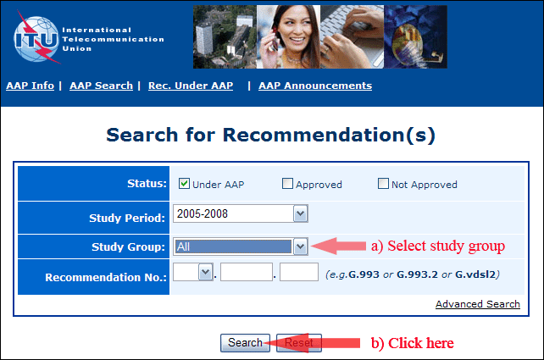
2) Select your Recommendation
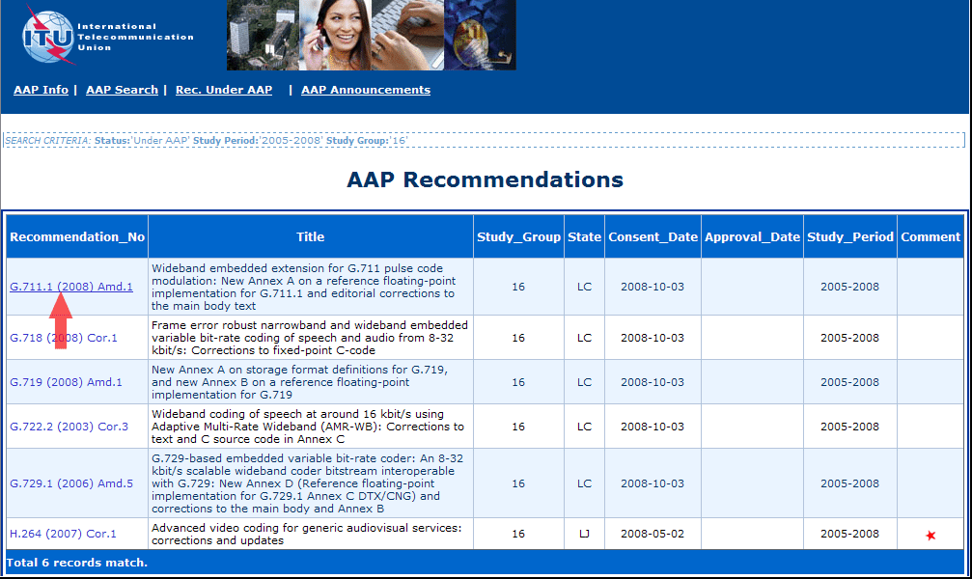
3) Click the "Submit Comment" button
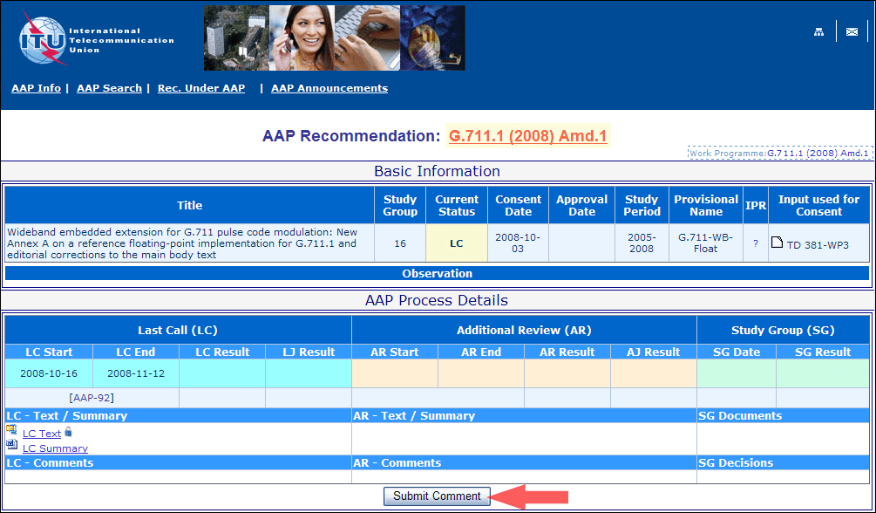
4) Complete the on-line form and click on "Submit"
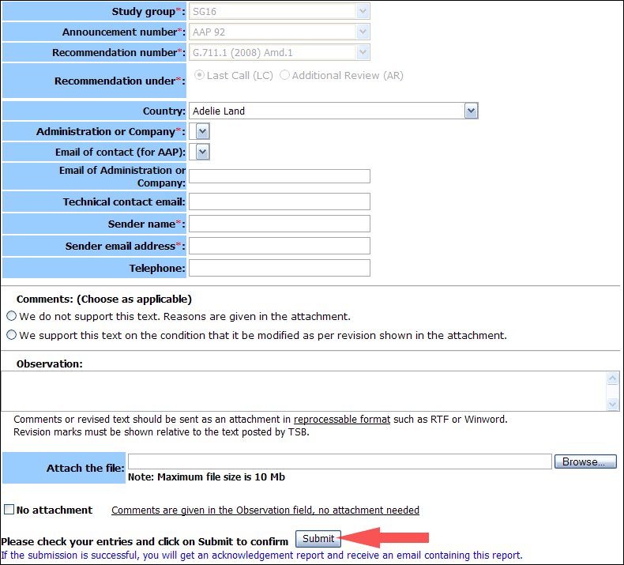
For more information, read the AAP tutorial on:
http://www.itu.int/ITU-T/aapinfo/files/AAPTutorial.pdf
Annex 3
(to TSB AAP-39)
Recommendations under LC/AR – Comment submission form
(Separate form for each Recommendation being commented upon)
ITU-T AAP comment submission form for the period 2009-2012
Study Group:
Announcement number:
Recommendation number:
Recommendation under: | Last call (LC)  Additional Review (AR)
Country:
Administration/Company:
Name of AAP Contact Person:
Email of AAP Contact Person:
Sender name:
(if different from AAP Contact Person)
Sender email address:
Telephone:
Comments:  (Choose as applicable) | We do not support this text. Reasons are given in the attachment.  We support this text on the condition that it be modified as per revision shown in the attachment.
Observations:
No attachment: Comments are given in the Observation field, no attachment needed
To be returned to: email: tsbsg....@itu.int
[or fax +41 22 730 5853]
Comments or revised text should be sent as an attachment in RTF or WinWord format.
Revision marks must be shown relative to the text posted by TSB.

