Unión Internacional de Telecomunicaciones  Oficina de Normalización de las Telecomunicaciones | 

Ginebra, 16 de junio de 2010

Ref:  Tel:  Fax:  Correo-e: | TSB AAP-38  AAP/MJ  +41 22 730 5860  +41 22 730 5853  tsbdir@itu.int | – A las Administraciones de los Estados Miembros de la Unión;  – A los Miembros del Sector UIT-T;  – A los Asociados del UIT-T  Copia:  – A los Presidentes y a los Vicepresidentes de las Comisiones de Estudio del UIT-T;  – Al Director de la Oficina de Desarrollo de las Telecomunicaciones;  – Al Director de la Oficina de Radiocomunicaciones

Asunto: | Situación de las Recomendaciones sometidas al proceso de aprobación alternativo (AAP)

Muy señora mía/Muy señor mío:

El proceso de aprobación alternativo (AAP) definido en la Recomendación A.8 del UIT-T se aplica a las Recomendaciones que no tienen consecuencias en materia de política o reglamentación y que no requieren, por lo tanto, la consulta formal de los Estados Miembros (véase el número 246B del Convenio de la UIT).
En el anexo 1 se enumera la lista de los textos cuyo estado ha cambiado con respecto a los anuncios TSB AAP precedentes.
Si desea formular un comentario en relación con una Recomendación sometida al AAP, le alentamos a utilizar el formulario de presentación de comentarios disponible en la página de la Recomendación que figura en el área AAP del sitio web del UIT-T, en la dirección http://www.itu.int/ITU-T/aap/ (véase también el anexo 2). Alternativamente, pueden presentarse comentarios completando el formulario del anexo 3 y remitiéndolo a la secretaría de la Comisión de Estudio correspondiente.
Le rogamos tenga en cuenta que no se alientan comentarios que se limiten a apoyar la adopción del texto en cuestión.
Le saluda atentamente,

Malcolm Johnson
Director de la Oficina de
Normalización de las Telecomunicaciones
Anexos: 3
Annex 1
(to TSB AAP-38)

Status codes used in the AAP announcements:
LC = Last Call
LJ = Last Call Judgment (includes comment resolution)
AR = Additional Review
AJ = Additional Review Judgment (includes comment resolution)
SG = For Study Group approval
A = Approved
AT = Approved with typographic corrections
AC = Approved after Additional Review of Comments
NA = Not approved
TAP = Moved to TAP (ITU-T A.8 / § 5.2)
ITU-T website entry page:
http://www.itu.int/ITU-T
Alternative approval process (AAP) welcome page:
http://www.itu.int/ITU-T/aapinfo
Note – A tutorial on the ITU-T AAP application is available under the AAP welcome page
ITU-T website AAP Recommendation search page:
http://www.itu.int/ITU-T/aap/
Study Group web pages and contacts:
SG 2 | http://www.itu.int/ITU-T/studygroups/com02 | tsbsg2@itu.int
SG 3 | http://www.itu.int/ITU-T/studygroups/com03 | tsbsg3@itu.int
SG 5 | http://www.itu.int/ITU-T/studygroups/com05 | tsbsg5@itu.int
SG 9 | http://www.itu.int/ITU-T/studygroups/com09 | tsbsg9@itu.int
SG 11 | http://www.itu.int/ITU-T/studygroups/com11 | tsbsg11@itu.int
SG 12 | http://www.itu.int/ITU-T/studygroups/com12 | tsbsg12@itu.int
SG 13 | http://www.itu.int/ITU-T/studygroups/com13 | tsbsg13@itu.int
SG 15 | http://www.itu.int/ITU-T/studygroups/com15 | tsbsg15@itu.int
SG 16 | http://www.itu.int/ITU-T/studygroups/com16 | tsbsg16@itu.int
SG 17 | http://www.itu.int/ITU-T/studygroups/com17 | tsbsg17@itu.int

Situation concerning Study Group 2 Recommendations under AAP
Rec # | Title | Last Call (LC) Period |  |  |  | Additional Review (AR) Period |  |  |  | Status
Rec # | Title | LC Start | LC End | LC  Result | LJ  Result | AR Start | AR End | AR  Result | AJ  Result | Status
M.3020 | Management interface specification methodology | 2010-06-16 | 2010-07-13 |  |  |  |  |  |  | LC
Situation concerning Study Group 11 Recommendations under AAP
Rec # | Title | Last Call (LC) Period |  |  |  | Additional Review (AR) Period |  |  |  | Status
Rec # | Title | LC Start | LC End | LC  Result | LJ  Result | AR Start | AR End | AR  Result | AJ  Result | Status
Q.3040 (Q.iptvsa) | Signalling and control plane architecture for IPTV | 2010-05-16 | 2010-06-12 | LJ |  |  |  |  |  | LJ
Q.3220 (Q.nacp.0) | Architectural Framework for NACF Signalling Interface Recommendations | 2010-05-16 | 2010-06-12 | A |  |  |  |  |  | A
Q.3321.1 | Resource control protocol no. 1 (rcp1) version 2 Protocol at the interface between service control entities and the Policy Decision Physical Entity (PD-PE) (Rs interface) | 2010-05-16 | 2010-06-12 | A |  |  |  |  |  | A
Q.3904 | The scenarios, list and types of tests for TM local and NUT testing for IMS on the Model networks | 2010-05-16 | 2010-06-12 | A |  |  |  |  |  | A
Q.3910 | Monitoring parameters set for NGN protocols | 2010-05-16 | 2010-06-12 | A |  |  |  |  |  | A
Q.3911 | Monitoring parameters set for voice services in NGN | 2010-05-16 | 2010-06-12 | A |  |  |  |  |  | A
Situation concerning Study Group 13 Recommendations under AAP
Rec # | Title | Last Call (LC) Period |  |  |  | Additional Review (AR) Period |  |  |  | Status
Rec # | Title | LC Start | LC End | LC  Result | LJ  Result | AR Start | AR End | AR  Result | AJ  Result | Status
Q.1742.8 | IMT-2000 References (approved as of 31 January 2010) to ANSI-41 evolved Core Network with cdma2000 Access Network | 2010-05-16 | 2010-06-12 | A |  |  |  |  |  | A
Y.2019 (Y.CD&S) | Content Delivery and Storage Architecture in NGN | 2010-05-16 | 2010-06-12 | LJ |  |  |  |  |  | LJ
Y.2233 Rev.1 (Y.ngn-account-R2) | Requirements and framework allowing accounting and charging capabilities in NGN | 2010-05-16 | 2010-06-12 | A |  |  |  |  |  | A
Situation concerning Study Group 15 Recommendations under AAP
Rec # | Title | Last Call (LC) Period |  |  |  | Additional Review (AR) Period |  |  |  | Status
Rec # | Title | LC Start | LC End | LC  Result | LJ  Result | AR Start | AR End | AR  Result | AJ  Result | Status
G.997.1 (2009) Amd.1 | Physical layer management for digital subscriber line (DSL) transceivers - Amendment 1 | 2009-10-16 | 2009-11-12 | LJ | AR | 2010-04-01 | 2010-04-21 | SG |  | AC
G.998.4 (G.inp) | Improved Impulse Noise Protection (INP) for DSL Transceivers | 2009-10-16 | 2009-11-12 | LJ | AR | 2010-04-01 | 2010-04-21 | SG |  | AC
G.9960 (2009) Amd.1 | Unified high-speed wire-line based home networking transceivers - Amendment 1 | 2010-02-01 | 2010-02-28 | LJ | SG |  |  |  |  | AC
G.9960 (2009) Cor.1 | Unified high-speed wire-line based home networking transceivers | 2010-02-01 | 2010-02-28 | LJ | SG |  |  |  |  | AC
G.9961 | Data link layer (DLL) for unified high-speed wire-line based home networking transceivers | 2010-02-01 | 2010-02-28 | LJ | SG |  |  |  |  | AC
G.9972 (G.cx) | Coexistence mechanism for wireline home networking transceivers | 2009-10-16 | 2009-11-12 | LJ | SG |  |  |  |  | AC

Annex 2
(to TSB AAP-38)
Using the on-line comment submission form
Comment submission
1) Go to AAP search Web page at http://www.itu.int/ITU-T/aap/
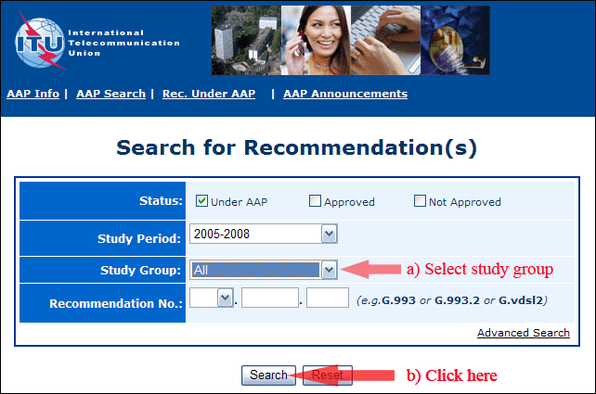
2) Select your Recommendation
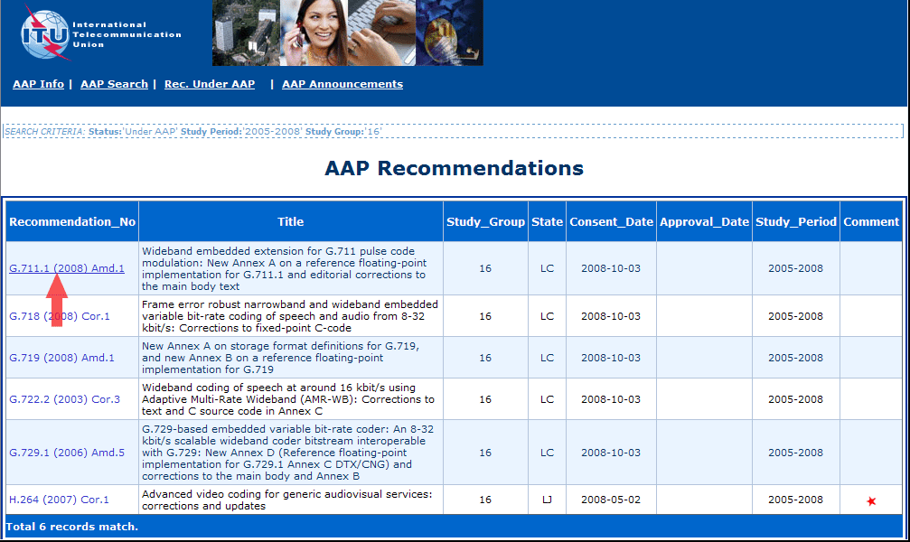
3) Click the "Submit Comment" button
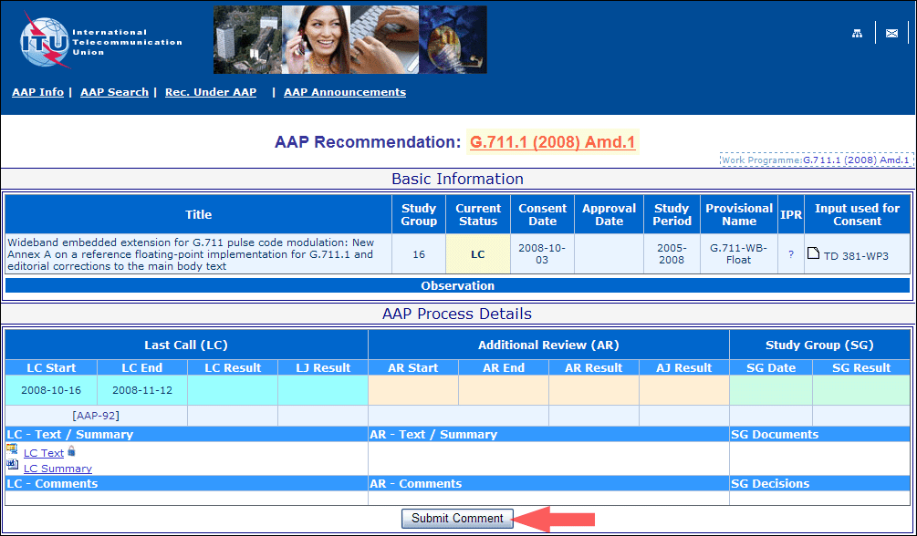
4) Complete the on-line form and click on "Submit"
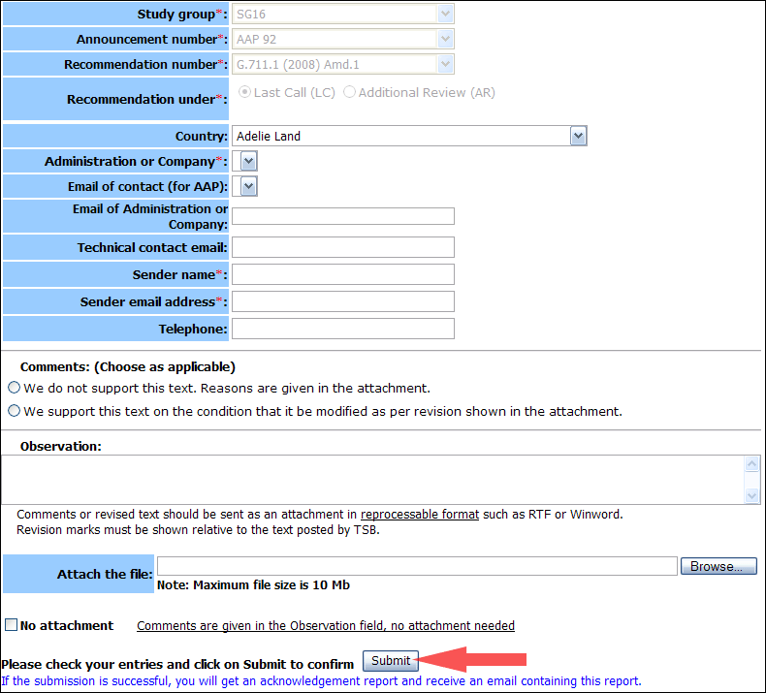
For more information, read the AAP tutorial on:
http://www.itu.int/ITU-T/aapinfo/files/AAPTutorial.pdf
Annex 3
(to TSB AAP-38)
Recommendations under LC/AR – Comment submission form
(Separate form for each Recommendation being commented upon)
ITU-T AAP comment submission form for the period 2009-2012
Study Group:
Announcement number:
Recommendation number:
Recommendation under: | Last call (LC)  Additional Review (AR)
Country:
Administration/Company:
Name of AAP Contact Person:
Email of AAP Contact Person:
Sender name:
(if different from AAP Contact Person)
Sender email address:
Telephone:
Comments:  (Choose as applicable) | We do not support this text. Reasons are given in the attachment.  We support this text on the condition that it be modified as per revision shown in the attachment.
Observations:
No attachment: Comments are given in the Observation field, no attachment needed
To be returned to: email: tsbsg....@itu.int
[or fax +41 22 730 5853]
Comments or revised text should be sent as an attachment in RTF or WinWord format.
Revision marks must be shown relative to the text posted by TSB.

