国 际 电 信 联 盟  电信标准化局 | 
2010年4月1日 ，日内瓦

参考号:  电话:  传真:  电子邮件: | 电信标准化局AAP-33  AAP/MJ  +41 22 730 5860  +41 22 730 5853  tsbdir@itu.int | – 致国际电联成员国各主管部门；  – 致ITU-T各部门成员；  – 致ITU-T 部门准成员  抄送：  – 电信标准化局研究组主席和副主席  – 电信发展局主任  – 无线电通信局主任

事由: | 有关采用替换批准程序（AAP）处理的建议书的情况

先生/女士，
ITU-T A.8 建议书中规定的建议书替换批准程序 (AAP) 适用于那些不会产生政策或 监管影响、因而不需与成员国正式协商的建议书（见国际电联《公约》第246B款）。
附件1列出了那些在以往电信标准化局AAP预告后地位发生变化的案文。
如您希望针对某个适用AAP的建议书提出意见，请使用可在ITU-T网站AAP区域 （http://www.itu.int/ITU-T/aap）的“建议书”网页上获取的《AAP意见在线提交表格》 （见附件2）。或者，可填妥附件3 中的表格并将意见发送给相关研究组的秘书处。
敬请留意，我们不鼓励提交仅支持通过所涉案文而没有实质内容的意见。

顺致敬意！

马尔科姆•琼森
电信标准化局主任

附件：3件
Annex 1
(to TSB AAP-33)

Status codes used in the AAP announcements:
LC = Last Call
LJ = Last Call Judgment (includes comment resolution)
AR = Additional Review
AJ = Additional Review Judgment (includes comment resolution)
SG = For Study Group approval
A = Approved
AT = Approved with typographic corrections
AC = Approved after Additional Review of Comments
NA = Not approved
TAP = Moved to TAP (ITU-T A.8 / § 5.2)
ITU-T website entry page:
http://www.itu.int/ITU-T
Alternative approval process (AAP) welcome page:
http://www.itu.int/ITU-T/aapinfo
Note – A tutorial on the ITU-T AAP application is available under the AAP welcome page
ITU-T website AAP Recommendation search page:
http://www.itu.int/ITU-T/aap/
Study Group web pages and contacts:
SG 2 | http://www.itu.int/ITU-T/studygroups/com02 | tsbsg2@itu.int
SG 3 | http://www.itu.int/ITU-T/studygroups/com03 | tsbsg3@itu.int
SG 5 | http://www.itu.int/ITU-T/studygroups/com05 | tsbsg5@itu.int
SG 9 | http://www.itu.int/ITU-T/studygroups/com09 | tsbsg9@itu.int
SG 11 | http://www.itu.int/ITU-T/studygroups/com11 | tsbsg11@itu.int
SG 12 | http://www.itu.int/ITU-T/studygroups/com12 | tsbsg12@itu.int
SG 13 | http://www.itu.int/ITU-T/studygroups/com13 | tsbsg13@itu.int
SG 15 | http://www.itu.int/ITU-T/studygroups/com15 | tsbsg15@itu.int
SG 16 | http://www.itu.int/ITU-T/studygroups/com16 | tsbsg16@itu.int
SG 17 | http://www.itu.int/ITU-T/studygroups/com17 | tsbsg17@itu.int

Situation concerning Study Group 9 Recommendations under AAP
Rec # | Title | Last Call (LC) Period |  |  |  | Additional Review (AR) Period |  |  |  | Status
Rec # | Title | LC Start | LC End | LC  Result | LJ  Result | AR Start | AR End | AR  Result | AJ  Result | Status
J.200 | Worldwide common core - Application environment for digital interactive television services | 2010-04-01 | 2010-04-28 |  |  |  |  |  |  | LC
Situation concerning Study Group 11 Recommendations under AAP
Rec # | Title | Last Call (LC) Period |  |  |  | Additional Review (AR) Period |  |  |  | Status
Rec # | Title | LC Start | LC End | LC  Result | LJ  Result | AR Start | AR End | AR  Result | AJ  Result | Status
Q.3222 (Q.nacp.Ng) | Requirements and protocol at the Ng interface between transport location management physical entities | 2010-02-01 | 2010-02-28 | LJ | SG |  |  |  |  | SG
X.603.1 (2007) Amd.2 | Information technology - Relayed multicast protocol: Specification for simplex group applications - Amendment 2: Revision of sub-control data and code-value | 2010-02-01 | 2010-02-28 | LJ | AT |  |  |  |  | AT
X.604 (X.mmc-1) | Mobile multicast communications - Framework | 2010-02-01 | 2010-02-28 | LJ | AT |  |  |  |  | AT
Situation concerning Study Group 13 Recommendations under AAP
Rec # | Title | Last Call (LC) Period |  |  |  | Additional Review (AR) Period |  |  |  | Status
Rec # | Title | LC Start | LC End | LC  Result | LJ  Result | AR Start | AR End | AR  Result | AJ  Result | Status
Y.1911 (Y.iptvintwrm) | Interworking between NGNs in support of nomadic IPTV services | 2010-02-16 | 2010-03-15 | SG |  |  |  |  |  | SG
Y.1991 (Y.iptvterms) | Terms and definitions for IPTV | 2010-02-16 | 2010-03-15 | AT |  |  |  |  |  | AT
Y.2012  (Y.NGN-FRA rev1  (ex Y.NGN-FRA R2)) | Functional requirements and architecture of the NGN | 2010-02-16 | 2010-03-15 | SG |  |  |  |  |  | SG
Y.2014  (Y.NACF rev1  (ex Y.NACF)) | Network attachment control functions in next generation networks | 2010-02-16 | 2010-03-15 | A |  |  |  |  |  | A
Y.2206 (Y.dsnreq) | Requirements for distributed service network (DSN) | 2010-02-16 | 2010-03-15 | LJ |  |  |  |  |  | LJ
Y.2216 (Y.ngn-mcc) | NGN capability requirements to support multimedia communication centre (MCC) service | 2010-02-16 | 2010-03-15 | A |  |  |  |  |  | A
Y.2613 (Y.PTDN) | The general technical architecture for public packet telecommunication data network (PTDN) | 2010-02-16 | 2010-03-15 | A |  |  |  |  |  | A
Situation concerning Study Group 15 Recommendations under AAP
Rec # | Title | Last Call (LC) Period |  |  |  | Additional Review (AR) Period |  |  |  | Status
Rec # | Title | LC Start | LC End | LC  Result | LJ  Result | AR Start | AR End | AR  Result | AJ  Result | Status
G.993.2 (2006)  Amd. 5 | Very high speed Digital subscriber Line Transceivers 2 - Amendment 5 | 2009-10-16 | 2009-11-12 | LJ | AR | 2010-04-01 | 2010-04-21 |  |  | AR
G.993.5 (G.vector) | Self-FEXT Cancellation (Vectoring) for use with VDSL2 transceivers | 2009-10-16 | 2009-11-12 | LJ | AR | 2010-04-01 | 2010-04-21 |  |  | AR
G.994.1 (2007) Amd.5 | Handshake procedures for digital subscriber line (DSL) transceivers - Amendment 5 | 2009-10-16 | 2009-11-12 | LJ | AR | 2010-04-01 | 2010-04-21 |  |  | AR
G.997.1 (2009) Amd.1 | Physical layer management for digital subscriber line (DSL) transceivers - Amendment 1 | 2009-10-16 | 2009-11-12 | LJ | AR | 2010-04-01 | 2010-04-21 |  |  | AR
G.998.4 (G.inp) | Improved Impulse Noise Protection (INP) for DSL Transceivers | 2009-10-16 | 2009-11-12 | LJ | AR | 2010-04-01 | 2010-04-21 |  |  | AR
G.999.1 Corr1 | LINK layer to PHY layer interface | 2010-02-01 | 2010-02-28 | LJ | AR | 2010-04-01 | 2010-04-21 |  |  | AR
Situation concerning Study Group 16 Recommendations under AAP
Rec # | Title | Last Call (LC) Period |  |  |  | Additional Review (AR) Period |  |  |  | Status
Rec # | Title | LC Start | LC End | LC  Result | LJ  Result | AR Start | AR End | AR  Result | AJ  Result | Status
G.191 V5 (STL2008) | Software tools for speech and audio coding standardization | 2010-03-01 | 2010-03-28 | A |  |  |  |  |  | A
G.718 (2008) Amd. 2 (G.718-SWB) | Variable bit rate embedded coding of speech signals: New Annex B on superwideband scalable extension for G.718 and corrections to main body fixed-point C-code and description text | 2010-03-01 | 2010-03-28 | A |  |  |  |  |  | A
G.729.1 (2006)  Amd. 6  (G.729.1-SWB) | G.729-based embedded variable bit-rate coder: An 8-32 kbit/s scalable wideband coder bitstream interoperable with G.729: New Annex E on superwideband scalable extension for G.729.1 | 2010-03-01 | 2010-03-28 | A |  |  |  |  |  | A
H.264.2 (V3) | Reference software for H.264 advanced video coding | 2010-03-01 | 2010-03-28 | LJ |  |  |  |  |  | LJ
H.740 (H.IPTV-AEH) | Application event handling for IPTV services | 2009-11-16 | 2009-12-13 | LJ | AR | 2010-03-01 | 2010-03-21 | AJ |  | AJ
T.802 (2005) Amd.1 | Information technology - JPEG 2000 image coding system: Motion JPEG 2000: Additional profiles for archiving applications | 2009-11-16 | 2009-12-13 | LJ | AR | 2010-04-01 | 2010-04-21 |  |  | AR

Annex 2
(to TSB AAP-33)
Using the on-line comment submission form
Comment submission
1) Go to AAP search Web page at http://www.itu.int/ITU-T/aap/
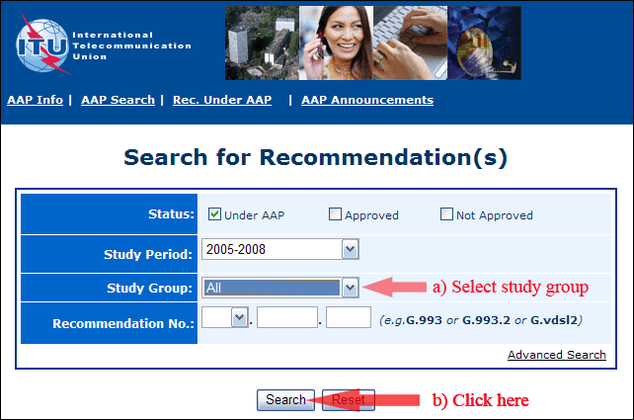
2) Select your Recommendation
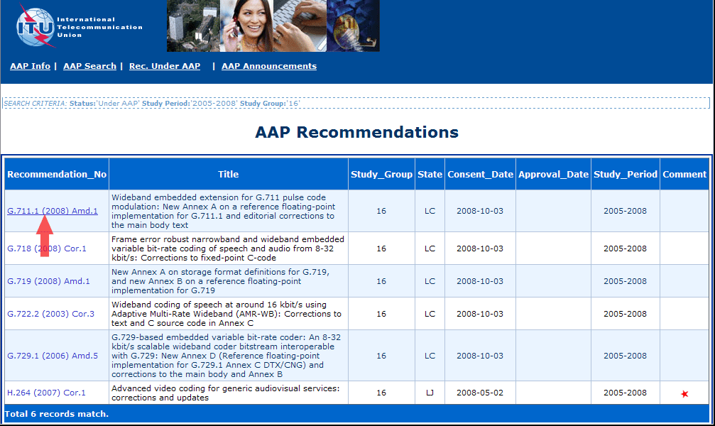
3) Click the "Submit Comment" button
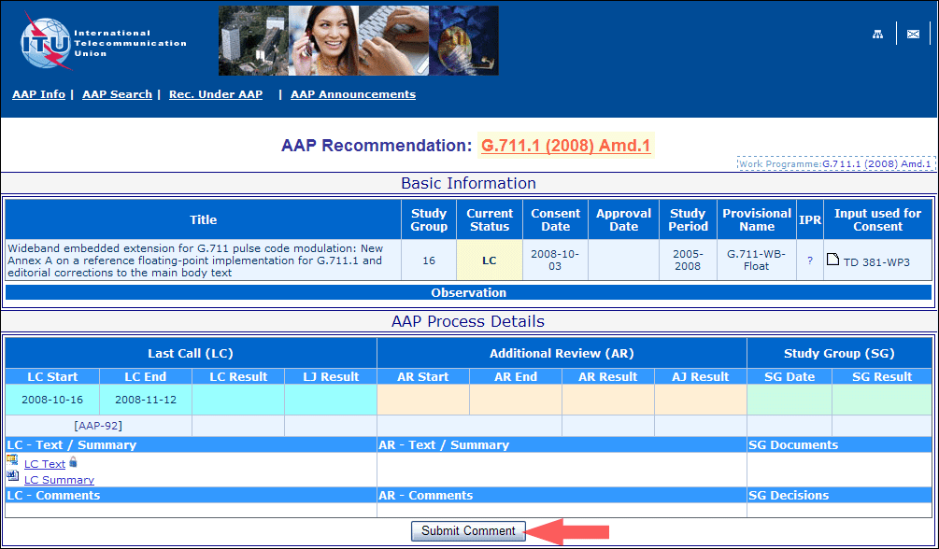
4) Complete the on-line form and click on "Submit"
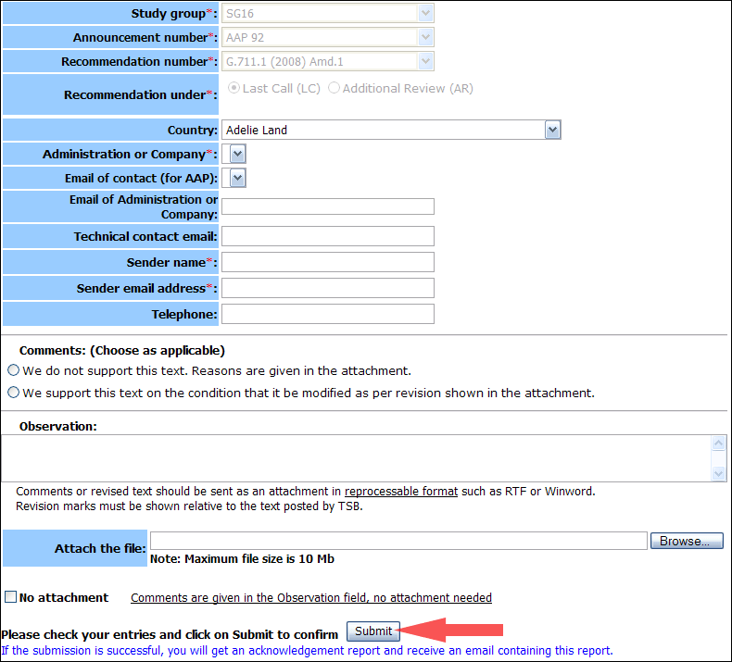
For more information, read the AAP tutorial on:
http://www.itu.int/ITU-T/aapinfo/files/AAPTutorial.pdf
Annex 3
(to TSB AAP-33)
Recommendations under LC/AR – Comment submission form
(Separate form for each Recommendation being commented upon)
ITU-T AAP comment submission form for the period 2009-2012
Study Group:
Announcement number:
Recommendation number:
Recommendation under: | Last call (LC)  Additional Review (AR)
Country:
Administration/Company:
Name of AAP Contact Person:
Email of AAP Contact Person:
Sender name:
(if different from AAP Contact Person)
Sender email address:
Telephone:
Comments:  (Choose as applicable) | We do not support this text. Reasons are given in the attachment.  We support this text on the condition that it be modified as per revision shown in the attachment.
Observations:
No attachment: Comments are given in the Observation field, no attachment needed
To be returned to: email: tsbsg....@itu.int
[or fax +41 22 730 5853]
Comments or revised text should be sent as an attachment in RTF or WinWord format.
Revision marks must be shown relative to the text posted by TSB.

