Unión Internacional de Telecomunicaciones  Oficina de Normalización de las Telecomunicaciones | 

Ginebra, 01 de diciembre de 2009

Ref:  Tel:  Fax:  Correo-e: | TSB AAP-26  AAP/MJ  +41 22 730 5860  +41 22 730 5853  tsbdir@itu.int | – A las Administraciones de los Estados Miembros de la Unión;  – A los Miembros del Sector UIT-T;  – A los Asociados del UIT-T  Copia:  – A los Presidentes y a los Vicepresidentes de las Comisiones de Estudio del UIT-T;  – Al Director de la Oficina de Desarrollo de las Telecomunicaciones;  – Al Director de la Oficina de Radiocomunicaciones

Asunto: | Situación de las Recomendaciones sometidas al proceso de aprobación alternativo (AAP)

Muy señora mía/Muy señor mío:

El proceso de aprobación alternativo (AAP) definido en la Recomendación A.8 del UIT-T se aplica a las Recomendaciones que no tienen consecuencias en materia de política o reglamentación y que no requieren, por lo tanto, la consulta formal de los Estados Miembros (véase el número 246B del Convenio de la UIT).
En el anexo 1 se enumera la lista de los textos cuyo estado ha cambiado con respecto a los anuncios TSB AAP precedentes.
Si desea formular un comentario en relación con una Recomendación sometida al AAP, le alentamos a utilizar el formulario de presentación de comentarios disponible en la página de la Recomendación que figura en el área AAP del sitio web del UIT-T, en la dirección http://www.itu.int/ITU-T/aap/ (véase también el anexo 2). Alternativamente, pueden presentarse comentarios completando el formulario del anexo 3 y remitiéndolo a la secretaría de la Comisión de Estudio correspondiente.
Le rogamos tenga en cuenta que no se alientan comentarios que se limiten a apoyar la adopción del texto en cuestión.
Le rogamos tomar nota que en vista del cierre anual de la UIT, no se publicará ningún anuncio AAP el 1 de enero de 2010. En consecuencia, la fecha límite de algunos textos ha sido prolongada ya que esta fecha límite cae alrededor de este período.
Le saluda atentamente,

Malcolm Johnson
Director de la Oficina de
Normalización de las Telecomunicaciones
Anexos: 3
Annex 1
(to TSB AAP-26)

Status codes used in the AAP announcements:
LC = Last Call
LJ = Last Call Judgment (includes comment resolution)
AR = Additional Review
AJ = Additional Review Judgment (includes comment resolution)
SG = For Study Group approval
A = Approved
AT = Approved with typographic corrections
AC = Approved after Additional Review of Comments
NA = Not approved
TAP = Moved to TAP (ITU-T A.8 / § 5.2)
ITU-T website entry page:
http://www.itu.int/ITU-T
Alternative approval process (AAP) welcome page:
http://www.itu.int/ITU-T/aapinfo
Note – A tutorial on the ITU-T AAP application is available under the AAP welcome page
ITU-T website AAP Recommendation search page:
http://www.itu.int/ITU-T/aap/
Study Group web pages and contacts:
SG 2 | http://www.itu.int/ITU-T/studygroups/com02 | tsbsg2@itu.int
SG 3 | http://www.itu.int/ITU-T/studygroups/com03 | tsbsg3@itu.int
SG 5 | http://www.itu.int/ITU-T/studygroups/com05 | tsbsg5@itu.int
SG 9 | http://www.itu.int/ITU-T/studygroups/com09 | tsbsg9@itu.int
SG 11 | http://www.itu.int/ITU-T/studygroups/com11 | tsbsg11@itu.int
SG 12 | http://www.itu.int/ITU-T/studygroups/com12 | tsbsg12@itu.int
SG 13 | http://www.itu.int/ITU-T/studygroups/com13 | tsbsg13@itu.int
SG 15 | http://www.itu.int/ITU-T/studygroups/com15 | tsbsg15@itu.int
SG 16 | http://www.itu.int/ITU-T/studygroups/com16 | tsbsg16@itu.int
SG 17 | http://www.itu.int/ITU-T/studygroups/com17 | tsbsg17@itu.int

Situation concerning Study Group 2 Recommendations under AAP
Rec # | Title | Last Call (LC) Period |  |  |  | Additional Review (AR) Period |  |  |  | Status
Rec # | Title | LC Start | LC End | LC  Result | LJ  Result | AR Start | AR End | AR  Result | AJ  Result | Status
E.4110 (E.41NGNS) | Framework for operations requirements of Next Generation Networks and Services | 2009-12-01 | 2010-01-12 |  |  |  |  |  |  | LC
M.3700 (X.object -neutral) | Common management services - Object Management - Requirements and Analysis - Protocol Neutral | 2009-12-01 | 2010-01-12 |  |  |  |  |  |  | LC
M.3701 (X.state-neutral) | Common management services - State Management - Requirements and analysis - Protocol Neutral | 2009-12-01 | 2010-01-12 |  |  |  |  |  |  | LC
M.3702 (X.notif-neutral) | Common Management Services - Notification management - Requirement and Analysis - Protocol Neutral | 2009-12-01 | 2010-01-12 |  |  |  |  |  |  | LC
M.3704 (X.perf-neutral) | Common Management Service - Performance Management - Requirements and Analysis -Protocol Neutral | 2009-12-01 | 2010-01-12 |  |  |  |  |  |  | LC
Situation concerning Study Group 5 Recommendations under AAP
Rec # | Title | Last Call (LC) Period |  |  |  | Additional Review (AR) Period |  |  |  | Status
Rec # | Title | LC Start | LC End | LC  Result | LJ  Result | AR Start | AR End | AR  Result | AJ  Result | Status
K.56 | Protection of radio base stations against lightning discharges | 2009-11-01 | 2009-11-28 | LJ |  |  |  |  |  | LJ
K.81 (K.hpem) | HPEM immunity guide for telecommunication systems | 2009-11-01 | 2009-11-28 | A |  |  |  |  |  | A
L.24 | Classification of outside plant waste | 2009-11-01 | 2009-11-28 | A |  |  |  |  |  | A
L.1000 (L.adapter) | Universal power adapter and charger solution for mobile terminals and other ICT devices | 2009-11-01 | 2009-11-28 | LJ |  |  |  |  |  | LJ
Situation concerning Study Group 9 Recommendations under AAP
Rec # | Title | Last Call (LC) Period |  |  |  | Additional Review (AR) Period |  |  |  | Status
Rec # | Title | LC Start | LC End | LC  Result | LJ  Result | AR Start | AR End | AR  Result | AJ  Result | Status
J.249 (J.redref) | Perceptual video quality measurement techniques for digital cable television in the presence of a reduced reference | 2009-12-01 | 2010-01-12 |  |  |  |  |  |  | LC
Situation concerning Study Group 11 Recommendations under AAP
Rec # | Title | Last Call (LC) Period |  |  |  | Additional Review (AR) Period |  |  |  | Status
Rec # | Title | LC Start | LC End | LC  Result | LJ  Result | AR Start | AR End | AR  Result | AJ  Result | Status
X.603.1 (2007) Amd.1 | Information technology - Relayed multicast protocol: Specification for simplex group applications - Amendment 1: Security extensions | 2009-10-16 | 2009-11-12 | LJ | A |  |  |  |  | A
Situation concerning Study Group 13 Recommendations under AAP
Rec # | Title | Last Call (LC) Period |  |  |  | Additional Review (AR) Period |  |  |  | Status
Rec # | Title | LC Start | LC End | LC  Result | LJ  Result | AR Start | AR End | AR  Result | AJ  Result | Status
Y.2002 (Y.NGN-UbiNet) | Overview of ubiquitous networking and of its support in NGN | 2009-10-01 | 2009-10-28 | LJ | AT |  |  |  |  | AT
Y.2007 (Y.NGN-Cap2) | NGN Capability Set 2 | 2009-10-01 | 2009-10-28 | LJ | SG |  |  |  |  | SG
Situation concerning Study Group 15 Recommendations under AAP
Rec # | Title | Last Call (LC) Period |  |  |  | Additional Review (AR) Period |  |  |  | Status
Rec # | Title | LC Start | LC End | LC  Result | LJ  Result | AR Start | AR End | AR  Result | AJ  Result | Status
G.652 | Characteristics of a single-mode optical fibre cable | 2009-10-16 | 2009-11-12 | LJ | AT |  |  |  |  | AT
G.709/Y.1331 | Interfaces for the Optical Transport Network (OTN) | 2009-10-16 | 2009-11-12 | LJ | AR | 2009-12-01 | 2009-12-21 |  |  | AR
G.973.1 (G.lcasub) | Longitudinal compatible DWDM applications for repeaterless optical fibre submarine cable systems | 2009-10-16 | 2009-11-12 | LJ | A |  |  |  |  | A
G.997.1 (2009) Cor.1 | Physical layer management for digital subscriber line (DSL) transceivers - Corrigendum 1 | 2009-10-16 | 2009-11-12 | LJ | A |  |  |  |  | A
Situation concerning Study Group 16 Recommendations under AAP
Rec # | Title | Last Call (LC) Period |  |  |  | Additional Review (AR) Period |  |  |  | Status
Rec # | Title | LC Start | LC End | LC  Result | LJ  Result | AR Start | AR End | AR  Result | AJ  Result | Status
T.834 (T.JXR-4) | Information technology - JPEG XR image coding system - Part 4: Conformance testing | 2009-12-01 | 2010-01-12 |  |  |  |  |  |  | LC
T.835 (T.JXR-5) | Information technology - JPEG XR image coding system - Part 5: Reference software | 2009-12-01 | 2010-01-12 |  |  |  |  |  |  | LC

Annex 2
(to TSB AAP-26)
Using the on-line comment submission form
Comment submission
1) Go to AAP search Web page at http://www.itu.int/ITU-T/aap/
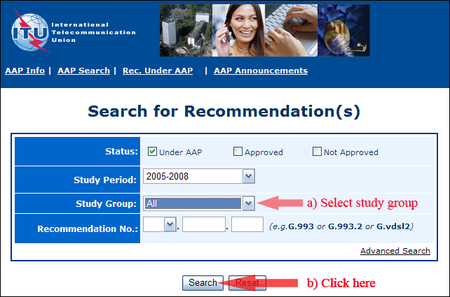
2) Select your Recommendation
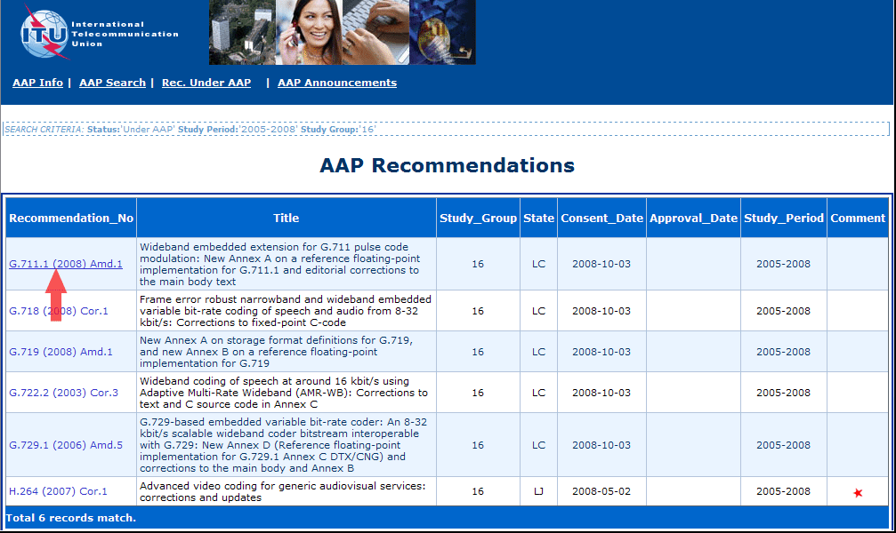
3) Click the "Submit Comment" button
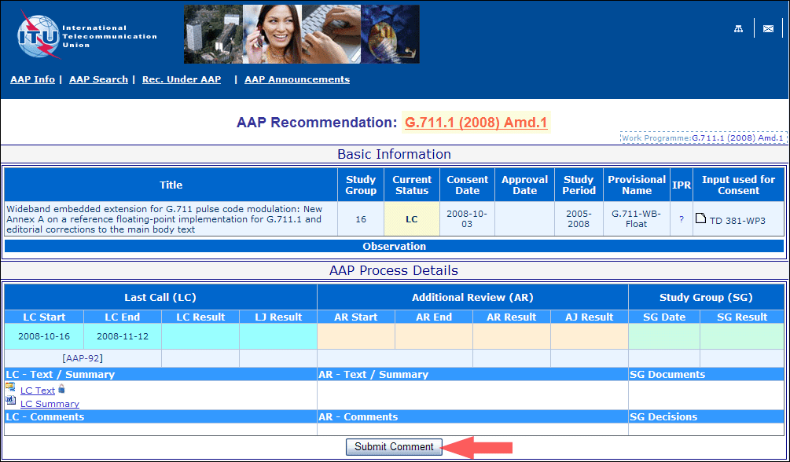
4) Complete the on-line form and click on "Submit"
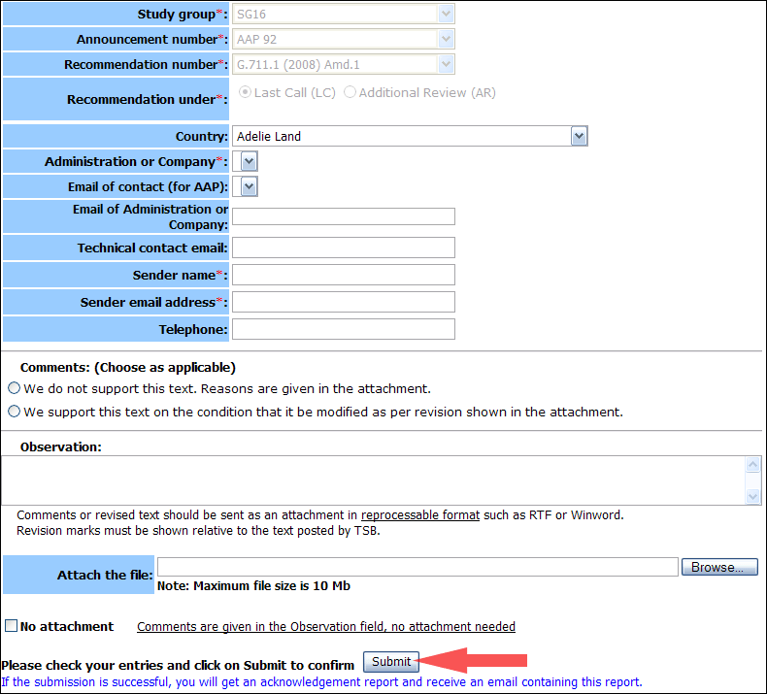
For more information, read the AAP tutorial on:
http://www.itu.int/ITU-T/aapinfo/files/AAPTutorial.pdf
Annex 3
(to TSB AAP-26)
Recommendations under LC/AR – Comment submission form
(Separate form for each Recommendation being commented upon)
ITU-T AAP comment submission form for the period 2009-2012
Study Group:
Announcement number:
Recommendation number:
Recommendation under: | Last call (LC)  Additional Review (AR)
Country:
Administration/Company:
Name of AAP Contact Person:
Email of AAP Contact Person:
Sender name:
(if different from AAP Contact Person)
Sender email address:
Telephone:
Comments:  (Choose as applicable) | We do not support this text. Reasons are given in the attachment.  We support this text on the condition that it be modified as per revision shown in the attachment.
Observations:
No attachment: Comments are given in the Observation field, no attachment needed
To be returned to: email: tsbsg....@itu.int
[or fax +41 22 730 5853]
Comments or revised text should be sent as an attachment in RTF or WinWord format.
Revision marks must be shown relative to the text posted by TSB.

