Международный союз электросвязи
Бюро стандартизации электросвязи

Женева, 1 октября 2009

Осн.:  Тел.:  Факс:  Эл. почта: | TSB AAP-22  AAP/MJ  +41 22 730 5860  +41 22 730 5853  tsbdir@itu.int | – Администрациям Государств – Членов Союза;  – Членам Сектора МСЭ-Т;  – Ассоциированным членам МСЭ-Т  Копии:  – Председателям и заместителям председателей Исследовательских комиссий МСЭ-Т;  – Директору Бюро Развития Электросвязи;  – Директору Бюро Радиосвязи

Предмет: | Положение относительно Рекомендаций, рассматриваемых в соответствии с альтернативным процессом утверждения (АПУ)

Уважаемая госпожа,
уважаемый господин,

Альтернативный процесс утверждения (АПУ), определенный в Рекомендации МСЭ-Т А.8, распространяется на Рекомендации, которые не имеют политических или регламентарных последствий и которые поэтому не требуют официальных консультаций с Государствами-Членами (см. п. 246B Конвенции МСЭ).
В Приложении 1 содержится перечень текстов, статус которых изменился по сравнению с предыдущими объявлениями об АПУ БСЭ.
Если вы желаете представить замечания относительно какой-либо Рекомендации, рассматриваемой в соответствии с АПУ, рекомендуем Вам использовать онлайновую форму для представления замечаний по АПУ, которая размещена на странице этой Рекомендации в разделе веб-сайта МСЭ-Т, посвященном АПУ, по адресу: http://www.itu.int/ITU-T/aap/ (см. Приложение 2). Замечания можно представить иным способом, заполнив приведенную в Приложении 3 форму и направив ее в секретариат заинтересованной исследовательской комиссии.
Просим принять к сведению, что не рекомендуется представлять замечания, являющиеся не чем иным, как поддержкой рассматриваемого текста.
С уважением,
Малколм Джонсон
Директор Бюро
стандартизации электросвязи
Приложения: 3
Annex 1
(to TSB AAP-22)

Status codes used in the AAP announcements:
LC = Last Call
LJ = Last Call Judgment (includes comment resolution)
AR = Additional Review
AJ = Additional Review Judgment (includes comment resolution)
SG = For Study Group approval
A = Approved
AT = Approved with typographic corrections
AC = Approved after Additional Review of Comments
NA = Not approved
TAP = Moved to TAP (ITU-T A.8 / § 5.2)
ITU-T website entry page:
http://www.itu.int/ITU-T
Alternative approval process (AAP) welcome page:
http://www.itu.int/ITU-T/aapinfo
Note – A tutorial on the ITU-T AAP application is available under the AAP welcome page
ITU-T website AAP Recommendation search page:
http://www.itu.int/ITU-T/aap/
Study Group web pages and contacts:
SG 2 | http://www.itu.int/ITU-T/studygroups/com02 | tsbsg2@itu.int
SG 3 | http://www.itu.int/ITU-T/studygroups/com03 | tsbsg3@itu.int
SG 5 | http://www.itu.int/ITU-T/studygroups/com05 | tsbsg5@itu.int
SG 9 | http://www.itu.int/ITU-T/studygroups/com09 | tsbsg9@itu.int
SG 11 | http://www.itu.int/ITU-T/studygroups/com11 | tsbsg11@itu.int
SG 12 | http://www.itu.int/ITU-T/studygroups/com12 | tsbsg12@itu.int
SG 13 | http://www.itu.int/ITU-T/studygroups/com13 | tsbsg13@itu.int
SG 15 | http://www.itu.int/ITU-T/studygroups/com15 | tsbsg15@itu.int
SG 16 | http://www.itu.int/ITU-T/studygroups/com16 | tsbsg16@itu.int
SG 17 | http://www.itu.int/ITU-T/studygroups/com17 | tsbsg17@itu.int

Situation concerning Study Group 5 Recommendations under AAP
Rec # | Title | Last Call (LC) Period |  |  |  | Additional Review (AR) Period |  |  |  | Status
Rec # | Title | LC Start | LC End | LC  Result | LJ  Result | AR Start | AR End | AR  Result | AJ  Result | Status
K.43 | Immunity requirements for telecommunication equipment | 2009-06-16 | 2009-07-13 | LJ | AT |  |  |  |  | AT
K.80 (K.high) | EMC requirements for telecommunication network equipment (1 GHz - 6 GHz) | 2009-06-16 | 2009-07-13 | LJ | AT |  |  |  |  | AT
Situation concerning Study Group 11 Recommendations under AAP
Rec # | Title | Last Call (LC) Period |  |  |  | Additional Review (AR) Period |  |  |  | Status
Rec # | Title | LC Start | LC End | LC  Result | LJ  Result | AR Start | AR End | AR  Result | AJ  Result | Status
Q.761 (1999) Amd.4 | Support for the Customized Alerting Tone (CAT) service | 2009-10-01 | 2009-10-28 |  |  |  |  |  |  | LC
Q.762 (1999) Amd.5 | Support for the Customized Alerting Tone (CAT) service | 2009-10-01 | 2009-10-28 |  |  |  |  |  |  | LC
Q.763 (1999) Amd.6 | Support for the Customized Alerting Tone (CAT) service | 2009-10-01 | 2009-10-28 |  |  |  |  |  |  | LC
Q.1902.1 (2001) Amd.3 | Support for Customized Alerting Tone (CAT) service | 2009-10-01 | 2009-10-28 |  |  |  |  |  |  | LC
Q.1902.2 (2001) Amd.5 | Support for the Customized Alerting Tone (CAT) service | 2009-10-01 | 2009-10-28 |  |  |  |  |  |  | LC
Q.1902.3 (2001) Amd.5 | Support for the Customized Alerting Tone (CAT) service | 2009-10-01 | 2009-10-28 |  |  |  |  |  |  | LC
Q.3306.1 | Protocol at the Rd interface between intra-domain Policy Decision Physical Entities (PD-PEs) (Rd interface) | 2009-10-01 | 2009-10-28 |  |  |  |  |  |  | LC
Q.3309 (Q.QCP) | QoS Coordination Protocol | 2009-10-01 | 2009-10-28 |  |  |  |  |  |  | LC
Situation concerning Study Group 13 Recommendations under AAP
Rec # | Title | Last Call (LC) Period |  |  |  | Additional Review (AR) Period |  |  |  | Status
Rec # | Title | LC Start | LC End | LC  Result | LJ  Result | AR Start | AR End | AR  Result | AJ  Result | Status
Q.1741.6 | IMT 2000 references to Release 8 of GSM-evolved UMTS core network | 2009-10-01 | 2009-10-28 |  |  |  |  |  |  | LC
Y.2002  (Y.NGN-UbiNet) | Overview of ubiquitous networking and of its support in NGN | 2009-10-01 | 2009-10-28 |  |  |  |  |  |  | LC
Y.2007  (Y.NGN-Cap2) | NGN Capability Set 2 | 2009-10-01 | 2009-10-28 |  |  |  |  |  |  | LC
Y.2221  (Y.USN-reqts) | Requirements for support of Ubiquitous Sensor Network (USN) applications and services in the NGN environment | 2009-10-01 | 2009-10-28 |  |  |  |  |  |  | LC
Y.2237 (Y.cmoip) | Functional model, service scenarios and use cases for QoS enabled mobile VoIP service | 2009-10-01 | 2009-10-28 |  |  |  |  |  |  | LC
Situation concerning Study Group 16 Recommendations under AAP
Rec # | Title | Last Call (LC) Period |  |  |  | Additional Review (AR) Period |  |  |  | Status
Rec # | Title | LC Start | LC End | LC  Result | LJ  Result | AR Start | AR End | AR  Result | AJ  Result | Status
G.711 (1988) Amd.1 | Pulse code modulation (PCM) of voice frequencies: new Annex A on lossless encoding of PCM frames | 2009-08-01 | 2009-08-28 | LJ | A |  |  |  |  | A
G.711.0 (G.711-LLC) | Lossless compression of G.711 pulse code modulation | 2009-08-01 | 2009-08-28 | AR |  | 2009-09-01 | 2009-09-21 | AC |  | AC
Situation concerning Study Group 17 Recommendations under AAP
Rec # | Title | Last Call (LC) Period |  |  |  | Additional Review (AR) Period |  |  |  | Status
Rec # | Title | LC Start | LC End | LC  Result | LJ  Result | AR Start | AR End | AR  Result | AJ  Result | Status
X.902 | Information technology - Open Distributed Processing - Reference model: Foundations | 2009-10-01 | 2009-10-28 |  |  |  |  |  |  | LC
X.903 | Information technology - Open distributed processing - Reference model: Architecture | 2009-10-01 | 2009-10-28 |  |  |  |  |  |  | LC
X.906 (2007) Cor.1 | Information technology - Open Distributed Processing - Use of UML for ODP system specification - Technical Corrigendum 1 | 2009-10-01 | 2009-10-28 |  |  |  |  |  |  | LC
X.1081 (2004) Amd.1 | The telebiometric multimodal model - A framework for the specification of security and safety aspects of telebiometrics - Amendment 1: Object identifier assignments under the Telebiometrics arc | 2009-10-01 | 2009-10-28 |  |  |  |  |  |  | LC
X.1082 (2007) Amd.1 | Telebiometrics related to human plysiology - Amendment 1: Object identifier assignments under the Telebiometrics arc | 2009-10-01 | 2009-10-28 |  |  |  |  |  |  | LC

Annex 2
(to TSB AAP-22)
Using the on-line comment submission form
Comment submission
1) Go to AAP search Web page at http://www.itu.int/ITU-T/aap/
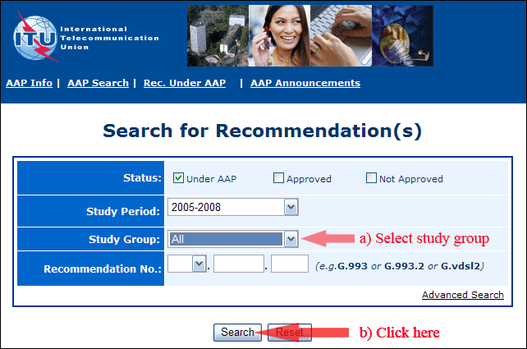
2) Select your Recommendation
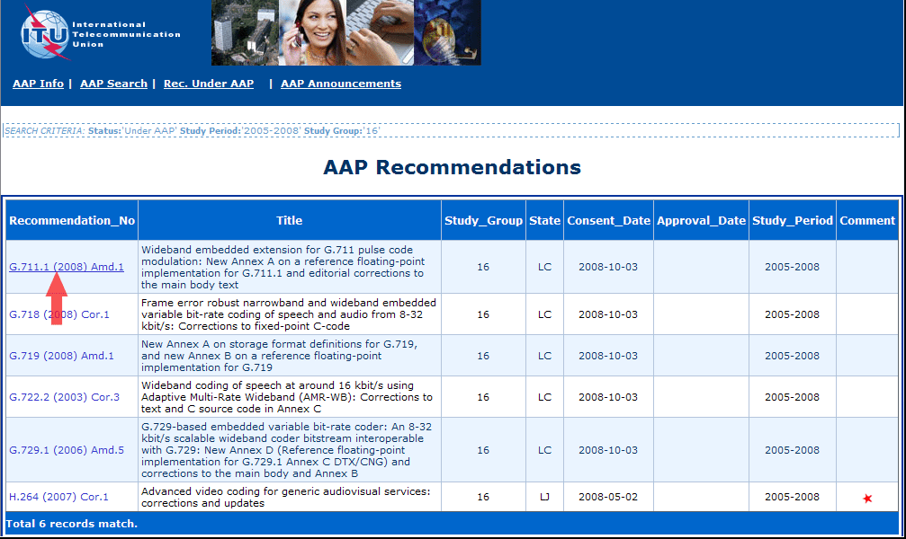
3) Click the "Submit Comment" button
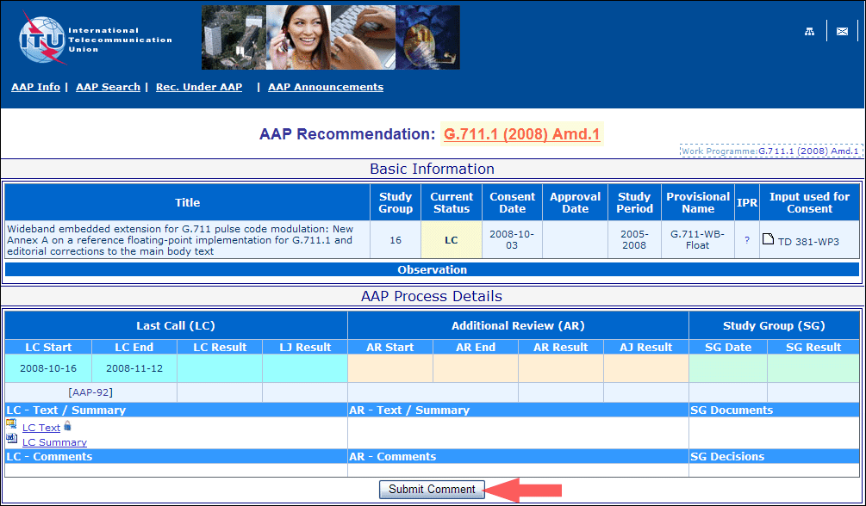
4) Complete the on-line form and click on "Submit"
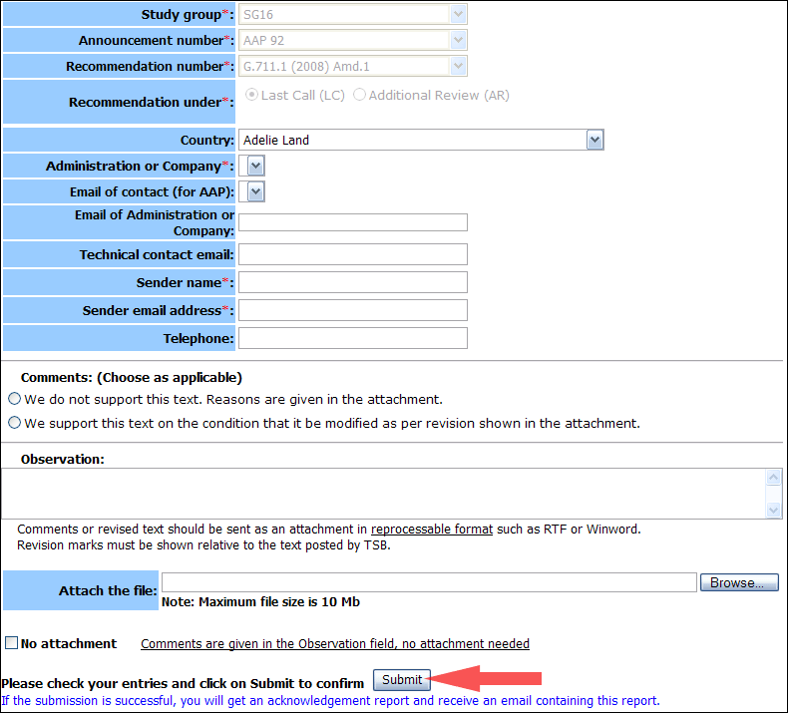
For more information, read the AAP tutorial on:
http://www.itu.int/ITU-T/aapinfo/files/AAPTutorial.pdf
Annex 3
(to TSB AAP-22)
Recommendations under LC/AR – Comment submission form
(Separate form for each Recommendation being commented upon)
ITU-T AAP comment submission form for the period 2009-2012
Study Group:
Announcement number:
Recommendation number:
Recommendation under: | Last call (LC)  Additional Review (AR)
Country:
Administration/Company:
Name of AAP Contact Person:
Email of AAP Contact Person:
Sender name:
(if different from AAP Contact Person)
Sender email address:
Telephone:
Comments:  (Choose as applicable) | We do not support this text. Reasons are given in the attachment.  We support this text on the condition that it be modified as per revision shown in the attachment.
Observations:
No attachment: Comments are given in the Observation field, no attachment needed
To be returned to: email: tsbsg....@itu.int
[or fax +41 22 730 5853]
Comments or revised text should be sent as an attachment in RTF or WinWord format.
Revision marks must be shown relative to the text posted by TSB.

