International Telecommunication Union  Telecommunication Standardization Bureau | 

Geneva, 1 October 2009

Ref:  Tel:  Fax:  E-mail: | TSB AAP-22  AAP/MJ  +41 22 730 5860  +41 22 730 5853  tsbdir@itu.int | – To Administrations of Member States of the Union;  – To ITU-T Sector Members;  – To ITU-T Associates  Copy:  – To the ITU-T Study Group Chairmen and Vice-Chairmen;  – To the Director of the Telecommunication Development Bureau;  – To the Director of the Radiocommunication Bureau

Subject: | Situation concerning Recommendations under the Alternative Approval Process (AAP)

Dear Sir/Madam,
The Alternative Approval Process (AAP) defined in Rec. ITU-T A.8 applies to Recommendations which do not have policy or regulatory implications and which, therefore, do not require formal consultation of Member States (see ITU Convention 246B).
Annex 1 lists those texts whose status has changed compared with previous TSB AAP Announcements.
If you wish to submit a comment relative to a Recommendation under AAP, you are encouraged to use the on-line AAP comment submission form available on the page of the Recommendation in the AAP area of the ITU-T website at http://www.itu.int/ITU-T/aap (see Annex 2). Alternatively, comments can be submitted by completing the form in Annex 3 and sending it to the secretariat of the concerned study group.
Please note that comments that simply support adoption of the text in question are not encouraged.
Yours faithfully,
Malcolm Johnson
Director of the Telecommunication Standardization Bureau
Annexes: 3
Annex 1
(to TSB AAP-22)

Status codes used in the AAP announcements:
LC = Last Call
LJ = Last Call Judgment (includes comment resolution)
AR = Additional Review
AJ = Additional Review Judgment (includes comment resolution)
SG = For Study Group approval
A = Approved
AT = Approved with typographic corrections
AC = Approved after Additional Review of Comments
NA = Not approved
TAP = Moved to TAP (ITU-T A.8 / § 5.2)
ITU-T website entry page:
http://www.itu.int/ITU-T
Alternative approval process (AAP) welcome page:
http://www.itu.int/ITU-T/aapinfo
Note – A tutorial on the ITU-T AAP application is available under the AAP welcome page
ITU-T website AAP Recommendation search page:
http://www.itu.int/ITU-T/aap/
Study Group web pages and contacts:
SG 2 | http://www.itu.int/ITU-T/studygroups/com02 | tsbsg2@itu.int
SG 3 | http://www.itu.int/ITU-T/studygroups/com03 | tsbsg3@itu.int
SG 5 | http://www.itu.int/ITU-T/studygroups/com05 | tsbsg5@itu.int
SG 9 | http://www.itu.int/ITU-T/studygroups/com09 | tsbsg9@itu.int
SG 11 | http://www.itu.int/ITU-T/studygroups/com11 | tsbsg11@itu.int
SG 12 | http://www.itu.int/ITU-T/studygroups/com12 | tsbsg12@itu.int
SG 13 | http://www.itu.int/ITU-T/studygroups/com13 | tsbsg13@itu.int
SG 15 | http://www.itu.int/ITU-T/studygroups/com15 | tsbsg15@itu.int
SG 16 | http://www.itu.int/ITU-T/studygroups/com16 | tsbsg16@itu.int
SG 17 | http://www.itu.int/ITU-T/studygroups/com17 | tsbsg17@itu.int

Situation concerning Study Group 5 Recommendations under AAP
Rec # | Title | Last Call (LC) Period |  |  |  | Additional Review (AR) Period |  |  |  | Status
Rec # | Title | LC Start | LC End | LC  Result | LJ  Result | AR Start | AR End | AR  Result | AJ  Result | Status
K.43 | Immunity requirements for telecommunication equipment | 2009-06-16 | 2009-07-13 | LJ | AT |  |  |  |  | AT
K.80 (K.high) | EMC requirements for telecommunication network equipment (1 GHz - 6 GHz) | 2009-06-16 | 2009-07-13 | LJ | AT |  |  |  |  | AT
Situation concerning Study Group 11 Recommendations under AAP
Rec # | Title | Last Call (LC) Period |  |  |  | Additional Review (AR) Period |  |  |  | Status
Rec # | Title | LC Start | LC End | LC  Result | LJ  Result | AR Start | AR End | AR  Result | AJ  Result | Status
Q.761 (1999) Amd.4 | Support for the Customized Alerting Tone (CAT) service | 2009-10-01 | 2009-10-28 |  |  |  |  |  |  | LC
Q.762 (1999) Amd.5 | Support for the Customized Alerting Tone (CAT) service | 2009-10-01 | 2009-10-28 |  |  |  |  |  |  | LC
Q.763 (1999) Amd.6 | Support for the Customized Alerting Tone (CAT) service | 2009-10-01 | 2009-10-28 |  |  |  |  |  |  | LC
Q.1902.1 (2001) Amd.3 | Support for Customized Alerting Tone (CAT) service | 2009-10-01 | 2009-10-28 |  |  |  |  |  |  | LC
Q.1902.2 (2001) Amd.5 | Support for the Customized Alerting Tone (CAT) service | 2009-10-01 | 2009-10-28 |  |  |  |  |  |  | LC
Q.1902.3 (2001) Amd.5 | Support for the Customized Alerting Tone (CAT) service | 2009-10-01 | 2009-10-28 |  |  |  |  |  |  | LC
Q.3306.1 | Protocol at the Rd interface between intra-domain Policy Decision Physical Entities (PD-PEs) (Rd interface) | 2009-10-01 | 2009-10-28 |  |  |  |  |  |  | LC
Q.3309 (Q.QCP) | QoS Coordination Protocol | 2009-10-01 | 2009-10-28 |  |  |  |  |  |  | LC
Situation concerning Study Group 13 Recommendations under AAP
Rec # | Title | Last Call (LC) Period |  |  |  | Additional Review (AR) Period |  |  |  | Status
Rec # | Title | LC Start | LC End | LC  Result | LJ  Result | AR Start | AR End | AR  Result | AJ  Result | Status
Q.1741.6 | IMT 2000 references to Release 8 of GSM-evolved UMTS core network | 2009-10-01 | 2009-10-28 |  |  |  |  |  |  | LC
Y.2002  (Y.NGN-UbiNet) | Overview of ubiquitous networking and of its support in NGN | 2009-10-01 | 2009-10-28 |  |  |  |  |  |  | LC
Y.2007  (Y.NGN-Cap2) | NGN Capability Set 2 | 2009-10-01 | 2009-10-28 |  |  |  |  |  |  | LC
Y.2221  (Y.USN-reqts) | Requirements for support of Ubiquitous Sensor Network (USN) applications and services in the NGN environment | 2009-10-01 | 2009-10-28 |  |  |  |  |  |  | LC
Y.2237 (Y.cmoip) | Functional model, service scenarios and use cases for QoS enabled mobile VoIP service | 2009-10-01 | 2009-10-28 |  |  |  |  |  |  | LC
Situation concerning Study Group 16 Recommendations under AAP
Rec # | Title | Last Call (LC) Period |  |  |  | Additional Review (AR) Period |  |  |  | Status
Rec # | Title | LC Start | LC End | LC  Result | LJ  Result | AR Start | AR End | AR  Result | AJ  Result | Status
G.711 (1988) Amd.1 | Pulse code modulation (PCM) of voice frequencies: new Annex A on lossless encoding of PCM frames | 2009-08-01 | 2009-08-28 | LJ | A |  |  |  |  | A
G.711.0 (G.711-LLC) | Lossless compression of G.711 pulse code modulation | 2009-08-01 | 2009-08-28 | AR |  | 2009-09-01 | 2009-09-21 | AC |  | AC
Situation concerning Study Group 17 Recommendations under AAP
Rec # | Title | Last Call (LC) Period |  |  |  | Additional Review (AR) Period |  |  |  | Status
Rec # | Title | LC Start | LC End | LC  Result | LJ  Result | AR Start | AR End | AR  Result | AJ  Result | Status
X.902 | Information technology - Open Distributed Processing - Reference model: Foundations | 2009-10-01 | 2009-10-28 |  |  |  |  |  |  | LC
X.903 | Information technology - Open distributed processing - Reference model: Architecture | 2009-10-01 | 2009-10-28 |  |  |  |  |  |  | LC
X.906 (2007) Cor.1 | Information technology - Open Distributed Processing - Use of UML for ODP system specification - Technical Corrigendum 1 | 2009-10-01 | 2009-10-28 |  |  |  |  |  |  | LC
X.1081 (2004) Amd.1 | The telebiometric multimodal model - A framework for the specification of security and safety aspects of telebiometrics - Amendment 1: Object identifier assignments under the Telebiometrics arc | 2009-10-01 | 2009-10-28 |  |  |  |  |  |  | LC
X.1082 (2007) Amd.1 | Telebiometrics related to human plysiology - Amendment 1: Object identifier assignments under the Telebiometrics arc | 2009-10-01 | 2009-10-28 |  |  |  |  |  |  | LC

Annex 2
(to TSB AAP-22)
Using the on-line comment submission form
Comment submission
1) Go to AAP search Web page at http://www.itu.int/ITU-T/aap/
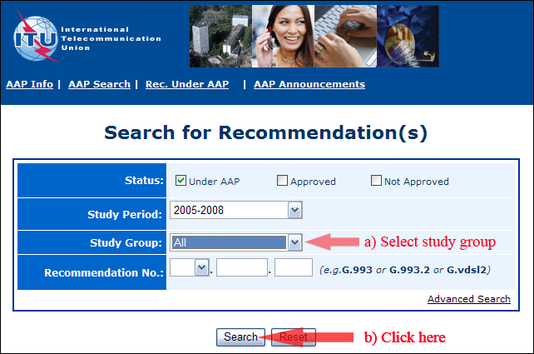
2) Select your Recommendation
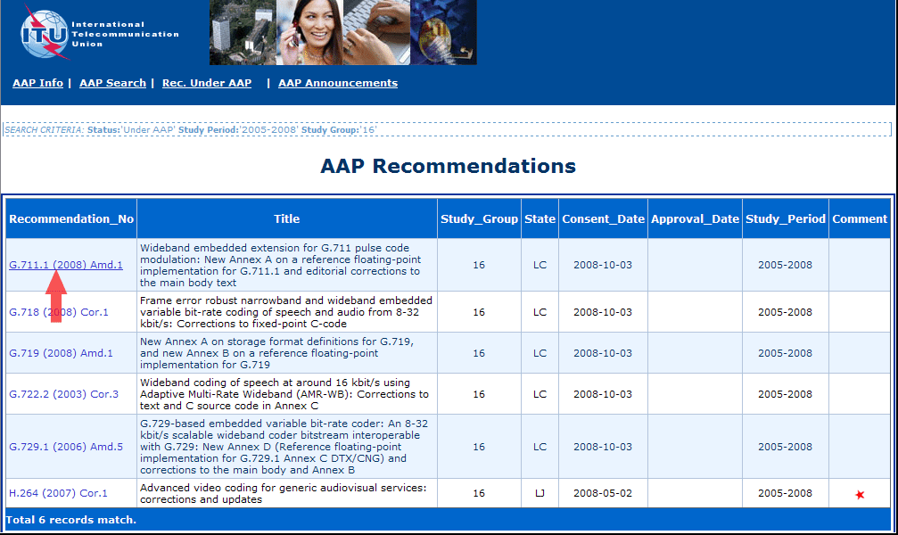
3) Click the "Submit Comment" button
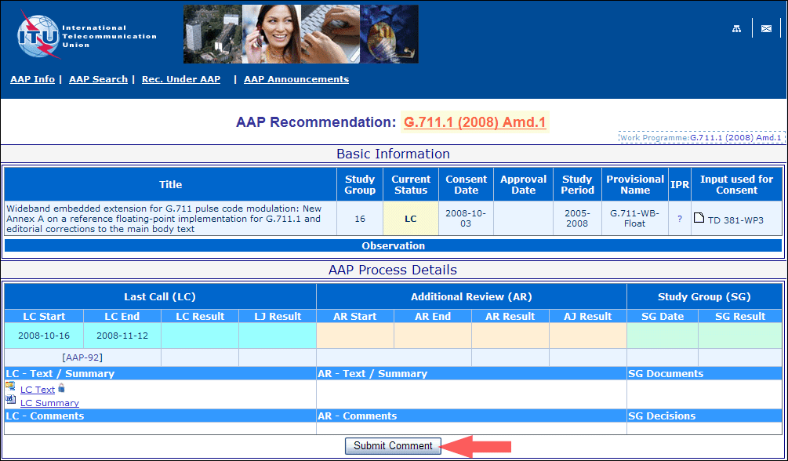
4) Complete the on-line form and click on "Submit"
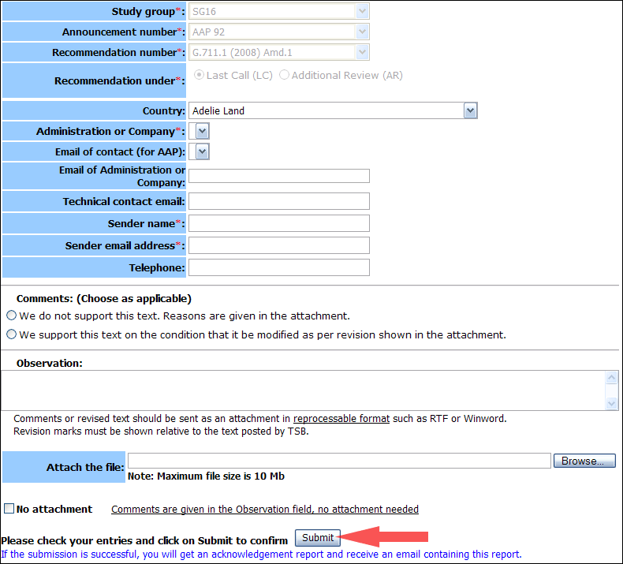
For more information, read the AAP tutorial on:
http://www.itu.int/ITU-T/aapinfo/files/AAPTutorial.pdf
Annex 3
(to TSB AAP-22)
Recommendations under LC/AR – Comment submission form
(Separate form for each Recommendation being commented upon)
ITU-T AAP comment submission form for the period 2009-2012
Study Group:
Announcement number:
Recommendation number:
Recommendation under: | Last call (LC)  Additional Review (AR)
Country:
Administration/Company:
Name of AAP Contact Person:
Email of AAP Contact Person:
Sender name:
(if different from AAP Contact Person)
Sender email address:
Telephone:
Comments:  (Choose as applicable) | We do not support this text. Reasons are given in the attachment.  We support this text on the condition that it be modified as per revision shown in the attachment.
Observations:
No attachment: Comments are given in the Observation field, no attachment needed
To be returned to: email: tsbsg....@itu.int
[or fax +41 22 730 5853]
Comments or revised text should be sent as an attachment in RTF or WinWord format.
Revision marks must be shown relative to the text posted by TSB.

