Международный союз электросвязи
Бюро стандартизации электросвязи

Женева, 1 апреля 2009

Осн.:  Тел.:  Факс:  Эл. почта: | TSB AAP-10  AAP/MJ  +41 22 730 5860  +41 22 730 5853  tsbdir@itu.int | – Администрациям Государств – Членов Союза;  – Членам Сектора МСЭ-Т;  – Ассоциированным членам МСЭ-Т  Копии:  – Председателям и заместителям председателей Исследовательских комиссий МСЭ-Т;  – Директору Бюро Развития Электросвязи;  – Директору Бюро Радиосвязи

Предмет: | Положение относительно Рекомендаций, рассматриваемых в соответствии с альтернативным процессом утверждения (АПУ)

Уважаемая госпожа,
уважаемый господин,

Альтернативный процесс утверждения (АПУ), определенный в Рекомендации МСЭ-Т А.8, распространяется на Рекомендации, которые не имеют политических или регламентарных последствий и которые поэтому не требуют официальных консультаций с Государствами-Членами (см. п. 246B Конвенции МСЭ).
В Приложении 1 содержится перечень текстов, статус которых изменился по сравнению с предыдущими объявлениями об АПУ БСЭ.
Если вы желаете представить замечания относительно какой-либо Рекомендации, рассматриваемой в соответствии с АПУ, рекомендуем Вам использовать онлайновую форму для представления замечаний по АПУ, которая размещена на странице этой Рекомендации в разделе веб-сайта МСЭ-Т, посвященном АПУ, по адресу: http://www.itu.int/ITU-T/aap/ (см. Приложение 2). Замечания можно представить иным способом, заполнив приведенную в Приложении 3 форму и направив ее в секретариат заинтересованной исследовательской комиссии.
Просим принять к сведению, что не рекомендуется представлять замечания, являющиеся не чем иным, как поддержкой рассматриваемого текста.
С уважением,
Малколм Джонсон
Директор Бюро
стандартизации электросвязи
Приложения: 3
Annex 1
(to TSB AAP-10)

Status codes used in the AAP announcements:
LC = Last Call
LJ = Last Call Judgment (includes comment resolution)
AR = Additional Review
AJ = Additional Review Judgment (includes comment resolution)
SG = For Study Group approval
A = Approved
AT = Approved with typographic corrections
AC = Approved after Additional Review of Comments
NA = Not approved
TAP = Moved to TAP (ITU-T A.8 / § 5.2)
ITU-T website entry page:
http://www.itu.int/ITU-T
Alternative approval process (AAP) welcome page:
http://www.itu.int/ITU-T/aapinfo
Note – A tutorial on the ITU-T AAP application is available under the AAP welcome page
ITU-T website AAP Recommendation search page:
http://www.itu.int/ITU-T/aap/
Study Group web pages and contacts:
SG 2 | http://www.itu.int/ITU-T/studygroups/com02 | tsbsg2@itu.int
SG 3 | http://www.itu.int/ITU-T/studygroups/com03 | tsbsg3@itu.int
SG 5 | http://www.itu.int/ITU-T/studygroups/com05 | tsbsg5@itu.int
SG 9 | http://www.itu.int/ITU-T/studygroups/com09 | tsbsg9@itu.int
SG 11 | http://www.itu.int/ITU-T/studygroups/com11 | tsbsg11@itu.int
SG 12 | http://www.itu.int/ITU-T/studygroups/com12 | tsbsg12@itu.int
SG 13 | http://www.itu.int/ITU-T/studygroups/com13 | tsbsg13@itu.int
SG 15 | http://www.itu.int/ITU-T/studygroups/com15 | tsbsg15@itu.int
SG 16 | http://www.itu.int/ITU-T/studygroups/com16 | tsbsg16@itu.int
SG 17 | http://www.itu.int/ITU-T/studygroups/com17 | tsbsg17@itu.int

Situation concerning Study Group 9 Recommendations under AAP
Rec # | Title | Last Call (LC) Period |  |  |  | Additional Review (AR) Period |  |  |  | Status
Rec # | Title | LC Start | LC End | LC  Result | LJ  Result | AR Start | AR End | AR  Result | AJ  Result | Status
J.286 (J.h-dpi) | Seamless splicing for heterogeneous MPEG-2/H.264 bitstreams | 2008-10-01 | 2008-10-28 | LJ | AR | 2009-03-01 | 2009-03-21 | AC |  | AC
Situation concerning Study Group 12 Recommendations under AAP
Rec # | Title | Last Call (LC) Period |  |  |  | Additional Review (AR) Period |  |  |  | Status
Rec # | Title | LC Start | LC End | LC  Result | LJ  Result | AR Start | AR End | AR  Result | AJ  Result | Status
G.107 | The E-model: a computational model for use in transmission planning | 2009-04-01 | 2009-04-28 |  |  |  |  |  |  | LC
G.1082 (G.IPTV MMRP (ex G.IPTV-QMA)) | Measurement-based methods for improving the robustness of IPTV performance | 2009-04-01 | 2009-04-28 |  |  |  |  |  |  | LC
P.57 | Artificial ears | 2009-04-01 | 2009-04-28 |  |  |  |  |  |  | LC
P.310 | Transmission characteristics for narrow-band digital handset and headset telephones | 2009-04-01 | 2009-04-28 |  |  |  |  |  |  | LC
P.342 | Transmission characteristics for narrow-band digital hands-free and loudspeaking telephony terminals | 2009-04-01 | 2009-04-28 |  |  |  |  |  |  | LC
P.833.1 | Methodology for the derivation of equipment impairment factors from subjective listening-only tests for wideband speech codecs | 2009-04-01 | 2009-04-28 |  |  |  |  |  |  | LC
P.834.1 (P.834.WB) | Extension of the methodology for the derivation of equipment impairment factors from instrumental models for wideband speech codecs | 2009-04-01 | 2009-04-28 |  |  |  |  |  |  | LC
Situation concerning Study Group 15 Recommendations under AAP
Rec # | Title | Last Call (LC) Period |  |  |  | Additional Review (AR) Period |  |  |  | Status
Rec # | Title | LC Start | LC End | LC  Result | LJ  Result | AR Start | AR End | AR  Result | AJ  Result | Status
G.709/Y.1331 (2003) Amd.3 | Interfaces for the optical transport network (OTN) | 2009-01-16 | 2009-02-12 | LJ | AR | 2009-04-01 | 2009-04-21 |  |  | AR
G.992.3 | Asymmetric digital subscriber line transceivers 2 (ADSL2) | 2008-12-16 | 2009-01-12 | LJ | AR | 2009-04-01 | 2009-04-21 |  |  | AR
G.994.1 (2007) Amd.3 | Handshake procedures for digital subscriber line (DSL) transceivers | 2009-01-16 | 2009-02-12 | LJ | AR | 2009-03-01 | 2009-03-21 | AC |  | AC
G.997.1 | Physical layer management for digital subscriber line (DSL) transceivers | 2009-01-16 | 2009-02-12 | LJ | AR | 2009-04-01 | 2009-04-21 |  |  | AR
G.8032/Y.1344 (2008) Amd.1 | Ethernet Ring protection | 2009-01-16 | 2009-02-12 | LJ | AR | 2009-04-01 | 2009-04-21 |  |  | AR
Situation concerning Study Group 16 Recommendations under AAP
Rec # | Title | Last Call (LC) Period |  |  |  | Additional Review (AR) Period |  |  |  | Status
Rec # | Title | LC Start | LC End | LC  Result | LJ  Result | AR Start | AR End | AR  Result | AJ  Result | Status
G.168 (V6) | Digital network echo cancellers | 2009-02-16 | 2009-03-15 | A |  |  |  |  |  | A
G.711.1 (2008) Amd.2 | Wideband embedded extension for G.711 pulse code modulation: New Annex B on G.711.1 usage in H.245 and editorial corrections to the main body text | 2009-02-16 | 2009-03-15 | A |  |  |  |  |  | A
G.718 (2008) Amd.1 (G.718-Float) | Frame error robust narrowband and wideband embedded variable bit-rate coding of speech and audio from 8-32 kbit/s: Floating point annex plus corrections to fixed-point C-code and description text | 2009-02-16 | 2009-03-15 | A |  |  |  |  |  | A
G.719 (2008) Amd.2 | Low-complexity, full-band audio coding for high-quality, conversational applications: New Annex C on G.719 packet format, capability identifiers and capability parameters | 2009-02-16 | 2009-03-15 | A |  |  |  |  |  | A
G.763 (1998) Cor.1 | Digital circuit multiplication equipment using G.726 ADPCM and digital speech interpolation: Corrections | 2009-02-16 | 2009-03-15 | A |  |  |  |  |  | A
H.221 (V8) | Frame structure for a 64 to 1920 kbit/s channel in audiovisual teleservices | 2009-02-16 | 2009-03-15 | A |  |  |  |  |  | A
H.222.0 (2006) Amd.3 (H.222.0-SVC) | Information technology - Generic coding of moving pictures and associated audio information: Systems: Transport of scalable video over ITU-T Rec. H.222.0 | ISO/IEC 13818-1 | 2009-02-16 | 2009-03-15 | A |  |  |  |  |  | A
H.222.0 (2006) Cor.2 | Information technology - Generic coding of moving pictures and associated audio information: Systems: Correction of transfer rate Rxn in the T-STD model | 2009-02-16 | 2009-03-15 | A |  |  |  |  |  | A
H.230 (V7) | Frame-synchronous control and indication signals for audiovisual systems | 2009-02-16 | 2009-03-15 | A |  |  |  |  |  | A
H.235.6 (2005) Cor.1 | H.323 security: Voice encryption profile with native H.235/H.245 key management: Correction of defects | 2009-02-16 | 2009-03-15 | A |  |  |  |  |  | A
H.242 (V7) | System for establishing communication between audiovisual terminals using digital channels up to 2 Mbit/s | 2009-02-16 | 2009-03-15 | A |  |  |  |  |  | A
H.248.14 Rev.1 ((Ed. 0.2)) | Gateway control protocol: Inactivity timer package | 2009-02-16 | 2009-03-15 | A |  |  |  |  |  | A
H.248.19 (2004) Amd.2 | Gateway Control Protocol: Decomposed multipoint control unit, audio, video and data conferencing packages: Floor Control Enhancements | 2009-02-16 | 2009-03-15 | AT |  |  |  |  |  | AT
H.248.42 (H.248.42 (2006) Amd.1) | Gateway control protocol: DCME interworking package: Parameters for enhanced event reporting control | 2009-02-16 | 2009-03-15 | A |  |  |  |  |  | A
H.248.52 Amd.1 | Gateway Control Protocol: QoS Support Packages: Clarifications and updates to the Differentiated Services package | 2009-02-16 | 2009-03-15 | A |  |  |  |  |  | A
H.248.53 | Gateway Control Protocol: Traffic Management Packages | 2009-02-16 | 2009-03-15 | A |  |  |  |  |  | A
H.248.56 Cor.1 | Gateway control protocol: Packages for virtual private network support: VLAN package clarifications | 2009-02-16 | 2009-03-15 | A |  |  |  |  |  | A
H.248.60 (H.248.cci) | Gateway control protocol: Identification of content of communication | 2009-02-16 | 2009-03-15 | A |  |  |  |  |  | A
H.248.61 (H.248.ipocs) | Gateway Control Protocol: Packages for Network Level H.248 Statistics | 2009-02-16 | 2009-03-15 | A |  |  |  |  |  | A
H.248.63 (H.248.resman) | Gateway Control Protocol: Resource Management Packages | 2009-02-16 | 2009-03-15 | A |  |  |  |  |  | A
H.248.65 (H.248.RSVP) | Gateway control protocol: Support of the resource reservation protocol | 2009-02-16 | 2009-03-15 | A |  |  |  |  |  | A
H.248.68 (H.248.RDT) | Gateway control protocol: Removal of Digits and Tones package | 2009-02-16 | 2009-03-15 | A |  |  |  |  |  | A
H.248.69 (H.248.MSRP) | Gateway control protocol: Packages for MSRP and H.248 Interworking | 2009-02-16 | 2009-03-15 | A |  |  |  |  |  | A
H.248.70 (H.248.DMI) | Gateway Control Protocol: Dialling Method Information Packages | 2009-02-16 | 2009-03-15 | A |  |  |  |  |  | A
H.262 (2000) Amd.3 | Information technology - Generic coding of moving pictures and associated audio information: Video: New level for 1080@50p/60p | 2009-02-16 | 2009-03-15 | A |  |  |  |  |  | A
H.264 (V4) (H.264-MVC) | Advanced video coding for generic audiovisual services | 2009-02-16 | 2009-03-15 | A |  |  |  |  |  | A
H.324 (V5) | Terminal for low bit-rate multimedia communication | 2009-04-01 | 2009-04-28 |  |  |  |  |  |  | LC
H.701 (H.IPTV-CDER) | Content Delivery Error Recovery for IPTV services | 2009-02-16 | 2009-03-15 | A |  |  |  |  |  | A
H.721 (H.IPTV-TDES.2) | IPTV Terminal Device, Basic Model | 2009-02-16 | 2009-03-15 | A |  |  |  |  |  | A
H.760 (H.IPTV-MAFR.0) | Overview of Multimedia Application Frameworks for IPTV | 2009-02-16 | 2009-03-15 | A |  |  |  |  |  | A
H.761 (H.IPTV-MAFR.9) | Nested Context Language (NCL) and Ginga-NCL for IPTV | 2009-04-01 | 2009-04-28 |  |  |  |  |  |  | LC
I.733 (G.vclad) | Voice on ATM Multiplication Equipment | 2009-02-16 | 2009-03-15 | A |  |  |  |  |  | A
T.800 (2002) Amd.2 | Information technology - JPEG 2000 image coding system: Core coding system: Extended profiles for cinema and video production and archival applications | 2009-02-16 | 2009-03-15 | A |  |  |  |  |  | A
T.803 (2002) Cor.1 | Information technology -JPEG 2000 image coding system: Conformance testing: Correction to G.4.4 | 2009-02-16 | 2009-03-15 | A |  |  |  |  |  | A
T.832 (T.JXR-2) | Information technology - JPEG XR image coding system - Part 2: Image coding specification | 2009-02-16 | 2009-03-15 | A |  |  |  |  |  | A
V.152 (2009) Amd.1 (V.152 Annex/Appendix [X]) | New Annex B on use of data signal detection and silence insertion in voiceband data and new Annex C on use of V.21 preamble for echo canceller control in a V.152 gateway | 2009-02-16 | 2009-03-15 | A |  |  |  |  |  | A

Annex 2
(to TSB AAP-10)
Using the on-line comment submission form
Comment submission
1) Go to AAP search Web page at http://www.itu.int/ITU-T/aap/
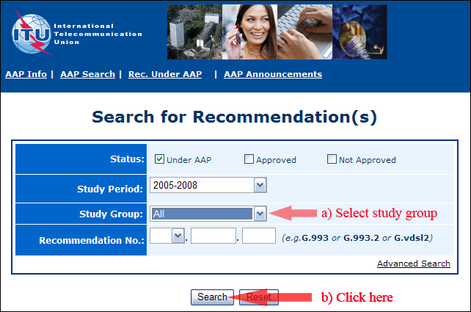
2) Select your Recommendation
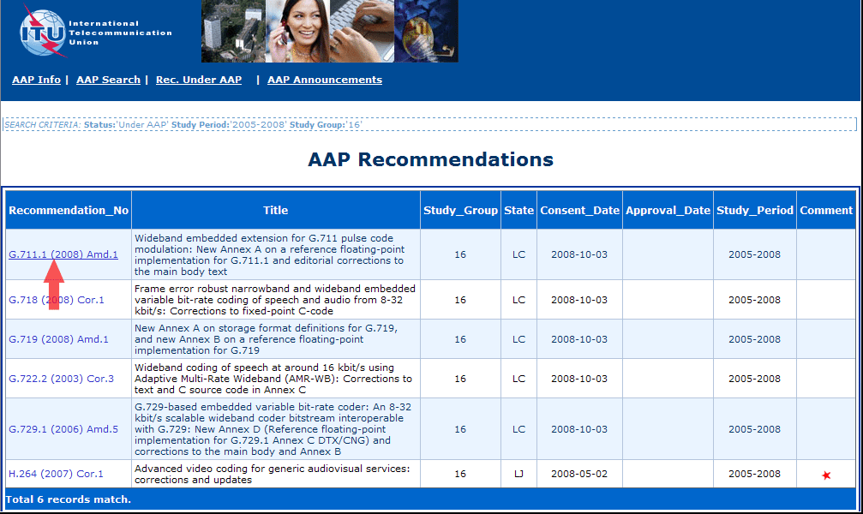
3) Click the "Submit Comment" button
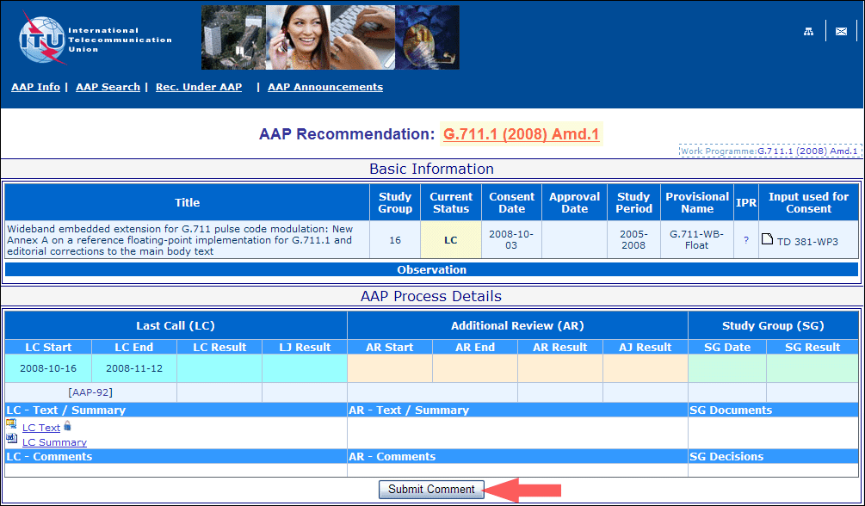
4) Complete the on-line form and click on "Submit"
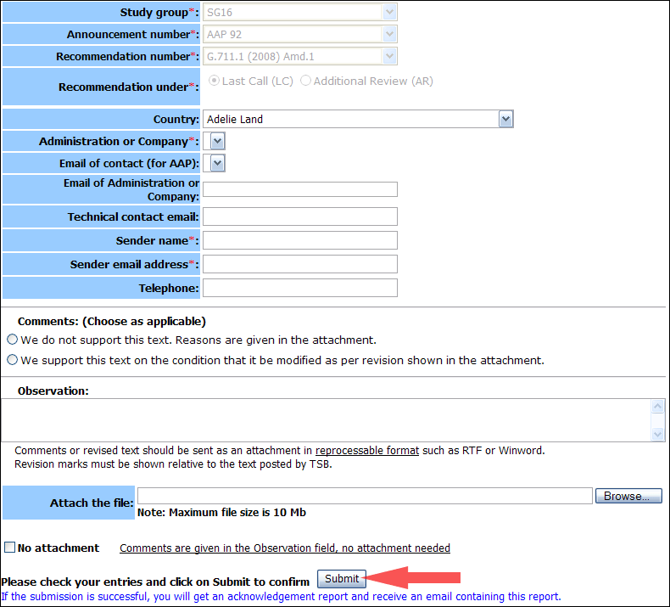
For more information, read the AAP tutorial on:
http://www.itu.int/ITU-T/aapinfo/files/AAPTutorial.pdf
Annex 3
(to TSB AAP-10)
Recommendations under LC/AR – Comment submission form
(Separate form for each Recommendation being commented upon)
ITU-T AAP comment submission form for the period 2009-2012
Study Group:
Announcement number:
Recommendation number:
Recommendation under: | Last call (LC)  Additional Review (AR)
Country:
Administration/Company:
Name of AAP Contact Person:
Email of AAP Contact Person:
Sender name:
(if different from AAP Contact Person)
Sender email address:
Telephone:
Comments:  (Choose as applicable) | We do not support this text. Reasons are given in the attachment.  We support this text on the condition that it be modified as per revision shown in the attachment.
Observations:
No attachment: Comments are given in the Observation field, no attachment needed
To be returned to: email: tsbsg....@itu.int
[or fax +41 22 730 5853]
Comments or revised text should be sent as an attachment in RTF or WinWord format.
Revision marks must be shown relative to the text posted by TSB.

