International Telecommunication Union  Telecommunication Standardization Bureau | 

Geneva, 16 February 2009

Ref:  Tel:  Fax:  E-mail: | TSB AAP-7  AAP/MJ  +41 22 730 5860  +41 22 730 5853  tsbdir@itu.int | – To Administrations of Member States of the Union;  – To ITU-T Sector Members;  – To ITU-T Associates  Copy:  – To the ITU-T Study Group Chairmen and Vice-Chairmen;  – To the Director of the Telecommunication Development Bureau;  – To the Director of the Radiocommunication Bureau

Subject: | Situation concerning Recommendations under the Alternative Approval Process (AAP)

Dear Sir/Madam,
The Alternative Approval Process (AAP) defined in Rec. ITU-T A.8 (2006) applies to Recommendations which do not have policy or regulatory implications and which, therefore, do not require formal consultation of Member States (see ITU Convention 246B).
Annex 1 lists those texts whose status has changed compared with previous TSB AAP Announcements.
If you wish to submit a comment relative to a Recommendation under AAP, you are encouraged to use the on-line AAP comment submission form available on the page of the Recommendation in the AAP area of the ITU-T website at http://www.itu.int/ITU-T/aap (see Annex 2). Alternatively, comments can be submitted by completing the form in Annex 3 and sending it to the secretariat of the concerned study group.
Please note that comments that simply support adoption of the text in question are not encouraged.
Yours faithfully,
Malcolm Johnson
Director of the Telecommunication Standardization Bureau
Annexes: 3
Annex 1
(to TSB AAP-7)

Status codes used in the AAP announcements:
LC = Last Call
LJ = Last Call Judgment (includes comment resolution)
AR = Additional Review
AJ = Additional Review Judgment (includes comment resolution)
SG = For Study Group approval
A = Approved
AT = Approved with typographic corrections
AC = Approved after Additional Review of Comments
NA = Not approved
TAP = Moved to TAP (ITU-T A.8 / § 5.2)
ITU-T website entry page:
http://www.itu.int/ITU-T
Alternative approval process (AAP) welcome page:
http://www.itu.int/ITU-T/aapinfo
Note – A tutorial on the ITU-T AAP application is available under the AAP welcome page
ITU-T website AAP Recommendation search page:
http://www.itu.int/ITU-T/aap/
Study Group web pages and contacts:
SG 2 | http://www.itu.int/ITU-T/studygroups/com02 | tsbsg2@itu.int
SG 3 | http://www.itu.int/ITU-T/studygroups/com03 | tsbsg3@itu.int
SG 5 | http://www.itu.int/ITU-T/studygroups/com05 | tsbsg5@itu.int
SG 9 | http://www.itu.int/ITU-T/studygroups/com09 | tsbsg9@itu.int
SG 11 | http://www.itu.int/ITU-T/studygroups/com11 | tsbsg11@itu.int
SG 12 | http://www.itu.int/ITU-T/studygroups/com12 | tsbsg12@itu.int
SG 13 | http://www.itu.int/ITU-T/studygroups/com13 | tsbsg13@itu.int
SG 15 | http://www.itu.int/ITU-T/studygroups/com15 | tsbsg15@itu.int
SG 16 | http://www.itu.int/ITU-T/studygroups/com16 | tsbsg16@itu.int
SG 17 | http://www.itu.int/ITU-T/studygroups/com17 | tsbsg17@itu.int

Situation concerning Study Group 15 Recommendations under AAP
Rec # | Title | Last Call (LC) Period |  |  |  | Additional Review (AR) Period |  |  |  | Status
Rec # | Title | LC Start | LC End | LC  Result | LJ  Result | AR Start | AR End | AR  Result | AJ  Result | Status
G.709/Y.1331 (2003) Amd.3 | Interfaces for the optical transport network (OTN) | 2009-01-16 | 2009-02-12 | LJ |  |  |  |  |  | LJ
G.800 (2007) Amd.1 | Unified functional architecture of transport networks | 2008-12-16 | 2009-01-12 | LJ | AR | 2009-02-16 | 2009-03-08 |  |  | AR
G.984.3 (2008) Amd.1 | Gigabit-capable Passive Optical Networks (G PON): Transmission convergence layer specification. Amendment 1 | 2009-01-16 | 2009-02-12 | A |  |  |  |  |  | A
G.984.4 (2008) Amd.1 | Gigabit-capable passive optical network (G-PON): ONT management and control interface specification | 2009-01-16 | 2009-02-12 | LJ |  |  |  |  |  | LJ
G.994.1 (2007) Amd.3 | Handshake procedures for Digital Subscriber line (DSL) transceivers | 2009-01-16 | 2009-02-12 | LJ |  |  |  |  |  | LJ
G.996.2 (G.lt) | Line Testing for Digital Subscriber lines (DSL) | 2009-01-16 | 2009-02-12 | LJ |  |  |  |  |  | LJ
G.997.1 | Physical layer management for Digital Subscriber Line (DSL) transceivers | 2009-01-16 | 2009-02-12 | LJ |  |  |  |  |  | LJ
G.999.1 | LINK layer to PHY layer interface | 2009-01-16 | 2009-02-12 | LJ |  |  |  |  |  | LJ
G.8032/Y.1344 (2008) Amd.1 | Ethernet Ring protection | 2009-01-16 | 2009-02-12 | LJ |  |  |  |  |  | LJ
G.9960 (G.hn) | Next generation home networking transceivers | 2009-01-16 | 2009-02-12 | LJ |  |  |  |  |  | LJ
Situation concerning Study Group 16 Recommendations under AAP
Rec # | Title | Last Call (LC) Period |  |  |  | Additional Review (AR) Period |  |  |  | Status
Rec # | Title | LC Start | LC End | LC  Result | LJ  Result | AR Start | AR End | AR  Result | AJ  Result | Status
G.168 (V6) | Digital network echo cancellers | 2009-02-16 | 2009-03-15 |  |  |  |  |  |  | LC
G.711.1 (2008) Amd.2 | Wideband embedded extension for G.711 pulse code modulation: New Annex B on G.711.1 usage in H.245 and editorial corrections to the main body text | 2009-02-16 | 2009-03-15 |  |  |  |  |  |  | LC
G.718 (2008) Amd.1 (G.718-Float) | Frame error robust narrowband and wideband embedded variable bit-rate coding of speech and audio from 8-32 kbit/s: Floating point annex plus corrections to fixed-point C-code and description text | 2009-02-16 | 2009-03-15 |  |  |  |  |  |  | LC
G.719 (2008) Amd.2 | Low-complexity, full-band audio coding for high-quality, conversational applications: New Annex C on G.719 packet format, capability identifiers and capability parameters | 2009-02-16 | 2009-03-15 |  |  |  |  |  |  | LC
G.763 (1998) Cor.1 | Digital circuit multiplication equipment using G.726 ADPCM and digital speech interpolation: Corrections | 2009-02-16 | 2009-03-15 |  |  |  |  |  |  | LC
H.221 (V8) | Frame structure for a 64 to 1920 kbit/s channel in audiovisual teleservices | 2009-02-16 | 2009-03-15 |  |  |  |  |  |  | LC
H.222.0 (2006) Amd.3 (H.222.0-SVC) | Information technology - Generic coding of moving pictures and associated audio information: Systems: Transport of scalable video over ITU-T Rec. H.222.0 | ISO/IEC 13818-1 | 2009-02-16 | 2009-03-15 |  |  |  |  |  |  | LC
H.222.0 (2006) Cor.2 | Information technology - Generic coding of moving pictures and associated audio information: Systems: Correction of transfer rate Rxn in the T-STD model | 2009-02-16 | 2009-03-15 |  |  |  |  |  |  | LC
H.230 (V7) | Frame-synchronous control and indication signals for audiovisual systems | 2009-02-16 | 2009-03-15 |  |  |  |  |  |  | LC
H.235.6 (2005) Cor.1 | H.323 security: Voice encryption profile with native H.235/H.245 key management: Correction of defects | 2009-02-16 | 2009-03-15 |  |  |  |  |  |  | LC
H.242 (V7) | System for establishing communication between audiovisual terminals using digital channels up to 2 Mbit/s | 2009-02-16 | 2009-03-15 |  |  |  |  |  |  | LC
H.248.14 Rev.1 ((Ed. 0.2)) | Gateway control protocol: Inactivity timer package | 2009-02-16 | 2009-03-15 |  |  |  |  |  |  | LC
H.248.19 (2004) Amd.2 | Gateway Control Protocol: Decomposed multipoint control unit, audio, video and data conferencing packages: Floor Control Enhancements | 2009-02-16 | 2009-03-15 |  |  |  |  |  |  | LC
H.248.42 (H.248.42 (2006) Amd.1) | Gateway control protocol: DCME interworking package: Parameters for enhanced event reporting control | 2009-02-16 | 2009-03-15 |  |  |  |  |  |  | LC
H.248.52 Amd.1 | Gateway Control Protocol: QoS Support Packages: Clarifications and updates to the Differentiated Services package | 2009-02-16 | 2009-03-15 |  |  |  |  |  |  | LC
H.248.53 | Gateway Control Protocol: Traffic Management Packages | 2009-02-16 | 2009-03-15 |  |  |  |  |  |  | LC
H.248.56 Cor.1 | Gateway control protocol: Packages for virtual private network support: VLAN package clarifications | 2009-02-16 | 2009-03-15 |  |  |  |  |  |  | LC
H.248.60 (H.248.cci) | Gateway control protocol: Identification of content of communication | 2009-02-16 | 2009-03-15 |  |  |  |  |  |  | LC
H.248.61 (H.248.ipocs) | Gateway Control Protocol: Packages for Network Level H.248 Statistics | 2009-02-16 | 2009-03-15 |  |  |  |  |  |  | LC
H.248.63 (H.248.resman) | Gateway Control Protocol: Resource Management Packages | 2009-02-16 | 2009-03-15 |  |  |  |  |  |  | LC
H.248.65 (H.248.RSVP) | Gateway control protocol: Support of the resource reservation protocol | 2009-02-16 | 2009-03-15 |  |  |  |  |  |  | LC
H.248.68 (H.248.RDT) | Gateway control protocol: Removal of Digits and Tones package | 2009-02-16 | 2009-03-15 |  |  |  |  |  |  | LC
H.248.69 (H.248.MSRP) | Gateway control protocol: Packages for MSRP and H.248 Interworking | 2009-02-16 | 2009-03-15 |  |  |  |  |  |  | LC
H.248.70 (H.248.DMI) | Gateway Control Protocol: Dialling Method Information Packages | 2009-02-16 | 2009-03-15 |  |  |  |  |  |  | LC
H.262 (2000) Amd.3 | Information technology - Generic coding of moving pictures and associated audio information: Video: New level for 1080@50p/60p | 2009-02-16 | 2009-03-15 |  |  |  |  |  |  | LC
H.264 (V4) (H.264-MVC) | Advanced video coding for generic audiovisual services | 2009-02-16 | 2009-03-15 |  |  |  |  |  |  | LC
H.701 (H.IPTV-CDER) | Content Delivery Error Recovery for IPTV services | 2009-02-16 | 2009-03-15 |  |  |  |  |  |  | LC
H.721 (H.IPTV-TDES.2) | IPTV Terminal Device, Basic Model | 2009-02-16 | 2009-03-15 |  |  |  |  |  |  | LC
H.760 (H.IPTV-MAFR.0) | Overview of Multimedia Application Frameworks for IPTV | 2009-02-16 | 2009-03-15 |  |  |  |  |  |  | LC
I.733 (G.vclad) | Voice on ATM Multiplication Equipment | 2009-02-16 | 2009-03-15 |  |  |  |  |  |  | LC
T.800 (2002) Amd.2 | Information technology - JPEG 2000 image coding system: Core coding system: Extended profiles for cinema and video production and archival applications | 2009-02-16 | 2009-03-15 |  |  |  |  |  |  | LC
T.803 (2002) Cor.1 | Information technology -JPEG 2000 image coding system: Conformance testing: Correction to G.4.4 | 2009-02-16 | 2009-03-15 |  |  |  |  |  |  | LC
T.832 (T.JXR-2) | Information technology - JPEG XR image coding system - Part 2: Image coding specification | 2009-02-16 | 2009-03-15 |  |  |  |  |  |  | LC
V.152 (2009) Amd.1 (V.152 Annex/Appendix [X]) | New Annex B on use of data signal detection and silence insertion in voiceband data and new Annex C on use of V.21 preamble for echo canceller control in a V.152 gateway | 2009-02-16 | 2009-03-15 |  |  |  |  |  |  | LC

Annex 2
(to TSB AAP-7)
Using the on-line comment submission form
Comment submission
1) Go to AAP search Web page at http://www.itu.int/ITU-T/aap/
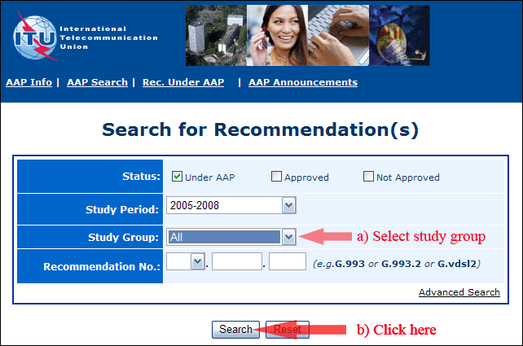
2) Select your Recommendation
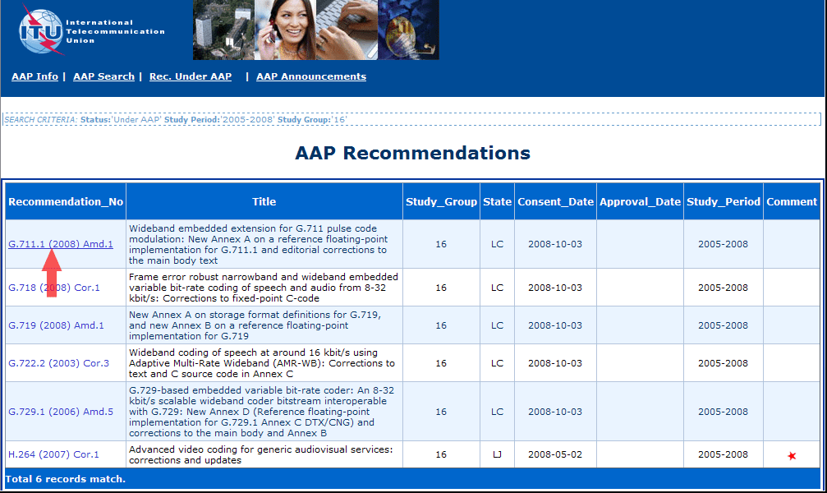
3) Click the "Submit Comment" button
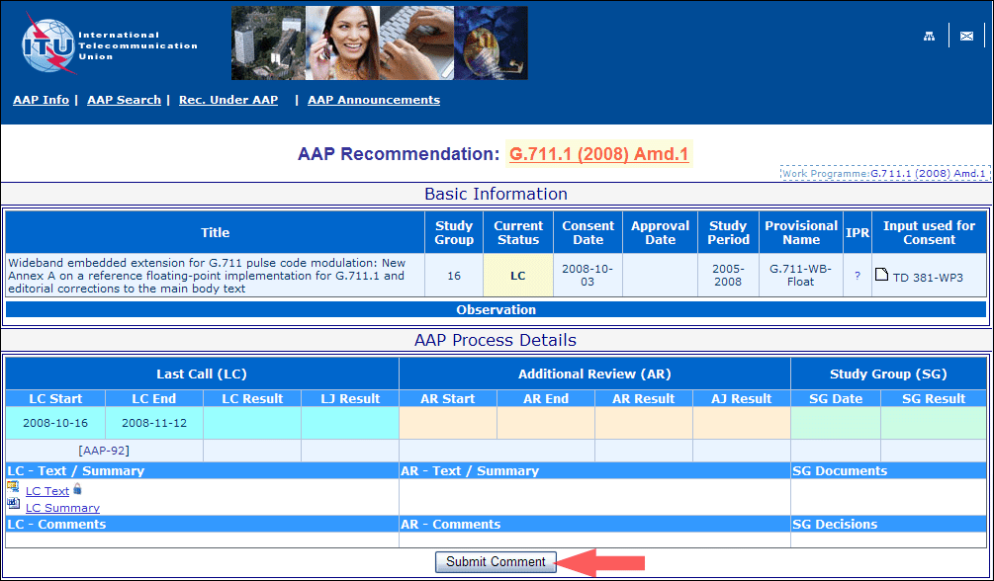
4) Complete the on-line form and click on "Submit"
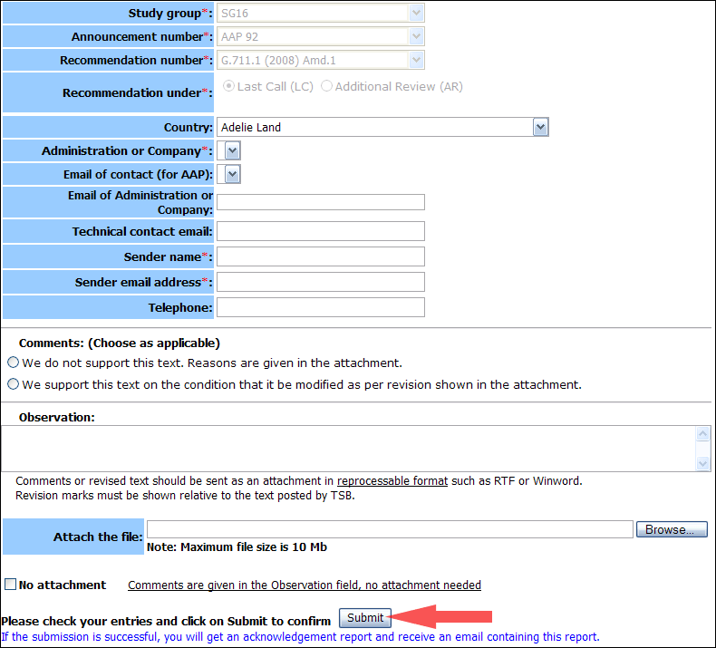
For more information, read the AAP tutorial on:
http://www.itu.int/ITU-T/aapinfo/files/AAPTutorial.pdf
Annex 3
(to TSB AAP-7)
Recommendations under LC/AR – Comment submission form
(Separate form for each Recommendation being commented upon)
ITU-T AAP comment submission form for the period 2009-2012
Study Group:
Announcement number:
Recommendation number:
Recommendation under: | Last call (LC)  Additional Review (AR)
Country:
Administration/Company:
Name of AAP Contact Person:
Email of AAP Contact Person:
Sender name:
(if different from AAP Contact Person)
Sender email address:
Telephone:
Comments:  (Choose as applicable) | We do not support this text. Reasons are given in the attachment.  We support this text on the condition that it be modified as per revision shown in the attachment.
Observations:
No attachment: Comments are given in the Observation field, no attachment needed
To be returned to: email: tsbsg....@itu.int
[or fax +41 22 730 5853]
Comments or revised text should be sent as an attachment in RTF or WinWord format.
Revision marks must be shown relative to the text posted by TSB.

