Union Internationale des Telecommunications  Bureau de la normalisation des télécommunications | 

Genève, le 16 décembre 2008

Réf:  Tél:  Fax:  E-mail: | TSB AAP-4  AAP/MJ  +41 22 730 5860  +41 22 730 5853  tsbdir@itu.int | – Aux administrations des Etats Membres de l'Union;  – Aux Membres du Secteur UIT-T;  – Aux Associés de l'UIT-T  Copie:  – Aux Présidents et Vice-Présidents des Commissions d'études de l'UIT-T;  – Au Directeur du Bureau de développement des télécommunications;  – Au Directeur du Bureau des radiocommunications

Objet: | Etat des Recommandations auxquelles s'applique la variante de la procédure d'approbation (AAP)

Madame, Monsieur,

La variante de la procédure d'approbation (AAP), définie dans la Recommandation UIT-T A.8, s'applique aux Recommandations qui n'ont pas d'incidence politique ou réglementaire et ne nécessitent donc pas une consultation formelle des Etats Membres (voir le numéro 246B de la Convention de l'UIT).
L'Annexe 1 énumère les textes dont le statut a changé par rapport aux annonces TSB AAP antérieures.
Si vous souhaitez soumettre des observations sur une Recommandation ayant fait l'objet de la procédure AAP, vous êtes encouragés à utiliser le formulaire en ligne de soumission des observations AAP, disponible dans l'espace AAP du site web de l'UIT-T à l'adresse http://www.itu.int/ITU-T/aap/, à la page de la Recommandation concernée (voir l'Annexe 2). Vous pouvez aussi soumettre vos observations en remplissant le formulaire figurant à l'Annexe 3 et en l'envoyant au secrétariat de la Commission d'études concernée.
Veuillez noter que les observations ayant simplement pour objet d'appuyer l'adoption du texte en question ne sont pas encouragées.
Veuillez noter qu'en raison de la fermeture annuelle de l'UIT fin décembre, aucune annonce AAP ne paraîtra en date du 1er janvier 2009. En conséquence, le délai de certains textes annoncés a été repoussé car la date limite coïncidait avec cette période.
Veuillez agréer, Madame, Monsieur, l'assurance de ma considération distinguée.
Malcolm Johnson
Directeur du Bureau de la normalisation des télécommunications

Annexes: 3
Annex 1
(to TSB AAP-4)

Status codes used in the AAP announcements:
LC = Last Call
LJ = Last Call Judgment (includes comment resolution)
AR = Additional Review
AJ = Additional Review Judgment (includes comment resolution)
SG = For Study Group approval
A = Approved
AT = Approved with typographic corrections
AC = Approved after Additional Review of Comments
NA = Not approved
TAP = Moved to TAP (ITU-T A.8 / § 5.2)
ITU-T website entry page:
http://www.itu.int/ITU-T
Alternative approval process (AAP) welcome page:
http://www.itu.int/ITU-T/aapinfo
Note – A tutorial on the ITU-T AAP application is available under the AAP welcome page
ITU-T website AAP Recommendation search page:
http://www.itu.int/ITU-T/aap/
Study Group web pages and contacts:
SG 2 | http://www.itu.int/ITU-T/studygroups/com02 | tsbsg2@itu.int
SG 3 | http://www.itu.int/ITU-T/studygroups/com03 | tsbsg3@itu.int
SG 5 | http://www.itu.int/ITU-T/studygroups/com05 | tsbsg5@itu.int
SG 9 | http://www.itu.int/ITU-T/studygroups/com09 | tsbsg9@itu.int
SG 11 | http://www.itu.int/ITU-T/studygroups/com11 | tsbsg11@itu.int
SG 12 | http://www.itu.int/ITU-T/studygroups/com12 | tsbsg12@itu.int
SG 13 | http://www.itu.int/ITU-T/studygroups/com13 | tsbsg13@itu.int
SG 15 | http://www.itu.int/ITU-T/studygroups/com15 | tsbsg15@itu.int
SG 16 | http://www.itu.int/ITU-T/studygroups/com16 | tsbsg16@itu.int
SG 17 | http://www.itu.int/ITU-T/studygroups/com17 | tsbsg17@itu.int

Situation concerning Study Group 5 Recommendations under AAP
Rec # | Title | Last Call (LC) Period |  |  |  | Additional Review (AR) Period |  |  |  | Status
Rec # | Title | LC Start | LC End | LC  Result | LJ  Result | AR Start | AR End | AR  Result | AJ  Result | Status
K.11 | Principles of protection against overvoltages and overcurrents | 2008-12-16 | 2009-01-12 |  |  |  |  |  |  | LC
K.77 (K.var) | Characteristics of Metal Oxide Varistors (MOVs) for the protection of telecommunications installations | 2008-12-16 | 2009-01-12 |  |  |  |  |  |  | LC
Situation concerning Study Group 12 Recommendations under AAP
Rec # | Title | Last Call (LC) Period |  |  |  | Additional Review (AR) Period |  |  |  | Status
Rec # | Title | LC Start | LC End | LC  Result | LJ  Result | AR Start | AR End | AR  Result | AJ  Result | Status
G.1080 (G.IPTV-QoE) | Quality of experience requirements for IPTV services | 2008-06-16 | 2008-07-13 | LJ | AR | 2008-11-16 | 2008-12-06 | AC |  | AC
Y.1563 (Y.ETHperf) | Ethernet frame transfer and availability performance | 2008-06-16 | 2008-07-13 | LJ | AR | 2008-12-16 | 2009-01-12 |  |  | AR
Situation concerning Study Group 13 Recommendations under AAP
Rec # | Title | Last Call (LC) Period |  |  |  | Additional Review (AR) Period |  |  |  | Status
Rec # | Title | LC Start | LC End | LC  Result | LJ  Result | AR Start | AR End | AR  Result | AJ  Result | Status
Y.2015 (Y.ipsplit) | General requirements for ID/locator separation in NGN | 2008-10-16 | 2008-11-12 | LJ | SG |  |  |  |  | SG
Y.2111 (Y.RACF-R2) | Resource and admission control functions in Next Generation Networks | 2008-10-16 | 2008-11-12 | LJ | AT |  |  |  |  | AT
Y.2113 (Y.enet) | Ethernet QoS control for Next Generation Networks | 2008-10-16 | 2008-11-12 | LJ | SG |  |  |  |  | SG
Y.2235 (Y.cwbs) | Converged web-browsing service scenarios in NGN | 2008-10-16 | 2008-11-12 | LJ | AT |  |  |  |  | AT
Y.2612 (Y.FPBN-addr) | Generic requirements and framework of FPBN addressing, routing and forwarding | 2008-10-16 | 2008-11-12 | LJ | SG |  |  |  |  | SG
Y.2807 (Y.mpls-mob) | MPLS-based mobility capabilities for NGN services | 2008-10-16 | 2008-11-12 | LJ | SG |  |  |  |  | SG
Situation concerning Study Group 15 Recommendations under AAP
Rec # | Title | Last Call (LC) Period |  |  |  | Additional Review (AR) Period |  |  |  | Status
Rec # | Title | LC Start | LC End | LC  Result | LJ  Result | AR Start | AR End | AR  Result | AJ  Result | Status
G.671 | Transmission characteristics of optical components and subsystems | 2008-12-16 | 2009-01-12 |  |  |  |  |  |  | LC
G.709/Y.1331 Cor.2 | Interfaces for the Optical Transport Network (OTN) | 2008-12-16 | 2009-01-12 |  |  |  |  |  |  | LC
G.798 Cor.1 | Characteristics of optical transport network hierarchy equipment functional blocks | 2008-12-16 | 2009-01-12 |  |  |  |  |  |  | LC
G.800 Amd.1 | Unified functional architecture of transport networks | 2008-12-16 | 2009-01-12 |  |  |  |  |  |  | LC
G.806 | Characteristics of Transport Equipment - Description Methodology and Generic Functionality | 2008-12-16 | 2009-01-12 |  |  |  |  |  |  | LC
G.808.1 (2006) Amd.1 | Generic protection switching - Linear trail and subnetwork protection | 2008-12-16 | 2009-01-12 |  |  |  |  |  |  | LC
G.985 Amd.1 | 100 Mbit/s point-to-point Ethernet based optical access system | 2008-12-16 | 2009-01-12 |  |  |  |  |  |  | LC
G.992.3 | Asymmetric digital subscriber line transcivers 2 (ADSL2) | 2008-12-16 | 2009-01-12 |  |  |  |  |  |  | LC
G.992.5 | Asymmetric Digital subscriber Line (ASDL) transceivers - Extended bandwidth ADSL2 (ADSL2plus) | 2008-12-16 | 2009-01-12 |  |  |  |  |  |  | LC
G.993.2 (2006) Amd.4 | Very high speed Digital subscriber Line Transceivers 2 | 2008-12-16 | 2009-01-12 |  |  |  |  |  |  | LC
G.7041 Amd.1 | Generic framing procedure (GFP) | 2008-12-16 | 2009-01-12 |  |  |  |  |  |  | LC
G.8011.1/Y.1307.1 | Ethernet Private Line Service | 2008-12-16 | 2009-01-12 |  |  |  |  |  |  | LC
G.8011.2/Y.1307.2 | Ethernet Virtual Private Line Service | 2008-12-16 | 2009-01-12 |  |  |  |  |  |  | LC
G.8011/Y.1307 | Ethernet over Transport – Ethernet Service Characteristics | 2008-12-16 | 2009-01-12 |  |  |  |  |  |  | LC
G.8021/Y.1341 Amd.1 | Characteristics of Ethernet Transport Network Equipment Functional Blocks | 2008-12-16 | 2009-01-12 |  |  |  |  |  |  | LC
G.9970 (G.hnta) | Generic Home Network Transport Architecture | 2008-12-16 | 2009-01-12 |  |  |  |  |  |  | LC
O.182 Amd.1 | Equipment to assess error performance on Optical Transport Network (OTN) interfaces | 2008-12-16 | 2009-01-12 |  |  |  |  |  |  | LC
X.85/Y.1321 Amd.2 | IP over SDH using LAPS | 2008-12-16 | 2009-01-12 |  |  |  |  |  |  | LC
Y.1714 | MPLS management and OAM Framework | 2008-12-16 | 2009-01-12 |  |  |  |  |  |  | LC
Situation concerning Study Group 16 Recommendations under AAP
Rec # | Title | Last Call (LC) Period |  |  |  | Additional Review (AR) Period |  |  |  | Status
Rec # | Title | LC Start | LC End | LC  Result | LJ  Result | AR Start | AR End | AR  Result | AJ  Result | Status
G.729.1 (2006) Amd.5 | G.729-based embedded variable bit-rate coder: An 8-32 kbit/s scalable wideband coder bitstream interoperable with G.729: New Annex D (Reference floating-point implementation for G.729.1 Annex C DTX/CNG) and corrections to the main body and Annex B | 2008-10-16 | 2008-11-12 | AR |  | 2008-11-16 | 2008-12-06 | AC |  | AC
H.264 (2007) Cor.1 | Advanced video coding for generic audiovisual services: corrections and updates | 2008-06-16 | 2008-07-13 | LJ | AR | 2008-12-16 | 2009-01-12 |  |  | AR
Situation concerning Study Group 17 Recommendations under AAP
Rec # | Title | Last Call (LC) Period |  |  |  | Additional Review (AR) Period |  |  |  | Status
Rec # | Title | LC Start | LC End | LC  Result | LJ  Result | AR Start | AR End | AR  Result | AJ  Result | Status
X.1056 (X.sim) | Security incident management guidelines for telecommunications organizations | 2008-12-16 | 2009-01-12 |  |  |  |  |  |  | LC
Z.167 (Z.146) | Testing and Test Control Notation version 3 (TTCN-3): Using ASN.1 with TTCN-3 | 2008-11-01 | 2008-11-28 | A |  |  |  |  |  | A
Z.169 | Testing and Test Control Notation version 3 (TTCN-3): TTCN-3 and the Use of XML | 2008-11-01 | 2008-11-28 | A |  |  |  |  |  | A

Annex 2
(to TSB AAP-4)
Using the on-line comment submission form
Comment submission
1) Go to AAP search Web page at http://www.itu.int/ITU-T/aap/
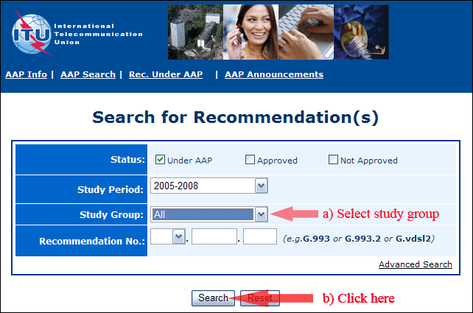
2) Select your Recommendation
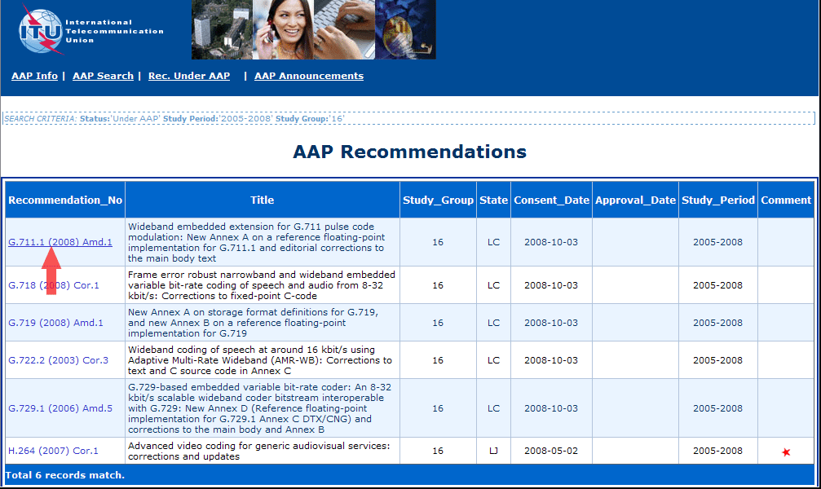
3) Click the "Submit Comment" button
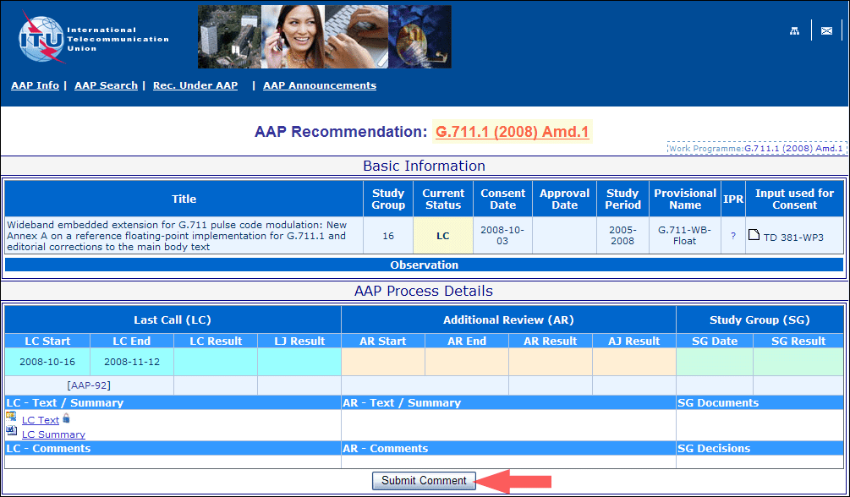
4) Complete the on-line form and click on "Submit"
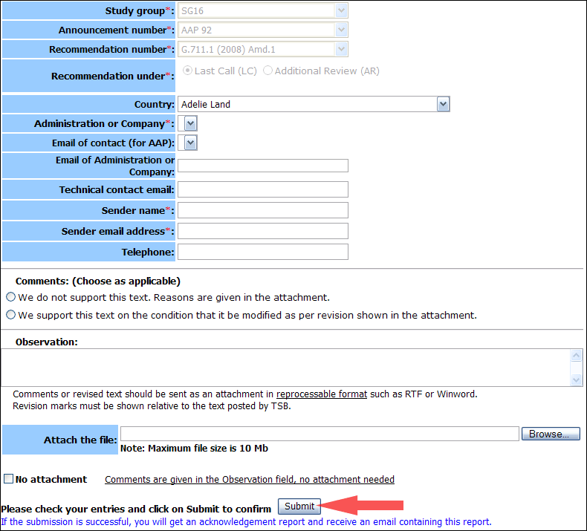
For more information, read the AAP tutorial on:
http://www.itu.int/ITU-T/aapinfo/files/AAPTutorial.pdf
Annex 3
(to TSB AAP-4)
Recommendations under LC/AR – Comment submission form
(Separate form for each Recommendation being commented upon)
ITU-T AAP comment submission form for the period 2009-2012
Study Group:
Announcement number:
Recommendation number:
Recommendation under: | Last call (LC)  Additional Review (AR)
Country:
Administration/Company:
Name of AAP Contact Person:
Email of AAP Contact Person:
Sender name:
(if different from AAP Contact Person)
Sender email address:
Telephone:
Comments:  (Choose as applicable) | We do not support this text. Reasons are given in the attachment.  We support this text on the condition that it be modified as per revision shown in the attachment.
Observations:
No attachment: Comments are given in the Observation field, no attachment needed
To be returned to: email: tsbsg....@itu.int
[or fax +41 22 730 5853]
Comments or revised text should be sent as an attachment in RTF or WinWord format.
Revision marks must be shown relative to the text posted by TSB.

