国 际 电 信 联 盟  电信标准化局 | 
2008年11月16日 ，日内瓦

参考号:  电话:  传真:  电子邮件: | 电信标准化局AAP-2  AAP/MJ  +41 22 730 5860  +41 22 730 5853  tsbdir@itu.int | – 致国际电联成员国各主管部门；  – 致ITU-T各部门成员；  – 致ITU-T 部门准成员  抄送：  – 电信标准化局研究组主席和副主席  – 电信发展局主任  – 无线电通信局主任

事由: | 有关采用替换批准程序（AAP）处理的建议书的情况

先生/女士，
ITU-T A.8 建议书中规定的建议书替换批准程序 (AAP) 适用于那些不会产生政策或 监管影响、因而不需与成员国正式协商的建议书（见国际电联《公约》第246B款）。
附件1列出了那些在以往电信标准化局AAP预告后地位发生变化的案文。
如您希望针对某个适用AAP的建议书提出意见，请使用可在ITU-T网站AAP区域 （http://www.itu.int/ITU-T/aap）的“建议书”网页上获取的《AAP意见在线提交表格》 （见附件2）。或者，可填妥附件3 中的表格并将意见发送给相关研究组的秘书处。
敬请留意，我们不鼓励提交仅支持通过所涉案文而没有实质内容的意见。

顺致敬意！

马尔科姆•琼森
电信标准化局主任

附件：3件
Annex 1
(to TSB AAP-2)

Status codes used in the AAP announcements:
LC = Last Call
LJ = Last Call Judgment (includes comment resolution)
AR = Additional Review
AJ = Additional Review Judgment (includes comment resolution)
SG = For Study Group approval
A = Approved
AT = Approved with typographic corrections
AC = Approved after Additional Review of Comments
NA = Not approved
TAP = Moved to TAP (ITU-T A.8 / § 5.2)
ITU-T website entry page:
http://www.itu.int/ITU-T
Alternative approval process (AAP) welcome page:
http://www.itu.int/ITU-T/aapinfo
Note – A tutorial on the ITU-T AAP application is available under the AAP welcome page
ITU-T website AAP Recommendation search page:
http://www.itu.int/ITU-T/aap/
Study Group web pages and contacts:
SG 2 | http://www.itu.int/ITU-T/studygroups/com02 | tsbsg2@itu.int
SG 3 | http://www.itu.int/ITU-T/studygroups/com03 | tsbsg3@itu.int
SG 5 | http://www.itu.int/ITU-T/studygroups/com05 | tsbsg5@itu.int
SG 9 | http://www.itu.int/ITU-T/studygroups/com09 | tsbsg9@itu.int
SG 11 | http://www.itu.int/ITU-T/studygroups/com11 | tsbsg11@itu.int
SG 12 | http://www.itu.int/ITU-T/studygroups/com12 | tsbsg12@itu.int
SG 13 | http://www.itu.int/ITU-T/studygroups/com13 | tsbsg13@itu.int
SG 15 | http://www.itu.int/ITU-T/studygroups/com15 | tsbsg15@itu.int
SG 16 | http://www.itu.int/ITU-T/studygroups/com16 | tsbsg16@itu.int
SG 17 | http://www.itu.int/ITU-T/studygroups/com17 | tsbsg17@itu.int

Situation concerning Study Group 2 Recommendations under AAP
Rec # | Title | Last Call (LC) Period |  |  |  | Additional Review (AR) Period |  |  |  | Status
Rec # | Title | LC Start | LC End | LC  Result | LJ  Result | AR Start | AR End | AR  Result | AJ  Result | Status
M.3160 (M.3100-neutral)* | Generic Management Information Model - Protocol Neutral | 2008-10-16 | 2008-11-12 | A |  |  |  |  |  | A
Situation concerning Study Group 11 Recommendations under AAP
Rec # | Title | Last Call (LC) Period |  |  |  | Additional Review (AR) Period |  |  |  | Status
Rec # | Title | LC Start | LC End | LC  Result | LJ  Result | AR Start | AR End | AR  Result | AJ  Result | Status
Q.1912.5 B | Interworking between Session Initiation Protocol (SIP) and Bearer Independent Call Control Protocol (BICC) or ISDN User Part (ISUP); Part 1: Protocol Implementation Conformance Statement (PICS) | 2008-09-16 | 2008-10-13 | LJ | AT |  |  |  |  | AT
Q.1912.5 C | Interworking between Session Initiation Protocol (SIP) and Bearer Independent Call Control Protocol (BICC) or ISDN User Part (ISUP); Part 2: Test Suite Structure and Test Purposes (TSS&TP) for Profile A and B | 2008-09-16 | 2008-10-13 | LJ | AT |  |  |  |  | AT
Q.1912.5 D | Interworking between Session Initiation Protocol (SIP) and Bearer Independent Call Control Protocol (BICC) or ISDN User Part (ISUP); Part 3: Test Suite Structure and Test Purposes (TSS&TP) for Profile C | 2008-09-16 | 2008-10-13 | LJ | AT |  |  |  |  | AT
Q.1912.5 E | Interworking between Session Initiation Protocol (SIP) and Bearer Independent Call Control Protocol (BICC) or ISDN User Part (ISUP); Part 4: "Abstract Test Suite (ATS) and partial Protocol Implementation eXtra Information for Testing (PIXIT) for Profile A and B" | 2008-09-16 | 2008-10-13 | LJ | AT |  |  |  |  | AT
X.607.1 (X.ectp-4)* | Information technology - Enhanced communications transport protocol: specification of qos management for duplex multicast transport | 2008-10-16 | 2008-11-12 | A |  |  |  |  |  | A
X.608.1 (X.ectp-6)* | Information technology - Enhanced communications transport protocol: Specification of QoS management for N-plex multicast transport | 2008-10-16 | 2008-11-12 | A |  |  |  |  |  | A
Situation concerning Study Group 12 Recommendations under AAP
Rec # | Title | Last Call (LC) Period |  |  |  | Additional Review (AR) Period |  |  |  | Status
Rec # | Title | LC Start | LC End | LC  Result | LJ  Result | AR Start | AR End | AR  Result | AJ  Result | Status
G.1080 (G.IPTV-QoE) | Quality of experience requirements for IPTV services | 2008-06-16 | 2008-07-13 | LJ | AR | 2008-11-16 | 2008-12-06 |  |  | AR
Situation concerning Study Group 13 Recommendations under AAP
Rec # | Title | Last Call (LC) Period |  |  |  | Additional Review (AR) Period |  |  |  | Status
Rec # | Title | LC Start | LC End | LC  Result | LJ  Result | AR Start | AR End | AR  Result | AJ  Result | Status
Y.2015 (Y.ipsplit) | General requirements for ID/locator separation in NGN | 2008-10-16 | 2008-11-12 | LJ |  |  |  |  |  | LJ
Y.2111 (Y.RACF-R2) | Resource and admission control functions in Next Generation Networks | 2008-10-16 | 2008-11-12 | LJ |  |  |  |  |  | LJ
Y.2113 (Y.enet) | Ethernet QoS control for Next Generation Networks | 2008-10-16 | 2008-11-12 | LJ |  |  |  |  |  | LJ
Y.2175 (Y.RACF-CentralMPLS) | Centralized RACF architecture for MPLS core networks | 2008-10-16 | 2008-11-12 | A |  |  |  |  |  | A
Y.2235 (Y.cwbs) | Converged web-browsing service scenarios in NGN | 2008-10-16 | 2008-11-12 | LJ |  |  |  |  |  | LJ
Y.2612 (Y.FPBN-addr) | Generic requirements and framework of FPBN addressing, routing and forwarding | 2008-10-16 | 2008-11-12 | LJ |  |  |  |  |  | LJ
Y.2807 (Y.mpls-mob) | MPLS-based mobility capabilities for NGN services | 2008-10-16 | 2008-11-12 | LJ |  |  |  |  |  | LJ
Y.2902 (2006) Amd.3 (Y.cgoe-cmpts Annex ftp.clnt) | The FTP client CGOE component | 2008-10-16 | 2008-11-12 | A |  |  |  |  |  | A
Y.2902 (2006) Amd.4 (Y.cgoe-cmpts Annex ftp.svr) | The FTP server CGOE component | 2008-10-16 | 2008-11-12 | A |  |  |  |  |  | A
Situation concerning Study Group 16 Recommendations under AAP
Rec # | Title | Last Call (LC) Period |  |  |  | Additional Review (AR) Period |  |  |  | Status
Rec # | Title | LC Start | LC End | LC  Result | LJ  Result | AR Start | AR End | AR  Result | AJ  Result | Status
G.711.1 (2008) Amd.1 (G.711-WB-Float) | Wideband embedded extension for G.711 pulse code modulation: New Annex A on a reference floating-point implementation for G.711.1 and editorial corrections to the main body text | 2008-10-16 | 2008-11-12 | A |  |  |  |  |  | A
G.718 (2008) Cor.1 (G.VBR-EV Amd.1) | Frame error robust narrowband and wideband embedded variable bit-rate coding of speech and audio from 8-32 kbit/s: Corrections to fixed-point C-code | 2008-10-16 | 2008-11-12 | A |  |  |  |  |  | A
G.719 (2008) Amd.1 (G.719-Float) | New Annex A on storage format definitions for G.719, and new Annex B on a reference floating-point implementation for G.719 | 2008-10-16 | 2008-11-12 | A |  |  |  |  |  | A
G.722.2 (2003) Cor.3 | Wideband coding of speech at around 16 kbit/s using Adaptive Multi-Rate Wideband (AMR-WB): Corrections to text and C source code in Annex C | 2008-10-16 | 2008-11-12 | A |  |  |  |  |  | A
G.729.1 (2006) Amd.5 | G.729-based embedded variable bit-rate coder: An 8-32 kbit/s scalable wideband coder bitstream interoperable with G.729: New Annex D (Reference floating-point implementation for G.729.1 Annex C DTX/CNG) and corrections to the main body and Annex B | 2008-10-16 | 2008-11-12 | AR |  | 2008-11-16 | 2008-12-06 |  |  | AR
Situation concerning Study Group 17 Recommendations under AAP
Rec # | Title | Last Call (LC) Period |  |  |  | Additional Review (AR) Period |  |  |  | Status
Rec # | Title | LC Start | LC End | LC  Result | LJ  Result | AR Start | AR End | AR  Result | AJ  Result | Status
X.500 | Information technology - Open Systems Interconnection - The Directory: Overview of concepts, models and services | 2008-10-16 | 2008-11-12 | A |  |  |  |  |  | A
X.501 | Information technology – Open Systems Interconnection – The Directory: Models | 2008-10-16 | 2008-11-12 | A |  |  |  |  |  | A
X.501 (2005) Cor.2 | Information technology – Open Systems Interconnection – The Directory: Models | 2008-10-16 | 2008-11-12 | A |  |  |  |  |  | A
X.509 | Information technology – Open Systems Interconnection – The Directory: Public-key and attribute certificate frameworks | 2008-10-16 | 2008-11-12 | A |  |  |  |  |  | A
X.509 (2005) Cor.2 | The Directory: Public-key and attribute certificate frameworks - Technical Corrigendum 2 | 2008-10-16 | 2008-11-12 | A |  |  |  |  |  | A
X.511 | Information technology - Open Systems Interconnection - The Directory: Abstract service definition | 2008-10-16 | 2008-11-12 | A |  |  |  |  |  | A
X.511 (2005) Cor.2 | The Directory: Abstract service definition - Technical Corrigendum 2 | 2008-10-16 | 2008-11-12 | A |  |  |  |  |  | A
X.518 | The Directory: Procedures for distributed operation | 2008-10-16 | 2008-11-12 | A |  |  |  |  |  | A
X.519 | Information technology - Open Systems Interconnection - The Directory: Protocol specifications | 2008-10-16 | 2008-11-12 | A |  |  |  |  |  | A
X.520 | Information technology - Open Systems Interconnection - The Directory: Selected attribute types | 2008-10-16 | 2008-11-12 | A |  |  |  |  |  | A
X.520 (2005) Cor.2 | The Directory: Selected attribute types - Technical Corrigendum 2 | 2008-10-16 | 2008-11-12 | A |  |  |  |  |  | A
X.521 | Information technology - Open Systems Interconnection - The Directory: Selected object classes | 2008-10-16 | 2008-11-12 | A |  |  |  |  |  | A
X.525 | Information technology - Open Systems Interconnection - The Directory: Replication | 2008-10-16 | 2008-11-12 | A |  |  |  |  |  | A
X.530 | Information technology - Open Systems Interconnection - The Directory: Use of systems management for administration of the Directory | 2008-10-16 | 2008-11-12 | A |  |  |  |  |  | A
X.680 | Information technology - Abstract Syntax Notation One (ASN.1): Specification of basic notation | 2008-10-16 | 2008-11-12 | A |  |  |  |  |  | A
X.681 | Information technology - Abstract Syntax Notation One (ASN.1): Information object specification | 2008-10-16 | 2008-11-12 | A |  |  |  |  |  | A
X.682 | Information technology - Abstract Syntax Notation One (ASN.1): Constraint specification | 2008-10-16 | 2008-11-12 | A |  |  |  |  |  | A
X.683 | Information technology - Abstract Syntax Notation One (ASN.1): Parameterization of ASN.1 specifications | 2008-10-16 | 2008-11-12 | A |  |  |  |  |  | A
X.690 | Information technology - ASN.1 encoding rules: Specification of Basic Encoding Rules (BER), Canonical Encoding Rules (CER) and Distinguished Encoding Rules (DER) | 2008-10-16 | 2008-11-12 | A |  |  |  |  |  | A
X.691 | Information technology - ASN.1 encoding rules: Specification of Packed Encoding Rules (PER) | 2008-10-16 | 2008-11-12 | A |  |  |  |  |  | A
X.692 | Information technology - ASN.1 encoding rules: Specification of Encoding Control Notation (ECN) | 2008-10-16 | 2008-11-12 | A |  |  |  |  |  | A
X.693 | Information technology - ASN.1 encoding rules: XML Encoding Rules (XER) | 2008-10-16 | 2008-11-12 | A |  |  |  |  |  | A
X.694 | Information technology - ASN.1 encoding rules: Mapping W3C XML schema definitions into ASN.1 | 2008-10-16 | 2008-11-12 | A |  |  |  |  |  | A
X.695 | Information technology - ASN.1 encoding rules: Registration and application of PER encoding instructions | 2008-10-16 | 2008-11-12 | A |  |  |  |  |  | A
X.1055 (X.rmg) | Risk management and risk profile guide | 2008-10-16 | 2008-11-12 | A |  |  |  |  |  | A
X.1086 (X.tpp1) | Telebiometrics Protection Procedures - Part1: A Guideline to Technical and Managerial Countermeasures for Biometric Data Security | 2008-10-16 | 2008-11-12 | A |  |  |  |  |  | A
X.1114 (X.homesec-4) | Authorization framework for home network | 2008-10-16 | 2008-11-12 | A |  |  |  |  |  | A
Z.110 | Criteria for use of formal description techniques by ITU-T | 2008-10-16 | 2008-11-12 | A |  |  |  |  |  | A
Z.111 | Notations and Guidelines for the Definition of ITU-T Languages | 2008-10-16 | 2008-11-12 | A |  |  |  |  |  | A
Z.151 (Z.urn) | User Requirements Notation (URN) | 2008-10-16 | 2008-11-12 | A |  |  |  |  |  | A
Z.450 | Quality aspects of protocol-related Recommendations | 2008-10-16 | 2008-11-12 | A |  |  |  |  |  | A

Annex 2
(to TSB AAP-2)
Using the on-line comment submission form
Comment submission
1) Go to AAP search Web page at http://www.itu.int/ITU-T/aap/
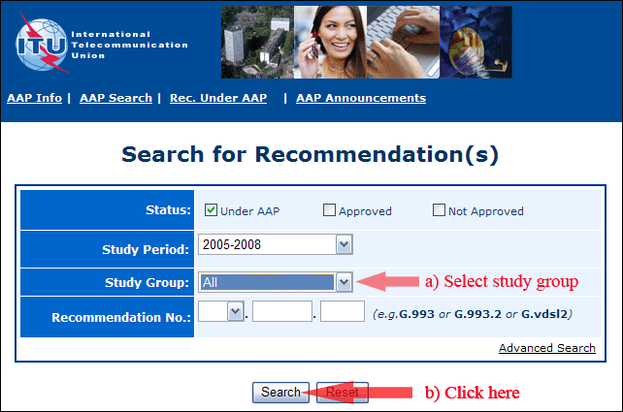
2) Select your Recommendation
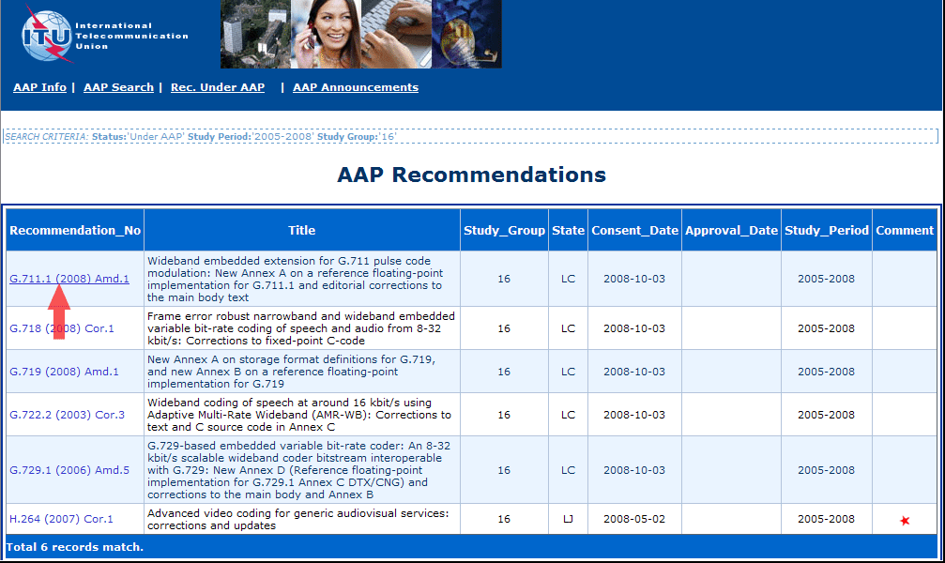
3) Click the "Submit Comment" button
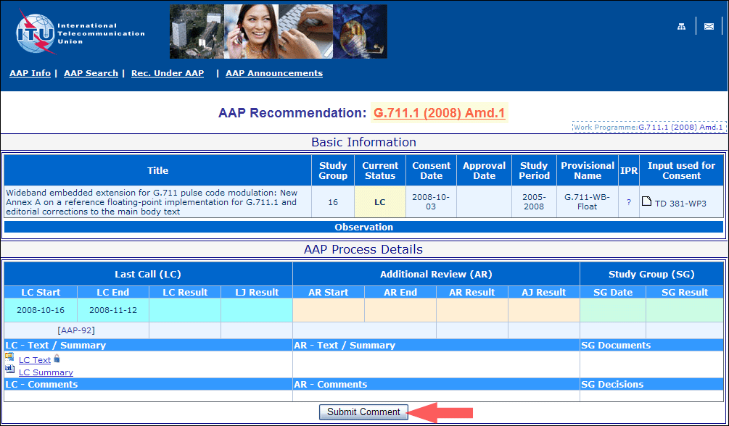
4) Complete the on-line form and click on "Submit"
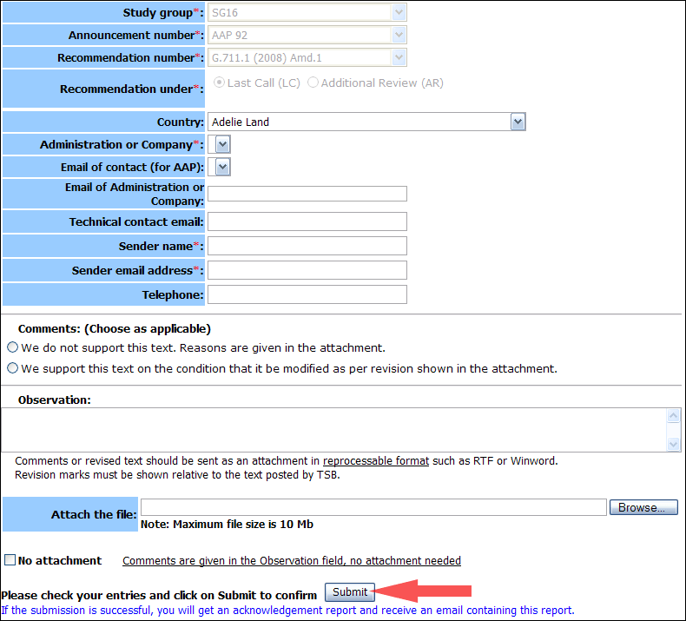
For more information, read the AAP tutorial on:
http://www.itu.int/ITU-T/aapinfo/files/AAPTutorial.pdf
Annex 3
(to TSB AAP-2)
Recommendations under LC/AR – Comment submission form
(Separate form for each Recommendation being commented upon)
ITU-T AAP comment submission form for the period 2009-2012
Study Group:
Announcement number:
Recommendation number:
Recommendation under: | Last call (LC)  Additional Review (AR)
Country:
Administration/Company:
Name of AAP Contact Person:
Email of AAP Contact Person:
Sender name:
(if different from AAP Contact Person)
Sender email address:
Telephone:
Comments:  (Choose as applicable) | We do not support this text. Reasons are given in the attachment.  We support this text on the condition that it be modified as per revision shown in the attachment.
Observations:
No attachment: Comments are given in the Observation field, no attachment needed
To be returned to: email: tsbsg....@itu.int
[or fax +41 22 730 5853]
Comments or revised text should be sent as an attachment in RTF or WinWord format.
Revision marks must be shown relative to the text posted by TSB.

* The responsibility for this Recommendation has changed from Study Group 4 to Study Group 2 as per WTSA-08 decisions.
* The responsibility for this Recommendation has changed from Study Group 17 to Study Group 11 as per WTSA-08 decisions.
* The responsibility for this Recommendation has changed from Study Group 17 to Study Group 11 as per WTSA-08 decisions.

