الا تحــاد الــدولي للاتصــالات
مكتب تقييس الاتصالات

 |  | جنيف، 16 نوفمبر 2008
المرجع:  الهاتف:  الفاكس:  البريد الإلكتروني: | TSB AAP-2  AAP/MJ  +41 22 730 5860  +41 22 730 5853  tsbdir@itu.int | - إلى إدارات الدول الأعضاء في الاتحاد؛  - إلى أعضاء قطاع تقييس الاتصالات؛  - إلى المنتسبين إلى قطاع تقييس الاتصالات  نسخة إلى:  - رؤساء لجان الدراسات في قطاع تقييس الاتصالات ونوابهم؛  - مدير مكتب تنمية الاتصالات؛  - مدير مكتب الاتصالات الراديوية

الموضوع: حالة التوصيات الخاضعة لعملية الموافقة البديلة (AAP)

حضرات السادة والسيدات،
تحية طيبة وبعد،
تنطبق عملية الموافقة البديلة (AAP) المعرفة في التوصية ITU-T A.8 على التوصيات التي لا تنطوي على بعد سياسي أوتنظيمي ولا تتطلب بالتالي استشارة الدول الأعضاء رسمياً (انظر الرقم 246B من اتفاقية الاتحاد).
ويتضمن الملحق 1 لائحة بالنصوص التي تغيرت حالتها مقارنة بما جاء في إعلانات عملية الموافقة البديلة السابقة.
إذا رغبتم في تقديم تعليق بشأن توصية ما خاضعة لعملية الموافقة البديلة، فنرجو منكم استعمال استمارة التعليق على الخط المتوفّرة على موقع قطاع تقييس الاتصالات على صفحة عملية الموافقة البديلة http://www.itu.int/ITU-T/aap على المدخل الخاص بالتوصية المعنية (انظر الملحق (2. وبديلاً من ذلك، يمكنكم تقديم التعليقات باستكمال الاستمارة الواردة في الملحق 3 وإرسالها إلى أمانة لجنة الدراسات المعنية بالأمر.
وتجدر الإشارة إلى أنه يفضّل عدم إرسال تعليقات تقتصر على تأييد اعتماد النص قيد النظر.

وتفضلوا بقبول فائق الاحترام والتقدير.
مالكولم جونسون
مدير مكتب تقييس الاتصالات

الملحقات: 3
Annex 1
(to TSB AAP-2)

Status codes used in the AAP announcements:
LC = Last Call
LJ = Last Call Judgment (includes comment resolution)
AR = Additional Review
AJ = Additional Review Judgment (includes comment resolution)
SG = For Study Group approval
A = Approved
AT = Approved with typographic corrections
AC = Approved after Additional Review of Comments
NA = Not approved
TAP = Moved to TAP (ITU-T A.8 / § 5.2)
ITU-T website entry page:
http://www.itu.int/ITU-T
Alternative approval process (AAP) welcome page:
http://www.itu.int/ITU-T/aapinfo
Note – A tutorial on the ITU-T AAP application is available under the AAP welcome page
ITU-T website AAP Recommendation search page:
http://www.itu.int/ITU-T/aap/
Study Group web pages and contacts:
SG 2 | http://www.itu.int/ITU-T/studygroups/com02 | tsbsg2@itu.int
SG 3 | http://www.itu.int/ITU-T/studygroups/com03 | tsbsg3@itu.int
SG 5 | http://www.itu.int/ITU-T/studygroups/com05 | tsbsg5@itu.int
SG 9 | http://www.itu.int/ITU-T/studygroups/com09 | tsbsg9@itu.int
SG 11 | http://www.itu.int/ITU-T/studygroups/com11 | tsbsg11@itu.int
SG 12 | http://www.itu.int/ITU-T/studygroups/com12 | tsbsg12@itu.int
SG 13 | http://www.itu.int/ITU-T/studygroups/com13 | tsbsg13@itu.int
SG 15 | http://www.itu.int/ITU-T/studygroups/com15 | tsbsg15@itu.int
SG 16 | http://www.itu.int/ITU-T/studygroups/com16 | tsbsg16@itu.int
SG 17 | http://www.itu.int/ITU-T/studygroups/com17 | tsbsg17@itu.int

Situation concerning Study Group 2 Recommendations under AAP
Rec # | Title | Last Call (LC) Period |  |  |  | Additional Review (AR) Period |  |  |  | Status
Rec # | Title | LC Start | LC End | LC  Result | LJ  Result | AR Start | AR End | AR  Result | AJ  Result | Status
M.3160 (M.3100-neutral)* | Generic Management Information Model - Protocol Neutral | 2008-10-16 | 2008-11-12 | A |  |  |  |  |  | A
Situation concerning Study Group 11 Recommendations under AAP
Rec # | Title | Last Call (LC) Period |  |  |  | Additional Review (AR) Period |  |  |  | Status
Rec # | Title | LC Start | LC End | LC  Result | LJ  Result | AR Start | AR End | AR  Result | AJ  Result | Status
Q.1912.5 B | Interworking between Session Initiation Protocol (SIP) and Bearer Independent Call Control Protocol (BICC) or ISDN User Part (ISUP); Part 1: Protocol Implementation Conformance Statement (PICS) | 2008-09-16 | 2008-10-13 | LJ | AT |  |  |  |  | AT
Q.1912.5 C | Interworking between Session Initiation Protocol (SIP) and Bearer Independent Call Control Protocol (BICC) or ISDN User Part (ISUP); Part 2: Test Suite Structure and Test Purposes (TSS&TP) for Profile A and B | 2008-09-16 | 2008-10-13 | LJ | AT |  |  |  |  | AT
Q.1912.5 D | Interworking between Session Initiation Protocol (SIP) and Bearer Independent Call Control Protocol (BICC) or ISDN User Part (ISUP); Part 3: Test Suite Structure and Test Purposes (TSS&TP) for Profile C | 2008-09-16 | 2008-10-13 | LJ | AT |  |  |  |  | AT
Q.1912.5 E | Interworking between Session Initiation Protocol (SIP) and Bearer Independent Call Control Protocol (BICC) or ISDN User Part (ISUP); Part 4: "Abstract Test Suite (ATS) and partial Protocol Implementation eXtra Information for Testing (PIXIT) for Profile A and B" | 2008-09-16 | 2008-10-13 | LJ | AT |  |  |  |  | AT
X.607.1 (X.ectp-4)* | Information technology - Enhanced communications transport protocol: specification of qos management for duplex multicast transport | 2008-10-16 | 2008-11-12 | A |  |  |  |  |  | A
X.608.1 (X.ectp-6)* | Information technology - Enhanced communications transport protocol: Specification of QoS management for N-plex multicast transport | 2008-10-16 | 2008-11-12 | A |  |  |  |  |  | A
Situation concerning Study Group 12 Recommendations under AAP
Rec # | Title | Last Call (LC) Period |  |  |  | Additional Review (AR) Period |  |  |  | Status
Rec # | Title | LC Start | LC End | LC  Result | LJ  Result | AR Start | AR End | AR  Result | AJ  Result | Status
G.1080 (G.IPTV-QoE) | Quality of experience requirements for IPTV services | 2008-06-16 | 2008-07-13 | LJ | AR | 2008-11-16 | 2008-12-06 |  |  | AR
Situation concerning Study Group 13 Recommendations under AAP
Rec # | Title | Last Call (LC) Period |  |  |  | Additional Review (AR) Period |  |  |  | Status
Rec # | Title | LC Start | LC End | LC  Result | LJ  Result | AR Start | AR End | AR  Result | AJ  Result | Status
Y.2015 (Y.ipsplit) | General requirements for ID/locator separation in NGN | 2008-10-16 | 2008-11-12 | LJ |  |  |  |  |  | LJ
Y.2111 (Y.RACF-R2) | Resource and admission control functions in Next Generation Networks | 2008-10-16 | 2008-11-12 | LJ |  |  |  |  |  | LJ
Y.2113 (Y.enet) | Ethernet QoS control for Next Generation Networks | 2008-10-16 | 2008-11-12 | LJ |  |  |  |  |  | LJ
Y.2175 (Y.RACF-CentralMPLS) | Centralized RACF architecture for MPLS core networks | 2008-10-16 | 2008-11-12 | A |  |  |  |  |  | A
Y.2235 (Y.cwbs) | Converged web-browsing service scenarios in NGN | 2008-10-16 | 2008-11-12 | LJ |  |  |  |  |  | LJ
Y.2612 (Y.FPBN-addr) | Generic requirements and framework of FPBN addressing, routing and forwarding | 2008-10-16 | 2008-11-12 | LJ |  |  |  |  |  | LJ
Y.2807 (Y.mpls-mob) | MPLS-based mobility capabilities for NGN services | 2008-10-16 | 2008-11-12 | LJ |  |  |  |  |  | LJ
Y.2902 (2006) Amd.3 (Y.cgoe-cmpts Annex ftp.clnt) | The FTP client CGOE component | 2008-10-16 | 2008-11-12 | A |  |  |  |  |  | A
Y.2902 (2006) Amd.4 (Y.cgoe-cmpts Annex ftp.svr) | The FTP server CGOE component | 2008-10-16 | 2008-11-12 | A |  |  |  |  |  | A
Situation concerning Study Group 16 Recommendations under AAP
Rec # | Title | Last Call (LC) Period |  |  |  | Additional Review (AR) Period |  |  |  | Status
Rec # | Title | LC Start | LC End | LC  Result | LJ  Result | AR Start | AR End | AR  Result | AJ  Result | Status
G.711.1 (2008) Amd.1 (G.711-WB-Float) | Wideband embedded extension for G.711 pulse code modulation: New Annex A on a reference floating-point implementation for G.711.1 and editorial corrections to the main body text | 2008-10-16 | 2008-11-12 | A |  |  |  |  |  | A
G.718 (2008) Cor.1 (G.VBR-EV Amd.1) | Frame error robust narrowband and wideband embedded variable bit-rate coding of speech and audio from 8-32 kbit/s: Corrections to fixed-point C-code | 2008-10-16 | 2008-11-12 | A |  |  |  |  |  | A
G.719 (2008) Amd.1 (G.719-Float) | New Annex A on storage format definitions for G.719, and new Annex B on a reference floating-point implementation for G.719 | 2008-10-16 | 2008-11-12 | A |  |  |  |  |  | A
G.722.2 (2003) Cor.3 | Wideband coding of speech at around 16 kbit/s using Adaptive Multi-Rate Wideband (AMR-WB): Corrections to text and C source code in Annex C | 2008-10-16 | 2008-11-12 | A |  |  |  |  |  | A
G.729.1 (2006) Amd.5 | G.729-based embedded variable bit-rate coder: An 8-32 kbit/s scalable wideband coder bitstream interoperable with G.729: New Annex D (Reference floating-point implementation for G.729.1 Annex C DTX/CNG) and corrections to the main body and Annex B | 2008-10-16 | 2008-11-12 | AR |  | 2008-11-16 | 2008-12-06 |  |  | AR
Situation concerning Study Group 17 Recommendations under AAP
Rec # | Title | Last Call (LC) Period |  |  |  | Additional Review (AR) Period |  |  |  | Status
Rec # | Title | LC Start | LC End | LC  Result | LJ  Result | AR Start | AR End | AR  Result | AJ  Result | Status
X.500 | Information technology - Open Systems Interconnection - The Directory: Overview of concepts, models and services | 2008-10-16 | 2008-11-12 | A |  |  |  |  |  | A
X.501 | Information technology – Open Systems Interconnection – The Directory: Models | 2008-10-16 | 2008-11-12 | A |  |  |  |  |  | A
X.501 (2005) Cor.2 | Information technology – Open Systems Interconnection – The Directory: Models | 2008-10-16 | 2008-11-12 | A |  |  |  |  |  | A
X.509 | Information technology – Open Systems Interconnection – The Directory: Public-key and attribute certificate frameworks | 2008-10-16 | 2008-11-12 | A |  |  |  |  |  | A
X.509 (2005) Cor.2 | The Directory: Public-key and attribute certificate frameworks - Technical Corrigendum 2 | 2008-10-16 | 2008-11-12 | A |  |  |  |  |  | A
X.511 | Information technology - Open Systems Interconnection - The Directory: Abstract service definition | 2008-10-16 | 2008-11-12 | A |  |  |  |  |  | A
X.511 (2005) Cor.2 | The Directory: Abstract service definition - Technical Corrigendum 2 | 2008-10-16 | 2008-11-12 | A |  |  |  |  |  | A
X.518 | The Directory: Procedures for distributed operation | 2008-10-16 | 2008-11-12 | A |  |  |  |  |  | A
X.519 | Information technology - Open Systems Interconnection - The Directory: Protocol specifications | 2008-10-16 | 2008-11-12 | A |  |  |  |  |  | A
X.520 | Information technology - Open Systems Interconnection - The Directory: Selected attribute types | 2008-10-16 | 2008-11-12 | A |  |  |  |  |  | A
X.520 (2005) Cor.2 | The Directory: Selected attribute types - Technical Corrigendum 2 | 2008-10-16 | 2008-11-12 | A |  |  |  |  |  | A
X.521 | Information technology - Open Systems Interconnection - The Directory: Selected object classes | 2008-10-16 | 2008-11-12 | A |  |  |  |  |  | A
X.525 | Information technology - Open Systems Interconnection - The Directory: Replication | 2008-10-16 | 2008-11-12 | A |  |  |  |  |  | A
X.530 | Information technology - Open Systems Interconnection - The Directory: Use of systems management for administration of the Directory | 2008-10-16 | 2008-11-12 | A |  |  |  |  |  | A
X.680 | Information technology - Abstract Syntax Notation One (ASN.1): Specification of basic notation | 2008-10-16 | 2008-11-12 | A |  |  |  |  |  | A
X.681 | Information technology - Abstract Syntax Notation One (ASN.1): Information object specification | 2008-10-16 | 2008-11-12 | A |  |  |  |  |  | A
X.682 | Information technology - Abstract Syntax Notation One (ASN.1): Constraint specification | 2008-10-16 | 2008-11-12 | A |  |  |  |  |  | A
X.683 | Information technology - Abstract Syntax Notation One (ASN.1): Parameterization of ASN.1 specifications | 2008-10-16 | 2008-11-12 | A |  |  |  |  |  | A
X.690 | Information technology - ASN.1 encoding rules: Specification of Basic Encoding Rules (BER), Canonical Encoding Rules (CER) and Distinguished Encoding Rules (DER) | 2008-10-16 | 2008-11-12 | A |  |  |  |  |  | A
X.691 | Information technology - ASN.1 encoding rules: Specification of Packed Encoding Rules (PER) | 2008-10-16 | 2008-11-12 | A |  |  |  |  |  | A
X.692 | Information technology - ASN.1 encoding rules: Specification of Encoding Control Notation (ECN) | 2008-10-16 | 2008-11-12 | A |  |  |  |  |  | A
X.693 | Information technology - ASN.1 encoding rules: XML Encoding Rules (XER) | 2008-10-16 | 2008-11-12 | A |  |  |  |  |  | A
X.694 | Information technology - ASN.1 encoding rules: Mapping W3C XML schema definitions into ASN.1 | 2008-10-16 | 2008-11-12 | A |  |  |  |  |  | A
X.695 | Information technology - ASN.1 encoding rules: Registration and application of PER encoding instructions | 2008-10-16 | 2008-11-12 | A |  |  |  |  |  | A
X.1055 (X.rmg) | Risk management and risk profile guide | 2008-10-16 | 2008-11-12 | A |  |  |  |  |  | A
X.1086 (X.tpp1) | Telebiometrics Protection Procedures - Part1: A Guideline to Technical and Managerial Countermeasures for Biometric Data Security | 2008-10-16 | 2008-11-12 | A |  |  |  |  |  | A
X.1114 (X.homesec-4) | Authorization framework for home network | 2008-10-16 | 2008-11-12 | A |  |  |  |  |  | A
Z.110 | Criteria for use of formal description techniques by ITU-T | 2008-10-16 | 2008-11-12 | A |  |  |  |  |  | A
Z.111 | Notations and Guidelines for the Definition of ITU-T Languages | 2008-10-16 | 2008-11-12 | A |  |  |  |  |  | A
Z.151 (Z.urn) | User Requirements Notation (URN) | 2008-10-16 | 2008-11-12 | A |  |  |  |  |  | A
Z.450 | Quality aspects of protocol-related Recommendations | 2008-10-16 | 2008-11-12 | A |  |  |  |  |  | A

Annex 2
(to TSB AAP-2)
Using the on-line comment submission form
Comment submission
1) Go to AAP search Web page at http://www.itu.int/ITU-T/aap/
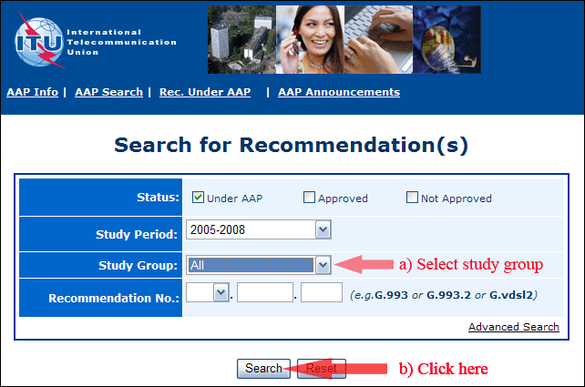
2) Select your Recommendation
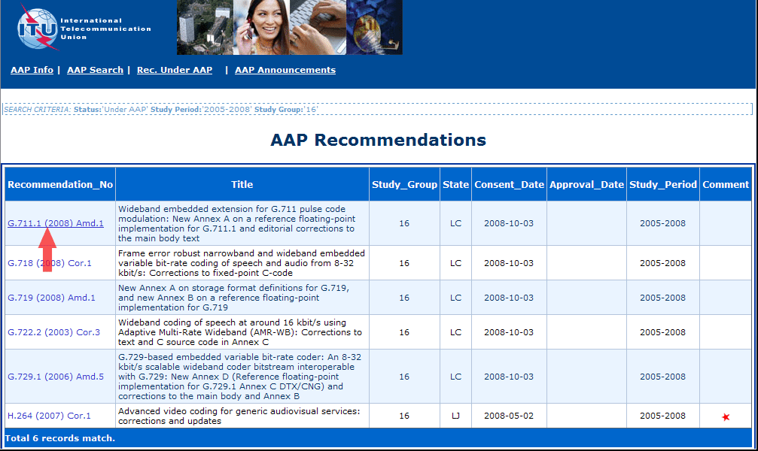
3) Click the "Submit Comment" button
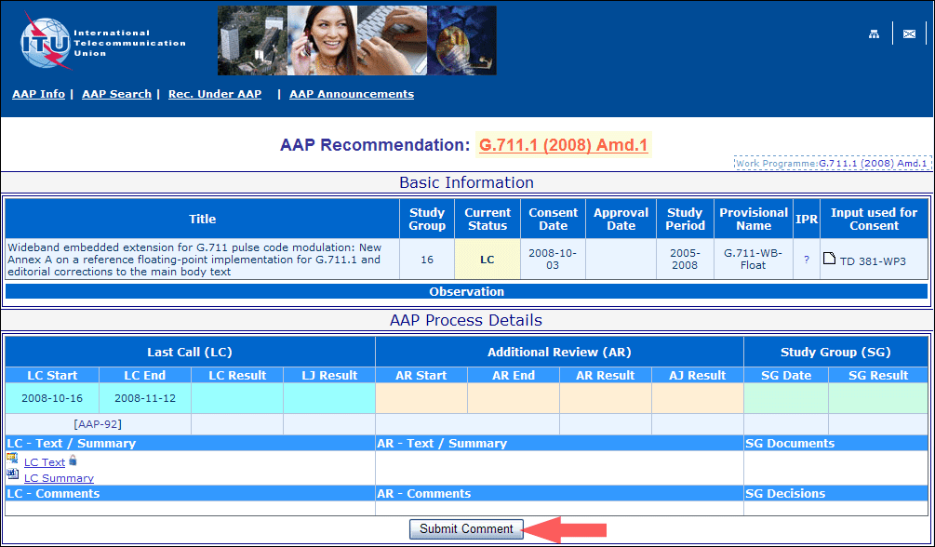
4) Complete the on-line form and click on "Submit"
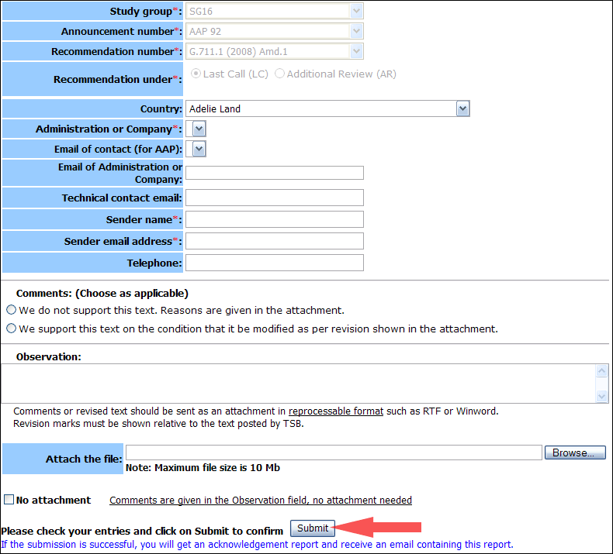
For more information, read the AAP tutorial on:
http://www.itu.int/ITU-T/aapinfo/files/AAPTutorial.pdf
Annex 3
(to TSB AAP-2)
Recommendations under LC/AR – Comment submission form
(Separate form for each Recommendation being commented upon)
ITU-T AAP comment submission form for the period 2009-2012
Study Group:
Announcement number:
Recommendation number:
Recommendation under: | Last call (LC)  Additional Review (AR)
Country:
Administration/Company:
Name of AAP Contact Person:
Email of AAP Contact Person:
Sender name:
(if different from AAP Contact Person)
Sender email address:
Telephone:
Comments:  (Choose as applicable) | We do not support this text. Reasons are given in the attachment.  We support this text on the condition that it be modified as per revision shown in the attachment.
Observations:
No attachment: Comments are given in the Observation field, no attachment needed
To be returned to: email: tsbsg....@itu.int
[or fax +41 22 730 5853]
Comments or revised text should be sent as an attachment in RTF or WinWord format.
Revision marks must be shown relative to the text posted by TSB.

* The responsibility for this Recommendation has changed from Study Group 4 to Study Group 2 as per WTSA-08 decisions.
* The responsibility for this Recommendation has changed from Study Group 17 to Study Group 11 as per WTSA-08 decisions.
* The responsibility for this Recommendation has changed from Study Group 17 to Study Group 11 as per WTSA-08 decisions.

