INTERNATIONAL TELECOMMUNICATION UNION |  |  |  | Focus Group On IPTV
TELECOMMUNICATION  STANDARDIZATION SECTOR  STUDY PERIOD 2005-2008 |  |  | FG IPTV- INTERIM -DOC-002 Rev2
 |  |  | English only
WG(s): 1 |  | 2nd FG IPTV meeting:  Busan, 16-20 October 2006
OUTPUT DOCUMENT
Source: | Editor
Title: | Working Document: IPTV Architecture

Content
1. Scope 2
2. References 2
3. Abbreviations 2
4. Definitions 2
5. Introduction 2
6. IPTV Relationship with NGN and other networks 3
7. Reference Model 4
8. IPTV Architecture 4
8.1 “Non-NGN-based” architecture 7
8.2 NGN-based IPTV Architecture 7
8.2.1 Non-IMS-based IPTV Architecture 7
8.2.2 IMS-based IPTV Architecture 8
8.3 Overall Architecture of IPTV 4

IPTV Architecture

Scope
[Editor’s Note: material is required for the scope.]

References
The following ITU-T Recommendations and other references contain provisions, which, through reference in this text, constitute provisions of this working document. At the time of publication, the editions indicated were valid. All Recommendations and other references are subject to revision; users of this working document are therefore encouraged to investigate the possibility of applying the most recent edition of the Recommendations and other references listed below. A list of the currently valid ITU-T Recommendations is regularly published.
The reference to a document within this Recommendation does not give it, as a stand-alone document, the status of a Recommendation
[1] ITU-T Recommendation Y.2012 (2006), Architecture and Requirement of the NGN

Abbreviations
This working document uses the following abbreviations.
IPTV Internet Protocol TV
NGN Next Generation Network
IMS

Definitions
This working document uses or defines the following terms:

Introduction
[Editor’s Note: introduction text is required here.]
3 approaches were identified for the architecture of IPTV.
(1) “NGN-based” and “IMS-based” architecture
An IPTV service component is drawn on top of the “other NGN service components” in NGN architecture shown in Figure 9. The IPTV service component is achieved by using IMS.
(2) “NGN-based” and “non-IMS-based” architecture
An IPTV service component is drawn on top of the “other NGN service components” in NGN architecture shown in Figure 7. The IPTV service component is achieved without using IMS.
(3) “Non-NGN-based” architecture
The architecture does not depend on NGN architecture [1], shown in Figure 6.
[Editor’s Note: need a figure to underline the differences between those 3 approaches.]

IPTV Relationship with NGN and other networks
The “NGN-based” architecture means the IPTV architecture in accordance with [1] for providing IPTV services. The NGN components described in [1] are shown in Figure 1.

[Editor’s Note: more text is needed here.]
[Editor’s Note: more text should be added to restate that the NGN Architecture does not exclude legacy networks .]

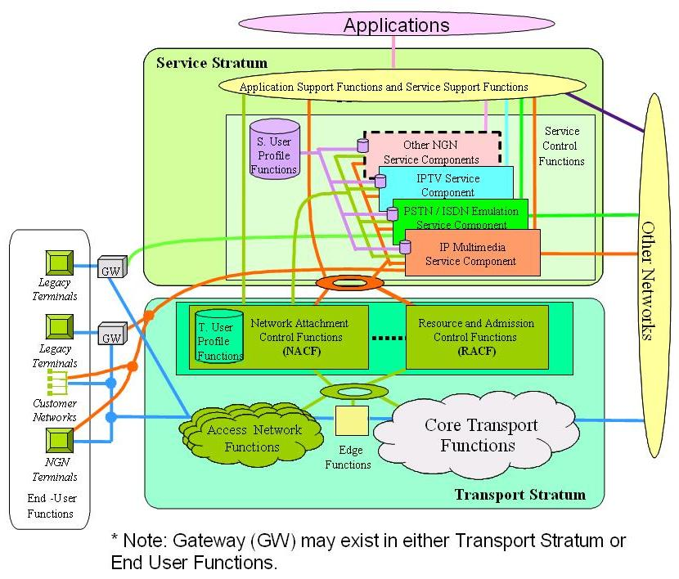
Figure 1 Transport and service configuration of the NGN

Reference Model

[Editor’s note : It was suggested during the scenarios that Content Aggregation Entity to be considered.]
Figure 2 Reference Model
[Editor’s note: The table of content is provisional and will include more sections]

IPTV Architecture

[Editor’s Note: There should be a section to describe Service Exchange Points. This note is coming from C-135 and not approved by WG.]

8.1 High Level Architecture of IPTV
[Editor’s Note: the ordering of those sections can be changed. ]

8.1.1 High Level Architecture 1

Figure 3 IPTV Functional Architecture
Information cross each reference point is listed as following (not complete),
- A: Content Stream
- B: Content Request, Descriptive Metadata/Content Info etc.
- C: Rights Management Interaction

- D: Service Interaction Message
- E: Content Location Info, Billing Info., Content Control Command, etc.
- F1: Play Control Signal
- F2: Content Stream
[Editor’s Note: The figure and attached text above is taken from FG IPTV-C-0170 with some modification.]

[Editor’s Note: the list below is picked from FG IPTV-C-0111 Figure 1.]
Service Management Platform Functions:
- Subscribe
- Service
- Account
- STB
- Content
- CP
- Resource
- Portal
- System
- Statistics

Figure 4 Functional Architecture of the Content Delivery Sub-system
[Editor’s Note: The diagram above is taken from FG IPTV-C-0169 with some modifications.]
[Editor’s Note: the diagram above is not yet approved by WG1. ]

8.1.2 High Level Architecture 2

Figure 5 Converged Applications

[Editor’s Note: the diagram above is coming from Ad-hoc meeting, and not be approved by WG1 yet.]

8.2 Non-NGN-based architecture

Figure 6 Non-NGN Based IPTV Architecture

[Editor’s Note: the diagram above is coming from Ad-hoc meeting, and not be approved by WG1 yet.]

8.3 NGN-based IPTV Architecture

8.3.1 Non-IMS-based IPTV Architecture

Figure 7 Non-IMS Based IPTV Architecture within an NGN Framework

[Editor’s Note: the diagram above is coming from Ad-hoc meeting, and not be approved by WG1 yet.]

Figure-8 Example of non-IMS-based architecture for unicast IPTV services

8.3.2 IMS-based IPTV Architecture

[Editor’s Note: The concept of maintenance needs to be introduced and need to be further studied.]

[Editor’s Note: IMS Argumentation need more text.]
IPTV IMS based architecture ensures:
  - SIP protocol dedicated to multimedia
  - Modular architecture
  - Easy integration with old telecommunication networks and exists services
  - Central billing system based on Parley OSA solution.
  - Third-party services
[Editor’s Note: the above text is not yet approved by WG1.]

Figure 9 IMS-Based IPTV Architecture within an NGN Framework
[Editor’s Note: the diagram above is coming from Ad-hoc meeting, and not be approved by WG1 yet.]

Figure 10 IMS-based architecture for IPTV

[Editor’s Note: The figure above is taken from FG IPTV-C-0156er1.]
[Editor’s Note: The entities in light blue in the figure above may require modifications beyond the ITU-T SG13 definition.]

Figure 11 Example of IMS-based architecture for unicast IPTV services

