Table of contents
Page
Executive summary iii
1 Introduction 1
2 Potentials of GHG abatement by ICT services 2
2.1 GHG reduction effects by ICT services 2
2.2 Existing studies and initiatives for GHG abatement and their limitations 4
3 Korea’s situation 8
3.1 Currents status of ICT industries 8
3.2 Current status of GHG emissions 9
3.3 Policies and regulations for climate change mitigation 10
3.4 Approach for the abatement of GHG emission in ICT industry 12
4 Approach and methodology in this report 14
4.1 Methodology development 14
4.2 Selection of ICT services 16
5 Second order effects of GHG emission abatement by ICT services (use stage) 18
5.1 Estimated GHG emission reductions by each ICT service 19
5.2 ICT services as abatement enablers 51
6 Conclusions and way forward 53
Acronyms 54
Bibliography 56

Executive summary
Information and communication technologies (ICTs) have drawn attention recently as a solution to reinforce environmental protection, reduce the impact created in the environment by human activities, and address key environmental challenges such as climate change.
The possible uses of ICT to promote environmental sustainability can be grouped into two types of applications which could be defined as ‘Greening of ICTs’ and ‘Greening through ICTs’. ‘Greening of ICT’ here refers to the reduction of carbon intensity of the ICT sector itself, while ‘Greening through ICT’ indicates the de-carbonization that can be achieved in other sectors by implementing ICT services. Considering that the greenhouse gas (GHG) emissions generated by the ICT sector represent about 2-3% of global emissions, it can be affirmed that ‘Greening through ICT’ may have greater effects on the environment since its positive effects can be applied to the overall global GHG emission potentially with much greater degree than ICT’s own footprint.
Many organizations including the International Telecommunication Union (ITU) have studied in recent years the positive role of ICTs toward climate change and the environment, developing technical standards and recommendations needed to mainstream the successful pilot projects implemented across many countries. Most initiatives implemented up to date have been focusing on the ‘Greening of ICTs’ and not ‘Greening through ICTs’, even though it is well known that ‘Greening through ICTs’ is a more effective way to abate GHG emissions. The recent ‘SMARTer 2020’ report confirmed the importance of ICT services and demonstrates that the positive contribution of ICTs to greening other sectors could be seven times the negative impact of ICTs to GHGs.
Korea is one of the most advanced countries in ICTs; the ICT industry has been a major sector in Korea since the late 1990s and it accounted for 10% of Korea’s GDP in 2011. Along with this industrial trend, the penetration rate of ICT equipment such as personal computers and mobile phones is very high. This means that the infrastructure of ICT is well equipped in Korea and the people’s technical acceptance in using ICT devices is high. The Korean government has also tried to apply ICT in government administration by implementing e-government initiatives as well as certain ICT services as a key strategy to achieve Korea’s new national vision, ‘Low Carbon, Green Growth’. The Korean government has been designing a Five-year Plan of Green Growth and Green IT National Strategy in order to actively participate in GHG emission reduction and climate change mitigation. Furthermore, Korea was selected as the host country of the secretariat of the United Nations Climate Fund under the name of GCF (Green Climate Fund).
However, detailed studies to assess the environmental impacts of ICT on GHG emissions in Korea need to be further developed. Therefore, the purpose of this report is to demonstrate the potential GHG reductions by ICT services, estimate the reduced volume of GHG, and identify major ICT GHG reduction enablers in Korea.
This report comprises a review of more than 30 ICT services through a literature study and global benchmarking. After having considered theoretical carbon abatement potentials, technology maturity, and the importance of each service in the context of domestic policies, 14 key ICT services have been identified: real-time navigation (RTN), bus information system (BIS), e-logistics, telepresence, home energy management system (HEMS), smart grid, e-commerce, e-government, e-civil service, e-health care, digital contents, smart motor, e-learning and smart work.
One of the objectives of this report is to assess the potential GHG reduction, which is achieved by segregating the areas impacted by ICT services to prevent double counting of the impacts. In order to avoid double counting in estimating the positive environmental effects on GHG emission by ICT services, the affected sectors have been grouped into three parts: transport, buildings, and industry. The enabling effects from ICT services were identified, estimated for each of the three sectors and summed up for comparison. This analysis then allows for recommendations on the sectors with the biggest abatement potential. The methodology adopted in this report follows some of the principles of Recommendation ITU-T L.1410: Methodology for the assessment of the environmental impact of information communication technology goods, networks and services. Specifically, this report follows some of the procedures in Part II of the Recommendation and estimates the reduced GHG emission from 2011 to 2020 using the following six steps: (1) identify the influenced sectors, (2) define the scope and boundary, (3) develop the reference product system (baseline scenario) and ICT scenarios, (4) estimate GHG abatement, (5) project GHG abatement by 2020, and (6) aggregate enabling effects in each sector.
In other words, this report focuses on the GHG emission reduction potential enabled by the use of ICT services, i.e. the negative impact corresponding to the production, use and end-of-life treatment of the ICT services themselves has not been analyzed in this report. Referring again to Recommendation ITU-T L.1410 Part II, this means that the enablement potential related to the reference product system has been considered but not the impact from the ICT service itself. Future research taking into account also the impact of the ICT product system would give a more accurate result. Excluding the negative impact of the ICT service itself principally means that the calculated potential may be too large and this effect should be evaluated in the future. However, referring to the relatively small footprint of the ICT sector, the simplified approach applied in this report can give a relevant indication of the potential of the assessed ICT services.
The first five steps of the assessment procedure were applied to all 14 ICT services and estimated GHG abatement in both 2011 and 2020. The sixth step, aggregating the GHG reduction by sectors, was conducted after figuring out GHG abatement of each ICT service.
This report identified the following key findings:
• The use of smart grids is estimated to give the highest potential among the 14 ICT services, followed by telepresence, e-commerce, e-civil service, e-logistics, RTN and e-government. The table below shows the potential GHG abatement of each ICT service.
Potential GHG emission reduction of 14 ICT services
ICT services | Year 2011 | Year 2020
 | GHG abatement (Units: million tCO₂e) | GHG abatement (Units: million tCO₂e)
1. Smart grid | 1.98 | 68.70
2. Telepresence | 0.86 | 11.03
3. E-commerce | 1.09 | 7.93
4. E-civil service | 0.47 | 6.11
5. E-logistics | 1.34 | 4.79
6. Real-time navigation | 0.59 | 3.57
7. E-government | 0.15 | 3.48
8. Home energy management system | 0.76 | 2.96
9. Smart motor (Industrial) | 1.61 | 2.89
10. Digital contents | 0.52 | 2.05
11. Smart work | 0.17 | 1.89
12. E-learning | 0.69 | 1.61
13. Bus information system | 0.25 | 1.40
14. E-health care | 0.02 | 0.04
Total | 10.3 | 118.4
• The total amount of expected GHG abatement through these 14 ICT services in 2020 is approximately 118 million tCO₂e, which is eleven times greater than the amounts abated in 2011.
• This 118 million tCO₂e forms approximately 14.5% of predicted Korea’s domestic GHG emission in 2020. This is approximately 5.8 times the predicted carbon footprint of ICT industry in Korea in 2020.
• All effects estimated in this report are segregated into three sectors and the expected GHG reduction is calculated in each sector. It is expected that the transport sector has the greatest potential for reducing GHG emission through the use of ICTs. Even though the industry sector has the greatest amount of GHG reduction, the portion of GHG reduction compared to the expected GHG emission based on Korean governmental estimation in the industry sector was relatively smaller, while the transport sector is expected to reduce more than 30% of GHG emission.
Potential GHG emission reduction compared to BAU
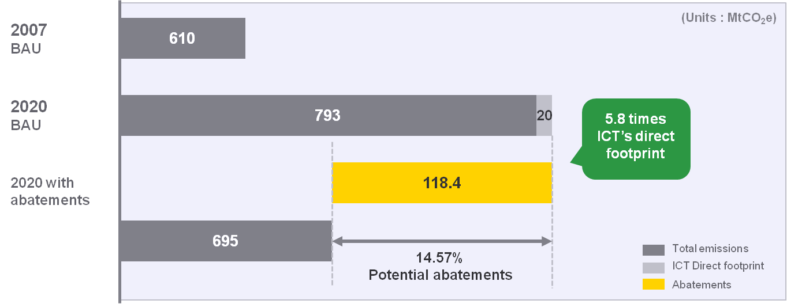

The role of ICTs in climate change mitigation is significant as it has the potential to reduce both the ICT sectors carbon footprint and the GHG emissions from other industries. Therefore, certain ICT services that are expected to reduce the high amount of GHG emission should be developed and implemented. However, it is challenging to assess this impact in an accurate manner because of the importance of usage scenarios which are difficult to predict.
This report is based on available and primary data. The following limitations related to the quantification of the environmental impact of the selected ICT services. The first order effects of ICTs, whether for use stage or embodied impact, have not been assessed. Furthermore, it was not possible to assess the life cycle impact of the reference scenario, only its use stage. Despite this, the obtained results are relevant as they give a first estimation of the GHG emissions reduction potential that ICTs could bring to Korea.
Quantification of ICTs impact on climate change mitigation is an effective tool to provide policy makers including mayors of cities, users, ICT industry, and other relevant stakeholders with more accurate information on the potential to achieve a low carbon society.

1 Introduction
Information and communication technology (ICT) has dramatically improved the quality of our lives and significantly contributed to economic growth. The development of the ICT sector has resulted in the increased consumption of resources and energy and has been responsible for an increase in the release of greenhouse gases (GHG). However, the ICT sector has the potential to create environmental benefits by allowing other sectors to save energy, produce and consume more efficiently and therefore reduce net GHG emissions.
Globally, the number of mobile cellular subscriptions rose from 145 million in 1996 to 6 billion in 2011. In Korea, over 52 million people used mobile phones in 2011 suggesting almost every Korean owns and uses a mobile phone. As the penetration rate of ICT services rises, the importance of ICT in environmental protection and climate change abatement (and adaptation) becomes greater; therefore, the role of ICTs should not be neglected in reducing greenhouse gas (GHG) emission.
Much research has been undertaken to assess ICTs impact on climate change mitigation. Among the various endeavours and initiatives in the domain of the assessment of ICTs impact on climate change mitigation, the activities of ITU-T Study Group 5 (SG5) are worth to mention here. ITU-T SG5 is responsible for developing methodologies for evaluating the ICT effects on climate change and publishing guidelines for using ICTs in an eco-friendly way. ITU-T SG5 work also encompasses common agreed methodologies for assessing the GHG emissions related to ICT, to facilitate the measurement of the impact of ICTs on emissions and support meaningful reporting and comparisons. ITU-T’s methodologies will help establish greener business cases and support informed consumer choices and climate-friendly business procurement.
This report is part of this effort and aims to show that ICT has the potential to significantly contribute to the emission reduction in many different sectors in Korea. The term, ‘Greening through ICTs’ has been proposed to distinguish between ICTs multi-layered impacts on GHG emissions in other sectors from its reduced carbon intensity in the ICT sector. More details are presented in the following chapter. Korea has been identified as the country of application for this report as it is a leading country in ICT distribution and green growth policy.
The purpose of this report is to undertake an assessment, and investigate the GHG reduction potential of ‘Greening through ICTs’ solutions and the corresponding reduction amounts in the GHG inventory of Korea. The scope of the report includes:
• The role of ICT in climate change mitigation
• Government policies and regulations for climate change
• ICT services of global and domestic telecom companies
• Comparison of GHG abatement potential of ‘Greening through ICTs’ and ‘Greening of ICTs’ services
• Potential contributions of ICT enablers to reduce GHG emission in Korea
• Approach and methodology to quantify the GHG emission reduction potential of the selected ICT enablers
• Quantification of GHG abatement potential by different enablers in the Korean context
• Prioritization (based on ease of implementation and GHG abatement potential) of ICT enablers in the Korean context.

2 Potentials of GHG abatement by ICT services

2.1 GHG reduction effects by ICT services
As the ICT industry markets increase sharply, their roles in daily lives have become more significant. According to SMARTer 2020, the estimated emissions from the ICT industry in 2011 were 0.9 GtCO₂e which is 1.9% of all global GHG emissions. By 2020, it is estimated that 1.3GtCO₂e emissions will be from the ICT industry as the use of ICT devices and services increases.
According to the ‘Mobile’s Green Manifesto 2012”, it has been estimated that CO₂e emissions from the network in different regions of the world were approximately 70 million MtCO₂e for 2010, which is less than 0.2% of the global total CO₂e emissions. It is shown that despite considerable growth in connections and traffic among mobile networks, their total network energy consumption increased only slightly from 2009 to 2010. In addition, the total energy per traffic unit has declined by 5% in the same period, indicating that the telecom industry is making strong progress towards reducing its total global GHG emission per connection.
Along with the endeavour to reduce the direct carbon footprint generated by the ICT sector, ICT plays a critical role in climate change since a variety of opportunities are associated with the use of ICT in terms of their enabling effects. High-speed Internet services allow consumers from many countries to enjoy online shopping instead of driving to retail stores, which requires less space for retail facilities and consumes less energy to build and operate stores. A research group from Carnegie Mellon University estimated that compared to traditional retail, e-commerce has approximately 30% lower energy consumption and GHG emissions.
As teleconference services become more accessible, there is the potential to replace air and land travel with video and audio conferences, reducing GHG emissions. If teleconferencing replaces air travel by 10% within the next 10 years in the United States, approximately 200 million tons of GHG abatement could be achieved (ACI, 2007). Telecommuting could reduce the consumption of fossil fuels and lower GHG emissions due to the reduced travel. Dematerialization is another key GHG abatement opportunity using ICT. The demand for paper mail, newspaper subscriptions, and physical billing is decreasing as e-mails, online newspapers, and web billing becomes more popular. Shifting all newspaper subscriptions from paper to online has the potential to reduce 57.4 million tons of CO₂ emissions over the next decade (ACI, 2007). Table 1 provides the list of expected impacts in different areas affected by ICT.
Table 1 − Expected emission reductions or growth by ICTs in selected areas
Affected areas for GHG reductions | Expected impacts (examples)
Buildings | • Less space for storages as retail stores are replaced by online shopping  • Higher energy efficiency by advanced cooling and heating systems
Industrial production | • Producing fewer products and goods through dematerialization  • Lower energy consumption per produced unit by using ICT-equipped machines such as smart motors
Waste | • Less GHG emission by replacing compact discs with music streaming and downloads
Energy supply systems | • Reduced power losses through accurate demand and supply estimation enabled by ICT  • Less use of fossil fuels and increased share of renewable energy enabled by the use of smart grids
Transportation | • Less use of vehicles with fewer trips due to telepresence and telecommuting  • Higher fuel efficiency of vehicles through the increased speed incurred from reduced traffic jams  • Higher fuel efficiency by using ICT-based smart transport systems, for example, bus information systems and real-time navigation
Others | • More leisure time for people, which can be spent for GHG increasing activities (rebound effect)
(Source: WWF, ‘The potential global CO₂reductions from ICT use’).
The term ‘green’ can be used to systematically explain the effects of ICT and its use. ‘Greening through ICTs’ refers to decarbonization of other sectors by implementing ICT solutions, while ‘Greening of ICTs’ indicates the reduced carbon intensity of the ICT sector itself, as described in Figure 1. According to a recent study, GHG abatement effect through ‘Greening though ICTs’ is estimated to be equivalent to five times the GHG abatement from the ICT sector if ICT enablers are actively utilized.
Figure 1 – Conceptual differences of ‘Greening of ICTs’ and ‘Greening through ICTs’
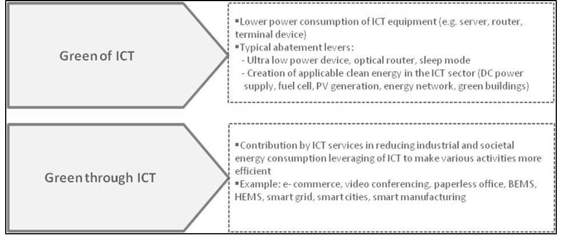

2.2 Existing studies and initiatives for GHG abatement and their limitations
Most literature published after the year 2000 on the impact of ICTs on the environment and climate change focuses on raising awareness of the various ICT services’ positive short-term environmental effects, but is unable to fully capture the multi-layered influences that ICT solutions have on the environment. Understanding the interaction between GHG emissions and ICT services is limited by of the following difficulties:
• Individual ICT solutions are deployed as part of multiple and inter-linked processes. For example, smart phone users simultaneously use several services such as music downloading, web-searching and navigation services. This multiple usage aspect acts as a hurdle to calculating the specific and direct emissions of a particular ICT service.
• ICT use has a broad and deep impact on the economy and society. As the impact of ICT services involves not only environmental but also societal issues, the characteristics of ICT effects are usually pervasive and transformative. They involve not only first order effects which can be captured in a relatively shorter time frame, but also second and other effects which occur over the longer time frame. These effects are further described in Figure 8.
• ICT services involve usage scenarios. The total impact of ICT services is accompanied with user behaviour, and changes can be abrupt and therefore difficult to predict.
Few studies have attempted to cover the complex dynamics outlined above in attempting to assess the potential of ICT services in reducing GHG emissions. However, more concrete and advanced approaches have been developed for certain ICT services with minimal input of usage scenario such as machine-to-machine and smart metering application,.
Not only do the complexities of the ICT services limit the scope and depth of recent studies but also the incompleteness and low confidence of ICT-related statistics. ICT-related statistics are usually collected for a large geographic boundary, such a national or continent level, focusing on ICT-related equipment production or ICT service subscription of the number of users. Therefore, it is very challenging sometimes to sort out ICT impact on the available ICT statistics.
From the timeline perspective, most reports analyze the future projections of GHG abatement by assuming an increased service penetration rate in terms of the improved efficiency, achieved by ICT. On the contrary, the historical analysis, which could suggest how much GHG emissions have been reduced by ICT services, has not yet been conducted. In addition, most of the reports mix the top down and bottom up approach to
develop a model and future scenarios in order to overcome the limitation of available statistics. Moreover, the quantification process in most of the reports carries the risk of overlapping impacts in the ICT services on estimating an accumulated GHG reduction potential within a certain geographic boundary.
To overcome these inherent difficulties in calculating ICT services’ GHG reduction potential, a report published by OECD suggests that the prerequisite for fully encompassing ICT effects on the environment should be the preparation of more expanded official statistics in the area of ICT use, industries, and products.
ITU-T, the Telecommunication Standardization Sector of ITU with its study groups has been working on producing international standards known as ITU-T Recommendations that are fundamental to the operation of today’s ICT networks. Furthermore, ITU-T identified the importance of determining the impact of ICTs on climate change from the standardization viewpoint and is focusing on the development of standardized methodologies to assess the environmental impact of ICT. Some of the tasks of the ITU-T study groups include:
• Developing Recommendations on methodology for assessing the environmental impact by ICTs, considering general principles, criteria of ICT impact evaluation, system boundaries, functional units and environmental load intensity
• Developing Recommendations on collecting and calculating reliable rough data to inject in the assessment model
• Developing Handbooks as necessary making reference to available databases related to common environmental load intensities.
ITU-T is composed of several study groups; Table 2 lists some of those study groups and their main activities.
Table 2 − Summary of the main work of some ITU-T study groups
Study group |  | Main tasks | Work highlights
Study Group 5 (SG5): Environment and climate change | • Lead SG on  • Electromagnetic compatibility and electromagnetic effects  • ICTs and climate change | • Developing methodologies to evaluate ICT effects on climate change and publish guidelines on using ICTs in an eco-friendly way  • Designing methodologies to reduce environmental effects | • Developed an energy-efficient one-charger-fits-all new mobile phone solution  • Encompassed common agreed methodologies for assessing the carbon footprint of ICTs  • Started work in an area important to the development of home networking technology
Study Group 15 (SG15): Transport and access and home | • Lead SG on  • Access network transport  • Optical technology  • Optical transport networks  • Smart grid | • Specialized in digital subscriber line (DSL) standards which provide broadband Internet connections for over 600 million households around the world  • Working on how to maximize network capacity between the exchange and the customer premises | • Standardization relating to passive optical networks (PONs) which are an effective way for implementing fibre-to-the-home/building  • Developing standards for the backbone architecture including the key standards for synchronous data transmission over fibre-optic networks, synchronous digital hierarchy (SDH)
Study Group 16 (SG16): Multimedia | • Lead SG on  • Multimedia coding, systems and applications  • Ubiquitous and Internet of Things applications  • Telecommunication/ ICT accessibility for persons with disabilities  • Intelligent Transport System (ITS) communication  • IPTV | • Multimedia (MM) coding, terminals, systems and applications along with coordination of the studies among the various ITU-T SGs.  • Ubiquitous applications such as e-health and e-business. | • The origin of a wide family of successful videoconferencing systems, it is now developing telepresence systems.  • The collaboration with ISO/IEC’s JPEG and MPEG working groups has led to world-class video compression standards: ITU-T H.264 and ITU-T H.265, that deliver excellent quality across for a wide range of applications.
More specifically, ITU-T Study Group 5 is developing a set of methodologies to assess the environmental impact of ICT. In the frame of ITU-T study group 5: “Environment and Climate Change”, the Question on methodologies develops a set of methodologies to assess the environmental impact of ICT as follows:
• Recommendation ITU-T L.1400 - General Umbrella – available here: http://www.itu.int/rec/T-REC-L.1400
Recommendation ITU-T L.1400 provides a definition of the different types of environmental impacts, and general principles for the evaluation of the ICT environmental impacts.
• Recommendation ITU-T L.1410 - Environmental impact of ICT goods, networks and services – available here : http://www.itu.int/rec/T-REC-L.1410
Recommendation ITU-T L.1410 complements ISO 14040 and ISO 14044 and provides guidance on how to assess the environmental impacts of ICT goods, networks and services. There are two Parts in the Recommendation: Part I: ICT Life cycle assessment: framework and guidance, and Part II: Comparative analysis between ICT and a reference product system (baseline scenario): framework and guidance. The two Parts describe clear steps to follow in order to assess the environmental impacts over the entire life cycle. This helps identify the major activities and life cycle stages that are impacting the environment, design and prepare action plans, prioritize actions and also identify risks, save costs and develop new opportunities.
• Recommendation ITU-T L.1420 Environmental impact of ICT in organizations – available here: http://www.itu.int/rec/T-REC-L.1420
Recommendation ITU-T L.1420 complements ISO 14064-1 and provides guidance on how to assess energy consumption and GHG emissions. Recommendation ITU-T L.1420 covers: the assessment of the life cycle environmental impact of ICT goods, networks and services used by an organization (“Non-ICT organizations”), the assessment of the environmental impact of an ICT organization (“ICT organizations”), the reporting of these impacts to ensure fair and transparent communications
• Recommendation ITU-T L.1430 Environmental impact of ICT projects.
This Recommendation specifies the principles, requirements and methods in order to quantify, monitor and report GHG emission reductions, energy consumption savings, energy efficiency improvements resulting from ICT projects, in complement to ISO 14064-2 and GHG Protocol.
• Environmental impact of ICT in cities, forthcoming Recommendation ITU-T L.1440
This Recommendation will present general principles on how to evaluate the environmental impact of information communication technologies (ICTs) in cities, or other urban areas with a focus on greenhouse gas (GHG) emissions.
• Environmental impact of ICT in countries, forthcoming Recommendation ITU-T L.1450
This Recommendation will present general principles on how to evaluate the environmental impacts of ICT in countries or group of countries and will evaluate how ICT may reduce the rate of GHG accumulation in the atmosphere by reducing demand for energy and to conserve scarce resources such as fossil fuels.
All Recommendations are built in close cooperation with a large number of representatives from the ICT sector and governments, and in cooperation for instance with ISO, ETSI, IEC, UNFCCC, UNEP, UN-HABITAT, GHG Protocol and other organizations.
Furthermore, ITU along with 50 partners developed a Toolkit on Environmental Sustainability for the ICT Sector with a special focus on “Assessment Framework for Environmental Impacts of the ICT Sector”. This document explores how the various standards and guidelines can be mapped so that an organization can create a sustainability framework that is relevant to its own business objectives and desired sustainability performance.

3 Korea’s situation

3.1 Currents status of ICT industries
Korea’s ICT-sector has grown to be a core industry accounting for 10.35% of the national GDP in 2011, as Figure 2 clearly suggests. According to statistics on Korea, the degree of contribution to GDP by ICT has increased from 3.53% in 1996 to 9.32% in 2007 and 10.35% in 2009. ICT industry has also contributed considerably to the trade surplus. The amount of ICT export was USD 120.9 billion corresponding to 33.3% of the total export in 2009. The Electronics and Telecommunications Research Institute (ETRI) in Korea predicts that the domestic market will increase from USD 36.5 billion in 2010 to USD 123.7 billion in 2020 with 13.0% of Compound Annual Growth Rate (CAGR).
Figure 2 − The increased proportion of ICT sector in all industries in Korea (source: Statistics Korea)
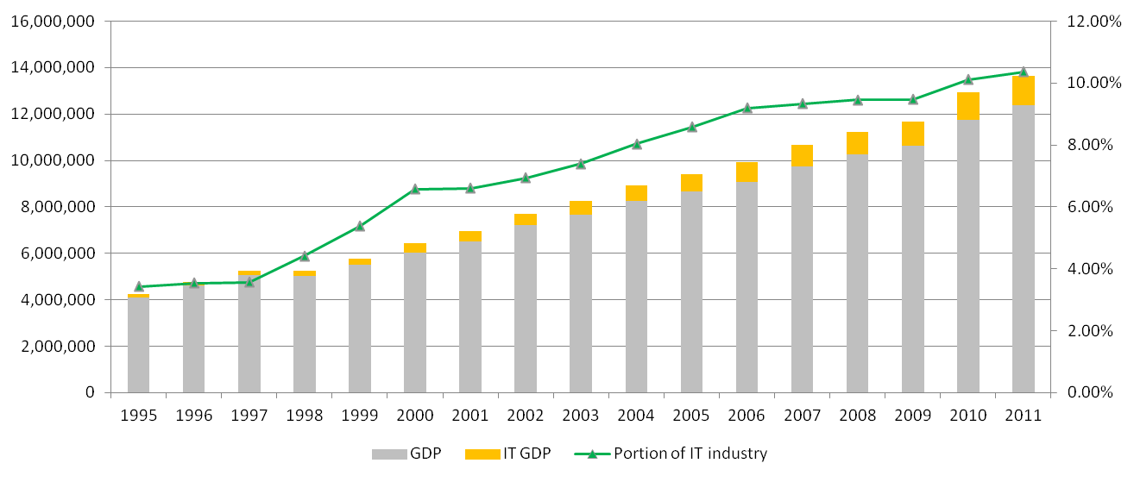

According to International Data Corporation, Samsung, the Korean mobile phone manufacturer, has emerged as the second biggest smartphone manufacturer capturing 22.8% of the world markets as of the fourth quarter of 2011. In addition, Korean LCD and DRAM takes market share of 53% and 63% respectively in the global market. It is noticeable that Samsung has topped the biggest market share in global flat-panel TV market for seven consecutive years. Besides market share of ICT industry, ICT usage rates have grown sharply in Korea. For instance, the number of PCs per 100 people had jumped from 25.01 in 1999 to 67.5 in 2009. Moreover, the penetration rate of mobile phones in Korea has increased steadily and reached over 100% in 2011, which indicates that almost everyone uses a mobile phone service.
All these figures indicate that the ICT sector is well-developed in Korea attributable to the strong support from ICT-related environments and infrastructures for consumers to enjoy those services. ICT development indices published by ITU summarize Korea’s advanced status in ICT, where Korea is ranked at the top among more than a hundred countries.

3.2 Current status of GHG emissions
Korea’s carbon emissions have increased significantly during the last 15 years, making Korea one of the countries with the fastest growth of carbon emissions.
Figure 3 − GHG emission and GHG emission per GDP in Korea
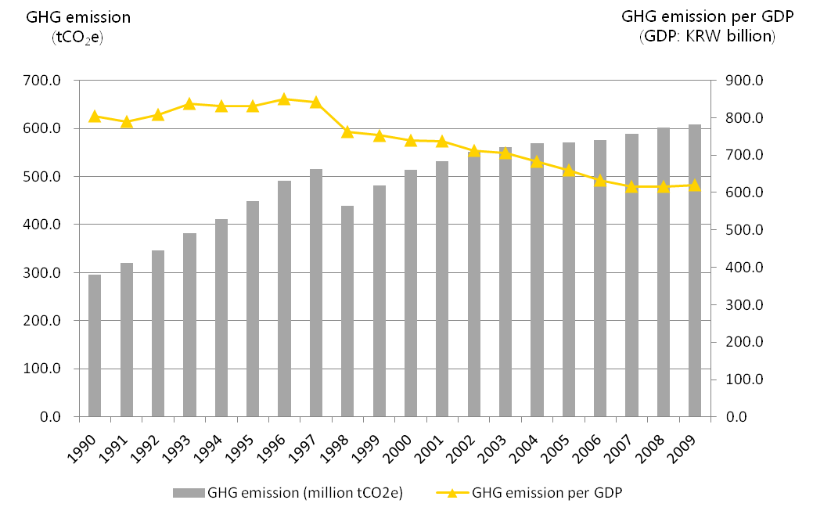

The emissions from ICT-related industry represented approximately 2% of the national GHG emission of 610 million tCO₂e in 2007. Among the total amount of emissions from ICT-related industries, the manufacturing of electronic components and graphic, sound or communication equipment accounted for more than 91%, and the wireless service comprised 6% of the entire ICT industries’ emissions as described in Figure 4. Considering that the ICT contribution level to the national economy reached 9.32% in the same year, it is clear that ICT has performed a key role in low-carbon green growth in the Korean economy.

Figure 4 − Composition of Korean GHG emission by ICT industry in 2007 (source: Korea energy Management Corporation)
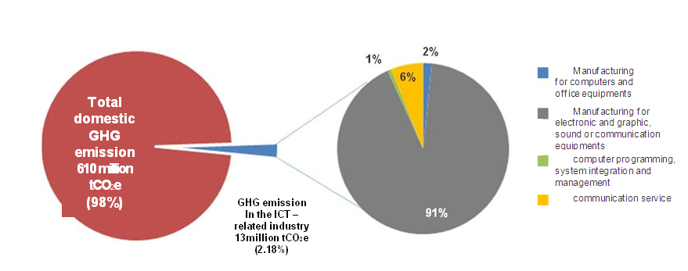

However, the amount of GHG emissions from this industry is forecast to increase as Korea’s ICT industry grows and more energy is required. Figure 5 presents the predicted GHG emission scenario of ICT-related industries in Korea. The amount of GHG emission from ICT industry is estimated at approximately 20.3 million tCO₂e by 2020 with an annual growth rate of 3.3% .
Figure 5 − The volume of GHG emission by the ICT industry in Korea (unit: million tCO₂e)
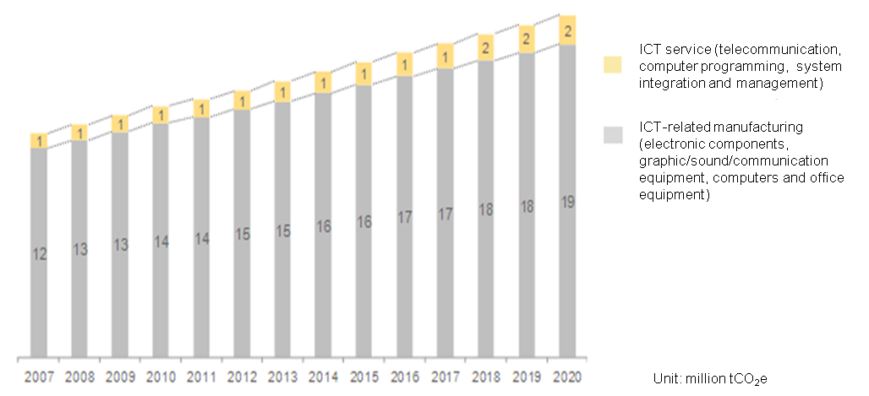

3.3 Policies and regulations for climate change mitigation
The rapid industrialization and urbanization induced by Korea’s remarkable economic growth has led to a significant pressure on its environment and natural resources. In addition, Korea’s high dependence on imported energy makes Korea particularly vulnerable to fluctuations in energy prices and supplies. Responding to these challenges, ‘Low Carbon, Green Growth’ was selected as Korea’s new national vision. In order to facilitate the realization of this new vision, the Presidential Committee on Green Growth (PCGG) was established in February 2009. PCGG has the overall responsibility to implement and manage the government’s participation in the international endeavour to reduce GHG emissions. Later on, the Framework Act on Low Carbon, Green Growth, which is the world’s first comprehensive law on climate change, energy, and sustainable development, was legislated. In July 2009, the country adopted the Five-year Plan of Green Growth (2009/2013) aiming to serve as a medium-term plan for implementing Korea’s low carbon green growth vision and outlining a set of three strategies and ten policy directions explained in Figure 6.
This Five-year Plan announces action plans for each of the ten policy directions in which ICT is a key implementation tool. Green ICT including green personal computers, telecommunications, and servers is selected under the policy direction to ‘develop green technologies as future growth engines.’ Advanced industries including u-health, smart grid, waste management using ICT, and public transportation equipped with a smart transportation system are also selected as priority areas. Under this Plan, USD 83.6 billion, representing 2% of GDP, will be spent in the area of climate change and energy, sustainable transportation and the development of green technologies.
Figure 6 − Korea’s five-year plan for green growth
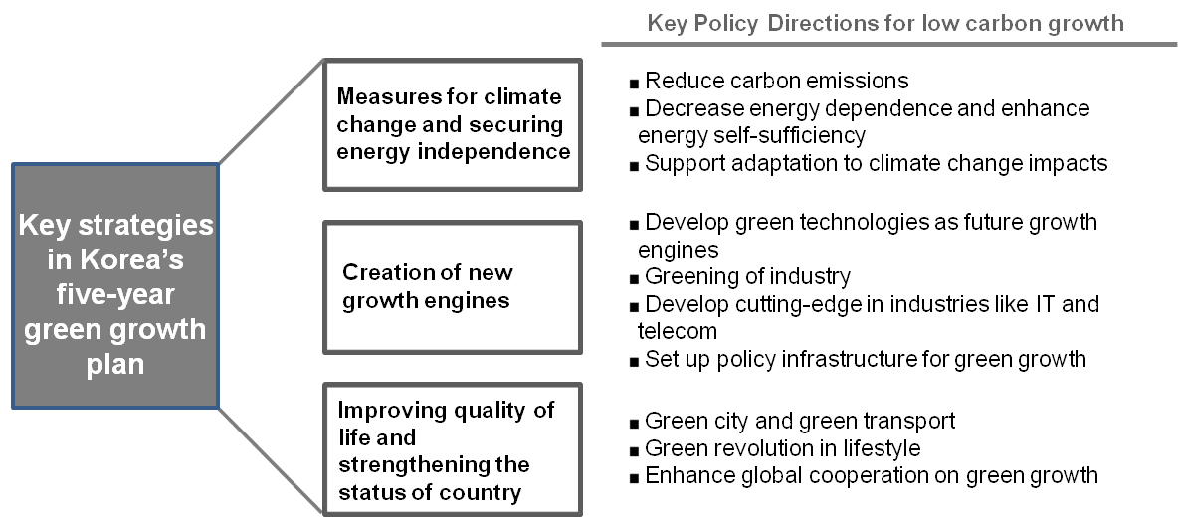

Several months before PCGG published the Five-Year Plan, it announced the ‘Green IT National Strategy’ which is based on the previous ICT policies. Under the vision of ‘a leading country in global green IT’, three key objectives are selected: (1) greening and making future growth engines of IT, (2) converging to smart low-carbon society which utilizes IT, and (3) capacity-building for climate change adaptation based on IT. The top nine policy directions including low carbon work environment, smart grid, and green ICT services are chosen accordingly. In October 2010, the Ministry of Knowledge and Economy announced the ‘IT Industry Vision 2020’ which emphasizes the importance of ICT industry in terms of sustainable economic growth. This aims to realize the concept of Smart Korea. Its major policy directions enhance an overall growth of industries and building creative ICTs.
As of 2012, Korea was selected as a host country of the secretariat of the United Nations Climate Fund under the name of GCF (Green Climate Fund), which is a UN fund established to distribute some of the aid pledged by developed countries to relatively poorer countries. Korea is expected to play a bigger role on the international stage in tackling global challenges and to become the centre for global efforts in order to move toward climate change and green growth.

3.4 Approach for the abatement of GHG emission in ICT industry
In this clause, a number of GHG reduction activities by Korean IT manufacturers and telecommunication players in Korea are introduced as quantified and reported by these organizations. These companies have been endeavouring to make a ‘greener’ workplace with their own visions voluntarily.
SK Telecom (SKT) has endeavoured continuously to reduce GHG emission. SKT has been participating in CDP (carbon disclosure project)) since 2008 in which a wide range of companies have participated. SKT has disclosed to the public, detailed information related to carbon emission. SKT has been selected as the top company in the telecommunication sector in CDP for two years in Korea. SKT has set three goals including ‘Responding to climate change’, ‘Reducing GHG emissions’ and ‘Establishing an eco-friendly corporate culture’ with specific strategies. SKT expanded the scope of GHG management and diagnosis of energy consumption by using real-time monitors. In addition, SKT endeavours continuously to reduce GHG emission in SKT offices. By establishing an integrated lighting control system and improving the efficiency of heating and air conditioning, SKT achieved 2.7% reduction in electricity consumption. In addition, SKT attempts to reduce paper use by expanding the use of electronic bills and, to minimize the impact on the environment, by complying with its duties for installing eco-friendly mobile communication network systems.
Samsung Group announced ‘Samsung Green Management Vision 2020’ in 2011. Under this Vision, Samsung Electronics plans to invest KRW 23 trillion into green businesses such as solar cells, secondary cells for vehicles, and light-emitting diodes (LED). According to its corporate sustainability report in 2012, Samsung Electronics has implemented its own ‘Eco-Management 2013.’ Through installing low carbon business places, producing eco-friendly products, and building green partnerships, it targets to reduce 50% of its GHG emission and produce 100% of eco-friendly products by 2013. It already accomplished reducing 23% of GHG emission at the user phase.
In 2009, LG Electronics (LGE) established a voluntary target for GHG emission reduction with strategic directives under the ‘Low Carbon Green Strategy.’ By operating low carbon factories and improving productivity, it aimed to reduce 0.15 MtCO₂ by 2020. This corresponds to 10% reduction compared to 2008 baseline. LGE has also encouraged its customers to use low carbon solutions, and its target was set to reduce 30 million tCO₂e compared to 2020 BAU (business-as-usual) based on 2007 at user stage. As a result of these endeavours, LGE has achieved substantial reductions. In 2010, LGE achieved an abatement of 0.16 million tCO₂e of GHG emission.
KT and LG U+ which are other telecommunication companies in Korea also made efforts to reduce GHG emissions. Under the vision of ‘Green Convergence Leader’, KT established its own GHG emission reduction target of 20% by 2013 compared to 2005. To attain this abatement target, KT has reduced the use of fossil fuels through alternative energy sources and upgraded telecom and ICT infrastructure as well as the green workplace. For instance, KT has started a Green Office programme which encouraged employees to participate in reducing GHG emission at the workplace. Ninety office buildings are equipped with a videoconference system so that carbon emissions and travel costs can be cut down with the accelerated work productivity.
Figure 7 − GHG emissions and abatement targets by major ICT companies: (a) SKT, (b) Samsung, (c) LG Electronics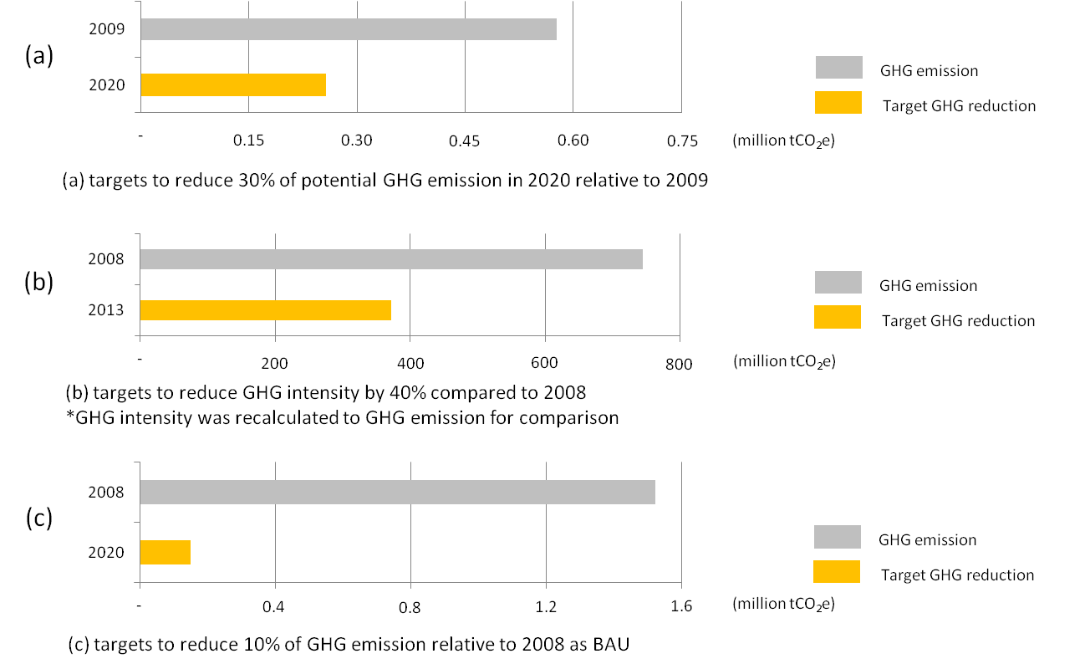

4 Approach and methodology in this report

4.1 Methodology development
Recommendation ITU-T L.1410 provides the framework and guidance to assess the environmental impact of ICT goods, networks and services (GNS) from the life cycle perspective. The methodology to assess the first order effect of ICT GNS is described in Part I. The comparative analysis based on life cycle assessment (LCA) results of the reference product system and ICT service is described in Part II. Some of the procedures and categories of the methodology in Part II of the Recommendation have been adopted to assess the positive second order effects from the use of ICT services in other sectors. It is worth noting that the second order effects assessed in this report do not review the negative impact of the ICT services themselves but assess only the ‘use stage’ of the reference product systems due to the lack of the life cycle inventory data for Korea.
As Part II of Recommendation ITU-T L.1410 compares the two different systems, ICT service and reference product system, a comparative analysis to assess the environmental impacts of ICT has also been applied. The Reference Product System refers to a case without using ICT services, represented by the energy consumption and GHG emissions of a base year. The ICT service case refers to the situation after adopting ICT services and estimates energy consumption and GHG emission enabled by ICT in the reference product system. By comparing these two different scenarios, this report analyzes the amount of GHG emission for each scenario and estimates the enabling effects of the ICT enablers.
Figure 8 − Different levels of ICT’s effects and their examples
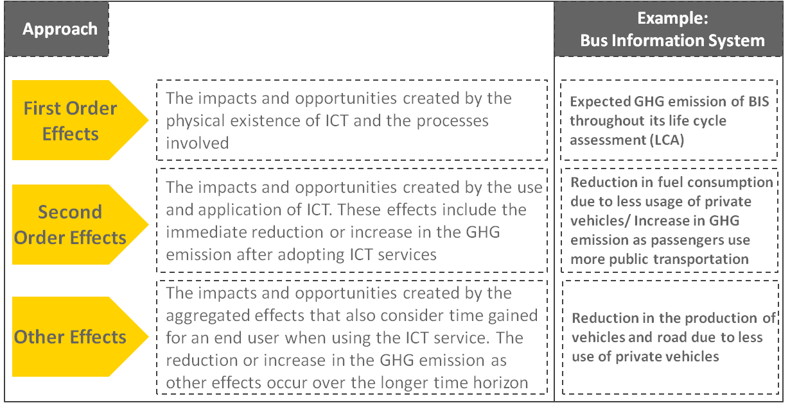

Recommendation ITU-T L.1410 divides the environmental impact of ICTs into three categories of impacts as described in Figure 8. This grouping method is adopted to assess the enabling effect of ICT. This report only calculates the positive effects in other sectors related to the use of ICTs in Korea and does neither take a life cycle perspective nor consider the negative impact from the ICT system itself due to the limited quantity of reliable data sources. In order to get more accurate information on the GHG reduction potential enabled by ICT services, the impact of the ICT product system itself should be studied too.
Figure 9 − Step-by-step approach to assess GHG emission reduction by ICT
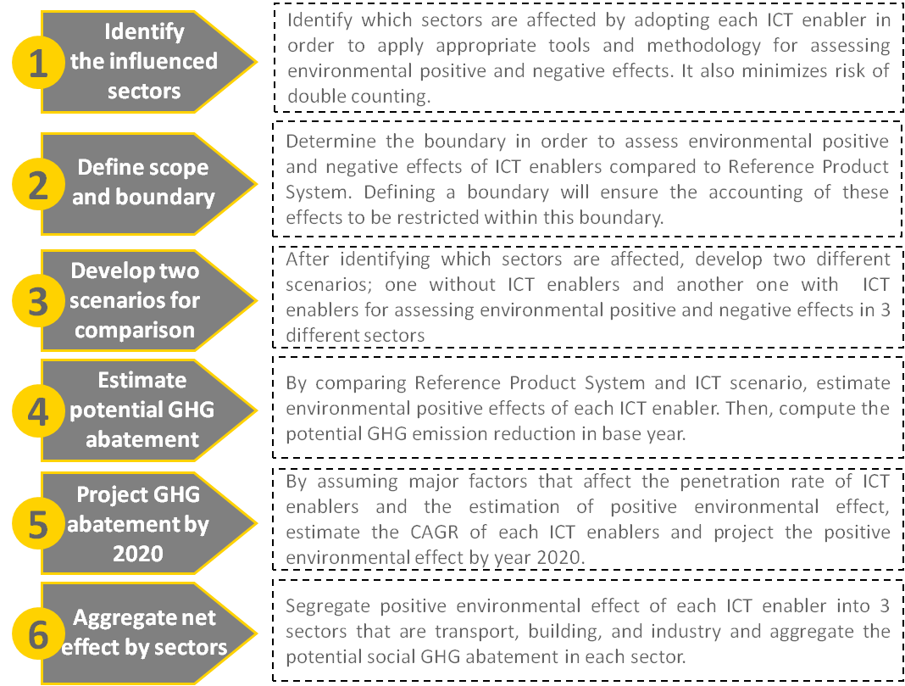
Potential reduction of GHG emission in use stage of ICT services is calculated in three affected sectors, such as transport, buildings, and industry. All enabling effects from ICT services are identified and estimated in each of the three sectors and summed up for comparison allowing them to be ranked in order of GHG abatement potential. By applying the procedures of Recommendation ITU-T L.1410, this report estimated potential GHG abatement from 2011 to 2020 by following these steps: (1) identifying the influenced sectors, (2) defining the scope and boundary, (3) developing the reference product system and ICT scenarios, (4) estimating GHG abatement, (5) projecting GHG abatement by 2020, and (6) aggregating enabling effects in each sector.
To categorize the enabling effect, the ITU-T methodology was applied. It divides ICT-affected areas into eight categories and provides specific equations to calculate energy reduction in each category. The eight categories are: 1) consumption of goods, 2) power and energy consumption, 3) movement of people, 4) movement of goods, 5) improved efficiency of office space, 6) storage of goods, 7) improved work efficiency and, 8) waste. The corresponding equations are shown in Table 3.
Table 3 − Calculation methods for energy reduction
ICT-affected areas | Equations to calculate energy reduction
Consumption of goods  (paper, CDs, DVDs, etc.) | Energy consumption to produce one unit of the product × Amount reduced
Power consumption/ energy consumption | Energy consumption per amount of fuel × fuel consumption reduced (per fuel)
Movement of people (cars, buses, rail, aircraft, etc.) | Energy consumption per amount of fuel × fuel consumption reduced (per fuel)
Movement of goods (mail, rail cargo, etc.) | Energy consumption per amount of fuel × fuel consumption reduced (per fuel)
Improved efficiency of office space (electricity, office area, etc.) | Energy consumption per office area × amount reduced
Storage of goods (warehouse area, etc.) | Energy consumption per storage area × amount reduced
Improved work efficiency | Energy consumption per area (m²) × area used per person (m²) × work efficiency improved
Waste (wastepaper, industrial wastes, etc.) | Energy consumption per amount of waste × amount reduced

4.2 Selection of ICT services
Fourteen ICT services have been considered in this report based on a review of the Korean government ICT strategy and plans and current ICT services. Through literature studies and global benchmarking, 30 ICT services were pre-screened. Based on carbon abatement potential, technology maturity and correspondence with domestic policies to the number of services to be reviewed, the number was reduced to 14. These are presented in Table 4.
Table 4 − Reviewed ICT services
Possible areas of improvement |  |  | Selected 14 services
Transportation | Virtual meetings | - Reduced building space through design  - HVAC (heating, ventilation, and air conditioning) automation  - Home energy management system  - Building energy management system  - Remote appliance power management  - Voltage optimization | - Real-time navigation  - Bus information system  - E-logistics  - Telepresence  - Smart work  - Home energy management system  - Smart grid  - E-health care  - E-learning  - E-commerce  - E-government  - E-civil service  - Digital contents  - Smart motor
 | Smart work
 | Smarter transport infrastructure
 | GPS route and fleet management
Smart building | Planning and construction | - Telecommuting  - Virtual office  - Video-conference/Audio-conference  - On-board telematics  - Loading optimization  - Real-time freight management  - Intelligent transportation system  - Personalized public transport  - GPS navigation system  - Street light switching  - Synchronized traffic and alert system
 | Smart appliances
 | Smart occupancy controls
 | Intelligent building controls
 | Smart meters
Commerce & services | E-commerce | - E-commerce  - Online banking  - Web taxation/Online billing  - E-book/e-paper  - Online media/Digital music  - Government for citizen  - E-health  - Online learning
 | Dematerialization of goods
 | E-government
 | E-health
 | E-learning
Production & energy supply systems | Advanced sensors and controls | - Smart motor  - Remote supply control  - Energy network monitoring  - Increased renewable energy  - Smart meter: Grid loading optimization
 | WiFi-stock & flow
 | Energy generation
 | Electricity distribution

5 Second order effects of GHG emission abatement by ICT services
(use stage)
To estimate the impacts of using ICT services to achieve GHG abatement, the potential of 14 ICT enablers was assessed: real-time navigation (RTN), bus information system, e-logistics, telepresence, home energy management system (HEMS), smart grid, e-commerce, e-government, e-civil service, e-health care, digital contents, smart motor, e-learning, and smart work. The list of the services and sectors affected by adopting these ICT enablers is detailed in Table 5.
Table 5 − Measurement and quantification by sectors
Possible areas | ICT enablers | Sectors potentially affected by ICT enablers
 |  | Transport | Buildings | Industry
Transportation | Real-time navigation | Reduced fuel consumption | Not applicable | Not applicable
Transportation | Bus information system | Reduced fuel consumption | Not applicable | Not applicable
Transportation | E-logistics | Reduced fuel consumption | Not applicable | Not applicable
Transportation | Telepresence | Reduced fuel consumption | Not applicable | Not applicable
Transportation | Smart work | Reduced fuel consumption | Reduced energy consumption | Not applicable
Smart building | Home energy management system | Not applicable | Reduced energy consumption | Not applicable
Smart building | Smart grid | Not applicable | Reduced energy consumption | Reduced energy consumption
Commerce/  Services | E-learning | Reduced fuel consumption | Reduced energy consumption | Not applicable
Commerce/  Services | E-commerce | Reduced fuel consumption | Reduced energy consumption | Not applicable
Commerce/  Services | E-government | Reduced fuel consumption | Reduced energy consumption | Reduced energy consumption
Commerce/  Services | E-civil service | Reduced fuel consumption | Reduced energy consumption | Not applicable
Commerce/  Services | E-health care | Reduced fuel consumption | Not applicable | Not applicable
Commerce/  Services | Digital contents | Not applicable | Not applicable | Reduced paper consumption
Production | Smart motor | Not applicable | Not applicable | Reduced electricity consumption

5.1 Estimated GHG emission reductions by each ICT service

5.1.1 Real-time navigation (RTN)
    - Definition and the expected effects
RTN is composed of GPS-based software which provides an optimal route to the destination with the latest traffic conditions taken into consideration. RTN service offers its service user’s time priority based routes which enable users to drive with higher speed and less travel time. Overall increase in speed instead of sitting idle in traffic jam improves fuel efficiency, resulting in GHG emission reduction compared to a distance priority based route. It also provides useful information such as nearby public parking lots. T-map by SKT is a representative example of RTN in Korea. This report focuses mainly on fuel reduction resulting from higher speed and less time spent on the road. Table 6 identifies the expected environmental effects by using RTN.
Table 6 − Expected effects by RTN
Types of effects | Positive effects | Negative effects | GHG emission
First order effects | N/A | - As RTN usage increases, production and use of RTN network increases | (+) Increase
Second order effects | - As driving time decreases and driving speed increases, fuel consumption of vehicles decreases | N/A | (-) Decrease
Other effects | - Production of vehicles decreases due to extended life span of vehicles and tyres | - As spare time of drivers increases, GHG emissions from other industries may increase as well | (+) and (-) Ambiguous
* Positive effects describe energy and GHG emissions reduction, and negative effects refer to increase in energy consumption and GHG emissions.
    - Scope and scenarios
Since the emission reduction by RTN is mainly derived from reduced fuel consumption in the transport sector as explained in Table 6, the number of consumers who use RTN was calculated based on the data on mobile Internet service subscribers and the percentage of those who are location-based service (LBS) subscribers. The <Survey on the Internet Usage> by Korea Internet Security Agency highlights that 48 million people are using mobile phones and 19.3% of mobile phone users use LBS, which results in 9.28 million RTN users in Korea.
In order to assess GHG reduction after using RTN, a comparative study boundary is set as follows.
• In transport:
• The number of vehicles
• The types of vehicles
• Annual travel distance per vehicle
• Percentage of travel distance navigated by RTN
Based on these parameters, the total travel distance was calculated for both the reference product system and ICT service for comparison. The results are presented in Table 7.
Table 7 − Comparative assessment of the effects of RTN
Functional unit | Reference product system | ICT service
To allow the population in Korea to reach their intended destination with their car during one year | Fuel consumption due to longer driving time and slower driving speed before using RTN | The changes in travel distance and fuel consumption after using RTN
Travel distance of vehicles | 139 billion km | 137 billion km
The changes in travel distance and fuel consumption by using RTN were estimated from the result of an experiment implemented in Japan, the Nissan SKY project.
Box 1 – ”Nissan SKY Project ”
ITU, ISO and Nissan conducted experiments in Yokohama, Japan in order to estimate the GHG abatement of VICS (Vehicle Information Communication System) which is based on GPS navigation.
The Japanese experiments regarding real-time navigation were applied because:
1) At the time when this report was completed, a proper set of data for assessing environmental impact by RTN in Korea did not exist.
2) The real-time navigation used for experiments in Japan has similar functions with that of RTN defined in this report.
3) The purpose of experiments carried out in Japan was the same as this report, which was assessing the positive environmental impacts of real-time navigations. It was concluded that 8.7% of fuel was less consumed thanks to RTN.
4) It is assumed that Korea and Japan have similar traffic environments.
Under this test, it was concluded that using RTN reduced the percentage of travel time by 11.9% and increased the percentage of speed by 17.8%. Considering fuel efficiency by speed, the study demonstrated that RTN approximately reduced 8.7% the fuel consumption at the end. This report assumed 8.7%of decline in travel distance by RTN since the average mileage and the emission factor in Yokohama are similar to those in Korea. Reduced travel distance: 139 billion km × 16%× 8.7% = 1 .9 billion km.
    - Potential GHG reduction
The amount of energy saved through reducing travel distance is calculated by applying the calculation method for the category “movement of people” as presented in Table 3 using the related values in Table 7. The amount of reduced GHG emission is assessed by dividing the travel distance by fuel efficiency and multiplying emission factor by calculating the volume of reduced fuel consumption. As a result, 0.59 tCO₂e of GHG emission is reduced in 2011 after using RTN.
Assuming that RTN service users, the intensity of service use and growth in automobile industry increase by a certain percentage, 22.1% of compound annual growth rate (CAGR) as a growth rate of RTN was applied. Since GHG emission reduction from RTN is directly proportional to the adoption of RTN, potential GHG abatement by RTN will increase at the same CAGR of 22.1%. As a result, it is expected to reduce 3.57 million tCO₂e of GHG emission by 2020.

5.1.2 Bus information system (BIS)
    - Definition and the expected effects
BIS is a GPS-based system which collects and transmits the real-time information of running buses and traffic conditions to a control centre and provides this information to bus drivers, bus stops and passengers through cable and wireless networks. This service is expected to improve the efficiency of bus operations, reduce the waiting time of passengers, and increase the number of passengers. As the function of BIS has improved, more passengers who used to commute by using their cars are expected to use BIS in order to save time and avoid driving congestions, which will reduce fuel consumption from private vehicles. As explained in Table 8, the effects of BIS are observed mainly in the transport sector.
Table 8 − Expected effects by BIS
Types of effects | Positive effects | Negative effects | GHG emission
First order effects | N/A | - As users of BIS increase, bus production, BIS equipment production and usage and BIS network usage increase | (+) Increase
Second order Effects | - As more people use buses rather than driving their own vehicles due to improvement of BIS, fuel consumption from vehicles decreases | - As the number of bus usage and number of passengers increase, fuel consumption in public transport sector increases  - GHG emission increase since increased usage of buses leads to maintenance and operation | (+) and (-) Ambiguous
Other effects | - Production of cars decreases due to the extended life span of cars and tyres |  | (+) and (-) Ambiguous
* Positive effects describe energy and GHG emissions reduction, and negative effects refer to increase in energy consumption and GHG emissions.
    - Scope and scenarios
In order to compare fuel consumption in the reference product system and ICT service scenarios, the number of increased bus passengers who would have used private vehicles instead of buses without BIS was calculated. According to the media report about the implemented BIS system in Bucheon, a small city near Seoul, the No. of bus passengers is reported to increase about 20% compared to the number in the previous year of the BIS implementation. Based on the fact that currently 860 million passengers are estimated to use BIS in Korea and that BIS could attract about 20% more passengers due to enhanced convenience after implementing BIS, changes in the number of passengers that impact the amount of GHG emission is set as 172 million.
In transport:
• The number of operated BIS lines
• Vehicle occupancy ratio (private vehicles)
• Vehicle occupancy ratio (buses)
The reference product system contains the fuel consumption of buses and private vehicles whose drivers will be converted into bus passengers. In the ICT service scenario, the amount of fuel consumption of private vehicles is expected to decrease while the amount of fuel used for buses should increase since there will be more passengers using buses after installing BIS. However, it was found out that the occupancy rate is approximately 27% per bus and per day, which means that even if BIS generates an increase in passengers for bus transportation, it will not affect the number of operated buses or lines. It will only increase the average number of passengers per bus, which will not influence the fuel consumption of buses.
Table 9 − Comparative assessment of the effects of BIS
Functional unit | Reference product system | ICT service
To allow the population of Korea to reach their intended destination by using bus during one year | Refers to the scenario that BIS is not adopted. | Refers to the changes in fuel consumption of private vehicles and average number of bus passengers after adopting BIS to intra-city buses
Travel distance of vehicles | 851 million km | Zero
    - Potential GHG reduction
The energy savings from reduced fuel consumption of private vehicles is calculated by applying the calculation method for the category ‘movement of people’ as demonstrated in Table 3 using the related values in Table 9. The amount of reduced GHG emission after installing BIS is calculated by dividing the travel distance of private vehicles by the fuel efficiency and multiplying the emission factor by the estimated amount of fuel. As a result, 0.25 tCO₂e of GHG emission is expected to be reduced in 2011 by adopting BIS.
Assuming that the current BIS takes approximately 18% of the total number of bus lines and that all the bus lines adopt BIS by 2020, it is calculated that BIS has 21% of CAGR, which means the penetration rate of BIS may increase by 21% annually. It is also assumed that GHG emission reduction from BIS is directly proportional to the adoption of BIS; potential GHG abatement by BIS will increase at the same CAGR of 21%. As a result, BIS is expected to reduce 1.40 million tCO₂e of GHG emission by 2020.

5.1.3 E-logistics
    - Definition and the expected effects
The e-logistics system operates with a set of facilities where materials are processed, manufactured, stored, and linked by transportation services using EDI (electronic data interchange). This enables firms to share data on stock levels, timing of deliveries, positioning of transit goods in the supply chain. At the operational level, geographic information systems (GISs), global positioning systems (GPSs) and on-board computers allow dispatchers to keep track of the current position of vehicles and communicate with drivers. This report focuses on the increase in efficiency of freight management, specifically improving load capacity per truck and therefore reducing the number of partially empty trucks. More details are shown in Table 10.
Table 10 − Expected effects by e-logistics
Types of effects | Positive effects | Negative effects | GHG emission
First order effects | N/A | - As e-logistics enables trucks to improve load capacity and reduce vacancy rate, each truck can consume more fuel. | (+) Increase
Second order effects | - As e-logistics enables trucks to improve load capacity and reduce vacancy rate, travel distance decreases regarding freight delivery | N/A | (-) Decrease
Other effects | - Production of trucks decreases due to less usage of freight vehicles | - Less freight-related traffic on the road can attract other traffic as overall traffic efficiency enhances. | (+) and (-) Ambiguous
* Positive effects describe energy and GHG emissions reduction, and negative effects refer to increase in energy consumption and GHG emissions.
    - Scope and scenarios
To estimate the emission reduction by e-logistics, the number of trucks that are able to implement e-logistics was calculated first. Then, the accumulated travel distances of trucks without e-logistics, a reference product system, and those of trucks with e-logistics, an ICT service were compared. The number of trucks is set as the number of registered trucks, except those destined for official usage trucks in Korea. Based on the data from <Analysis for Amount of Freight Delivered Among Cities> by The Korea Transport Institute, three million trucks are registered.
In order to assess the GHG reduction after using e-logistics, a comparative study boundary is set as follows.
In transport:
• The amount of cargo (in tons)
• The amount of cargo transported (per vehicle/km)
Based on these parameters, the annual average travel distance per truck is calculated both for the reference product system and ICT service for comparison. The results are presented in Table 11. For the ICT service, it was assumed that 20% of the registered trucks have implemented the e-logistics system, which is approximately 624 thousand trucks. The total amount of cargo transported in both scenarios is the same. Based on prognosis for Japan that the load capacity will increase by 16.7% if e-logistics is applied, the e-logistics system is predicted to improve the load capacity per truck from 1.8 ton to 2.1 ton. Under the assumption that the same amount of tracks is used, each truck needs to drive shorter distances (i.e. fewer times the same distance) to load the same amount of cargo. Thus, without e-logistics, a truck needs 18 thousand km while a truck with e-logistics only needs 16 thousand km for delivering the same amount of cargo.
Table 11 − Comparative assessment of the effects of e-logistics
Functional unit | Reference product system | ICT service
To allow truck drivers in Korea to deliver a certain amount of cargo during one year | The amount of GHG emission when trucks transport freight without e-logistics | The amount of GHG emission when 20% of registered trucks transport freight using e-logistics.
Annual average travel distance per truck | 18 thousand km/truck | 16 thousand km/truck
    - Potential GHG reduction
Fuel consumption of the reference product system is assessed by applying the calculation method for the category “movement of goods” as presented in Table 3 using the related values in Table 11. Here, the total reduced travel distance of trucks was calculated by multiplying the travel distance per truck by the number of trucks that use e-logistics, which leads to 1.7 billion km. The amount of reduced GHG emission is assessed by multiplying the emission factor per kilometer by the total travel distance of trucks. Based on the prognosis for 2011 used in this report, 1.34 million tCO₂e of GHG emission was expected to be reduced.
Based on the fact that the amount of cargo transported increased by 1.89% of CAGR, and the assumption that 70% of registered trucks will implement e-logistics by 2020 in accordance with the goals of the Korean ministry, CAGR of the penetration rate of e-logistics is assumed to be 15.2%. Since GHG emission reduction from the service is directly proportional to the adoption of the service, potential GHG abatement by e-logistics will increase at the same CAGR of 15.2%. As a result, approximately 4.79 million tCO₂e of GHG emission is expected to be reduced in 2020.

5.1.4 Telepresence
    - Definition and the expected effects
Telepresence is the service which enables workers to have remote meetings by using wireless and cable communication, thus removing the need for physical travel. The meetings can be facilitated by screen monitors enabling participants to see other attendees face to face similar to a physical meeting. This service is expected to reduce the time spent caused by the movement of people and to improve the productivity of workers. Telepresence in this report is limited to the service for global conferences and meetings that reduce overseas business trips. More details are shown in Table 12.
Table 12 − Expected effects by telepresence
Types of effects | Positive effects | Negative effects | GHG emission
First order effects | N/A | - Production and usage of Telepresence equipment  - As usage of telepresence increases, network usage for communicating among attendees increases | (+) Increase
Second order effects | - As telepresence replaces business trips, fuel consumption of planes decreases | - Telepresence increases energy consumption in offices | (+) and (-) Ambiguous
Other effects | - Production of airplanes decreases due to their extended life span | - More physical meetings happen because people get to know each other through telepresence | (+) and (-) Ambiguous
* Positive effects describe energy and GHG emissions reduction, and negative effects refer to increase in energy consumption and GHG emissions.
    - Scope and scenarios
In order to estimate the emission reduction derived from implementing telepresence, the number of employees who used to go on business trips had been set and the amount of fuel consumption for airplanes between the reference product system and ICT service was compared. According to <Statistical Yearbook of Immigration Management> from the National Archives of Korea, 81 thousand people boarded on airplanes for overseas business trips. As mentioned above, the number of employees who go abroad for business trips was counted and business trips between domestic cities were excluded.
The reference product system for having overseas business trips by using airplanes is that 81 thousand workers would have continued using airplanes. This scenario includes the following steps within the comparative study boundary:
• The number of employees who replace international physical meetings with telepresence
• The number of airplanes that are expected not to be operated
The total flight distance is calculated and the result is presented in Table 13. Based on the <Yearbook of Information Society Statistics> by the National Information Society Agency, approximately 1.1% of companies have adopted telepresence for virtual meetings as of 2010, and it was calculated that 896 business travellers among 81 thousandcan replace their overseas conferences by telepresence. In reality, companies which adopt telepresence are not expected to replace all their travelling; however, in this report, 100% of replacement of travelling is assumed due to lack of data.
Table 13 − Comparative assessment of the effects of telepresence
Functional unit | Reference product system | ICT service
To allow the business travellers to attend meetings with their counterparts | GHG emission from airplanes due to conference participation when telepresence is not adopted. | GHG emission coming from replacing overseas conferences by telepresence implementation
Flight distance | 469.095 million km | 469.066 million km
The point here is that the use of airplanes is assumed to be decreased only by 6.52 after implementing telepresence since the average number of passengers per airplane is 137.32,. The passenger decrease by about 895 travelers cannot lead to reducing dramatically the number of airplanes. As a result, 28 thousand km of flight distance was reduced.
    - Potential GHG abatement
Fuel consumption in the reference product system is assessed by applying the calculation method for the category ‘movement of people’ as presented in Table 3 using the related values in Table 13. The reduced GHG emission by the decreased number of operating flights is assessed by multiplying an emission factor of flight to the reduced travel distance of flights. In 2011, 0.86 million tCO₂e of GHG emission is expected to be cut down as a result of telepresence.
According to <Yearbook of Information Society Statistics> by the National Information Society Agency, the number of companies that start to use telepresence has increased by 32.82% of CAGR. It is assumed that the penetration rate of telepresence will increase at the same rate as the published data, 32.82%. By assuming that GHG emission reduction by telepresence is proportional to the adoption of telepresene, potential GHG abatement by telepresence would increase at the same CAGR of 32.82%. It is estimated that 11 million tCO₂e of GHG emission is reduced by the use of telepresence.

5.1.5 Home energy management system (HEMS)
    - Definition and the expected effects
Through the cable and wireless network, HEMS enables electronic home appliances to interact with each other in order to monitor and control energy consumption. HEMS monitors and traces the usage pattern of users and helps users reduce and control energy usage automatically. In this report, the main impact of deploying HEMS is to save electric power by putting the electronic appliances in a stand-by mode using the remote control and reducing electricity consumption by providing real-time information to users, thereby resulting in maximum reduction of energy use. Table 14 demonstrates environmental effects from HEMS.
Table 14 − Expected effects by HEMS
Types of effects | Positive effects | Negative effects | GHG emission
First order effects | N/A | - Emissions generated from manufacturing and HEMS equipment usage | (+) Increase
Second order effects | - As HEMS optimizes electronic home appliances, it reduces standby and loss of electricity of appliances | - Since HEMS enables electronic home appliances to interact via networks and to monitor consumption patterns of users, energy consumption may increase | (+) and (-) Ambiguous
Other effects | - Production of home appliances decreases due to extended life span  - Power plants for electricity downsize as demand for electricity decreases | - Saved energy may be used for other purposes | (+) and (-) Ambiguous
* Positive effects describe energy and GHG emissions reduction, and negative effects refer to increase in energy consumption and GHG emissions.
    - Scope and scenarios
In order to assess GHG emission reduction after implementing HEMS in households, the types of households were classified into apartments and other housing forms where the apartments were divided into 2 groups: Those constructed before 2005 and those constructed after that date. According to <Statistics on Housing Environment of Apartments> by Land & Housing Institute, seven million and 0.8 million households live in apartments built before and after 2005 respectively, and 8 million households live in the other forms of housing. It was assumed here that 15%, 25%, and 10%, respectively, of households who live in apartments before 2005, and those who live in apartments after 2005, and other housing forms are able to implement HEMS in the base year based on the predicted housing condition and a media analysis.
In buildings:
• The penetration rate of HEMS in each type of houses
• Electricity consumption per household
Based on these parameters, the total electricity consumption is calculated for both the reference product system and ICT service for comparison. In ICT service, 23.9% less electricity is consumed by savings in both stand-by electricity and loss of electricity. According to an assumption made by Telstra, network enabled Presence-Based Power solutions, which has a similar function to HEMS, could have a potential to reduce 50% of standby power and electricity loss (orphaned energy).
The results of the different electricity consumption of the total households are presented in Table 15.
Table 15 − Comparative assessment of the effects of HEMS
Functional unit | Reference product system | ICT service
To allow households in Korea to use home appliances with the same convenience level | Electricity consumption of households before implementing HEMS. | Electricity consumption of households after implementing HEMS.
Electricity consumption | 55 billion kWh | 54 billion kWh
    - Potential GHG reduction
The amount of saved energy resulting from reduced electricity consumption of domestic households is calculated by applying to calculation method for the category ‘power consumption & energy consumption’ shown in Table 3, using the related values in Table 15. In 2011, implementing HEMS with the different penetration rates for each type of houses will bring 0.76 million tCO₂e of GHG emission reduction by multiplying the emission factor by the reduced electricity consumption in the building sector.
Based on the data of <Statistics on Housing Environment of Apartments> by Land & Housing Institute, different penetration rates were applied to different types of houses. As shown by the Land & Housing Institute statistics previously referred to, the penetration rate of HEMS will be approximately 15.06% by 2020, which means that HEMS will expand at CAGR by 15.06%. Since GHG emission reduction from HEMS is directly proportional to the implementation of HEMS, potential GHG abatement by HEMS will increase at the same CAGR of 15.06%. As a result, 2.96 million tCO₂e of GHG emission is expected to be cut down in 2020.

5.1.6 Smart grid
    - Definition and the expected effects
Smart grid is a broadly used service and its usage is defined differently depending on the projects. According to Korea Smart Grid Institute, it is defined as a future electrical grid which optimizes energy efficiency by grafting ICT to the electrical grid to enable both electricity suppliers and consumers to mutually exchange real-time information. It is also expected to create other values such as reducing the amount of imported energy, increasing exports, and preventing the installation of new power plants by 2030. The essential components of smart grids are advanced smart meters, EV (electric vehicle) charging infrastructure, dispersed generation system, self-healing power grids, etc. In this report, only the implementation of advanced smart meters and its associated GHG emission reduction potential is considered. However, other effects of smart grids are also described in Table 16.
Table 16 − Expected effects by smart grid
Types of effects | Positive effects | Negative effects | GHG emission
First order effects | N/A | - Equipment production  - For controlling, interacting, and monitoring electricity use and network usage increase | (+) Increase
Second order effects | - Smart grid reduces loss of electricity during power transmission and distribution through remote monitoring | N/A | (-) Decrease
Other effects | - Optimization of electricity usage boosts the development of renewable energy | - Rebound effect may happen | (-) Decrease
* Positive effects describe energy and GHG emissions reduction, and negative effects refer to increase in energy consumption and GHG emissions.

    - Scope and scenarios
Since the smart grid covers various technologies and system components many of which are still under development, the potential impacts of the advanced smart meter, which is known as AMI (advanced metering infrastructure), is the main focus in this report.
AMI, an advanced concept for simple remote meter reading, includes a smart grid infrastructure that enables meter reading automatically and mutually between digital meters and modems with high-speed PLC (power line communication). AMI also makes it easier to manage data and analyze consumption patterns in situations such as different geographical areas and time zones. AMI is expected to save cost and time for meter reading and improve efficiency of energy supply as it monitors energy consumption in real time.
In order to estimate the amount of saved energy by AMI, data for current and potential users was extracted from Korea Electronic Power Corporation. As of November 2011, 18 million and 301 thousand customers consume low-voltage and high-voltage power, respectively.
In buildings:
• The penetration rate of AMI in both low-voltage and high-voltage customers
• The sales volume of low-voltage and high-voltage power
Based on these parameters, the total electricity consumption in the reference product system and ICT service are calculated below. KEPCO (Korea Electric Power Company) estimated that about 6% of electricity consumption is saved based on findings from a test bed project which installed AMI to 500 thousand households. In this report, a more conservative value was used for the saving potential, and it was assumed that 3% of electricity consumption would be saved after implementing AMI to 50 thousand of low-voltage customers and 140 thousand of high-voltage customers. The annual electricity consumption assessed in Table 17 is the sum of low-voltage and high-voltage consumption.
Table 17 − Comparative assessment of the effects of smart grid
Functional unit | Reference product system | ICT service
To allow low- and high-voltage customers in Korea to use smart meter | Annual electricity consumption of high and low voltage of power service in customers before smart grid implementation | Annual electricity consumption resulting from rational consumption after installing the smart grid
Electricity consumption | 434 billion kWh | 429 billion kWh
    - Estimated potential GHG reduction
The amount of saved energy of low-voltage and high-voltage power after installing AMI is assessed by applying the calculation method for ‘power consumption & energy consumption’ of Table 3 using the related values in Table 17. The reduction in electricity consumption is expected to reach 4.5 billion kWh in 2011 and the GHG emission saving is calculated by multiplying this reduction in electricity consumption with the corresponding emission factor.
To predict how many customers will use AMI, the target data from the Korea Electronic Power Corporation (KEPCO) was cited. The Ministry of Knowledge and Economy and KEPCO planned to increase the number of customers up to 18 million in low-voltage and 301 thousand in high-voltage by 2020; these numbers were taken into account to assess the amount of GHG savings in 2020. The CAGR of the smart grid was calculated as 48.28%, which means that the penetration rate of AMI will expand at this rate. Since GHG emission reduction is proportional to the implementation of the smart grid, the potential GHG abatement by the smart grid will increase at the same rate of 48.28%. We projected GHG abatement by 2020 with calculated CAGR and 68 million tCO₂e of GHG emission is expected to be reduced by the smart grid.

5.1.7 E-commerce
    - Definition and the expected effects
E-commerce refers to online selling or buying of goods and services. Customers are able to purchase a variety of goods and services without visiting stores, which leads to reducing fuel consumption of vehicles and mobility time. In addition, e-commerce could reduce the electricity consumption particularly for lighting, heating and cooling in buildings. However, fuel consumption and GHG emission caused by parcel delivery service should be added since the amount of parcel delivery is expected to increase after adopting e-commerce. In this report, the key effects generated from e-commerce are reduction in gasoline and electricity power in transport and buildings. More details are presented in Table 18.
Table 18 − Expected effects by e-commerce
Types of effects | Positive effects | Negative effects | GHG emission
First order effects | N/A | - Emission generated by manufacturing and using e-commerce equipment such as PCs and mobile phones. | (+) Increase
Second order effects | - As consumers do not need to visit shopping malls, shopping distances decrease  - As the number of visiting consumers decreases, consumption for electricity and heating and cooling in buildings decreases | - Since the amount of parcel delivery to each consumer increases, the fuel consumption of trucks increases | (+) and (-) Ambiguous
Other effects | - Reduction in number of commuting consumers decreases the energy consumption and GHG emission related to maintenance of vehicles and roads | - Increase in income from using e-commerce may induce more spending  - Additional time saved by e-commerce can lead to other consumption and its related energy consumption and GHG emission  - The increased availability of shopping opportunities may lead to increased shopping | (+) and (-) Ambiguous
* Positive effects describe energy and GHG emissions reduction, and negative effects refer to increase in energy consumption and GHG emissions.
    - Scope and scenarios
In order to compare the differences in energy consumption between the reference product system and ICT service, the number of customers who are able to purchase goods and services through e-commerce is calculated. Based on <2010 Census> by Statistics Korea and <Survey on the Internet Usage>, it was found that the population who has purchasing power and the usage rate of online shopping are 35 million and 43.72%, respectively. Fifteen million customers are identified as e-commerce participants as a result.
The reference product system contains the electricity consumption in shopping stores, and fuel consumption resulting from visiting the stores by private cars had 15 million customers who continued shopping at the stores. In the ICT scenario, it is considered that the fuel consumption of trucks will be increased as the number of delivered parcels rises after adopting e-commerce, compared to the reference product system.
In transport:
• The number of online transactions per customer per year
• Round-trip distance for visiting stores (of private cars) on the basis of car-using time related to the annual Korean purchasing activity
• Travel distance for delivering parcels (of trucks)
In buildings:
• The number of online transactions per customer per year
• Energy consumption for cooling and heating
• Energy consumption for lighting
By applying these parameters, the total travel distance for private cars and trucks and electricity consumption in buildings are calculated for both scenarios, as shown in Table 19. In the ICT service scenario, the reduced travel distance of private cars is subtracted and the increased travel distance derived from trucks is added in the transport sector.
Table 19 − Comparative assessment of the effects of e-commerce
Functional unit | Reference product system | ICT service
To allow the population in Korea with the purchasing power to shop and purchase goods | GHG emission when presuming that the purchase is done by visiting the store before implementing e-commerce. | GHG emission when consumers have their shopping delivered without going to the store after implementing e-commerce.
Travel distance of private vehicles | 27 billion km | 24 billion km
Travel distance of trucks | 302 million km | 1 billion km
Electricity consumption | 12.83 billion kWh | 12.20 billion kWh
For this report, online shoppers are assumed to apply online shopping approximately 20 times per year which is considered as a conservative estimation.
In the transport sector, travelling, in the reference product system includes all shopping visits to the stores, whereas the travel distance for the ICT service scenario includes all visits by offline shoppers and the offline shopping visits made by the those adopting e-commerce (i.e. all their shopping except for the 20 occasions saved according to the scenario applied). Additionally, in the ICT scenario, the travel distance of trucks is expected to increase since parcels that online shoppers purchase without visiting the stores are supposed to be delivered to individual customers is significantly affected. The national statistics for changes in truck distance due to increase in parcel delivery, which is approximately 705 million km, is adopted to calculate this contribution.
In the building sector, electricity consumption for heating, cooling and lighting was extracted from <Analysis Report on National GHG emission-household and commercial part> and the saved electricity consumption in the ICT service scenario is calculated by multiplying the replaced number of shopping to the expected energy consumption per every visit.
    - Potential GHG reduction
Energy reduction in both the reference product system and the ICT service is calculated by applying the calculation methods for the categories ‘movement of people’, ‘movement of goods’, and ‘power consumption & energy consumption’ as shown in Table 3, using the related values in Table 19. For the transport sector, the amount of reduced GHG emission is calculated by dividing the total travel distance of both private vehicles and trucks by fuel efficiency and multiplying the emission factor by the calculated volume of consumed fuel. As a result, 0.72 million tCO₂e of GHG emission is expected to be reduced in 2011 in the transport sector.
For the building sector, the amount of reduced GHG emission is assessed by multiplying the emission factor by the decreased amount of electricity power, which leads to 0.28 million tCO₂e in 2011. In total, the total amount of reduced GHG emission by applying e-commerce is 1 million tCO₂e in 2011.
E-commerce in this report is mainly limited to B2C (business-to-consumer) and C2C (consumer-to-consumer) since it is related to retail shops. According to the historical background of the rapid growth rate of B2C and C2C from 2002 to 2010, 26% of CAGR as the penetration rate of e-commerce was applied. Since GHG emission reduction from e-commerce is directly proportional to the adoption of e-commerce, the potential GHG abatement will also increase in the same manner as CAGR by 26%. By 2020, approximately 1.89 million tCO₂e of GHG emission is expected to be reduced by e-commerce.

5.1.8 E-government
    - Definition and the expected effects
The Korean government has been promoting e-government since the early 2000s. According to the e government project report, e-government falls into three main sectors: work efficiency, civil service, and organizational democracy. In this report, the impacts of ICT on administrative affairs are demonstrated in two parts: e-government service and e-civil service, respectively. E-civil service is explained in clause 5.1.9.
E-government, defined as G2G (government-to-government) is the service which aims to process government tasks between public organizations, administrative offices, and local governments so as to accomplish a paperless workplace and improve productivity and efficiency. It also induces informatization of whole processes from producing official documents to archiving them. By expanding e-document usage to almost all public offices and encouraging employees to send and receive e-documents, it is predicted that time and money will be saved and work efficiency will be improved. Regarding work efficiency, e-government has been expected to eliminate unnecessary work processes, simplify complicated processes, and integrate duplicated work. In this report, government tasks in G2G are considered by reducing visits, fuel and electricity consumption and by having a paperless environment.
Table 20 − Expected effects by e-government
Types of effects | Positive effects | Negative effects | GHG emission
First order effects | N/A | - Emission generated by manufacturing and using e-government equipment | (+) Increase
Second order effects | - As travel distances of people who visit administrative agencies to acquire documents decreases, the relevant GHG emission is reduced  - Since the number of people who visit agencies decreases, electricity consumption in buildings is reduced  - By sharing information through digital documents, paper use is reduced | N/A | (-) Decrease
Other effects | - Paper reduction can lead to divestment in manufacturing industry and reduce related GHG emission | - Any efficiency may be exploited to increase work-load. | (-) Decrease
* Positive effects describe energy and GHG emissions reduction, and negative effects refer to increase in energy consumption and GHG emissions.
    - Scope and scenarios
As mentioned, only document exchanges between government and administrative offices are considered in this report. In order to estimate the amount of reduced energy consumption by e-government, the number of information exchanges related to provision among government departments was set at 66.8 million, according to <2011 national Informatization White Paper> by the Ministry of Public Administration and Security. As this information exchange is generally performed by use of dedicated vehicles, the improvement potential can be substantial.
The reference product system contains the fuel consumption of dedicated vehicles for exchanging public documents, electricity consumption in buildings, and paper use of 66.8 million of the documents that would have been issued.
In transport:
• Round-trip distance for visiting government offices calculated by using the time spent for issuing and submitting documents, average driving speed within cities and vehicle occupancy ratio
• The percentage of using transport mode to visit government offices
In buildings:
• The number of administrative districts, which is assumed to be the number of government offices
• Average surface area of organizations related to civil services
• Electricity consumption per unit area of national public buildings
• The percentage of electricity consumption of heating/cooling/lighting in electricity consumption for public administrative services
In industry:
• The average paper use per document
Based on these parameters, the total travel distance for exchanges between government and administrative offices including travelling for visiting government offices, electricity consumption for cooling, heating and lighting, and paper use for official documents are calculated for both the reference product system and ICT service scenarios as presented in Table 21. The ICT service scenario models a potential case where visits to governmental offices and use of papers are replaced by use of online documents which are made available over internet. In reality it is likely that part of the online document will be printed by the readers but this scenario aims to investigate the full enablement potential that would occur if no printing took place.
Table 21 − Comparative assessment of the effects of e-government
Functional unit | Reference product system | ICT service
To allow government officers to share official documents and information. | GHG emission when administrative documents are submitted as civil documents before implementing e-government. | GHG emission resulting from the reduction of travel distance for visiting government offices, paper use, and building energy after implementing e-government.
Travel distance | 480 million km | Zero
Electricity consumption | 79 million kWh | 69 million kWh
The amount of paper used | 100 million paper | Zero
    - Potential GHG reduction
The energy consumption for both scenarios is calculated by applying the calculation methods for the categories ‘movement of people’, ‘power consumption & energy consumption’, and ‘consumption of goods’ as shown in Table 3 using the related values in Table 21. In the transport sector, the reduced GHG emission is calculated by dividing the travel distance of dedicated vehicles by the fuel efficiency and multiplying the emission factor by the reduced amount of fuel. 0.14 million tCO₂e of GHG emission was expected to have been reduced in the transport sector in 2011.
For the building sector, the amount of reduced GHG emission is calculated by multiplying the emission factor to the reduced amount of energy consumption, which leads to four thousand tCO₂e of GHG emission.
For the industry sector, the amount of reduced GHG emission is calculated by multiplying the emission factor by the reduced amount of paper use and this calculation leads to 642 tCO₂e. In total, 0.15 million tCO₂e of GHG emission by e-government is expected to be cut down in 2011.
Considering the number of administrative documents among government organizations from 2005 until 2010, 42% of CAGR as an increase rate of e-government was applied. Since GHG emission reduction from e-government is directly proportional to the implementation of e-government, it is estimated that the potential GHG abatement by e-government increases at the same rate of 42%. As a result, 3.48 million tCO₂e of GHG emission from fuel, electricity and paper is expected to be reduced by 2020 by implementing e-government.

5.1.9 E-civil service
    - Definition and the expected effects
The e-civil service, which is known as G4C (government for citizen) in Korea, is the key service to realize e-government. It was first introduced in 2002 and the service became in earnest from 2005. Since e-civil service is the public service which mainly focuses on the citizens and enables them to access and utilize civil services much easier, the impacts of this service are assessed separately from e-government. E-civil service is defined as “the service which all citizens can browse and issue public documents; this civil service can be provided through Internet from anywhere round the clock and for 365 days, without visiting government offices” according to e-civil service portal of the Korean government. Since people can access this service online without visiting government offices, the processes for resolving civil complaints are expected to be faster and more efficient. Considering these positive impacts of e-civil service, it is expected to grow considerably in the future. E-civil service conducted in this report targets citizens for which trips to government offices have been eliminated.
Table 22 − Expected effects by e-civil service
Types of effects | Positive effects | Negative effects | GHG emission
First order effects | N/A | - Emission generated by manufacturing and use of e-civil service equipment | (+) Increase
Second order effects | - As travel distance of people who visit administrative offices to acquire documents decreases, the relevant GHG emission is reduced  - Since the number of people who visit government offices decreases, the utilized building areas could be optimized so that electricity consumption of building is reduced. | N/A | (-) Decrease
Other effects | - Paper reduction can lead to divestment in manufacturing industry and reduce related GHG emission | - Paper may be printed at home less efficiently | (+) and (-) Ambiguous
* Positive effects describe energy and GHG emissions reduction, and negative effects refer to increase in energy consumption and GHG emissions.
    - Scope and scenarios
Based on information regarding the current usage of e-civil service, this case estimated the GHG emissions associated with the reduced need for transport and energy which may currently be avoided. A future case when e-civil service is more fully adopted is then modelled.
Since e-civil service aims to improve the convenience of citizens, the number of citizens who are able to use this service needs to be defined. We calculated the number of citizens who use e-civil service by considering the current level of awareness and the actual utilization percentage of e-civil service to the number of population aged from 15 to 64, i.e. 36 million persons. According to <2011 National Informatization White Paper> from the Ministry of Public Administration and Security, the level of awareness and the actual utilization percentage of e-civil service are 93% and 60% of the number of citizens, respectively. Based on these values, 20 million citizens are set as potential users of the e-civil service as of 2011.
The reference product system includes the potential travel distance for visiting public offices for civil complaints and electricity consumption at public offices if 20 million citizens had not used the e-civil service. For travelling only, the percentage of the overall distance related to potential e-civil service users who drive private vehicles was included in the reference product system, and could be avoided when using the e-civil service.
In contrast to the e-government assessment, potential reduction in paper use is excluded in this case since it seems more likely that the citizens will print documents at their homes.
In transport:
• The number of e-civil service use per citizen
• Round-trip distance for visiting government offices calculated by using the average driving speed in cities and the time spent for dealing with civil complaints
• Vehicle utilization and vehicle occupancy ratio
In buildings:
• The number of administrative districts, which is assumed to be the number of government offices
• Average surface area of organizations related to civil services
• Electricity consumption per unit area of national public buildings
• The percentage of electricity consumption of heating/cooling/lighting in electricity consumption for public administrative services
Based on these parameters, the total travel distance for visiting government offices and electricity consumption for cooling, heating and lighting are calculated for both the reference product system and ICT service scenarios as presented in Table 23. In the ICT service scenario, it is assumed that visiting government offices is replaced by issuing online documents instead of travelling to the offices. It may be questioned that all potential e-service utilization as of 2011 corresponds to savings in transport as accessibility of information is likely to increase its usage. Due to lack of data, this effect was not considered in this report.
Table 23 − Comparative assessment of the effects of e-civil service
Functional unit | Reference product system | ICT service
To allow the population in Korea to issue official/governmental documents. | GHG emission of the direct visits when possible e-civil service users are not using the service. | Reduction of GHG emission when the possible e-civil service users are not directly visiting institutions after implementing the service.
Travel distance | 1.5 billion km | Zero
Electricity consumption | 79 million kWh | 40 million kWh
    - Potential GHG reduction
The energy consumption for both scenarios is calculated by applying the calculation methods for the categories ‘movement of people’, and ‘power consumption & energy consumption’ as shown in Table 3 using the related values in Table 23. For the transport sector, the reduced GHG emission is calculated by dividing the travel distance of private vehicles by fuel efficiency and multiplying the emission factor by the reduced amount of fuel. 0.45 million tCO₂e of GHG emission is expected to be reduced in the transport sector in 2011.
For the building sector, the amount of reduced GHG emission is calculated by multiplying the emission factor by the reduced amount of energy consumption, which leads to 17 thousand tCO₂e of GHG emission. In summary, by adopting e-civil service, 0.47 million tCO₂e of GHG emission is expected to be cut down in total.
Considering the number of civil complaint documents processed between 2005 and 2010 with the increase in the membership of the civil service portal, it is estimated that e-civil service grows at 33.1% of the annual growth rate. Since GHG emission reduction from e-civil service is directly proportional to the implementation of e-civil service, it was assumed that the potential GHG abatement by e-civil service will increase at the same CAGR of 42%. By applying this rate as CAGR, 3.48 million tCO₂e of GHG emission is expected to be reduced by 2020.

5.1.10 E-health care
    - Definition and the expected effects
E-health care is a diagnosis, prescription, and treatment service that uses electronic processes and communication networks rather than physical meetings. In e-health care, the patients can transmit their medical information to doctors or any other health care practitioners without visiting hospitals or health care centres. By using the e-health care service, doctors can monitor patients’ conditions continuously and remotely, and patients can communicate with doctors more efficiently and save on their transportation time and expenses. More detailed environmental aspects of e-health care are presented in Table 24.
Table 24 − Expected effects by e-health care
Types of effects | Positive effects | Negative effects | GHG emission
First order effects | N/A | - Emission generated by manufacturing and use of e-health care equipment | (+) Increase
Second order effects | - As the number of patients who used to visit hospitals drops due to the adoption of e-health care, fuel consumption of vehicles is reduced | - E-health care related personnel such as nurses and technicians can increase the movement related to GHG emission. | (+) and (-) Ambiguous
Other effects | - As patients acquire remote medical care at their homes, energy consumption in hospitals is reduced  - Hospital construction may be decreased in the long term | - Due to the increase of the spare time of patients, energy consumption in other sectors may increase | (+) and (-) Ambiguous
* Positive effects describe energy and GHG emissions reduction, and negative effects refer to increase in energy consumption and GHG emissions.
    - Scope and scenarios
The number of patients and hospitals that are supposed to incorporate the e-health care system was estimated based on the number of beds in general hospitals, and the amount of fuel used by patients visiting health care providers was compared. The two groups of patients who visit health care centres are considered as patients with chronic diseases such as high blood pressure, diabetes, and pregnant women who need regular check-ups. It was estimated that the number of those patients is around 14.4 million. From ‘the Year Book on Family Statistics’ by the National Health Insurance Corporation, it was assumed that 21.82% of hospitals, i.e. general hospitals, can be regarded as qualified to adopt e-health care, which corresponds to 1.7 million hospitals.
Based on the fact that a patient visits the hospital 5.8 times a year on average in South Korea, the number of hospital visits of those patients, which could be replaced by e-health, was about 84 million patient visits. Then, it was assumed that among 21.82% of the total hospitals which are qualified to adopt the e-health system, only 30% has adopted the e-health system. Therefore, it was assumed that a total of 5.5 million patient visits can be replaced by the e-health system in Korea. It may be argued if all the assumed visits could actually be reduced or if some would still need to take place. Due to lack of data, this has not been considered in this report.
The reference product system is the transportation by car that 14.4 million patients would have continued to use based on the following data:
• Average distance to a hospital
• Vehicle occupancy rate
• Annual number of patient visits
• E-health service rate
Based on these data, the number of patient visits and the total travel distance that would have been used instead of using e-health care were estimated to be 5.5 million and 60.7 million km, respectively, as presented in Table 25. The ICT service scenario assumes that patients perform a self-diagnosis for their blood pressure or sugar level and transmit these data to doctors via Internet or smartphones without visiting them.
Table 25 − Comparative assessment of the effects of e-health care
Functional unit | Reference product system | ICT service
To allow the population in Korea with chronic diseases or regular check-ups to have proper medical care | GHG emissions by the vehicles directly transporting patients to the outpatient clinic when the potential users of the e-health care system are not using the service. | GHG emission reduction when the potential users of the e-health care system are using the service.
Travel distance | 60 million km | Zero
    - Potential GHG reduction
The energy saving and GHG abatement by e-health care occurs in the transport sector. The category ‘Movement of people’ in the calculation method in Table 3 is applied to assess energy consumption in the reference product system. The amount of GHG emission can be obtained simply by multiplying the fuel efficiency and the emission factor by the travel distance. As a result, 0.02 million tCO₂e of GHG is derived from e-health care.
Considering the growth rate of patients with chronic diseases and the estimated growth rate of e-health care market, 10.5% of CAGR was accepted in order to project the abatement of GHG emission. In conclusion, 0.04 million tCO₂e of potential GHG emission would be reduced by e-health care in 2020.

5.1.11 Digital content
    - Definition and the expected effects
Digital content is a new type of publication form that stores contents such as music and texts in digital format. Compact discs (CD), MP3 files, and e-books are examples of digital contents. Nowadays, paper books and documents are converted to e-books and streaming music sites are accessed instead of purchasing music CDs. Introducing digital contents makes replication and dissemination extremely easy and significantly helps to save the related energy and resources as well as storage space. More information on the environmental effects of the digital contents is shown in Table 26.
Table 26 − Expected effects by digital contents
Types of effects | Positive effects | Negative effects | GHG emission
First order effects | N/A | - GHG emission generated by producing and using equipment for digital contents and storage | - (-) Decrease
Second order effects | - Reduction in GHG emission from using less CDs and paper | N/A | - (-) Decrease
Other effects | - Reduction in paper use in corporations  - Required storage space is decreased by dematerialization |  | - (+) and (-) Ambiguous
* Positive effects describe energy and GHG emissions reduction, and negative effects refer to increase in energy consumption and GHG emissions.
    - Scope and scenarios
In order to quantify the amount of GHG mitigation by digital contents, the reference product system where there is no use of digital music or e-books was compared to an ICT service scenario where digital contents are incorporated. The major impacted sector is industry and the following data are collected and evaluated for the quantification.
• The market volume of e-books and the average price of an e-book to estimate the annual sales of e-books
• The number of pages per book
• The number of sheets of business papers used by companies
• The penetration rate of e-documents
• The number of downloaded music
• Average number of songs per CD
From the above data, it was identified that 9 million e-books are sold. By multiplying the average number of pages per book, we simulated that 1.2 billion sheets of papers would have been used to publish the e-books in paper. For music, it was assumed that each CD contains 7 songs on average and the number of CDs that would have been manufactured is 425 million based on the annual music download of 3 billion songs. Companies use 128 billion sheets of papers annually. Since the penetration rate of companies that adopt and share digital documents in Korea is 34%, it was estimated that 43 billion sheets of paper would have been used in the reference product system. The ICT service scenario suggests that all this paper and CDs are dematerialized.
Table 27 − Comparative assessment of the effects of digital contents
Functional unit | Reference product system | ICT service
To allow the population in Korea to purchase books and music and consume paper in the offices. | The amount of GHG emissions when potential users of the digital contents use CDs and paper books. | The reduction of GHG emissions when potential users of the digital contents use less CDs and paper books but more digital contents.
The volume of CD production | 425 million CDs | Zero
The amount of paper sheets used in offices | 43 billion sheets | Zero
The total number of sheets in paper books | 1.2 billion sheets | Zero
    - Estimated potential GHG reduction
Since it is hard to assess the exact number of CDs and paper reduced by digital contents, the actual use was studied and it was assumed that the current digital contents of MP3 and e-books would have been produced as CDs and paper books in the reference product system. Thus, in the ICT service scenario, no emissions related to CDs and paper books are expected and the emissions are set to zero.
We applied the equation of Table 3 related to the category ‘consumption of goods’ and applicable emission factors to calculate the GHG emission in the reference product system. The results were that 0.24 million tCO₂e for CDs and 0.29 million tCO₂e for paper used in offices and books, respectively.
In order to predict the increase in GHG abatement by digital contents, the annual growth rate of the domestic e-book market, 16%, was selected from ‘Plan of Facilitating e-Book Market for Green Growth’, announced by Korea Information Society Development Institute, to calculate the future GHG abatement by digital contents. This process led to an approximately 2.05 million tCO₂e of GHG mitigation in 2020.

5.1.12 Smart motor
    - Definition and the expected effects
A motor converting electrical energy into mechanical power becomes smart when it can adjust its power usage to a required output usually through variable speed drives, intelligent motor controller, and machine-to-machine wireless communication. Therefore, smart motor can optimize its energy use and significantly save electrical energy. The environmental effects by smart motor are shown in Table 28.
Table 28 − Expected effects by smart motor
Types of effects | Positive effects | Negative effects | GHG emission
First order effects | N/A | - Emission generated by production and use of equipment for smart motor | (+) Increase
Second order effects | - Facilities need less electricity for supplying power after installing smart motor | N/A | (-) Decrease
Other effects | - Maintenance and operation fees for facilities and equipment are expected to be reduced | N/A | (-) Decrease
* Positive effects describe energy and GHG emissions reduction, and negative effects refer to increase in energy consumption and GHG emissions.
    - Scope and scenarios
A comparison of the electricity consumption before and after adopting smart motors was made. The boundary for this report is defined by the motors used for the manufacturing industry. From ‘2008 Energy Survey’, the electricity consumption in the reference product system was determined. In the ICT service scenario, it was assumed that 8%of the current manufacturing factories use smart motors and that they save 50% of energy based on an ABB Motor report. Table 29 presents the electrical energy use under both scenarios. Compared to the reference product system, 3.7 million kWh of electricity is estimated to be saved in the ICT service scenario by applying the calculation method for the category ‘power and energy consumption’ shown in Table 3.
Table 29 − Comparative assessment of the effects of smart motor
Functional unit | Reference product system | ICT service
To allow the factories in Korea to operate machines. | Consumption of electricity due to inefficient facility systems before the implementation of smart motor. | Reduced consumption of electricity due to efficient facility systems after the implementation of smart motor.
Electricity consumption | 92 billion kWh | 88 billion kWh
    - Estimated potential GHG reduction
After multiplying the emission factor of electricity consumed by the reduced amount of electricity, the GHG abatement potential in 2011 is estimated: 3.7 billion kWh × 0.435tCO₂e/ MWh/ 10³ = 1.6 million tCO₂e
Based on the growth rate of the general motion control market, it was assumed that the penetration rate of the smart motor will increase to CAGR of 6.7%. Because potential GHG reduction by the smart motor will increase at the same rate as the growth rate of the smart motor, the reduced amount of GHG emission between 2012 and 2020 was simulated based on the emission reduction in 2011 and the CAGR of the smart motor. As a result, 2.90 million tCO₂e of GHG emission could be reduced in 2020 by installing smart motors in manufacturing industries.

5.1.13 E-learning
    - Definition and the expected effects
E-learning is an education system using ICTs. E-learning makes it possible to provide different levels of classes for diverse students because students can select learning methods and proceed at their own speed. Another key characteristic of e-learning is that lectures are delivered by personal computers and wire or wireless network systems, which allows incredible flexibility in time and space as well as low carbon emission. By enrolling in e-learning courses, students can take classes even at home without commuting, while, at the same time, educational institutions can save energy on heating and cooling their buildings. Table 30 presents more specific impacts of e-learning with regard to the environment.
Table 30 − Expected effects by e-learning
Types of effects | Positive effects | Negative effects | GHG emission
First order effects | N/A | - Emission generated by producing e-learning equipment | (+) Increase
Second order effects | - As students who used to attend private institutions can register now online for educational programmes, the travel distance of each student is reduced  - Due to reduction in the number of students in institutions, building areas could be optimized leading to reduced energy consumption for buildings | - Energy consumption for lighting and heating increases at home in Korea | (+) and (-) Ambiguous
Other effects | - As the number of students who attend institutions decreases, and the institutions are replaced by online programmes, the number of institutions can be decreased | - Available time saved by students can be used in less environmental friendly ways | (+) and (-) Ambiguous
* Positive effects describe energy and GHG emissions reduction, and negative effects refer to increase in energy consumption and GHG emissions
    - Scope and scenarios
To quantify the impact of e-learning on GHG emission, first the number of e-learning users was calculated, and second the amount of fuel used for commuting to schools and the electricity consumption at schools was estimated. It was considered that the population between the age of 3 to 64 are able to access and use e-learning systems and applied the percentage of e-learning use from ‘2010 Status Report on E-Learning Industry’ published by the National IT Industry Promotion Agency. As a result, we estimated that 24.2 million people are e-learning users in Korea.
The reference product system is that these people would have continued to go to school by buses and cars, and the schools would have spent electricity for heating, cooling, etc. The following parameters are obtained to calculate GHG emission by the reference product system.
In transport:
• The number of class days of e-learning
• Average commuting distance to schools
• Form of transportation for commuting: two major forms of transportation: buses and cars are included in this report
• Percentage of each transportation form
• Vehicle occupancy rate of cars and buses
In buildings:
• The number of class days of e-learning
• Electrical energy use of schools per unit area
• The area occupied by each student
• Number of annual hours of classes
It is important to note that, in Korea, most students are taking extra-curriculums beside regular school classes and e-learning service is more focused on replacing these not-regular classes. In order to assess the number of replacements, the number of class days for e-learning per month (approximately 12 times) was used on average.
As e-learning is increasing the availability of education, it may be questioned if all students would actually have been travelling without the e-learning possibility being made available. Due to lack of data, this effect has not been considered
Utilizing these parameters, the total distance to schools and electricity consumption are estimated for the reference product system, which assumed that 24.2 million people would have gone to school or any other educational institution instead of taking classes through e-learning. In the ICT service scenario, e-learners take classes at home rather than going to school. As a consequence, schools can save electricity by turning off the lights or air conditioners. Table 31 shows the calculated values of the distance and electrical energy use according to both scenarios.
Table 31 − Comparative assessment of the effects of e-learning
Functional unit | Reference product system | ICT service
To allow the population in Korea to have extra-curriculums or classes. | GHG emission due to transportation to academic and educational centres before the implementation of e-learning. | Reduction of GHG emission after the usage of e-learning resulting from the decrease in electricity consumption in buildings and in travel distances
Travel distance by buses | 57.3 million km | Zero
Travel distance by private vehicles | 1.9 billion km | Zero
Electricity consumption at schools | 83.3 thousand MWh | Zero
    - Potential GHG abatement
Energy consumption in the reference product system is calculated in accordance with ‘movement of people’ and ‘power and energy consumption’ categories in Table 3 using the related values in Table 31. In the transport sector, the amount of GHG emitted by the private vehicles is assessed by dividing the commuting distance to schools by fuel efficiency and multiplying the emission factor by the calculated volume of used fuel. For buses, i.e. buses charted by the educational institutions, emission per kilometer is multiplied by the commuting distance. As a result, 0.57 million tCO₂e of GHG emission for private vehicles and 80.9 thousand tCO₂e for buses were calculated, respectively.
In the building sector, the amount of reduced GHG emission was estimated by multiplying the emission factor by the reduced amount of energy consumption, which leads to 36.2 thousand tCO₂e. Therefore, the total amount of GHG emission without implementing e-learning is 0.69 million tCO₂e in 2011.
Based on the increased number of users and access hours per user presented in ‘2010 Status Report on E-Learning Industry’, it was assumed that CAGR of e-learning is 10.0%. Since mitigation by e-learning is proportional to the total hours of access to e-learning, the same CAGR of 10.0% can be used to simulate GHG abatement. As a result of using e-learning, 1.61 million tCO₂e of GHG emission is expected to be reduced in 2020.

5.1.14 Smart work
    - Definition and the expected effects
Smart work is a system that allows employees to choose their workplace with flexibility. This system became popular due to the development of ICTs such as personal computers, broadband, and smartphones. Employees can work and access their companies’ computer servers from remote locations. Virtualization technology has also catalyzed smart work. By introducing the smart work system, employees can save dramatically on their commuting time and transportation expenses, and the office space can be utilized more efficiently. All of these can induce environmental impacts. More details are shown in Table 32.
Table 32 − Expected effects by smart work
Types of effects | Positive effects | Negative effects | GHG emission
First order effects | N/A | - Emissions from data usage and equipment production | (+) Increase
Second order effects | - As smart work allows the employees to choose their workplace, commuting time and fuel consumption for transportation can be reduced  - As employees do not have to work at the office, electricity consumption in buildings can be decreased | - As employees work at places anywhere they want, electricity consumption in certain buildings increases by using lights and electronic appliances. | (+) and (-) Ambiguous
Other effects | N/A | - As spare time increases by reducing the time spent for commuting, people can use more energy in other industries | (+) Increase
* Positive effects describe energy and GHG emissions reduction, and negative effects refer to increase in energy consumption and GHG emissions.
    - Scope and Scenarios
To estimate the reduced emission by smart work, the number of employees who participated in smart work was calculated and related to the amount of fuel used for commuting and electricity use at office buildings. From ‘The Implementation Plan for Smart Work’ announced by the Ministry of Public Administration and Security of Republic of Korea, we found out the working population and the penetration rate of smart work which were 22.9 million and 2.0%, respectively. Based on these values, 462 thousand workers were identified as participants.
The reference product system included the energy consumption for 462 thousand workers commuting by cars or buses and their electricity consumption at the office. This scenario includes the following steps within the comparative study boundary.
In transport:
• The number of days for smart work
• Commuting distances
• Form of transportation for commuting: two major forms of transportation: buses and private vehicles were considered for this report
• Percentage of each transportation form
In buildings:
• The number of days for smart work
• Electricity consumption is calculated with the electricity consumption of office area per employee
Based on these parameters, the total commuting distance and electrical energy consumption are calculated for the reference product system. The results are presented in Table 33. In the ICT service scenario, it was assumed that employees work at home or any suitable place; therefore, commuting by cars or buses is unnecessary and energy can be saved at their work place.
Table 33 − Comparative assessment of the effects of smart work
38 Functional unit | 39 Reference product system | 40 ICT service
To allow the employees in Korea to commute to their offices | Before implementing smart work, employees commuting and working at the office led to energy consumption because energy was required to operate vehicles and buildings | Smart work reduces GHG emission by decreasing both energy consumption for transportation and facilities in offices.
Commuting distance by buses | 332 million km | Zero
Commuting distance by private vehicles | 10 million km | Zero
Electricity consumption at office buildings | 122 thousand MWh | Zero
    - Potential GHG abatement
Energy consumption of the reference product system is assessed by applying the calculation method for the categories ‘movement of people’ and ‘power and energy consumption’ as presented in Table 3, using the related values in Table 33. For the transport sector, the amount of GHG emitted from private vehicles was assessed by dividing the commuting distance with fuel efficiency and multiplying the emission factor by the calculated volume of used fuel. For buses, emission per kilometer was multiplied by the commuting distance due to data availability. These calculations resulted in 98.6 thousand tCO₂e of GHG emission for private vehicles and 14.2 thousand tCO₂e for buses.
For the building sector, the amount of reduced GHG emission was calculated by multiplying the emission factor by the reduced amount of energy consumption, which resulted in 531 thousand tCO₂e. Therefore, the total amount of GHG emission without implementing smart work was 0.17 million tCO₂e in 2011.
According to ‘The Implementation Plan for Smart Work’, the Korean government decided to encourage more public agencies and private companies to adopt smart work systems and reach the target of 30.15% by 2015. Based on this goal, the assumption was made that the penetration rate of smart work will increase to 30% by 2020, which means that smart work will expand at CAGR by 31.0%. Since GHG emission reduction from smart work is directly proportional to the adoption of smart work, potential GHG abatement by smart work will increase at the same CAGR of 31.0%. GHG abatement was simulated each year from 2012 to 2020 by using the reduced GHG emission in 2011 and CAGR of smart work. In 2020, approximately 1.89 million tCO₂e of GHG will be reduced by smart work.

5.2 ICT services as abatement enablers
ICT’s impacts on GHG abatement were evaluated for 14 ICT services. Figure 10 presents the estimated reduction of GHG emission by all 14 services in 2011 and 2020. The top three enablers in 2011 were found to be the smart grid, e-logistics, and smart motor, while the smart grid, telepresence, and e-commerce were identified as the top three enablers in 2020. The smart grid is expected to be the most powerful enabler in Korea due to the high energy-saving potential of smart meters. The high annual growth rate of service use in telepresence and e-commerce could contribute to reducing GHG emission in 2020.
Figure 10 shows that GHG emission will increase as Korea’s economy is expected to grow continuously, while ICTs can reduce the emission compared to the BAU scenario. This report suggests that the amount of expected GHG reduction through 14 ICT services can reach approximately 118.4 million tCO₂e by 2020, starting from 10.4 million tCO₂e in 2011. The reduced GHG of 118.4 million tCO₂e would be consistent with 14.57% of Korea’s anticipated domestic GHG emission in 2020. GHG emission from the ICT industry including manufacturing and services in 2020 is predicted to be 20.2 million tCO₂e as mentioned in clause 3. This indicates that the mitigation impact of ICT services would be 5.8 times of carbon footprint of the ICT industry in Korea. It is important to note that these numbers are very sensitive to the assumptions made, and that they could not be interpreted without understanding the assumptions and data that lie behind them. Furthermore, it is important to keep in mind that these figures do not take into consideration a life cycle perspective and reflect only the positive effects in other sectors when ICT services are used, and do not reflect the first order impacts of the ICT services themselves. Nevertheless, the results indicate that ICTs would play a significant role in reducing Korea’s domestic GHG emission.

Figure 10 − Potential GHG abatement of each service compared to the expected direct footprint
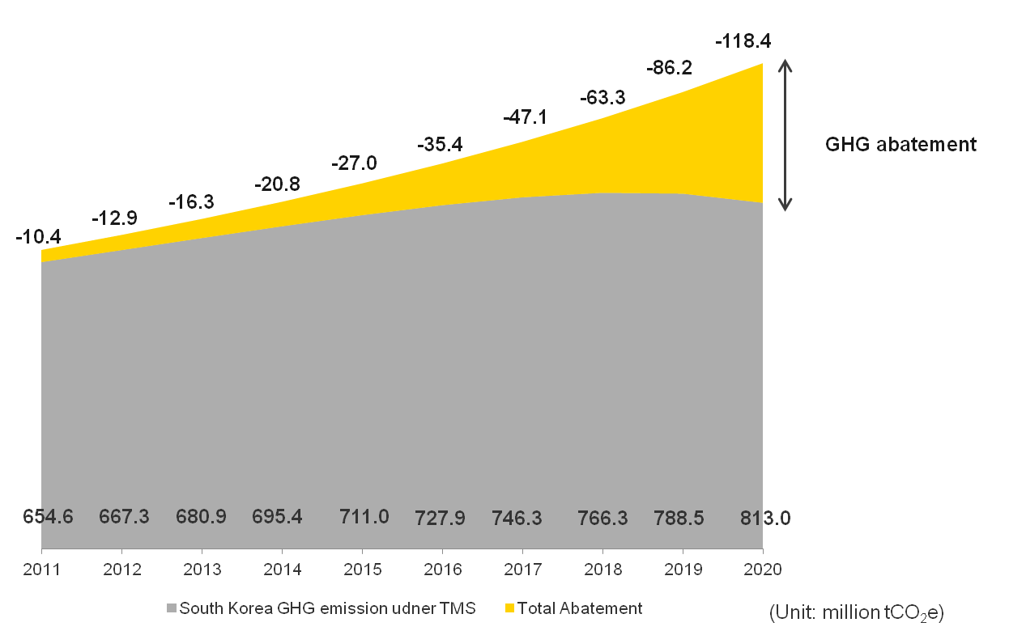

As mentioned above, all second order effects considered in this report are categorized into transport, building and industry. Figure 11 shows that the transport sector has the biggest potential in reducing GHG emissions compared to the building and industry sectors. This is because the use of ICT reduces the frequency and distance of movement by people and products.
Figure 11 − Potential aggregate GHG abatement by sectors (units: million tCO₂e)
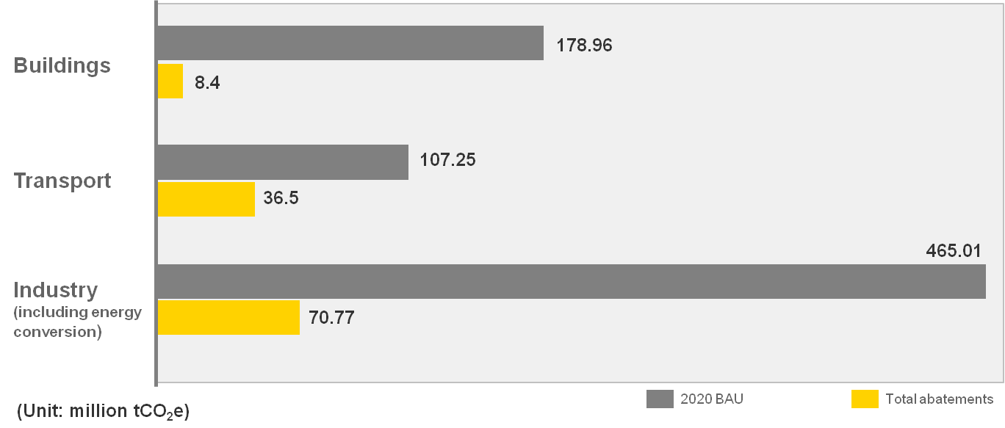

6 Conclusions and way forward
Korea is recognized as the top ranked country among the 155 countries in the ICT Development Index by ITU. Currently, Koreans use ICT services in every corner of life from smart government and e-civil service to real-time navigation and various types of digital contents. This report estimated the selected 14 ICT services' GHG abatement potential in Korea, and concluded that these ICT services can mitigate GHG emission by 118.4 million tCO₂e in 2020. This potential abatement would correspond to 15% of Korea’s GHG emission in 2020 and would exceed five times its ICT sector's direct GHG emission. Smart grids, e-logistics, and smart motors were identified as the top three enablers in 2011, while e-logistics and smart motor are expected to be replaced by telepresence and e-commerce in 2020 in terms of potential GHG reduction.
This report is based on thorough research and presents the first assessment based on primary data on how much domestic GHG emissions can be reduced through ICT. Due to the nature of the assessment and the limitations in available data, a high number of assumptions are made, and the results do not consider the full life cycle and reflect only the positive effects in other sectors when ICT services are used; the results do not reflect the first order impacts of the ICT services themselves. However, referring to the relatively small footprint of the ICT sector, the approach applied gives a clear indication of the potential of the assessed ICT services.
This report is focused on investigating ICT’s enabling potentials. Currently, the next phase of this report, which includes experiments, surveys, and LCA analysis in several services, including RTN, is in progress. The next phase includes activities such as collecting relevant data for more accurate assessment and calculating the carbon emissions of the ICT services themselves in order to further enhance the assessment. Furthermore, this kind of assessment could benefit from involvement by a country or cities’ authorities since they may have better opportunities to access and process data.
Quantification of ICTs impact on climate change mitigation is an effective tool to provide policy makers including mayors of cities, users, ICT industry, and other relevant stakeholders with more accurate information on the potential to achieve a low carbon society. In ITU-T, the experts in ICT as well as in the climate change sectors are collaborating to prepare the methodologies for quantifying and globally standardizing ICT’s GHG abatement potential. In particular, when preparing the ITU-T L.1400-series of Recommendations, much research and many discussions are currently in process to continuously and gradually enhance the methodologies.
A quantification methodology for the GHG abatement potential of ICT services is available in Recommendation ITU-T L.1410 and methodologies to assess their impacts in projects, cities, and countries are underway. Along with these efforts, national policies are fostered and created for innovation and green ICT solutions that are expected to positively influence the environment. The authors hope that this report also contributes to the global collective endeavour for ‘Greening through ICT’.

Acronyms
AC Alternating Current
AMI Advanced Metering Infrastructure
B2C Business-to-Consumer
BAU Business-As-Usual
BEMS Building Energy Management Systems
BIS Bus Information System
BT British Telecom
C2C Consumer-to-Consumer
CAGR Compound Annual Growth Rate
CDP Carbon Disclosure Project
CO₂e Carbon dioxide
CSR Corporate Social Responsibility
DC Direct Current
EDI Electronic Data Interchange
EV Electric Vehicle
G2G Government-to-Government
G4C Government for Citizen
GDP Gross Domestic Product
GeSI Global e-Sustainability Initiative
GHG Greenhouse Gas
GIS Geographic Information System
GNS Goods, Networks, and Services
GPS Global Positioning System
GSMA Global System for Mobile communications Association
HEMS Home Energy Management System
HP Hewlett-Packard
HVAC Heating, Ventilation, and Air Conditioning
ICT Information and Communication Technology
IDC International Data Corporation
ITU International Telecommunication Union
ITU-T International Telecommunication Union – Telecommunication Standardization Sector
LBS Location-Based Service
LCA Life Cycle Assessment
LCD Liquid Crystal Display
LED Light-Emitting Diodes
LGE LG Electronics
OECD Organization for Economic Co-operation and Development
PCGG Presidential Committee on Green Growth
PLC Power Line Communication
PV generation Photovoltaic generation
RTN Real-Time Navigation
SDH Synchronous Digital Hierarchy
SKT SK Telecom
WWF World Wide Fund for Nature

Bibliography
ARC Advisory Group, <General Motion Control Worldwide Outlook>, 2008.
Chungcheongbuk-Do Office of Education, <School Planning and Accommodation>, 2011 (Published in Korean).
EC, <On Mobilizing Information and Communication Technologies to facilitate the transition to an energy-efficient, low-carbon economy>, 2009.
ETNO-WWF, <Saving the Climate @ the Speed of Light>, 2006.
EU Commission press release, "Commission pushes ICT use for a greener Europe", 12 March 2009.
GeSI, <SMARTer 2020>
GSMA, Climate Group, <Mobile's Green Manifesto>, 2009.
IEA, <World Energy Outlook>, 2007.
IPCC (Intergovernmental Panel on Climate Change), <Synthesis Report>, 2007.
ITU, “Measuring the Information Society 2011”, 2011.
Recommendation ITU-T L.1400 (2012), Overview and general principles of methodologies for assessing the environmental impact of information and communication technologies.
Recommendation ITU-T L.1410 (2012), Methodology for the assessment of the environmental impact of information and communication technology goods, networks and services.
ITU-T FG-ICT&CC Deliverable 3.
Kim et al., <Research on Problems and Improvements of Green ICT>, 2nd edition on 18 volume of Environmental Policy, 2010 (Published in Korean).
Korea Communications Commission, Korea Association for ICT Promotion, <2010 Statistical Yearbook of Broadcasting and Communication Industry>, 2010 (Published in Korean).
Korea Digital Content Association, <Survey in National Businesses>, 2009 (Published in Korean).
Korea Electrotechnology Research Institute, <Survey on the Standby Power Consumption of Home Electronics>.
Korea Electric Power Corporation (KEPCO), <The Monthly Report on Major Electric Power Statistics, No. 397>, 2011 (Published in Korean).
Korea Energy Economics Institute, <Energy Consumption Survey>, 2008.
Korea Energy Management Corporation (KEMCO), <Analysis Report on National GHG Emission in 2008/2009>, 2008, 2009 (Published in Korean).
Korea Energy Management Corporation (KEMCO), <Analysis Report on National GHG Emission>, 2010 (Published in Korean).
Korea Energy Management Corporation (KEMCO), <Survey on the Status of Energy Use and GHG Emission>, 2008 “Running characteristics by transportation methods” (Published in Korean).
Korea Food Research Institute, <Consumer Response Regarding the Bargain in the Traditional Markets>, 2009.
Korea Information Society Development Institute, <Plan to Activate the E-book Market for Green Development>, 2010 (Published in Korean).
Korea Internet Security Agency, < Survey on the Internet Usage>, 2010.
Korea Institute for Industrial Economics & Trade (KIET), <Developmental Vision of Korean Industry 2020>, 2005 (Published in Korean).
Korea Logistics News, “Status of the Quantity of Parcels Transported”, 2011 (Published in Korean).
Korea Transportation Safety Authority, <Survey on the actual condition of the mileage of cars>, 2008 (Published in Korean).
Land & Housing Institute, <Statistics on Housing Environment of Apartments>, 2008 (Published in Korean).
LG Economic Research Institute (LGERI), <Koreans’ 24 Hours per day>, 2010 (Published in Korean).
Ministry of Economy, Trade and Industry (METI), Japan, <Green IT Initiative in Japan>, 2008.
Ministry of Health & Welfare<2009 Yearbook of Health, Welfare and Family Statistics>, 2009.
Ministry of Information and Communication, Korea Internet Security Agency, <Survey on the Internet Usage>, 2007.
Ministry of Knowledge Economy, <Roadmap for Establishing Low Carbon-Green Society by 2020> “Industrial, Divisional and Annual GHG Reduction Targets”, 2011 (Published in Korean).
Ministry of Public Administration and Security, <2011 National Informatization White Paper>2011.
Ministry of Public Administration and Security, <Smart Work Promotion Plan>, 2010 (Published in Korean).
Ministry of Public Administration and Security, <Revised Standard Version of Public Property Management Ordinance in City, Country, District> (Published in Korean).
Ministry of Public Administration and Security, <The Current State of Community Centers in Korea> (Published in Korean).
Ministry of Science, Technology and Innovation, Denmark, <Action Plan for Green IT>, 2008.
National Archives of Korea<Statistical Yearbook of Immigration Management>, 2004 (Published in Korean).
National Health Insurance Corporation, <National Health Insurance Statistical Yearbook for 2009>, 2009.
National Information Society Agency(NIA), <Propulsion Strategy for Low Carbon- Green Growth based on IT>, 2009 (Published in Korean).
National Information Society Agency(NIA), <Yearbook of Information Society Statistics>
“Status of Implementing Remote Meeting”, 2010 (Published in Korean)
National Information Society Agency(NIA), OECD, <Environment and ICT – Analysis of Global Issues and Trends>, 2008 (Published in Korean).
National Institute of Environmental Research, <Research in GHG Reduction of Cars>, 2005 (Published in Korean).
National IT Industry Promotion Agency, <2010 E-learning Industry Status Survey>, 2010.
NTT Docomo, <CSR Report 2011> 2011.
NTT Group, <CSR Report 2011> 2011.
NTT 情報流通基盤総合研究所<産業におけるIT活用による環境影響評価に関する研究＞, 2010
OECD, <Assessing Policy Responses to the Economic Crisis: Investing in Innovation for Long-Term Growth>, 2009.
OECD, <Towards Green ICT Strategies: Assessing Policies and Programmes on ICT and the Environment>, 2009.
OECD, <OECD Factbook>, 2010.
Romm J., <The Internet and the New Energy Economy>, 2002.
Seoul City Government<Establishment item on Seoul City’s Public Transportation Plan>, “Analysis on operation of bus”, 2007 (Published in Korean).
Seoul Emergency Operations Center, <Statistics on Monthly Emergency Mobilization> (Published in Korean).
Statistics Korea, <2010 Population and Housing Census Sampling Results> “Based on Housing Condition, IT Device, Transportation”, 2011 (Published in Korean).
Stern Review HM Treasury, <Stern Review on the Economics of climate change> Executive summary, 2006.
Telstra, <Towards a High-Bandwidth, Low-Carbon Future>, 2007.
The 3rd National Energy Committee, <1st National Energy Master Plan>, 2008 (Published in Korean).
The association of national bus businesses, <Manual on Statistics of Bus>, 2007 (Published in Korean).
The Committee of Education and Culture, <Press Release from the Seoul Metropolitan City Council> “2010 Status of commuting distance of the seventh graders”, 2010 (Published in Korean).
The Korea Transport Institute, <Comparison of the Freight Movement between Nation and Regions>, 2008 (Published in Korean).
The Korea Transport Institute, <Trend Analysis of National Logistics Costs>, 2008 (Published in Korean).
The research institute of mail management, <Strategy of Diversifying Profit in E-Post Business>, 2009 (Published in Korean).
Vodafone, <Carbon Connections>, 2009.
社団法人産業環境管理協会(JEMAI) <情報通信技術サービスの環境効率事例及び算定基準に関する検討成果報告書>
日産自動車株式会社, <日産SKYプロジェクト評価結果＞, 2008
日本総務省(MIC), <地球環境問題への対応に向けたICT政策に関する研究会報告書>, 2008
日本総務省(MIC), <情報通信白書2011>, 2011

According to Measuring the Information Society 2012 published by ITU, Korea tops the ICT Development Index (IDI) for the second consecutive year.
According to Recommendation ITU-T L.1400: Overview and general principles of methodologies for assessing the environmental impact of information and communication technologies, an ICT service is produced in one or more nodes of the network and provided to users or other ICT systems over the ICT network.
http://www.itu.int/ITU-D/ict/statistics/at_glance/keytelecom.html
Data from KTOA, Korea Telecommunications Operators Association (http://stat.ktoa.or.kr/default_client.asp)
NIPA (National IT Industry Promotion Agency).
SMARTer 2020, GeSI, 2012
http://www.gsma.com/publicpolicy/wp-content/uploads/2012/06/Green-Manifesto-2012.pdf
Carnegie Mellon, Green Design Institute, <Life Cycle Comparison of Traditional Retail and E-commerce Logistics for Electronic Products>
However, it should be noted that GHG emission reduction potential of e-commerce has a risk of rebound effects, such as the higher availability of e-commerce leading to increased consumption and GHG emissions.
GeSI, <SMART 2020>, 2008. The term ‘ICT enablers’ in this report refers to the ‘Greening through ICTs’ solutions.
WWF, <The potential global CO₂ reductions from ICT use>; GeSI, <Evaluating the carbon-reducing impacts of ICT>
First, second, and third order impact is set by orders of approximation referring to how precise an approximation is. ( Refer to Figure 8, Categories of ICT’s effects for a more detailed description).
Machine-to-machine (M2M) refers to technologies that enable both wireless and wired systems to communicate with other devices.
Vodafone, <Carbon connections>
NTT,<情報流通基盤総合研究所産業におけるIT活用による環境影響評価に関する研究＞
ICT statistics on this report refers to the statistics related to ICT industry and quantification of GHG emission reduction in 14 ICT services, such as population growth, changes in ICT industry markets, and changes in the number of ICT service users in Korea.
OECD, <Measuring the Relationship between ICT and the Environment>
Itu.int/ITU-T/climatechange/ess. This document summarizes the scope and purpose of the different energy and GHG management standards and guidelines. In particular, it examines the relationships between assessment targets and assessment criteria. This document was released in September, 2012.
Statistics Korea, http://kostat.go.kr/portal/korea/index.action
The bank of Korea. http://kosis.kr/nsikor/view/stat10.do?task=viewStatTbl&act=new&tblid=DT_074Y048&orgid= 301&language=kor&is_rss=Y
National IT Industry Promotion Agency. https://www.nipa.kr/know/periodicalView.it?identifier=02-001-110617-000016&menuNo=28&code=B_ITA_01
‘Worldwide Mobile Phone Tracker’, IDC, Feb. 2012.
International Data Corporation.
Figures demonstrated the global market share as of 1st half of 2011. “Your gateway to the Korean IT industry”, National IT industry Promotion Agency
National Computerization Agency of Korea.
National IT Industry Promotion Agency (NIPA).
Korea Communications Commission, http://news.hankooki.com/lpage/economy/201203/h2012031517332421500.htm
ITU, <Measuring the Information Society 2011>
Korean Statistical Information Service, http://kosis.kr/gen_etl/start.jsp?orgId=106&tblId=DT_106N_99_2800006&conn_path=I2&path =환경>기타>온실가스배출통계국가온실가스배출통계추이
Korea Energy Management Corporation (KEMCO), <National GHG Emission Analysis Report> 2008 and 2009.
Estimated based on <Analysis report on national GHG emissions in 2008/2009> by Korea Energy Management Corporation and <Korean industry vision by 2020> by Korea Institute for Industrial Economics & Trade. This estimation has not been done following ITU-T L.1420, and GHG emissions mentioned here only cover emissions in the boundary of scope 1 and 2.
Estimated based on <Analysis report on national GHG emissions in 2008/2009> by Korea Energy Management Corporation and <Korean industry vision by 2020> by Korea Institute for Industrial Economics & Trade. This estimation has not been done following ITU-T L.1420, and GHG emissions mentioned here only cover emissions in the boundary of scope 1 and 2.
http://www.greengrowth.go.kr/?page_id=42478
Ubiquitous health, which is similar to e-health, a health system combined with IT.
The numbers referred here as GHG reduction potential or achieved for South Korean companies are not estimated based on ITU-T methodology or proved by ITU-T. All numbers cited here are based on the respective company’s sustainability reports.
SK Telecom is a leading telecommunication company in Korea along with KT and LG U+.
https://www.cdproject.net/en-US/Pages/HomePage.aspx
GHG emissions mentioned here cover emissions in the boundary of scope 1 and 2. Figures may not be based on assessment made in accordance with Recommendation ITU-T L.1410.
This report uses the following units for assessing GHG emissions: GHG emissions = tCO₂e ktCO₂e = 1,000 tCO₂e MtCO₂e = 1,000,000 tCO₂e GtCO₂e = 1,000,000,000 tCO₂e
The calculation methods are from “Focus Group on ICTs and Climate Change, Deliverable 3: Methodologies” and they have been simplified for better understanding. http://www.itu.int/oth/T3307000005/en
The definition of ‘smart motor’ is identified in clause 5.1.12.
All reductions estimated here are potential.
Time priority route vs Distance priority route.
<Survey on the Internet Usage> by Korea Internet Security Agency, 2011.
Fuel reduction rate (8.7%) from VICS (Vehicle Information and Communication System) of Nissan, Japan, study is adopted as distance reduction assuming fuel efficiency in Korea is similar to that in Yokohama, Japan. Total reduced distance was applied to Korean real fuel efficiency and GHG abatement coefficiency.
Afterwards, similar experiments, but with higher number of samples, were carried out in order to assess RTN’s impact on the environment in Seoul, Korea, in 2012. It is concluded that RTN service in Korea has a potential to reduce 12.8% of CO₂ emissions and 11.8% of fuel consumption.
Estimated travel distance navigated by RTN based on <T-map user statistics>, SK telecom.
Assumed as percentage in travel distance based on SKY experiments by Nissan Motor.
Fuel efficiency of car: 8.32 km/l and Emission factor for gasoline (car): 2.47tCO₂e/kl are applied based on data from Korea Transportation Safety Authority, <Survey on the actual condition of the mileage of cars>, 2008. http://m.ts2020.kr/knowledge.do?cmd=view&m_menu=knowledge&pageNum=5&param_ctg_cd=23&param_ctg_ref=4&param_ctg_level=1&data_seq=519 and KEMCO, <Analysis Report on National GHG emission in 2008/2009> http://file1.mltm.go.kr/portal/common/download/DownloadMltm2.jsp?FilePath=portal%2FDextUpload%2F201110%2F20111025_160755_749.pdf&FileName=%B1%B3%C5%EB%BA%CE%B9%AE+%BF%C2%BD%C7%B0%A1%BD%BA+%B9%E8%C3%E2%B7%AE+%C1%B6%BB%E7.pdf
Assumed that it would increase from 16% to 70%.
Assumed that it would increase from 19.3% to more than 95%.
Adopted data of average growth rate of the number of cars between 2002 and 2011 in Korea.
The association of national bus businesses, <Manual on Statistics of Bus> and based on the number of bus lines installed in 8 metropolitan cities in Korea. http://www.bus.or.kr/files1/2006%EB%85%84%ED%8C%90%ED%86%B5%EA%B3%84%ED%8E%B8%EB%9E%8C%20%EC%84%9C%EC%8B%9D.zip
he assumption from media analysis which reports the increase in the number of passengers after adopting new BIS in Korea. It is said that after Bucheon installed BIS, about 75% of the civil complaints regarding bus systems is reduced, and the percentage of passengers increased by 20%. http://wellgolf.com/board/view.php?id=19hole_5&page=17&page_num=15&category=&sn=off&ss=on&sc=on&keyword=&prev_no=&select_arrange=headnum&desc=asc&no=430
EY Analysis, Bus Business Statistics, National Bus Association.
Emission factor for gasoline (bus): 0.00141 tCO₂e/km is applied based on data from KEMCO, <Analysis Report on National GHG emission in 2008/2009>
Calculated by the number of BIS lines in eight metropolitan cities as of 2008 based on<Manual on Statistics of Bus> 18% is the portion of current BIS lines among all bus lines in eight metropolitan cities in Korea.
Those are trucks that are used for official tasks or duties such as by the government.
<Analysis for amount of freight delivered among cities> by the Korea Transport Institute
NTT 情報流通基盤総合研究所 ＜産業におけるIT活用による環境影響評価に関する研究＞, 2010 According to NTT Information Sharing Laboratory Group to Japanese Ministry of Environment, e-Logistics, because of E-Logistics system, loading efficiency of trucks will be approximately 16.70%
Emission factor for gasoline (trucks): 0.0008 tCO₂e/km is applied based on data from KEMCO, <Analysis Report on National GHG emission in 2008/2009>
Based on data from <Analysis for Amount of Freight Delivered Among Cities> by The Korea Transport Institute, the growth rate of cargo amount from 2002 to 2008, which is 1.89%.
According to Ministry of Land, Transport, and Maritime Affairs, they set their goal as “2020 plans for GHG emission reduction in logistics”. Specifically, they planned to enhance low carbon logistics up to 70% by 2020. 1) http://www.newswire.co.kr/newsRead.php?no=637009, or 2) http://file1.mltm.go.kr/LCMS/DWN.jsp?fold=law&fileName=%B1%B9%B0%A1%B9%B0%B7%F9%B1%E2%BA%BB% B0%E8%C8%B9_%BC%F6%C1%A4%B0%E8%C8%B9(2011-2020).hwp
http://www.hikorea.go.kr/ptimg/moj_sts/2004/index.html <Statistical Yearbook of Immigration Management>, by the National Archives of Korea.
http://file1.mltm.go.kr/portal/common/download/DownloadMltm2.jsp?FilePath=portal% 2FDextUpload%2F201110%2F20111025_160755_749.pdf&FileName=%B1%B3%C5%EB%BA%CE%B9%AE+%BF%C2%BD%C7%B0%A1%BD%BA+%B9%E8%C3%E2%B7%AE+%C1%B6%BB%E7.pdf Korea Energy Management Corporation (KEMCO), <Analysis Report on National GHG Emission>, 2010.
Since only 896 business travellers are replaced by telepresence and the average number of passengers per airplane is 137.32, about 6.52 airplanes are estimated to have decreased.
Emission factor for flights: 29.8 tCO₂e/km is applied based on data from KEMCO, <Analysis Report on National GHG emission in 2008/2009>
http://huri.jugong.co.kr/update/focus/stat_apt.asp this is a national statistical report for housing environment of apartment since 1980. In Korea, apartment buildings are the main housing type and it may vary by countries. According to <Statistics on Housing Environment of Apartments>by Land & Housing Institute
We applied the result from <Towards high bandwidth low carbon future> by Telstra, that 50% of stand-by electricity and loss of electricity is reduced after implementing HEMS.
Network enabled Presence-Based Power allows a user-focused energy flow, in which only devices inside the physical range of engagement of the user are activated according to Telstra.
Emission factor of electricity consumed: 0.435 tCO₂e/MWh is applied based on data from KEMCO, <Analysis Report on National GHG emission in 2008/2009>
Based on the published data, the percentage of apartments built before and after, and other types of houses is 5.24%, 44.76% and 50%, respectively. Assuming that 25%, 15%, and 10% of each house adopt HEMS in 2011, and 80%, 60%, and 30% of each house will adopt HEMS in 2020.
http://www.smartgrid.or.kr/eng.htm
http://www.etnews.com/201111010090 It mainly states the potential positive impacts of AMI in Korea.
Low voltage refers to alternating current (AC) voltage of equal or less than 600V or direct current (DC) voltage of equal or less than 750V.
High voltage refers to alternating current (AC) voltage of higher than 600V and less than 7,000V or direct current (DC) voltage of higher than 750V.
http://www.etnews.com/201111010090 Since KEPCO started investing more than USD 10 billion for 10 years from 2010 along with the Korean government, it is expected to reduce 6% of energy around the nation by 2020.
Starting by 500 thousand households in 2010, KEPCO has planned to invest for AMI including 2-3 steps of test bed project.
Based on media analysis, (http://www.etnews.com/201111010090), it was assumed that fuel efficiency of high-voltage customers is not highly affected. In addition, based on “Methodology for estimating energy savings related with Smart Metering”, 3% of energy savings potential was adopted, which is the lowest figure among various cases.
It was the sum of energy reductions from both low-voltage and high-voltage customers. The total electricity consumption from 18 million people who use low voltage with AMI (penetration rate of 3%) is calculated first and then the 3% of efficiency increase in assumed based on http://www.etnews.com/201111010090. The same approach is applied to the reduction in electricity consumption for high voltage.
Emission factor of electricity consumed: 0.435 tCO₂e/MWh is applied based on data from KEMCO, <Analysis Report on National GHG emission in 2008/2009>
http://www.greendaily.co.kr/news/articleView.html?idxno=17034 This is the article about the energy cost effect by AMI, one type of smart grid, and some other positive impacts on the environment. It is said that the Ministry of Knowledge and Economy and KEPCO are going to invest USD 103.3 million per year to increase the number of customers using AMI.
http://census.go.kr/hcensus/ui/html/foreigner/enGuide.html
By the Ministry of Information and Communication and Korea Internet & Security Agency http://isis.nida.or.kr/board/fileDown.jsp?pageId=040100&bbsId=7&itemId=720&athSeq=2
It is because electricity consumption will be lowered as shopping areas could be reduced when less customers visit stores for shopping.
http://www.kisdi.re.kr/kisdi/common/download?type=DR&file=1%7C11136 The research institute of mail management, <Strategy of Diversifying Profit in E-Post Business>, 2009 (Published in Korean) shows that almost all parcels originated from B2C market, of which 70% are derived from e-commerce. All the data related to parcel-delivering is based on Korea Logistics News, “Status of the Quantity of Parcels Transported”, 2011 (Published in Korean).
file:///C:/WINDOWS/TEMP/ESV08[1].pdf Based on the data from Korea Energy Economics Institute, <Energy Consumption Survey>, 2008, annual average electricity consumption in wholesale and retail businesses is used.
http://www.kfma.ne.kr/studydata/26-4/26-4-5.pdf
Travel distance for offline shopping is calculated as 11 km based on the data from <Korean’s 24 Hours usage pattern> by LG Economic Research Institute.
Total reduced travel distance, therefore, is calculated by the total number of online shopping * average km to the commercial building, dividing by vehicle occupancy ratio.
(1) The potential travel distance of offline shopping: the population with purchasing power*the average number of visiting stores (which is the annual average number of transactions in result)*the average distance to the store/vehicle occupancy ratio. (2) The potential travel distance of e-commerce: the number of transactions of e-commerce*the average distance to the store/vehicle occupancy ratio.
According to the research institute of mail management, <Strategy of Diversifying Profit in E-Post Business>, 2009 (Published in Korean) almost 70% of parcels are derived from e-commerce.
This figure is brought by applying 70% to the annual truck mileage for parcel service based on <Analysis Report on National GHG and energy consumption> by KEMCO.
Energy consumption per every visit is calculated by dividing the total energy consumption (13 billion kWh) in commercial buildings by the potential number of visiting stores by people who have purchasing power.
Fuel efficiency of car: 8.32km/l, Emission factor for gasoline (car): 2.47 tCO₂e/kl, Emission factor for gasoline (trucks): 0.0008 tCO₂e/km are applied based on data from Korea Transportation Safety Authority, <Survey on the actual condition of the mileage of cars>, 2008 and KEMCO, <Analysis Report on National GHG emission in 2008/2009>
http://www.mopas.go.kr/gpms/view/jsp/download/userBulletinDownload.jsp?userBtBean.bbsSeq=1011245&userBtBean.ctxCd =1002&userBtBean.orderNo=2 Ministry of Public Administration and Security, <2007 Annual Report for e-government project>
It was assumed that one government office is located in each administrative region. 1) Average distance between buildings is modelled as 13 km by calculating two major government offices. 2) Average speed in Seoul is assumed based on the average speed of commercial taxis according to The Korea Transport Institute http://www.datanews.co.kr/site/datanews/DTWork.asp?itemIDT=1002304&aID=20111202140424650
Electricity consumption in official buildings was based on <Energy Consumption Survey>, Korea Energy Economics Institute 2008, Electricity consumption in official buildings. It is said that on an average, 215m² is used for governmental work and 128kWh/m² is energy consumption per space.
According to <2011 national Informatization White Paper> by the Ministry of Public Administration and Security, the amount of paper used and expected to be saved was set. http://www.mopas.go.kr/gpms/ns/mogaha/user/userlayout/bulletin/userBtView.action?userBtBean.ctxCd=1289&userBtBean.ctxType=21010002&userBtBean.bbsSeq=1021023
We assumed that people will not print out the information acquired.
Fuel efficiency of car: 8.32km/l and Emission factor for gasoline (car): 2.47tCO₂e/kl are applied based on data from Korea Transportation Safety Authority, <Survey on the actual condition of the mileage of cars>, 2008 and KEMCO, <Analysis Report on National GHG emission in 2008/2009>
Emission factor of electricity consumed: 0.435 tCO₂e/MWh is applied based on data from KEMCO, <Analysis Report on National GHG emission in 2008/2009>
http://www.minwon.go.kr/new_info/introduce/AA090_info_introduce_summary.jsp
This positive second order effect is assumed based on the fact that energy consumption is subject to the number of visitors in the related buildings.
Travel distance is estimated by the average distance between public offices in Seoul for this report, which is 13 km.
According to <2011 national Informatization White Paper> by the Ministry of Public Administration and Security, the average citizen uses approximately the e-civil service 13 times per year. http://www.mopas.go.kr/gpms/ns/mogaha/user/userlayout/bulletin/userBtView.action?userBtBean.ctxCd=1289&userBtBean.ctxType=21010002&userBtBean.bbsSeq=1021023
It is assumed that citizens who visit government offices drive their own cars by 50% and vehicle occupancy ratio is 1.23.
Electricity consumption in official buildings was based on <Energy Consumption Survey>, Korea Energy Economics Institute 2008, Electricity consumption in official buildings. It is said that on an average, 215m² is used for governmental work and 128kWh/m² is energy consumption per space.
Fuel efficiency of car: 8.32km/l and Emission factor for gasoline (car): 2.47tCO₂e/kl are applied based on data from Korea Transportation Safety Authority, <Survey on the actual condition of the mileage of cars>, 2008 and KEMCO, <Analysis Report on National GHG emission in 2008/2009>
Emission factor of electricity consumed: 0.435 tCO₂e/MWh is applied based on data from KEMCO, <Analysis Report on National GHG emission in 2008/2009>
“Overall national informatization status (in Korean)”, NIA.
http://www.nhic.or.kr/portal/site/main/menuitem.74b68c0b767ded38b31148b4062310a0/ This is the percentage of general hospitals among all hospitals in Korea according to the data from National Health Insurance Corporation.
The average distance to hospitals is the data from Seoul Emergency Operations Center, <Statistics on Monthly Emergency Mobilization>
KEEI (Korea Energy Economics Institute, <Energy Consumption Survey>
Fuel efficiency of car: 8.32km/l and Emission factor for gasoline (car): 2.47tCO₂e/kl are applied based on data from Korea Transportation Safety Authority, <Survey on the actual condition of the mileage of cars>, 2008 and KEMCO, <Analysis Report on National GHG emission in 2008/2009>
http://www.kisdi.re.kr/kisdi/fp/kr/publication/selectResearch.do?cmd=fpSelectResearch&curPage=3&sMenuType= 3&controlNoSer=1&controlNo=12132&langdiv=1&searchKey=TITLE&searchValue=&sSDate=&sEDate= <Market analysis report for domestic digital contents industry>, Korea IT Industry Promotion Agency and Korea Digital Media Industry Association
http://www.itsa.or.kr/down.asp?f_name=4.pdf Assumed that a single book composes 266 pages according to National Information Society Agency (NIA), <Propulsion Strategy for Low Carbon- Green Growth based on IT>, 2009.
Media analysis.
Korea Digital Content Association, <Survey in National Businesses>, 2009.
Korea Digital Content Association, <Survey in National Businesses>, 2009.
Previous research related to digital content indicates that the ICT service itself could contribute substantially to emissions. As this report does not cover the first order effects of the ICT service, this effect is not visible in the results.
Emission factor for paper: 0.0064 tCO₂e/1,000 sheets and Emission factor for CDs: 0.000554 tCO₂e/CD are applied based on data from KEMCO, <Analysis Report on National GHG emission in 2008/2009>
<2008 Energy Survey>, Korea Energy Economics Institute.
High efficient motor promotion statistics, KEMCO.
It is explained that energy-saving drive brings the motor speed down to match the actual demand needed by the application, and this often cuts down energy consumption by 50% and in extreme cases by as much as 90%. ABB drives and motors for improving energy efficiency, http://www.abb.com/motors&generators http://www05.abb.com/global/scot/scot201.nsf/veritydisplay/06089e41600d59b3c1257a130024f543/$file/EN_ABB_drives_and_motors_energy_efficiency_REVB.pdf
Emission factor of electricity consumed: 0.435 tCO₂e/MWh is applied based on data from KEMCO, <Analysis Report on National GHG emission in 2008/2009>
ARC Advisory Group, <General Motion Control Worldwide Outlook>, 2008.
E-Learning here does not replace regular school hours. As mentioned, e-Learning plays a role as assisting and replacing the extra-curriculums.
http://www.goodlearn.kr/upload/book/1301360664225.pdf The number of e-learning attendance per student
2.2 km is average commuting distance for students based on <Report on population and housing census> in 2010 www.census.go.kr
Based on <Report on population and housing census> in 2010, the use rate of private cars for commuting was 62% among the households that possess vehicles. The use rate for buses is 5.5% according to the same reference.
According to “Educational institution construction plans” by Chungcheong-buk-do (a region in Korea) Office of Education, students occupy 2.5m² on average and electricity consumption per m² is 146kWh per year.
http://www.goodlearn.kr/upload/book/1301360664225.pdf The number of e-learning attendance per student
In this report, it is assumed that there are two types of students who commute by private cars and buses. The penetration rate of cars in households and the percentage of using cars and buses for commuting are based on Statistics Korea, <2010 Population and Housing Census Sampling Results>
We assumed that the buses affected here will be the chartered buses by the education institutions.
For attending extra-curriculum classes, it is common in Korea to use private vehicles or buses charted by the educational institutions. However, this may differ from country to country.
Fuel efficiency of car: 8.32km/l Emission factor for gasoline (car): 2.47tCO₂e/kl and emission factor for gasoline (bus): 0.00141 tCO₂e/km are applied based on data from Korea Transportation Safety Authority, <Survey on the actual condition of the mileage of cars>, 2008 and KEMCO, <Analysis Report on National GHG emission in 2008/2009>
Emission factor of electricity consumed: 0.435 tCO₂e/MWh is applied based on data from KEMCO, <Analysis Report on National GHG emission in 2008/2009>
Current percentage of smart work in Korea, based on <Smart Work Promotion Plan> from Ministry of Public Administration and Security
It is modelled based on the average distance between the middle of metropolitan and major residential districts in Seoul.
According to <Report on population and housing census> in 2010 www.census.go.kr, transportation mode for commuting was introduced. For instance, 47.4% of workers use private vehicles and 14.3% use buses for commuting.
Current days of smart work in Korea, which is 62 days, based on <Smart Work Promotion Plan> from Ministry of Public Administration and Security.
According to <Analysis Report on National GHG emission-household and commercial part>, electricity consumption per m² is 216 kWh on average.
National Energy Survey 2008, KEEI.
Fuel efficiency of car: 8.32km/l Emission factor for gasoline (car): 2.47tCO₂e/kl and Emission factor for gasoline (bus): 0.00141 tCO₂e/km are applied based on data from Korea Transportation Safety Authority, <Survey on the actual condition of the mileage of cars>, 2008 and KEMCO, <Analysis Report on National GHG emission in 2008/2009>
Emission factor of electricity consumed: 0.435 tCO₂e/MWh is applied based on data from KEMCO, <Analysis Report on National GHG emission in 2008/2009>
ITU Statistics, Measuring the Information Society, 2012.

