Key results of the work on MPLS-TP
The relationship between the ITU-T Recommendations and the IETF RFCs that they will normatively reference is provided in the figure below:
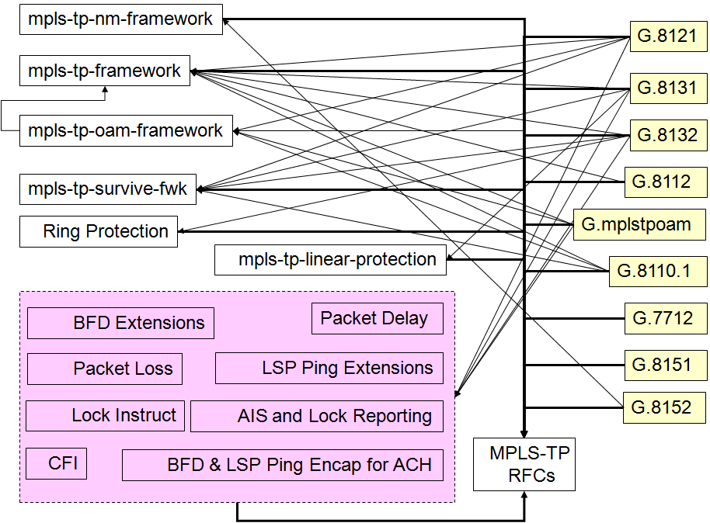
The relationship between the ITU-T Recommendations and the Recommendations that they must normatively reference is illustrated in the figure below:
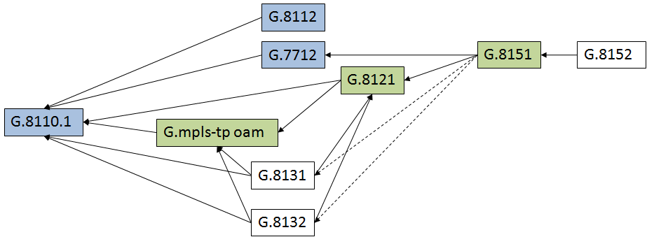
Notes:
G.8101 is not shown. The development of G.8101 is dependent on the completion of the Recommendations that will use the terms being defined.
The dashed line indicates that the initial version of G.8151 may not include the model for linear and or ring protection.
It was noted that it may be possible to consent the Recommendations in three blocks:
1) G.8110.1, G.7712, G.8112 in June 2010:
2) G.mpls-tp oam, G.8121, G.8151 in February 2011:
3) G.8131, G.8132, G.8152 in December 2011.
Further details of the work on MPLS-TP can be found on the ad hoc MPLS-TP web page.

