ITU IT Handbook

TSB Rapporteurs Meeting



Updated by Guy Girardet on Tuesday, November 22, 2011

# Participating in a Meeting

## Logging into the Meeting Room

1. Open your browser and enter the name of the meeting room: http://itu.adobeconnect.com/tsbrapporteurworkshop/
2. When prompted, please logon as a guest.
3. Enter your name in the format First Name, Last Name + (Organization). For example Guy Girardet (ITU).

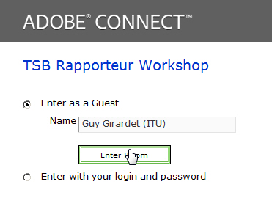

1. Once the meeting host has approved your request, you will be logged into the meeting room.
2. You will see a video of the meeting room. You will also be able to see presentations and documents for the current session.
3. Use the chat pod in the bottom right corner of the meeting room if you wish to exchange messages with the moderator (Kevin Quinto)

Note: Please login to the meeting room at least 15 minutes before the session is due to start. This will ensure that we can start the training on time.

## What an Adobe Connect Meeting room looks like

A Connect room is composed of a number of layouts. Each layout has one or more "pods". The pods in the graphic below are described in the following table.

|  |  |
| --- | --- |
| Pod | What it does |
| Video Pod | Used to display any video used in the web meeting. If additional participants display video, this will share the same video pod |
| Attendee Pod | Displays names of all participants logged into the meeting room. Participants are grouped according to their respective roles: Hosts, Presenters and Participants. |
| Share Pod | Used to share meeting documents. Can contain documents uploaded to the Connect server and can also be used for screen sharing |
| Chat Pod | Used to exchange chat messages. Messages can be sent to everyone, or privately to individuals. |

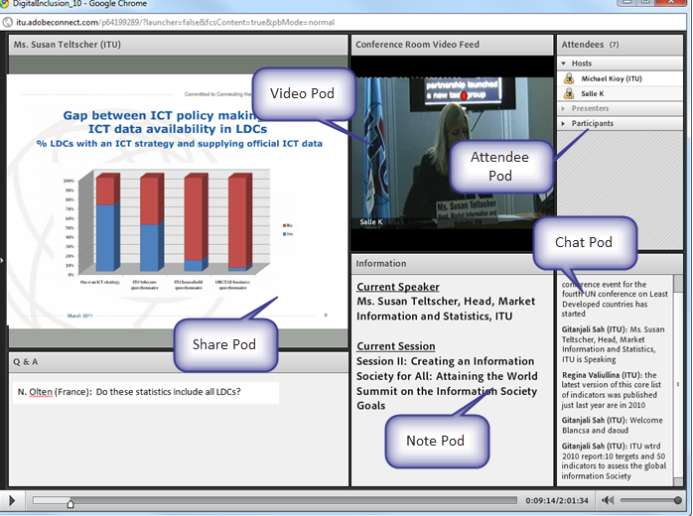

## How audio works

The audio-conference will start 15 minutes before each session. Once the audio-conference has started you will be able to hear the audio through your computer speakers.

If you wish to make an oral intervention, you will need to join the audio-conference using a landline phone. The following section will tell you how to get the system to call you back on a landline number.

## Listening through your computer speakers

Once the audio-conference has started, you will be able to hear the audio from the ITU meeting room through your speakers.

* To listen to the audio through your speakers:
* When the rPhone dialog box appears, select Close
* 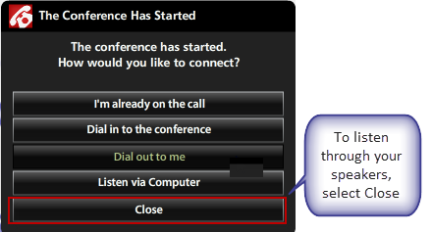

## Joining the audio-conference

If you wish to make an oral intervention you first need to join the audio-conference. You can then raise your hand to signal to the moderator that you would like to intervene.

* To join the audio-conference:

1. Select the telephone icon at the bottom right of the rphone Audio Bridge.

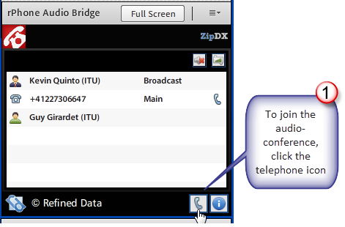

1. Choose dial-out to me.

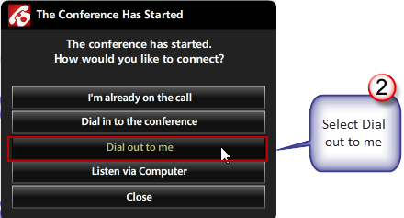

1. Select your country from the list.
2. Enter your area code and your number.

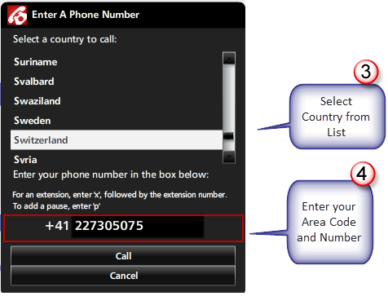

1. Your phone will ring, and you will be connected to the audio-conference.

## Requesting the Floor

1. Once you have joined the audio-conference, select the raise hand icon at the top of the web meeting room. This will tell the moderator that you wish to make an intervention. The moderator will communicate your request to the Chair. Your telephone will be unmuted and you can take the floor.

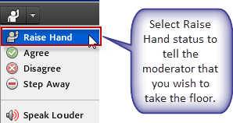

1. Once you have been given the floor, you will be un-muted you and you will hear a prompt telling you that you have the floor.
2. Please go ahead and make your intervention. Once you have finished, you can stay on the audio-conference, or hang-up, if you wish to return to listening through your speakers.

Note: When making an oral intervention, please be sure to a) use your handset and not a speaker phone and b) ensure that your computer speakers are muted, or turned down.