PRACTICAL INFORMATION

Ad-hoc meeting for ISO/ITU Joint Task Force on ITS
Telecommunications Standardization
24th August 2011, Kyoto (Japan)
Address of the meeting | Kyoto Research Park  93, Chudoji Awatacho, Shimogyo-ku Kyoto 600-8815, Japan  cf. http://www.krp.co.jp/english/
mEETING Date | 24 August 2011
REGISTRAtion | Please make on-line registration through web page below;  http://www.itu.int/cgi-bin/htsh/edrs/ITU-T/workshop/edrs.registration.form?_eventid=3000290
RECOMMENDED HOTEL | Kyoto Tokyu Hotel  Please use following hotel reservation form (Annex 1).  # Please send the form no later than 22nd July by  e-mail: kyototokyu-res@dune.ocn.ne.jp  or  Fax: +81-75-341-2488  cf. http://www.kyoto-h.tokyuhotels.co.jp/en/
PRACTICAL INFORMATION | Please read the following page

1. Meeting place
Kyoto Research Park
Address: 93, Chudoji Awatacho, Shimogyo-ku, Kyoto 600-8815
TEL/ FAX: +81-75-322-7800 / +81-75-322-5348
URL: http://www.krp.co.jp/english/
MAP: http://maps.google.com/maps?q=34.99476,+135.740161

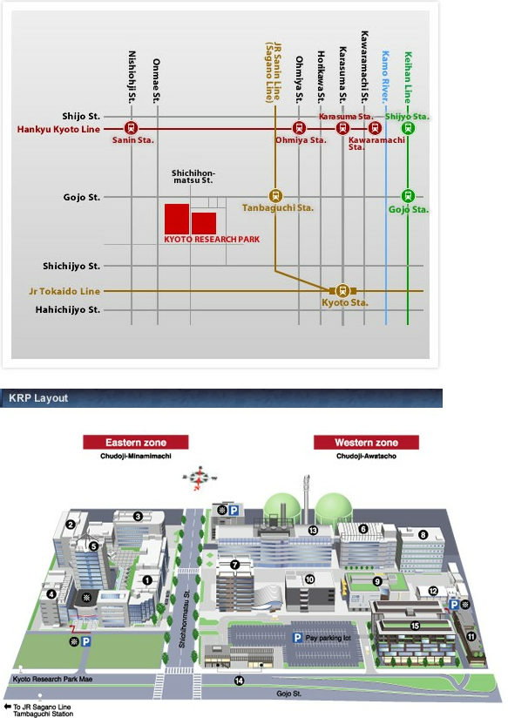
N

Bird-eyed View
Bus
# 80
Bus
# 43
43, 73, 75, 80
Gojyo
(Subway K10 )

Bus
# 73
Buss# 75

Kyoto Tokyu Hotel

JR Kyoto Station
Kyoto (Subway K11)

Subway

Meeting rooms:
4th floor of Bldg. #1

Bus from Hotel,,Kyoto Station
Bus back to Hotels, Kyoto Station
Kyoto Research Park Mae
Please be reminded that North in downward in this Bird-eyed picture, opposite from conventional Street/Bus Route Map indicated above
2. Accommodation

Kyoto Tokyu Hotel
Reservation: See attached reservation form (Annex 1)
Deadline: 22th July, 2011
Address: Gojo-sagaru, Horikawa-dori, Shimogyo-ku, Kyoto 600-8519
TEL/ FAX: +81-75-341-2411 / +81-75-341-2488
URL: http://www.kyoto-h.tokyuhotels.co.jp/en/
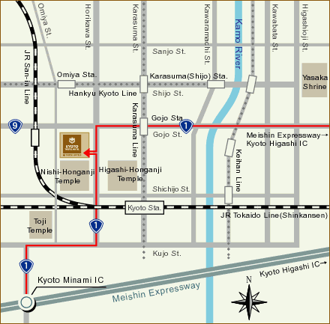
Access from JR Kyoto Station by Shuttle Bus:
Shuttle service from/to JR Kyoto station (Hachijo-guchi) is available. The shuttle runs every 15 to 30 mins between 8:15 and 20:30.
See http://www.kyoto-h.tokyuhotels.co.jp/en/location.html
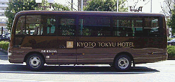
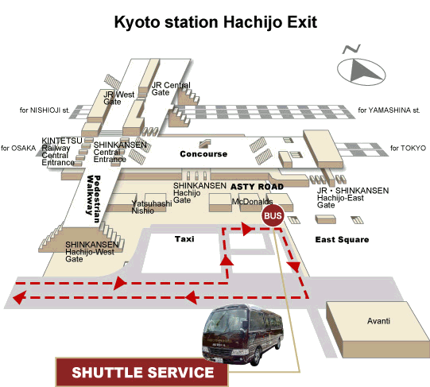
Access to Kyoto Research Park by City Bus:
HorikawaGojo -- Route 73 (4mins, 220yen) --> KyotoResearchPark-mae
-- Route 75 (4mins, 220yen) -->
-- Route 80 (4mins, 220yen) -->
-- Route 43 (4mins, 220yen) -->

http://www.kyotocitybusguide.net/result/?departure=HorikawaGojo%2Fbus&departure_code=43063&arrival=KyotoResearchPark-mae%2Fbus&arrival_code=42666&calendar=08%2F22%2F2011&priority=shortTime&submit=route+search
Information on other hotels

Following is the list of hotels you may make reservation directly by yourselves.

Near JR Kyoto Station (take bus # 73 or #75 to the venue)
  - Kyoto Tower Hotel
http://www.kyoto-tower.co.jp/tower_hotel/english.html
  - Kyoto Century Hotel
http://www.kyoto-centuryhotel.co.jp/english/index.html
  - Hotel New Hankyu Kyoto
http://www.hankyu-hotel.com/cgi-bin2/cms2/index_en.cgi?hid=30kyotoshh
  - Rihga Royal Hotel Kyoto
http://www.rihga.com/kyoto/index.html
  - Apa Hotel Kyoto-Ekimae
http://www.apahotel.com/hotel/kansai/01_kyoto-ekimae/english/index.html
  - Hotel Granvia Kyoto
http://www.granviakyoto.com/
  - New Miyako Hotel
http://www.miyakohotels.ne.jp/newmiyako/english/index.html

Near Gojyo (Karasuma Gojyo) (take bus # 73, #80 or #43)

Citadines Karasuma-Gojo Kyoto
http://www2.citadines.com/japan/kyoto/karasuma_gojo.html
  - Aranvert Hotel Kyoto
http://www.aranvert.co.jp/en/index.htm
  - Comfort Inn Kyoto
http://www.comfortinn.com/hotel-kyoto-japan-JP016?sid=xWHBKM.Yu29Og8lM.17

Near Karasuma Shijyo
(Subway “Shijyo” (K09) next to “Gojyo”(K10) above)
  - Karasuma Kyoto Hotel
http://karasuma.kyotohotel.co.jp/english/
  - Karasuma Toyoko Inn Kyoto Shijyo-Karasuma
http://www.toyoko-inn.com/e_hotel/00053/index.html
  - Mitsui Garden Hotel Kyoto Shijyo
http://www.gardenhotels.co.jp/eng/kyoto/

Others
- ANA Hotel Kyoto (Subway “Nijyojyo-mae” (T14))
http://www.ichotelsgroup.com/h/d/6c/1/en/hd/kstna
- Kyoto Kokusai Hotel (Subway “Nijyojyo-mae” (T14))
http://www.kyoto-kokusai.com/e/index.html
- Kyoto Hotel Okura (Subway “Shiyakusho-mae” (T12) )
http://okura.kyotohotel.co.jp/english/
- Westin Miyako, Kyoto (Subway “Keage” (T09))
http://www.starwoodhotels.com/westin/property/overview/index.html?propertyID=1427&language=en_US
- Hotel Gimmond Kyoto (Subway “Karasuma Oike” (K8))
http://www.gimmond.co.jp/kyoto/english/e_index.html
- Hyatt Regency Kyoto
http://kyoto.regency.hyatt.com/hyatt/hotels/index.jsp?null
Following URLs may also help you:
http://www.hotels.com/
http://www.booking.com/
http://www.expedia.com/Hotels

3. Access
3.1 Access to Kyoto station
- From “Kansai International Airport (KIX)” - recommended
  - About 75 minutes by Airport Shuttle Train “Haruka”
  - See http://www.kyoto-magonote.jp/en/transport/kix-kyoto/access/
- From Tokyo Station: via Narita Airport (NRT) or Haneda Airport (HND)
  - 2 hours 15 minutes by “Shinkansen Nozomi” (Bullet Train)
- From “Osaka (Itami) Airport (ITM)” - domestic flight only
  - About 55 minutes by Limousine bus
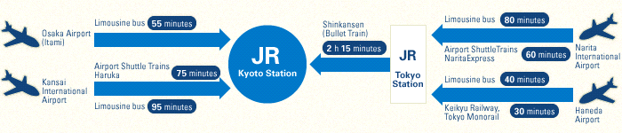
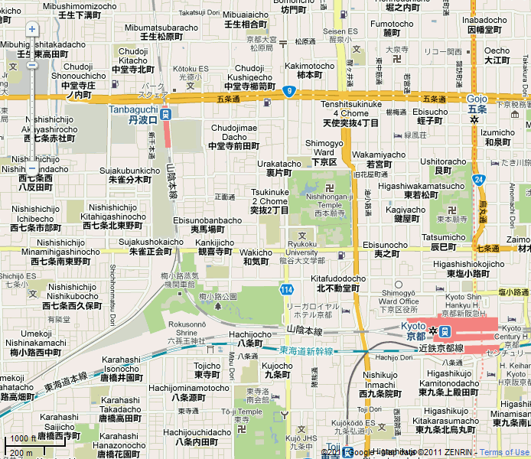
Bus
#43
Kyoto Research Park Mae
#43, #73, #75, & #80
Subway Gojyo (K10)

Bus#80

Kyoto Tokyu Hotel

Bus
#73

Bus#75

Hotel’s Shuttle Bus
Kyoto Station
Bus Terminal C5

3.2 Access from the Hotels/Kyoto Station to the venue
From Kyoto Station: Take Bus # 73 or #75 at C5 Bus stop of Kyoto Station Bus Terminal,
Take off the Bus at “Kyoto Reserch Park Mae”
From Kyoto Tokyu Hotel: Take Bus #43, #73, #75 or #80 at “Horikawa Gojyo” near by the Hotel,
Take off at “Kyoto Reserch Park Mae”
Subway Connection: Change from Subway (K10) to Bus (#43, #73 or #80) at Gojyo
Bus Stop to go to Research Park Bus Stop return from Research Park
4. Social Event

Date: 24th August (Wed), 19:00~21:00
Place: Junsei restaurant (Traditional Kyoto cuisine)
Location: Nanzenjimon mae, Sakyo-ku, Kyoto
cf. http://www.to-fu.co.jp/en/
# The restaurant is subject to change.

Please indicate on your registration form (Annex 2) whether you (and your guest) will be interested in attending the social event. Please note that the expected fee for the social event is 8,000 yen.

5. Hotel Reservation form for Kyoto Tokyu Hotel only

Hotel reservation: See Annex 1
Complete and return the hotel reservation form in Annex 1 to KYOTO TOKYU HOTEL no later than 22nd July by e-mail: kyototokyu-res@dune.ocn.ne.jp or Fax: +81-75-341-2488

6. General information
6.1 Currency
The unit of Japanese currency is Yen (JPY: \). [$1 = \80]
Bank notes are 1000Yen, 2000Yen, 5000Yen and 10000Yen. Coin denominations are 1Yen, 5Yen, 10Yen, 50Yen, 100Yen and 500Yen.

6.2 Public transportation
City Bus: The Kyoto City bus is useful for getting around various places within Kyoto.
Subway: Two subway lines bisect Kyoto. The entrance to the Subway Station is indicated by a subway sign.
See http://www.city.kyoto.jp/koho/eng/access/transport.html

Kyoto City Bus travel map: http://www.kyotocitybusguide.net/search/
Train Route Finder: http://www.jorudan.co.jp/english/

6.3 Using Electric Appliances in Japan
The standard voltage in Japan is 100 volts AC50/60 Hz with two flat parallel prongs plug (Type A: same as in US).

6.4 Useful information
Official Kyoto travel guide: http://www.kyoto.travel/
Kyoto City Tourism Association: http://www.kyoto-magonote.jp/en/
ANNEX 1

京都東急ホテル 宿泊予約申込書 / KYOTO TOKYU HOTEL Reservation Form
Fax to: (075) - 341 - 2488 / Fax to : +81-75-341-2488

ISO/ITU Joint Task Force Ad-hoc meeting
必要事項を記入の上ﾌｧｯｸｽ又はﾒｰﾙにてお申し込み下さい。（締め切り 2011年7月22日）
Please complete this form and return it by fax or E-mail Deadline 22th JUL, 2011
京都東急ホテル / KYOTO TOKYU HOTEL
〒600-8519京都市下京区堀川五条下ﾙ580
Gojo-sagaru, Horikawa-dori, Shimogyo-ku, Kyoto, Japan
TEL 075-341-2411 Phone: +81-75-341-2411
FAX 075-341-2488 Fax : +81-75-341-2488
E-mail:kyototokyu-res@dune.ocn.ne.jp http://www.kyoto-h.tokyuhotels.co.jp
FAMILY NAME: Prof / Dr / Mr / Ms
FIRST NAME:
COMPANY:
ADDRESS:

TELEPHONE: FAX:
E-MAIL:
Room Rate: The rate includes service charge, tax and breakfast.
Check in 13:00  Check out 11:00 | Single Room | Twin Room for  single person use | Twin Room or  Double Room  (for two persons)
Rate per night | JPY9,000 | JPY12,000 | JPY15,500
禁煙ﾙｰﾑﾘｸｴｽﾄ / I request a non－smoking room.
ｲﾝﾀｰﾈｯﾄご利用（24時間1260円）/ I request to use internet access (Fee JPY1,260/Day)
Check in Date : Arrival time:
Check out Date : Departure time:

- This is credit card guarantee information for your booking.
Please pay at hotel same credit card or cash when you check-out
CREDIT CARD: Master AMEX VISA Diners UC DC JCB
NUMBER: Number : | | | | | | | | | | | | | | | | |
Exp Date: | | | | | |
ANNEX 2

Registration for joint social event
for
ISO TC 204
ITU-T JTF Ad-hoc
and
ITU-T FG-Distraction

Please register for the joint social event by completing the form below indicating whether you (and your guest) will be interested in attending the social event. Please note that the expected fee for the social event is 8,000 yen.

Please complete and send this form via e-mail to: i3cinfo@ttc.or.jp not later than
5th August 2011

FIRST NAME |  |  |  |  |  | FAMILY NAME
Please indicate with a "X", the appropriate selection.
Prof. |  |  | Dr. |  | Mr. |  |  |  |  | Ms.
Participating in |  |  | ISO TC 204 |  | ITU-T FG-Distraction |  |  |  |  | Joint Task Force .
ORGANIZATION:
COUNTRY:
Tel: |  |  | Fax: |  |  |  | E-mail:
I will participate to the Social event (Wed. 24 Aug.) with guest(s).

___________________

