Greetings to all participants,
Texas Instruments staffs are looking forward to hosting ITU-T Interactions of Voiceband Signal Processing Functions and their End-to-End Coordination workshop, on April 21, 2010 in Germantown Maryland, USA.
Note: This workshop is scheduled to follow right after the ITU-T Study Group 16, joint Q15, 16, and 18 Rapporteurs' Interim Meetings that are scheduled during April 14 through 20th, 2010 in the same location.

Texas Instruments building is located at:
Texas Instruments,  20450 Century Boulevard,  Germantown, MD. 20874 | Primary contact: Warren Karapetian  Office phone: +1-301-407-9307  Cell Phone: +1-240-446-7132  Front desk: +1-301-407-9300  Email: wkarapetian@ti.com

This meeting will be held in Texas Instruments (TI) training room equipped with a large screen projector, Wi-Fi access for the registered guests, and conference call facilities. This room can accommodate about 15 participants surrounding the main table, and additional sitting accommodations may be provided for up to 30 additional visitors (if needed). TI will provide some refreshments throughout these meetings. Upon your arrival to TI, you should register with the front desk and obtain your visitor badges.
Included in this document are driving directions and several maps to TI building location, and a few hotels that are conveniently located near TI offices. Similar information may be obtained from the following link:
http://www.telogy.com/training/Directions.html

Note: For the international travelers, there are two airports available:

- Dulles International (IAD), and
- Baltimore Washington International (BWI).
Note: You may also consider Regan Nation Airport (DCA) for USA domestic flights.

Have a safe journey and my best regards.
Warren Karapetian
Directions from the airports to Texas Instruments building in Germantown, MD.

From Dulles International Airport (IAD):
Washington Dulles International Airport is located 25 miles (40 km) west of the central business district of Washington, D.C., in Dulles, Virginia http://www.mwaa.com/dulles

Travel time to TI: Approximately 50 minutes with no traffic delays.
- Take the Dulles Access Road toward Washington
- Exit onto I-495 North (Capitol Beltway Inner Loop) toward Maryland
- After crossing the American Legion Bridge into Maryland, bear left and continue to Exit 38 (I-270 North: Rockville/Frederick)
- Follow I-270 North for approximately 14 miles to Exit 15B (MD 118 South/Germantown Rd)
- Go about 0.2 mile and turn right at the first traffic light onto Aircraft Drive (next to the BP gas station)
- Go about 0.1 mile to the next light and turn right onto Century Blvd.
- Go about 0.8 mi until Century Blvd ends; Texas Instruments is the building directly in front and to your left at 20450 Century Blvd. (It is the last of a number of two-story, red brick buildings.)

From Baltimore Washington International Airport (BWI):
Baltimore Washington International airport is located in Maryland, about 10 miles (16 km) south of Baltimore, and 30 miles (48 km) northeast of Washington, D.C http://www.bwiairport.com/en

Travel time to TI: Approximately 60 minutes with no traffic delays.
- Follow airport signs to I-195 West
- Follow I-195 West for 4.4 miles and exit at I-95 south toward Washington
- Continue on I-95 South for 19 miles to Exit 27 I-495 West (Capital Beltway Outer Loop) toward Silver Spring
- Continue on I-495 West for 15 miles to Exit 35 (I-270 North/Frederick)
- Follow I-270 North for approximately 14 miles to Exit 15B (MD 118 South/Germantown Rd)
- Go about 0.2 mile and turn right at the first traffic light onto Aircraft Drive (next to the BP gas station)
- Go about 0.1 mile to the next light and turn right onto Century Blvd.
- Go about 0.8 mi until Century Blvd ends; Texas Instruments is the building directly in front and to your left at 20450 Century Blvd. (It is the last of a number of two-story, red brick buildings.)

From Reagan National Airport (DCA):
Ronald Reagan Washington National Airport is located 3 miles (5 km) south of the central business district of Washington, D.C., in Arlington County, Virginia http://www.mwaa.com/national/

Travel time to TI: Approximately 50 minutes with no traffic delays.
- Take the George Washington Parkway north, along the Potomac River
- Exit onto I-495 North (Capitol Beltway Inner Loop) toward Maryland
- After crossing the American Legion Bridge into Maryland, bear left and continue to Exit 38 (I-270 North: Rockville/Frederick)
- Follow I-270 North for approximately 14 miles to Exit 15B (MD 118 South/Germantown Rd)
- Go about 0.2 mile and turn right at the first traffic light onto Aircraft Drive (next to the BP gas station)
- Go about 0.1 mile to the next light and turn right onto Century Blvd.
- Go about 0.8 mile until Century Blvd ends; Texas Instruments is the building directly in front and to your left at 20450 Century Blvd. (It is the last of a number of two-story, red brick buildings.)
Hotel suggestions:
Please contact the hotel reservations or click on the hotel name (blue links) listed below for the associated hotel reservation website. Note: Some of the lowest rates listed below are for advance purchases. Hotel rates provided below are not guaranteed, and are subject to availability. Early reservations will help you save some money.

Hilton Hotel (highly recommended)  Distance: 5.0 miles  620 Perry Parkway  Gaithersburg, MD 20877  +1 301 977-8900  from $81 + Tax (if reserved 3 weeks in advance)  Hampton Inn (visitors’ most favorite)  Distance: 1.9 miles  20260 Goldenrod Lane  Germantown, MD 20876  +1 301 428-1300 (Ask for TI corporate rate)  from $89+Tax  Homestead Studio & Suites (walking distance)  Distance: 0.5 miles  20141 Century Blvd  Germantown, MD 20874  +1 301 515-4500  starting at $89 +Tax with kitchen  ($69.99 if more than 10 participants are staying).  Extended StayAmerica  Distance: 2.3 miles  12450 Milestone Center Dr  Germantown, MD 20876  +1 301-540-9369  starting at $89 +Tax with kitchen  ($69.99 if more than 10 participants are staying).  Holiday Inn  Distance: 5.0 miles  2 Montgomery Village Ave.  Montgomery Village, MD 20886  +1 301 948-8900 (Reservations 800 315-2621)  from $153 - $161 + Tax | Fairfield Inn & Suites by Marriott (walking distance)  Distance: 0.7 miles  20025 Century Blvd  Germantown, MD 20874  +1 301 916-0750 (Ask for TI corporate rate)  From $129 +Tax  Wyndham Garden Hotel Gaithersburg  Distance: 5.0 miles  805 Russell Ave  Montgomery Village, MD 20879  +1 301 670-0008  from $71 to $91 + Tax (includes breakfast)  Residence Inn by Marriot  Distance: 8.0 miles  9721 Washingtonian Blvd  Gaithersburg, MD 20878  +1 301 590-3003  from $139 +Tax (includes breakfast and social hour)  Contact Ellen 301-590-3003 for better rates.  Marriot Washingtonian Center  Distance: 8.0 miles  9751 Washingtonian Blvd  Gaithersburg, MD 20878  +1 301 590-0044  from $160 +Tax  Summerfield Suites by Hyatt  Distance: 9.0 miles  200 Skidmore Blvd.  Gaithersburg, MD 20877  +1 301 527-6000  from $128 +Tax

Additional information and suggestions:

- Most hotels in this area provide a free Wi-Fi connection to their guests, and TI will also provide a Wi-Fi connection during your visit. Participants’ names and email address would be required to establish Wi-Fi access accounts prior to your arrival to TI building.

- Most hotels in this area do not offer a free shuttle ride to and from the listed airports, since the airports are located more than 50 miles away from TI location. However, please ask if they provide a complementary shuttle ride from the hotel to the TI building during your reservation process, since most of the hotels are only 1 to 9 miles away from TI location.

- If you decide to take a taxi from the airport to your hotel, it may cost you about $100 to $120 for each way. You may consider sharing the taxi to save some money. It may be more economical to rent a car during your visit rather than using Taxi services. Majority of hotels in Maryland provide free parking for their guests.

- The rental car cost may vary from $380 to $650 per week depending on the car type and options. (See Avis, Hertz, National, Enterprise, and Budget car rental websites for more information and availability.

- Public transportations are available from the airports via combination of bus rides and metro rail, but I will not recommend it after a long international flight. You are better off getting a rental car or a Taxi. However, for the weekend tourist, the hotel shuttle, bus or a taxi can get you to the Shady Grove metro station (about 5 to 8 minutes car ride) which is most convenient way to get to downtown Washington DC, and completely avoid the hassle of finding a parking lot, or the high cost of parking. If you have a rental car, you can also park your car in the Shady Grove Metro station for a reasonable fee. see http://map.mapnetwork.com/destination/dc/

- If you would like to use the Metro system, then the following links could be helpful:
http://en.wikipedia.org/wiki/Washington_Metro
http://www.wmata.com/rider_tools/tripplanner/tripplanner_form_solo.cfm
http://www.nationalrealty.biz/map/metro.htm
http://map.mapnetwork.com/destination/dc/

- For international travelers, you must be in the airport 3 hours prior to your departure time to ensue sufficient time to clear through the airport security check points.

Driving directions from Washington Dulles International Airport (IAD) to TI building:
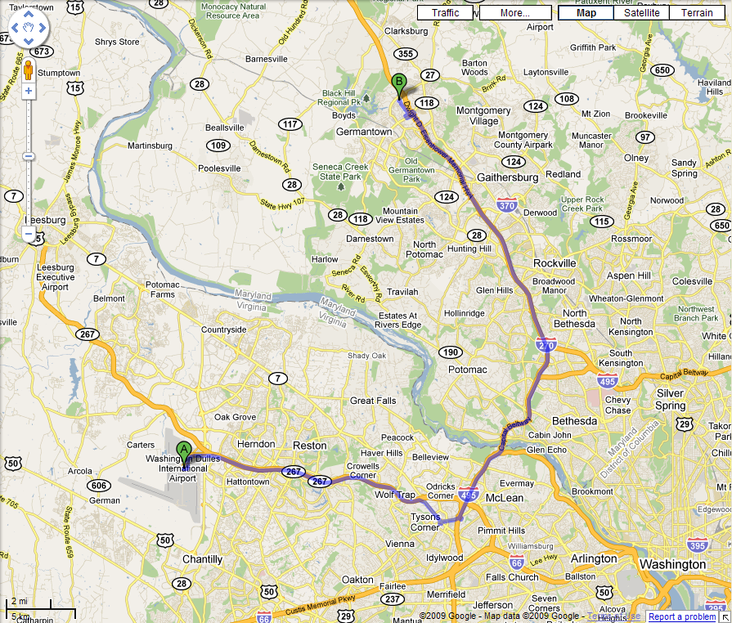
Google map driving directions from Washington Dulles International, at Chantilly, VA 20152

1. | Head east on Saarinen Cir |  | 0.3 mi
2. | Continue onto Dulles Airport Access and Toll Rd |  | 11.1 mi
3. | Exit onto Leesburg Pike/VA-7 E toward Tysons Corner |  | 1.8 mi
4. | Merge onto Chain Bridge Rd/VA-123 N via the ramp to McLean |  | 1.1 mi
5. | Merge onto Capital Beltway/I-495 N via the ramp to Rockville/Baltimore |  | 8.0 mi
6. | Slight left at I-270 Spur N |  | 1.9 mi
7. | Merge onto I-270 N |  | 12.1 mi
8. | Exit onto Germantown Rd |  | 0.7 mi
9. | Turn right at Aircraft Dr |  | 0.1 mi
10. | Take the 1st right onto Century Blvd |  | 0.9 mi
11. | Turn left at the end of the road and see the building map for 20450 Century Blvd building |  | 246 ft
To Texas Instruments at 20450 Century Blvd
Germantown, MD 20874

Driving directions from Baltimore Washington International Airport (BWI) to TI building:
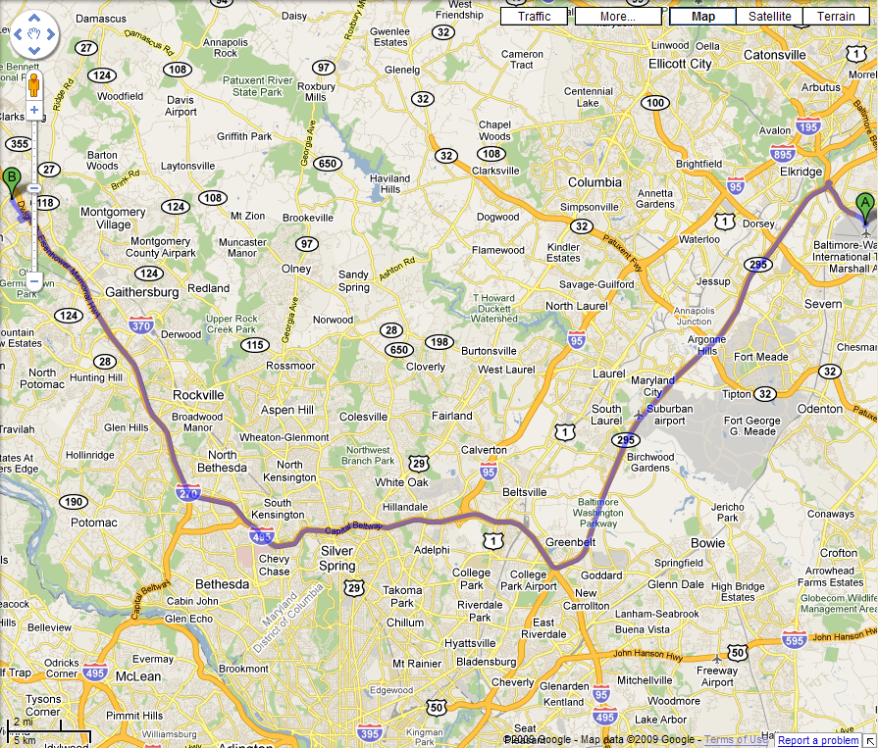

Google map driving directions from Baltimore-Washington International Thurgood Marshall Airport in Hanover, MD 21076

1. | Head east on Elm Rd toward Gov Harry R Hughes Dr |  | 0.8 mi
2. | Continue onto I-195 W |  | 1.5 mi
3. | Take exit 2B for MD-295 S/Balt/Wash Pkwy toward Washington |  | 0.3 mi
4. | Merge onto MD-295 S |  | 18.0 mi
5. | Take the exit onto I-495 N/I-95 N toward Silver Spring/Baltimore, continue to follow I-495 N |  | 13.5 mi
6. | Slight right at I-270 N (signs for I-270 N/Frederick) |  | 14.8 mi
7. | Exit onto Germantown Rd |  | 0.7 mi
8. | Turn right at Aircraft Dr |  | 0.1 mi
9. | Take the 1st right onto Century Blvd |  | 0.9 mi
10. | Turn left at the end of the road and see the building map for 20450 Century Blvd building |  | 246 ft
To Texas Instruments at 20450 Century Blvd
Germantown, MD 20874

Driving directions from Reagan National Airport (DCA) to TI building:
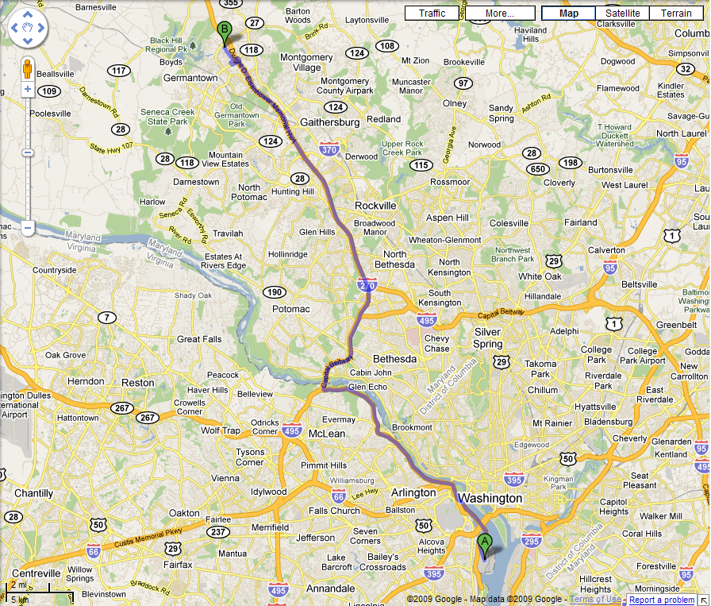
Google map driving directions from Ronald Reagan Washington National Airport in Arlington, VA 22202

1. | Head north toward Aviation Cir/Ronald Reagan Washington National Airport Access Rd |  | 0.1 mi
2. | Continue straight onto Aviation Cir/Ronald Reagan Washington National Airport Access Rd |  | 0.6 mi
3. | Take the ramp onto George Washington Memorial Pkwy |  | 11.7 mi
4. | Take the exit onto I-495 N toward Maryland |  | 4.4 mi
5. | Slight left at I-270 Spur N |  | 1.9 mi
6. | Merge onto I-270 N |  | 12.1 mi
7. | Exit onto Germantown Rd |  | 0.7 mi
8. | Turn right at Aircraft Dr |  | 0.1 mi
9. | Take the 1st right onto Century Blvd |  | 0.9 mi
10. | Turn left at the end of the road and see the building map for 20450 Century Blvd building |  | 246 ft
To Texas Instruments at 20450 Century Blvd
Germantown, MD 20874

Supplementary information for the weekend tourist:

If you want to explore the Washington DC and Maryland during your stay, then I suggest checking out the following links for useful information. But, first, I suggest familiarizing yourself with the DC sites and select what you really want to see on the map: http://map.mapnetwork.com/destination/dc/. Then proceed to the following attractions listed below. Note: most tourist attractions and museums in Washington DC are free. So, just get over there and have some fun. ☺

Note: The most common tourist driving error is to make a right turn on red traffic light in DC while driving. However, it is permitted in Maryland and Virginia after a short stop and yielding to the incoming traffic to make a right turn on red traffic light, unless specifically stated by the traffic sign. So, watch out for this inconsistency.

For up to date DC traffic report, see http://www.traffic.com/Washington-DC-Traffic/Washington-DC-Traffic-Reports.html

- Washington DC has so many places to visit during the weekends. The most prominent sites are:

- The Washington Capitol building and its tours are awesome. Don’t forget your camera!
- The Whitehouse inside tour. You need advance planning and willing to stay in long lines, if interested.
- National Air & Space Museum (a must see for all the engineers and scientist!)
- National Museum of American History (for the history buffs).
- National Museum of Natural History (well worth seeing it).
- Washington Monument
- Smithsonian Museum is a must see.
  - http://www.mnh.si.edu/
  - http://www.si.edu/
  - http://www.si.edu/Museums/
- Washington Botanical gardens is an old time favorite
  - http://www.usbg.gov/
  - http://dc.about.com/od/touristattractions/a/USBotanicalGard.htm
- Washington National Cathedral architecture is stunning.
  - http://www.nationalcathedral.org/visit/
- Washington National Zoo is a nice place to walk around on a sunny day.
  - http://nationalzoo.si.edu/default.cfm
  - http://dc.about.com/cs/familyactivities/a/NationalZoo.htm
- Abraham Lincoln’s monuments and the reflection pool at night are beautiful to photograph.
  - http://showcase.netins.net/web/creative/lincoln/sites/memorial.htm
- Great Falls Park in Virginia and Maryland side are great for hiking, rock climbing, fishing, rafting, or canoeing.
- Georgetown pubs and night clubs are also one of the evening attractions, if you like drinking, and loud music.
- The Cherry Blossoms in Washington DC will be at their peak of beauty in the monument area during April.

From more details and tours see the following link: http://www.thedistrict.com/ and checkout the 10 tips for Washington DC tourists: http://www.usatoday.com/travel/destinations/cityguides/dc/2008-09-08-10-tourist-tips_N.htm

- In comparison to Washington DC that all the tourist attractions are clustered together, Maryland tourist attractions are a bit more scattered. However, there are many interesting things to see in Maryland as well. I suggest clicking on the remaining links for the possible activities:

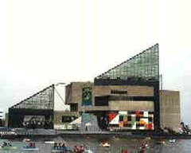

If you choose to drive about an hour away from TI, you can visit National Aquarium in Baltimore, one of the world’s largest aquariums. http://www.aqua.org/ located in 501 East Pratt Street, Baltimore, MD 21202-3103
Telephone: +1-410-576-3800

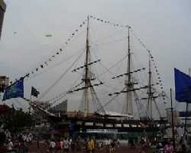

If you like walking through an old ship from 1855 era, the USS Constellation is only a 5 minute walk form the National Baltimore Aquarium on the inner harbor area. The Phillips seafood restaurant is famous for its cuisine throughout the region, and if you like other types of food, then just walk to the 2nd floor of the mall, and try hundreds of international food eateries located on the same spot. The parking buildings are readily available all around the inner harbor area for a reasonable fee. So find a good parking first and then get ready to do some walking and sightseeing.

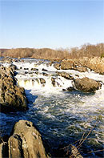

If you are into fishing or canoeing, you can try the Great falls area or do some white water rafting, but don’t forget your helmet. We need you back on the following Monday!

The following links provide much broader list of fun things to do in Maryland:
http://maps.google.com/maps?hl=en&um=1&ie=UTF-8&q=maryland+tourist+attractions&fb=1&gl=us&hq=tourist+attractions&hnear=maryland&view=text&ei=DBNFS8jTMM-0tgeR5sSNCQ&sa=X&oi=local_group&ct=more-results&resnum=1&ved=0CCIQtQMwAA

http://visitmaryland.org/Pages/Welcome.aspx
http://www.wegoplaces.com/USA_State_MD.aspx
http://www.touristinformationdirectory.com/maryland/chamber_commerce.htm
http://www.planetware.com/tourist-attractions/maryland-usmd.htm

Hope you enjoy your stay in Maryland, and get out there and visit a few interesting spots during your visit.

-Warren

