PRACTICAL INFORMATION ON

STUDY GROUP 5 MEETING AND THE SYMPOSIUM ON PROGRESSING THE CLIMATE CHANGE THROUGH GREEN ICT STANDARDS

- Venue

ITU-T SG5 Meeting
The ITU-T SG5 will be held from 20th of September to 28th of September 2011 at ‘Sapphire Ballroom’(3F) and meeting rooms on the 36th floor of Lotte Hotel, Seoul, Korea.
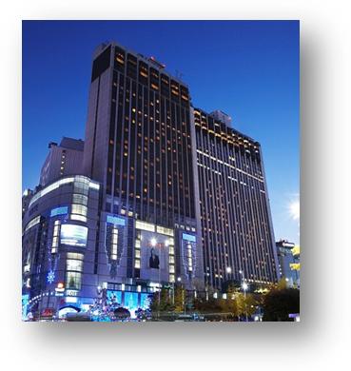
Address | 1, Sogong-Dong, Jung-Gu, Seoul, Korea 100-721
Facilities | Club Floor, Fitness Club, Business Center, Duty Free Shop
Telephone | +82-2-771-1000
Fax | +82-2-752-3758
Website | www.lottehotelseoul.com

Symposium on “Progressing the climate agenda through green ICT standards”
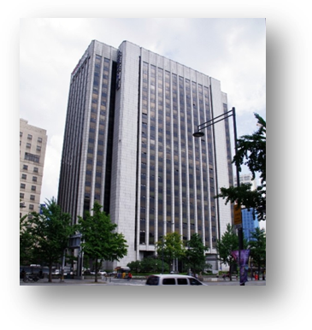
The Symposium will be held on 19th of September 2011 at ‘International Conference Hall’(20F) in Korea Press Center, Seoul, Korea.
Address | 33, Taepyeongro, Jung-Gu, Seoul, Korea 100-721
Facilities | VIP Room, Press Room
Telephone | +82-2-2001-7114
Fax | +82-2-2001-7770
Website | www.kpf.or.kr

How to get from Lotte Hotel to Press Center
It takes 10 minutes by walk and 5 minutes by taxi as below map.
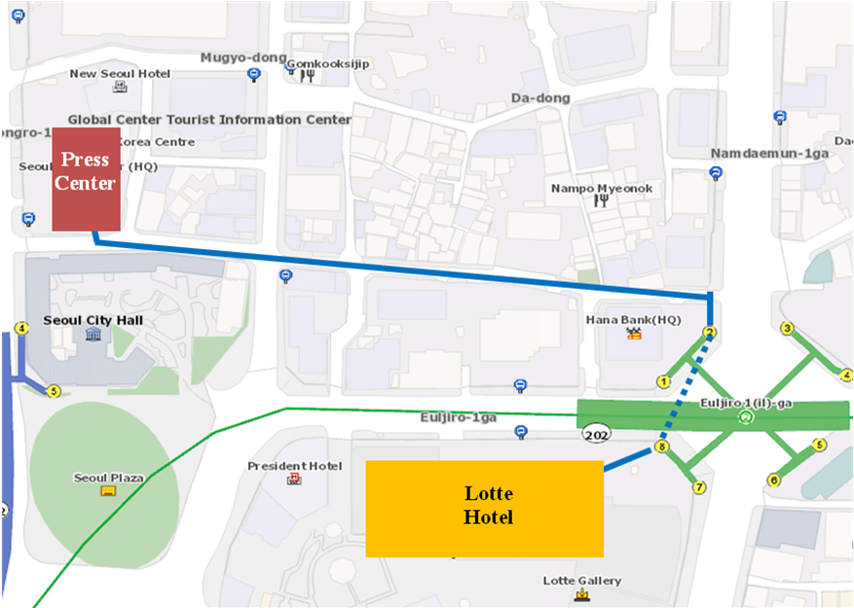

- National Coordinator

Dr. Sam Young CHUNG
Tel: +82 2 710 6595
Fax: +82 2 710 6639
E-mail: sychung@kcc.go.kr

Ms. Hye Young (Grace) Hwang
Tel: +82 2 338 1082
Fax: +82 2 338 1083
E-mail: sg5_general@kcc.go.kr

- Accommodation and hotel reservations
The Korea Administration has obtained special rates in different downtown hotels. Next page shows a map indicating each hotel’s proximity to the meeting venue together with a chart including the corresponding hotel rates.
Delegates are kindly requested to fill out the corresponding reservation form, send it directly to the hotel, copy to Ms. Grace at: sg5_general@kcc.go.kr or fax. +82 2 338 1083.
It is important to make your reservation as soon as possible. All reservations must include a credit card number. You shall receive a confirmation message once your reservation has been accepted by the hotel. In case of failure to attend the meeting, all reservations must be cancelled well in advance.
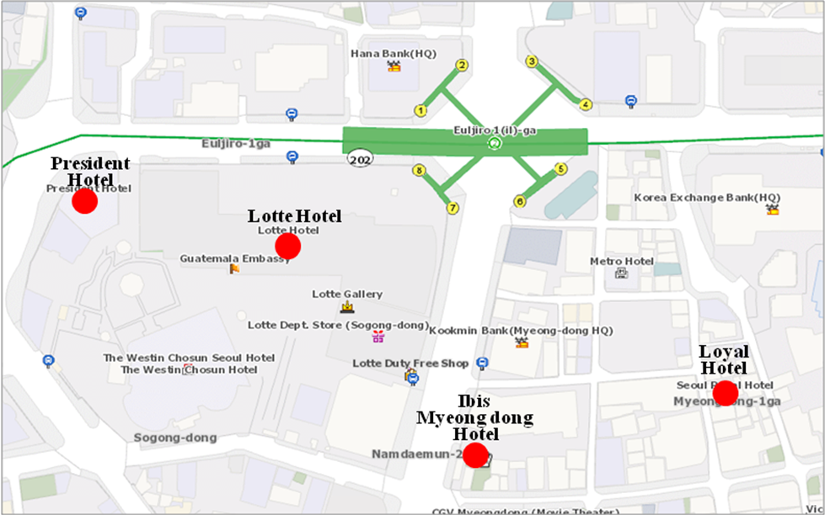

HOTEL | CATEG. | ROOM | RATE | NOTES
(1) Lotte Hotel (Venue)  1 Sogong-dong Jung-gu Seoul  Tel: +82. 2-759-7311~6  Fax: +82. 2-773-4910  Check-In: 2:00 PM  Check-Out: 12:00 PM  reservation@hotellotte.co.kr www.lottehotelseoul.com/index.asp | Standard  (Basis on Single Occupancy) | Superior  Deluxe | KRW 254,100 (≒USD 234)  KRW 278,300 (≒USD 257) | Included Taxes  buffet breakfast  : KRW 30,250 (≒USD 29)  Double occupancy charge will be added KRW 24,200 (≒USD 25)
 | Deadline of Reservation |  | 1st of August
 | Cancelation Policy |  | Inform to the hotel of any cancellations by 6:00 pm on the date of arrival or be charged for one night.
(2) Ibis-Myeongdong Hotel  59-5 Myeongdong 1ga Jung-gu Seoul  Tel: +82. 2-6361-8888  Fax: +82. 2-6361-8050  Check-In: 2:00 PM  Check-Out: 12:00 PM  ibismres@ambatel.com  ibis.ambatel.com/FrontSite/ibis/myeongdong/Default.aspx | Standard | Double  Twin | KRW 172,480 (≒USD 159)  KRW 188,650 (≒USD 174) | Included Taxes  buffet breakfast  : KRW 16,500 (≒USD 15)
 | Deadline of Reservation |  | 29th of August
 | Cancelation Policy |  | 50% penalty fee from 14days prior to check in date.  100% penalty fee from 7days prior to check in date.
(3) Hotel President  188-3 Euljiro 1ga Jung-gu Seoul  Tel: +82. 2-753-3131  Fax: +82. 2-752-7417  Check-In: 2:00 PM  Check-Out: 12:00 PM  marketing@hotelpresident.co.kr  www.hotelpresident.co.kr/english | Standard | Twin or Double | KRW 165,000 (≒USD 152) | Included Taxes  buffet breakfast  : KRW 22,000 (≒USD 20)
 | Deadline of Reservation |  | 19th of August
 | Cancelation Policy |  | 100% penalty fee from 7days prior to check in date.
(4) Royal Hotel  6 Myeongdong 1ga Jung-gu Seoul  Tel: +82. 2-2129-5754~7  Fax: +82. 2-2129-5880  Check-In: 2:00 PM  Check-Out: 12:00 PM  reser@royal.co.kr  www.royal.co.kr | Standard | Double  Twin | KRW 187,000 (≒USD 173)  KRW 203,500 (≒USD 188) | Included Taxes  buffet breakfast  : KRW 15,400 (≒USD 14)
 | Deadline of Reservation |  | 19th of August
 | Cancelation Policy |  | 50% penalty fee from 28th of August  75% penalty fee from 5th of September  100% penalty fee from 12nd of September

Participants are requested to reserve a hotel on a first-come-first-served basis through E-mail or Fax. Please note that there is a limit of the number of available rooms of Hotels. Therefore, if the reservations are full, it will be shifted to nearby Hotel and the reservation counter of the hotel will inform the corresponding participants about the situation

- Flights and transportation

Incheon International Airport handles all international air traffic and is 60 minutes away from the Seoul. Delegates have several transfer options from the airport to their hotel in the city of Seoul:
ITU-T SG5 and Symposium on “Progressing the climate agenda through green ICT standards” Information desk: Korea Secretariat will open the Information desk for participants’ convenience at arrivals (see below map). It will be opened from 18th of September to 19th of September at 7:00AM to 7:00PM. (Operating hours can be changed to depend on the participant's schedule) If you need to help to go to Seoul, drop by the information desk and get information.
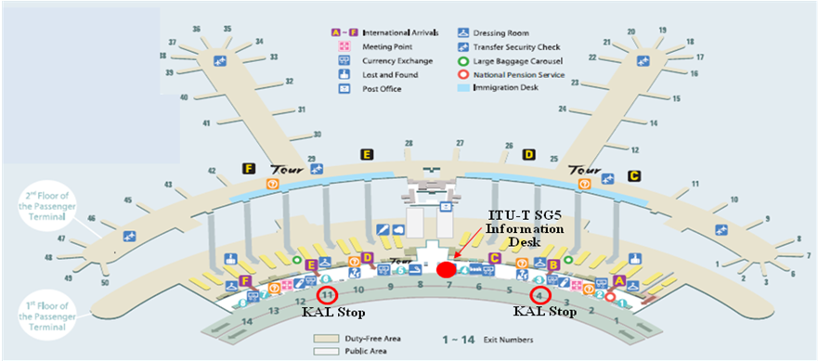
Car services and private taxis: taxi is recommended if you arrive late at night and buses are no longer operating or if you have heavy baggage or there are many members in your party. If you go to Myeong-dong (near the main venue) by a deluxe taxi late at night, you need to pay about 100,000 won. The fare varies depending on distance (meters).
Airport Bus: Airport buses run from Incheon Int'l Airport to various parts of Seoul. You can buy a ticket for your destination at the ticket desk on the arrival floor (1st floor). You can get information on bus routes and bus stops at the Airport Information Desk. Also Korea Secretariat will be operating the ITU-T SG5 and Symposium Information desk for participants’ convenience. If you would like to go from Incheon International Airport to the Lotte Hotel (main venue) you can use a KAL limousine bus.
Airport Railroad Express and Seoul Metro: Incheon International Airport Station of AREX is located on the first underground level of the Transportation Center at Incheon International Airport. You can get to Seoul and Lotte Hotel (main venue) using Airport Railroad Express and Seoul Metro.
How to get from Incheon Int’l Airport to Lotte Hotel :
- Get on the Airport Railroad Express on 1st floor of Incheon International Airport
- Transfer to line number 2 (green line) at the Hongik University station
- Get off the train at the Uljiro1(il)-ga station
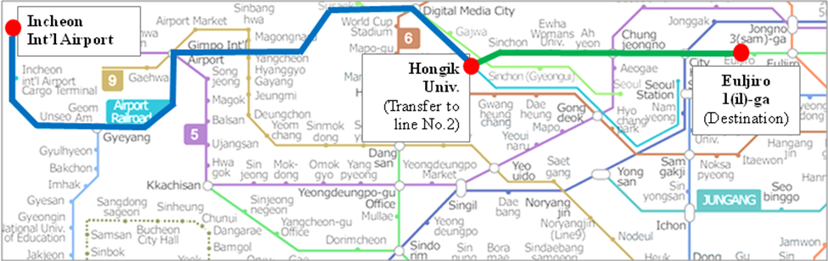
If you want to further information, please visit below website :
Airport Railroad Express : http://www.airport.kr/iiacms/pageWork.iia?_scode=C1203020000&fake=1308136787130
Seoul Metro :
http://www.seoulmetro.co.kr/eng/

Information for KAL limousine bus from Incheon Int’l Airport to the Lotte Hotel
- Course Time : About 1 hour and 20 min / Adult(15,000won), Child(10,000won)
- Boarding : KAL Stop - 4B or 11A
- Ticket Office : ITU-T SG 5 and Symposium Information desk at Incheon International Airport
(Ticket for the Bus departure from the entrance of the Hotel is sold at Front desk of Main building and New Wing)
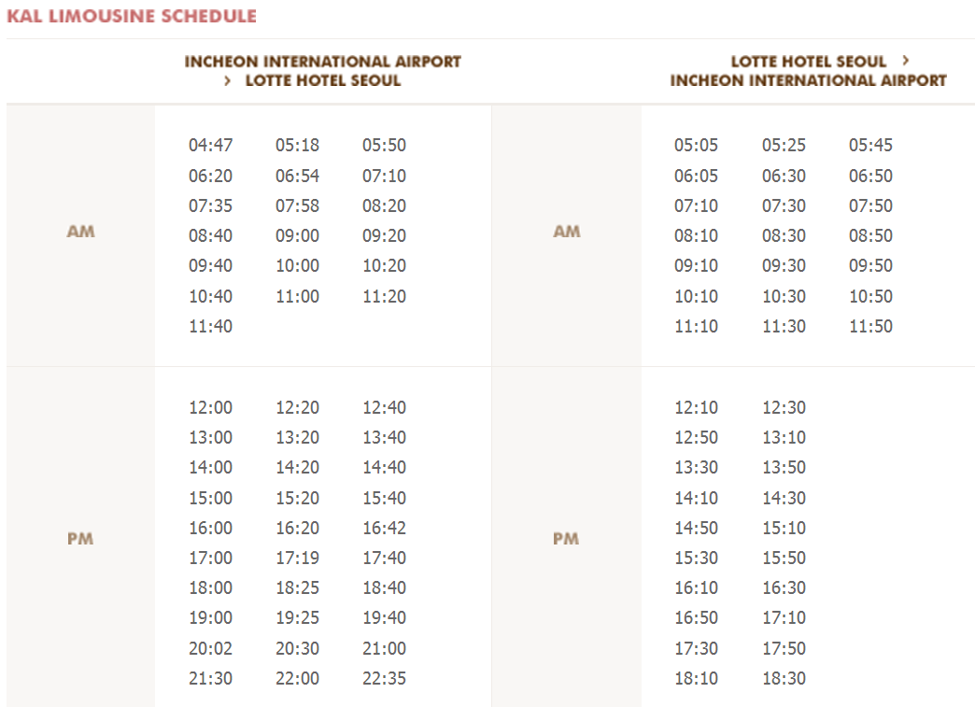
For further information, please visit the following web page: http://english.visitkorea.or.kr/enu/GK/GK_EN_2_2_2_3.jsp

- GENERAL INFORMATION

Introduction

The Korean Peninsula is located in North-East Asia and roughly 1,030 km (612 miles) long and 175 km (105 miles) wide at its narrowest point. Korea's total land area is 100,140 sq km, and it has a population of 48.7 million people (2009). Korea is a culturally diverse and economically advanced country full of dynamism. Building upon incredible post-war economic growth, Korea is the 12th largest economy in the world, and is becoming a powerful focal point of the Asian economic block. With a history tracing back more than 5,000 years, Korea is also rightly proud of its dazzling culture. It possesses 8 UNESCO cultural heritage sites, which compares favourably with any other nation in the world.

- The City of Seoul
Seoul is the capital and largest city of the Republic of Korea (South Korea). With a population of over 10 million, it is one of the world's largest cities and is by far the most densely populated city among OECD nations. The Seoul National Capital Area, which includes the Incheon metropolis and most of Gyeonggi province, has 24.5 million inhabitants, and is the world's second largest metropolitan area. Almost half of South Korea's population lives in the Seoul National Capital Area, and nearly a quarter in Seoul itself, making it the country's foremost economic, political, and cultural center

- Visa
Most delegates do not require a visa to enter Korea. You can check all visa requirements at http://www.mofat.go.kr/english/visa/apply/index.jsp. However, for more certainty we recommend you consult your embassy or consulate.
Those who require a visa to enter Korea should contact Ms. Ellva or Grace at sg5_visa@kcc.go.kr in order to request a personalized letter of invitation addressed to the petitioner via e-mail. This letter shall then be delivered to the petitioning country’s Korea Embassy in order to get the visa.

- Language
Korean is the official language (English, Japanese and Chinese are also spoken).

- Power
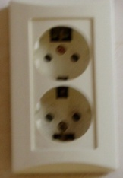
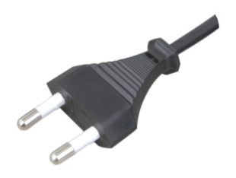
Supply voltage is 220V, 50Hz~60Hz. Participants are requested to bring the A-type adapter which is two parallel pronged and requested to bring the electric transformer, if necessary, for your equipments

Electrical Outlet

- Climate
The month of September is autumn that is well and truly in Seoul. In the mid September, Korea will be hot but less humid than August. Temperature is between 17 °C ~ 25°C.

- Currency
The unit of Korean currency is Korean Won (KRW). Also the most widely accepted credit cards are American Express, VISA and Master card.
Examples of exchange rates as of 10 June, 2011 is US$1= 1083.00 KRW
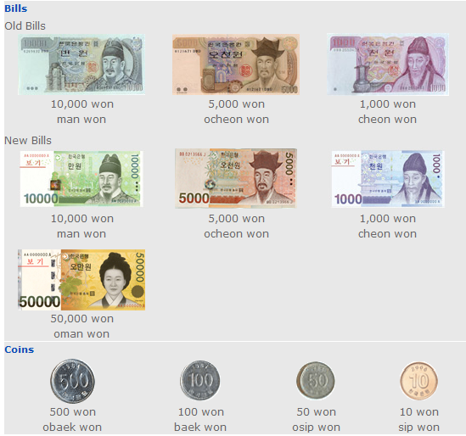

- Tax Refund
At the airport, passengers can get a 10% refund of the amount paid for Value Added Tax (VAT), if they have bought national products for amounts over $ 30 (per purchase slip) at the shops and within 3 months of departure from Korea adhered to the “Global Refund” system.
For further information, please visit: http://english.visitkorea.or.kr/enu/SH/SH_EN_7_1_4.jsp
- Business hours
Banks, post offices, and public offices generally open from 09:30 to 16:00 on weekdays but are closed on Saturdays and Sundays. Most of the shops are open from 10:00 to 22:00 through the entire week. However, some shops in Itaewon and Dongdaemon Shopping Mall are opened all night.
- Customary Tip
It is not customary tip in Korea. However, a 10% service charge and 10% taxes is added to your bill at all tourist hotels and some larger restaurants.

- Useful Information
For further information on the city of Seoul, please visit the following web page: http://english.seoul.go.kr

- Attire
Formal attire is recommended for officials attending the Meeting of Study Group 5 and the Symposium, on “Progressing the climate agenda through green ICT Standards” throughout the event.

- Invitation to the Welcome Dinner

The Communications Secretary of the Republic of Korea are pleased to invite the officials attending the meeting to the Welcome Dinner to be celebrated on Tuesday 20 September 2011 at 6.30 pm at the Sapphire Ballroom of the venue.

Suggested attire: Formal

ANNEX 3
(to TSB Circular 204)
ITU-T Study Group 5 meeting and Symposium
Seoul, Republic of Korea, 19-28 September 2011
*****

HOTEL RESERVATION

Please type or print clearly. Retain a copy for your records. Please send this form to the Hotel and one copy to Grace, e-mail address: sg5_general@kcc.go.kr Tel: (+82 2) 338-1082, Fax: (+82 2) 338-1083

Last Name: |  |  |  |  |  |  |  | First Name:
Organization-Company:
Address: |  |  |  |  |  |  |  |  |  |  |  | Country
Tel.: |  |  |  | Fax: |  |  |  |  |  | E-mail:
Hotel Information |  |  |  |  | Please choose type of room |  |  |  |  |  |  |  | Remarks
Hotel Name |  |  | Number |  | Room Type |  |  |  |  | Breakfast |  |  | Remarks
 |  |  |  |  | Double |  |  |  |  | Included |  |  | e.g. Smoking or  Non-Smoking
 |  |  |  |  | Twin |  |  |  |  | Excluded |  |  | e.g. Smoking or  Non-Smoking
Shared with:
Arrival date and time:
Airline and flight No.:
Departure date and time:
I authorize the use of the following credit card to guarantee my hotel reservation:
Type of Card: |  | Number:
Name on Card : |  | Expiration Date:

