 |  | International Telecommunication Union
 |  | ITU-T | Technical Paper
 |  | TELECOMMUNICATION  STANDARDIZATION SECTOR  OF ITU |  | (13 December 2013)
SERIES L:
CONSTRUCTION, INSTALLATION AND PROTECTION OF TELECOMMUNICATION CABLES IN PUBLIC NETWORKS
 | Potential for primary energy savings in TLC/ICT centres through free cooling

Summary
This Technical Paper refers to the Best Practices defined in Recommendation ITU-T L.1300. More precisely, this Technical Paper firstly provides an introduction of potential for primary energy savings in TLC/ICT centres through the free cooling solution. Then, a probabilistic model for the inlet conditions is defined and finally an analysis on room temperature and energy consumption is reported.
Keywords
Best practice, data centre, energy efficient, information and communication technology and climate change (ICT & CC).

Change Log
This document contains Version 1 of the ITU-T Technical Paper on “Potential for primary energy savings in TLC/ICT centres through free cooling” approved at the ITU-T Study Group 5 meeting held in Lima, 2-13 December 2013.

Editor: | Gianluca Griffa  Telecom Italia  Italy | Tel: +39 331 600 1341  Email: gianluca.griffa@telecomitalia.it

Contents
Page
1 Scope 4
2 Definitions 4
3 Abbreviations 4
4 Introduction 4
5 Probabilistic model for the inlet conditions 5
5.1 Temperature model 6
5.2 Relative humidity model 7
6 Room temperature 9
7 Energy analysis 12
References and Bibliography 16

List of Tables
Page
Table 1 – System operation with ΔT=0°C 12
Table 2 – System operation with ΔT=4.5°C 13
Table 3 – System operation with ΔT=8.5°C 13
Table 4 – Energy saving obtained with the free cooling + the adiabatic free cooling system 14

List of Figures
Page
Figure 1 – Temperature for an average day of January 6
Figure 2 – Temperature in a typical day of January and model curves 6
Figure 3 – Relative humidity for a typical day in January, plus model curves 7
Figure 4 – Comparison between calculated and surveyed yearly temperature distributions 8
Figure 5 – Schema of air distribution according to configuration 1 9
Figure 6 – Schema of air distribution in scenarios 3 and 4 10
Figure 7 – Rack aisle and air distribution system 10
Figure 8 – Air temperature in scenario 3 11
Figure 9 – Air temperature in scenario 4 11
Figure 10 – Filtration and humidification section 12
Figure 11 – Italian towns on the modified ETSI diagram 14

ITU-T Technical Paper
Potential for primary energy savings in TLC/ICT centres through free cooling
Summary
This Technical Paper describes potential for primary energy savings in TLC/ICT centres through free cooling based on Recommendation ITU-T L.1300.
Keywords
Best practice, data centre, energy efficient, information and communication technology and climate change (ICT & CC).

1 Scope
This Technical Paper describes potential for primary energy savings in TLC/ICT centres through free cooling based on Recommendation ITU-T L.1300. The scope of this Technical Paper includes:
– an introduction of potential for primary energy savings in TLC/ICT centres through free cooling;
– probabilistic model for the inlet conditions; and
– room temperature and energy analysis.

2 Definitions
This Technical Paper uses the following terms:
2.1 power density: The energy consumption of ICT equipment per rack cabinet of floor area of a server room.

3 Abbreviations
RH Relative Humidity

4 Introduction
The growth of modern society is characterized by dynamism in communications, and in recent years the field of telecommunications has achieved great importance in the socio-economic development of many countries. Such a trend requires increased power installation in data centres that serve to allocate routers, switches, computers, and many other equipment that have high energy requirements. Such data centres generate heat that must be dissipated. To give an example, the mean value of electrical power density installed in Italian telecommunication plants is about 450 W/m² and all this electrical power is converted into endogenous power.
In 2007, electrical energy consumption for Italian telecommunications was 4000 GWh, which is 1.25% of global electrical energy consumption for that year. Moreover, data shows that the global demand for electrical energy has increased by 0.4% with respect to 2006 data, but that the increase in telecommunications was 1.5%. The most important Italian telecommunication company is the second national user for energy consumption; with 0.7% of total national energy demand (the largest user is the national railway transport company). More than half of the energy consumption is used for fixed network and mobile equipment, and approximately 16% of this part is used for cooling.
In total, electrical energy purchased or generated by the group in 2007 amounts to 2.15 TWh, i.e., about 2.3% more than energy used in 2006, and 7.36% more than energy used in 2005. Equipment in data centres have to operate within defined temperature and humidity conditions, because their internal circuits are sensitive to excessively high or low temperature and humidity. Furthermore, the equipment cannot be switched off because data must be transmitted from centre to centre 24 hours a day, 7 days per week. ETSI standard EN 300 019-1-3 establishes the upper and lower limits for temperature and humidity in which equipment must operate.
To maintain correct operating conditions, the cooling system must operate continuously, absorbing large amounts of electricity. To contribute to energy saving policies, such as the 20/20/20 objectives established by the European Commission, the use of alternative cooling systems for data centres conditioning is crucial. Free cooling consists of the direct use of external air to cool the environment. The temperature of external air can be reduced by injecting water spray, if the external humidity is lower than 100%. This is called adiabatic free cooling. Free cooling is a rational option for the telecommunication sector, as the temperature tolerated in data centres is usually above outdoor temperature and because of the non-stop operation of the equipment. Knowledge of typical external temperature and relative humidity is particularly important for a correct design of a free cooling system. Such information is available for various locations, and otherwise a model may be used. A possible model is presented in the next section. This is particularly useful because of the small number of parameters required for its application to a location. In addition, it provides a general behaviour that should be adopted for compact representation of the suitability of free cooling systems in a location.
This Technical Paper describes a general approach to the energy analysis of free cooling systems and its application to telecommunication centres located in Italy. In the mid-period it could also be applied to data centres. First, a probabilistic model for ambient temperature and relative humidity is presented. This is the basis for predicting the air inlet condition. Then some theoretical and experimental data obtained from measurements in the Telecom Italia telecommunication laboratory are presented. These data allow one to relate the inlet air condition to the operating conditions of the equipment. Ultimately, the energy savings that can be achieved through use of free cooling systems in Italy is calculated. Italian locations are classified in terms of energy saving due to free cooling and adiabatic free cooling use, and the opportunity of using such a technique is highlighted through a pictorial representation on the Mollier diagram, where the limits of the ETSI standard are also drawn. With respect to the ETSI diagram, here the properties of the probabilistic model of temperature and relative humidity are used for a more compact representation.

5 Probabilistic model for the inlet conditions
External air temperature and relative humidity (RH) define the applicability of free cooling. If the temperature is too high, a large air mass flow rate may be necessary to keep the internal temperature within acceptable limits. However, it may be impossible if the external temperature is above the maximum internal temperature. A model that represents the daily temperature (and RH) trend, allows temperature distribution to be foreseen for an assigned geographical site on the basis of little data, generally available for most locations. This model is composed of two parts. The first part is an equation that makes it able to describe hourly temperature and RH in the average day of each month. Then a stochastic model is applied in order to account for expected deviations.

5.1 Temperature model
The model is aimed at obtaining an average daily temperature trend for an assigned site and an assigned time step; temperature distribution has been described by simplified mathematical functions that require the lowest number of independent variables. The model has been generated thanks to a large amount of meteorological data referred to over a period of seven years. It has been created on the basis of data available from Turin. First, hourly data have been averaged to obtain 24 mean temperature values for every month (e.g., the value corresponding to the average temperature in January at 1 a.m. is obtained from the mean 31·7 temperatures recorded at 1 a.m.). The average temperature of a typical day of January is shown in Figure 1. Similar curves are obtained for the other months.
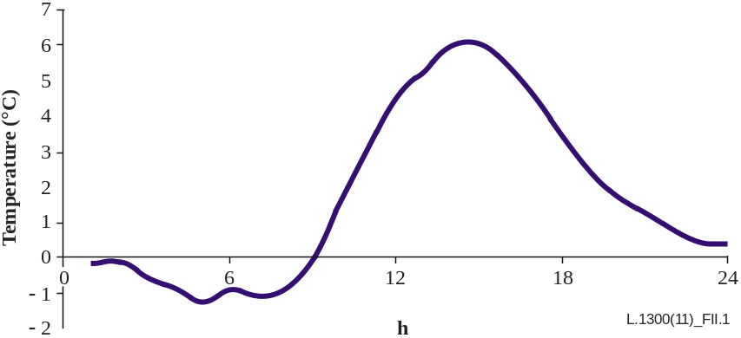
Figure 1 – Temperature for an average day of January
The model has been obtained by considering two different periods: daytime and night-time. The sequence of the hours, during the day, has been modified and fictitious time units have been used: the day starts at sunrise (the first hour is the hour corresponding to sunrise) and finishes at the hours that come before sunset. The first hour will be different for different geographical areas and for different months. Night-time starts at sunset. Figure 2 shows the shifted temperature curve and the two curves used for modelling daytime and night-time, which are described in the following.
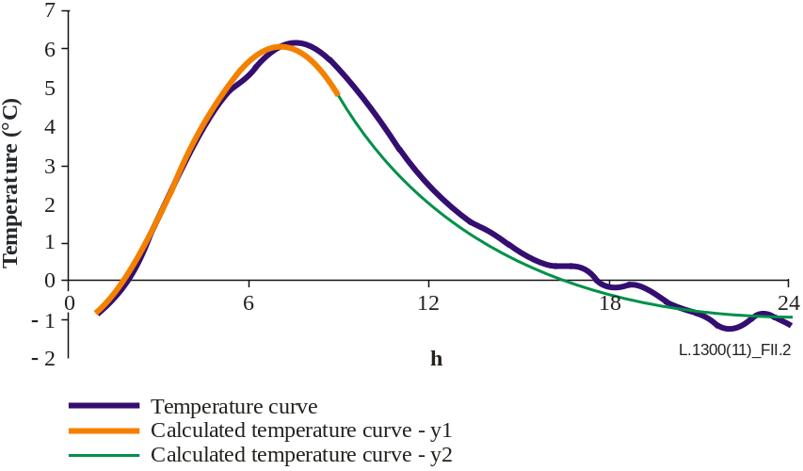
Figure 2 – Temperature in a typical day of January and model curves
A harmonic function is used to model the daytime temperature:
y₁ = A+ B⋅sin(ω × x − k) (II-2.1)
where A is the average between the maximum and minimum temperatures in an examined month; B is half of the difference between maximum and minimum temperatures; x is the current hour (sunrise ≤ x ≤ sunset ); k is an empirical coefficient and its value is constant in every month; ω is the pulsation:
ω = 2 π/(H × FF) (II-2.2)
where H refers to daylight time (from sunrise to sunset); FF is an empirical coefficient, that assumes two different values: in winter FF is equal to 1.6, otherwise it is equal to 1.45.
The curve corresponding to night-time is selected to describe the behaviour of a body that is losing heat, so it has been represented with an exponential function:
y₂ = b + (y₁(x_{SUNSET} ) – b) × exp(h × (x – x_{SUNSET}) (II-2.3)
where b is the minimum average value of the temperature Tmin, x_{SUNSET} is the actual sunset time, h is an empirical coefficient: its value is constant in every month and is equal to –0.231, x is the current hour (x > sunset). Only 4 parameters are required to obtain an average temperature daily trend for the chosen location:
1) highest monthly temperature (average value);
2) lowest monthly temperature (average value);
3) latitude;
4) longitude.
Latitude and longitude are capital to set location sunrise and sunset times.

5.2 Relative humidity model
Daily average distribution of the relative humidity has been obtained in the same way as described in the temperature model. Figure 3 shows the relative humidity for an average day in January and the two curves are used to model the daytime portion and the night-time portion.
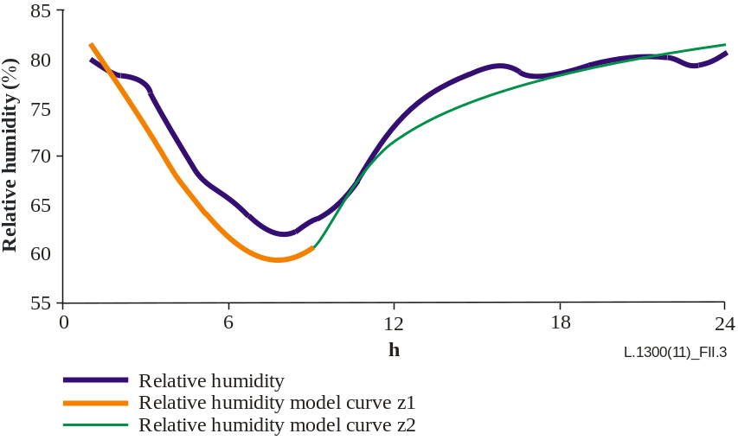
Figure 3 – Relative humidity for a typical day in January, plus model curves
The daytime portion has been represented with a harmonic function:
Z₁ = C + D × (–sin(ω × x – q) (II-2.4)
where C is the mean between the lowest and the highest relative humidity (average value), D is obtained from half of the difference between the lowest and highest relative humidity (average value), q is an empirical coefficient, and its value is equal to 0.8. Compared to the previous model, this one differs due to the different way of calculating lowest and highest air relative humidity. Because of the difficulty in obtaining such information, data has been taken from the mean relative humidity value, lowest temperature (average value) and corresponding saturated steam pressure. On the basis of the average humidity value, corresponding water vapour ratio has been calculated using the well-known expression:
x_{M} = 0.622 × (ϕ_{M} × p_{vs} (T_{M})/(p_{atm} – ϕ_{M} × p_{vs}(T_{M}) (II-2.5)
where φ_{M} is the average relative humidity, pvs is the saturated steam pressure calculated at reference temperature, p_{atm} is the atmospheric pressure, x_{M} is the water vapour ratio. Lowest and highest relative humidity have been calculated with the hypothesis of keeping a constant water vapour ratio:
ϕ_{min} = (p_{atm} × x_{M})/(0.622 × p_{vs} (T_{max}) + x_{M} × p_{vs} (T_{max}) (II-2.6)
ϕ_{max} = (2 × ϕ_{mean}) – ϕ_{min} (II-2.7)
The night-time portion has been modelled with a logarithmic function:
z₂ = z₁ (x_{SUNSET}) + M × ln(x – x_{SUNSET}) + G (II-2.8)
where G is an empirical coefficient equal to 4.5, while M is:
(z₁(x_{SUNRISE}) – z₁(x_{SUNSET}) – G)/ln(24 – H) (II-2.9)
Deviation analysis
The aim of this part of the model is to introduce deviations with respect to the average hourly temperature and the relative humidity trend.
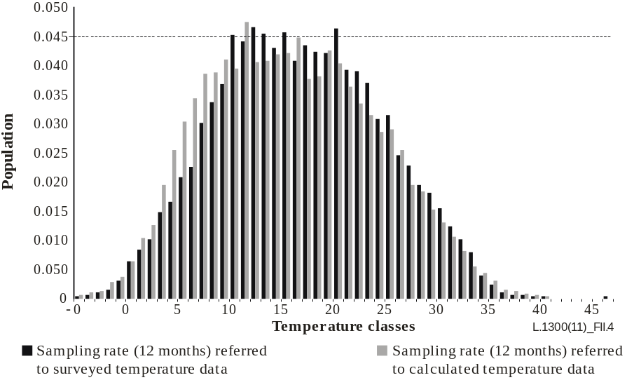
Figure 4 – Comparison between calculated and surveyed yearly temperature distributions
The relative frequency distribution of the differences has been approximated as a normal distribution. The standard deviation on difference between calculated mean values and real temperature and relative humidity values has been determined for Turin. The deviation for temperature is 3.5°C, while for humidity it is 15.5%. The model has been the validated comparison of calculated distribution with available data for Rome and Palermo. Figure 4 shows a comparison between calculated temperature and modelled temperature for a year.

6 Room temperature
Cooling of data centre rooms depends on two different factors: external conditions and internal conditions. Meteorological models allow the forecasting of external factors in order to class location on the basis of operative conditions of equipment. When external air goes into areas, it exchanges heat with the air of the rooms that benefit from the exchange in different ways, according to different room configurations. For this reason, it is vital to know how external parameters need to be modified by referring to equipment suction conditions. A second model has been created to reproduce machine work modalities in Telecom Italia data centre rooms, located in Turin. Room pressure is less than outside pressure because external air has to enter and to cool the environment. The testing laboratory is divided into two contiguous parts (Room 1 and Room 2) divided by a watertight door. Room 1 is about three times wider than Room 2, and has seven rows of racks containing equipment that differ for power. Room 2 is characterized by a large power density but, compared to Room 1, air entrance is penalized because of larger friction losses in the inlet air ducts. In Room 2, there are four rows of racks and four air ducts for external air inlet. The layout is not optimum, because in the same passage there is equipment that expels air utilized for circuit cooling and also equipment that takes in air to cool the circuit, so the second one takes in high temperature air. Room 2 has been selected for the analysis shown hereafter. The results of such an analysis are used as the reference for further considerations.
Four operating scenarios of the room are considered:
1) Ideal condition obtained by installing equipment of the same type with inlet vents all facing a cold aisle, and the outlet vents facing a hot aisle. Fresh air enters from the ceiling above the cold aisle and exhaust air is extracted from the ceiling above the hot aisle. Figure 5 shows a schema of this configuration, which theoretically allows one to feed the racks with fresh air at the same temperature as the inlet temperature of the room. This scenario is the best one, but is not always applicable in real data centres, especially if there is equipment with the inlet vent on the same side as the outlet vent.
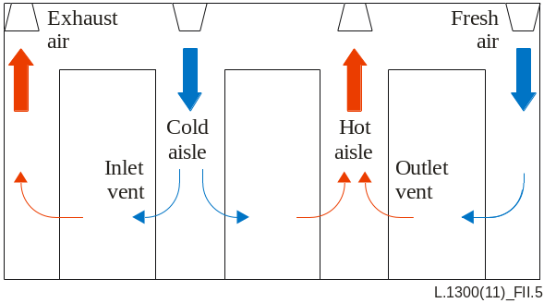
Figure 5 – Schema of air distribution according to configuration 1
2) Ideal condition corresponding to perfect air mixing in the room. This means that the inlet temperature in the racks is equal to the exhaust air temperature (i.e., the temperature of air exiting the room). This temperature can be calculated as follows:
Φ = m × c × (T_{ex} −T_{in}) (II-2.10)
where Φ is the heat generation in the room (corresponding to the installed power capacity), m is the air mass flow rate, c is the air specific heat, T_{ex} is the exhaust air temperature and T_{in} is the fresh air temperature. If the system is sized with regards to a fresh airflow of 400 Nm³/h per kW of installed power, the temperature of air entering the racks is about 7.4°C higher than fresh air temperature.
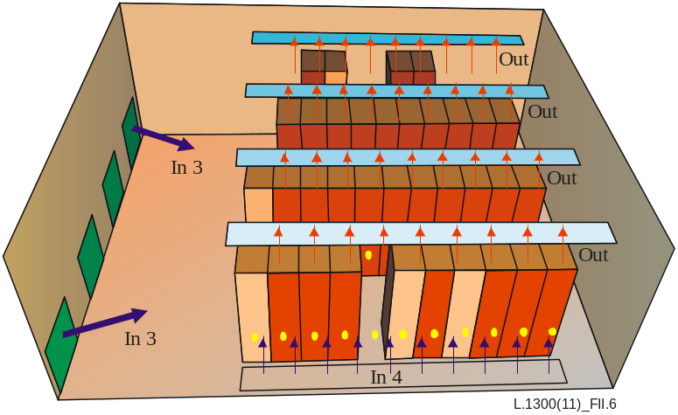
Figure 6 – Schema of air distribution in scenarios 3 and 4
3) Real conditions obtained by distributing fresh air from four large vents on the side wall. Two of these vents are indicated as in 3 in Figure 6. These two vents supply about 13 500 Nm³/h of fresh air, which corresponds to 300 Nm³/h/kW. The other two vents, one of which is shown in Figure 7, are located on the opposite wall. These two vents supply about 1500 Nm³/h of fresh air, which corresponds to 33 Nm³/h/kW. Exhaust air is extracted from 36 vents on the ceiling (indicated as out in Figures 23 and 24). Temperature distribution corresponding to this scenario is shown in Figure 8. Temperatures have been measured in the aisles (10 measurements for each aisle) at 1 metre from the floor and then the distribution is obtained through interpolation. The maximum temperature is about 8.5°C higher than fresh air temperature. This scenario is interesting as such a configuration may be easily obtained in a data centre.
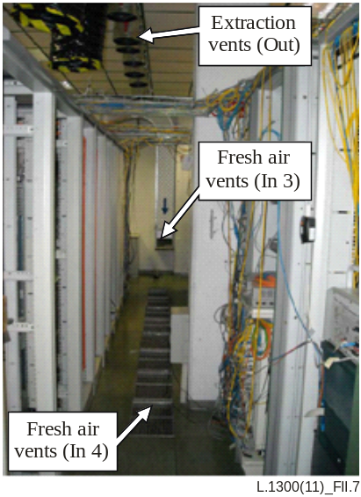
Figure 7 – Rack aisle and air distribution system
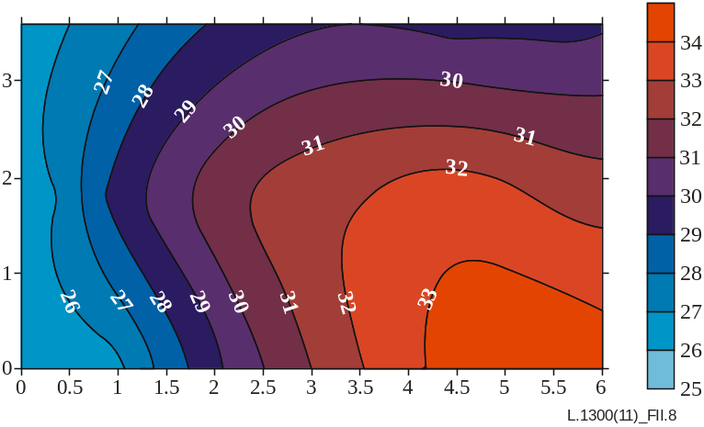
Figure 8 – Air temperature in scenario 3
4) Real condition obtained by distributing fresh air from distribution vents on the floor. These vents are indicated as in Figures 23 and 24. The total amount of fresh air is the same as in scenario 3. Exhaust air is extracted from the vents on the ceiling as in scenario 3. Temperature distribution obtained from measurements at 1 metre from the floor, is shown in Figure 9. The maximum temperature is about 4.5°C higher than fresh air temperature. This scenario is not always applicable in data centres, as it requires distribution ducts below the floor.
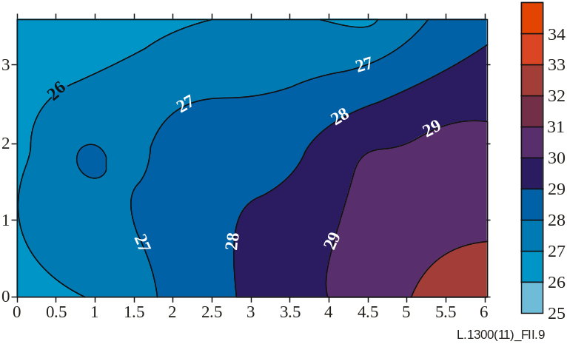
Figure 9 – Air temperature in scenario 4

7 Energy analysis
Energy analysis of free cooling systems is conducted considering the difference between fresh air temperature and inlet vent temperature as a parameter. Three cases are considered: ΔT=0°C, ΔT=4.5°C, ΔT=8.5°C. Air temperature on the inlet vent of the racks is therefore calculated starting from the external temperature obtained through the probabilistic model and adding the ΔT corresponding with the examined scenario. Relative humidity is calculated starting from the ambient value and considering the effect due to ΔT. If the condition is within the limits of the ETSI diagram, only the fans of the free cooling system are used. On the basis of measurements conducted during tests, the electric power required by the fans at full load is about 1.9 kW. Clearly this value depends on the installation. For usual installations, ventilation power per installed power of the TLC equipment is expected to be smaller. When the point is outside the limits and it is possible to obtain acceptable operating conditions through adiabatic saturation, the humidification section (see Figure 10) is turned on. The measured electric power required by the water pumps is about 0.8 kW. Should such a process prove insufficient, the chillers are turned on. Chillers are characterized by an average COP equal to 4.
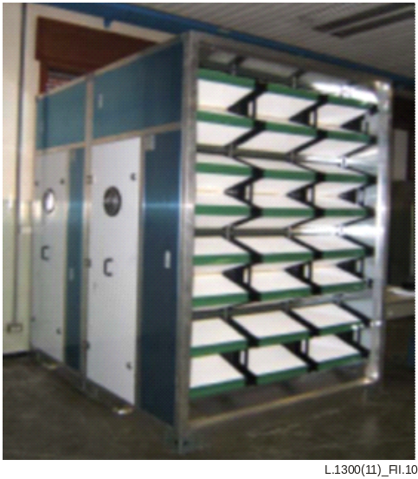
Figure 10 – Filtration and humidification section
The results obtained for seven Italian towns are presented in Tables 1-3 for the various values of ΔT. In the case of ΔT=0°C and ΔT=4.5°C, the free cooling system allows the equipment to comply with the ETSI standard [b-ETSI EN 300 019-1-3]. In fact, more than 90% of the inlet conditions are within the limits. In the case of ΔT=8.5°C only for Turin (located in northern Italy) the free cooling system is able to comply with the standard. For plants installed in Parma, Rome and Florence (all in central Italy) the standard is complied with, without using the chillers, as the combination of free cooling and adiabatic free cooling is sufficient to have more than 90% of the inlet conditions within the limits. For the last three towns, chillers are required.
Table 1 – System operation with ΔT=0°C
Town | Free cooling | Adiabatic free cooling | Chillers
Turin | 99.0% | 0.0% | 1.0%
Parma | 99.0% | 0.0% | 1.0%
Rome | 99.1% | 0.0% | 0.9%
Florence | 98.2% | 0.0% | 1.7%
Foggia | 97.9% | 0.1% | 2.0%
Olbia | 98.2% | 0.1% | 1.7%
Catania | 96.1% | 0.0% | 3.9%
Table 2 – System operation with ΔT=4.5°C
Town | Free cooling | Adiabatic free cooling | Chillers
Turin | 97.9% | 0.1% | 1.9%
Parma | 96.3% | 0.9% | 2.8%
Rome | 95.3% | 1.3% | 3.4%
Florence | 94.4% | 1.2% | 4.4%
Foggia | 93.5% | 1.4% | 5.1%
Olbia | 94.3% | 1.3% | 4.5%
Catania | 91.5% | 1.1% | 7.4%
Table 3 – System operation with ΔT=8.5°C
Town | Free cooling | Adiabatic free cooling | Chillers
Turin | 92.8% | 1.7% | 5.5%
Parma | 87.7% | 4.2% | 8.1%
Rome | 85.3% | 5.3% | 9.4%
Florence | 86.6% | 3.8% | 9.7%
Foggia | 84.3% | 4.6% | 11.2%
Olbia | 85.0% | 4.5% | 10.5%
Catania | 82.1% | 4.1% | 13.8%
A pictorial representation can be used to represent the opportunity of using free cooling and adiabatic free cooling in a data centre located in a specific place. This representation makes use of the temperature and relative humidity limits of the ETSI standard [b-ETSI EN 300 019-1-3] drawn on the Mollier diagram. In addition, the properties of the Gaussian distribution are considered. In this way a point corresponding to the average annual temperature and relative humidity guarantees that 90% of the points are within the limits, so that the standard is complied with. Figure 11 shows this representation for 106 Italian towns.
Circles refer to ΔT=0°C, crosses to ΔT=4.5°C and triangles to ΔT=8.5°C. Points within the curves marked in red mean that the free cooling system is able to comply with the limits. All towns except one (Lampedusa, which is an island in the middle of the Mediterranean sea) are within the limits, with ΔT=0°C. If a ΔT=4.5°C is considered, about half the towns require additional cooling systems, while considering ΔT=8.5°C most towns need them. The farther the point is from the curve, the larger is the additional cooling to be supplied with chillers.
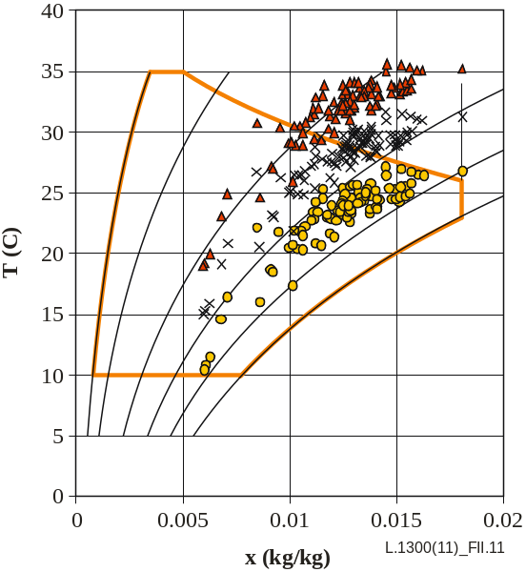
Figure 11 – Italian towns on the modified ETSI diagram
Table 4 shows the energy savings obtained for the seven towns using the free cooling and the adiabatic free cooling systems as much as possible. Calculations have been performed, considering the goal of 90% of the points within the limits of allowed operating conditions. The cooling load Q is obtained as:
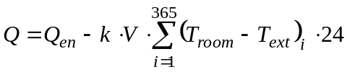
where Q_{en} is the endogenous heat generation (a constant power of 45 kW is considered in calculations), k is the volumetric heat transfer coefficient (0.9·10-3 kW/(m³K), V is the room volume, T_{room} is the daily average internal temperature and T_{ext} is the daily average ambient temperature. This model has been used with the intention of creating a simple reference for calculating the energy savings. While designing a specific system, a detailed analysis is required.
Primary energy consumptions and savings are calculated considering the average efficiency of power plants installed in Italy, (about 0.46). Energy saving is the same with ΔT=0°C and ΔT=4.5°C as only the free cooling system is used. This amount is larger for towns in the south part as the cooling load is larger. In the case of ΔT=8.5°C energy savings reduce for all towns except Turin, where the free cooling system is sufficient to comply with the standards. In the case of Catania for instance, a reduction of about 29 MWh occurs.
Table 4 – Energy saving obtained with the free cooling + the adiabatic free cooling system
Town | Primary energy consumption with chillers (kWh) | Primary energy saving (kWh)
Town | Primary energy consumption with chillers (kWh) | ΔT=0°C | ΔT=4.5°C | ΔT=8.5°C
Turin | 174157 | 140942 | 140942 | 140942
Parma | 175409 | 142195 | 142195 | 140889
Rome | 177439 | 144224 | 144224 | 143241
Florence | 176835 | 143620 | 143620 | 142925
Foggia | 177655 | 144440 | 144440 | 120190
Olbia | 178562 | 145347 | 145347 | 122389
Catania | 178994 | 145779 | 145779 | 117027

References and Bibliography
[ITU-T L.1300] Recommendation ITU-T L.1300 (2011), Best practices for green data centres.
[b-ETSI EN 300 019-1-3] ETSI EN 300 019-1-3 (1992), Environmental Engineering (EE); Environmental conditions and environmental tests for telecommunications equipment; Part 1-3: Classification of environmental conditions; Stationary use at weather protected locations.

_________________

