Standardization Sector
ITU-T Focus Group Technical Report
(12/2022)
ITU/WMO/UNEP Focus Group on Artificial Intelligence for Natural Disaster Management
Standardization Roadmap on Natural Disaster Management: Trends and Gaps in Standardization

ITUPublications | International Telecommunication Union

Technical Report ITU-T FG-AI4NDM-Roadmap
Standardization Roadmap on Natural Disaster Management: Trends and Gaps in Standardization
Summary
This Technical Report is a deliverable of the ITU/WMO/UNEP Focus Group on Artificial Intelligence for Natural Disaster Management (FG-AI4NDM). The report provides the results of a detailed and systematic survey (in roadmap form) of past, present, and planned pre-standardization and standardization activities in the domain of natural disaster management (with an initial focus on standards development organizations and United Nations bodies) as well as an analysis of trends and gaps.
Keywords
Disasters, disaster management cycle, disaster recovery, natural disaster response, natural hazards, standards, SDOs, UN.
Note
This is an informative ITU-T publication. Mandatory provisions, such as those found in ITU-T Recommendations, are outside the scope of this publication. This publication should only be referenced bibliographically in ITU-T Recommendations.
Acknowledgement
This Technical Report was prepared under the leadership of Ms Monique Kuglitsch, Chair of FG-AI4NDM (Fraunhofer HHI, Germany) and David Oehmen WG-Roadmap Chair (United Nations Framework Convention on Climate Change)
It is based on the contributions of various authors who participated in the Focus Group activities.
Ms David Oehmen and Ms Ramona O'Dwyer-Stock (UNFCCC) served as the main editors of this Technical Report. Ms Mythili Menon (FG-AI4NDM Advisor) and Ms Hiba Tahawi (FG-AI4NDM Assistant) served as the FG-AI4NDM Secretariat.
Change Log
This document contains Version 1 of the Focus Group Report – Standardization Roadmap on Natural Disaster Management: Trends and Gaps in Standardization" approved at the eighth meeting of FG-AI4NDM on 19 December 2022.

Editors: | David Oehmen  UNFCCC  Germany | Email: doehmen@unfccc.int
 | Ramona O'Dwyer-Stock  UNFCCC  Germany | Email: rodwyer-stock@unfccc.int

© ITU 2024
Some rights reserved. This publication is available under the Creative Commons Attribution-Non Commercial-Share Alike 3.0 IGO licence (CC BY-NC-SA 3.0 IGO; https://creativecommons.org/licenses/by-nc-sa/3.0/igo).
For any uses of this publication that are not included in this licence, please seek permission from ITU by contacting TSBmail@itu.int.
Table of Contents
Page
1 Scope 1
2 References 1
3 Abbreviations and acronyms 1
4 Introduction 3
5 Methods 5
6 Results 8
7 Trend and gap analysis 26
8 Outlook 36
9 Conclusion 37
Bibliography 38
Annex 1 – Lists of SDOs and related groups 42

Technical Report FG-AI4NDM Roadmap
Standardization Roadmap on AI for Natural Disaster Management: Trends and Gaps in Standardization

1 Scope
This Technical Report delivers a detailed and systematic survey (in roadmap form) of past, present, and planned pre-standardization and standardization activities in this domain (with an initial focus on standards development organizations and United Nations bodies). The main objectives of the roadmap are to:
– prevent the duplication of effort,
– understand the types of technologies being applied to natural disaster management,
– maximize synergies within the disaster management community, and
– highlight areas where progress is being made (i.e., trends) and where it is needed (i.e., gaps).
This Technical Report offers an overview of standardization activities related to AI (and complementary technologies) for natural disaster management.

2 References
[ITU-T X.1303] Recommendation ITU-T X.1303 (2007), Common alerting protocol (CAP 1.1).
[ITU-T Y.4472] Recommendation ITU-T Y.4472 (2020), Open data application programming interfaces (APIs) for IoT data in smart cities and communities.
[ITU-T Q.5050] Recommendation ITU-T Q.5050 (2019), Framework for solutions to combat counterfeit ICT devices.

3 Abbreviations and acronyms
This Technical Report uses the following abbreviations and acronyms:
AI Artificial Intelligence
ANSI American National Standards Institute
ASTAP Asia-Pacific Telecommunity Standardization Program
CAP Common Alerting Protocol
DOI Digital Object Identifier
DSC Data Supply Chain
DSS Decision Support System
EDA Exploratory Data Analysis
EG DRMRS Expert Group on Disaster Risk Management Relief
EMTEL Emergency communications
EO Earth Observation
ESRI Economic and Social Research Institute
ETC Emergency Telecommunications Cluster
ETSI European Telecommunications Standards Institute
ETSI ENTEL Technical committee (TC) Emergency Telecommunications
EWS Early Warning System
FAO Food and Agriculture Organization
FG-AI4EE Focus Group on Environmental Efficiency for AI and other Emerging Technologies
FG-AI4H Focus Group on Artificial Intelligence for Health
GDPR General Data Protection Regulation
GGRF Global Geodetic Reference Frame
GIS Geographic Information System
GML Geography Markup Language
ICT Information and communication technology
IEC International Electrotechnical Commission
IEEE Institute of Electrical and Electronics Engineers
IOM International Organization for Migration
IoT Internet of Things
ISO International Organization for Standardization
ISO TC292 International Organization for Standardization Technical Committee 292 Security and Resilience
ITU International Telecommunication Union
ITU-D ITU Telecommunication Development Sector
ITU-D SG1 ITU-D Study Group 1
ITU-D SG2 ITU-D Study Group 2
ITU-R ITU Radiocommunication Sector
ITU-R SG2 ITU-R Study Group 2
ITU-R SG5 ITU-R Study Group 5
ITU-R SG7 ITU-R Study Group 7
ITU-T ITU Telecommunication Standardization Sector
ITU-T SG5 ITU-T Study Group 5
ITU-T SG7 ITU-T Study Group 7
ITU-T SG11 ITU-T Study Group 11
ITU-T SG13 ITU-T Study Group 13
ITU-T SG16 ITU-T Study Group 16
ITU-T SG20 ITU-T Study Group 20
ITU-T JCA-AHF ITU-T Joint Coordination Activity on Accessibility and Human Factors
ITU-T JCA-IoT ITU-T Joint Coordination Activity on Internet of Things
ITU-T SC&C ITU-T Smart Cities and Communities
KML Keyhole Markup Language
ML Machine Learning
MLOps Machine Learning Operations
NDM Natural Disaster Management
OGC Open Geospatial Consortium
SampleML Sample Markup Language
SampleML-AI/ML SWG Sample Markup Language for Artificial Intelligence and Machine Learning Standards Working Group (OGC)
SDO Standards Development Organization
SyC Smart Cities System Committee Smart Cities
UAV Unmanned Aerial Vehicle
UN United Nations
UNDRR United Nations Office for Disaster Risk Reduction
UNDP United Nations Development Programme
UNEP United Nations Environment Programme
UNFCCC United Nations Framework Convention on Climate Change
UNGA United Nations General Assembly
UNGGIM United Nations Committee of Experts on Global Geospatial Information Management
UNHCR United Nations High Commissioner for Refugees
UNICEF United Nations International Children's Emergency Fund
UNITAR United Nations Institute for Training and Research
UNOOSA United Nations Office for Outer Space Affairs
UNU United Nations University
WFP World Food Programme
WG Working Group
WMO World Meteorological Organization

4 Introduction
As emerging information and communication technologies (ICTs) become established, so does the need for comprehensive guidelines integrating science, technology, expertise, and experience. Benefits of these guidelines can include enabling interoperability, assisting with regulation, and supporting capacity building. Standards development organizations (SDOs) are a purveyor of such guidelines (hereinafter, standards) and can operate on international (e.g., International Telecommunication Union (ITU), the International Organization for Standardization (ISO), and the International Electrotechnical Commission (IEC)), regional (e.g., European Telecommunications Standards Institute (ETSI)), or national (e.g., American National Standards Institute (ANSI)) scales. Alongside SDO-approved standards, other guidelines can be produced and brought into practice by non-SDOs (hereinafter, activities) [b-UNESCO]. Consequently, the standardization landscape is highly dynamic with many relevant stakeholders working on a diverse range of topics. In this scenario, it would be prudent to ensure sustained collaboration among these stakeholders to avoid duplication of efforts and to identify relevant gaps where standardization is required.
The ITU is the United Nations specialized agency for ICTs. It also serves as an international SDO and the only one in the United Nations system. ITU's core standardization activities are carried out through its Telecommunication Standardization Sector (ITU-T). Within the ITU-T, Focus Groups are a mechanism that can bring together internal and external experts to assist with the pre-standardization of specific applications of ICTs and other emerging technologies. For example, the Focus Group on AI for Natural Disaster Management (FG-AI4NDM) was established to explore the potential of AI for managing natural disasters and—in addition to its two official UN partners (World Meteorological Organization and UN Environment)—includes volunteers and experts from various sectors (e.g., UN bodies (e.g., UN Climate Change; United Nations Educational, Scientific and Cultural Organization; UN Development Programme; and United Nations Office for Disaster Risk Reduction), intergovernmental organizations (e.g., European Commission, African Union), governmental agencies (e.g., National Aeronautics and Space Administration, British Geological Survey, and National Observatory of Athens), academic/research institutions, and the private sector (e.g., IBM, One Concern, and SpaceML)). The relationship between the FG-AI4NDM deliverables is depicted in Figure 1. To avoid duplication of effort and to maximize synergies within the standardization and disaster management communities, the FG-AI4NDM established a Working Group for Mapping AI-related Activities in Natural Disaster Management (WG-Roadmap). The aim of WG-Roadmap is to systematically survey past, present, and planned standardization activities in this domain, concentrating on SDOs and UN bodies. Through this survey, this technical report aims to identify standardization trends, and underscore gaps that can be used to guide future standardization activities. This technical report builds on the work of the ITU-T Focus Group on Disaster Relief Systems, Network Resilience and Recovery, which completed its mandate in May 2014.
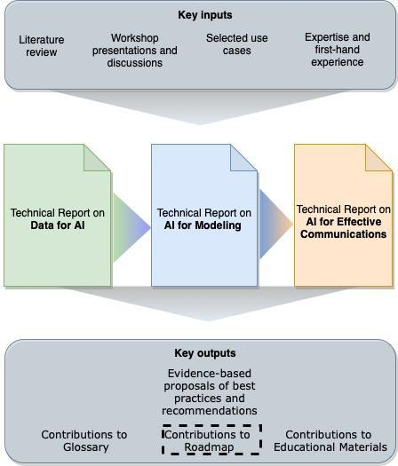
Figure 1 – The relationship between the FG-AI4NDM deliverables and the Roadmap
This report opens by describing the methods that were used to curate and analyse the database of standards and activities. Curation involved the research of literature and online sources, distribution of liaison statements, and circulation of an online questionnaire to relevant parties. To analyse the standards, a qualitative data analysis software was applied (Figure 2).
This report presents the results of these methods, a database consisting of 79 contributions (45 standards and 34 activities), followed by a discussion of the main trends and gaps. An analysis of the results shows that existing standardization activities are mostly oriented towards "reactive" phases of the disaster management cycle and natural (as opposed to man-made) disasters, with geophysical and hydrological hazards as front runners. The most prominent technology mentioned was not AI/ML, but the Internet of Things (IoT). With regard to data, topics such as storage and privacy were common; and in terms of modelling, scalability and validation were prevalent. In cases where AI-based methods were applied, supervised techniques seemed most common. Finally, it was found that operational implementation leaned toward forecasting rather than tools such as dashboards, decision support systems, or hazard/susceptibility maps.
In comparison with ongoing focus group activities, it was found that many of the gaps in existing standards are being addressed through the use cases and technical reports being developed within the remit of FG-AI4NDM. However, it is also apparent that—as technology and standardization progresses – this database of standards and related activities will need to be continuously updated through leveraging the newly founded partnerships within the UN and SDO communities.
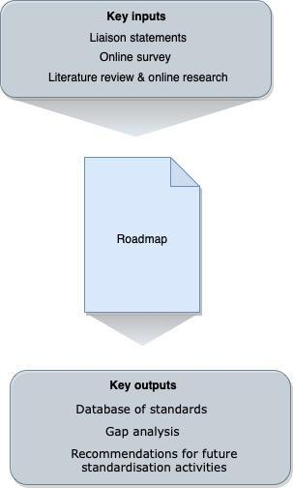
Figure 2 – Key inputs and outputs of the roadmap

5 Methods
As shown in Figure 2, the Roadmap is populated with information that was acquired using three methods. First, a survey of the existing literature and online resources provided an overview of the standardization landscape in this domain. To delve deeper, relevant SDOs and UN bodies were contacted directly via liaison statements containing a form to complete (Tables 1 and 2, respectively).
Table 1 – The form distributed via liaison statement to relevant SDOs.
Category title | Explanation
Acronym | Identifier for the standard
SDO | Official name of the standards development organization
Title | Name of the standard
Description | Brief summary of the standard. Can include: To what does this standard apply? What is the context or problem being addressed? What are the goals of the standard?
Main disaster group | Specifies whether the standard applies to natural disasters and/or other types of disasters
Disaster management phase | Specifies the phase of the disaster management cycle that is relevant for this standard (mitigation, preparedness, response, or recovery)
Relevant technologies | Indicates the types of technologies that are impacted by the standard. Includes artificial intelligence (AI), internet of things (IoT), unmanned aerial vehicles (UAVs), and early warning systems
Status | What is the current status of the standard (to be submitted, submitted, accepted, etc.)?
Link | Provides a website where more detail can be found
Contact | Provides the name of a contact person to access more information
Table 2 – The form distributed via liaison statement to relevant UN agencies
No. | Category title | Explanation
1 | UN name | Official name of the UN body
2 | UN acronym | Acronym for the UN body
3 | Name of activity
4 | Name of department | Part of the UN body that is responsible for activity
5 | Name of coordinator | Name of person responsible for this activity or department
6 | Objectives | A brief description of the objective(s) of the activity
7 | Type of natural hazard addressed | Atmospheric, hydrologic, oceanographic, biologic, or geophysical
8 | Disaster management phase | The phase of the disaster management cycle covered by this activity
9 | Timeframe for implementation | Proposed timeline for completion of the activity
10 | Status | Present status of the activity (e.g., planned, ongoing, completed, under submission for approval)
11 | Output | The output of this department (e.g., technologies, databases, events, or publications)
12 | Link | A website where more detail can be found
13 | Contact | The name of a contact person who could provide more information
14 | Name of activity
To supplement the inputs acquired through the completed liaison statements, an online form was developed using SurveyMonkey and distributed to key networks.
For the analysis, this Report focuses on the standards (rather than activities). These standards were coded and analysed with a data analysis software. With the guidance of the other Working Groups (WGs) of the FG-AI4NDM and the final version of the Glossary, key terms (relating to the respective focus areas of the Working Groups) were selected. The software then searched the text in all 42 publicly available standards documents (indicated by asterisk in Table 3), and, for each term, returned a count of the standards in which the term appeared at least once. In the figures below, this count is expressed as a percentage of the total number of standards (42).

6 Results
Through the survey, liaison statements, and online form, 45 standards could be identified (Table 3). These came from SDOs including ISO, IEC, IEEE, ETSI, and ASTAP, with two-thirds of the standards (30) coming from the ITU (primarily, ITU-T (17) and ITU-R (13)). Across the United Nations system, 34 activities in this domain were also identified. Several sister UN agencies such as the WFP, UNDP, WMO, and UNU provided information on projects in the context of disaster reconnaissance (after a disaster strikes). However, many of these activities are not technology-centric; focusing more on the relationship between emergency response and humanitarian aid, with human personnel responsible for interventions.
Liaison statements sent proved to be an effective channel for inviting inputs to the roadmap. Additionally, individual research carried out within WG-Roadmap also yielded positive results in terms of gathering inputs from online databases for different SDOs given in Tables 3 and 4.
Table 3 – Standards-based Outcomes from SDOs
Acronym | SDO/organization | Related group | Title | Status
 | ASTAP | EG DRMRS | Report "Local-area resilient information sharing and communication systems" | Under Study
ETSI TR 102 445* | ETSI | EMTEL | Emergency Communications (EMTEL); Overview of Emergency Communications Network Resilience and Preparedness | Published
ETSI TR 102 641* | ETSI | EMTEL | Satellite Earth Stations and Systems (SES); Overview of present satellite emergency communications resources | Published
ETSI TR 103 582* | ETSI | EMTEL | Study of use cases and communications involving IoT devices in provision of emergency situations | Published
ETSI TS 102 182* | ETSI | EMTEL | Emergency Communications (EMTEL); Requirements for communications from authorities/organizations to individuals, groups or the general public during emergencies | Published
ETSI TS 102 900* | ETSI | EMTEL | Emergency Communications (EMTEL); European Public Warning System (EU-ALERT) using the Cell Broadcast Service | Published
ETSI TS 102 181 v1.3.1* | ETSI | EMTEL | Emergency Communications (EMTEL); Requirements for communication between authorities/organizations during emergencies | Published
ETSI TS 103 625* | ETSI | EMTEL | Emergency Communications (EMTEL); Transporting Handset Location to PSAPs for Emergency Calls - Advanced Mobile Location | Published
IEC 63152:2020* | IEC |  | Smart cities - City service continuity against disasters - The role of the electrical supply | Published
IEEE 1716-2014 | IEEE |  | IEEE Recommended Practice for Managing Natural Disaster Impact on Key Electrical Systems and Installations in Petroleum and Chemical Facilities | Published
 | IEEE |  | User inclusive crowdsourcing disaster reporting system: Reporting and forecast | Published
ISO 22301:2019* | ISO |  | Security and resilience — Business continuity management systems — Requirements | Published
ISO 22320:2018* | ISO |  | Security and resilience — Emergency management — Guidelines for incident management | Published
ISO/IEC 27031:2011(en)* | ISO |  | Information technology — Security techniques — Guidelines for information and communication technology readiness for business continuity | Published
ISO 21110:2019(en)* | ISO |  | Information and documentation — Emergency preparedness and response | Published
ITU-R M.1637* | ITU-R | SG5 | Global cross-border circulation of radiocommunication equipment for use in emergency and disaster relief situations | Published
ITU-R F.1105-4* | ITU-R | SG5 | Fixed wireless systems for disaster mitigation and relief operations | Published
ITU-R M.1826-1* | ITU-R | SG5 | Harmonized frequency channel plan for broadband public protection and disaster relief operations at 4 940-4 990 MHz in Regions 2 and 3 | Published
ITU-R M.2009-2* | ITU-R |  | Radio interface standards for use by public protection and disaster relief operations in accordance with Resolution 646 (Rev.WRC-15) | Published
ITU-R M.2015-2* | ITU-R | SG5 | Frequency arrangements for public protection and disaster relief radiocommunication systems in accordance with Resolution 646 (Rev.WRC-15) | Published
M.2291-1 (11/2016)* | ITU-R |  | The use of International Mobile Telecommunications for broadband public protection and disaster relief applications | Published
Report M.2085-1* | ITU-R |  | Role of the amateur and amateur-satellite services in support of disaster mitigation and relief | Published
Report M.2377-1* | ITU-R | SG5 | Radiocommunication objectives and requirements for Public Protection and Disaster Relief (PPDR) | Published
Report RS.2178* | ITU-R | SG7 | The essential role and global importance of radio spectrum use for earth observations and for related applications | Published
M.1042-3* | ITU-R | SG5 | Disaster communications in the amateur and amateur-satellite services | Published
BO.1774-2* | ITU-R | SG6 | Use of satellite and terrestrial broadcast infrastructures for public warning, disaster mitigation and relief | Published
Report M.2415-0* | ITU-R | SG5 | Spectrum needs for Public Protection and Disaster Relief | Published
RS.1859-1* | ITU-R | SG7 | Use of remote sensing systems for data collection to be used in the event of natural disasters and similar emergencies | Published
ITU-T Y.4468* | ITU-T | SG20 | Minimum set of data transfer protocol for automotive emergency response system | Published (Approved)
Technical Report | ITU-T | FG-SSC | Standardization roadmap for smart sustainable cities | Published
HSTP-DIS-UAV* | ITU-T | SG16 | Use cases and service scenarios of disaster information service using unmanned aerial vehicles | Published (Agreed)
ITU-T L.300-series Sup.35* | ITU-T | SG15 | Framework of disaster management for network resilience and recovery | Published (Agreed)
ITU-T L.SRDT_adaptation* | ITU-T | SG5 | Sustainable and Resilient Digital Technologies for Adaptation to Climate Change | Under-development
ITU-T Q.3060* | ITU-T | SG11 | Signaling architecture of the fast deployment emergency telecommunication network to be used in a natural disaster | Consented
Q.Sig_Req_ETS_IMS_roaming* | ITU-T | SG11 | Signaling requirements for emergency telecommunication service in IMS roaming environment | Under-Study
Y.KPI-Flood* | ITU-T | SG20 | Key Performance Indicators of ICT based Urban Flood Disaster Prevention and Mitigation Capability | Under-Study
Y.sup.aisr* | ITU-T | SG13 | Artificial intelligence standardization roadmap | Under-Study
ITU-T E.102* | ITU-T | SG2 | Terms and definitions for disaster relief systems, network resilience and recovery | Published (Approved)
ITU-T Y.4467* | ITU-T | SG20 | Minimum set of data structure for automotive emergency response system | Published (Approved)
ITU-T E.119* | ITU-T | SG2 | Requirements for safety confirmation and broadcast message service for disaster relief | Published (Approved)
ITU-T E.Suppl.1 to ITU-T E.100 series* | ITU-T | SG2 | Framework of disaster management for disaster relief system | Published (Agreed)
ITU-T H.785.0* | ITU-T | SG16 | Digital signage: Requirements for disaster information services | Published
ITU-T Y.4119* | ITU-T | SG20 | Requirements and capability framework for IoT-based automotive emergency response system | Published (Approved)
Y.RA-PHE* | ITU-T | SG20 | Requirements and reference architecture of smart service for public health emergency | Under Study
Y.smart-evacuation* | ITU-T | SG20 | Framework of Smart Evacuation during emergencies in smart cities and communities | Under-Study

Table 4 – UN activities related to the use of AI (and complementary technologies) for natural disaster management
Acronym | UN entity | Name of Department | Objective | Status
FAO | Food and Agriculture Organization | Plant Production & Protection Division | Combines an online monitoring platform for mapping data collected by the FAMEWS mobile app whenever fields are scouted, or pheromone traps are checked for FAW. The platform provides a real-time situation overview with maps and analytics of FAW infestations at global, country and sub-country levels. The FAMEWS mobile app enables data collection of scouting data, which can be collected manually or through an image recognition model which provides immediate advice on FAW infestation. The global monitoring platform and the mobile are designed to expand with the evolving needs of farmers, analysts and decision-makers. Both are freely accessible and are helping reduce crop yield losses and risk of further introduction and spread of FAW. | Ending 2022
IOM | International Organization for Migration | Displacement Tracking Matrix Global Team | DTM Global team Applies AI in Anomaly detection on migration data, and contextualisation of these data using #IDETECT, Rural / urban land classifications of displacement settings from DTMs central data warehouse, quality control routines (based on usual statistics, time-series models, NLP, aerial image recognition, etc.). AI is also applied in analysis of Drone imagery in displacement camps to facilitate a data-driven response to crisis severity measures on living conditions in camps during natural disasters. | Ongoing
IOM | International Organization for Migration | Displacement Tracking Matrix Global Team | This project, pilots a novel form of Collective Intelligence (CI) by enabling returnees in Iraq to validate and improve data collection processes and analysis related to conditions in their local area. In doing so, the CI methodology allows for more meaningful participation by affected populations than typically afforded and improves accountability and transparency. By collecting data through digital channels, this initiative examined whether a larger and more diverse cross-section of returnees could be engaged to validate findings from key informant (KI) data collection. Using GPS technology, location-specific conclusions drawn from existing data collection activities were shared with affected communities to confirm, reject and provide open-ended, qualitative input. To aid in classification of text-based responses, an AI trained model was included in the analysis. This project used the Valence Aware Dictionary and Sentiment Reasoner (VADER) algorithm to classify feedback messages in the survey based on its polarity (negative, neutral and positive) and on the intensity of the polarity categories. | Ended
UNDP | United Nations Development Programme | Crisis Bureau | Following hurricane Iota in Columbia, the UNDP contributed its Household and Building Damage Assessment toolkit which provides real time visual, interactive and dynamic reports. Along with the diagnostic methodology, UNDP is making use of mixed realities (Augmented Reality and Virtual Reality), using 360 cameras and drones to complement the data collected and thus link experts, allies and members of government in an immersive experience that allows them to "live reality" through which the archipelago is passing. This tool, called "Augmented Development" seeks to accurately monitor the diagnosis and recovery process, as well as to make more accurate and faster decisions without the need for the time, resources and logistics required for the displacement of the team. | Ended 2020
UNDP | United Nations Development Programme | Crisis Bureau | UNDP in Timor-Leste enlisted support from UNDP's SURGE Data Hub for the Household and Building Damage Assessment (HBDA) Toolkit, a key instrument to collect evidence and information to support authorities in crisis-affected countries. In Timor-Leste, the HBDA facilitated a framework for the assessment of flood and landslide damage on residential and non-residential infrastructures, as well as livelihood impacts, needs and conditions of disaster-affected households. The HBDA's survey was tailored to the country's context and adapted to the local language of Tetum. | Ended 2021
UNDP | United Nations Development Programme | Crisis Bureau | The UNDP Country Office with the support of the UNDP Crisis Bureau in New York and the UNDP Regional Hub in Panama, and in partnership with the Association of Indigenous Leaders in Suriname (VIDS) implemented a Covid-19 Rapid Digital Socioeconomic Impact Assessment among 300 Indigenous Households in Suriname in 2020. | Ended 2020
UNEP | United Nations Environment Programme | Ecosystems Division, Resilience to Disasters and Conflicts Global Support Branch | In partnership with ITU and WMO:  – Conduct a comprehensive literature review of the developments in the field of AI, Robotics and IoT to identify those with potential applications in Environmental Disaster Response.  – Identify technologies which have been developed and employed, even at pilot phase, for emergency response and prepare a technology forecast for its potential applications in environmental emergency response.  – Identify research and technology partners in academia, research laboratories and industries who are currently working on the area of applications of 4IR technologies and form a network for information exchange and potential collaborations.  – Prepare training programme on the potential applications of 4IR technologies in environmental emergency response. | Ongoing
UNGA | United Nations General Assembly |  | In its resolution 61/110 of 14 December 2006 the United Nations General Assembly agreed to establish the "United Nations Platform for Space-based Information for Disaster Management and Emergency Response - UN-SPIDER" as a new United Nations programme, with the following mission statement: "Ensure that all countries and international and regional organizations have access to and develop the capacity to use all types of space-based information to support the full disaster management cycle". A number of initiatives in recent years have contributed in making space technologies available for humanitarian aid and emergency response. Yet, UN-SPIDER is the first to focus on the need to ensure access to and use of such technologies during all phases of the disaster management cycle, including the risk reduction phase which is crucial for reducing the losses of lives and property. UN-SPIDER works in delivering resources for Member States to facilitate the acquisition and processing of space remote sensing data. | Ongoing
UNGP | United Nations Global Pulse | Executive Office of the Secretary General | PulseSatellite - Humanitarian response to natural disasters and conflicts can be assisted by satellite image analysis. In a humanitarian context, very specific satellite image analysis tasks must be done accurately and in a timely manner to provide operational support. PulseSatellite is a collaborative satellite image analysis tool which leverages neural network models that can be retrained on-the-fly and adapted to specific humanitarian contexts and geographies. The tool grew out of a long standing collaboration with UNOSAT which began by building an AI model for counting structures in refugee and IDP settlements. This was then expanded to a web-based toolkit - PulseSatellite - that can be easily adapted to other remote sensing applications and which allows for the incorporation of models created by other users. Currently, we have three models loaded into the system - one that allows users to map structures in refugee settlements, a roof density detection model (e.g. for slum mapping), and a flood mapping application. PulseSatellite is now open for use by other UN agencies. | Ongoing
UNGP | United Nations Global Pulse | Executive Office of the Secretary General | Over the past year we have continued to catalogue ongoing research and elaborate on lessons learned, pitfalls and ways forward to use AI to effectively and safely tackle current and future public health crises. We have published several papers in journals and conferences on this topic in order to provide a reference point for the wider community. | Ongoing
UNGP | United Nations Global Pulse | Executive Office of the Secretary General | We seek to understand how COVID-19 spreads in refugee and IPD settlements. We initially focussed our efforts on the Cox's Bazar settlement in Bangladesh, and have since begun modelling other settlements around the world. Our model simulates the movements and interactions of each individual in the settlement, incorporating information about family structures and demographic attributes, to understand how COVID-19 might spread under various intervention strategies. With almost 80 million forcibly displaced people in the world, we hope that this work will inspire more modelling groups to focus on these vulnerable populations, which have been traditionally under-served by such efforts, to ensure no one is left behind. | Ongoing
UNGP | United Nations Global Pulse | Executive Office of the Secretary General | Radio remains the most reliable and affordable medium of accessing and sharing information in most of the developing world. Indeed, studies have shown that radio remains more prevalent as a means of communication in many parts of the world than social media. Since 2019, UN Global Pulse has worked with the WHO to explore the use of data from radio talk shows to signal early warnings of health risks and health-related matters. We have developed a radio monitoring pipeline which can 'listen' to radio stations, transcribe the audio using machine learning speech-to-text models, and analyse the content using a series of NLP methods for display in a frontend dashboard. The dashboard is designed to be used by infodemic managers and decision makers to inform public health interventions and communication strategies. | Ended 2021
UNGP | United Nations Global Pulse | Pulse Lab Jakarta | Our Pulse Lab Jakarta and the International Organization for Migration (IOM) undertook research using data from an Indonesian telecom provider to gather insights on internal displacement of people affected by a tsunami and subsequent landslides in the Central Sulawesi province of Indonesia. An interactive visualization was designed to make sense of the results. Among its functions, the dashboard communicates the distribution of subscribers, and highlights the most popular destinations where people traveled to after the disasters. | Ended 2018
UNGP | United Nations Global Pulse |  | Predicting forced displacement is an important undertaking of many humanitarian aid agencies, which must anticipate flows in advance in order to provide vulnerable refugees and Internally Displaced Persons (IDPs) with shelter, food, and medical care. While there is a growing interest in using machine learning to better anticipate future arrivals, there is little standardized knowledge on how to predict refugee and IDP flows in practice. Researchers and humanitarian officers are confronted with the need to make decisions about how to structure their datasets and how to fit their problem to predictive analytics approaches, and they must choose from a variety of modelling options. In an academic paper and an accompanying set of practitioner focused "modeling cards," we attempt to facilitate a more comprehensive understanding of this emerging field of research by providing a systematic model-agnostic framework, adapted to the use of big data sources, for structuring the prediction problem. | Ongoing
UNGP | United Nations Global Pulse |  | UN Global Pulse and UNHCR are working to calculate and anticipate the number of displaced persons a) that have already crossed the Brazil-Venezuela border and b) that can potentially cross in order to understand their need for humanitarian support and overall strengthen protection efforts, particularly once COVID-19-related border restrictions are lifted. This project consists of: (i) a queue modelling tool for simulating border crossings under different conditions, (ii) a nowcasting effort to calculate the amount of urban population and potentially identify interest in population movements to Brazil using big data sources, and (iii) predictive models for forecasting future arrivals/ population movements. | Ending 2022
UNHCR | United Nations High Commissioner for Refugees | Innovation Service | Project Jetson is UNHCR's first AI-based predictive analytics experiment to predict the movement of internally displaced persons within Somalia, as well as to discover and understand the factors that cause or exacerbated that forced displacement. This project focused on the development of predictive models for forecasting future arrivals and population movements in each region. This is done using a variety of datasets (e.g., conflict, weather/climate anomalies, market commodity prices, and historical population movement) and utilizes different computer science and data science techniques (e.g., artificial intelligence, specifically supervised machine learning for time series analysis). The project follows UNHCR guidance for data responsibility, data protection, ethics and human rights due diligence, as well as OCHA peer-review framework for predictive analytics projects. The Innovation Service intends for Project Jetson to lead to evidence-informed decision-making in contingency planning, improved humanitarian action through preparedness and risk reduction, and strengthened protection for those who are forcibly displaced. | Ended 2019
UNHCR | United Nations High Commissioner for Refugees | Innovation Service | The Innovation Service explored with several teams different open-source and commercial tools and computer science techniques (e.g., topics modelling, natural language processing) to quantify, analyse and help the organization understand issues related to UNHCR's protection mandate. For example, protection-related incidents such as hate speech, discrimination, xenophobia against refugees and asylum seekers, as well as other persons of concern to UNHCR are commonly expressed online. The ability to quickly identify issues arising from text-based data (e.g., search engines, documents and reports, social media, and other text-based information), helps UNHCR colleagues to become more agile in advocacy and response. The aim of this initiative is to leverage information technologies to increase capacity for text analysis and provide actionable insights and evidence-informed decision-making for UNHCR and its partners, particularly in preparedness and response. The Innovation Service seeks to use new computer science techniques (natural language processing, supervised learning) to create an efficient process that will save time by avoiding the manual analysis and classification of data, and contribute to the UNHCR Action Plan against hate speech and xenophobia, as well as with the UN Secretary General Action plan on the use of new technologies to counter hate speech, discrimination and xenophobia online. | Ongoing
UNICEF | United Nations Children's Fund | Humanitarian | UNICEF is increasingly use geospatial-mapping techniques to predict the flow patterns of floods and the new trajectories of storm zones to help Governments make data backed decisions to re-locate vulnerable populations to higher ground, re-locate schools, health facilities and key infrastructure in the pathways of repeated storms to help keep them out of harm's way and operational for the communities. | Ongoing?
UNITAR | United Nations Institute for Training and Research | United Nations Satellite Centre (UNOSAT) | "The United Nations Satellite Centre (UNOSAT) has recently launched UNOSAT S-1 FloodAI: an end-to-end pipeline where Copernicus Sentinel-1 Synthetic Aperture Radar (SAR) imagery of flood-prone areas are automatically downloaded and processed by a deep learning model to output flood vector data and update operational dashboards. Access to timely and accurate data could not only inform the decision making process to help optimize the disaster response, but it also has the potential to significantly reduce the loss of life and mitigate structural damage, particularly in the context of humanitarian operations, thus supporting both national authorities and international emergency management organizations for the benefit of local populations.  Update 2021: now fully deployed and embedded as one of the UNOSAT Rapid Mapping Service." | Ongoing
UNITAR | United Nations Institute for Training and Research | United Nations Satellite Centre (UNOSAT) | The United Nations Satellite Centre (UNOSAT) partner with Trillium Technologies and FDL Europe to test and use ML4Floods: an ecosystem of data, models and code pipelines to tackle flooding with machine learning (ML). | Ended 2021
UNITAR | United Nations Institute for Training and Research | United Nations Satellite Centre (UNOSAT) | "With decades of experience analysing satellite imagery and mapping natural disasters, refugee settlements, conflict, and related issues UNOSAT has emerged as a primary partner for organizations wishing to explore AI for humanitarian applications. In addition, large amounts of UNOSAT analyses are publicly available in vector format both from its' website and the Humanitarian Data Exchange, and this has proven valuable for organizations seeking training data for AI development. In turn, multiple such organizations have reached out to UNOSAT for guidance on imagery analysis, allowing UNOSAT to learn a great deal about the state of the field. This partnership model has been very effective in particular with UN Global Pulse and the two organizations have collaborated extensively to develop algorithms that can identify and map refugee shelters in satellite imagery. Importantly, UNOSAT and Pulse have paid particular attention to the accuracy of outputs of these algorithms given the high- threshold of accuracy UNOSAT requires for its operations. This process and results were detailed in a 2018 academic paper by Pulse and UNOSAT. Currently, UNOSAT also developed an end-to-end pipeline where images of flood-prone areas are automatically downloaded from satellites covering the affected areas and processed by machine learning algorithms to shorten the time needed to deliver disaster maps to humanitarian organizations. The system would allow for near-real-time monitoring and surveillance. UNOSAT is also pursuing algorithm development for change detections which would help enable various analyses such as landslide detection and damage assessments. Finally, UNOSAT together with CERN and the European Space Agency will engage in a challenge over the next several months to extract building footprints from satellite imagery.  Update in 2021 report: The focus is now not only on mapping refugee settlements, but on building footprints in general and damage assessment. | Ongoing
UNU | United Nations University | Institute for Water, Environment and Health (UNU-INWEH) | The Project has developed a Web-based Spatial Decision Support System (WSDSS) to address flood-related information gaps in the currently available flood early warning and risk management systems. The WSDSS comprises a historical flood mapping tool (HFMT) and a flood risk prediction tool (FRPT). The HMFT generates inundation maps for significant floods from 1984 till the present using open Earth data. The tool applies a water classification algorithm to 'stacks' of historical satellite imagery derived from Landsat and Sentinel 2 to reveal inundation patterns over space and time. HFMT is a hindcast tool that allows impacts of inundation on various socio-economic sectors to be analysed. The FRPT uses AI models to generate current and future flood risk maps at the city, district, and river basin level for three climate change scenarios. The AI models are trained using the inundation maps generated by the HMFT and open datasets, including land use, land cover, precipitation, temperature, gender, and age-disaggregated socio-economic data. WSDSS improves the spatial and temporal coverage of national and regional flood early warning and risk management systems and enhances the spatial resolution of the outputs. WSDSS will build the capacity of flood forecasting centres in Global South to use AI models, big data, and cloud computing to analyse the impacts of climate change. | Ongoing
UNU | United Nations University | Institute for Water, Environment and Health (UNU-INWEH) | WHO (2020) has identified increased human risk of antimicrobial resistance (AMR) resistance as a top ten urgent health problem for the next decade. Using a text mining approach, over 12,000 title/abstracts have been reviewed to provide a rapid review and historical analysis of the past three decades of AMR research. It highlights how human health, animal health and industrial research and development increasingly have increasingly received greater attention in scientific endeavors. There, however, remains a significant gap of knowledge of the impact of AMR research and interventions with regards to the environment – especially, with regards to water-related exposure pathways. This research unpacks such gaps of knowledge in consideration of the need to develop a one health AMR stewardship framework that adequately addresses environmental water-related AMR risks. | Ended 2021
UNU | United Nations University | Institute for Water, Environment and Health (UNU-INWEH) | The objective of this project is to develop a model-based risk mapping tool for cholera which separately evaluates outbreak probability, outbreak transmission efficiency and population susceptibility to severe health outcomes based on a range of health, environmental and climatic, infrastructural (including WASH), and demographic data. Greater understanding of the interaction of different disease outcomes and variables and can inform the integrated development of multi-sectoral cholera control efforts. The tool will be presented as a spatial index-based decision support system that can be adapted: to visualize multiple dimensions of cholera risk; and for use in different countries to help inform context-appropriate allocation of public resources. | Ended 2022
WFP | World Food Programme | Emergency Operations Division | AI for Human is an artificial-intelligence-assisted building damage detection and classification tool used in the aftermath of natural disasters such as floods, cyclones and earthquakes. The project was focused on the development of methods and processing environments to detect changes in infrastructure and buildings by using machine learning techniques. The main focus is on the demand-driven development of existing deep learning methods and the provision of software for humanitarian organizations, to speed up response times in emergencies. WFP is particularly interested in exploring and testing the use of artificial intelligence-enabled procedures, for instance, for detecting infrastructure damages caused by natural disasters. WFP will provide the datasets used for the case study The project will also evaluate and illustrate the opportunities and limitations pertaining to the machine learning methods in this specific technology. | Ended 2021
WFP | World Food Programme | Emergency Operations Division | This project explores the systematic development and evaluation of national and global data and metadata published on the Internet to assess its usability for United Nations Activities on Artificial Intelligence (AI) 197 the derivation of crisis-related information. National and global databases published on the Internet and blogs, newsfeeds and social media contributions are a complementary source of information on satellite imagery and derived products. Therefore, the acquisition and aggregation of such data and the integrated presentation of these two sources of information (e.g. in mapping products of the ZKI or web-based services) can greatly contribute to an overall analysis. The fusion techniques will be developed and tested grounded on past or ongoing crisis situations. For example, humanitarian emergencies such as floods in Mozambique in 2019 can be included in the model (from M1). Data on refugee camps and their dynamic developments will also be added systematically (from M13). Finally, analyses of food security issues such as post harvest loss estimation in Africa can also potentially enhance the model. | Ongoing
WFP | World Food Programme | Emergency Response | When disaster strikes, WFP and its humanitarian partners must respond as quickly and efficiently as possible. A lack of on-the-ground accurate information that can be extracted in a low-resource environment can delay emergency response. The solution, DEEP is an open-source machine learning application that works offline, on commercially available laptops to quickly quantify damage in the area. A fundamental part of DEEP is the capacity-building activity for local populations, to enable them to use the app in an emergency situation. | Ongoing
WFP | World Food Programme | Emergency Response | When disasters strike, needs assessments are conducted by humanitarian experts based on the first information collected, their knowledge, and their experience. However, we do not have access to past data that could help build an innovative AI-driven logistic provision model for emergency in cyclones. We have collaborated with Omdena Challenge (crowd-sourced) to bring 40 AI experts and aspiring data scientists from around the world to build the model. The team mapped the correlation factors to determine which populations are most in need. As an example, below the income level is correlated with the number of people affected. Taking advantage of past data, the data model predicts affected populations. Once an affected population has been identified, humanitarian actors need to design comprehensive emergency operations, including how much food and what type of food is needed. The project team built a food basket tool, which facilitates calculating the needs of affected populations. The tool also has features to account for factors influencing population needs, such as days to be covered, the number of affected people, pregnancies, children, etc. | Ended 2020
WFP | World Food Programme | INKA | As part of its frontier innovations portfolio, WFP has been exploring new technologies that can automate this process and speed up response times. WFP partnered with Google Research to set up SKAI, a humanitarian response mapping project powered by artificial intelligence – an approach that combines statistical methods, data and modern computing techniques to automate specific tasks. SKAI assesses damage to buildings by applying computer vision – computer algorithms that can interpret information extracted from visual materials such as, in this case, satellite images of areas impacted by conflict, climate events, or other disasters. The key to this process is a machine learning model developed specifically for SKA, which detects damaged buildings by comparing imagery of the same buildings before and after the disaster. SKAI aims to leverage the power of artificial intelligence and remote sensing to assess damage within 24 hours after disasters take place. | Ongoing
WFP | World Food Programme | INKA | FamPred project is complementary to WFP's HungerMap LIVE humanitarian mapping project (https://hungermap.wfp.org). FamPred expands the HungerMap LIVE's capabilities to forecast food crises by adding projections on insufficient food consumption. Artificial intelligence offers new opportunities for forecasting food insecurity in complex systems, where an approach known as "reservoir computing" is among the most promising. The project aims to develop a reservoir-computing-based prediction model using relevant datasets for the identified geographies in HungerMap LIVE. This model would strengthen WFP's and national governments' capacities to predict crises, deploy resources and prevent food crises outbreaks, ensuring communities at risk of hunger continue to get the support they need, when they need it. | Ended 2021
WFP | World Food Programme | Research, Assessment and Monitoring Division | Crop land and type mapping is crucial in the assessment of agricultural production of a country. It is also a critical prerequisite for the monitoring and assessment of changes in agricultural livelihood resources, which is particularly important in areas affected by conflict, natural disasters and other disruptions, allowing staff to timely allocate resources and deliver food assistance. However, the collection of ground data tends to take considerable time and may be particularly expensive and hard to carry out in emergency contexts. The current project explores innovative methodologies for making the crop type mapping process more efficient and cost-effective. A combination of images from drones and satellites such as Sentinel-2 open up new possibilities for obtaining accurate data from the ground. WFP is testing the use of drones to capture images from much larger areas, compared to conventional data collection methods which use enumerators or smartphone applications which lead to relatively small sample sizes. The drone images are then classified into different crop types with high or sufficient accuracy. The ultimate goal is to use the drone data to train the Sentinel-2's machine learning model to recognise different types of crops over larger unsampled areas. As a result, this new process combining artificial intelligence with drone and satellite imagery data will substantially reduce field work and automate the process of crop type mapping. | Ongoing
WFP | World Food Programme | Research, Assessment and Monitoring Division | HungerMapLIVE brings together different streams of publicly available information on food security, nutrition, conflict, weather and a variety of macro-economic data – including from WFP – all in one place to provide a holistic overview of the food security situation at global, country and sub-national levels. The resulting analysis is displayed on an interactive map using advanced data visualization tools. As WFP's global food security monitoring system, the HungerMap LIVE: enhances operational effectiveness by identifying areas that are sliding towards food insecurity, providing information on shocks, hazards and other drivers of hunger in real time, ensuring more informed and timely response to food crises; maximizes efficiency by providing continuously updated data at a lower cost and in less time, compared to traditional food security monitoring systems alone; ensures continuously updated information in countries of interest, regardless of accessibility issues and the scale of WFP's operational presence. | Ongoing
WFP | World Food Programme | Research, Assessment and Monitoring Division | In emergency and development contexts, communication with affected communities is crucial. Having access to accurate, tailored information and engaging in a dialogue contributes to the resilience and ability of people to cope with a crisis. Since 2016, WFP has been working on the development and rollout of humanitarian chatbots to help deliver vital information to the people in urgent need. This technology improves WFP's outreach to populations in hard-to-reach areas using a mobile device or a computer and complementing existing communication channels and WFP's food security monitoring systems. This technology has proven to be particularly useful during COVID-19, as communication with affected communities has become even more crucial in times of unprecedented uncertainty. Chatbots are highly customizable. For example, chatbots can be deployed as part of an assets creation programme to provide information about the use of assets as well as to collect feedback from the users. As part of Complaint Feedback and Mechanism (CFM) systems, chatbots have been useful in offering access to information 24/7. Moreover, the analytics produced by chatbots can inform further interactions; WFP staff can monitor errors and improve the technology and user experience over time. As such, chatbots are highly user-friendly and do not require a high level of computer literacy, making them accessible to large segments of the population. | Ongoing
WMO | World Meteorological Organization | Science and Innovation Department | Improved sub-seasonal to seasonal (S2S) forecasts could enhance food security, the sustainable management of energy and water resources, and reduce disaster risk by providing earlier warnings for natural hazards. The World Meteorological Organization (WMO) has launched a competition to improve, through artificial intelligence and/or machine learning techniques, the current precipitation and temperature forecasts for 3 to 6 weeks into the future from the best computational fluid dynamic models available today. All the codes and scripts will be hosted at Renkulab, developed by the Swiss Data Science Center, and training and verification data will be accessible from the European Weather Cloud and IRI Data Library. Data access scripts will be provided. After the competition, open access will be provided to all the codes and results. | Ongoing

7 Trend and gap analysis
Through an analysis of existing standards (Table 3), several recurring themes could be found: disaster management phases, disaster types, technologies (including acquisition methods), data-related considerations (both data standards and data handling approaches), model-related considerations (including types of learning), and implementation of AI/ML technologies for operational purposes. The scope of this Roadmap was oriented to focus on trends and gaps among these themes when analysing those standards that were downloadable and freely available online (42 of the 45 total standards; indicated with an asterisk in Table 3).
Disaster management phase
The disaster management cycle consists of four main phases: prevention/mitigation, preparedness, response/relief, and recovery [b-FEMA] [b-UN-SPIDER]. These phases reflect proactive and reactive steps that can be taken to enhance resilience, reduce impacts, and restore communities (Figure 3).
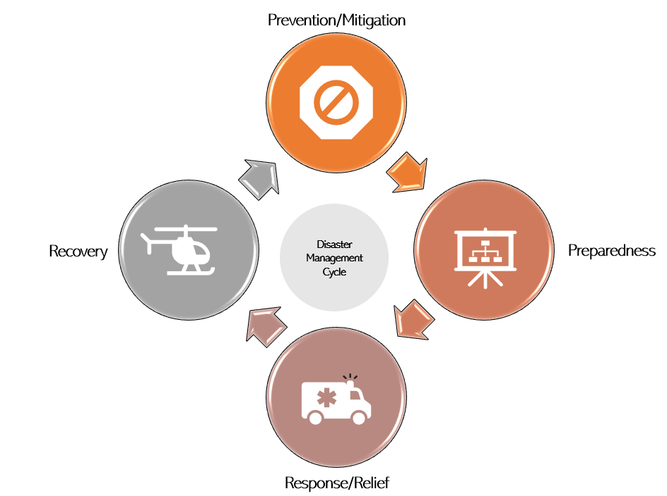
Figure 3 – The disaster management cycle
Prevention/mitigation encompasses efforts aiming to prevent or minimize future disasters. It includes enforcing building codes and retrofitting infrastructure, constructing levees and digging channels to redirect water [b-FEMA], identifying hazards and impacts, and educating the public about hazards and mitigation strategies [b-Sun]. Some ways that artificial intelligence is being used to support prevention/mitigation is through the production of hazard maps and forecasts (e.g., [b-Marti]). This phase is followed by preparedness, which refers to steps that can be used to anticipate, respond to, and recover from disasters. These are taken in advance of a disaster to dampen the impacts. They can range from disseminating early warnings to preparing for evacuations [b-DG-ECHO-1]. One way that artificial intelligence is contributing to preparedness is through near-real-time detection in early warning systems [b-Thüring] [b-Lin]. Immediately before, during, and just after a disaster is the response (also sometimes referred to as the "relief") phase [b-UNDRR]. This includes evacuation, first response (firefighting, search and rescue), and humanitarian efforts. Here, artificial intelligence has shown usefulness in decision support systems, dashboards (e.g., the Ororatech Wildfire Solution platform [b-Orora]), chatbots, and related tools. The final phase of the disaster management cycle—recovery—refers to rebuilding efforts. It includes damage assessment, debris removal, and reconstruction. Through object detection, artificial intelligence has shown great value in damage assessment applications (e.g., CrowdLearn as described by [b-Zhang]).
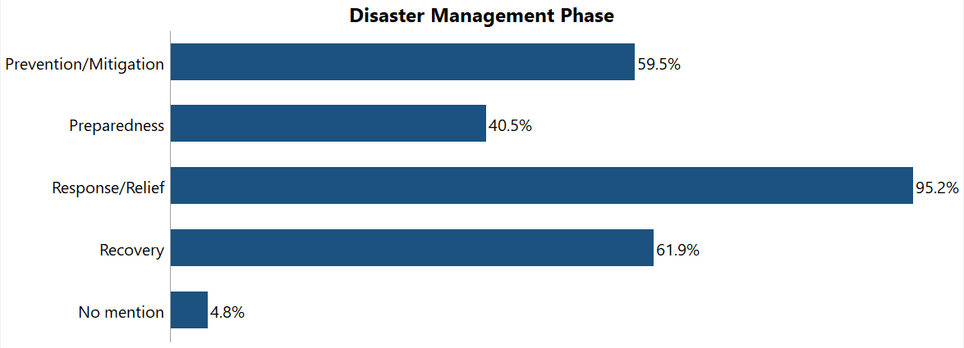
Figure 4 – The standards containing a reference to each phase of
the disaster management cycle
The analysis of these terms within the standards database (prevention/mitigation, preparedness, response/relief, and recovery) reveals that most standards are geared toward response/relief, followed by recovery and prevention/mitigation (Figure 4). These results are well aligned to those of [b-Sun], whose literature review also showed a predominance of response-related articles. It is also noted that fewer standards address preparedness and standardization activities thus far show a slight bias towards the reactive phases. Overall, disaster management phases are well-covered in the standardizations to-date, with only 4.8% of standards not containing any reference to them.
Disaster types
There are various ways to define a disaster, depending on the perspective of the person or organization using the term. For instance, the International Federation of Red Cross and Red Crescent Societies defines disasters as a disruption to the functioning of a community, which exceeds that community's ability to cope [b-IFRC]. Other definitions also emphasize impacts to the environment [b-JRC]. Depending on the cause or trigger, a disaster can be classified as natural or man-made. Natural disasters are generally defined as a "potentially damaging physical event" [b-ISDR] of a predominantly natural origin [b-Kuglitsch], and include atmospheric (e.g., windstorms), [b-UNDP-2] biological (e.g., insect plagues), [b-Zhou] geophysical (e.g., volcanic eruptions), [b-Aberdeen] hydrological (e.g., floods), [b-UNOSAT] and oceanographic (e.g., tsunamis) [b-Nature] events. Man-made disasters include nuclear and industrial accidents [b-DG-ECHO-2].
For the analysis, different natural disasters were grouped under their respective high-level natural disaster types as follows: atmospheric disasters included cyclones, tornados, and storms; biological disasters included pandemics, epidemics, insect infestations, and point-source outbreaks; geophysical disasters included landslides, avalanches, earthquakes, and volcanic eruptions; hydrological disasters included floods and droughts; and oceanographic disasters included tsunamis. Instances of both the higher- and lower-level terms were sought in the existing standards, and the results for the lower-level terms were aggregated into the higher-level term count.
When analysing the content of the standards for instances of the terms natural versus man-made disaster, it was found that the majority of the standards were dedicated to natural disasters (57.1%; not shown), although one-third (33.3%; not shown) did not address any specific type.
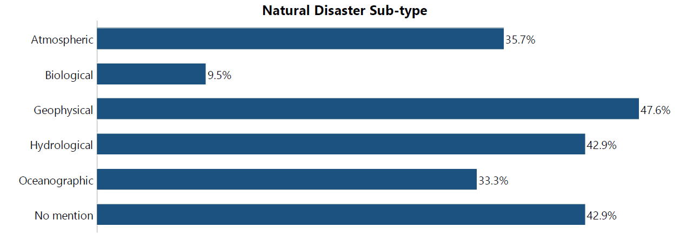
Figure 5 – The standards containing a reference to natural disaster subtypes
When, in a second step, the occurrence of parent terms atmospheric, biological, geophysical, and hydrological (including their child terms) was explored, it was found that most standards are related to geophysical and hydrological processes (Figure 5). Despite the widespread impacts of the COVID pandemic, relatively few standards involved biological types of natural disasters (9.5%). Again, a considerable number did not address any specific natural disaster sub-type (42.9%), suggesting a trend towards disaster-agnostic standardizing activities.
Technologies
In the context of technologies, the expressions that were explored encompass artificial intelligence (AI) and machine learning (ML); Big Data; Internet of Things (IoT); unmanned aerial vehicles (UAVs), drones, and earth observations (EO); geographical information systems (GIS); digital twins; and cloud or edge computing. The selection of these terms were guided by the activities of the other working groups and work streams of the FG-AI4NDM.
AI refers to "systems that display intelligent behavior by analyzing their environment and taking actions – with some degree of autonomy – to achieve specific goals" [b-Ranschaert]. All of the use cases being explored by the FG-AI4NDM apply AI-based methods in some capacity. One subdomain of AI is machine learning (ML). Per Google, ML describes a system that takes input data to train a predictive model. The trained model can then make predictions from new data that are drawn from the same distribution as was used to train the model [b-Khekale]. As ML-based models require a large quantity of high-quality data to perform, they can benefit from Big Data. These datasets, which can be produced through IoT devices including networked mobile devices, personal computers, sensors, radio-frequency identification markings, and cameras [b-Michael], have a scale that is difficult to obtain, manage, and manipulate in a timely manner using traditional computing tools [b-Patel]. In the field of earth observations (EO), that is, observations about Earth's physical, chemical, and biological systems [b-GEO], Big Data are ascribed to the boom in remote sensing systems—sensors mounted on satellites, drones (also known as UAV), and aircraft. These sensors record Earth's conditions and processes from a distance and can be interpreted with the aid of ground truthing. To contextualize these spatial data by their location, GIS is an important tool. According to the Economic and Social Research Institute (ESRI), it "creates, manages, analyses, and maps all types of data [...] integrating location data (where things are) with all types of descriptive information [and providing] a foundation for mapping and analysis that is used in science and almost every industry" [b-ESRI]. GIS is sometimes used in the context of digital twins: models that are designed to accurately reflect a physical object [b-IBM-1]. A well-known example, Destination Earth (DestinE), is a highly accurate digital model of Earth that can be used to monitor and predict human and natural processes and interactions [b-DestinE]. Transmitting data from the site of collection to the site of computation is a challenge that can be addressed through cloud or edge computing. Cloud computing refers to servers, operating systems, networks, software, applications, and storage equipment that provide a scalable and elastic pool of shareable physical or virtual resources [b-ISO-1]. For instance, the European Commission has sponsored five cloud-based platforms [b-Copernicus] to centralize access to Copernicus data, information, and processing tools. An alternative approach to handling large volumes of data is through edge computing. This can also be defined as "distributed computing framework that brings enterprise applications closer to data sources such as IoT devices or local edge servers" [b-IBM-2].
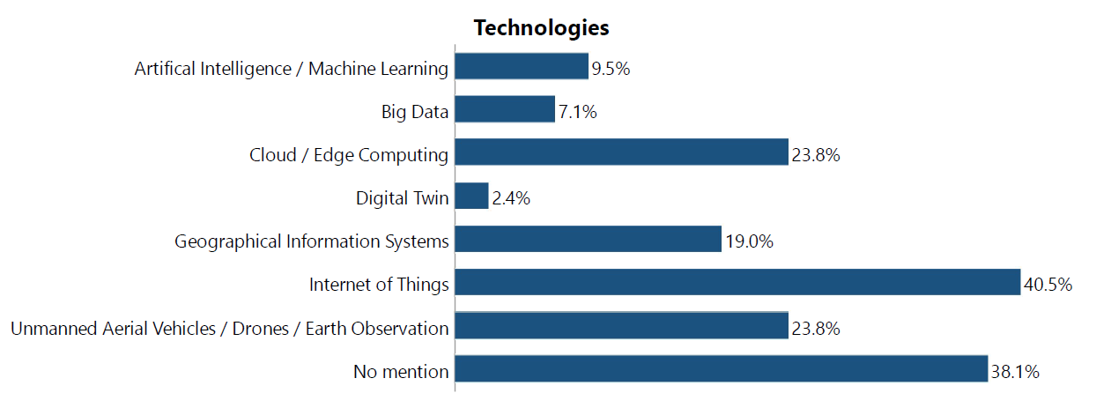
Figure 6 – The standards containing a reference to different technologies
As shown in Figure 6, the technology referenced by the highest number of existing standards is the Internet of Things (40.5%), followed by equal numbers referencing cloud / edge computing and unmanned aerial vehicles (UAVs) / drones / earth observations (EO). On the other hand, very few standards reference digital twin (2.4%), Big Data (7.1%), or artificial intelligence (AI) / machine learning (ML) (9.5%). References to IoT largely originate from the document "ETSI TR 103 582 EMTEL; Study of use cases and communications involving IoT devices in provision of emergency situations." It is noted that a considerable number of the existing standards (38.1%) did not refer to any of these technologies, but instead referred to related topics such as communications or data architecture.
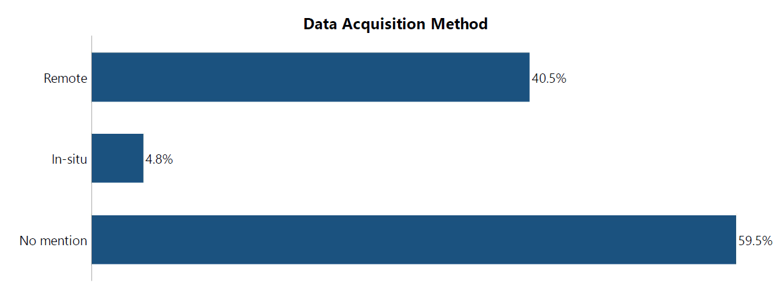
Figure 7 – The standards containing a reference to different
data-acquisition technology types
The report also analysed the number of standards considering in-situ versus remote data-acquisition technologies (Figure 7). In-situ technologies register conditions at or near a collection site. They include gauges, which measure discharge of a river; weather stations, which measure variables such as temperature, humidity and pressure, wind direction and speed, precipitation duration and amount, and irradiance [b-MeteoSwiss]; and seismographs, which record the motion of the ground during an earthquake [b-USGS]. Devices with sensors that record conditions from a distance (e.g., satellites) are considered remote. Some of these remote sensing devices have active sensors, meaning that they send a signal to an object and then register the returned signal. Radar, which stands for radio detection and ranging, falls into this category. Passive sensors measure energy that is naturally produced [b-NRC-1]. Examples include infrared or thermal sensors (whereby thermal radiation between 780 m and 1 mm is detected) [b-NRC-2] and visible or optical sensors rely on the sun as the source of illumination [b-Booysen].
Based on the above, it was found that standardization efforts to date are geared towards remote data acquisition methods (40.5%) rather than in-situ (4.8%), although a majority do not refer to either.
Data-related considerations
In the space of data-related considerations (Figure 8), terms related to data standards were first sought: Open Geospatial Consortium (OGC), data format standards, Global Geodetic Reference Frame (GGRF), sample markup language, data governance, data themes, data supply chain (DSC), exploratory data analysis (EDA), and digital object identifier (DOI).
The Open Geospatial Consortium (OGC) is an example of an SDO in the geosciences field, aiming to "make location information Findable, Accessible, Interoperable, and Reusable (FAIR) [...] combining consensus-based open standards, innovation projects, and partnership building" [b-OGC-1]. Data format standards specify grammars to be used when encoding data [b-ID4D]. Examples of such standards in the geosciences include markup languages such as geographic markup language (GML) [b-OGC-2] or keyhole markup language (KML) [b-OGC-3], which specify how geographic visualizations or annotations should be encoded. As the OGC points out, an essential part of machine learning processes is the sample data which are used to train ML applications [b-OGC-4]. With a lack of consistent sample data becoming a bottleneck to the advancement of ML for EO data, the OGC established the SampleML-AI/ML Standards Working Group to define a sample markup language (SampleML) for AI and ML data [b-OGC-4]. The Global Geodetic Reference Frame is "the framework which allows users to precisely determine and express locations on the Earth, as well as to quantify changes of the Earth in space and time" [b-UN-GGIM]. Meanwhile, data governance refers to the establishment of rules and regulations surrounding the ownership, management, and sharing of data to maintain its quality and security [b-IBM-3]. Data themes are recurring high-level ideas or concepts in a dataset and "can include application data themes that are captured for a specific purpose, such as health and utilities; and socio-economic themes that are used for demographic studies" [b-UN-GGIM]. Data supply chain refers to "the lifecycle process of data; selection, procurement, transfer, quality assurance, warehousing/storage, data management, transformation, monitoring, and distribution — feeding data pipelines for use in data products" [b-SentinelOne]. Exploratory data analysis is "an initial examination of data to determine its salient characteristics and assess its quality" [b-Bevilacqua]. Finally, a digital object identifier provides "persistent unique [digital] identification" to objects, allowing their identification, traceability, and management [b-DOI].
It was noted that these terms were nearly absent from the existing standardization documents, with only one reference to data format standards and only one document referencing OGC.
In a second analysis, terms related to data handling were considered: machine learning operations (MLOps) and related concepts of data preparation, data cleaning, and data authentication; data curation; data annotation and labelling; data storage; data bias and representativeness; data ownership; open data; and data privacy.
MLOps refers to best practices to run AI successfully. As noted above, it includes elements such as data preparation, data cleaning, and data authentication. Data preparation refers to steps taken to make AI-ready datasets. If a dataset is incomplete, contains outliers, or is noisy, data cleaning can be used to correct such artificial artifacts (e.g., validation with actual or synthetic data) [b-Gonzalez]. Meanwhile, data authentication refers to approaches to ascertain whether data are genuine, authentic, and properly described. It can involve the use of passwords, identifiers, or encryption [b-Vert]. Data curation, which aims to preserve the value of data and to deliver it to end users in a way that it can be visualized and used, includes considerations such as: security, respected rights, data sharing rules, policies for "data life" scenarios, and secure file transfer. When applying supervised algorithms, data annotation and labelling are necessary. This can involve several steps: defining an annotation task, selecting experts to do the annotation, preparing annotation guidelines (e.g., defining classes with examples), selecting annotation exercises and platforms, and finalizing annotations for the data objects [b-Tseng]. Other important considerations are data storage (see, for instance, the cloud-based approaches described above) and data bias (or representativeness). Bias can refer to an exclusion, preference, distortion, or manipulation of data. Without correction, biased data can result in biased algorithms. Data ownership and open data are closely related topics. Ownership refers to the legal rights and complete control over a single piece or set of data elements governing the acquisition, use, and distribution of data assets [b-Techopedia-1]. Meanwhile, open data are those that are publicly accessible through open standards, protocols, or other means [b-Data-Europa]. A final consideration is data privacy, which is defined by SNIA as "an area of data protection that concerns the proper handling of sensitive data including, notably, personal data but also other confidential data, such as certain financial data and intellectual property data, to meet regulatory requirements as well as protecting the confidentiality and immutability of the data" [b-SNIA].
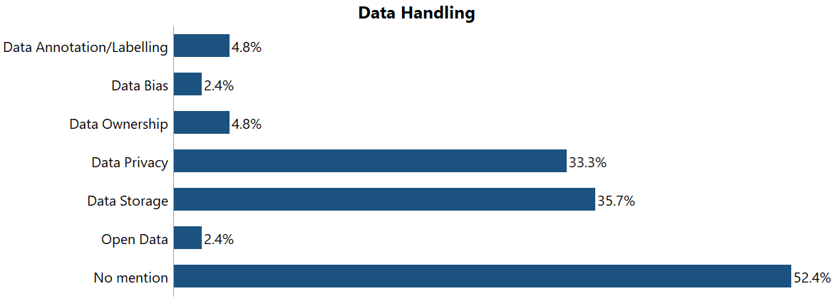
Figure 8 – The standards containing a reference to data handling-related terms
Figure 8 shows that standards within the database focus most on data storage (35.7%) and data privacy (33.3%) while data bias and open data are the data handling aspects less frequently considered. None of the standards to date refer to MLOps or to data curation, and a majority of standards (52.4%) did not consider any of these data handling terms.
Model-related considerations
The report also considers the following modelling-related considerations (Figure 8): harm avoidance; autonomy; transparency, explainability, and interpretability; open source; stakeholder inclusion; legal (implications); scalability; and validation.
When developing models, the principle of harm avoidance calls for the anticipation of possible harmful effects of the model and their proactive mitigation, for example through controls or restrictions on the distribution of the model [b-EPRS-1]. Autonomy refers to the ability of stakeholders to assess or provide inputs to a model based on their outcomes. In the field of AI, transparency, explainability, and interpretability are often used interchangeably. While they are closely related, they carry distinct meanings. Transparency refers to the ability to enable all stakeholders to understand how an AI system is developed, trained, operated, and deployed in the relevant application domain [b-OECD], including the logic, limitations, and consequences of decision-making. Explainability refers to efforts to make sure that artificial intelligence programs are transparent in their purposes and how they can be explained in human terms [b-Techopedia-2]. Interpretability refers to the ability of users to understand how a model arrived at a decision or predict a model's result [b-Rao] [b-Cramer]. Open source data are free and publicly available (although their use and redistribution may be subject to certain conditions) [ITU-T Y.4472]. Stakeholder inclusion refers to the involvement of parties who may be affected by the model's outputs in the design, development, testing, or assessment of the model, such that their needs are represented [b-WEF]. Another consideration in the development of models is the legal implication of outputs. When a model is applied to personal data, for example, the outputs may also be considered personal data and fall under the General Data Protection Regulation (GDPR) [b-EPRS-2]. Meanwhile, certain problems may require more powerful and thus resource-intensive models. In other cases, resources may be limited. Scalability refers to the ability of models to be scaled up or down to fit the needs of the problem [b-Techopedia-3]. Finally, validation is the process of checking the quality of the data to which the model is to be applied, including its accuracy [b-Hinton].
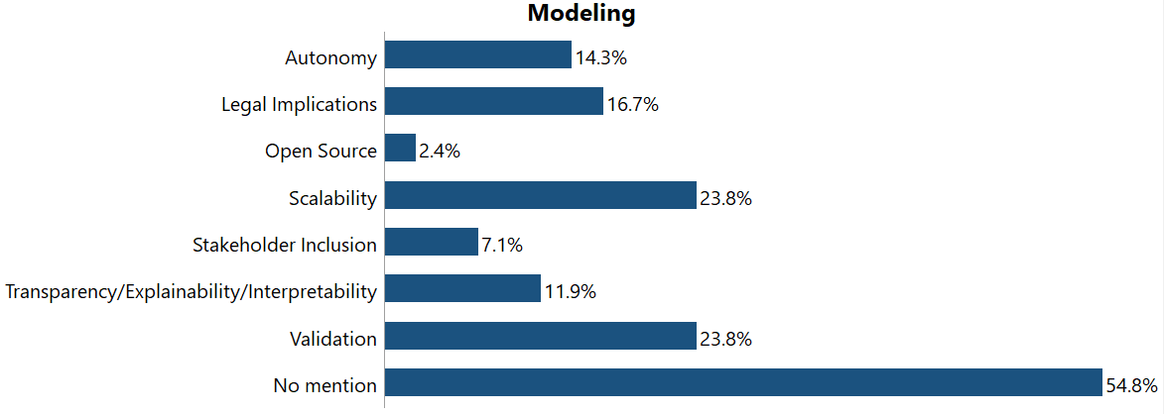
Figure 9 – The standards containing a reference to general model-related terms
It was found that scalability and validation were the modelling-related considerations most commonly referenced (23.8%), while stakeholder inclusion was rarely mentioned (7.1%) and open-source considerations were largely absent (2.4%). No standards referred to harm avoidance, and a majority of standards (54.8%) did not refer to any modelling considerations.
The report also analyses the number of references to different types of machine learning (Figure 9) including supervised (regression, classification), unsupervised (clustering, association), transfer, and reinforcement. As with natural disaster sub-types, both the higher-level terms and lower-level terms (in parentheses) were sought before aggregating all results to the higher-level term. In supervised learning, a computer is provided with examples of the associations in a data set (labelled as inputs and outputs, hence "labelled data") which it learns to recognise and predict [b-ISO-2]. Unsupervised learning models, on the other hand, are applied to unlabelled datasets and identify patterns and associations in the data themselves [b-ISO-2]. Reinforcement learning iteratively provides a model with feedback, such that it learns by trial and error [b-van-Otterlo]. Finally, in transfer learning, a model designed for a given application is refined and applied to another domain, such that the new domain can benefit from the existing labelled data [b-West].
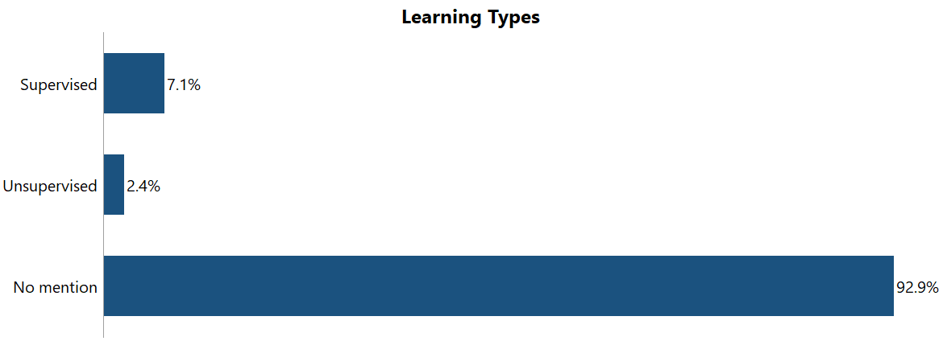
Figure 10 – The standards containing a reference to different learning types
It was found that the vast majority of standards did not reference a specific learning type (Figure 10). Where a learning technique was mentioned, supervised learning techniques were referenced more frequently than unsupervised techniques, and no mention of transfer and reinforcement learning were found.
Implementation of AI/ML for operational purposes
The last series of terms that were sought related to implementation of AI/ML technologies for operational purposes. These terms encompass Common Alerting Protocol (CAP), alerts and early warning systems, forecasts, hazard maps, decision support systems (DSS), dashboards, and chatbots.
In brief, the CAP is a simple but general format for exchanging all-hazard emergency alerts and public warnings over all kinds of ICT networks [ITU-T X.1303]. Emergency alerts (as well as those derived from early warning systems (EWS)) are based on real-time detection and near-real time (short lead time) forecasts aimed to provide timely and effective warning information using integrated communication mediums in a systematic manner to the targeted population to reduce the impact of disasters [b-UNDP-1]. Forecasts can also have an important role for possible scenario investigation, risk estimation, and decision-making. For instance, machine learning models can be used to predict the intensity and location of impending natural disasters. Forecasts and their associated probabilities can be utilized as an integral part of a communication system to provide local, regional, and country-based alerts of a possible crisis. Hazard maps are a tool that can be used to visualize areas that are vulnerable to a certain type of hazard (e.g., via recurrence intervals) through a likelihood reference. For the generation of hazard maps, AI is often used in conjunction with GIS tools (e.g., ArcGIS, MapGIS; see Figure 6). According to the Pacific Northwest Seismic Network, "hazard maps are tools that when properly utilized by planners, developers, and engineers, can save lives and economic losses by avoiding exposure to some hazards while designing other development to mitigate or neutralize the potential negative effects of these hazards" [b-PNSN]. DSS is a different type of tool that can help disaster managers solve problems by identifying possible means to address community outreach, providing the influence of warning message content on the public and, thereby, performing complete impact analysis of the disaster event which can help in response coordination and preparedness activities. Dashboard is a related tool that assists to prioritize areas where relief should be targeted and regions that should be monitored. By providing complete visibility to the underlying input and output variables that contribute to the severity assessment from AI for NDM models, users can make informed decisions. Finally, chatbots are computer programs intended to simulate dialogues with human users [b-Adamopoulou].
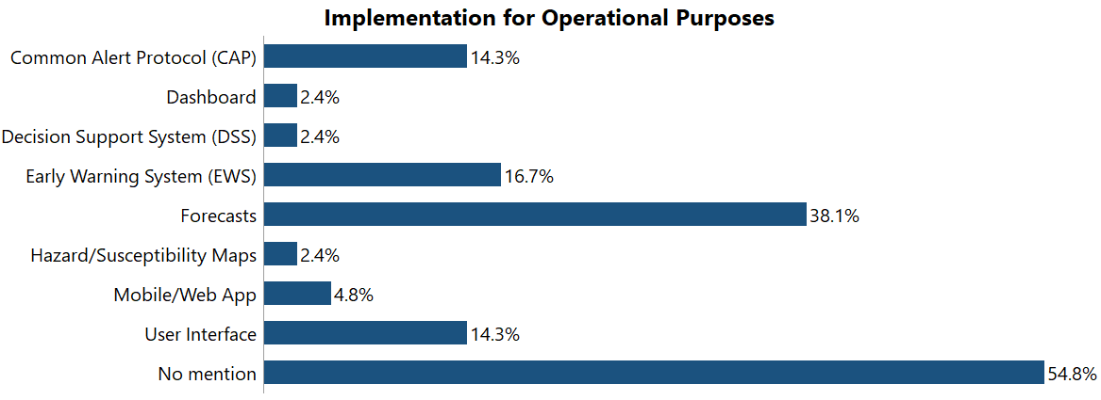
Figure 11 – The standards containing a reference to operational implementation of AI
Figure 11demonstrates how common these terms were in the standards database. The most common method of implementation was in forecasts, followed by a similar number of references to early warning systems (EWS), Common Alert Protocol (CAP), and user interfaces. Dashboards, decision support systems (DSS), and hazard/susceptibility maps were least frequently mentioned. Still, a majority of current standards do not reference any of the implementation methods that were sought.

8 Outlook
The analysis of standards reveals the following trends. Most past or present activities are related to supporting response/relief and recovery with a focus on natural disasters of geophysical and hydrological origins. The most prominent technology is IoT and there is a bias towards data collection through remote sensing. Although data standards were elusive, considerations related to data storage and privacy were present. In terms of modelling, scalability and validation were common terms, as well as supervised (as opposed to unsupervised) learning approaches. At the operational implementation stage, forecasts dominated the standards.
In terms of gaps – and how they relate to the activities of the Focus Group on AI for Natural Disaster Managements – it is observed that existing standards neglect earlier phases of the disaster management cycle, certain types of natural hazards (e.g., biologic), and man-made hazards. In this context, FG-AI4NDM is contributing to the standardization landscape through focusing on earlier phases of the disaster management cycle (including preparedness) and through analysis of use cases related to biological hazards (insect plagues and vector-borne diseases). It is also observed that few existing standards consider AI/ML, digital twins, and Big Data, as well as in situ sources of EO. Within the Focus Group, all use cases apply AI/ML in some capacity, several use cases explore digital twins, and many apply Big Data. At the data stage, the lack of standards related to bias and open data can reduce trust in AI-based models. Therefore, the Working Group on Data for AI is exploring both topics in depth. At the modelling stage, standards related to open source and stakeholder inclusion are also needed. The latter is a key factor in the transparency of AI-based models, which is a leitmotif in the Technical Report by the Working Group on AI for Modeling. Finally, with regards to operational implementation, additional standardization activities should target dashboards, decision support systems, and hazard/susceptibility maps; three tools that feature prominently in the Focus Group use cases.

9 Conclusion
The trends and gaps highlighted in this report reveal the importance of close interaction among SDOs and UN bodies to ensure that new standards do not duplicate past or present activities but, rather, contribute where efforts are needed.
This report was able to contextualize that the ongoing activities of FG-AI4NDM (including the three technical reports; on "Data for AI," on "AI for Modeling," and on "AI for Communications") are making an important contribution to the standardization landscape. It also demonstrates that standardization activities within the domain of disaster management must progress to keep up with technological advances and demands. Therefore, this Roadmap should be updated in the coming years to ensure that any future standardization in this domain is of value to the greater community.

Bibliography

[b-Aberdeen] University of Aberdeen: Understanding volcanic eruptions with thermal imaging
https://www.abdn.ac.uk/stories/volcanic-eruptions/index.html
[b-Adamopoulou] Adamopoulou, E. and Moussiades, L. (2020) Chatbots: History, technology, and applications. https://doi.org/10.1016/j.mlwa.2020.100006
[b-Bevilacqua] Bevilacqua, A., Pitman, E.B., Patra, A., Neri, A., Bursik, M. and Voight, B. (2019) Probabilistic Enhancement of the Failure Forecast Method Using a Stochastic Differential Equation and Application to Volcanic Eruption Forecasts. Front. Earth Sci. 7, 135 https://doi.org/10.3389/feart.2019.00135
[b-Booysen] Booysen, R., Gloaguen, R., Lorenz, S., Zimmermann, R., Nex, P. A. M. (2021). Geological Remote Sensing. Ed. Alderton, D. and Elias, S.A. Encyclopedia of Geology (2nd Ed.), Academic Press.
[b-Copernicus] Copernicus (n.d.) Data and Information Access Services. https://www.copernicus.eu/en/access-data/dias
[b-Cramer] Cramer, J.S. (1986). Econometric Applications of Maximum Likelihood Methods. New York, NY: Cambridge University Press
[b-Data-Europa] European Commission, Data (n.d.) What is open data? https://data.europa.eu/elearning/en/module1/#/id/co-01
[b-DestinE] European Commission (n.d.) Destination Earth https://digital-strategy.ec.europa.eu/en/policies/destination-earth
[b-DG-ECHO-1] European Commission, Directorate-General for European Civil Protection and Humanitarian Aid Operations (ECHO) (2021) Guidance Note. Disaster Preparedness. https://reliefweb.int/report/world/dg-echo-guidance-note-disaster-preparedness-2021
[b-DG-ECHO-2] European Commission, Directorate-General for European Civil Protection and Humanitarian Aid Operations (ECHO) (2017) Overview of natural and man-made disaster risks the European Union may face. https://data.europa.eu/doi/10.2795/861482
[b-DOI] DOI (2019) DOI Handbook - Introduction. https://www.doi.org/doi_handbook/1_Introduction.html
[b-EPRS-1] European Parliamentary Research Service (2020) European framework on ethical aspects of artificial intelligence, robotics and related technologies. https://www.europarl.europa.eu/RegData/etudes/STUD/2020/654179/EPRS_STU(2020)654179_EN.pdf
[b-EPRS-2] European Parliamentary Research Service (2020) The impact of the General Data Protection Regulation (GDPR) on artificial intelligence. https://www.europarl.europa.eu/RegData/etudes/STUD/2020/641530/EPRS_STU(2020)641530_EN.pdf
[b-ESRI] ESRI (n.d.) What is GIS? https://www.esri.com/en-us/what-is-gis/overview
[b-FEMA] FEMA (n.d.) Emergency Management in the United States. Livestock in Disasters Unit 4 https://training.fema.gov/emiweb/downloads/is111_unit%204.pdf
[b-GEO] Group on Earth Observations. FAQ. https://www.earthobservations.org/g_faq.html
[b-Gonzalez] Gonzalez, A.R. and Datcu, M. (2011) Data Cleaning: Approach for Earth Observation Image Information Mining. ESA-EUSC-JRC Conference, Ispra, Italy. pp.117-120
[b-Hinton] Hinton, G. (2009) Deep belief networks. Scholarpedia 4, 5, 5947
[b-IBM-1] IBM (n.d.) What is a digital twin? https://www.ibm.com/topics/what-is-a-digital-twin
[b-IBM-2] IBM (n.d.) What is edge computing? https://www.ibm.com/cloud/what-is-edge-computing
[b-IBM-3] IBM (n.d.) What is data governance? https://www.ibm.com/topics/data-governance
[b-ID4D] Identification 4 Development (2022) Data standards. https://id4d.worldbank.org/guide/data-standards
[b-IFRC] IFRC (n.d.) What is a disaster? https://www.ifrc.org/our-work/disasters-climate-and-crises/what-disaster
[b-ISDR] UN International Strategy for Disaster Reduction (2007) Hyogo Framework for Action 2005-2015: Building the Resilience of Nations and Communities to Disasters. https://www.unisdr.org/files/1037_hyogoframeworkforactionenglish.pdf
[b-ISO-1] International Organization for Standardization (2014) ISO/IEC 17788:2014: Information technology—Cloud computing—Overview and vocabulary. https://www.iso.org/standard/60544.html
[b-ISO-2] International Organization for Standardization (2015) ISO/IEC 2382:2015 Information technology – Vocabulary. https://www.iso.org/standard/63598.html
[b-JRC] Joint Research Centre (n.d.) Natural and man-made hazards. https://joint-research-centre.ec.europa.eu/scientific-activities-z/natural-and-man-made-hazards_en
[b-Khekale] Khekale, A. (2021) Machine learning/Artificial Intelligence on IBM I https://www.anandk.dev/2021/02/Machine-learning-on-ibmi.html
[b-Kuglitsch] Kuglitsch, M.M., Pelivan, I., Ceola, S. et al. (2022) Facilitating adoption of AI in natural disaster management through collaboration. Nat Commun 13, 1579
[b-Lin] Lin, J.-T. et al. (2021) Early warning for great earthquakes from characterization of crustal deformation patterns with deep learning. J. Geophys. Res. Solid Earth 126, e2021JB022703
[b-Marti] Marti, A. (2021) Methodology for Windstorm and Hailstorm Hazard Modelling and Mapping for Georgia. Decision B.19/12 Scaling-up a Multi-Hazard Early Warning System and the Use of Climate Information in Georgia. United Nations Development Programme.
[b-MeteoSwiss] MeteoSwiss (n.d.) Measurement Instruments. https://www.meteoswiss.admin.ch/weather/measurement-systems/land-based-stations/automatic-measurement-network/measurement-instruments.html
[b-Michael] Michael, K., and Miller, K.W. (2013) Big Data: New Opportunities and New Challenges [Guest Editors' Introduction] Computer 46, 6, pp. 22–24
[b-Nature] Early forecasting of tsunami inundation from tsunami and geodetic observation data with convolutional neural networks
https://www.nature.com/articles/s41467-021-22348-0
[b-NRC-1] Natural Resources Canada (n.d.) Passive vs. Active Sensing. https://www.nrcan.gc.ca/maps-tools-publications/satellite-imagery-air-photos/remote-sensing-tutorials/introduction/passive-vs-active-sensing/14639
[b-NRC-2] Natural Resources Canada (n.d.) Thermal Imaging. https://www.nrcan.gc.ca/maps-tools-and-publications/satellite-imagery-and-air-photos/tutorial-fundamentals-remote-sensing/satellites-and-sensors/thermal-imaging/9319
[b-OECD] OECD (2022) Transparency and explainability (Principle 1.3) https://oecd.ai/en/dashboards/ai-principles/P7
[b-OGC-1] Open Geospatial Consortium (2022) https://www.ogc.org/about
[b-OGC-2] Open Geospatial Consortium (2022) Geography Markup Language. https://www.ogc.org/standards/gml
[b-OGC-3] Open Geospatial Consortium (2022) Keyhole Markup Language. https://www.ogc.org/standards/kml
[b-OGC-4] Open Geospatial Consortium (2021) Sample Markup Language for Artificial Intelligence Machine Learning (SampleML-AI/ML) - Standards Working Group Charter. https://portal.ogc.org/files/97072
[b-Orora] Orora Technologies (n.d.) Wildfire Solution. https://ororatech.com/wildfire-solution/
[b-Patel] Patel, A.B., Birla, M., Nair, U. (2012) Addressing big data problem using Hadoop and Map Reduce, in: 2012 Nirma University International Conference on Engineering, NUiCONE, pp. 1–5
[b-PNSN] PNSN (n.d.) Hazard Maps. https://pnsn.org/outreach/hazard-maps-and-scenarios/hazard-maps
[b-Rao] Rao, C.R. & Govindaraju, V. (eds.) (2013) Handbook of Statistics Volume 31
[b-SentinelOne] Sentinel One Blog (2020) Data Visibility: A Guide to the What, Why, and How. https://www.sentinelone.com/blog/data-visibility/
[b-SNIA] SNIA (2022) What is Data Privacy? https://www.snia.org/education/what-is-data-privacy
[b-Sun] Sun, W., Bocchini, P. & Davison, B.D. (2020) Applications of artificial intelligence for disaster management. Nat Hazards 103, pp. 2631–2689
[b-Techopedia-1] Techopedia (n.d.) What Does Data Ownership Mean? https://www.techopedia.com/definition/29059/data-ownership
[b-Techopedia-2] Techopedia (2022) Explainable Artificial Intelligence (xAI) https://www.techopedia.com/definition/33240/explainable-artificial-intelligence-xai
[b-Techopedia-3] Techopedia (2017) https://www.techopedia.com/definition/9269/scalability
[b-Thüring] Thüring, T. et al. (2015) Robust snow avalanche detection using supervised machine learning with infrasonic sensor arrays. Cold Reg. Sci. Technol. 111, pp. 60–66
[b-Tseng] Tseng, T., Stent, A., & Maida, D. (2020). Best Practices for Managing Data Annotation Projects. BloomBerg. arXiv preprint arXiv:2009.11654.
[b-UNDP-1] UNDP (2018) Five approaches to build functional early warning systems. https://www.adaptation-undp.org/resources/manual/five-approaches-build-functional-early-warning-systems
[b-UNDP-2] Windstorm and Hailstorm Hazard Methodology for Modelling and Mapping for Georgia
[b-UNDRR] UNDRR (n.d.) Response. https://www.undrr.org/terminology/response
[b-UNESCO] UNESCO (2022) Recommendation on the Ethics of Artificial Intelligence. https://unesdoc.unesco.org/ark:/48223/pf0000381137
[b-UN-GGIM] UN Global Geospatial Information Management (2018) E/C.20/2018/7/Add.1 ; ANNEX 1 - Minimum list of global fundamental geospatial data themes. https://ggim.un.org/documents/E-C20-2018-7-Add_1-Global-fundamental-geospatial-data-themes.pdf
[b-UNOSAT] UNOSAT Flood AI Dashboards for Nepal: The creation of a one-stop-shop for real-time evidence-based decision-making
https://nepal.un.org/en/158756-unosat-floodai-dashboards-nepal-creation-one-stop-shop-real-time-evidence-based-decision
[b-UN-SPIDER] UN-SPIDER (n.d.) Risks and Disasters. https://www.un-spider.org/risks-and-disasters
[b-USGS] USGS (n.d.) Seismometers, seismographs, seismograms - what's the difference? How do they work? https://www.usgs.gov/faqs/seismometers-seismographs-seismograms-whats-difference-how-do-they-work
[b-van-Otterlo] van Otterlo, M. & Wiering, M. (2012) Reinforcement learning and markov decision processes. Reinforcement Learning. Adaptation, Learning, and Optimization. Vol. 12. pp. 3–42.
[b-Vert] Vert, G. and Nasser, S. (2007) Spatial Data Authentication Using Mathematical Visualization. https://www.cse.unr.edu/~fredh/papers/journal/17-sdaumv/paper.pdf
[b-WEF] World Economic Forum (2022) A Blueprint for Equity and Inclusion in Artificial Intelligence. https://www3.weforum.org/docs/WEF_A_Blueprint_for_Equity_and_Inclusion_in_Artificial_Intelligence_2022.pdf
[b-West] West, J., Ventura, D., Warnick, S. (2007) Spring Research Presentation: A Theoretical Foundation for Inductive Transfer. Brigham Young University, College of Physical and Mathematical Sciences. Archived from the original on 2007-08-01. Retrieved 2007-08-05
[b-Zhang] Zhang, D., Zhang, Y., Li, Q., Plummer, T., and Wang, D. (2019) CrowdLearn: A Crowd-AI Hybrid System for Deep Learning-based Damage Assessment Applications. IEEE 39th International Conference on Distributed Computing Systems (ICDCS) pp. 1221-1232
[b-Zhou] Zhou,Y., Liu,W., Bi,H., Chen,R., Zong,S., Youqing Luo (2022) Special Issue Prevention and Control of Forest Diseases: A Detection Method for Individual Infected Pine Trees with Pine Wilt Disease Based on Deep Learning

Annex 1
Lists of SDOs and related groups

SDO/Organization | Description
Asia-Pacific Telecommunity Standardization Program (ASTAP) | The Asia-Pacific Telecommunity (APT) Standardization Program (ASTAP) was formed in 1998 in order to establish regional cooperation on standardization among APT Members and to contribute to global standardization activities. It is one of the major APT Work Program in the Area of Standardization and Technology Development. Over the years, ASTAP has matured to fulfil its objectives and has become a regional platform for cooperative standardization activities. Currently, ASTAP is working on many important areas related to standardization and technology development. Among those are Bridging Standardization Gap, Green ICT, EMF Exposure, M2M, Future Network, NGN, Seamless Access Communication, Multimedia Applications, Information Security, SNLP and Accessibility and Usability. Recently, ASTAP has included the issues of Conformance and Interoperability (C&I) in its activities.  Source: https://www.apt.int/APTASTAP
European Telecommunications Standards Institute (ETSI) | ETSI provides members with an open, inclusive and collaborative environment. This environment supports the timely development, ratification and testing of globally applicable standards for ICT-enabled systems, applications and services.  Source: https://www.etsi.org/standards#Pre-defined%20Collections
International Electrotechnical Commission (IEC) | The IEC is a global, not-for-profit membership organization, whose work underpins quality infrastructure and international trade in electrical and electronic goods. Our work facilitates technical innovation, affordable infrastructure development, efficient and sustainable energy access, smart urbanization and transportation systems, climate change mitigation, and increases the safety of people and the environment.  Source: https://iec.ch/
Institute of Electrical and Electronics Engineers (IEEE) | IEEE is the world's largest technical professional organization dedicated to advancing technology for the benefit of humanity. IEEE and its members inspire a global community through its highly cited publications, conferences, technology standards, and professional and educational activities.  Source: https://www.ieee.org/
International Organization for Standardization (ISO) | ISO is an independent, non-governmental international organization with a membership of 167 national standards bodies. Through its members, it brings together experts to share knowledge and develop voluntary, consensus-based, market relevant International Standards that support innovation and provide solutions to global challenges.  Source: https://www.iso.org/
ITU Radiocommunication Sector (ITU-R) | ITU-R plays a vital role in the global management of the radio-frequency spectrum and satellite orbits - limited natural resources which are increasingly in demand from a large and growing number of services such as fixed, mobile, broadcasting, amateur, space research, emergency telecommunications, meteorology, global positioning systems, environmental monitoring and communication services - that ensure safety of life on land, at sea and in the skies.  Source: https://www.itu.int/en/ITU-R/
ITU Telecommunication Standardization Sector (ITU-T) | The Study Groups of ITU's Telecommunication Standardization Sector (ITU-T) assemble experts from around the world to develop international standards known as ITU-T Recommendations which act as defining elements in the global infrastructure of information and communication technologies (ICTs).  Source: https://www.itu.int/en/ITU-T/
Open Geospatial Consortium (OGC) | The Open Geospatial Consortium (OGC) is an international consortium of more than 500 businesses, government agencies, research organizations, and universities driven to make geospatial (location) information and services FAIR - Findable, Accessible, Interoperable, and Reusable.  Source: https://www.ogc.org/

SDO/Organization | Related Group | Description
ASTAP | Expert Group on Disaster Risk Management Relief System (EG DRMRS) | This Group aims to:  – Study and discuss about future activities and related work items for strengthening and dissemination of information and communication solutions for management of emergency and disaster risk, based on the APT recommendations and other information and communication solutions  – Collaborate and cooperate with ITU  – Promote specific action items for strengthening and dissemination of information and communication solutions for management of emergency and disaster risk  – Study and compare other standardizations which are related to information and communication solutions for management of emergency and disaster risk  Source: https://www.apt.int/ASTAP-DRMRS
ETSI | Technical Committee Emergency Telecommunication (EMTEL) | The TC EMTEL is responsible for the capture of European requirements concerning emergency communication services, covering typically the four scenarios in case of an emergency e.g. communication of citizens with authorities, from authorities to citizens, between authorities and amongst citizens. In addition, EMTEL deals with topics like location (e.g. Advanced Mobile Location), NG112 opening emergency services communications to data, video and text, communications involving IoT devices in emergency situations and alerting.  Source: https://www.etsi.org/committee/emtel
ITU-R | SG5 – Terrestrial services | Scope of the Group includes systems and networks for fixed, mobile, radiodetermination, amateur and amateurs satellite services.  Source: https://www.itu.int/dms_pub/itu-r/opb/gen/R-GEN-SGB-2020-PDF-E.pdf#page=36&pagemode=none
 | SG6 – Broadcasting service | Scope of the Group includes radiocommunication broadcasting, including vision, sound, multimedia and data services principally intended for delivery to the general public.  Source: https://www.itu.int/dms_pub/itu-r/opb/gen/R-GEN-SGB-2020-PDF-E.pdf#page=36&pagemode=none
 | SG7 – Science Services | Scope includes:  – Systems for space operation, space research, Earth exploration and meteorology, including the related use of links in the inter-satellite service.  – Systems for remote sensing, including passive and active sensing systems, operating on both ground-based and space-based platforms.  – Radio astronomy and radar astronomy.  – Dissemination, reception and coordination of standard-frequency and time-signal services, including the application of satellite techniques, on a worldwide basis.  Source: https://www.itu.int/dms_pub/itu-r/opb/gen/R-GEN-SGB-2020-PDF-E.pdf#page=36&pagemode=none
ITU-T | SG2 – Operational aspects of service provision and telecommunication management | ITU-T Study Group 2 is responsible for studies relating to:  – continued deployment of numbering, naming, addressing and identification (NNAI) requirements and resource assignment, including criteria and procedures for reservation, assignment and reclamation;  – evolution of and specification of use of NNAI requirements and resource assignment, including criteria and procedures for reservation, assignment and reclamation for future telecommunication/ICT architectures, capabilities, technologies, applications and services;  – principles of administering global NNAI resources;  – principles and operational aspects of routing, interworking, number portability and carrier switching;  – principles of service provision, definition and operational requirements for current and future telecommunication/ICT architectures, capabilities, technologies, applications and services;  – operational and management aspects of networks, including network traffic management, designations and transport-related operations procedures;  – operational aspects of interworking between traditional telecommunication networks and evolving and emerging telecommunication/ICT architectures, capabilities, technologies, applications and services;  – evaluation of feedback from operators, manufacturing companies and users on different aspects of network operation;  – management of future telecommunication/ICT architectures, capabilities, technologies, applications and services;  – evolution of the management interface specification methodology;  – specifying interfaces to management systems to support the communication of identity information within or between organizational domains; and  – the operational impact of the Internet, convergence (services or infrastructure) and future services, such as over-the-top (OTT), on international telecommunication services and networks.  Source: https://www.itu.int/en/ITU-T/studygroups/2022-2024/02/Pages/default.aspx
ITU-T | SG5 – EMF, environment, climate action, sustainable digitalization, and circular economy | ITU T Study Group 5 is responsible for the development of standards on the environmental aspects of ICT and digital technologies and protection of the environment, including electromagnetic phenomena and climate change.  Study Group 5 will study how the digital transformation can be shaped to ensure it supports transitions towards more sustainable societies.  Study Group 5 will also study issues related to resistibility, human exposure to electromagnetic fields (EMF), circular economy, energy efficiency and climate change adaptation and mitigation. It will develop international standards, guidelines, technical papers and assessment frameworks that support the sustainable use and deployment of ICTs and digital technologies, and evaluate the environmental performance, including biodiversity, of digital technologies such as, but not limited to, 5G, artificial intelligence (AI), smart manufacturing, automation, etc.  Source: https://www.itu.int/en/ITU-T/studygroups/2022-2024/05/Pages/default.aspx
ITU-T | SG11 – Signalling requirements, protocols, test specifications and combating counterfeit telecommunication/ICT devices | ITU-T Study Group 11 (SG11) is responsible for signalling, producing international standards (ITU-T Recommendations) that define how telephone calls and other ICT services are handled in the network.  Source: https://www.itu.int/en/ITU-T/studygroups/2022-2024/11/Pages/default.aspx
ITU-T | SG13 – Future networks and emerging network technologies | The international standards (ITU-T Recommendations) developed by ITU‑T Study Group 13 (SG13) address the requirements, architectures, functional capabilities and application programming interfaces of converged future networks. Key areas of focus include network softwarization and orchestration, information-centric networking, content-centric networking, and the application of machine learning technologies.  Source: https://www.itu.int/en/ITU-T/studygroups/2022-2024/13/Pages/default.aspx
ITU-T | SG15 – Networks, technologies and infrastructures for transport, access and home | The international standards (ITU-T Recommendations) developed by Study Group 15 detail technical specifications giving shape to global communication infrastructure. The group's standards define technologies and architectures of optical transport networks enabling long-haul global information exchange; fibre- or copper-based access networks through which subscribers connect; and home networks connecting in-premises devices and interfacing with the outside world.  Source: https://www.itu.int/en/ITU-T/studygroups/2022-2024/15/Pages/default.aspx
ITU-T | SG16 – Multimedia and related digital technologies | ITU-T Study Group 16 is responsible for studies relating to ubiquitous multimedia applications, multimedia capabilities, multimedia services and multimedia applications for existing and future networks. This encompasses information and communication technologies (ICTs) for multimedia systems, applications, terminals and delivery platforms; accessibility for digital inclusion; ICTs for active assisted living; human interfaces; multimedia aspects of distributed ledger technologies; media and signal coding and systems; and digital multimedia services in various verticals (health, culture, mobility, etc.).
ITU-T | SG20 – Internet of Things (IoT) and smart cities and communities | ITU-T Study Group is the lead on  – Internet of Things and its applications  – smart cities and communities and related digital services  – Internet of Things identification  – digital health related to Internet of Things and smart cities and communities  Source: https://www.itu.int/en/ITU-T/studygroups/2022-2024/20/Pages/default.aspx
ITU-T | Focus Group on Smart Sustainable Cities (FG-SSC) | The FG-SSC acted as an open platform for smart-city stakeholders – such as municipalities; academic and research institutes; non-governmental organizations (NGOs); and ICT organizations, industry forums and consortia – to exchange knowledge in the interests of identifying the standardized frameworks needed to support the integration of ICT services in smart cities.  Source: https://www.itu.int/en/ITU-T/focusgroups/ssc/Pages/default.aspx
___________________

For instance, [ITU-T Q.5050].
ITU-T SG2, ITU-T SG5, ITU-T SG11, ITU-T SG13, ITU-T SG16, ITU-T SG20, ITU-T JCA-AHF, ITU-T JCA-IoT, ITU-T SC&C, ITU/WHO FG-AI4H, and ITU-T FG-AI4EE; ITU-D SG1 and ITU-D SG2; ITU-R SG5 and ITU-R SG7; ISO TC292; ETSI EMTEL; IEC Syc Smart Cities; and ETC) and UN bodies (i.e., WMO, UN Environment, UNHCR, IOM, UNDRR, UNFCCC, World Bank, UNOOSA, and UN GGIM.
https://www.surveymonkey.de/r/T2SZ5RX
Out of the 45 standards collected, 42 were a part of the analysis as the remaining three were not publicly made available.
Those accompanied by an asterisk (*) were included in the analysis.
A use case entitled "Unified Methodology for Windstorm and Hailstorm Hazard Modeling and Mapping" was submitted to FG-AI4NDM from Mitiga Solutions. The use-case was included under the Topic Group-AI for Hail and Windstorm Hazard Mapping
A use case entitled "Identification and Classification of Pest Infested Coniferous Forest Using AI" from Yamagata University was submitted to FG-AI4NDM. The use-case was included under the Topic Group-AI for Insect Plague Monitoring and Detection.
A use case entitled "Towards Forecasting Eruptions Using Machine Learning of Volcano Seismic Data" from Institut des Sciences de la Terre and University of Michigan. The use-case was included under the Topic Group-AI for Volcanic Eruption Forecasting.
A use case entitled "Using ML to Reconstruct Flooded Area under Clouds in Optical Satellite Images: The Mozambique Use Case" from RSS Hydro was submitted to FG-AI4NDM. The use-case was included under the Topic Group-AI for Flood Monitoring and Detection.
A use case entitled "Enabling Natural Hazards Risk Information Sharing Using Derived Products of Export-Restricted Real-Time GNSS Data for Detection of Ionospheric Total Electron Disturbances" from NASA Jet Propulsion Laboratory was submitted to FG-AI4NDM. The use-case was included under the Topic Group-AI for Geodetic Enhancements to Tsunami Monitoring and Detection.
FG-AI4NDM is developing a Technical Report on "AI for Modeling."
A use case entitled "An Intelligent Big Data Analysis System for Wildfire Management" from China Academy of Information and Communications was submitted to FG-AI4NDM. The use-case was incorporated within Topic Group-AI for Wildfire Monitoring and Detection.
FG-AI4NDM is developing the Technical Report on "Data for AI."
A use case entitled "Multimodal Databases and Artificial Intelligence for Airborne Wildfire Detection and Monitoring" from Universidade de Lisboa, University of Coimbra was submitted to FG-AI4NDM. The use-case was incorporated within Topic Group-AI for Wildfire Monitoring and Detection.
A use case entitled "Utilizing AI & Probabilistic Modeling for Strategic Resilience" from One Concern was submitted to FG-AI4NDM. The use-case was incorporated within Topic Group-AI for Multihazard Communications Technologies.
A use case entitled "Flash Flooding Monitoring System in Mexico" from Instituto Tecnológico de Colima and University of Colima was submitted to FG-AI4NDM. The use-case was included under the Topic Group-AI for Flood Monitoring and Detection.
A use case entitled "Earthquake Disaster Mitigation through AI on Smart Seismic Networks" from QuakeSaver. The use-case was incorporated within Topic Group-AI for Earthquake Monitoring, Detection, and Forecasting.
Please note the distinction between the acronym ML referring to machine learning and SampleML, where ML refers to markup language.
FG-AI4NDM is developing a Technical Report on "AI for Communications."
A use case entitled "Probing Seismogenesis for Fault Slip and Earthquake Hazards" from Los Alamos National Laboratory was submitted to FG-AI4NDM.
As shown in the Focus Group use case entitled "Unified Methodology for Windstorm and Hailstorm Hazard Modeling and Mapping" from Alejandro Marti.
As shown in the Focus Group use case entitled "AI Enabled Citizen-centric Decision Support System for Disaster Managers" from Rajkumar Upadhyay, Pankaj Kumar Dalela, Saurabh Basu, Sandeep Sharma, and Anugandula Naveen Kumar.
As shown in the Focus Group use case entitled "Multi-hazard Use Case for Operations Risk Insights and Day One Relief for Natural Disaster Response" from Jil Christensen, Tom Ward, Chet Karwatowski, and Rinku Kanwar.
As shown in the Focus Group use case entitled "Proposal of an AI Chatbot Use Case as a Multihazard Communication Technologies" from Kiyonori Ohtake, Toshiaki Kuri, Tsutomu Nagatsuma, Masugi Inoue, and Hideo Imanaka.
Multistakeholder inclusion, meanwhile, is something that FG-AI4NDM explored in detail in a recent publication

