|  |  |  |  |  |
| --- | --- | --- | --- | --- |
|  | **国 际 电 信 联 盟**  **电信标准化局** |  |  |  |

2017年7月21日，日内瓦

|  |  |  |
| --- | --- | --- |
| 文号： | **电信标准化局第2/16号集体函** | 致：   * 国际电联各成员国主管部门， * ITU-T部门成员， * 参加第16研究组工作的ITU-T部门准成员和 * 国际电联学术成员 |
| 电话： | +41 22 730 6805 |
| 传真： | +41 22 730 5853 |
| 电子邮件： | [tsbsg16@itu.int](mailto:tsbsg16@itu.int) |  |

|  |  |
| --- | --- |
| 事由： | **第16研究组的会议； 2017年10月16日 – 27日，中国澳门** |

尊敬的先生/女士：

我高兴地通知您，第16研究组（多媒体编码、系统和应用）应中华人民共和国澳门会展协会的邀请，将于2017年10月16日至27日（含）在中国澳门召开会议。

在此期间，若干其他会议也将同期同地举行，具体有视频编码联合协作团队（JCT-VC）和视频联合专家组（JVET）、ISO/IEC JTC1 SC29 WG1（JPEG）和WG11（MPEG）以及关于电子服务多媒体方面的联合协调活动。请注意，上述各项会议均与第16研究组的会议分开单独注册。

我谨通知您，第一天的会议将于**11时15分**开始。与会者的注册工作将自8时30分起在会议入口处开始。有关会议厅安排的具体信息将通过第16研究组的电子邮件通讯录散发，而且主办方将在现场展示通知。有关该会议的更多信息见本函**附件A**，实用信息见**附件D**。除此附件中的信息外，主办方已设置网站，帮助代表为此会议进行准备：参见<http://itutsg16.medmeeting.org>。

会议**议程**草案和**时间表**草案经第16研究组主席（罗忠先生，中华人民共和国）及其管理团队同意制定，分别载于**附件B**和**C**。

第16研究组会议期间可能组织小型讲习班，探讨例如“沉浸式”业务等内容。更多具体信息将在第16研究组网站上提供（<http://itu.int/go/tsg16>）。

祝您与会顺利且富有成效！

|  |  |
| --- | --- |
| 顺致敬意！  电信标准化局主任 李在摄 | This QR code redirects to the latest meeeting information at: http://handle.itu.int/11.1002/groups/sg16 ITU-T SG16 |
| 最新会议信息 |

**附件：**4件

**附件A**

提交文稿

**提交文稿的截止日期：**提交文稿的截止日期为会议召开日的12个日历日之前。此类文稿将在第16研究组的网站上发布，因而必须在**2017年10月3日之前**寄达电信标准化局。在会议开始日至少**两**个月之前收到的文稿可以应要求予以翻译。

**文稿直发/提交**：现已在网上设置了一个文稿直发系统。该系统方便ITU-T成员预留文稿号，并直接将文稿上传至ITU-T的网络服务器或直接进行修改。有关文稿直发系统的进一步信息和指南见以下网址：<http://itu.int/net/ITU-T/ddp/>。

**模板：**请使用提供的一套模版起草您的会议文稿。这些模版可以在ITU-T各研究组网页中的“代表资源”（Delegate resources）（[http://itu.int/ITU-T/studygroups/templates](http://www.itu.int/ITU-T/studygroups/templates/index.html)）处找到。应在所有文件的首页上注明文稿联系人的姓名、传真号码和电话号码以及电邮地址。

**工作方法与设施**

**口译服务**：根据与ITU-T第16研究组管理团队达成的一致意见，此次会议仅以英文进行。

**无纸会议：**会议将为无纸化会议。

**无线局域网**设施：将在会场提供，供代表使用。

**打印机：**将在会场提供，供代表使用。

**注册和与会补贴**

**注册：**为便于主办方做出必要安排，请您通过信函、传真（+41 22 730 5853）或电子邮件（[tsbreg@itu.int](mailto:tsbreg@itu.int)）的方式在**2017年9月16日之前**将代表贵主管部门、部门成员、部门准成员、学术机构、区域性组织和/或国际组织或其它实体出席会议的人员名单发至我处。同时亦请各主管部门注明其代表团团长的姓名（如果有副团长，亦盼一并注明）。

**请注意，ITU-T会议的与会者只能通过[ITU‑T第16研究组网页](http://itu.int/go/tsg16)进行网上预注册**。

**与会补贴：**我们高兴地通知您，为促进[最不发达国家或低收入国家](http://www.itu.int/en/ITU-T/info/Documents/list-ldc-lic.pdf)代表与会，国际电联视可用资金情况，可以向每相关主管部门提供两份非全额与会补贴。请进一步注意，若申请两（2）份非全额与会补贴，至少一份必须是经济舱机票。申请与会补贴时必须得到相关国际电联成员国主管部门的授权。与会补贴申请表（请使用所附**表1**）必须在**2017年9月4日**之前填妥并交回国际电联。请注意，决定是否颁发与会补贴的标准包括：电信标准化局的可用预算情况；申请人向会议提交文稿的情况；国家与区域间的公平分配；性别平衡。参会必须进行预注册。

**（会前）重要截止日期**

|  |  |  |
| --- | --- | --- |
| 两个月前 | 2017-08-16 | – 提交需翻译的文稿  – 要求提供无障碍服务设施  – 要求提供签证协办函 |
| 六个星期前 | 2017-09-04 | – 申请与会补贴 |
| 一个月前 | 2017-09-16 | – 预注册（通过研究组主页在线进行） |
| 12个日历日前 | 2017-10-03 | – 提交文稿的最后截止日期 |

**FORM 1 - FELLOWSHIP REQUEST**

|  |  |  |  |  |  |
| --- | --- | --- | --- | --- | --- |
|  | **Meeting of ITU-T Study Group 16 (Macao, China, 16-27 October 2017)**  Request for one partial fellowship  (Submission deadline: **4 September 2017**) | | | |  |
| Please return completed form, preferably by email, to: ITU Fellowships, Geneva (Switzerland) | | | E-mail: [fellowships@itu.int](mailto:fellowships@itu.int) Tel: +41 22 730 5227 Fax: +41 22 730 5778 | | |
| **Applications from women are encouraged** | | | | | |
| Registration number (required): (Pre-registration is [online only](http://itu.int/go/tsg16)) | |  | | | |
| Title(s) of contributions submitted/planned: | |  | | | |
| Country ([list of eligible countries](http://www.itu.int/en/ITU-D/LDCs/Pages/List_LDCs.aspx)): | |  | | | |
| Name of the Administration/Organization: | |  | | | |
| Professional role/title: | |  | | | |
| Mr/Mrs/Ms: | |  | | | |
| Applicant’s family name: | |  | | | |
| Applicant’s given name: | |  | | | |
| Address: | |  | | | |
| Telephone: | |  | | | |
| Fax: | |  | | | |
| Email: | |  | | | |
| Passport number: | |  | | | |
| Date and place of issue: | |  | | | |
| Passport valid until (date): | |  | | | |
| Nationality: | |  | | | |
| Date of birth: | |  | | | |
| Please select your preferred fellowship type (one only),  which ITU will do its best to accommodate:  **Economy class air ticket (duty station -> Macao -> duty station)**  **Subsistence allowance intended to cover accommodation, meals & misc. expenses** | | | | | |
| **Signature of applicant:** | | | | **Date:** | |
| TO VALIDATE THIS FELLOWSHIP REQUEST, THE NAME, TITLE AND SIGNATURE OF THE CERTIFYING OFFICIAL DESIGNATING THE PARTICIPANT MUST BE COMPLETED BELOW, ALONG WITH AN OFFICIAL STAMP.  N.B. IT IS IMPERATIVE THAT FELLOWS BE PRESENT FROM THE FIRST TO THE LAST DAY OF THE MEETING. | | | | | |
| **Signature and stamp of certifying official:** | | | | **Date:** | |

**ANNEX B**

**Draft agenda**

|  |  |
| --- | --- |
|  | Opening of meeting, meeting agenda and documentation |
|  | Status of texts consented, agreed, deleted and current list of Implementors guides |
|  | Approval of previous SG16 meeting report (SG16-R1 to R4) |
|  | Feedback and status reports on interim activities and collaboration matters (*inter alia* ITU-T SG9, ITU-T SG12, IETF, IEC TC100, ISO/IEC JTC1/SC 29/WGs 1 & 11, CITS) |
|  | Promotion activities and workshops of interest to SG16 |
|  | Objectives for this meeting |
|  | Guidelines for the meeting of Working Parties and of Plenary Question |
|  | IPR Roll call |
|  | Review and approval of meeting results, including update of SG16 work programme |
|  | Future work |
|  | Date and place of the next meeting of SG16 |
|  | Miscellaneous |
|  | Closing of the meeting |

**ANNEX C**

**Draft Timetable of SG16 meeting (Macao, China, 16-27 October 2017)**

**

**Notes:**

|  |  |
| --- | --- |
|  | "P" stands for plenary. |
|  | Question 1/16, which is allocated to the Plenary, will have sessions as needed during the meeting. |
|  | The Joint Collaborative Team on Video Coding (JCT-VC) is tentatively planned to meet also during the weekend. See <http://itu.int/go/jctvc> for final dates and other details. Sessions of the related but separate informal Joint Video Experts Team (JVET) between ITU-T Q6/16 and ISO/IEC JTC1 SC29/WG11 (MPEG) is expected to start meeting on Wed 18 October 2017, further details will be announced in the [Q6/16 mailing list](https://www.itu.int/en/ITU-T/studygroups/2017-2020/16/Pages/video/vceg.aspx). |

*For schedule updates, please see:* <http://itu.int/go/tsg16>.

**ANNEX D**

**Practical information**

(Please see an updated version of this practical information on the [SG16 website](http://itu.int/go/tsg16).)

## Meeting Venue

**Venue:** Holiday Inn Macao Cotai Central

**Address:** Level 4, Holiday Inn Macao Cotai Central  
 Sands Cotai Central,   
 Cotai Strip, Macao, China

**Tel:** +853 2828 2228

**Website:** <https://www.sandscotaicentral.com/offers/holiday-inn-macao.html>

**Conference Venue Floor Plan**

<https://www.sandscotaicentral.com/content/dam/macao/sandscotaicentral/master/main/home/meetings/floorplans-charts/holidayInn-factsheet-stay-connected_en.pdf>

## Hotels

A block of rooms at preferential prices has been made at the conference hotel:

Holiday Inn Macao Cotai Central  
 Address: Sands Cotai Central, Cotai Strip, Macao, China  
 Tel: +853 2828 2228  
 Hotel Booking System: <http://itutsg16.medmeeting.org/>

**Hotel reservations** will be carried out through the online system above.

Delegates can walk between the hotel and the meeting venue, which only takes less than one minute. Further details will be provided shortly in the logistics information document on the conference website.

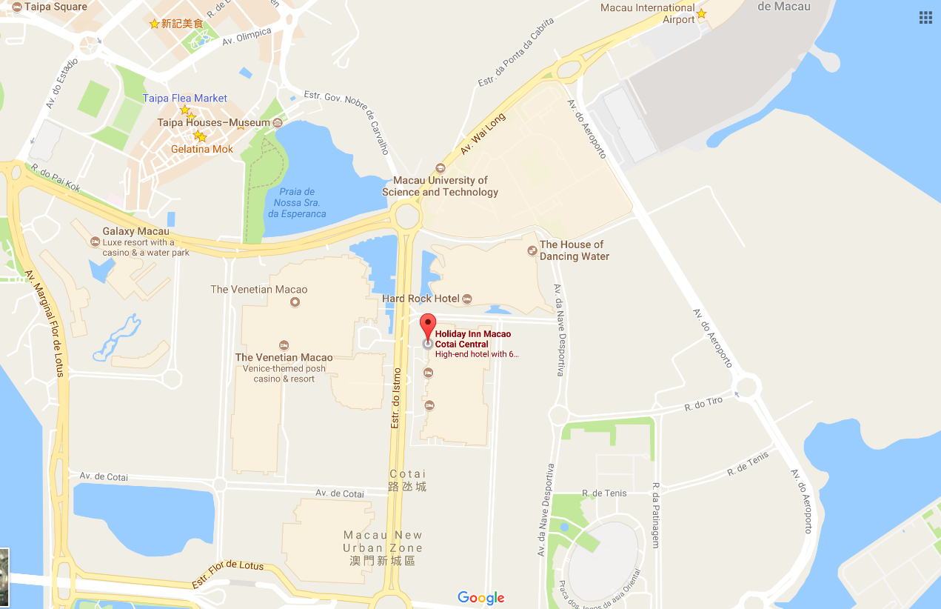

## Passports and Visas

Non-residents of the Macao Special Administrative Region are required to possess a valid passport and "entry permit" or "visa" for entry to Macao, except for people prescribed by certain law, administrative regulation or international law document.

**3.1 DO I NEED A VISA?**  
Visit: <http://www.fsm.gov.mo/psp/eng/EDoN.html> to find out whether you need a visa or not.

* Macao is either visa free or visa-upon-arrival for most countries.
* Only visitors from Bangladesh, Nepal, Nigeria, Pakistan, Sri Lanka and Vietnam are required to apply for a Macao visa in advance through a Chinese embassy or consulate.
* Visitors from mainland China can apply for a Hong Kong Macao Entry Permit to travel to Macao for up to seven days at your local Immigration Authority/Police Bureau. If you need a business visa to stay at Macao for more than seven days, please contact the Conference Secretariat to issue you an invitation letter no later than September 22.

**3.2 INVITATION LETTER**

If you need a letter of invitation, please fill out the [invitation letter form](https://www.medmeeting.org/Upload/user/785821/file/20170715/20170715122804_8527.pdf) available at the following URL and send it as early as possible with a **copy of your travel document** by e-mail to Conference Secretariat at [itutsg16macau@gmail.com](mailto:itutsg16macau@gmail.com), in order to leave plenty of time to process the application. To receive an invitation letter, requests should be submitted before 16 August 2017.

**Invitation letter form:** [https://www.medmeeting.org/Upload/user/785821/file/20170715/‌20170715122804_8527.pdf](https://www.medmeeting.org/Upload/user/785821/file/20170715/20170715122804_8527.pdf)

## Transportation and site information

How to get to Macao:

**4.1 By air**

* **Helicopters**East Asia Airlines and Heli Express Limited co-operates aircraft between the helipads on the Macao and Hong Kong Ferry terminal (Outer Harbour Ferry Terminal).

Hotline:   
Macao (853) 2872 7288  
Hong Kong (852) 2108-9898  
Shenzhen: (86) 755-2777-8333  
Website: [www.heliexpress.com](http://www.heliexpress.com/)

* **Aircraft (Via Macao International Airport)**  
  The airport is located on Taipa Island and is 15 minutes away from the Macao Ferry Terminal, 20 minutes from the Barrier Gate and only 10 minutes away from the COTAI Frontier Post. It operates 24 hours a day.

Hotline  
Macao: (853) 2886 111  
Website: [www.macao-airport.com](http://www.macao-airport.com)

There are approximately a dozen and a half companies flying to and from Macao, connecting to several cities in Mainland China, Korea (Rep. of) and Southeast Asia. For more information on immigration and customs formalities, please visit [www.fsm.gov.mo](http://www.fsm.gov.mo/).

**4.2 By sea (via Hong Kong International Airport)**

* **To and from Hong Kong**Tourists can find quite a number of jetfoils and Catamarans available, run by TurboJET or First Ferry, which differ in speed, comfort and price.
* **TurboJET**   
  Hotline  
  Macao : (853) 87907039  
  Hong Kong: (852) 28593333  
  Shenzhen: (86) (755) 2777 6818  
  Website: [www.turbojet.com.hk](http://www.turbojet.com.hk/)
* **First Ferry**  
  Hotline  
  Macao: (853) 2872 6301  
  Hong Kong: (852) 2131-8181   
  Website: [www.nwff.com.hk](http://www.nwff.com.hk/)
* **Cotai Chu Kong Shipping Management Services Co., Ltd**  
  Hotline  
  Macao: (853) 2885 0595  
  Hong Kong: (852) 2359 9990  
  Website: <http://www.cotaiwaterjet.com/index.html>

The above information is for reference only. For more information, please visit [http://www.macaotourism.gov.mo](http://www.macautourism.gov.mo/).

## 5. Local information

**5.1 Currency exchange**

The Pataca (MOP) is Macao’s official currency. The exchange rate is MOP103.20 = HKD100.00. There is an acceptable variation up to 10%. Roughly 8 Patacas is equivalent to 1 US Dollar. Please check the currency exchange rate in the local bank system or use the following link as a reference: <http://www.xe.com>.

**5.2 Climate**

Annual average temperature is about 23ºC (73ºF) and ranges from 20ºC (68ºF) to 26ºC (79ºF). Humidity levels are high in the city, where the average annual relative humidity tops 79%.October to December is the most pleasant season to visit Macao, when visitors can enjoy warm autumn days with low humidity.

**5.3 Time Zone:** GMT+8:00

**5.4 Electricity**

The electricity in Macao is generally 220V, 50Hz. Please make sure you have the proper adapter.

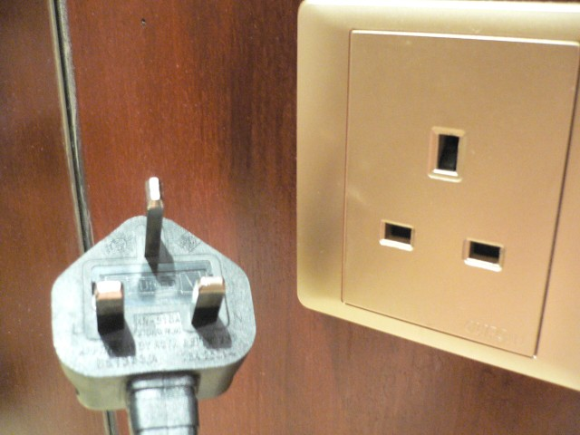

**5.5 Emergency Numbers:** In case of emergency, please dial 999/110/112.

**5.6 Nearest Hospital**

**University Hospital**Block H, Macao University of Science and Technology, Avenida Wai Long, Taipa, Macao  
Tel: (853) 28821838  
Fax: (853) 28821788   
E-mail: [hospital_enquiry@must.edu.mo](mailto:hospital_enquiry@must.edu.mo)

**5.7** If you have any questions about the meeting arrangements, please contact (preferably by e-mail) the **local contact person**:

**Conference Manager**

**Mr Andrew Jiang**  
Macao Convention & Exhibition Association  
Tel: +853 2871 5616  
Fax: +853 2871 5606  
E-mail: [itutsg16macau@gmail.com](mailto:itutsg16macau@gmail.com)  
  
Conference Website: <http://itutsg16.medmeeting.org/en>

__________________