Geneva, 21 January 2014

Telecommunication Standardization
Bureau
Ref:  Tel:  Fax: | TSB Circular 79  COM 12/HO  +41 22 730 6356  +41 22 730 5853 | - To Administrations of Member States of the Union
E-mail: | tsbsg12@itu.int | Copy:  - To ITU-T Sector Members;  - To ITU-T Associates;  - To ITU-T Academia;  - To the Chairman and Vice-Chairmen of Study Group 12;  - To the Director of the Telecommunication Development Bureau;  - To the Director of the Radiocommunication Bureau

Subject: | Study Group 12 calls for participation on first phase of P.NATS, opinion model for estimating audiovisual quality of adaptive streaming type video

Action: | Please announce your provisional intention to participate in the P.NATS development by 7 February 2014 to the  e-mail reflector of Q14/12

Dear Sir/Madam,
1 ITU-T Study Group 12, Question 14/12 aims at accelerating the work on the first phase of P.NATS, opinion model for estimating audiovisual quality of adaptive streaming type video.
2 The call for participation on P.NATS is given in Annex 1 to this Circular.
3 I should be grateful if you could announce your provisional intention to participate in the P.NATS development, not later than 7 February 2014, by email to the Q14/12 reflector (t13sg12q14@lists.itu.int).
4 Any requests for further details or clarification with respect to this call for participation should be sent to the Rapporteurs of Q14/12, Mr Jörgen Gustafsson (jorgen.gustafsson@ericsson.com) and Mr Alexander Raake (alexander.raake@telekom.de) as well as to the Study Group 12 Secretariat (tsbsg12@itu.int).

5 I should like to stress the importance of your participation in this work item as it would help Study Group 12 in its efforts to progress the work of Q14/12.

Yours faithfully,

Malcolm Johnson
Director of the Telecommunication
Standardization Bureau

Annex: 1
ANNEX 1
(to TSB Circular 79)
Call for participation on first phase of P.NATS
Opinion model for estimating audiovisual quality of adaptive streaming type video
Abstract
This Call for Participation is directed to parties who are interested to contribute to a P.NATS model for objective assessment of progressive download and adaptive streaming type video, with focus on adaptive streaming. Those parties are invited to announce their interest in contributing to P.NATS and spending further active development and analysis efforts into the project. Interested parties are expected to announce their interest before 7 February 2014.

Background
The P.1201 series of recommendation has recently been extended with a new Appendix to support progressive download type of video (App. I of Rec. ITU-T P.1201). The next step in Q14/12 model standardization is support for adaptive streaming, aiming at a more comprehensive model that includes the capabilities of P.1201 App. I. This work will be conducted in the new work item P.NATS, aiming at a first Recommendation consented by end of 2014.

P.NATS work item
The P.NATS model will be developed using a dedicated training phase with a jointly developed set of training databases followed by cross-validation using a validation set of databases. In the cross-validation, coefficients of the submitted models will be tuned, and the ideal mix of model components to be determined.
The P.NATS work item is planned to have two tracks. The P.NATS work of Phase 1, Track 1 (until end of 2014) will be carried out targeting a bitstream-based parametric model (payload and/or header information), where the provided information is currently planned to be given as side information (e.g. in case of video given per frame). As such, the first, main track is planned to result in a new recommendation for a parametric objective opinion model for adaptive streaming type video, in a similar fashion as the P.1201 models. In the second, parallel track, a recommendation is being developed which describes how the output of a full-reference video quality estimation model can be used to obtain the pure, shorter-term video quality (probably targeting 5 to 15 sec segments), and which of the existing, standardized models will be most suitable for that.
The building blocks of the P.NATS model are shown in Figure 1 below:
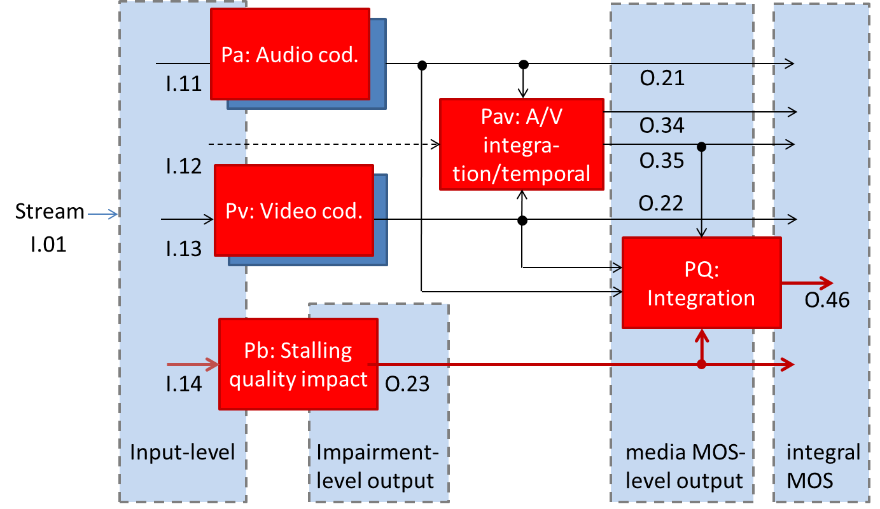

Figure 1: Building blocks of the P.NATS model

The individual outputs can be summarized as follows:
- O.21: Audio quality
  - Segment/short-term/“per-frame“ scores, only segment-specific memory
- O.22: Video quality
  - Segment/short-term/per-frame scores, only segment-specific memory
- O.23: Perceptual buffering indicator
  - Has ist own integration
- O.34: Audiovisual short-term quality
  - Segment/short-term/per-frame scores, only segment-specific memory
  - Window-size same as for/synced with O.21, O.22
- Q.35: Audiovisual quality
  - Includes aspects of temporal integration
- O.46: Final media session quality score
- Comment: The time window for O.21, O.22, O.34 still needs to be determined.

The further development will comprise further discussions on the exact type of output information that will be used for benchmarking the different models (in terms of Figure 1: O.46 or additional, weighted outputs O.21, O.22, O.23, O.34, O.35). It is noted that the output nomenclature can be read as follows: The last number is incrementally specifying the index of the output, the first number specifies the level at which the information is obtained (the higher, the closer to the final media session quality score).
The optional Track 2 targets the use of FR-models for getting estimations in terms of output O.22. It is envisaged that the Track 2 may be carried out complementary/in parallel to Track 1, setting up possible databases with short sequences for evaluating FR-models, at the same time enabling training/evaluation of video quality module candidates (Pv-module in Fig. 1) in terms of output O.22.

Requirements on parties
Interested parties are requested to announce their intent to participate before 7 February 2014, and then take part in creating the initial documents: Terms of Reference and Requirement Specification. The parties who take part in this first step can then, before 28 February 2014 commit to take part in the continued work, contribute to drafting the required documents, and take part in finally creating the new P.NATS recommendation. This work will include producing a number of subjective test databases. If the majority of the proponents consider that the requirement specification or the terms of reference documents are not mature enough, then the deadline for the second response will be delayed accordingly. The second deadline, however, is restricted by the targeted finalization date for Phase 1, Track 1, which has been planned for the end of 2014.
The five subjective test databases created in the P.NAMS-PD work item (resulting in a new Appendix to P.1201) will be used for training of the P.NATS model candidates. Parties that did not take part in the P.NAMS-PD work item are requested to submit one more training database than the previous P.NAMS-PD participants, so as to achieve an equal contribution of training databases by all P.NATS participants. To accommodate the previously submitted databases from P.NAMS-PD, additional parties are requested to provide the respective additional database in a similar fashion as was done by the P.NAMS-PD participants.
The announcement of participation in the mentioned project is divided into two steps:
- Interested parties must announce their provisional intention to participate in the P.NATS development by 7 February 2014 to the e-mail reflector of Q14/12.
- A commitment to participate in the P.NATS development has to be made by 28 February, 2014 to the TSB of ITU-T SG12 (tsbsg12@itu.int) and to the Co-Rapporteurs of Q14/12 (alexander.raake@telekom.de and jorgen.gustafsson@ericsson.com). Only parties who have previously announced to participate may make this commitment. This final commitment is based on a Requirement specification and Terms of Reference for P.NATS that is considered as sufficient by Q14/12 for starting the development work, and which will be established jointly involving all declared participants according to this call for participation. It is noted that in case of later withdrawal, leaving parties have to grant usage of the already contributed test databases. These aspects will, as it was done for example for the P.NAMS & P.NBAMS or POLQA development, legally handled outside ITU-T using a respective agreement between the parties. Handling of this matter within SG12 has to address how cases must be handled when participants do not deliver their test-databases to the pool.

Draft overview time plan
- Call for participation sent out January 2014
- Initial announcement for participation 7 February 2014
- Stable Terms of Reference 26 February 2104
- Commitment for participation 28 February 2014
(Interim Meeting Q.14/12)
- Creation of training databases March – April 2014
- Model submission April/May 2014
- Creation of validation databases June/July 2014
- Winning model(s) selection End of August 2014
- Consent on new recommendation November 2014

Communication
Participants are encouraged to respond to this call for participation as indicated above. Participants are also encouraged to subscribe to the Question 14 e-mail reflector of SG12 (t13sg12q14@lists.itu.int), to join the Q14/12 conference calls announced on the email reflector, and to participate in the SG12 meetings and Q14/12 interim meetings. More information about Study Group 12 can be found at http://www.itu.int/en/ITU-T/studygroups/2013-2016/12/Pages/default.aspx.

_____________

