|  |  |
| --- | --- |
| **Bureau de la normalisation des télécommunications** | **Description: logo_F_** |
|  |  |

Genève, le 29 septembre 2014

|  |  |  |  |
| --- | --- | --- | --- |
| Réf.: | **Lettre collective TSB 2/SG5RG-ARB** |  | |
| Tél.: | +41 22 730 6301 |  | |
| Fax: E-mail: | +41 22 730 5853 [tsbsg5@itu.int](mailto:tsbsg5@itu.int) | – Aux Administrations des Etats Membres de l'Union;  – Aux Membres du Secteur UIT-T;  – Aux Associés de l'UIT-T participant aux travaux de la Commission d'études 5;  – Aux établissements universitaires participant aux travaux de l'UIT-T;  – Au Bureau régional de l'UIT pour la région des Etats arabes | |
| Objet: | **Deuxième réunion du Groupe régional de la Commission d'études 5 de l'UIT‑T  pour la région des Etats arabes (SG5RG-ARB),  Koweït (Koweït), 25 novembre 2014, de 15 h 30 à 17 heures** | |

Madame, Monsieur,

Nous avons l'honneur de vous informer qu'à l'aimable invitation du Ministère des communications du Koweït, le [Groupe régional de la Commission d'études 5 de l'UIT‑T pour la région des Etats arabes](http://www.itu.int/en/ITU-T/studygroups/2013-2016/05/sg5rgarb/Pages/default.aspx) (SG5RG-ARB) tiendra sa deuxième réunion à l'hôtel The Regency Kuwait à Koweït (Koweït) le 25 novembre 2014, de 15 h 30 à 17 heures.

Veuillez noter que les réunions ci-après auront lieu au même endroit que celle du Groupe SG5RG‑ARB.

• Le Forum régional économique et financier des télécommunications/TIC de l'UIT‑D pour les Etats arabes se tiendra le 23 novembre 2014.

• La réunion du Groupe régional de la Commission d'études 3 de l'UIT-T pour la région des Etats arabes (SG3RG-ARB) se tiendra les 24 et 25 novembre 2014.

• Le Forum régional UIT sur la normalisation pour la région des Etats arabes et la réunion du Groupe régional de la Commission d'études 2 de l'UIT-T pour la région des Etats arabes (SG2RG-ARB) se tiendront le 25 novembre 2014. A toutes fins utiles, un calendrier détaillé des réunions figure dans l'**Annexe D**.

L'enregistrement des participants débutera à 8 h 30 à l'hôtel The Regency Kuwait. Les précisions relatives aux salles de réunion seront affichées aux entrées du lieu de la réunion. Des renseignements complémentaires sur la réunion sont donnés dans l'**Annexe A**.

Le projet d'**ordre du jour** de la réunion, établi par le Président du Groupe SG5RG-ARB, figure dans l'**Annexe B**.

Vous trouverez dans l'**Annexe C** des renseignements pratiques relatifs au lieu de la réunion.

Veuillez noter que la participation suivie des délégués serait utile aux travaux du groupe.

Je vous souhaite une réunion constructive et agréable.

Veuillez agréer, Madame, Monsieur, l'assurance de ma considération distinguée.

Malcolm Johnson  
Directeur du Bureau de la  
normalisation des télécommunications

**Annexes**: 4

ANNEXE A

(à la Lettre collective TSB 2/SG5RG-ARB)

PRÉSENTATION DES CONTRIBUTIONS

**DÉLAI DE SOUMISSION DES CONTRIBUTIONS:** Nous vous invitons à soumettre vos contributions par courrier électronique à l'adresse [tsbsg5@itu.int](mailto:tsbsg5@itu.int). Les contributions doivent être soumises au moins 12 (douze) jours calendaires avant la réunion. Ces contributions, qui seront publiées sur le site web du Groupe SG5RG-ARB, devront donc parvenir au TSB **le 12 novembre 2014 au plus tard**.

**GABARITS:** Pour élaborer votre contribution, veuillez utiliser l'ensemble de gabarits (templates) mis à votre disposition. Ces gabarits sont accessibles à l'adresse [http://itu.int/ITU‑T/studygroups/templates](http://itu.int/ITUT/studygroups/templates). Le nom de la personne à contacter au sujet de la contribution, ses numéros de télécopie et de téléphone ainsi que son adresse électronique doivent figurer sur la page de couverture de tous les documents.

MÉTHODES DE TRAVAIL ET INSTALLATIONS

**INTERPRÉTATION**: En accord avec le président du Groupe SG5RG-ARB, le Forum et la réunion se dérouleront en anglais et un service d'interprétation sera assuré en arabe et en français.

**RÉSEAU LOCAL SANS FIL (WLAN):** Des équipements et un accès à l'Internet seront mis à disposition sur le lieu de la réunion.

**RÉUNIONS SANS PAPIER:** La réunion se déroulera sans document papier.

INSCRIPTION ET BOURSES

**INSCRIPTION:** Afin de permettre aux organisateurs de prendre les dispositions nécessaires, nous vous saurions gré de bien vouloir faire parvenir par lettre, par télécopie (+41 22 730 5853) ou par courrier électronique ([tsbreg@itu.int](mailto:tsbreg@itu.int)) **au plus tard le 25 octobre 2014**, la liste des personnes qui représenteront votre Administration, Membre de Secteur, Associé, établissement universitaire, organisation régionale et/ou internationale ou autre entité. Les administrations sont invitées à indiquer également le nom du Chef de délégation (et du Chef adjoint, le cas échéant).

**Veuillez noter que l'inscription préalable des participants aux réunions de l'UIT‑T se fait en ligne sur le site web de l'UIT-T (**[**http://www.itu.int/en/ITU-T/studygroups/2013-2016/05/sg5rgarb/Pages/default.aspx**](http://www.itu.int/en/ITU-T/studygroups/2013-2016/05/sg5rgarb/Pages/default.aspx) **)**.

**BOURSES:** Nous avons le plaisir de vous informer qu'il sera accordé une bourse partielle par administration, **uniquement pour les pays de la région des Etats arabes**, en fonction des ressources financières disponibles, afin de faciliter la participation des pays les moins avancés ou des pays en développement à faible revenu (<http://www.itu.int/en/ITU-T/info/Pages/resources.aspx>). Toute demande de bourse doit être agréée par l'administration concernée de l'Etat Membre de l'UIT. Les demandes de bourses (établies à l'aide du **Formulaire 1** ci-joint) doivent être renvoyées à l'UIT au plus tard le **12 octobre 2014**. Veuillez noter que les critères sur la base desquels il est décidé d'attribuer une bourse sont les suivants: budget disponible à l'UIT; contributions fournies à la réunion par le demandeur; répartition équitable entre les pays; enfin, parité hommes-femmes.

**PRINCIPALES ÉCHÉANCES (avant la réunion)**

12 octobre:- demandes de bourses

12 novembre:- contributions

25 octobre:- inscriptions

**FORM 1 - FELLOWSHIP REQUEST**

(to TSB Collective letter 2/SG5RG-ARB)

|  |  |  |  |  |  |  |  |
| --- | --- | --- | --- | --- | --- | --- | --- |
|  | **ITU-D Regional Economic and Financial Forum of Telecommunications/ ICTs for Arab States, ITU-T Study Group 3RG-ARB, ITU Regional Standardization Forum in the Arab Region, ITU-T Study Group 2RG-ARB and 5RG-ARB meetings**  Kuwait City, Kuwait, 23-25 November 2014 | | | | | |  |
| **Please return to:** | | | | **ITU**  **Geneva (Switzerland)** | **E-mail :** [**bdtfellowships@itu.int**](mailto:bdtfellowships@itu.int)  **Tel: +41 22 730 5227**  **Fax: +41 22 730 5778** | | | |
| **Request for one partial fellowship to be submitted before 12 October 2014** | | | | | | | |
|  | | | Participation of women is encouraged | | | |  | |
| Registration Confirmation I.D. No: …………………………………………………………………………… (Note: It is imperative for fellowship holders to pre-register via the on-line registration form at <http://www.itu.int/en/ITU-T/studygroups/2013-2016/05/sg5rgarb/Pages/default.aspx>)  **I wish to attend the following :**   |  |  | | --- | --- | |  | ITU-D Regional Economic and Financial Forum of Telecommunications/ICTs for Arab States (0930-1700 on 23 November)  *in conjunction with* ITU-T SG3RG-ARB on Economic and Policy Issues (0930-1700 on 24 November & 0930-1230 on 25 November) | |  | ITU Regional Standardization Forum for the Arab Region (0930-1230 on 25 November) | |  | ITU-T SG2RG-ARB (1400-1530 on 25 November) | |  | ITU-T SG5RG-ARB (1530-1700 on 25 November) |   **Country: \_\_\_\_\_\_\_\_\_\_\_\_\_\_\_\_\_\_\_\_\_\_\_\_\_\_\_\_\_\_\_\_\_\_\_\_\_\_\_\_\_\_\_\_\_\_\_\_\_\_\_\_\_\_\_\_\_\_\_\_\_\_\_\_\_\_\_\_\_\_\_\_\_\_\_\_\_\_\_\_\_\_\_\_\_\_\_\_\_\_\_\_\_\_\_\_\_\_\_\_\_**  **Name of the Administration or Organization: \_\_\_\_\_\_\_\_\_\_\_\_\_\_\_\_\_\_\_\_\_\_\_\_\_\_\_\_\_\_\_\_\_\_\_\_\_\_\_\_\_\_\_\_\_\_\_\_\_\_\_\_\_\_\_\_\_\_\_\_\_\_\_\_\_\_\_\_\_\_**  **Mr. / Ms. \_\_\_\_\_\_\_\_\_\_\_\_\_\_\_\_\_\_\_\_\_\_\_\_\_\_\_\_\_\_\_\_\_\_\_\_\_\_\_(family name) \_\_\_\_\_\_\_\_\_\_\_\_\_\_\_\_\_\_\_\_\_\_\_\_\_\_\_\_\_\_\_\_\_\_\_\_\_\_(given name)**  **Title: \_\_\_\_\_\_\_\_\_\_\_\_\_\_\_\_\_\_\_\_\_\_\_\_\_\_\_\_\_\_\_\_\_\_\_\_\_\_\_\_\_\_\_\_\_\_\_\_\_\_\_\_\_\_\_\_\_\_\_\_\_\_\_\_\_\_\_\_\_\_\_\_\_\_\_\_\_\_\_\_\_\_\_\_\_\_\_\_\_\_\_\_\_\_\_\_\_\_\_\_** | | | | | | | | |
| **Address: \_\_\_\_\_\_\_\_\_\_\_\_\_\_\_\_\_\_\_\_\_\_\_\_\_\_\_\_\_\_\_\_\_\_\_\_\_\_\_\_\_\_\_\_\_\_\_\_\_\_\_\_\_\_\_\_\_\_\_\_\_\_\_\_\_\_\_\_\_\_\_\_\_\_\_\_\_\_\_\_\_\_\_\_\_\_\_\_\_\_\_\_\_\_\_\_\_\_\_\_**  **\_\_\_\_\_\_\_\_\_\_\_\_\_\_\_\_\_\_\_\_\_\_\_\_\_\_\_\_\_\_\_\_\_\_\_\_\_\_\_\_\_\_\_\_\_\_\_\_\_\_\_\_\_\_\_\_\_\_\_\_\_\_\_\_\_\_\_\_\_\_\_\_\_\_\_\_\_\_\_\_\_\_\_\_\_\_\_\_\_\_\_\_\_\_\_\_\_\_\_\_\_\_\_\_\_\_\_\_\_\_**  **Tel.: \_\_\_\_\_\_\_\_\_\_\_\_\_\_\_\_\_\_\_\_\_\_\_\_\_\_\_\_ Fax: \_\_\_\_\_\_\_\_\_\_\_\_\_\_\_\_\_\_\_\_\_\_\_\_\_\_\_\_ E-Mail:\_\_\_\_\_\_\_\_\_\_\_\_\_\_\_\_\_\_\_\_\_\_\_\_\_\_\_\_\_\_\_\_\_**  **PASSPORT INFORMATION :**  **Date of birth: \_\_\_\_\_\_\_\_\_\_\_\_\_\_\_\_\_\_\_\_\_\_\_\_\_\_\_\_\_\_\_\_\_\_\_\_\_\_\_\_\_\_\_\_\_\_\_\_\_\_\_\_\_\_\_\_\_\_\_\_\_\_\_\_\_\_\_\_\_\_\_\_\_\_\_\_\_\_\_\_\_\_\_\_\_\_\_\_\_\_\_\_\_\_\_**  **Nationality: \_\_\_\_\_\_\_\_\_\_\_\_\_\_\_\_\_\_\_\_\_\_\_\_\_\_\_\_\_\_\_\_\_\_\_\_\_\_\_\_\_\_ Passport number: \_\_\_\_\_\_\_\_\_\_\_\_\_\_\_\_\_\_\_\_\_\_\_\_\_\_\_\_\_\_\_\_\_\_\_\_\_\_\_\_**  **Date of issue: \_\_\_\_\_\_\_\_\_\_\_\_\_\_\_\_\_\_\_ In (place) : \_\_\_\_\_\_\_\_\_\_\_\_\_\_\_\_\_\_\_\_\_\_\_\_\_\_\_\_\_Valid until (date): \_\_\_\_\_\_\_\_\_\_\_\_\_\_\_\_\_\_\_\_\_\_\_** | | | | | | | | |
| **Please select your preference for one of the two options below:** | | | | | | | | |
| **□ Economy class air ticket (duty station / Kuwait City / duty station).**  **□ Daily subsistence allowance intended to cover accommodation, meals & misc. expenses.** | | | | | | | | |
| **Signature of fellowship candidate:** | | | | | | **Date:** | | |
| **TO VALIDATE FELLOWSHIP REQUEST, NAME, TITLE AND SIGNATURE OF CERTIFYING OFFICIAL DESIGNATING PARTICIPANT MUST BE COMPLETED BELOW WITH OFFICIAL STAMP.**  **N.B. IT IS IMPERATIVE THAT FELLOWS BE PRESENT FROM THE FIRST DAY OF A PARTICULAR MEETING TO THE LAST DAY OF THAT MEETING.**  **N.B. PREFERENCE WILL BE GIVEN TO APPLICANTS THAT WILL ATTEND MOST OF THE MEETINGS THAT WILL TAKE PLACE IN KUWAIT CITY FROM 23 TO 25 NOVEMBER 2014.** | | | | | | | | |
| **Signature** | | | | | | **Date** | | |

**ANNEX B**(to TSB Collective letter 2/SG5RG- ARB)

|  |
| --- |
| **DRAFT AGENDA OF ITU-T SG5RG-ARB**  **(Kuwait City, Kuwait, 25 November 2014)** |
| 1. Opening of the meeting |
| 1. Adoption of the agenda |
| 1. Results of the Plenipotentiary Conference (PP-14) |
| 1. Results of the World Telecommunication Development Conference (WTDC-14) |
| 1. Results of the Working Part 1 and Working Party 2 meetings (July 2014) |
| 1. Results of the Working Party 3 meeting held in Geneva (May 2014) |
| 1. Results of the last ITU-T SG5 meeting held in Lima (December 2013) |
| 1. Focus Group on Smart Sustainable Cities (FG SSC) |
| 1. Focus Group on Smart Water Management (FG SWM) |
| 1. Organization of the work of SG5 RG-ARB |
| 1. Discussion on ITU-T SG5 RG-ARB priorities |
| 1. Work program and schedule |
| 1. Other business |

**ANNEX C**(to TSB Collective letter 2/SG5RG- ARB)

**Practical information for participants**

1. **Venue**

**Hotel Regency Kuwait**

Al Bida'a, Al Tawoon Street, Salmiya

**Email:** [info@theregencykuwait.com](mailto:info@theregencykuwait.com)

**Telephone:** +965 2576 66 66

**Fax:** +965 2576 69 99

**Website:** [**http://www.theregencykuwait.com/default-en.html**](http://www.theregencykuwait.com/default-en.html)

**2. About Kuwait City**

**Kuwait City** is the capital and largest city of Kuwait. It has a population of 2.38 million in the metropolitan area. Located at the heart of the country on the shore of the Persian Gulf, and containing Kuwait's parliament, most governmental offices, the headquarters of most Kuwaiti corporations and banks, it is the political, cultural and economic center of Kuwait. Kuwait City is considered a **Beta -** Global city.

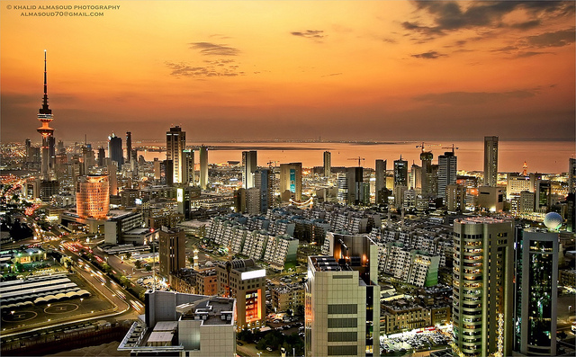

Kuwait City’s trade and transportation needs are served by Kuwait International Airport, Mina Al-Shuwaik (Shuwaik Port) and Mina Al Ahmadi (Ahmadi Port) 50 kilometres (31 miles) to the south, on the Persian Gulf coast. Kuwait City is ranked as one among the 25 largest GDP cities in the world along with New York, Tokyo, Moscow, Mumbai and other financial hubs including Singapore and Dubai.

**3. Weather**

Kuwait City has a hot desert climate and is one of the hottest cities in summers on earth. Its winters are warm with very little rainfall. Sand storms are quite frequent in mid-year.

The weather in November is moderate and approximate temperatures will vary between 20º-25ºC. Rain frequency does increase around November.

**4. Hotel Accommodation**

**Hotel Regency Kuwait (also meeting venue for the events)**

The Regency offers 203 luxurious rooms including 51 suites, as well as the largest meetings and convention facilities in Kuwait. It is a short 15 minute drive from Kuwait’s International Airport and close to the main downtown district of Kuwait City.

The white marble lobby with its 22 meter tall glass atrium offers beautifully landscaped ocean and garden views. This is where families and businessmen gather to sample light refreshments, savor refined pastries and enjoy a selection of gourmet coffees/teas at Regency Gourmet or simply sit on the sun terrace to enjoy The Regency's High Tea and gorgeous vistas.

Shady summer lounge areas are provided in summer and three swimming pools give guests a chance to cool off, while a further two pools are provided exclusively for female guests. In line with Sharia’a ethics, men and women are required to use conservative swimwear in the pools. The Ladies’ Lounge is the only one of its kind in Kuwait and provides a unique all-ladies rendezvous for special events or simply relaxation whether by the pool, in the lounge or by the beautiful beach.

The Regency is well known across Kuwait and the entire Gulf region for its extensive conference and banqueting facilities totalling over 8,000 square meter. A diverse range of meeting rooms are equipped with the latest technology including high speed Wi-Fi. The hotel’s versatility means it is prized for large-scale weddings, high level conferences and social events.

Website: <http://www.theregencykuwait.com/default-en.html>

Address: Al Bida'a, Al Tawoon Street, Salmiya

Email: [info@theregencykuwait.com](mailto:info@theregencykuwait.com)

Telephone: +965 2576 66 66

Fax: +965 2576 69 99

|  |  |
| --- | --- |
| ROOM TYPE | ROOM RATE |
| Single Room | **60 KD per night + 15% service + shuttle service from/to the airport** |

Check In Time: **14:00 hours**

Check Out Time: **12:00 noon**

Credit Cards Accepted: **Visa Card, Master Card, JCB International, American Express, and Diners Club**

**Recommended hotels location map:**

**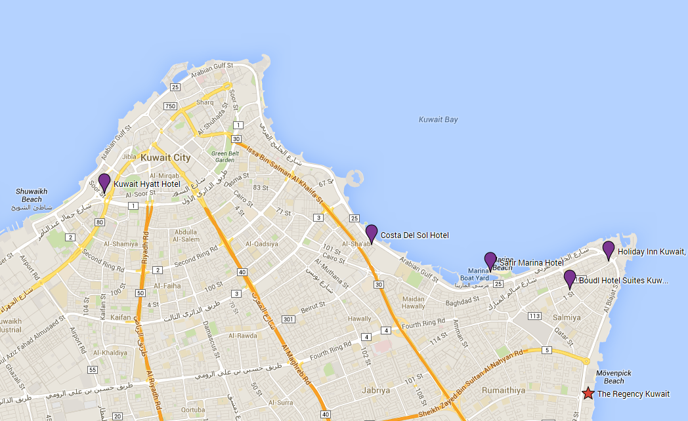**

**Other Recommended Hotels**

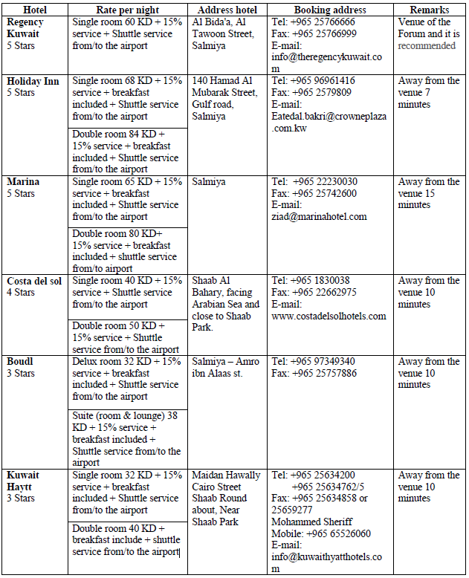

**5. Visa Information**

A valid passport & visa are required to enter The State of Kuwait except for nationalities from the following countries that will be issued entry permits upon arrival at the airport in the state of Kuwait:

United states of America, New Zealand, Australia, Canada, Germany, France, Luxembourg, Belgium, Netherlands, Japan, Norway, Sweden, Austria, Switzerland, Greece, Ireland, Portugal, Denmark, Vatican, Monaco, Spain, Finland, Tolkhstein, SanMarino, Andorra, Iceland, Hong Kong, Malaysia, Singapore, South Korea, China.

Each participant is requested to consult the Kuwaiti Embassy in his/her country of origin to obtain the visa.

Please note that the invitation letter will be circulated to all Kuwaiti Embassies abroad, in order to facilitate the procedures for obtaining a valid visa, furthermore, you can contact the hotel or the tour company you chose to apply for the visa at the following official website:

<http://www.e.gov.kw/MOI_en/Pages/ServiceContent/V2693StateVisit.aspx>

**Should you have any queries regarding obtaining a valid visa or need further assistance please feel free to contact:**

**Mr. Ali Alsalem**

Public Relations Dept.

Tel: + 965 969 665 04

Fax: +965 249 274 85

E-mail: [al.salem@hotmail.com](mailto:al.salem@hotmail.com)

**Very Important Note:**

To facilitate the procedures for obtaining a visa, you should send a copy of your passport [data page and validity of the passport page (special visas countries)] and send it at the above mentioned fax and E-mail.

**Official Working hours:**

Working days: Sunday - Thursday (From 8.00 am to 2.00 pm)

Weekends: Friday & Saturday (holidays)

**6. Transportation from Airport to Hotel**

In order to secure reception at the airport and transportation to hotels, participants are requested to fill the hotel reservation form (**Form 2**) and send it to the hotels, which they chose for accommodation.

The Ministry of Communications will provide transportation only from the hotels to the forum's venue and vice versa.

Tariff for Kuwait airport taxi services ranges between KD 4 for areas near the airport and KD 20 for border areas.

Regarding mobile taxis the fare will be according to the odometer.

Taxi fares in Kuwait city ranges between 2.5 - 3.5 KD.

There are two companies in Kuwait that run public buses: **Kuwait Public Transport Company (KPTC)** and **City Bus,** operating around 50 routes.

City Buses are slightly more expensive with prices around 150 - 250 fils for most trips. Travel on KPTC Buses range from as little as 50 - 150 fils.

**7. Time zone**

UTC/GMT + 0300 hours

**8. Currency**

The national currency of Kuwait is the “*Kuwaiti Dinar (*KD, KWD*)”*.

Banking hours are from 8.30am to 3.00pm, from Sunday to Thursday. Some branches open from 4pm to 6pm.

The exchange rate in Kuwait is pegged to the dollar, other currencies rate can be consulted at  [http://www.oanda.com/currency/converter/](http://www.bbkonline.com/Pages/CurrencyConvertor.aspx) or <http://www.xe.com/> .

As of September 2014:

**1 Euro = 0.383 KWD** (approx.).

**1 US$ = 0.282 KWD** (approx.).

**9. Electricity (voltage used)**

AC power voltage in Kuwait is 240V/50 Hz. Find below used outlets (UK plug):

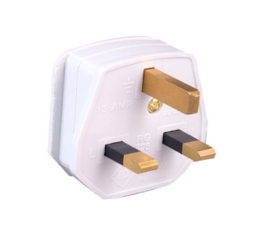

**10. General Information**

|  |  |
| --- | --- |
| Government: | Constitutional Monarchy |
| Emir: | Sabah al-Sabah |
| Crown Prince: | Nawaf al-Sabah |
| Prime Minister: | Jabber Al-Hamad al-Sabah |
| Area: | 17’820 sq.km. |
| Population: | 4,044,500 (approx.) |
| Capital: | Kuwait City |
| Language: | Arabic |

**ANNEX D**(to TSB Collective letter 2/SG5RG-ARB)

****

**Draft Schedule of ITU-T Regional Study Group Meetings   
(SG3RG-ARB, SG2RG-ARB and SG5RG-ARB),**

**Associated BDT and TSB Forums**(23-25 November 2014, Kuwait City, Kuwait)

|  |  |  |
| --- | --- | --- |
| **Sunday 23rd of November 2014**[[1]](#footnote-1)[1] | | |
| 9:30 – 17:00 | **ITU-D Regional Economic and Financial Forum of Telecommunications/ICTs for Arab States ​** | |
| *Lunch Break* | *12:30 – 14:00* | |
| **Monday 24th of November 2014**[[2]](#footnote-2)[1] | | |
| 9:30 – 17:00 | **ITU-T SG3RG-ARB:  ARB regional group for Study Group 3** | |
| *Lunch Break* | *12:30 – 14:00* | |
| **Tuesday 25th of November 2014**[[3]](#footnote-3)[1] | | |
| 9:30 – 12:30  (Parallel Sessions) | **ITU Regional Standardization Forum in the Arab Region** | **ITU-T SG3RG-ARB:  ARB regional group for Study Group 3** (cont’d, if required) |
| 14:00 - 15:30 | **ITU-T SG2RG-ARB:  ARB regional group for Study Group 2** | |
| 15:30 – 17:00 | **ITU-T SG5RG-ARB:  ARB regional group for Study Group 5** | |

Following the above ITU meetings, the Arab Standardization Team, ASTeam, will meet from 0930 to 1700 on Wednesday 26th and Thursday 27th November 2014, with lunch breaks from 1230-1400.

**FORM 2 – HOTEL RESERVATION FORM**

(to TSB Collective letter 2/SG5RG-ARB)

|  |
| --- |
| **HOTEL RESERVATION FORM**  ***(to be submitted before 10 November 2014)*** |

**(*CAPITAL LETTERS*)**

|  |
| --- |
| **1.**  **Mr. / Mrs.**  **(Family name) (First name)**  **2. Country :**    **3.Address :**    **4. Tel.:\_\_\_\_\_\_\_\_\_\_\_\_\_\_\_\_\_\_ Fax: \_\_\_\_\_\_\_\_\_\_\_\_\_\_\_\_\_\_ E-mail :** |

|  |
| --- |
| **PLEASE SEND DIRECTLY TO THE CHOSEN HOTEL** |

|  |
| --- |
| **5. Specify name of hotel**  **Hotel Fax No.**  **Booking of a single room**  **Booking of a double room**  **from to**  ***for*  *nights*** |
| **6. Arrival Date :**  ***Day:* \_\_\_\_\_\_\_\_\_\_\_\_\_ *Time : \_\_\_\_\_\_\_\_\_\_\_\_\_\_\_\_\_* *Flight No.* : \_\_\_\_\_\_\_\_\_\_\_\_\_\_\_\_** |
| **7.Departure date :**  ***Day :* \_\_\_\_\_\_\_\_\_\_\_\_ *Time : \_\_\_\_\_\_\_\_\_\_\_\_\_\_\_\_\_* *Flight No.* : \_\_\_\_\_\_\_\_\_\_\_\_\_\_\_** |

|  |  |  |
| --- | --- | --- |
| **Date : Signature :** | | |
| ***To be returned before 10/11/2014, to:***  **cc:** | | the hotel chosen  **Mrs. Laila HUSSAIN Head of European & American affairs section External Relations Dept. MOC/Kuwait Tel:** [**+965 24820378**](tel:%2B965%2024820378) **Fax:** [**+ 965 24847058**](tel:%2B%20965%2024847058) **E-mail:** [**hussainl@ties.itu.int**](mailto:hussainl@ties.itu.int) |

\_\_\_\_\_\_\_\_\_\_\_\_\_\_

1. [1]  With A/E/F interpretation. [↑](#footnote-ref-1)
2. [↑](#footnote-ref-2)
3. [↑](#footnote-ref-3)