Unión Internacional de Telecomunicaciones
Oficina de Normalización de las Telecomunicaciones
Ginebra, 11 de marzo de 2015
Ref.: | Carta Colectiva TSB 3/9
Tel.: | +41 22 730 5858 | A:
Fax:  Correo-e: | +41 22 730 5853  tsbsg9@itu.int | – las Administraciones de los Estados  Miembros de la Unión;  – los Miembros del Sector UIT-T;  – los Asociados que participan en los  trabajos de la Comisión de Estudio 9 y a  – las Instituciones Académicas del UIT-T
Asunto: | Reunión de la Comisión de Estudio 9; Beijing (China),  10-17 de junio de 2015
Muy Señor mío/Muy Señora mía:
Me complace invitarle a asistir a la reunión de la Comisión de Estudio 9 (Cable y TV de banda ancha) que se celebrará en Beijing (China), en la Sede de la UIT, del 10 al 17 de junio de 2015 ambos inclusive, por amable invitación de la Academia de Ciencia de la Radiodifusión, SAPPRFT de China.
Me permito informarle que la reunión comenzará a las 09.30 horas del primer día. La inscripción de los participantes comenzará a las 08.30 horas. En el lugar de celebración se dispondrá de información detallada sobre las salas de reunión, que le será facilitada en el mostrador de inscripción. En el Anexo A se facilita información general acerca de la reunión, y en el Anexo B se proporciona información práctica.
El proyecto de orden del día de la reunión y el proyecto de programa de trabajo, preparados de acuerdo con el Presidente de la Comisión de Estudio (Sr. Arthur Webster, EE.UU.) y su equipo de dirección, figuran en los Anexos E y F, respectivamente.
Podría tener lugar una exhibición los dos primeros días de la reunión de la CE 9. El anfitrión desea invitar a los expertos de la CE 9 a exponer las investigaciones recientes en el campo de la normalización de la CE 9, lo cual interesará e impulsará las futuras labores de la Comisión de Estudio. Debido a las limitaciones de espacio disponible, sólo se aceptará un número limitado de solicitudes por orden de recepción. Se pide a los solicitantes que rellenen y presenten al anfitrión, en la dirección gebing@abs.ac.cn, el formulario de solicitud que figura en el Anexo D, lo antes posible y, en cualquier caso, antes del 10 de abril de 2015.
Le deseo una reunión agradable y productiva.
Atentamente.
Chaesub Lee
Director de la Oficina de Normalización
de las Telecomunicaciones
Anexos: 6

ANEXO A
Presentar contribuciones
PLAZO PARA LA PRESENTACIÓN DE CONTRIBUCIONES: El plazo para la presentación de contribuciones es de 12 (doce) días naturales previos a la reunión. Dichas contribuciones se publicarán en el sitio web de la Comisión de Estudio 9. Por tanto, las citadas contribuciones deberán obrar en poder de la TSB a más tardar el 28 de mayo de 2015. Las contribuciones recibidas por lo menos dos meses antes del comienzo de la reunión podrán traducirse, si así se requiere.
PUBLICACIÓN DIRECTA/PRESENTACIÓN DE DOCUMENTOS: Se dispone ahora de un sistema en línea para la publicación directa de las contribuciones. El sistema de publicación directa permite a los Miembros del UIT-T reservar números de contribución y cargar y revisar contribuciones directamente en el servidor web del UIT-T. Para obtener más información y directrices relativas al nuevo sistema de publicación directa, puede acudir a la siguiente dirección http://itu.int/net/ITU-T/ddp/.
PLANTILLAS: Le recomendamos utilizar el juego de plantillas facilitado para preparar su contribución. Las plantillas se pueden descargar desde la página web de cada Comisión de Estudio del UIT-T en "Delegate resources" (http://itu.int/ITU-T/studygroups/templates). El nombre, los números de telefax y de teléfono, así como la dirección de correo electrónico de la persona de contacto para la contribución deberán figurar en la portada de todos los documentos.

MÉTODOS DE TRABAJO E INSTALACIONES
INTERPRETACIÓN: En acuerdo con el equipo de dirección de la CE 9 del UIT-T, esta reunión se celebrará únicamente en inglés.
REUNIONES SIN PAPEL: la reunión tendrá lugar sin papel.
LAN INALÁMBRICA: Los delegados dispondrán de instalaciones de red de área local inalámbrica en el lugar de celebración. En el Anexo B se facilita información detallada al respecto.
IMPRESORAS: Los delegados dispondrán de impresoras en el lugar de celebración del evento.

INSCRIPCIÓN y BECAS
INSCRIPCIÓN: Para que la TSB pueda tomar las disposiciones necesarias, le ruego me comunique cuanto antes, por carta, por fax (+41 22 730 5853) o por correo electrónico (tsbreg@itu.int) y a más tardar el 15 de abril de 2015, una lista de las personas que representarán a su Administración, Miembro del Sector, Asociado, Institución Académica, organización regional y/o internacional u otra entidad. Se ruega también a las administraciones que indiquen el nombre de su Jefe de Delegación (y jefe adjunto, si procede).
No olvide que la preinscripción de los participantes a las reuniones del UIT-T se efectúa en línea desde el sitio web del UIT-T: (http://www.itu.int/en/ITU-T/studygroups/2013-2016/09/Pages/default.aspx).
BECAS: Tenemos el placer de comunicarle que se concederán dos becas parciales por administración, sujetas a la financiación disponible, con objeto de facilitar la participación de los países menos adelantados y países en desarrollo con bajos ingresos
(http://itu.int/en/ITU-T/info/Pages/resources.aspx). La solicitud debe ser autorizada por la Administración correspondiente del Estado Miembro de la UIT. Las solicitudes de beca (para las que debe utilizarse el Formulario 1) deberán obrar en poder de la UIT a más tardar el 29 de abril de 2015. Le invitamos a tomar nota de que entre los criterios que llevaron a la decisión de conceder una beca figuran los siguientes: el presupuesto disponible de la TSB; las contribuciones del solicitante a la reunión; la distribución equitativa entre países y regiones, y la paridad entre hombres y mujeres.
VISADOS: Para entrar en China, puede que necesite una carta de invitación del anfitrión (SAPPRFT), que tendría que presentar a la Embajada o el Consulado de China de su zona a fin de obtener su visado (para la carta de invitación, véase el ANEXO C) ese visado debe solicitarse y obtenerse en la oficina (embajada o consulado) que representa a China en su país o, en su defecto, en la más próxima a su país de partida. Rogamos tenga presente que la aprobación del visado puede llevar cierto tiempo, por lo que le recomendamos que presente su solicitud de visado lo antes posible.
PLAZOS CLAVE (antes de la reunión)
10 de abril de 2015:  10 de abril de 2015:  10 de abril de 2015: | – presentación de las contribuciones cuya traducción se requiera  – solicitudes de carta para la obtención del visado  – solicitudes para participar en la exhibición
15 de abril de 2015: | – preinscripción
29 de abril de 2015: | – solicitudes de beca
28 de mayo de 2015: | – fecha límite para la presentación de contribuciones

ANNEX B

PRACTICAL INFORMATION

Meeting Venue
Merchantel Hotel,
No.2 Xibianmen Outer Street, Xicheng District, Beijing, China.
http://www.cytshotels.com/gdgj/merchantel/index.shtml
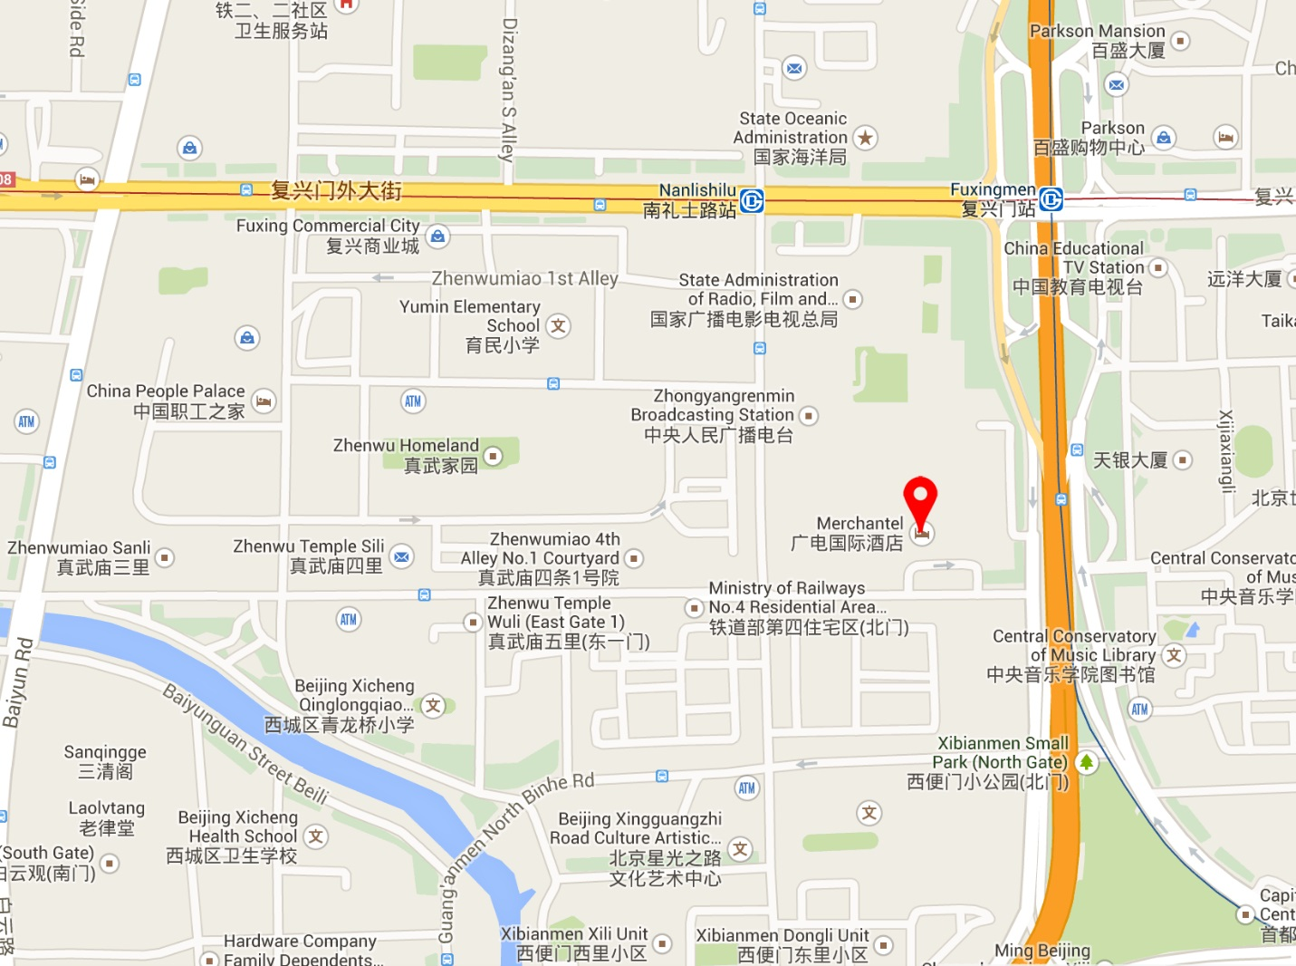

Transportation and site information
Transportation:
About 34.2KM from Beijing Capital International Airport, Beijing. Taxi about 110RMB.

Passports and Visas
All foreign visitors entering China must have a valid passport. Visitors from countries whose citizens require a visa should at the earliest time and well in advance of travel apply for a visa at a Chinese Embassy or consulate. The following provides information relating to entry into China.
For an invitation letter, please see Annex C.

Climate – during June
Monthly Average values of the temperature and precipitation in Beijing, China are given in the table below:
 | June
Average Max Temperature | 30C / 86F
Average Minimum Temperature | 19C / 66F
Average Precipitation | 78 mm
http://en.weather.com.cn/weather/101010100.shtml

Hotels
VENUE: Merchantel Hotel, No.2 Xibianmen Outer Street, Xicheng District, Beijing
http://www.cytshotels.com/gdgj/merchantel/index.shtml
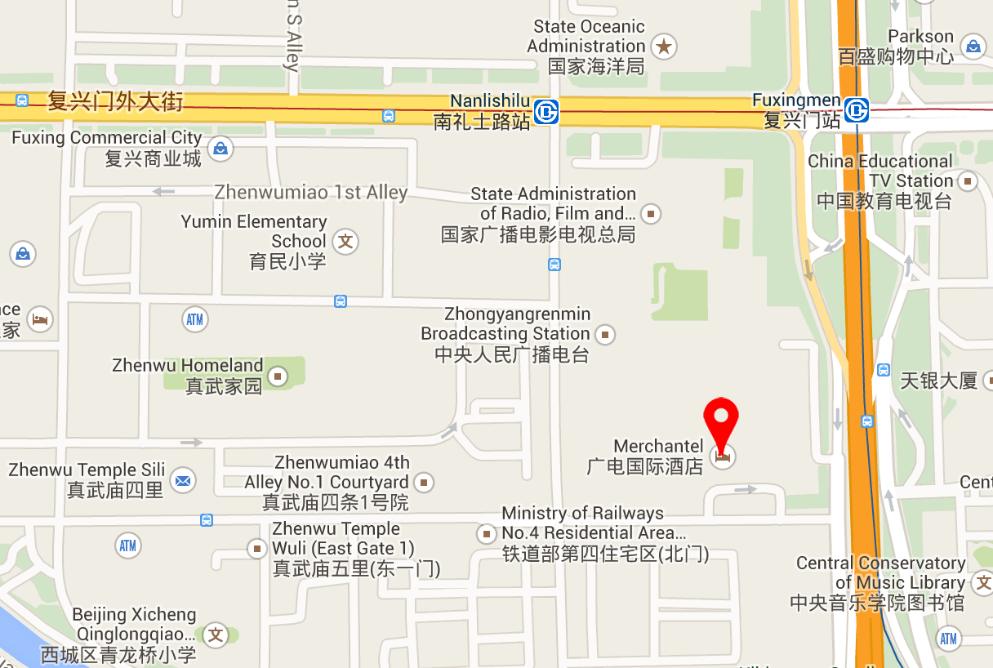

Other hotels close to the venue:
InterContinental Beijing Financial Street Hotel, No.11 Financial Street, Xicheng District, Beijing
http://www.ihg.com/intercontinental/hotels/gb/en/beijing/pegha/hoteldetail
The Westin Beijing Financial Street, 9B Financial Street, XiCheng District, Beijing,
http://www.starwoodhotels.com/westin/property/overview/index.html?propertyID=1704&language=en_US&localeCode=en_US

The way to the meeting venue from “InterContinental Beijing Financial Street Hotel” and “The Westin Beijing Financial Street Hotel”:
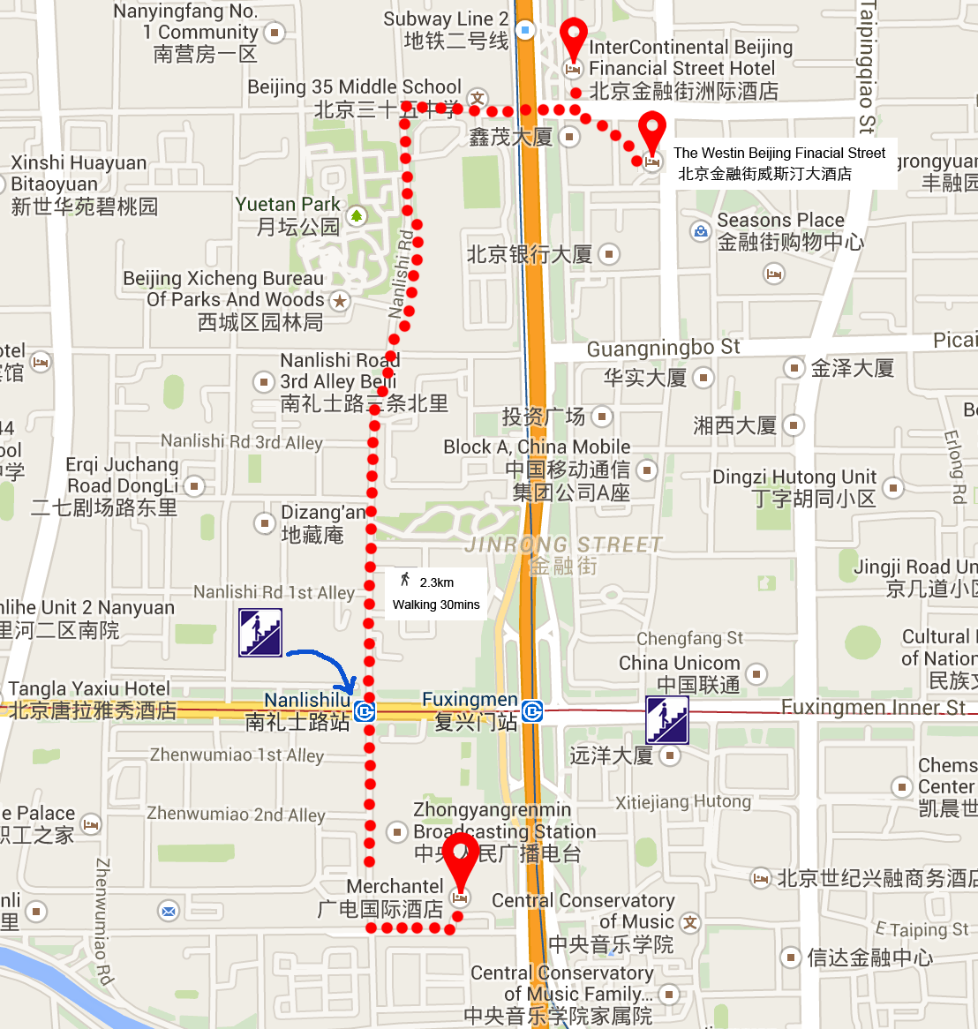
China People Palace, No.1 Zhenwumiao Street, Xicheng District, Beijing
http://www.zgzgzj.com/introduce_en-us.php
The way to the meetings venue from “China People Palace hotel”:
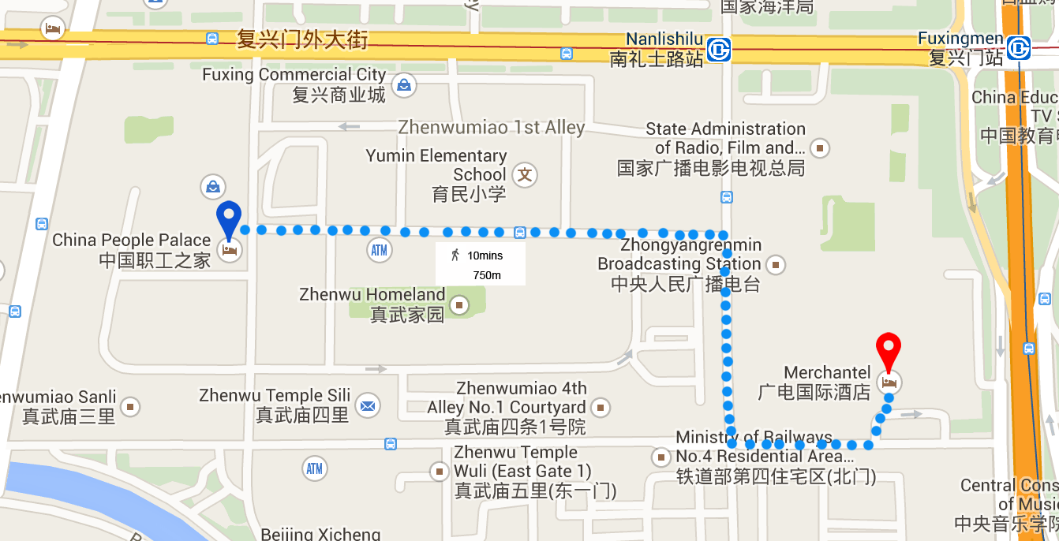

Internet access and wireless coverage
All meeting rooms will have a wireless network with access to the Internet. Every guest room offers a high-speed Internet access for free. The access to Internet will be granted using the LAN technologies listed below:
- Wireless via WiFi: IEEE 802.11a/n on 5.2 GHz and 802.11g/n on 2.4 GHz.

Technical assistance
In case you have any technical problem at the venue (e.g. connecting to internet, finding meeting rooms etc.) please contact for help:
Bing Ge, +86 13901281949, gebing@abs.ac.cn
Bo Li, +86 13811931714, libo@abs.ac.cn

Electricity
The electricity in China is generally 220V, 50HZ. . Please make sure you have the proper adapter.
Chinese standard
Such a socket is common in China, Australia, New Zealand and many other countries.

Useful information
Currency exchange

The currency in China is the RMB Yuan (￥); please check the currency exchange rate in the local bank system or use the following link as a reference: http://www.xe.com/

Additional information
General Information for stay in Beijing:
Mobile phone: GSM and CDMA, WCDMA, TD-SCDMA, TD-LTE services provided by China Mobile, China Unicom and China Telecom.
Currency: local currency RMB Yuan (￥), the exchange rate of US$ and RMB is around 6.2.
Tipping: Tipping is not necessary.
Time Zone: GMT+8:00.
Emergency Number: In case of emergency please dial 110.
Sight Seeing:
The Temple of Heaven, Mansion of Prince Gong, etc.
For more information by http://english.visitbeijing.com.cn

Contact persons
Bing Ge (gebing@abs.ac.cn)
Jingfei Cui (cuijingfei@abs.ac.cn)
Feng Ouyang (ouyangfeng@abs.ac.cn)
Liyue Zhu (zhuliyue@abs.ac.cn)

ANNEX C
INVITATION LETTER REQUEST FORM
All foreign visitors entering China must have a valid passport. Visitors from countries whose citizens require a visa should at the earliest time and well in advance of travel apply for a visa at a Chinese Embassy or consulate. You may need a letter of invitation from the Chinese host, which you will need to present to the Chinese Embassy/Consulate in your area in order to obtain your visa. The visa must be requested as soon as possible and at least four (4) weeks before the start date of the meeting and obtained from the office (embassy or consulate) representing China in your country or, if there is no such office in your country, from the one that is closest to the country of departure. In order to obtain the invitation letter, please:
- Fill out the form below
- Provide the electronic copy of your passport (the name, date of birth, nationality, passport number, valid date of passport, etc. must be seen clearly)
- Provide the electronic copy of previous Chinese visa and records (if you have been to China before)
- Send the info in a), b) and c) as email attachments to Bing Ge gebing@abs.ac.cn and Jingfei Cui cuijingfei@abs.ac.cn ; please mark as reference in the subject “Invitation letter request for ITU-T SG9 Plenary meetings”:
(It is recommended to scan your passport page and email it to us so that it is discernible and can be used).
Company
Applicant Information |  |  |  | Mr Miss Ms Mrs
 |  |  |  | Date of birth :
 |  |  |  | Place of Issue:
 | Date of Issue: |  |  | Date of Expiry:
 | Marital Status:
 | If the country in which you'll obtain your visa is different from your nationality, please indicate it here:
Address | Telephone Number:  Fax Number:  E-mail:
Note
Date of arrive at China |  |  | Date of departure from China
(Please do not forget to attach a copy of your passport photograph page before sending.)
In order to receive an invitation letter, your information should be provided to the host before 10 April 2015.
FORM 1 - FELLOWSHIP REQUEST
(to TSB Collective letter 3/9)
ITU-T Study Group 9 meeting
Beijing, China, 10-17 June 2015
Please return to: |  | ITU  Geneva (Switzerland) |  | E-mail: bdtfellowships@itu.int  Tel: +41 22 730 5227  Fax: +41 22 730 5778
Request for one partial fellowship to be submitted before 29 April 2015
 |  |  | Participation of women is encouraged
Registration Confirmation I.D. No: ……………………………………………………………………………
(Note: It is imperative for fellowship holders to pre-register via the online registration form at: http://www.itu.int/en/ITU-T/studygroups/2013-2016/09/Pages/default.aspx)
Country: _____________________________________________________________________________________________
Name of the Administration or Organization: ______________________________________________________
Mr / Ms _______________________________(family name) ________________________________(given name)
Title: _________________________________________________________________________________________________
Address: _____________________________________________________________________________________________________
_____________________________________________________________________________________________________
Tel.: _________________________ Fax: _________________________ E-Mail: __________________________________
PASSPORT INFORMATION:
Date of birth: ________________________________________________________________________________________
Nationality: ______________________________ Passport number: _______________________________________
Date of issue: ______________ In (place): _________________________Valid until (date): __________________
Please select your preference
(which ITU will do its best to accommodate)
□ Economy class air ticket (duty station / Beijing / duty station)
□ Daily subsistence allowance intended to cover accommodation, meals & misc. expenses
Signature of fellowship candidate: |  |  |  |  | Date:
TO VALIDATE FELLOWSHIP REQUEST, NAME, TITLE AND SIGNATURE OF CERTIFYING OFFICIAL DESIGNATING PARTICIPANT MUST BE COMPLETED BELOW WITH OFFICIAL STAMP.
N.B. IT IS IMPERATIVE THAT FELLOWS BE PRESENT FROM THE FIRST DAY TO THE END OF THE MEETING.
Signature: |  |  |  |  | Date:

ANNEX D
Exhibitors’ Requirement Form
(Note: Please complete and return to gebing@abs.ac.cn by 10 April 2015 to reserve a booth. Considering the limited space and options, all participants should provide their own computers and storage, and please keep them to a minimum.)

Company Name | Contact person including contact details | Email address

Type of equip. to be displayed

Item(s) required | Description | Quantity
Tables
Chairs
Flat Screens
Network switch
Power supply
Space required
Panels
Power consumption expected for equipment:
Dimension, weight of equipment
Additional notes
(if any)

ANNEX E
Draft Agenda
# | Agenda items
 | Opening of the meeting
 | Feedback on interim activities since last meeting
 | TSAG/RevCom (June 2015) results relevant to SG9
 | Rapporteurs, Associates and other roles
 | Contributions for opening Plenary
 | Report from other Groups/Workshops
 | AOB for opening Plenary
 | Intellectual Property Rights inquiry
 | “Consent” on draft Recommendations proposed for approval in accordance with Recommendation A.8
 | Approval of Working Parties reports and Question meetings report
 | New/amended Questions (if any)
 | New appointment and change of appointment of Rapporteur(s), Associate Rapporteur(s), liaison officers
 | Update of SG9 Work Programme
 | Outgoing Liaison Statements
 | Date and place of the next SG9 meeting
 | Future Interim activities (Rapporteurs, WPs)
 | AOB
 | Closing
Note: Items 1 to 7 are expected to be addressed in the opening Plenary (10 June 2015) and items 8 to 18 are expected to be addressed in the closing Plenary (17 June 2015).

ANNEX F
Draft Timetable
SG9 draft meeting plan (10-17 June 2015, Beijing, China)
 | Wednesday 10  June |  |  |  | Thursday 11  June |  |  |  | Friday 12  June |  |  |  | Sat 13  June | Sun 14  June | Monday 15  June |  |  |  | Tuesday 16  June |  |  |  | Wednesday 17  June
Sessions | 1 | 2 | 3 | 4 | 1 | 2 | 3 | 4 | 1 | 2 | 3 | 4 |  |  | 1 | 2 | 3 | 4 | 1 | 2 | 3 | 4 | 1 | 2 | 3 | 4
PLEN | X | 2 |  |  |  |  |  |  |  |  |  |  |  |  |  |  |  |  |  |  |  |  | X | X | X | X
WPs |  | 2 |  |  |  |  |  |  |  |  |  |  |  |  |  |  |  |  |  | X | X | X
Q1/9 |  |  | 3 |  | X |  |  |  |  |  |  | 3 |  |  | X |  |  | 3
Q2/9 |  |  | X |  | 4 |  |  | X | 4 | X |  |  |  |  | X |  |  | 4
Q3/9 |  |  | X |  |  |  | X | X |  |  | X | X |  |  |  | X |  | X
Q4/9 |  |  |  | X | X | X | X |  | X | X |  |  |  |  | X |  |  | X | X
Q5/9 |  |  | 5 | X | 5 | X |  |  | 5 | X |  |  |  |  | 5 | X |  |  | X
Q6/9 |  |  | X |  | X |  |  |  |  | X
Q7/9 |  |  | 3 |  |  | X |  | X |  |  | X | 3 |  |  |  |  | X | 3 | X
Q8/9 |  |  | 5 |  | 5 |  | X |  | 5 |  | X |  |  |  | 5 |  | X
Q9/9 |  |  | 5 |  | 5 |  |  | X | 5 |  |  | X |  |  | 5 |  |  | X
Q10/9 |  |  |  |  |  |  | X | X |  |  | X | X |  |  |  |  | X |  | X
Q11/9 |  |  |  |  |  | X |  |  |  |  |  |  |  |  |  | X
Q12/9 |  |  |  | X | 4 |  | X |  | 4 |  | X |  |  |  |  | X | X | 4
Q13/9 |  |  |  | X |  | X |  |  | X |  |  | X |  |  | X | X | X |  | X
Newcomers |  | 1
Session 1: 0930 – 1045; Session 2: 1115-1230; Session 3: 1430-1545; Session 4: 1615-1730;

PLEN | Plenary sessions
WPs | Working Parties 1 and 2 Plenary sessions
X | Represents a meeting session
 | Indicates a lunch/evening session
1 | A newcomers orientation session will follow the WPs/9 opening plenary sessions (1230-1330)
2 | WP1/9 and WP2/9 Plenary sessions will be held sequentially and will follow SG9 Plenary
3 | Joint session of Q1 and Q7/9
4 | Joint session of Q2 and Q12/9
5 | Joint session Q5, Q8, Q9

_____________

