International telecommunication union
Telecommunication Standardization Bureau
 |  |  | Geneva, 11 March 2015
Ref: | TSB Collective letter 3/9 |  | - To Administrations of Member States of the Union;  - To ITU-T Sector Members;  - To ITU-T Associates participating in the work of Study Group 9 and  - To ITU-T Academia
Tel: | +41 22 730 5858
Fax: | +41 22 730 5853
E-mail: | tsbsg9@itu.int
Subject: | Meeting of Study Group 9; Beijing, China, 10-17 June 2015
Dear Sir/Madam,
It is my pleasure to inform you that Study Group 9 (Broadband cable and TV) will meet in Beijing, China, from 10 to 17 June 2015 inclusive, at the kind invitation of the Academy of Broadcasting Science, Ministry of Industry and Information Technology/SAPPRFT, China.
I should like to inform you that the meeting will open at 0930 hours on the first day. Participant registration will begin at 0830 hours. Detailed information concerning the meeting rooms will be available onsite and provided to you at the registration desk. General information about the meeting is set forth in Annex A, while practical information can be found in Annex B.
The draft Agenda of the meeting and its draft Timetable, prepared in agreement with the Chairman of the Study Group (Mr Arthur Webster, USA) and its management team, are set out in Annex E and F respectively.
An exhibition may be held during the first two days of SG9 meeting. The host would like to invite SG9 experts to showcase recent research in the field of SG9 standardization, which will interest and energize future SG9 work. Only a limited number of applications will be accepted on a first come, first served basis, due to the limited space available. Applicants are requested to fill in and submit to the host at gebing@abs.ac.cn, the application form to be found in Annex D, as soon as possible and before 10 April 2015.
I wish you a productive and enjoyable meeting.
Yours faithfully,
Chaesub Lee
Director of the Telecommunication
Standardization Bureau
Annexes: 6
ANNEX A
MAKING CONTRIBUTIONS
DEADLINES FOR CONTRIBUTIONS: The deadline for contributions is 12 (twelve) calendar days before the meeting. Such contributions will be published on the Study Group 9 website and must therefore be received by TSB not later than 28 May 2015. Contributions received at least two months before the start of the meeting may be translated, if requested.
DIRECT POSTING/DOCUMENT SUBMISSION: A direct posting system for contributions is available on-line. The direct posting system allows ITU-T members to reserve contribution numbers and to upload/revise contributions directly to the ITU-T web server. Further information and guidelines for the direct posting system are available at the following address: http://itu.int/net/ITU-T/ddp/.
TEMPLATES: Please use the provided set of templates to prepare your meeting documents. The templates are accessible from each ITU-T study group web page, under “Delegate resources” (http://itu.int/ITU-T/studygroups/templates). The name, fax and telephone numbers and e-mail address of the person to be contacted about the contribution should be indicated on the cover page of all documents.
WORK METHODS AND FACILITIES
INTERPRETATION: As per agreement of ITU-T SG9 management team, this meeting will be held in English only.
PAPERLESS MEETINGS: The meeting will be run paperless.
WIRELESS LAN facilities will be available for use by delegates at the venue. Detailed information is available in ANNEX B item 6.
PRINTERS: Printers will be made available to the delegates at the venue of the event.
REGISTRATION and FELLOWSHIPS
REGISTRATION To enable TSB and the host to make the necessary arrangements, please send by letter, fax (+41 22 730 5853) or e-mail (tsbreg@itu.int) not later than 15 April 2015, the list of people who will be representing your Administration, Sector Member, Associate, Academic Institution, regional and/or international organization or other entity. Administrations are requested also to indicate the name of their head of delegation (and deputy head, if applicable).
Please note that pre-registration of participants to ITU-T meetings is carried out online at the ITU-T website (http://www.itu.int/en/ITU-T/studygroups/2013-2016/09/Pages/default.aspx).
FELLOWSHIPS: We are pleased to inform you that two partial fellowships per administration will be awarded, subject to available funding, to facilitate participation from Least Developed or Low Income Developing Countries (http://itu.int/en/ITU-T/info/Pages/resources.aspx). An application for a fellowship must be authorized by the relevant Administration of the ITU Member State. Fellowship requests (please use enclosed Form 1), must be returned to ITU not later than 29 April 2015. Please note that the decision criteria to grant a fellowship include: the available TSB budget; contributions by the applicant to the meeting; equitable distribution among countries and regions, and gender balance.
VISAS: To enter China, you may need a letter of invitation from the host (SAPPRFT), which you will need to present to the Chinese Embassy/Consulate in your area in order to obtain your visa (see ANNEX C for the Invitation letter). The visa must be requested and obtained from the office (embassy or consulate) representing China in your country or, if there is no such office in your country, from the one that is closest to the country of departure. Please be aware that visa approval might take time so kindly make your visa request as soon as possible.
KEY DEADLINES (before meeting)
10 April 2015: - submit contributions for which translation is requested
10 April 2015: - requests for visa support letter
10 April 2015 - application for exhibition
15 April 2015: - pre-registration
29 April 2015: - fellowship requests
28 May 2015: - final deadline for contributions

ANNEX B

PRACTICAL INFORMATION

Meeting Venue
Merchantel Hotel,
No.2 Xibianmen Outer Street, Xicheng District, Beijing, China.
http://www.cytshotels.com/gdgj/merchantel/index.shtml
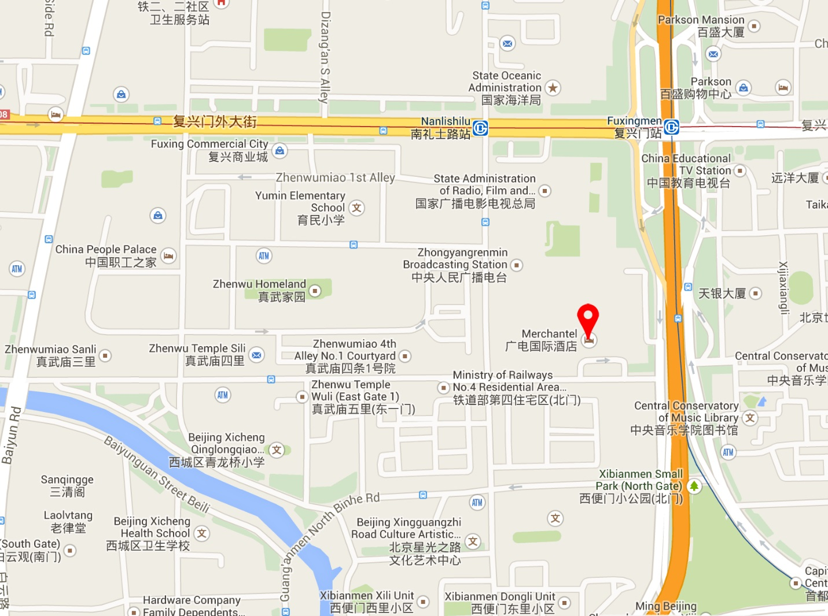

Transportation and site information
Transportation:
About 34.2KM from Beijing Capital International Airport, Beijing. Taxi about 110RMB.

Passports and Visas
All foreign visitors entering China must have a valid passport. Visitors from countries whose citizens require a visa should at the earliest time and well in advance of travel apply for a visa at a Chinese Embassy or consulate. The following provides information relating to entry into China.
For an invitation letter, please see Annex C.

Climate – during June
Monthly Average values of the temperature and precipitation in Beijing, China are given in the table below:
 | June
Average Max Temperature | 30C / 86F
Average Minimum Temperature | 19C / 66F
Average Precipitation | 78 mm
http://en.weather.com.cn/weather/101010100.shtml

Hotels
VENUE: Merchantel Hotel, No.2 Xibianmen Outer Street, Xicheng District, Beijing
http://www.cytshotels.com/gdgj/merchantel/index.shtml
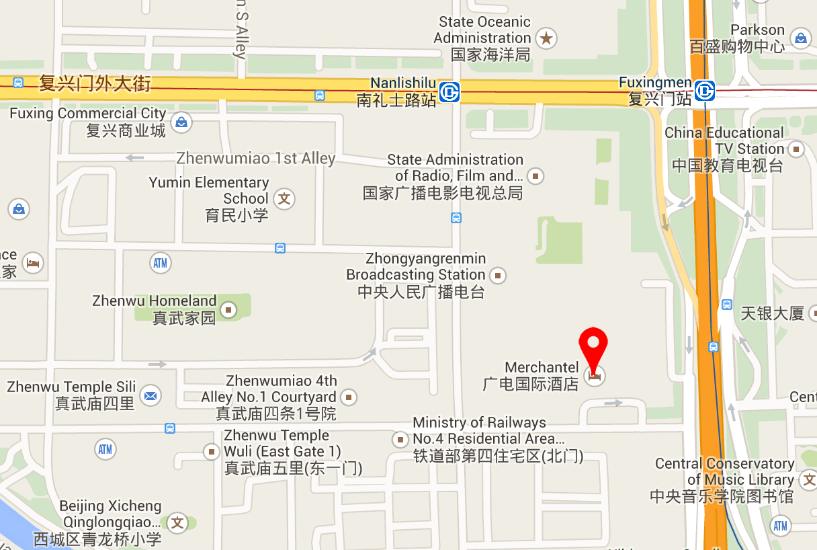

Other hotels close to the venue:
InterContinental Beijing Financial Street Hotel, No.11 Financial Street, Xicheng District, Beijing
http://www.ihg.com/intercontinental/hotels/gb/en/beijing/pegha/hoteldetail
The Westin Beijing Financial Street, 9B Financial Street, XiCheng District, Beijing,
http://www.starwoodhotels.com/westin/property/overview/index.html?propertyID=1704&language=en_US&localeCode=en_US

The way to the meeting venue from “InterContinental Beijing Financial Street Hotel” and “The Westin Beijing Financial Street Hotel”:
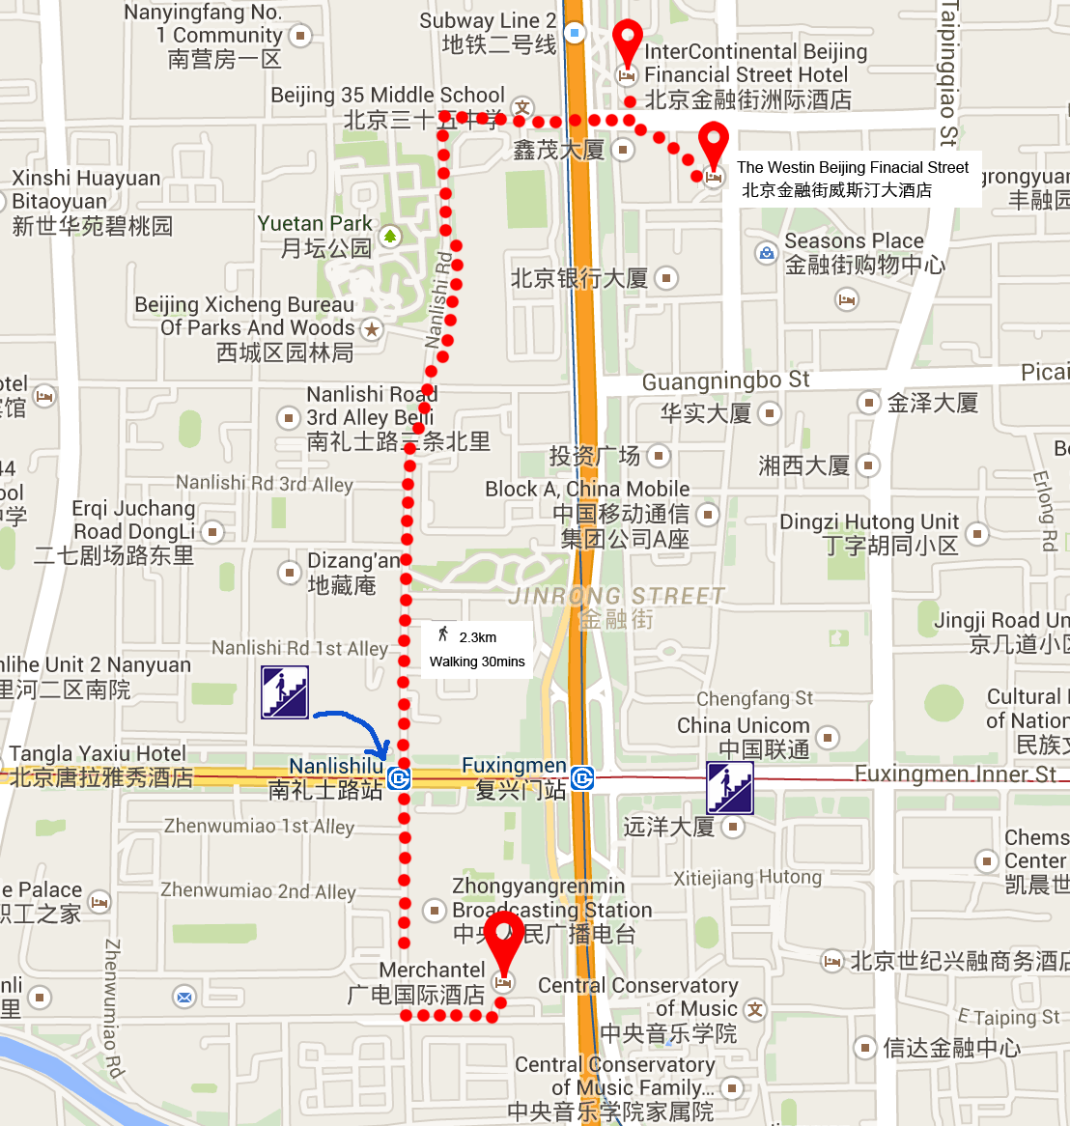
China People Palace, No.1 Zhenwumiao Street, Xicheng District, Beijing
http://www.zgzgzj.com/introduce_en-us.php
The way to the meetings venue from “China People Palace hotel”:
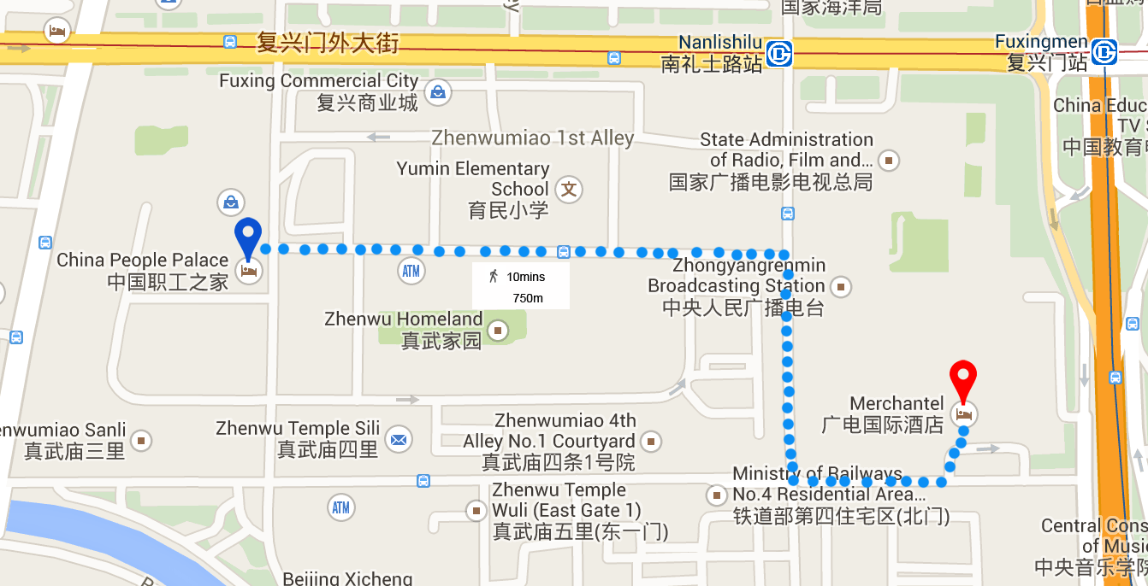

Internet access and wireless coverage
All meeting rooms will have a wireless network with access to the Internet. Every guest room offers a high-speed Internet access for free. The access to Internet will be granted using the LAN technologies listed below:
- Wireless via WiFi: IEEE 802.11a/n on 5.2 GHz and 802.11g/n on 2.4 GHz.

Technical assistance
In case you have any technical problem at the venue (e.g. connecting to internet, finding meeting rooms etc.) please contact for help:
Bing Ge, +86 13901281949, gebing@abs.ac.cn
Bo Li, +86 13811931714, libo@abs.ac.cn

Electricity
The electricity in China is generally 220V, 50HZ. . Please make sure you have the proper adapter.
Chinese standard
Such a socket is common in China, Australia, New Zealand and many other countries.

Useful information
Currency exchange

The currency in China is the RMB Yuan (￥); please check the currency exchange rate in the local bank system or use the following link as a reference: http://www.xe.com/

Additional information
General Information for stay in Beijing:
Mobile phone: GSM and CDMA, WCDMA, TD-SCDMA, TD-LTE services provided by China Mobile, China Unicom and China Telecom.
Currency: local currency RMB Yuan (￥), the exchange rate of US$ and RMB is around 6.2.
Tipping: Tipping is not necessary.
Time Zone: GMT+8:00.
Emergency Number: In case of emergency please dial 110.
Sight Seeing:
The Temple of Heaven, Mansion of Prince Gong, etc.
For more information by http://english.visitbeijing.com.cn

Contact persons
Bing Ge (gebing@abs.ac.cn)
Jingfei Cui (cuijingfei@abs.ac.cn)
Feng Ouyang (ouyangfeng@abs.ac.cn)
Liyue Zhu (zhuliyue@abs.ac.cn)

ANNEX C
INVITATION LETTER REQUEST FORM
All foreign visitors entering China must have a valid passport. Visitors from countries whose citizens require a visa should at the earliest time and well in advance of travel apply for a visa at a Chinese Embassy or consulate. You may need a letter of invitation from the Chinese host, which you will need to present to the Chinese Embassy/Consulate in your area in order to obtain your visa. The visa must be requested as soon as possible and at least four (4) weeks before the start date of the meeting and obtained from the office (embassy or consulate) representing China in your country or, if there is no such office in your country, from the one that is closest to the country of departure. In order to obtain the invitation letter, please:
- Fill out the form below
- Provide the electronic copy of your passport (the name, date of birth, nationality, passport number, valid date of passport, etc. must be seen clearly)
- Provide the electronic copy of previous Chinese visa and records (if you have been to China before)
- Send the info in a), b) and c) as email attachments to Bing Ge gebing@abs.ac.cn and Jingfei Cui cuijingfei@abs.ac.cn ; please mark as reference in the subject “Invitation letter request for ITU-T SG9 Plenary meetings”:
(It is recommended to scan your passport page and email it to us so that it is discernible and can be used).
Company
Applicant Information |  |  |  | Mr Miss Ms Mrs
 |  |  |  | Date of birth :
 |  |  |  | Place of Issue:
 | Date of Issue: |  |  | Date of Expiry:
 | Marital Status:
 | If the country in which you'll obtain your visa is different from your nationality, please indicate it here:
Address | Telephone Number:  Fax Number:  E-mail:
Note
Date of arrive at China |  |  | Date of departure from China
(Please do not forget to attach a copy of your passport photograph page before sending.)
In order to receive an invitation letter, your information should be provided to the host before 10 April 2015.
FORM 1 - FELLOWSHIP REQUEST
(to TSB Collective letter 3/9)
ITU-T Study Group 9 meeting
Beijing, China, 10-17 June 2015
Please return to: |  | ITU  Geneva (Switzerland) |  | E-mail: bdtfellowships@itu.int  Tel: +41 22 730 5227  Fax: +41 22 730 5778
Request for one partial fellowship to be submitted before 29 April 2015
 |  |  | Participation of women is encouraged
Registration Confirmation I.D. No: ……………………………………………………………………………
(Note: It is imperative for fellowship holders to pre-register via the online registration form at: http://www.itu.int/en/ITU-T/studygroups/2013-2016/09/Pages/default.aspx)
Country: _____________________________________________________________________________________________
Name of the Administration or Organization: ______________________________________________________
Mr / Ms _______________________________(family name) ________________________________(given name)
Title: _________________________________________________________________________________________________
Address: _____________________________________________________________________________________________________
_____________________________________________________________________________________________________
Tel.: _________________________ Fax: _________________________ E-Mail: __________________________________
PASSPORT INFORMATION:
Date of birth: ________________________________________________________________________________________
Nationality: ______________________________ Passport number: _______________________________________
Date of issue: ______________ In (place): _________________________Valid until (date): __________________
Please select your preference
(which ITU will do its best to accommodate)
□ Economy class air ticket (duty station / Beijing / duty station)
□ Daily subsistence allowance intended to cover accommodation, meals & misc. expenses
Signature of fellowship candidate: |  |  |  |  | Date:
TO VALIDATE FELLOWSHIP REQUEST, NAME, TITLE AND SIGNATURE OF CERTIFYING OFFICIAL DESIGNATING PARTICIPANT MUST BE COMPLETED BELOW WITH OFFICIAL STAMP.
N.B. IT IS IMPERATIVE THAT FELLOWS BE PRESENT FROM THE FIRST DAY TO THE END OF THE MEETING.
Signature: |  |  |  |  | Date:

ANNEX D
Exhibitors’ Requirement Form
(Note: Please complete and return to gebing@abs.ac.cn by 10 April 2015 to reserve a booth. Considering the limited space and options, all participants should provide their own computers and storage, and please keep them to a minimum.)

Company Name | Contact person including contact details | Email address

Type of equip. to be displayed

Item(s) required | Description | Quantity
Tables
Chairs
Flat Screens
Network switch
Power supply
Space required
Panels
Power consumption expected for equipment:
Dimension, weight of equipment
Additional notes
(if any)

ANNEX E
Draft Agenda
# | Agenda items
 | Opening of the meeting
 | Feedback on interim activities since last meeting
 | TSAG/RevCom (June 2015) results relevant to SG9
 | Rapporteurs, Associates and other roles
 | Contributions for opening Plenary
 | Report from other Groups/Workshops
 | AOB for opening Plenary
 | Intellectual Property Rights inquiry
 | “Consent” on draft Recommendations proposed for approval in accordance with Recommendation A.8
 | Approval of Working Parties reports and Question meetings report
 | New/amended Questions (if any)
 | New appointment and change of appointment of Rapporteur(s), Associate Rapporteur(s), liaison officers
 | Update of SG9 Work Programme
 | Outgoing Liaison Statements
 | Date and place of the next SG9 meeting
 | Future Interim activities (Rapporteurs, WPs)
 | AOB
 | Closing
Note: Items 1 to 7 are expected to be addressed in the opening Plenary (10 June 2015) and items 8 to 18 are expected to be addressed in the closing Plenary (17 June 2015).

ANNEX F
Draft Timetable
SG9 draft meeting plan (10-17 June 2015, Beijing, China)
 | Wednesday 10  June |  |  |  | Thursday 11  June |  |  |  | Friday 12  June |  |  |  | Sat 13  June | Sun 14  June | Monday 15  June |  |  |  | Tuesday 16  June |  |  |  | Wednesday 17  June
Sessions | 1 | 2 | 3 | 4 | 1 | 2 | 3 | 4 | 1 | 2 | 3 | 4 |  |  | 1 | 2 | 3 | 4 | 1 | 2 | 3 | 4 | 1 | 2 | 3 | 4
PLEN | X | 2 |  |  |  |  |  |  |  |  |  |  |  |  |  |  |  |  |  |  |  |  | X | X | X | X
WPs |  | 2 |  |  |  |  |  |  |  |  |  |  |  |  |  |  |  |  |  | X | X | X
Q1/9 |  |  | 3 |  | X |  |  |  |  |  |  | 3 |  |  | X |  |  | 3
Q2/9 |  |  | X |  | 4 |  |  | X | 4 | X |  |  |  |  | X |  |  | 4
Q3/9 |  |  | X |  |  |  | X | X |  |  | X | X |  |  |  | X |  | X
Q4/9 |  |  |  | X | X | X | X |  | X | X |  |  |  |  | X |  |  | X | X
Q5/9 |  |  | 5 | X | 5 | X |  |  | 5 | X |  |  |  |  | 5 | X |  |  | X
Q6/9 |  |  | X |  | X |  |  |  |  | X
Q7/9 |  |  | 3 |  |  | X |  | X |  |  | X | 3 |  |  |  |  | X | 3 | X
Q8/9 |  |  | 5 |  | 5 |  | X |  | 5 |  | X |  |  |  | 5 |  | X
Q9/9 |  |  | 5 |  | 5 |  |  | X | 5 |  |  | X |  |  | 5 |  |  | X
Q10/9 |  |  |  |  |  |  | X | X |  |  | X | X |  |  |  |  | X |  | X
Q11/9 |  |  |  |  |  | X |  |  |  |  |  |  |  |  |  | X
Q12/9 |  |  |  | X | 4 |  | X |  | 4 |  | X |  |  |  |  | X | X | 4
Q13/9 |  |  |  | X |  | X |  |  | X |  |  | X |  |  | X | X | X |  | X
Newcomers |  | 1
Session 1: 0930 – 1045; Session 2: 1115-1230; Session 3: 1430-1545; Session 4: 1615-1730;

PLEN | Plenary sessions
WPs | Working Parties 1 and 2 Plenary sessions
X | Represents a meeting session
 | Indicates a lunch/evening session
1 | A newcomers orientation session will follow the WPs/9 opening plenary sessions (1230-1330)
2 | WP1/9 and WP2/9 Plenary sessions will be held sequentially and will follow SG9 Plenary
3 | Joint session of Q1 and Q7/9
4 | Joint session of Q2 and Q12/9
5 | Joint session Q5, Q8, Q9

_____________

