الاتحـاد الدولـي للاتصـالات
مكتب تقييس الاتصالات

 |  | جنيف، 11 مارس 2015
المرجع: | TSB Collective letter 3/9 | إلى:  - إدارات الدول الأعضاء في الات‍حاد؛  - أعضاء قطاع تقييس الاتصالات في الات‍حاد؛  - ال‍منتسبين إلى قطاع تقييس الاتصالات ال‍مشاركين في أعمال ل‍جنة الدراسات 9؛  - الهيئات الأكادي‍مية ال‍منضمة إلى قطاع تقييس الاتصالات
الهاتف: | +41 22 730 5858
الفاكس: | +41 22 730 5853
البريد الإلكتروني: | tsbsg9@itu.int
الموضوع: | اجتماع لجنة الدراسات 9؛ بيجين، الصين، 17-10 يونيو 2015
حضرات السادة والسيدات،
ت‍حية طيبة وبعد،
يسعدني أن أدعوكم إلى حضور اجتماع ل‍جنة الدراسات 9 (الشبكات الكبلية والتلفزيونية عريضة النطاق) التي ستجتمع في بيجين، الصين، في الفترة 17-10 يونيو 2015، وذلك بدعوة كري‍مة من أكادي‍مية علوم الإذاعة، SAPPRFT، الصين.
وأود إفادتكم بأن الاجتماع سيُفتتح في الساعة 0930 من اليوم الأول. وسيبدأ تسجيل ال‍مشاركين في الساعة 0830. وستتاح في مكان الاجتماع التفاصيل ال‍متعلقة بقاعات الاجتماع وي‍مكنكم ال‍حصول عليها من مكتب التسجيل. وترد معلومات عامة عن الاجتماع في الملحق A، بينما ترد معلومات عملية أخرى في الملحق B.
يرد في الملحقين E وF على التوالي مشروع جدول أعمال الاجتماع ومشروع جدوله الزمني اللذان أُعدا بالاتفاق مع رئيس ل‍جنة الدراسات (السيد آرثر ويبستر، الولايات ال‍متحدة الأمريكية) وفريق إدارتها.
وي‍مكن تنظيم معرض خلال أول يومين من اجتماع ل‍جنة الدراسات 9. وتود ال‍جهة ال‍مضيفة دعوة خبراء اللجنة إلى عرض البحوث ال‍حديثة في م‍جال عمل التقييس الذي تضطلع به اللجنة، م‍ما سيشكل أه‍مية لعمل اللجنة في ال‍مستقبل ويدفعه قدماً. ونظراً إلى ال‍مساحة ال‍محدودة ال‍متاحة، لن يُقبل سوى عدد م‍حدود من الطلبات ال‍مقدمة ب‍حسب تاريخ ورودها. ويرجى من مقدمي الطلبات استكمال الاستمارة الواردة في الملحق D وإرسالها إلى ال‍جهة ال‍مضيفة إلى العنوان: gebing@abs.ac.cn، في أقرب وقت م‍مكن قبل 10 أبريل 2015.
أت‍منى لكم اجتماعاً مثمراً وم‍متعاً.
وتفضلوا بقبول فائق التقدير والاحترام.
تشيساب لي
مدير مكتب تقييس الاتصالات
الملحقات: 6

ال‍ملحـق A
تقديم المساهمات
الموعد النهائي لتقديم المساهمات: ينبغي تقدي‍م ال‍مساه‍مات قبل الاجتماع بفترة لا تقل عن اثني عشر (12) يوماً تقوي‍مياً. وستنشر هذه ال‍مساه‍مات في ال‍موقع الإلكتروني للجنة الدراسات 9 ولذلك لا بد أن يتسلمها مكتب تقييس الاتصالات في موعد لا يتجاوز 28 مايو 2015. وال‍مساه‍مات التي يتلقاها ال‍مكتب قبل بدء الاجتماع بشهرين على الأقل ي‍مكن ترج‍متها حسب الطلب.
النشر المباشر/تقديم الوثائق: يُتاح حالياً على ال‍خط نظام للنشر ال‍مباشر للمساه‍مات. ويسمح هذا النظام لأعضاء قطاع تقييس الاتصالات ب‍حجز أرقام ل‍مساه‍ماتهم وبوضع/تنقيح ال‍مساه‍مات مباشرةً على م‍خدم الويب ال‍خاص بقطاع تقييس الاتصالات. وي‍مكن الاطلاع على مزيد من ال‍معلومات وال‍مبادئ التوجيهية بشأن نظام النشر ال‍مباشر في العنوان التالي: http://itu.int/net/ITU-T/ddp/.
النماذج المعيارية: يُرجى استعمال م‍جموعة النماذج ال‍معيارية ال‍متاحة لكم لإعداد وثائقكم. وي‍مكن ال‍حصول على هذه النماذج من كل موقع إلكتروني من مواقع ل‍جان دراسات قطاع تقييس الاتصالات ت‍حت العنوان "موارد للمندوبين" (http://itu.int/ITU-T/studygroups/templates). وينبغي أن تتضمن صفحة غلاف ج‍ميع الوثائق اسم الشخص الذي ي‍مكن الاتصال به بشأن ال‍مساه‍مة وأرقام الفاكس والهاتف وعنوان البريد الإلكتروني.
أساليب العمل والمرافق المتاحة
الترجمة الشفوية: سيجري هذا الاجتماع باللغة الإنكليزية فقط وفقاً لما اتفق عليه فريق إدارة ل‍جنة الدراسات 9 لقطاع تقييس الاتصالات.
عقد الاجتماعات بدون استخدام الورق: سيدار الاجتماع بدون استخدام الورق.
الشبكة المحلية اللاسلكية: يتاح للمندوبين استخدام مرافق الشبكة ال‍محلية اللاسلكية في مكان الاجتماع. وتوجد أيضاً معلومات تفصيلية في البند 6 من الملحق B.
الطابعات: ستتاح طابعات للمندوبين في مكان ال‍حدث.
التسجيل والمنح
التسجيل: لتمكين مكتب تقييس الاتصالات وال‍جهة ال‍مضيفة من ات‍خاذ الترتيبات الضرورية، يرجى إرسال قائمة الأشخاص الذين سيمثلون إدارتكم أو عضو القطاع أو ال‍منتسب أو ال‍مؤسسة الأكادي‍مية أو ال‍منظمة الإقليمية و/أو الدولية أو أي كيان آخر، عن طريق البريد العادي أو الفاكس (+41 22 730 5853) أو البريد الإلكتروني (tsbreg@itu.int) وذلك في موعد لا يتجاوز 15 أبريل 2015.
ويُرجى من الإدارات أيضاً أن تبين اسم رئيس وفدها (ونائب الرئيس إن أمكن).
يرجى ملاحظة أن التسجيل المسبق للمشاركين في اجتماعات قطاع تقييس الاتصالات يجري على الخط من خلال الموقع الإلكتروني لقطاع تقييس الاتصالات: (http://www.itu.int/en/ITU-T/studygroups/2013-2016/09/Pages/default.aspx).
المنح: يسرّنا أن نعلمكم أن كل إدارة ي‍مكنها ال‍حصول على منحتين جزئيتين تبعاً للتمويل ال‍متاح، وذلك لتيسير ال‍مشاركة من أقل البلدان ن‍مواً ومن البلدان النامية ذات الدخل ال‍منخفض (http://itu.int/en/ITU-T/info/Pages/resources.aspx). وكل طلب للحصول على منحة لا بد من اعتماده من جانب الإدارة ال‍معنية في الدولة العضو في الات‍حاد. وي‍جب إرسال كل طلب للحصول على منحة (يُرجى استخدام الاستمارة 1 ال‍مرفقة) إلى الات‍حاد في موعد أقصاه 29 أبريل 2015. ويُرجى ملاحظة أن قرار تقدي‍م منحة يتوقف على معايير منها: ال‍ميزانية ال‍متاحة لدى مكتب تقييس الاتصالات؛ وال‍مساه‍مات ال‍مقدمة من مقدم الطلب إلى الاجتماع؛ والتوزيع ال‍منصف بين البلدان وال‍مناطق؛ والتوازن بين ال‍جنسين.
التأشيرة: وللتمكن من الدخول إلى الصين، قد ت‍حتاجون إلى رسالة دعوة من ال‍جهة ال‍مضيفة (SAPPRFT) لتقدي‍مها إلى السفارة/القنصلية الصينية في ال‍منطقة التي توجدون فيها من أجل ال‍حصول على التأشيرة (انظر الملحق C فيما يتعلق برسالة الدعوة). وي‍جب طلب التأشيرة وال‍حصول عليها من ال‍مكتب (السفارة أو القنصلية) الذي ي‍مثل الصين في بلدكم، أو من أقرب مكتب من بلد ال‍مغادرة في حالة عدم وجود مثل هذا ال‍مكتب في بلدكم. وأرجو أن تعلموا أن ال‍موافقة على تأشيرة الدخول قد تستغرق وقتاً طويلاً، ولذلك أرجو التكرم بتقدي‍م طلب التأشيرة في أقرب وقت م‍مكن.
أهم المواعيد النهائية (قبل الاجتماع)
10 أبريل 2015: | - تقدي‍م ال‍مساه‍مات ال‍مطلوب ترج‍متها
10 أبريل 2015: | - طلبات ال‍حصول على رسالة دعم طلب التأشيرة
10 أبريل 2015: | - تقدي‍م طلب ال‍مشاركة في ال‍معرض
15 أبريل 2015: | - التسجيل ال‍مسبق
29 أبريل 2015: | - طلبات ال‍حصول على منح
28 مايو 2015: | - ال‍موعد النهائي لتقدي‍م ال‍مساه‍مات

ANNEX B

PRACTICAL INFORMATION
- Meeting Venue
Merchantel Hotel,
No.2 Xibianmen Outer Street, Xicheng District, Beijing, China.
http://www.cytshotels.com/gdgj/merchantel/index.shtml
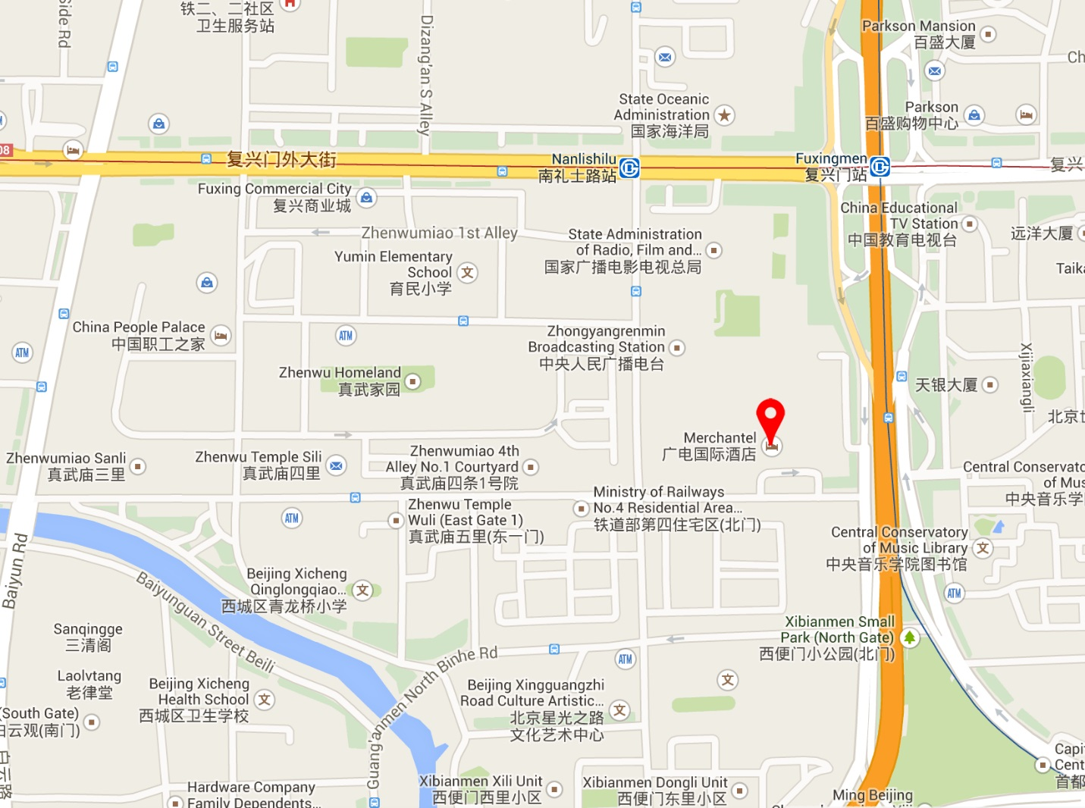
- Transportation and site information
Transportation:
About 34.2KM from Beijing Capital International Airport, Beijing. Taxi about 110RMB.
- Passports and Visas
All foreign visitors entering China must have a valid passport. Visitors from countries whose citizens require a visa should at the earliest time and well in advance of travel apply for a visa at a Chinese Embassy or consulate. The following provides information relating to entry into China.
For an invitation letter, please see Annex C.

- Climate – during June
Monthly Average values of the temperature and precipitation in Beijing, China are given in the table below:
 | June
Average Max Temperature | 30C / 86F
Average Minimum Temperature | 19C / 66F
Average Precipitation | 78 mm
http://en.weather.com.cn/weather/101010100.shtml
- Hotels
VENUE: Merchantel Hotel, No.2 Xibianmen Outer Street, Xicheng District, Beijing
http://www.cytshotels.com/gdgj/merchantel/index.shtml
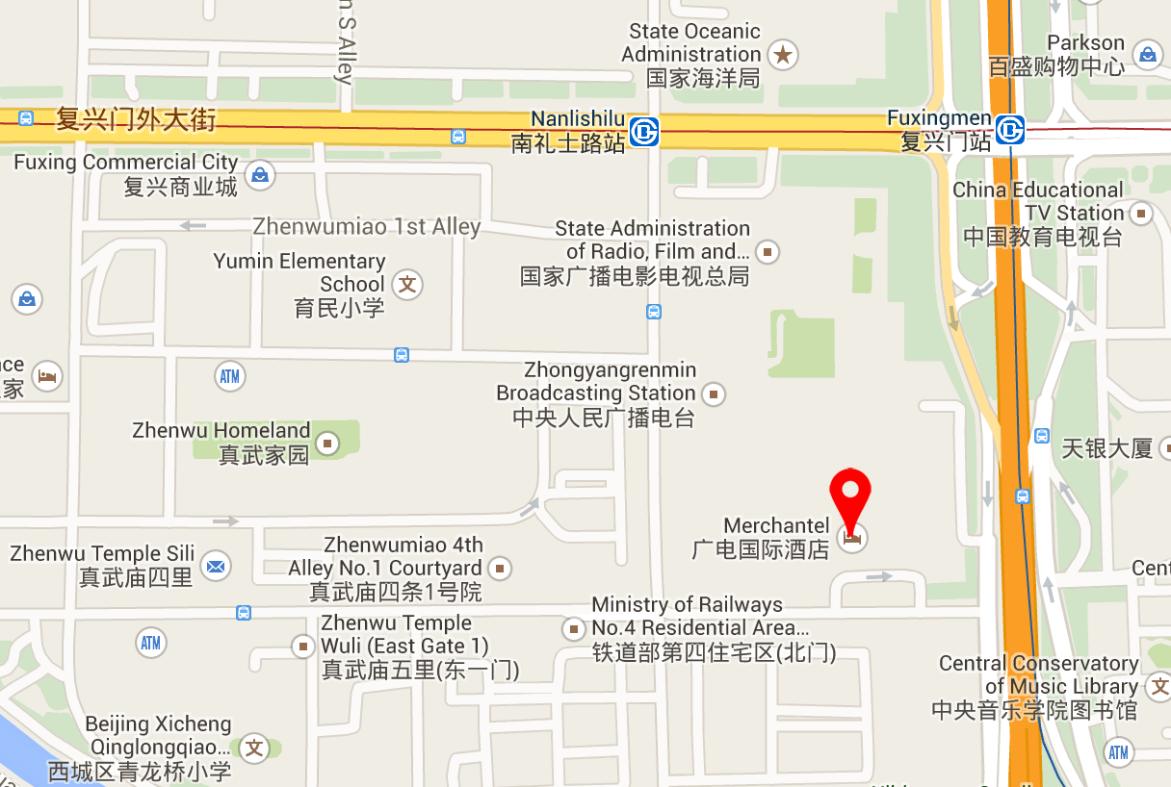

Other hotels close to the venue:
InterContinental Beijing Financial Street Hotel, No.11 Financial Street, Xicheng District, Beijing
http://www.ihg.com/intercontinental/hotels/gb/en/beijing/pegha/hoteldetail
The Westin Beijing Financial Street, 9B Financial Street, XiCheng District, Beijing,
http://www.starwoodhotels.com/westin/property/overview/index.html?propertyID=1704&language=en_US&localeCode=en_US

The way to the meeting venue from “InterContinental Beijing Financial Street Hotel” and “The Westin Beijing Financial Street Hotel”:
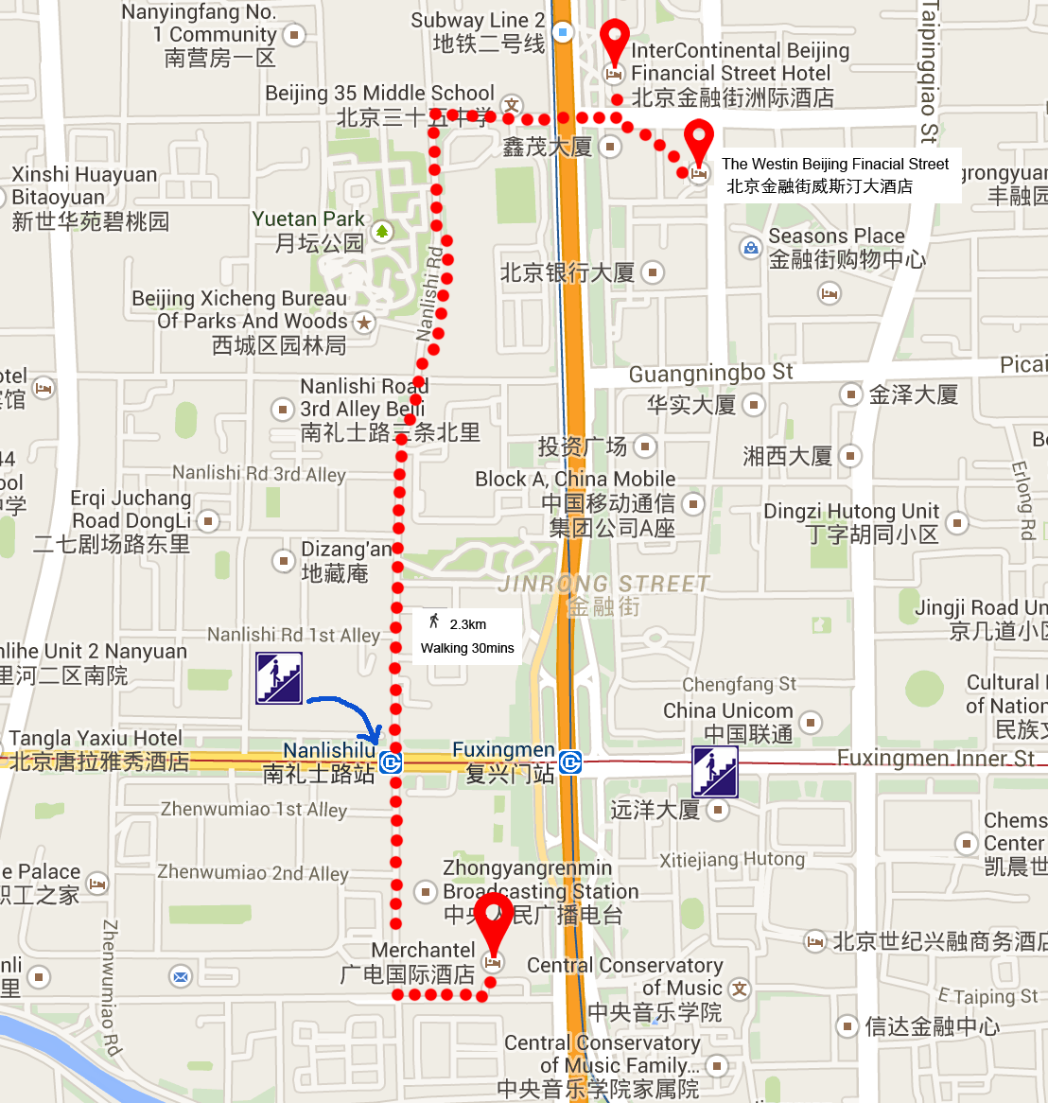
China People Palace, No.1 Zhenwumiao Street, Xicheng District, Beijing
http://www.zgzgzj.com/introduce_en-us.php
The way to the meetings venue from “China People Palace hotel”:
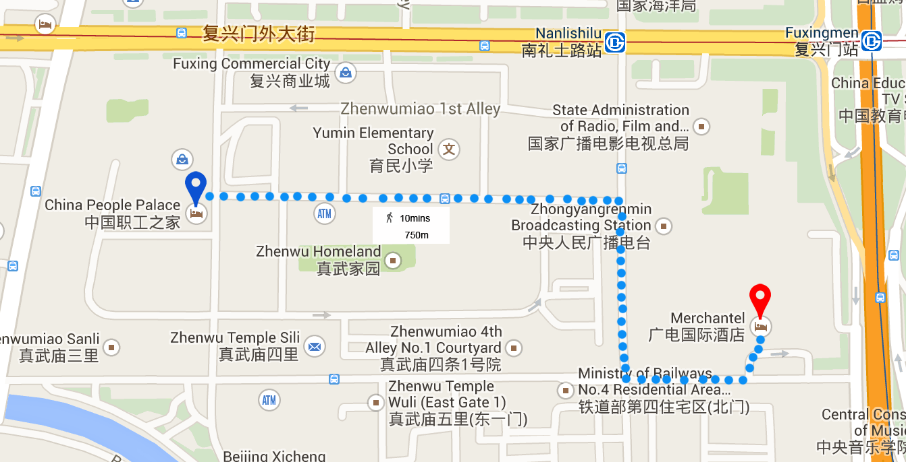

- Internet access and wireless coverage
All meeting rooms will have a wireless network with access to the Internet. Every guest room offers a high-speed Internet access for free. The access to Internet will be granted using the LAN technologies listed below:
- Wireless via WiFi: IEEE 802.11a/n on 5.2 GHz and 802.11g/n on 2.4 GHz.
- Technical assistance
In case you have any technical problem at the venue (e.g. connecting to internet, finding meeting rooms etc.) please contact for help:
Bing Ge, +86 13901281949, gebing@abs.ac.cn
Bo Li, +86 13811931714, libo@abs.ac.cn
- Electricity
The electricity in China is generally 220V, 50HZ. . Please make sure you have the proper adapter.
Chinese standard
Such a socket is common in China, Australia, New Zealand and many other countries.
- Useful information
Currency exchange

The currency in China is the RMB Yuan (￥); please check the currency exchange rate in the local bank system or use the following link as a reference: http://www.xe.com/
- Additional information
General Information for stay in Beijing:
Mobile phone: GSM and CDMA, WCDMA, TD-SCDMA, TD-LTE services provided by China Mobile, China Unicom and China Telecom.
Currency: local currency RMB Yuan (￥), the exchange rate of US$ and RMB is around 6.2.
Tipping: Tipping is not necessary.
Time Zone: GMT+8:00.
Emergency Number: In case of emergency please dial 110.
Sight Seeing:
The Temple of Heaven, Mansion of Prince Gong, etc.
For more information by http://english.visitbeijing.com.cn
- Contact persons
Bing Ge (gebing@abs.ac.cn)
Jingfei Cui (cuijingfei@abs.ac.cn)
Feng Ouyang (ouyangfeng@abs.ac.cn)
Liyue Zhu (zhuliyue@abs.ac.cn)

ANNEX C
INVITATION LETTER REQUEST FORM
All foreign visitors entering China must have a valid passport. Visitors from countries whose citizens require a visa should at the earliest time and well in advance of travel apply for a visa at a Chinese Embassy or consulate. You may need a letter of invitation from the Chinese host, which you will need to present to the Chinese Embassy/Consulate in your area in order to obtain your visa. The visa must be requested as soon as possible and at least four (4) weeks before the start date of the meeting and obtained from the office (embassy or consulate) representing China in your country or, if there is no such office in your country, from the one that is closest to the country of departure. In order to obtain the invitation letter, please:
- Fill out the form below
- Provide the electronic copy of your passport (the name, date of birth, nationality, passport number, valid date of passport, etc. must be seen clearly)
- Provide the electronic copy of previous Chinese visa and records (if you have been to China before)
- Send the info in a), b) and c) as email attachments to Bing Ge gebing@abs.ac.cn and Jingfei Cui cuijingfei@abs.ac.cn ; please mark as reference in the subject “Invitation letter request for ITU-T SG9 Plenary meetings”:
(It is recommended to scan your passport page and email it to us so that it is discernible and can be used).
Company
Applicant Information |  |  |  | Mr Miss Ms Mrs
 |  |  |  | Date of birth :
 |  |  |  | Place of Issue:
 | Date of Issue: |  |  | Date of Expiry:
 | Marital Status:
 | If the country in which you'll obtain your visa is different from your nationality, please indicate it here:
Address | Telephone Number:  Fax Number:  E-mail:
Note
Date of arrive at China |  |  | Date of departure from China
(Please do not forget to attach a copy of your passport photograph page before sending.)
In order to receive an invitation letter, your information should be provided to the host before 10 April 2015.

FORM 1 - FELLOWSHIP REQUEST
(to TSB Collective letter 3/9)
ITU-T Study Group 9 meeting
Beijing, China, 10-17 June 2015
Please return to: |  | ITU  Geneva (Switzerland) |  | E-mail: bdtfellowships@itu.int  Tel: +41 22 730 5227  Fax: +41 22 730 5778
Request for one partial fellowship to be submitted before 29 April 2015
 |  |  | Participation of women is encouraged
Registration Confirmation I.D. No: ……………………………………………………………………………
(Note: It is imperative for fellowship holders to pre-register via the online registration form at: http://www.itu.int/en/ITU-T/studygroups/2013-2016/09/Pages/default.aspx)
Country: _____________________________________________________________________________________________
Name of the Administration or Organization: ______________________________________________________
Mr / Ms _______________________________(family name) ________________________________(given name)
Title: _________________________________________________________________________________________________
Address: _____________________________________________________________________________________________________
_____________________________________________________________________________________________________
Tel.: _________________________ Fax: _________________________ E-Mail: __________________________________
PASSPORT INFORMATION:
Date of birth: ________________________________________________________________________________________
Nationality: ______________________________ Passport number: _______________________________________
Date of issue: ______________ In (place): _________________________Valid until (date): __________________
Please select your preference
(which ITU will do its best to accommodate)
□ Economy class air ticket (duty station / Beijing / duty station)
□ Daily subsistence allowance intended to cover accommodation, meals & misc. expenses
Signature of fellowship candidate: |  |  |  |  | Date:
TO VALIDATE FELLOWSHIP REQUEST, NAME, TITLE AND SIGNATURE OF CERTIFYING OFFICIAL DESIGNATING PARTICIPANT MUST BE COMPLETED BELOW WITH OFFICIAL STAMP.
N.B. IT IS IMPERATIVE THAT FELLOWS BE PRESENT FROM THE FIRST DAY TO THE END OF THE MEETING.
Signature: |  |  |  |  | Date:

ANNEX D
Exhibitors’ Requirement Form
(Note: Please complete and return to gebing@abs.ac.cn by 10 April 2015 to reserve a booth. Considering the limited space and options, all participants should provide their own computers and storage, and please keep them to a minimum.)

Company Name | Contact person including contact details | Email address

Type of equip. to be displayed

Item(s) required | Description | Quantity
Tables
Chairs
Flat Screens
Network switch
Power supply
Space required
Panels
Power consumption expected for equipment:
Dimension, weight of equipment
Additional notes
(if any)

ANNEX E
Draft Agenda
# | Agenda items
 | Opening of the meeting
 | Feedback on interim activities since last meeting
 | TSAG/RevCom (June 2015) results relevant to SG9
 | Rapporteurs, Associates and other roles
 | Contributions for opening Plenary
 | Report from other Groups/Workshops
 | AOB for opening Plenary
 | Intellectual Property Rights inquiry
 | “Consent” on draft Recommendations proposed for approval in accordance with Recommendation A.8
 | Approval of Working Parties reports and Question meetings report
 | New/amended Questions (if any)
 | New appointment and change of appointment of Rapporteur(s), Associate Rapporteur(s), liaison officers
 | Update of SG9 Work Programme
 | Outgoing Liaison Statements
 | Date and place of the next SG9 meeting
 | Future Interim activities (Rapporteurs, WPs)
 | AOB
 | Closing
Note: Items 1 to 7 are expected to be addressed in the opening Plenary (10 June 2015) and items 8 to 18 are expected to be addressed in the closing Plenary (17 June 2015).

ANNEX F
Draft Timetable
SG9 draft meeting plan (10-17 June 2015, Beijing, China)
 | Wednesday 10  June |  |  |  | Thursday 11  June |  |  |  | Friday 12  June |  |  |  | Sat 13  June | Sun 14  June | Monday 15  June |  |  |  | Tuesday 16  June |  |  |  | Wednesday 17  June
Sessions | 1 | 2 | 3 | 4 | 1 | 2 | 3 | 4 | 1 | 2 | 3 | 4 |  |  | 1 | 2 | 3 | 4 | 1 | 2 | 3 | 4 | 1 | 2 | 3 | 4
PLEN | X | 2 |  |  |  |  |  |  |  |  |  |  |  |  |  |  |  |  |  |  |  |  | X | X | X | X
WPs |  | 2 |  |  |  |  |  |  |  |  |  |  |  |  |  |  |  |  |  | X | X | X
Q1/9 |  |  | 3 |  | X |  |  |  |  |  |  | 3 |  |  | X |  |  | 3
Q2/9 |  |  | X |  | 4 |  |  | X | 4 | X |  |  |  |  | X |  |  | 4
Q3/9 |  |  | X |  |  |  | X | X |  |  | X | X |  |  |  | X |  | X
Q4/9 |  |  |  | X | X | X | X |  | X | X |  |  |  |  | X |  |  | X | X
Q5/9 |  |  | 5 | X | 5 | X |  |  | 5 | X |  |  |  |  | 5 | X |  |  | X
Q6/9 |  |  | X |  | X |  |  |  |  | X
Q7/9 |  |  | 3 |  |  | X |  | X |  |  | X | 3 |  |  |  |  | X | 3 | X
Q8/9 |  |  | 5 |  | 5 |  | X |  | 5 |  | X |  |  |  | 5 |  | X
Q9/9 |  |  | 5 |  | 5 |  |  | X | 5 |  |  | X |  |  | 5 |  |  | X
Q10/9 |  |  |  |  |  |  | X | X |  |  | X | X |  |  |  |  | X |  | X
Q11/9 |  |  |  |  |  | X |  |  |  |  |  |  |  |  |  | X
Q12/9 |  |  |  | X | 4 |  | X |  | 4 |  | X |  |  |  |  | X | X | 4
Q13/9 |  |  |  | X |  | X |  |  | X |  |  | X |  |  | X | X | X |  | X
Newcomers |  | 1
Session 1: 0930 – 1045; Session 2: 1115-1230; Session 3: 1430-1545; Session 4: 1615-1730;

PLEN | Plenary sessions
WPs | Working Parties 1 and 2 Plenary sessions
X | Represents a meeting session
 | Indicates a lunch/evening session
1 | A newcomers orientation session will follow the WPs/9 opening plenary sessions (1230-1330)
2 | WP1/9 and WP2/9 Plenary sessions will be held sequentially and will follow SG9 Plenary
3 | Joint session of Q1 and Q7/9
4 | Joint session of Q2 and Q12/9
5 | Joint session Q5, Q8, Q9

_____________

