INTERNATIONAL TELECOMMUNICATION UNION |  | Focus Group On  Car Communication
TELECOMMUNICATION  STANDARDIZATION SECTOR  STUDY PERIOD 2013-2016 |  | FG CarCOM-C-48
English only
Original: English
 |  | Geneva, 18-19 February 2013
CONTRIBUTION
Source: | FG Chairman
Title: | Draft 20 of FG.VSSR

FG.VSSR – Draft 20
FG CarCom SubSystem Requirements for Automotive Speech Services
Summary
This Specification defines test methodologies for and standard behaviour of subsystems used in automotive speakerphone terminals. The purpose is to provide guidance on the design and optimization of subsystems as well as diagnostic capabilities needed to give a consistent and high Quality of Service of the overall speakerphone terminal for the users of such devices. This specification is intended to give guidance to all parties involved in the design and integration of speakerphone terminals. This specification covers both, narrowband and wideband systems.

Keywords
Hands-Free, Speakerphone, Motor Vehicles, Subsystem, Quality of Service, Performance, Performance

Contents

Table of content
Contents 2
1) Scope 9
2) References 9
3) Definitions 11
4) Abbreviations 12
5) Conventions 15
6) How to Use the Specification 16
7) Architectures 16
7.1 Distributed speakerphone 17
7.2 System with integrated microphone 18
7.3 System with integrated speaker 18
7.4 System with integrated microphone and speaker 19
7.5 System Delay, Subsystem Delay and Buffering 19
8) Subsystems 20
8.1 Test Interface description 20
8.1.1 Analog electrical interface 20
8.1.2 Digital electrical interface 20
8.1.3 Acoustic interface 20
8.1.4 Wireless interface 21
8.1.5 Test signal levels 21
8.2 Acoustic Subsystem 21
8.2.1 Microphone subsystem (send path) 22
8.2.2 Audio subsystem (receive path) 39
8.2.3 Coupling between acoustical subsystems (echo path) 54
8.3 Signal Enhancement Subsystem 55
8.3.1 Test set-up 55
8.3.2 Round-Trip Delay of Signal Enhancement 57
8.3.3 Signal enhancement delay in send direction 58
8.3.4 Signal enhancement delay in receive direction 59
8.3.5 Signal enhancement send junction loudness ratings 59
8.3.6 Receive signal enhancement loudness ratings 60
8.3.7 Signal enhancement send sensitivity frequency response 61
8.3.8 Signal enhancement receive sensitivity frequency response 68
8.3.9 Signal Enhancement Send Speech Quality (MOS-LQO-SE) 74
8.3.10 Signal Enhancement Receive Speech Quality (MOS-LQO-RE) 75
8.3.11 Signal Enhancement Send Speech Quality Stability (MOS-LQO-STB-SE) 75
8.3.12 Signal Enhancement Receive Speech Quality Stability (MOS-LQO-STB-RE) 76
8.3.13 Signal Enhancement Send Intelligibility (SIE) 76
8.3.14 Signal Enhancement Receive Intelligibility (RIE) 77
8.3.15 Signal Enhancement Send Idle Channel Noise (SICNE) 77
8.3.16 Signal Enhancement Receive Idle Channel Noise (RICNE) 77
8.3.17 Discrimination against out-of-band signals after Send Enhancement (DOSE) 78
8.3.18 Spurious out-of-band signal after Receive Enhancement (SORE) 78
8.3.19 Distortion in Send after Enhancement (DSE) 79
8.3.20 Distortion in Receive after Enhancement (DRE) 79
8.3.21 Signal Enhancement Weighted Terminal Coupling Loss (TCLwE) 80
8.3.22 Signal Enhancement Echo Level Versus Time (ELVTE) 80
8.3.23 Signal Enhancement Spectral Echo Attenuation (SEAE) 81
8.3.24 Signal Enhancement Initial Convergence without background noise (ICE) 81
8.3.25 Signal Enhancement Initial Convergence With Background Noise (ICBNE) 82
8.3.26 Signal Enhancement Echo Performance with Time Variant Echo Path (TVEPE) 82
8.3.27 Signal Enahncement Echo Performance with Time Variant Echo Path and Artificial Voice (TVEPE-AV) 83
8.3.28 Signal Enhancement Send Activation (SAE) 83
8.3.29 Signal Enhancement Receive Activation (RAE) 84
8.3.30 Signal Enhancement Send Attenuation Range (SARE) 84
8.3.31 Signal Enhancement Receive Attenuation Range (RARE) 84
8.3.32 Signal Enhancement Attenuation Range in Send during Double-Talk (ASDTE) 85
8.3.33 Signal Enhancement Attenuation Range in Receive during Double-Talk (ARDTE) 85
8.3.34 Detection of Echo Components during Double-Talk after Enhancement (DECDTE) 86
8.3.35 Signal Enhancement Sent Speech Attenuation during Double-Talk (SSADTE) 86
8.3.36 Signal Enhancement Speech-to-Echo Ratio (SpERE) 87
8.3.37 SNR Improvement after Enhancement (SNRIE) 87
8.3.38 Signal Enhancement Background Noise Transmission After Call Set-up (BGNTACSE) 87
8.3.39 Enhanced Speech Quality in the Presence of Background Noise (SQPBGNE) 88
8.3.40 Enhanced Quality of Background Noise Transmission with Far End Speech (QBGNTFSE) 88
8.3.41 Enhanced Quality of Background Noise Transmission with Near End Speech (QBGNTNSE) 89
8.3.42 Comfort Noise Injection after Enhancement (CNIE) 89
8.3.43 Speech Recognition Accuracy Indicator after Enhancement (SRAIE) 90
8.3.44 Send path 90
8.3.45 Echo path 90
8.3.46 Receive path 90
8.4 Network Access Subsystem 90
8.4.1 Send path 90
8.4.2 Echo path 91
8.4.3 Receive path 91
8.4.4 Send-receive path coupling 91
9) Bidirectional Signal Transport: Wired and Short range Wireless Transmission 91
9.1 Bidirectional transport delay in send direction 93
9.1.1 Parameter description 93
9.1.2 Test 93
9.1.3 Performance level classification based on values of this parameter 94
9.1.4 Design guidance and root-cause analysis 94
9.2 Bidirectional transport delay in receive direction 94
9.2.1 Parameter description 94
9.2.2 Test 95
9.2.3 Performance level classification based on values of this parameter 95
9.2.4 Design guidance and root-cause analysis 95
9.3 Bidirectional transport send junction loudness ratings 96
9.3.1 Parameter description 96
9.3.2 Test 96
9.3.3 Performance level classification based on values of this parameter 96
9.3.4 Design guidance and root-cause analysis 96
9.4 Bidirectional transport receive loudness ratings 97
9.4.1 Parameter description 97
9.4.2 Test 97
9.4.3 Performance level classification based on values of this parameter 97
9.4.4 Design guidance and root-cause analysis 98
9.5 Bidirectional transport linearity in send direction 98
9.5.1 Parameter description 98
9.5.2 Test 98
9.5.3 Performance level classification based on values of this parameter 98
9.5.4 Design guidance and root-cause analysis 99
9.6 Bidirectional transport linearity in receive direction 99
9.6.1 Parameter description 99
9.6.2 Test 99
9.6.3 Performance level classification based on values of this parameter 99
9.6.4 Design guidance and root-cause analysis 100
9.7 Bidirectional transport send sensitivity frequency response 100
9.7.1 Parameter description 100
9.7.2 Test 100
9.7.3 Performance level classification based on values of this parameter 100
9.7.4 Design guidance and root-cause analysis 102
9.8 Bidirectional transport receive sensitivity frequency response 103
9.8.1 Parameter description 103
9.8.2 Test 103
9.8.3 Performance level classification based on values of this parameter 103
9.8.4 Design guidance and root-cause analysis 105
9.9 Bidirectional transport idle channel noise in send 105
9.9.1 Parameter description 105
9.9.2 Test 105
9.9.3 Performance level classification based on values of this parameter 106
9.9.4 Design guidance and root-cause analysis 106
9.10 Bidirectional transport idle channel noise in receive 107
9.10.1 Parameter description 107
9.10.2 Test 107
9.10.3 Performance level classification based on values of this parameter 107
9.10.4 Design guidance and root-cause analysis 108
9.11 Bidirectional transport noise cancellation test in send direction 108
9.11.1 Parameter description 108
9.11.2 Test 108
9.11.3 Performance level classification based on values of this parameter 108
9.11.4 Design guidance and root-cause analysis 109
9.12 Bidirectional transport one-way speech quality in send direction 109
9.12.1 Parameter description 109
9.12.2 Test 109
9.12.3 Performance level classification based on values of this parameter 110
9.12.4 Design guidance and root-cause analysis 110
9.13 Bidirectional transport speech quality stability in send direction 110
9.13.1 Parameter description 110
9.13.2 Test 110
9.13.3 Performance level classification based on values of this parameter 112
9.13.4 Design guidance and root-cause analysis 112
9.14 Bidirectional transport one-way speech quality in receive direction 113
9.14.1 Parameter description 113
9.14.2 Test 113
9.14.3 Performance level classification based on values of this parameter 113
9.14.4 Design guidance and root-cause analysis 114
9.15 Bidirectional transport speech quality stability in receive direction 114
9.15.1 Parameter description 114
9.15.2 Test 114
9.15.3 Performance level classification based on values of this parameter 114
9.15.4 Design guidance and root-cause analysis 114
9.16 Verification of bidirectional transport disabled echo control 115
9.16.1 Parameter description 115
9.16.2 Test 115
9.16.3 Performance level classification based on values of this parameter 116
9.16.4 Design guidance and root-cause analysis 117
10) Unidirectional Signal Transport: Wired and Short range Wireless Transmission 117
10.1 Test setup 117
10.2 Unidirectional transport delay 118
10.2.1 Parameter description 118
10.2.2 Test 118
10.2.3 Performance level classification based on values of this parameter 118
10.2.4 Design guidance and root-cause analysis 119
10.3 Unidirectional transport junction loudness ratings 119
10.3.1 Parameter description 119
10.3.2 Test 119
10.3.3 Performance level classification based on values of this parameter 119
10.3.4 Design guidance and root-cause analysis 120
10.4 Unidirectional transport linearity 120
10.4.1 Parameter description 120
10.4.2 Test 120
10.4.3 Performance level classification based on values of this parameter 120
10.4.4 Design guidance and root-cause analysis 121
10.5 Unidirectional transport sensitivity frequency response 121
10.5.1 Parameter description 121
10.5.2 Test 121
10.5.3 Performance level classification based on values of this parameter 121
10.5.4 Design guidance and root-cause analysis 123
10.6 Unidirectional transport idle channel noise 124
10.6.1 Parameter description 124
10.6.2 Test 124
10.6.3 Performance level classification based on values of this parameter 124
10.6.4 Design guidance and root-cause analysis 125
10.7 Unidirectional transport noise cancellation test 125
10.7.1 Parameter description 125
10.7.2 Test 125
10.7.3 Performance level classification based on values of this parameter 125
10.7.4 Design guidance and root-cause analysis 126
10.8 Unidirectional transport speech quality 126
10.8.1 Parameter description 126
10.8.2 Test 126
10.8.3 Performance level classification based on values of this parameter 126
10.8.4 Design guidance and root-cause analysis 127
10.9 Unidirectional transport speech quality stability 127
10.9.1 Parameter description 127
10.9.2 Test 127
10.9.3 Performance level classification based on values of this parameter 128
10.9.4 Design guidance and root-cause analysis 129
10.10 System with integrated microphone and speaker 129
11) Microphone sensitivity (in anechoic conditions) 130
11.1 Parameter description 130
11.2 Test 130
11.3 Performance level classification based on values of this parameter 130
11.4 Design guidance and root-cause analysis 131
12) Microphone frequency response (in anechoic conditions) 131
12.1 Parameter description 131
12.2 Test 131
12.3 Performance level classification based on values of this parameter 131
12.4 Design guidance and root-cause analysis 134
13) Microphone directional characteristics (in anechoic conditions) 134
13.1 Parameter description 134
13.2 Test 134
13.3 Performance level classification based on values of this parameter 134
13.4 Design guidance and root-cause analysis 135
14) Microphone distortion (in anechoic conditions) 135
14.1 Parameter description 135
14.2 Test 135
14.3 Performance level classification based on values of this parameter 135
14.4 Design guidance and root-cause analysis 136
15) Microphone maximum sound pressure level (in anechoic conditions) 136
15.1 Parameter description 136
15.2 Test 136
15.3 Performance level classification based on values of this parameter 136
15.4 Design guidance and root-cause analysis 137
16) Microphone self-noise (in anechoic conditions) 137
16.1 Parameter description 137
16.2 Test 137
16.3 Performance level classification based on values of this parameter 137
16.4 Design guidance and root-cause analysis 138
1. Introduction 145
2. Signal-to-Noise Ratio Measurement 145
3. Noise Variance Tracking and Voice Activity Detection 146
4. Speech Pause Detection 147
5. Measurement Setup 148
References 149
X.1 General 150
X.2 Frame interval 150
X.3 Delay 150
X.4 Arbitration between two subsystems having different frame intervals 151
Case 1) Sender’s and receiver’s frame intervals are identical 151
Case 2) Sender’s frame interval is a multiple of receiver’s frame interval 151
Case 3) Receiver’s frame interval is a multiple of sender’s frame interval 153
Case 4) Other cases 153
X.5 Example 154

Scope
The aim of this Specification is the definition of test methods and requirements for subsystems of automotive narrowband and wideband speakerphone terminals and other speech services using the speakerphone acoustic interface. The Specification covers
- Definition of subsystems based on different system architectures
- Performance requirements for subsystems
- Diagnostic information
- Guidance on component and subsystem optimization
- Coordination of subsystems
- Both, narrowband and wideband systems
- Acoustic interface requirements for other speech services such as speech recognition and application prompt playback

The methods, the analysis and the performance parameters described in this Specification are based on test signals and test procedures as defined in ITU-T Recommendations P.50 [10], P.501 [11], P.502 [12] and P.340 [18], P.380 [19], P.1100[xx], P.1110 [xx] and ETSI ES 202 739 [24] and ETSI ES 202 740 [25].

References
The following ITU-T Recommendations and other references contain provisions, which, through reference in this text, constitute provisions of this Recommendation. At the time of publication, the editions indicated were valid. All Recommendations and other references are subject to revision; users of this Recommendation are therefore encouraged to investigate the possibility of applying the most recent edition of the Recommendations and other references listed below. A list of the currently valid ITU-T Recommendations is regularly published.
The reference to a document within this Recommendation does not give it, as a stand-alone document, the status of a Recommendation
[1] Berger, J., Results of objective speech quality assessment including receiving terminals using the advanced TOSQA2001, ITU-T Contribution, Dec. 2000, COM 12-20-E
[2] ETSI EG 202 396-1: Speech quality performance in the presence of background noise; Part 1: Background noise simulation technique and background noise database.
[3] Fingscheidt, T., Suhadi, S.: Quality Assessment of Speech Enhancement Systems by Separation of Enhanced Speech, Noise, and Echo, INTERSPEECH 2007, Antwerp, Belgium, Aug. 2007.
[4] Steinert, K., Suhadi, S., Fingscheidt, T., A Comparison of Instrumental Measures for Wideband Speech Quality Assessment of Hands-free Systems in Echoic Condition, DAGA 2009, Rotterdam, The Netherlands, March 2009.
[5] IEC 61260: Electroacoustics - Octave-band and fractional-octave-band filters - Part 1: Specifications, 1995.
[6] IEC 60268-4: Sound system equipment - Part 4: Microphones, 2004.
[7] ITU-T Recommendation G.122: Influence of National Systems on Stability and Talker Echo in International Connections.
[8] ITU-T Recommendation P.340: Transmission Characteristics and Speech Quality Parameters of Hands-free Telephones.
[9] ITU-T Recommendation P.380: Electroacoustic Measurements on Headsets
[10] ITU-T Recommendation P.50 (1993) : Artificial Voices.
[11] ITU-T Recommendation P.501: Test Signals for Use in Telephonometry.
[12] ITU-T Recommendation P.502: Objective Analysis Methods for Speech Communication Systems, Using Complex Test Signals.
[13] ITU-T Recommendation P.56: Objective Measurement of Active Speech Level.
[14] ITU-T Recommendation P.57 : Artificial Ears.
[15] ITU-T Recommendation P.58: Head and Torso Simulators for Telephonometry.
[16] ITU-T Recommendation P.581 (05/00): Use of Head and Torso Simulators (HATS) for Hands-free Terminal Testing.
[17] ITU-T Recommendation P.79: Calculation of Loudness Rating for Telephone Sets.
[18] ITU-T Recommendation P.800: Methods for Subjective Determination of Transmission Quality.
[19] ITU-T Recommendation P.800.1: Mean Opinion Score (MOS) Terminology.
[20] ITU-T Recommendation P. 862.2: Wideband extension to Recommendation P.862 for the assessment of wideband telephone networks and speech codecs.
[21] ITU-T Recommendation P. 862.1: Mapping Function for Transforming P.862 Raw Result Scores to MOS-LQO.
[xx] ITU-T Recommendation P.863, “Methods for objective and subjective assessment of speech quality”, 11/2011
[22] Sottek, R., Genuit, K.: Models of Signal Processing in Human Hearing, International Journal of Electronics and Communications, pp. 157-165, 2005.
[23] Kettler, F., Gierlich, H.W.: Evaluation of Hands-Free Terminals, in “Topics in Speech and Audio Processing” edited by E. Hänsler, G. Schmidt, Springer, ISBN: 978-3-540-70601-4.
[24] ETSI ES 202 739: Transmission requirements for wideband VoIP terminals (handset and headset) from a Performance perspective as perceived by the user
[25] ETSI ES 202 740: Transmission requirements for wideband loudspeaking and hands-free terminals from a Performance perspective as perceived by the user
[26] ETSI EG 202 396-3: Speech quality performance in the presence of background noise; Part 3: Background noise transmission - objective model.
[27] ISO 3745: Acoustics -- Determination of sound power levels of noise sources using sound pressure -- Precision methods for anechoic and hemi-anechoic rooms
P.1100
P.1110
G. 100.1

Definitions
Artificial ear: Device incorporating an acoustic coupler and a calibrated microphone for the measurement of the sound pressure and having an overall acoustic impedance similar to that of the median adult human ear over a given frequency band.
Codec: Combination of an analogue-to-digital encoder and a digital-to-analogue decoder operating in opposite directions of transmission in the same equipment.
Composite Source Signal (CSS): Signal composed in time by various signal elements.
Diffuse field equalization: Equalization of the HATS sound pick-up, equalization of the difference, in dB, between the spectrum level of the acoustic pressure at the ear Drum Reference Point (DRP) and the spectrum level of the acoustic pressure at the HATS Reference Point (HRP) in a diffuse sound field with the HATS absent using the reverse nominal curve given in Table 3 of ITU-T Recommendation P.58 [15].
Ear-Drum Reference Point (DRP): Point located at the end of the ear canal, corresponding to the ear-drum position.
Freefield reference point: Point located in the free sound field, at least in 1,5 m distance from a sound source radiating in free air (in case of a head and torso simulator [HATS] in the center of the artificial head with no artificial head present).
Freefield equalization: The transfer characteristic of the artificial head is equalized in such a way that for frontal sound incidence in anechoic conditions the frequency response of the artificial head is flat. This equalization is specific to the HATS used.
Hands-Free Reference Point (HFRP): A point located on the axis of the artificial mouth, at 50 cm from the outer plane of the lip ring, where the level calibration is made, under free-field conditions. It corresponds to the measurement point 11, as defined in ITU-T Rec. P.51.
Hands-free terminal: Telephone set that does not require the use of hands during the communications session; examples are headset, speakerphone and group-audio terminal.
Head And Torso Simulator (HATS) for telephonometry: Manikin extending downward from the top of the head to the waist, designed to simulate the sound pick-up characteristics and the acoustic diffraction produced by a median human adult and to reproduce the acoustic field generated by the human mouth.
Headset: Device which includes telephone receiver and transmitter which is typically secured to the head or the ear of the wearer.
MOS-LQO (Mean Opinion Score – Listening-only Quality Objective): The score is calculated by means of an objective model which aims at predicting the quality for a listening-only test situation. Objective measurements made using the model given in ITU-T Rec. P.862 give results in terms of MOS-LQO (for further information see Annex A).
MOS-TQO (Mean Opinion Score – Talking Quality Objective): The score is calculated by means of an objective model which aims at predicting the quality for a talking-only test situation. Methods generating a MOS-TQO are currently under development and not yet standardized.
Mouth Reference Point (MRP): The MRP is located on axis and 25 mm in front of the lip plane of a mouth simulator.
Nominal setting of the volume control: When a receive volume control is provided, the setting which is closest to the nominal RLR of 2 dB.
Receive loudness rating (RLR): The loudness loss between an electric interface in the network and the listening subscriber's ear. (The loudness loss is here defined as the weighted (dB) average of driving e.m.f. to measured sound pressure.)
Send loudness rating (SLR): The loudness loss between the speaking subscriber's mouth and an electric interface in the network. (The loudness loss is here defined as the weighted (dB) average of driving sound pressure to measured voltage.)
Wideband speech: Voice service with enhanced quality compared to PCM G.711 and allowing the transmission of a vocal frequency range of at least 150 Hz to 7 kHz

Abbreviations
ACR Absolute category rating
A/D Analogue/Digital
AGC Automatic Gain Control
AH,R Attenuation Range in receive direction
AH,R,dt Attenuation Range in receive direction during Double Talk
AH,S Attenuation Range in Send direction
AH,S,dt Attenuation Range in Send direction during Double Talk
BGN BackGround Noise
BT Bluetooth
BTR Bluetooth Reference Point
COH_{REF-LSP} Coherence between the test points LSP and REF
CSS Composite Source Signal
D/A Digital/Analogue
D D-Value is computed directly from measurements of the difference Δ_{Sm} between the send sensitivities for diffuse and direct sound, S_{si} (diff) and S_{si} (direct), respectively.
Δ_{Sm} = S_{si} (diff) − S_{si} (direct) (E-2)
D is computed as a weighted average of Δ_{Sm}
DELSM DELSM is sometimes used for Δ_{Sm}. (see D-Value)
DOOB_{SES} Discrimination Against Out-of-Band Signals After Signal Enhancement, Send
DRP Drum Reference Point
D_{SER} Distortion in Receive after Signal Enhancement
D_{SES} Distortion in Send after Signal Enhancement
DTX Discontinuous Transmission
DUT Device under Test
EC_{BD} Bidirectional Transport Echo Cancellation
EEB Early Energy Balance
ELVT_{SE} Signal Enhancement Echo Level Versus Time
ERL Echo Return Loss

FFT Fast Fourier Transform
FR_{AS} Frequency Response Audio Subsystem
FR_{BDR} Frequency Response Bidirectional Transport, Receive
FR_{BDS} Frequency Response Bidirectional Transport, Send
FR_{MS} Frequency Response Microphone, Send
FR_{SES} Frequency Response Signal Enhancement Subsystem, Send
FR_{SER} Frequency Response Signal Enhancement Subsystem, Receive
FR_{UD} Frequency Response Unidirectional Transport
HATS Head And Torso Simulator
HATS-HFRP Head And Torso Simulator – Hands Free Reference Point
HF System Hands Free System
HFT Hands Free Terminal
HVAC Heating Ventilation Air Condition
IC_{SE} Signal Enhancement Initial Convergence without background noise
JLR Junction Loudness Rating
JLR_{BDR} Junction Loudness Rating Bidirectional Transport, Receive
JLR_{BDS} Junction Loudness Rating Bidirectional Transport, Send
L _{SER} Receive Signal Level Signal Enhancement
SLR _{SES} Send Loudness Rating Signal Enhancement
JLR_{UD} Junction Loudness Rating Unidirectional Transport
L_{S,min} minimum activation level (Send Direction)
L_{MS} Microphone Output Level, Send
LIN_{MS} Microphone Input/Output Linearity, Send
LIN_{REF-LSP} Audio Subsystem Linearity between REF and LSP
LQ_{AS} Audio Subsystem Speech Quality
LQ_{BDR} Bidirectional Transport Speech Quality, Receive
LQ_{BDS} Bidirectional Transport Speech Quality, Send
LQ_{MS} Microphone Speech Quality, Send
LQ_{UD} Unidirectional Transport Speech Quality
LQS_{BDR} Bidirectional Transport Speech Quality Stability, Receive
LQS_{BDS} Bidirectional Transport Speech Quality Stability, Send
LQS_{UD} Unidirectional Transport Speech Quality Stability
LQBGN_{MS} Microphone Speech Quality with Background Noise, Send
MOS Mean Opinion Score
MOS-LQO_{SER} Signal Enhancement Receive Speech Quality
MOS-LQO_{SES} Signal Enhancement Send Speech Quality
MRP Mouth Reference Point
N_{AS} Audio Subsystem Idle Noise
N_{BDR} Bidirectional Transport Idle Noise, Receive
N_{BDS} Bidirectional Transport Idle Noise, Send
N_{MS} Microphone Idle Noise, Send

N_{UD} Unidirectional Transport Idle Noise
NC Noise Criterion
NC_{BDR} Bidirectional Transport Noise Cancellation, Receive
NC_{BDS} Bidirectional Transport Noise Cancellation, Send
NC_{UD} Unidirectional Transport Noise Cancellation
NR Noise Reduction
OHC Overhead Console
OL_{ASmax} Audio Subsystem maximum output level
OVL_{MS} Microphone Overload Point
OVL_{AS} Audio Subsystem Overload Point
PCM Pulse Code Modulation
RFIFAP Reference Interface Access Point
POI Point Of Interconnection
QoS Quality of Service
REV_{MS} Microphone Reverberation, Send
RLR Receive Loudness Rating
SEA_{SE} Signal Enhancement Spectral Echo Attenuation
SINR Speech to idle noise ratio
SINR_{SER} Speech to idle noise ratio Signal Enhancement, Receive
SINR_{SES} Speech to idle noise ratio Signal Enhancement, Send
SNR Signal to Noise Ratio
SNRD SNR Difference
SLR Send Loudness Rating
SOOB_{SER} Spurious Out-of-Band Signals After Signal Enhancement, Receive
SRW Short Range Wireless Transmission
SRWAP Short Range Wireless Reference Access Point
Test Point Subsystem Access Point
S_{si}(diff) Diffuse field sensitivity
S_{si}(direct) Direct sound sensitivity
SNNR Signal to Noise Ratio
SNR_{M} Microphone SNR
T_{AS} Audio Subsystem Delay
T_{BDR} Bidirectional Transport Delay, Receive
T_{BDS} Bidirectional Transport Delay, Send
T_{UD} Unidirectional Transport Delay
TCL_{SE} Signal Enhancement Terminal Coupling Loss (wideband)
TCLw Weighted Terminal Coupling Loss
TCLw_{SE} Signal Enhancement Weighted Terminal Coupling Loss (narrowband)
T_{REF-LSP} Audio Subsystem Delay between REF and LSP
Tr,R built-up time (Receive Direction)
Tr,S built-up time (Send Direction)
T_{s} Send Delay hands-free terminal
T_{SES} Send Delay signal enhancementT_{r} Receive Delay hands-free terminal
T_{SER} Receive Delay signal enhancement
T_{SERTD} Round Trip Delay signal enhancement
T_{rtd-HF} Round Trip Delay hands-free terminal

Conventions
dBm: absolute power level relative to 1 milliwatt, expressed in dB
dBm0: absolute power level in dBm referred to a point of zero relative level (0 dBr point)
dBm0p: weighted dBm0, according to ITU-T Recommendation O.41
dBm0(C): C weighted dBm0, according to ISO 1999
dBov: dB relative to the overload point of a digital system according to ITU-T Recommendation G.100.1dBPa: sound pressure level relative to 1 Pa, expressed in dB
dBPa(A): A-weighted sound pressure level relative to 1 Pa, expressed in dB
dBSPL: sound pressure level relative to 20µPa, expressed in dB; (94dBSPL=0dBPa)

dBV(P): P-weighted voltage relative to 1 V, expressed in dB, acc. to O.41

dBr: relative power level of a signal in a transmission path referred to the level at a reference point on the path (0 dBr point)
N: Newton
Vrms: Voltage – root mean square
cPa: Compressed Pascal, sound pressure at the output of the hearing model in the “Relative Approach” after nonlinear signal processing by the human ear

How to Use the Specification
This specification uses the concept of performance classes for each parameter to be tested. It is the intention to identify the quality of the different subsystems by the classification based on the different parameters. The following general definition applies:

Performance class 1:
Performance class 1 characterizes an exceptionally good implementation of the relevant parameter. Performance class 1 can typically only be achieved with special constraints or effort in terms of design, cost and time.
Performance class 2:
Performance class 2 characterizes an implementation which most likely fulfils the requirements in ITU-T Recommendation P.1100 and P.1110. Performance class 2 can be expected to be representative for good implementations.
Performance class 3:
Performance class 3 characterizes some weakness for the parameter under test. If a parameter is fulfilling just Performance class 3 it may be acceptable only given that other parameters benefit from that or may compensate the weakness of this parameter and the complete system is still fulfilling the requirements of ITU-T Recommendation P.1100 and P.1110.
Performance class 4:
Performance class 4 characterizes an unacceptable weakness of the parameter under test.

Architectures

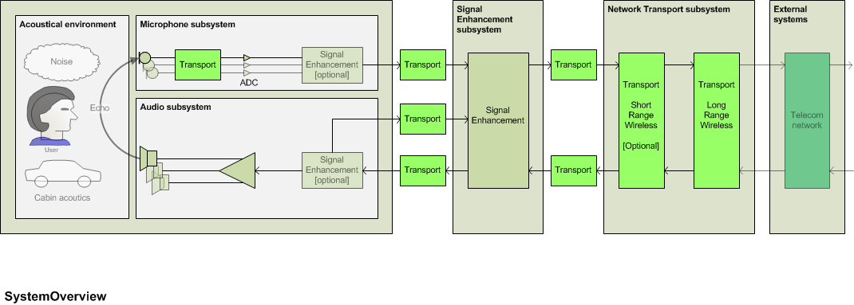
Fig. 7.1 Abstract architecture – System Overview
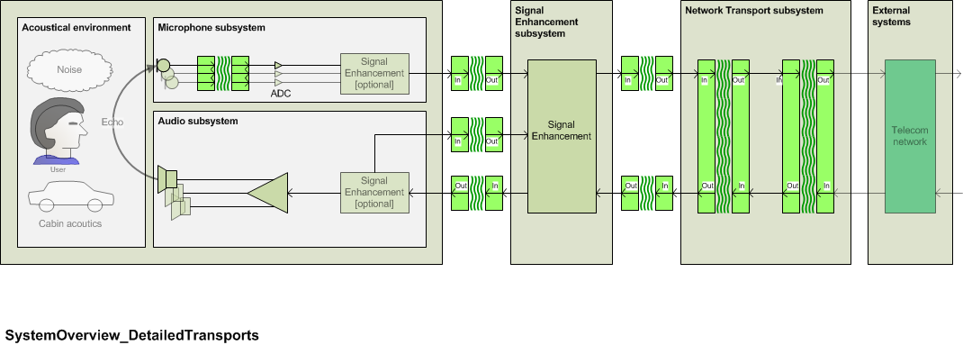
Fig. 7.2: System Overview with detailed transport

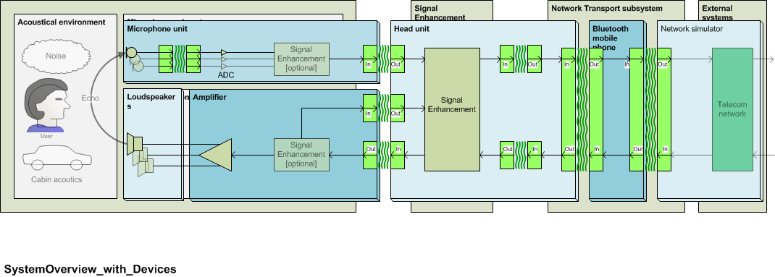
Fig. 7.3: System overview with the example of typical devices

Distributed speakerphone
The subsystems are tested as described in the different sections of this specification. The test points for the different subsystems are shown in Fig. 7.2
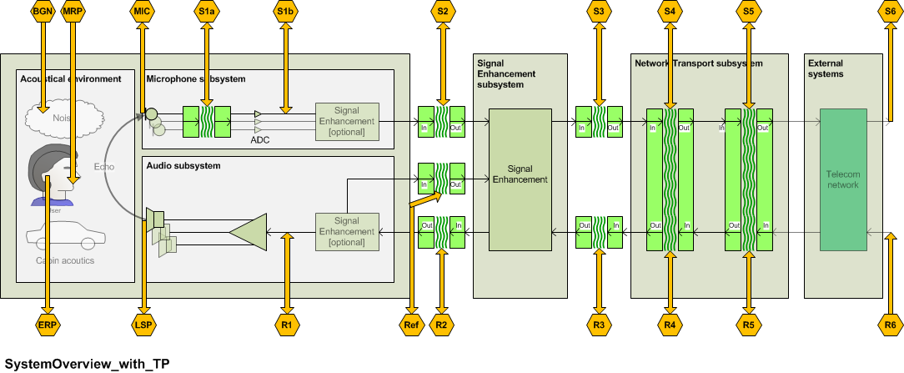

Fig. 7.4 Abstract architecture and Testpoints
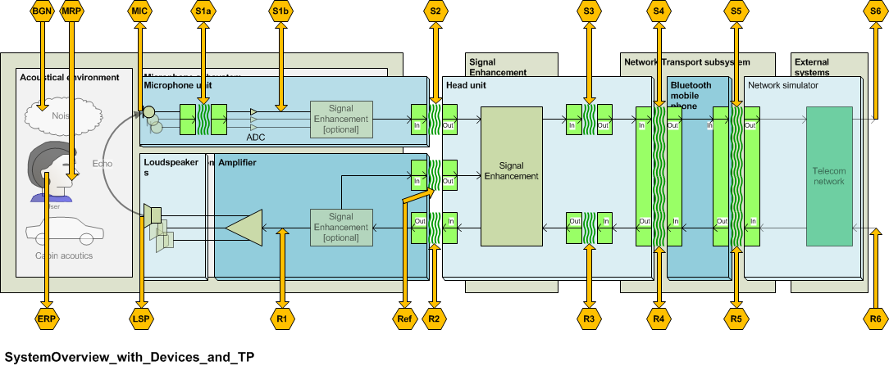
Fig. 7.5 System overview and test points, example of a typical implementation

System with integrated microphone
The system is tested as described in ITU-T Rec. P.1100 (for narrowband systems) or in ITU-T Rec. P.1110 (for wideband systems). If no network access is provided by the system the system is connected to a reference interface replacing the network access system. The requirements as given in ITU-T Recs. P.1100 and P.1110 apply.

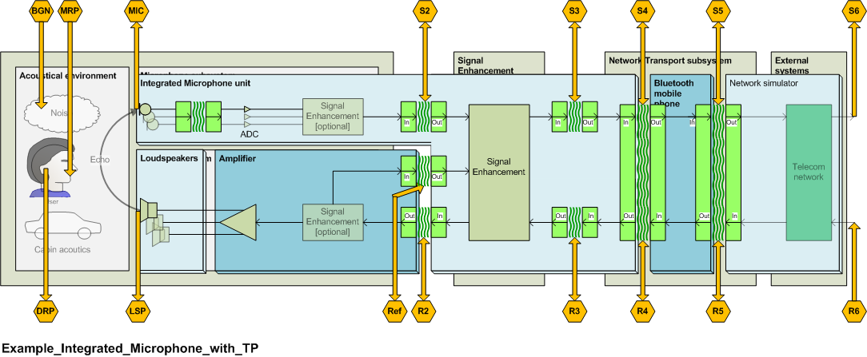
Fig. 7.6: System with integrated microphone
The loudspeaker subsystem is tested as described in section xx.
The network access subsystem is tested as described in section xx.

System with integrated speaker
The system is tested as described in ITU-T Rec. P.1100 (for narrowband systems) or in ITU-T Rec. P.1110 (for wideband systems). If no network access is provided by the system the system is connected to a reference interface replacing the network access system. The requirements as given in ITU-T Recs. P.1100 and P.1110 apply.

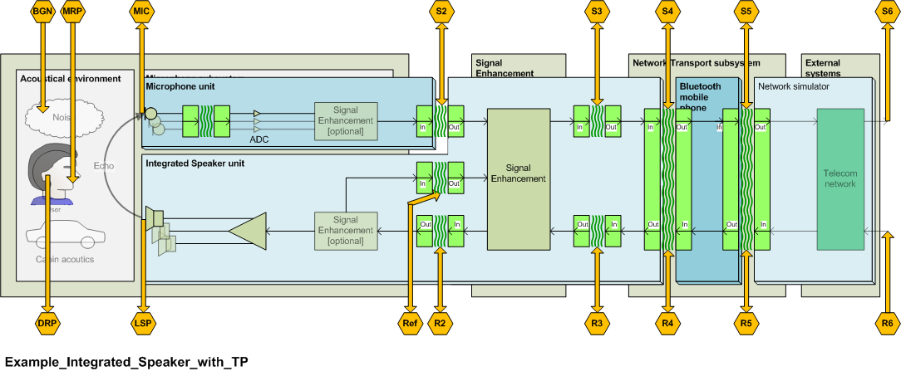
Fig. 7.7: System with integrated speaker
The microphone subsystem is tested as described in section xx.
The network access subsystem is tested as described in section xx.

System with integrated microphone and speaker
The system is tested as described in ITU-T Rec. P.1100 (for narrowband systems) or in ITU-T Rec. P.1110 (for wideband systems). If no network access is provided by the system the system is connected to a reference interface replacing the network access system. The requirements as given in ITU-T Recs. P.1100 and P.1110 apply.
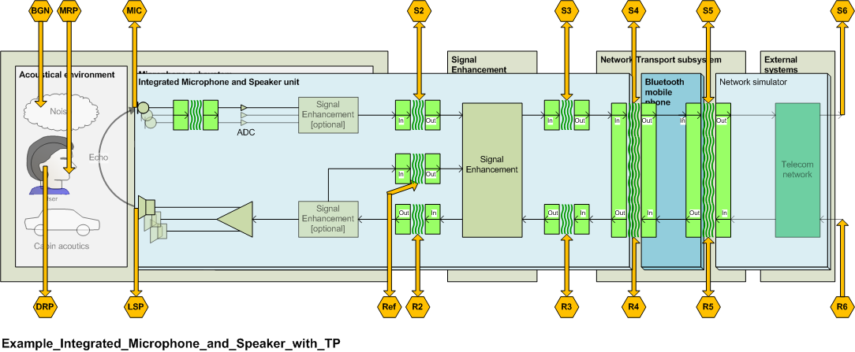
Fig. 7.8: System with integrated microphone and speaker

System Delay, Subsystem Delay and Buffering
The system delay is measured as described in ITU-T Recommendations P.1100 [xx] for narrowband systems and P.1110 [xx] for wideband systems. The subsystem delay as described and measured within this specification only includes the algorithmic delay. In case a subsystem is implemented in a hardware the computational delay is measured (see Annex G).
It is known that buffering needed in order to e.g. take care of different frame sizes in subsystems may cause a significant increase of the system delay. Therefore buffering and frame sizes should ideally be optimized to get a minimum system delay.
Annex G describes synchronization issues and the impact of different frame sizes and buffering in detail and gives guidance how to optimize subsystems to achieve a mostly low system delay.

Subsystems

Test Interface description

Analog electrical interface
The analog interface of the test system should match the impedance and the sensitivity of the system under test.

Digital electrical interface
The digital interface of the test system should provide a dynamic range of at least 16 bit equivalent and otherwise should match the interface specification of the system under test.

Acoustic interface

Artificial mouth
The artificial mouth of the artificial head shall conform to ITU-T Recommendation P.58 [xx]. The artificial mouth is equalized at the MRP according to ITU-T Recommendation P.340 [xx].
The sound pressure level is calibrated at the HATS-HFRP so that the average level at HATS-HFRP is -28.7 dBPa. The sound pressure level at the MRP has to be corrected correspondingly. The detailed description for equalization at the MRP and level correction at the HATS-HFRP can be found in ITU-T Recommendation P.581 [xx].
When testing with vehicle noise, the output level of the mouth is increased to account for the “Lombard effect”. The Lombard effect refers to the change in speaking behaviour caused by acoustic noise. The level is increased by 3 dB for every 10 dB that the long-term A-weighted noise level exceeds 50 dB(A) [xx]. This relationship is shown in the following formula:
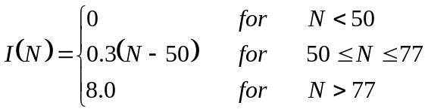
Where:
I = The dB increase in mouth output level due to noise level
N = The long-term A-weighted noise level measured near the driver’s head position
As an example, if the vehicle noise measures 70 dB(A), then the output of the mouth would be increased by 6 dB. No gain is applied for noise levels below 50 dB(A). The maximum amount of gain that can be applied is 8 dB. Vehicle noise levels are measured using a measurement microphone positioned near the driver’s head position.

Artificial ear
For speakerphone hands-free terminals the ear signals of both ears of the artificial head are used. The artificial head is free-field or diffuse-field equalized (see ITU-T Recs. P.1100 and P.1110), more detailed information can be found in ITU-T Recommendation P.581 [xx].

Wireless interface
The interface of the test system should conform to the interface specification of the wireless system under test.

Test signal levels
In general the test signal levels are individual to the system design and vary between implementations. However, if not stated otherwise as a general rule the following test signal levels shall be used:
For digital interfaces the nominal signal level is derived by measuring the signal level at the according digital input of the subsystem when applying a signal with nominal level either at the acoustical interface of the hands-free terminal or at the POI.
Typically the nominal test signal level should be -22 dBov at the digital interface for digital systems. (assuming a nominal signal level of -16dBm0 and an overload point of 3.14 dBm0 for digital transmission systems)
For analog interfaces a similar approach can be taken. The nominal signal level is derived by measuring the signal level at the according analog input of the subsystem when applying a signal with nominal level either at the acoustical interface of the hands-free terminal or at the POI.

Acoustic Subsystem
The acoustic subsystem and related test points are shown in Fig. 8.1. This figure also shows that the acoustic subsystem can be further divided into the following subsystems:
- Microphone subsystem (send path)
- Audio subsystem (receive path)
- Coupling between transducers subsystems (echo path).

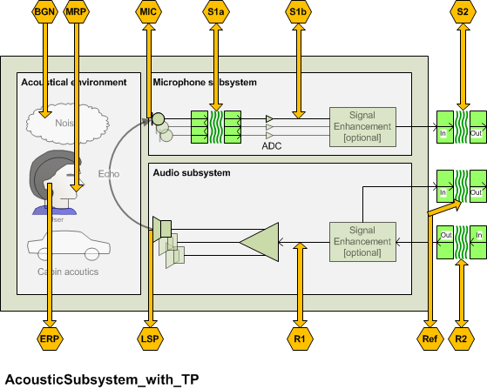
Fig. 8.1: Acoustic subsystem and test points

Microphone subsystem (send path)

        - Send Speech-to-Noise Ratio (SpNR)
          - Is application dependent?
          - Soft & loud speakers
          - Wind buffeting noise
          - Belt microphone noise issues; Structure borne noise
        - Cover spectral and time variant components
        - Send Distortion + Noise (SDN) ?
        - Delay
        - For multi microphone solutions only:
          - Delay variation (over sensors and time)
          - Frequency response variation (over sensors and time)
          - Level variation (over sensors and time)

The microphone subsystem may consist of one or more microphones and may include a signal enhancement layer for the microphone signal as well.

The purpose of this section is to provide guidance for positioning microphones and optimize the microphone performance parameters in such a way that the microphone provides optimum input signals to the speech enhancement.
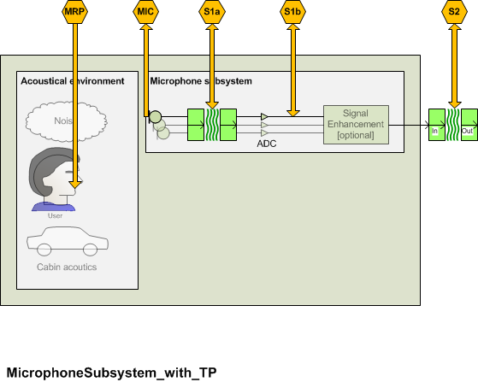
Fig. 8.2: Microphone subsystem and test points

The DUT is connected to the reference interfaces. The reference interfaces are calibrated as specified in clause 8.1.

This clause is applicable to single microphones but not to the output of microphone arrays.

Microphone measurements in the car
Positioning of hands-free microphones
The speech quality in hands-free communication is significantly affected by the positioning of the hands-free microphone. As the optimal microphone position can vary strongly depending on vehicle design as well as on specific requirements, there is no universally valid rule for the positioning of the microphone. However, there are some guidelines which should be considered. Nevertheless, in practice, this often means to find the best compromise, as not all requirements can be equally fulfilled.
– The hands-free microphone should always be placed as close as possible to the speaker, as within the near field of a sound source (in a vehicle this is up to 80-100 cm) the speech level drops by 1/d². In practical applications, this typically means an analogous loss in signal-to-noise ratio. For this reason, a single microphone placed nearby might give a better performance than a microphone array, which is placed further away.
– There has to be a direct path between the speaker's mouth and the microphone. If this is not given, this might result in a significant decrease in signal-to-noise ratio as well as in speech quality since the speech signal becomes reverberant.
– The direction of the highest sensitivity of the microphone should point in the direction of the speaker's mouth. If different seating positions or several speakers are to be covered by one microphone, a compromise for the microphone position has to be found, as the direction of the highest sensitivity might not cover all. However, this often means a significantly reduced performance in comparison to an optimal alignment of the microphone for a single speaker. In this case, the application of additional microphones might be considered to achieve an optimal speech quality.
– A direct airstream to the microphone, e.g., from the air conditioning, has to be avoided as the speech signal might be highly disturbed by wind buffeting.
– Saturation of the microphone by loudspeakers nearby, e.g., by a centre-speaker, has to be avoided. If necessary, the levels of the affected loudspeakers have to be reduced.
Coupling of structure-borne sound to the microphone has to be avoided.
NOTE 1 – When the microphone is measured in the car, it is recommended to use the power supply provided by the car/car hands-free system.
NOTE 2 – If the microphone is integrated digitally in the car, it is recommended to measure the microphone at a digital access point, if available. Care should be taken in order to correctly calibrate the access point.
NOTE 3 – In case the car is not available it is recommended to integrate the microphone in a surrogate environment as close as possible to the production environment. In case wind noise may have a major influence on the microphone performance it is recommended to also simulate the wind noise.

Microphone overload point (in the car)

Parameter description
The microphone overload point OVL_{MS} is measured from the test point (Mic) to the test point (S1a) or the test point (S2).
The microphone overload point is determined by the highest signal which is received by the microphone in the car without distorting. This maybe the speech signal of the near end speaker, the background noise picked up by the hands-free microphone or the signal received from the car audio system.

Test
1) The maximum spectrum is recorded by a reference microphone close to the hands-free microphone (MIC) by generating, background noise, near end speech and the signal generated by the car audio system with maximum volume.
- The background noise conditions to be simulated are found in Annex D of ITU-T Rec. P.1100 and P.1110. The background noise producing the maximum level at the microphone is used.
- The maximum near end signal is generated by generating the British-English single talk sequence described in clause 7.3.2 of ITU-T Recommendation P.501 [xx] with a level as described in 8.1.3.1.
- The maximum loudspeaker signal is generated by injecting the British-English single talk sequence described in clause 7.3.2 of ITU-T Recommendation P.501 [xx] nominal signal level at the far end and setting the audio volume control to maximum.
2) For the signal producing the maximum level (Lev_{max}) the coherence between the reference microphone positioned at MIC and S2 is determined. The coherence is determined as an average of the coherence function in the frequency range from 100 Hz to 7 kHz.
3) The measurement is repeated by reducing the signal level of the worst case signal in steps of 1 dB until the required coherence is achieved.

NOTE: The British-English single talk sequence based tests are averaged over the complete speech sequence voice.

Performance level classification based on values of this parameter
To claim compliance with a certain Performance class the Microphone overload point has to meet the requirements for the applicable Performance classes for the Microphone overload point as defined in table xx:
Table xx –Limits for the Microphone overload point above 0.95 coherence

Performance Class | OVL re Lev_{max}
1 | 0 dB
2 | -3 dB
3 | -6 dB
4 | -9 dB

Design guidance and root-cause analysis
The microphone is the first element in the transmission system of the hands-free system. Its dynamic range should be adapted to the type of car it is used in. Besides other factors this requires careful consideration of the maximum acoustical level it may be exposed to. Any amplitude distortion (clipping) introduced by the microphone may impact the speech sound quality, the transmission quality of the background noise, the performance of any noise canceller and the performance of echo cancellers.

Microphone frequency response (in the car)

Parameter description
The microphone frequency response in send FR_{MS} is measured from the test point (Mic) to the test point (S1a) or the test point (S2).

Test
1) The test arrangement is according to clause 8.2.
2) The British-English single talk sequence described in clause 7.3.2of ITU-T Recommendation P.501 [xx] is used as the test signal. Alternatively, a periodic noise signal or CS signal according to [ITU-T P.501] can be used. The correct activation of the measurement object during the measurement has to be ensured by the test lab. The artificial mouth is equalized at the MRP, the test signal level shall be –4.7 dBPa at the MRP. The test signal level is the average level of the complete test signal. Finally, the level at the HATS-HFRP is adjusted to –28.7 dBPa.
3) The measured power density spectrum at the MRP is used as the reference power density spectrum for determining the frequency response in send direction.
4) The sensitivity frequency response is determined in third octave intervals as given by [IEC 61260] for frequencies of 100 Hz and 8 kHz, inclusive. For calculation, the average measured level is referred to the level of the reference signal in each frequency band averaged over the complete test sequence length.
5) The sensitivity is determined in dBV/Pa.

Performance level classification based on values of this parameter
To claim compliance with a certain Performance class the frequency response has to meet the requirements for the applicable Performance classes for the microphone send sensitivity as defined in the tables below:
The masks are drawn by straight lines between the breaking points in Table 9-xx to 9-xx on a logarithmic (frequency) – linear (dB sensitivity) scale.
Table xx – Tolerance mask for the send sensitivity frequency response for Performance class 1
Frequency | Upper limit | Lower limit
100 Hz | 2 dB | –∞ dB
300 Hz | 2 dB | –2dB
500 Hz | 2 dB | -2 dB
1 000 Hz | 2 dB | –2 dB
2 500 Hz | 2 dB | -2 dB
3 100 Hz | (Note) | –2 dB
5 000 Hz | (Note) | -2 dB
7 000 Hz | 3 dB | -2 dB*
11 000 Hz | 3 dB | –2 dB*
12 000 Hz | 3 dB | –∞ dB*
NOTE 1 – The limits for intermediate frequencies lie on a straight line drawn between the given values on a linear (dB) – logarithmic (Hz) scale. All sensitivity values are expressed in dB on an arbitrary scale.
* NOTE 2 – If the microphone is purely used for speech communication and not used for speech recognition or other services an upper limit of 7 kHz is sufficient.
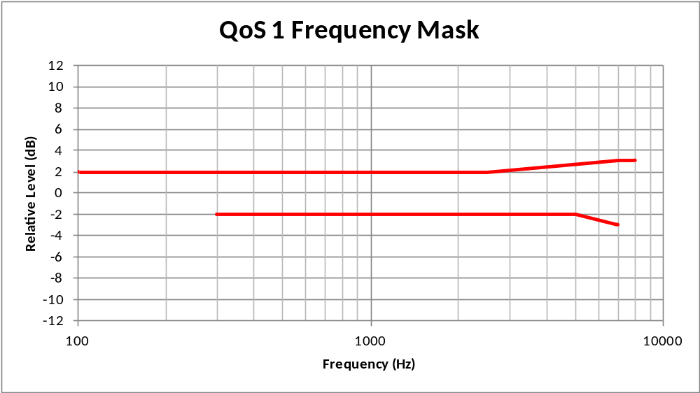

Table xx – Tolerance mask for the send sensitivity frequency response for Performance class 2
Frequency | Upper limit | Lower limit
100 Hz | - | –∞ dB
300 Hz | 2 dB | –5 dB
500 Hz | 2 dB | -4 dB
1 000 Hz | 2 dB | –2 dB
2 500Hz | 4 dB | -2 dB
3 100 Hz | (Note) | –2 dB
5 000 Hz | (Note) | –∞ dB
6 300 Hz | 5 dB | –∞ dB
8 000 Hz | - | –∞ dB
NOTE – The limits for intermediate frequencies lie on a straight line drawn between the given values on a linear (dB) – logarithmic (Hz) scale. All sensitivity values are expressed in dB on an arbitrary scale.

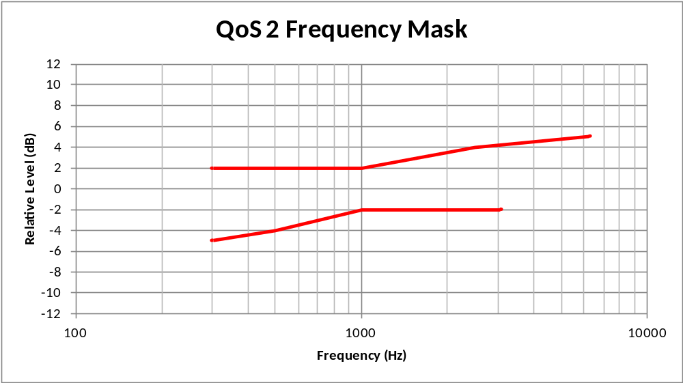
Table xx – Tolerance mask for the send sensitivity frequency response for Performance class 3
Frequency | Upper limit | Lower limit
100 Hz | - | –∞ dB
300 Hz | 4 dB | –10 dB
500 Hz | 4 dB | -8 dB
1 000 Hz | 4 dB | –4 dB
2 500Hz | 8 dB | (Note)
3 100 Hz | 8 dB | –4 dB
5 000 Hz | 8 dB | –∞ dB
6 300 Hz | 8 dB | –∞ dB
8 000 Hz | - | –∞ dB
NOTE – The limits for intermediate frequencies lie on a straight line drawn between the given values on a linear (dB) – logarithmic (Hz) scale. All sensitivity values are expressed in dB on an arbitrary scale.
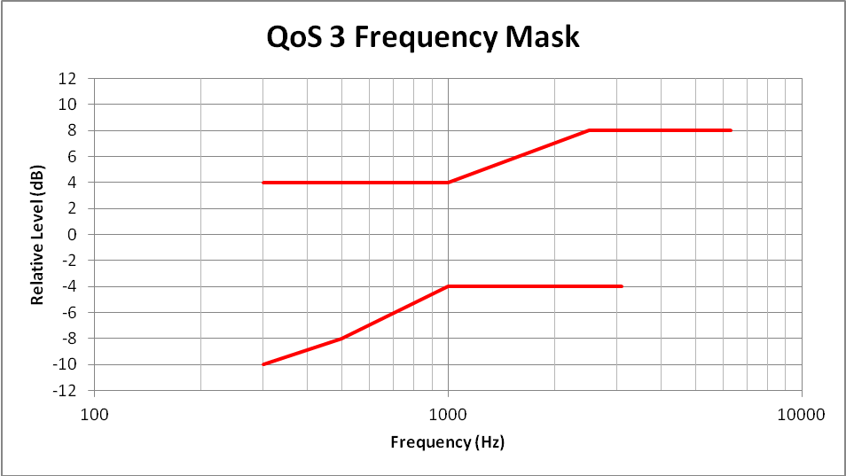

Table xx – Tolerance mask for the send sensitivity frequency response for Performance class 4
Frequency | Upper limit | Lower limit
100 Hz | N/A | N/A
300 Hz | N/A | N/A
500 Hz | N/A | N/A
1 000 Hz | N/A | N/A
2 500Hz | N/A | N/A
3 100 Hz | N/A | N/A
5 000 Hz | N/A | N/A
6 300 Hz | N/A | N/A
8 000 Hz | N/A | N/A
NOTE – The limits for intermediate frequencies lie on a straight line drawn between the given values on a linear (dB) – logarithmic (Hz) scale. All sensitivity values are expressed in dB on an arbitrary scale.

NOTE: Performance class 1 mask is intended to support high quality wideband with no need to equalize the response. Performance class 2 is intended to support high quality narrowband with no need to equalize the response. Performance class 3 is intended to support narrowband communication and some equalization may be required.

Design guidance and root-cause analysis
NOTE – Ideally, the response characteristics of the microphone should be flat in the frequency range of wideband transmission (100 Hz – 7 kHz). However, especially in the presence of background noise, a bandwidth limitation may be desirable. No explicit recommendation can be given here since such limitation would depend on the level and spectral content of the background noise and ideally should be adaptive. If, however, a bandwidth limitation is introduced, it should be made at both, the high and low frequencies.

Microphone idle channel noise (in the car)

Parameter description
The microphone idle channel noise in send N_{MS} is measured from the test point (Mic) to the test point (S1a) or the test point (S2).

Test
1) The British-English single talk sequence described in clause 7.3.2of ITU-T Recommendation P.501 [xx] with an average signal level of -4.7 dBPa [ITU-T P.50] is applied at the MRP. The test signal level is the average level of the complete test signal. Finally, the level at the HATS-HFRP is adjusted to –28.7 dBPa. The output level at the hands-free microphone is measured using a speech level voltmeter according to ITU-T P.56. This level is the reference speech signal level.

2) For the noise measurement, no test signal is used. However, all sources which potentially contribute to noise at the output of the microphone such as GSM noise, electrical noise introduced by the car must be considered. In order to ensure a reliable activation of active microphone arrangements, an activation signal is inserted before the actual measurement. The activation signal consists of a sequence of 4 composite source signals according to [ITU-T P.501]. The spectrum of the test at the MRP is calibrated under free-field conditions. The level of the activation signal is –28.7 dBPa measured at the HATS-HFRP.
3) The test arrangement is according to clause 7.1.
The idle channel noise is measured at the output of the test circuit according to Figure 7-2 in the frequency range between 100 Hz and 8 kHz. The measurement requires a time window which starts exactly at the end of the activation signal. Any "ringing" of filters or receivers shall be taken into account, the time window must be shifted accordingly. The length of the time window is 1 second which is the averaging time for the idle channel noise. The test lab has to ensure the correct activation of the microphone/microphone arrangement during the measurement. If the microphone arrangement is deactivated during measurement, the measurement window has to be cut to the duration when the microphone remains activated.
The power density spectrum of the noise signal is determined using FFT (8 k samples/48 kHz sampling rate or equivalent). A Hann window is used.
If it is known that the microphone stays activated without any activation signal, no activation signal is required. In this case, a simple noise measurement is conducted.
4) The idle channel noise is determined by A-weighting and referring to the reference speech signal level as determined with speech sequence. Spectral peaks are measured in the frequency domain. The average noise spectrum used for determining the spectral peak should be calculated as the arithmetic mean of the noise spectrum values when stated in dBVP.

Performance level classification based on values of this parameter
To claim compliance with a certain Performance class the speech to idle noise ratio SINR has to meet the requirements for the applicable Performance classes for the SINR as defined in table xx:
Spectral peaks in the frequency domain shall not exceed the averaged spectrum by more than 10 dB.

Table xx –Limits for the idle channel noise re. reference speech signal level

Performance Class | SINR | Interpretation
1 | > 40 dB
2 | > 30 dB
3 | > 25 dB
4 | ≤ 20 dB

Design guidance and root-cause analysis
Be sure that receive path is deactivated, Check shielding, check microphone preamplifier should not demodulate RF into NF,

Microphone SNR (in the car)

Parameter description
The SNR measurement is based on individual broadband estimations of the speech signal power and the noise signal power and is performed using the reference-free measurement method described in Annex G.
NOTE 1 – It is recognized that fan noise, which varies from car to car and depends upon the relative positioning of the microphone and fan, may contribute significantly to the noise perceived by the far end user. In order to determine the impact of the level and spectral content of this noise under different operating conditions, a noise test as described below may be used.
NOTE 2 – The method described requires stationary type of background noise and therefore should be applied for constant driving conditions or conditions where the background noise can be considered to be stationary.
The microphone signal to noise ration SNR_{M} is measured at the test point (S1a) or the test point (S2). Test point (S2) should only be used if test point (S1a) is not accessible.

Test

- The test arrangement is according to clause 8.1.
- The speech test signal used is the British-English single talk sequence described in clause 7.3.2of ITU-T Recommendation P.501 [xx]. To account for the Lombard effect, the test signal level is adjusted to the level as specified in clause 8.1, the test signal level is measured as "active speech level" according to [ITU-T P.56].
- For the measurement speech and background noise are recorded simultaneously while driving.
- The actual measurement is conducted with the hands-free microphone.
- The SNR is calculated according to Annex G.

NOTE – The method is applicable in the SNR range from –10dB to +30dB. Care should be taken that the resulting SNR in the measurement is within this SNR-range.

Performance level classification based on values of this parameter
Background noises for driving speed ≤ 80 km/h:
To claim compliance with a certain Performance class the SNRD has to meet the requirements for the applicable Performance classes for the SNRD as defined in table xx:
Table xx –Limits for the SNRD

Performance Class | SNRD
1 | xx dB
2 | TBD
3 | TBD
4 | TBD

Background noises for driving speed ≤ 120 km/h:
To claim compliance with a certain Performance class the SNRD has to meet the requirements for the applicable Performance classes for the SNRD as defined in table xx:
Table xx –Limits for the SNRD

Performance Class | SNRD
1 | xx dB
2 | TBD
3 | TBD
4 | TBD

Design guidance and root-cause analysis
Insufficient SNRD can be caused by an insufficient directivity of the microphone used, by the wrong orientation of the microphone or by the wrong microphone placement (e.g. too far away from the speaker), too high background noise at the microphone location.

New tests to be defined

Microphone Send ReVerberation (SRV)

Parameter description
The microphone reverberation in send REV_{MS} is measured from the test point (MRP) to the test point (S1a) or the test point (S2).
A measure for determining the subjectively perceived reverberation is defined in ITU-T Recommendation P.340 [xx]. The Early Energy Balance is a measure which seems to correlate to the subjectively perceived reverberation when transmitting reverberant speech over hands-free terminals. The EEB is defined as:
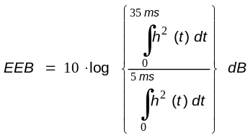

Test

- The test arrangement is according to clause 8.1.
- The test signal should be composed of an activation signal (e.g. voiced sound of the CSS) and a maximal-length sequence of several periods as described in [ITU-T P.340] . The period length must be longer than the length at the impulse response of the system under test.
- The impulse response is calculated from the average of several periods, beginning with the second period.
- The delay introduced by the system under test and the test system has to be compensated for.
- From this the Early Energy Balance (EEB) is calculated.

Performance level classification based on values of this parameter
To claim compliance with a certain Performance class the EEB has to meet the requirements for the applicable Performance classes for the EEB as defined in table xx:
Table xx –Limits for the TBD

Performance Class | EEB
1 | x
2
3
4

Design guidance and root-cause analysis
Too high reverberation may lead to hollow sounding speech. The reverberation may be caused by positioning of the microphone(s) too close to reflecting surfaces (typically windows) or by insufficient damping of reflecting surfaces in a car. Additional damping of surfaces or changing the microphone position may help to correct the problem.

Microphone Send Input/Output Linearity

Parameter description
The microphone Send Input/Output Linearity LIN_{MS} is measured from the test point (Mic) to the test point (S1a) or the test point (S2).
The microphone linearity is determined by the measurement of the A-weighted output level between input and output in the level range from -40 dB to +6 dB re. to the nominal input signal level and referring the measured level to the input signal level.

Test
- The test arrangement is according to clause 8.1. The spectrum at MIC is recorded by a reference microphone close to the hands-free microphone (MIC).
- The test signal used is the British-English single talk sequence described in clause 7.3.2of ITU-T Recommendation P.501 [xx]. The correct activation of the measurement object during the measurement has to be ensured by the test lab. The artificial mouth is equalized at the MRP, the test signal level shall be -30 dB, -20 dB, -10 dB, 0 dB and +8 dB re to –4.7 dBPa at the MRP. The test signal level is the average level of the complete test signal.
- The A-weighted output level is determined at the test point S2 and referred to the input signal level.
- The measurement is repeated for all input signal levels.

Performance level classification based on values of this parameter
To claim compliance with a certain Performance class the measured level difference between input and output has to meet for all input signal levels the requirements for the applicable Performance classes as defined in table xx:
Table xx –Limits for the LIN_{MS}

Performance Class | LIN_{MS}
1 | < 0.2 dB
2 | Xx
3 | Xx
4 | Xx

Design guidance and root-cause analysis

Microphone Send speech quality

Parameter description
The microphone listening speech quality in send LQ_{MS} is measured from the test point (MRP) to the test point (S1a) or the test point (S2).
The test is intended to determine any impairment of the listening speech quality introduced by the microphone.

Test
The tests method to be used is ITU-T Recommendation P.863.
NOTE: ITU-T Recommendation P.863 [xx] does not provide a wideband mode. Wideband systems are evaluated on a superwideband scale. Therefore the MOS Requirements are given in MOS-LQOsw. See P.863 for more information.

1) The test signals used are the English test sequences as specified in [ITU-T P.501, Annex B] (2 male speakers, 2 female speakers, two sentences each). The test signal level is the nominal signal level measured as "active speech level" according to [ITU-T P.56]. The speech activity should be between 30% and 70%.
The original speech signal is used as the reference signal for the determination of the speech quality.
2) The test arrangement is according to clause 8.1. For wideband systems MOS-LQOsw is determined. For narrowband systems MOS-LQOn is determined
The calculation is made using the signal recorded at the test point (S2).

Performance level classification based on values of this parameter
To claim compliance with a certain Performance class the listening speech quality in send has to meet the requirements for the applicable Performance classes as given in the table below:
Table xx –Limits for the microphone listening speech quality in send

Performance Class | MOS-LQOn | MOS-LQOsw
1 | > 4.2 | > 4.5
2 | > 3.8 | > 4.1
3 | > 3.4 | > 3.7
4 | ≤ 3.4 | ≤ 3.7

Design guidance and root-cause analysis
No impairment on listening speech quality should be introduced by the microphone. Any degradation of listening speech quality will deteriorate the overall listening speech quality and should be avoided. Therefore the listening speech quality under quiet conditions is checked. Potential degradations of the microphone listening speech quality in send may be caused by noise (e.g. circuit noise), non optimum frequency response characteristics, additional reverberance or impairments introduced by signal processing such as non linearities.

Microphone Send speech quality with background noise

Parameter description
The microphone speech quality in send with background noise LQBGN_{MS} is measured at the test point (S1a) or the test point (S2) with the reference point (Mic) for the unprocessed speech + noise signal.
The speech quality in background noise is tested based on [b-ETSI EG 202 396-3]. The test method described leads to three MOS-LQO quality numbers:
N-MOS-LQO: Transmission quality of the background noise
S-MOS-LQO: Transmission quality of the speech
G-MOS-LQO: Overall transmission quality
For this test, the speech level is adjusted at the MRP to take into account the Lombard effect. The level adjustment is calculated according to clause 8.1.

Test
- The test arrangement is given in clause 8.1.
2) According to the specification of the manufacturer/test lab, the background noise is played back. The background noise should be applied for at least 5 s in case speech enhancement is used in order to adapt noise reduction algorithms in advance the test.
3) The near end speech signal consists of 8 sentences of speech (2 male and 2 female talkers, 2 sentences each). Appropriate speech samples can be found in [ITU-T P.501]. The preferred language for wideband is French since the objective method was validated with the French language. The preferred language in narrowband is English. The test signal level is the signal level according to clause 8.1 measured as "active speech level" according to [ITU-T P.56]. The speech activity should be between 30% and 70%.Three signals are required for the tests:
– The clean speech signal is used as the undisturbed reference (see [b-ETSI EG 202 396-3]).
– The speech plus undisturbed background noise signal is recorded at the microphone position (Mic) using an omnidirectional measurement microphone with a linear frequency response between 50 Hz and 12 kHz.
– The send signal is recorded at the test point (S2).
N-MOS-LQO, S-MOS-LQO and G-MOS-LQO are calculated as described in [b-ETSI EG 202 396-3].

Performance level classification based on values of this parameter
Background noises for driving speed ≤ 80 km/h:
To claim compliance with a certain Performance class the listening speech quality with background noise in send has to meet the requirements for the applicable Performance classes as given in the table below:
Table xx –Limits for the listening speech quality with background noise in send: N-MOS

Performance Class | N-MOS-LQOn | N-MOS-LQOw
1 | > 4.0 | > 4.0
2 | > 3.0 | > 3.0
3 | > 2.5 | > 2.5
4 | ≤ 2.5 | ≤ 2.5
Table xx –Limits for the listening speech quality with background noise in send: S-MOS

Performance Class | S-MOS-LQOn | S-MOS-LQOw
1 | > 4.0 | > 4.0
2 | > 3.0 | > 3.0
3 | > 2.5 | > 2.5
4 | ≤ 2.5 | ≤ 2.5

Table xx –Limits for the listening speech quality with background noise in send: G-MOS

Performance Class | G-MOS-LQOn | G-MOS-LQOw
1 | > 4.0 | > 4.0
2 | > 3.0 | > 3.0
3 | > 2.5 | > 2.5
4 | ≤ 2.5 | ≤ 2.5

Background noises for driving speed ≤ 120 km/h:
To claim compliance with a certain Performance class the listening speech quality with background noise in send has to meet the requirements for the applicable Performance classes as given in the table below:
Table xx –Limits for the listening speech quality with background noise in send: N-MOS

Performance Class | N-MOS-LQOn | N-MOS-LQOw
1 | > 3.5 | > 3.5
2 | > 2.5 | > 2.5
3 | > 2.0 | > 2.0
4 | ≤ 2.0 | ≤ 2.0
Table xx –Limits for the listening speech quality with background noise in send: S-MOS

Performance Class | S-MOS-LQOn | S-MOS-LQOw
1 | > 3.5 | > 3.5
2 | > 2.5 | > 2.5
3 | > 2.0 | > 2.0
4 | ≤ 2.0 | ≤ 2.0

Table xx –Limits for the listening speech quality with background noise in send: G-MOS

Performance Class | G-MOS-LQOn | G-MOS-LQOw
1 | > 3.5 | > 3.5
2 | > 2.5 | > 2.5
3 | > 2.0 | > 2.0
4 | ≤ 2.0 | ≤ 2.0

Design guidance and root-cause analysis
The microphone send speech quality with background noise mainly depends on the SNR at the hands-free microphone. Other factors which may influence the speech quality in background noise are the microphone placement (which may help to improve the SNR) and the microphone frequency response characteristics. Further impact can be expected by wind buffeting caused e.g. by poorly designed outlets for air conditioning or heating systems.
A methodology for more detailed investigation of background noise modulations due to noise cancelling algorithms can be found in Annex E.

Audio subsystem (receive path)
The audio subsystem and its related access points are shown in Fig. 8.xx. The audio subsystem may consist of one or more loudspeakers with associated amplifiers and an associated signal enhancement system. In difference to other subsystems the audio subsystem may provide an output signal (reference channel) for the echo canceller which is part of the signal enhancement subsystem (see 8.3).

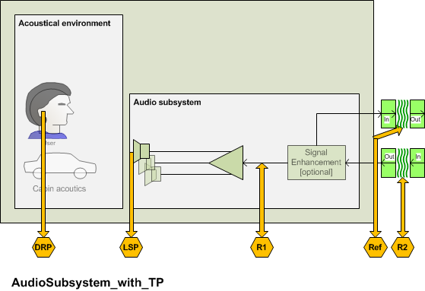
Fig. 8.3: Audio subsystem and test points

Note – All measurements and requirements are made for stand still or low speed conditions. Any speed or noise dependant equalization, compression or other functionality is not covered by the chapter because this functionality is considerd to be very car specific and no general recommendation can be given.

        - Receive Conversational Gain (RCG)
        - Receive speech quality (MOS-LQO)
        - Receive Intelligibility (RI)
        - Cabin Noise (CN)
        - Receive Input/Output Linearity

Audio subsystem delay

Parameter description
The delay T_{AS} is measured from the test point (R2) to the test point (DRP). The delay T_{AS} should be minimized. The measurement is conducted at nominal volume control setting.
The system delay t_{System} depends on the transmission method used and the delay of the reference interface. The delay t_{System} must be known and deducted from the test result.

Test
1) For the measurements, a composite source signal (CSS) according to [ITU-T P.501] is used. The pseudo random noise (pn)-part of the CSS has to be longer than the maximum expected delay. It is recommended to use a pn sequence of 16 k samples (with 48 kHz sampling rate). The test signal is inserted at test point (R2) at a level according to clause 8.1.5.
The reference signal is the original signal (test signal).
The test set-up is according to clause 8.1.
2) The delay is determined by cross-correlation analysis between the measured signal at the DRP and the original signal. The measurement is corrected by delays which are caused by the test equipment. The measurement is corrected by delays which are caused by the test equipment.
3) The delay is measured in ms and the maximum of the cross-correlation function is used for the determination.

T_{measure} = T_{AS} + T_{System}

Performance level classification based on values of this parameter
To claim compliance with a certain Performance class the delay in the send direction has to meet the requirements for the applicable Performance classes for the delay T_{AS} as defined in table xx:
Table xx –Limits for the audio subsystem delay for speech communication services

Performance Class | T_{AS}
1 | < 7 ms
2 | < 12 ms
3 | < 30 ms
4 | ≥ 30 ms

Design guidance and root-cause analysis
Low delay is essential for a seamless conversational performance especially for highly interactive conversations. Delay also contributes to echo perception: Higher delay low leads to higher impairment resulting even from low level echo components (see ITU-T Rec. G. 111 [xx]). Therefore any design providing as low delay in the connection as possible is preferable. Furthermore higher delays may impair the performance of the echo canceller in the signal enhancement subsystem.

Audio subsystem sensitivity frequency response

Parameter description
The frequency response FR_{AS} is measured from the test point (R2) to the test point (DRP). The measurement is conducted at nominal volume control setting.
The sensitivity response on the audio subsystem should be mostly flat in the entire frequency range.

Test
1) The test signal used for the measurements shall be the British-English single talk sequence described in clause 7.3.2 of ITU-T Recommendation P.501 [22]. The test signal level is the nominal signal level, the level is averaged over the complete test signal.
Note: If the signal enhancement subsystem includes an equalization function for the receive path the equalization curve should be determined and applied to the test signal inserted. Such a pre-equalized signal is used for the measurements.
The measured power density spectrum at the test point (R2) interface is used as the reference power density spectrum for determining the audio subsystem sensitivity.
2) The test arrangement is according to clause 8.1. The audio subsystem frequency response is determined in third octave intervals, as given by [IEC 61260] for frequencies of 100 Hz and 8 kHz, inclusive. In each third octave band, the level of the measured signal is referred to the level of the reference signal averaged over the complete test sequence length.
3) The sensitivity is determined in dBPa/V.

Performance level classification based on values of this parameter
To claim compliance with a certain Performance class the frequency response has to meet the requirements for the applicable Performance classes for the unidirectional transport FR_{AS} as defined in the tables below:
The masks are drawn by straight lines between the breaking points in Table 8-xx to 8-xx on a logarithmic (frequency) – linear (dB sensitivity) scale.
Table xx – Tolerance mask for the wideband audio subsystem sensitivity frequency response for Performance class 1
100 Hz | 3 dB | –6 dB
200 Hz | 3 dB | -6 dB
315 Hz | 3 dB | –3 dB
6 300 Hz | 3 dB | –3 dB
7 600 Hz | 3 dB | -6 dB
8 000 Hz | 3 dB | x
NOTE – The limits for intermediate frequencies lie on a straight line drawn between the given values on a linear (dB) – logarithmic (Hz) scale. All sensitivity values are expressed in dB on an arbitrary scale.
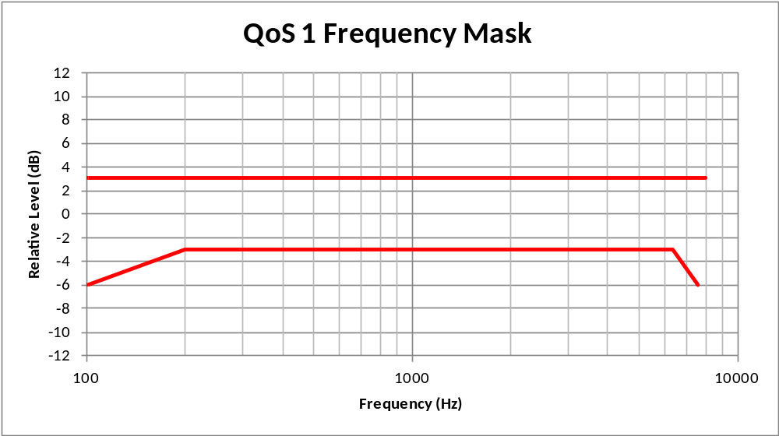
Table xx – Tolerance mask for the wideband audio subsystem sensitivity frequency response for Performance class 2
Frequency | Upper limit | Lower limit
100 Hz | 8 dB | –∞ dB
250 Hz | 8 dB | -9 dB
315 Hz | 8 dB | –6 dB
400 Hz | 6 dB | -6 dB
5 000 Hz | 6 dB | -6 dB
7 000 Hz | 6 dB | –9 dB
8 000 Hz | 6 dB | –∞ dB
NOTE – The limits for intermediate frequencies lie on a straight line drawn between the given values on a linear (dB) – logarithmic (Hz) scale. All sensitivity values are expressed in dB on an arbitrary scale.
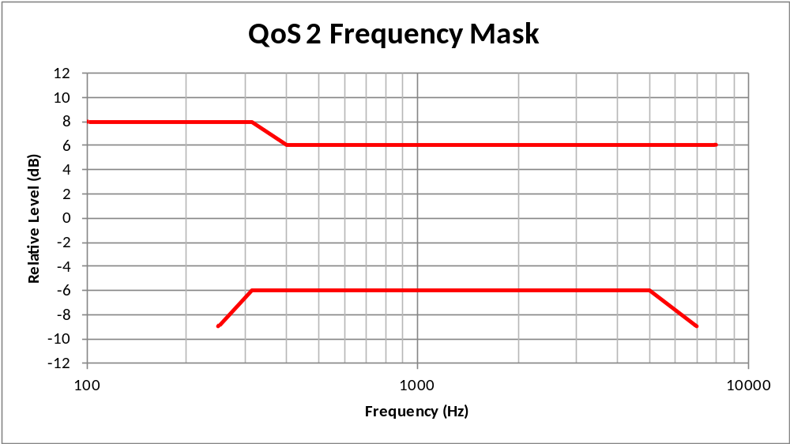
Table xx – Tolerance mask for the wideband audio subsystem sensitivity frequency response for Performance class 3
Frequency | Upper limit | Lower limit
100 Hz | 8 dB | –∞ dB
250 Hz | 8 dB | -∞ dB
315 Hz | 8 dB | –9 dB
400 Hz | 6 dB | -6 dB
5 000 Hz | 6 dB | -9 dB
7 000 Hz | 6 dB | –12 dB
8 000 Hz | 6 dB | –∞ dB
NOTE – The limits for intermediate frequencies lie on a straight line drawn between the given values on a linear (dB) – logarithmic (Hz) scale. All sensitivity values are expressed in dB on an arbitrary scale.
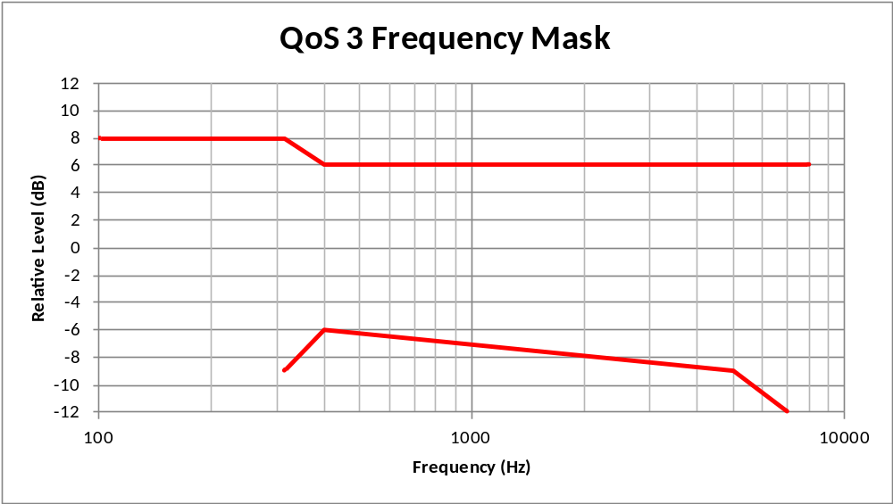
Table xx – Tolerance mask for the wideband audio subsystem sensitivity frequency response for Performance class 4
Frequency | Upper limit | Lower limit
100 Hz | N/A | N/A
250 Hz | N/A | N/A
315 Hz | N/A | N/A
400 Hz | N/A | N/A
5 000 Hz | N/A | N/A
7 000 Hz | N/A | N/A
8 000 Hz | N/A | N/A
NOTE – The limits for intermediate frequencies lie on a straight line drawn between the given values on a linear (dB) – logarithmic (Hz) scale. All sensitivity values are expressed in dB on an arbitrary scale.
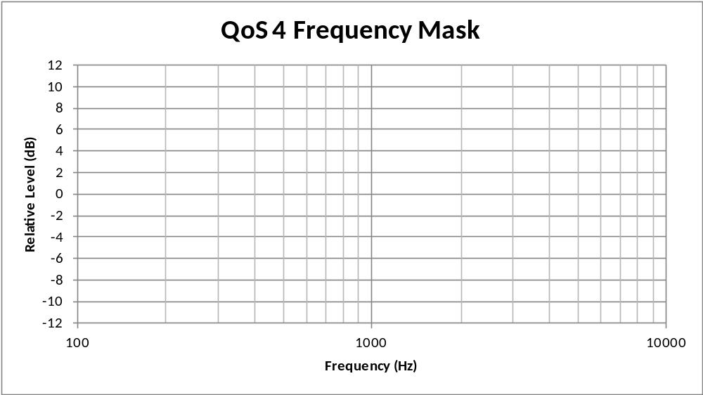
Table xx – Tolerance mask for the audio subsystem sensitivity frequency response for Performance class 1
Frequency [Hz] | Upper limit | Lower limit
200 | 3 dB | -6 dB
250 | 3 dB | (Note)
315 | 3 dB | –3 dB
400 | 3 dB | –3 dB
3 100 | 3 dB | –3 dB
3 400 | 3 dB | -6 dB
4 000 | 3 dB | –∞ dB
NOTE – The limits for intermediate frequencies lie on a straight line drawn between the given values on a linear (dB) – logarithmic (Hz) scale. All sensitivity values are expressed in dB on an arbitrary scale.
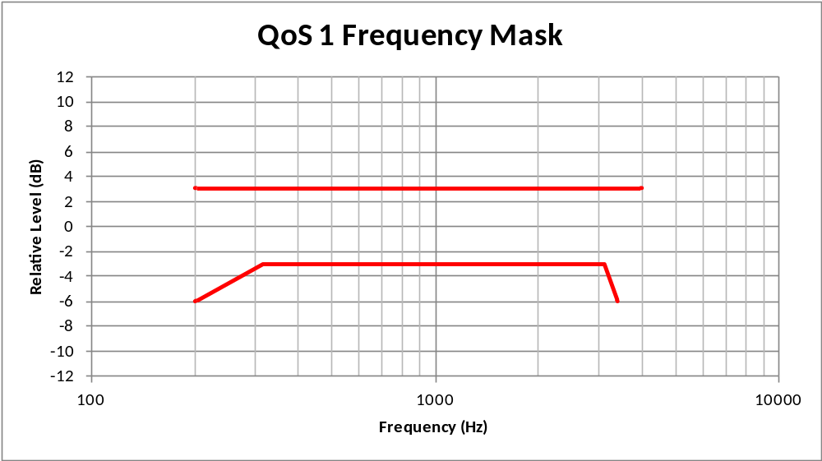
Table xx – Tolerance mask for the narrowband audio subsystem sensitivity frequency response for Performance class 2
Frequency [Hz] | Upper limit | Lower limit
200 | 6 dB | –∞ dB
250 | 6 dB | –∞ dB
315 | 6 dB | –9 dB
400 | 6 dB | –6 dB
3 100 | 6 dB | –6 dB
4 000 | 6 dB | –∞ dB
NOTE – The limits for intermediate frequencies lie on a straight line drawn between the given values on a linear (dB) – logarithmic (Hz) scale. All sensitivity values are expressed in dB on an arbitrary scale.
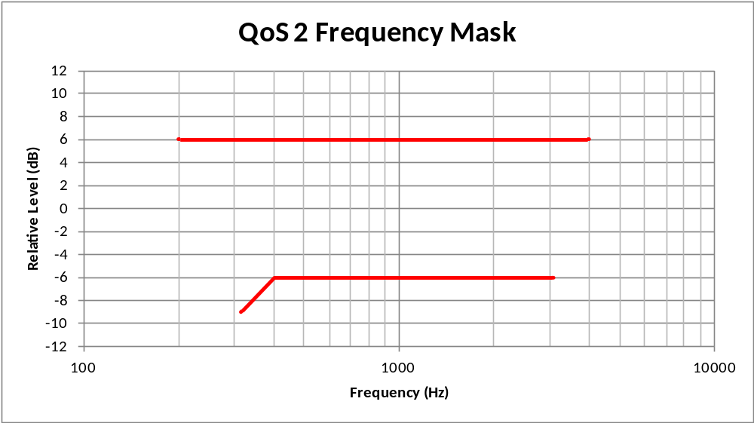
Table xx – Tolerance mask for the narrowband audio subsystem sensitivity frequency response for Performance class 3
Frequency [Hz] | Upper limit | Lower limit
200 | 6 dB | –∞ dB
250 | 6 dB | –∞ dB
315 | 6 dB | –12 dB
400 | 6 dB | –8dB
3 100 | 6 dB | –8 dB
4 000 | 6 dB | –∞ dB
NOTE – The limits for intermediate frequencies lie on a straight line drawn between the given values on a linear (dB) – logarithmic (Hz) scale. All sensitivity values are expressed in dB on an arbitrary scale.
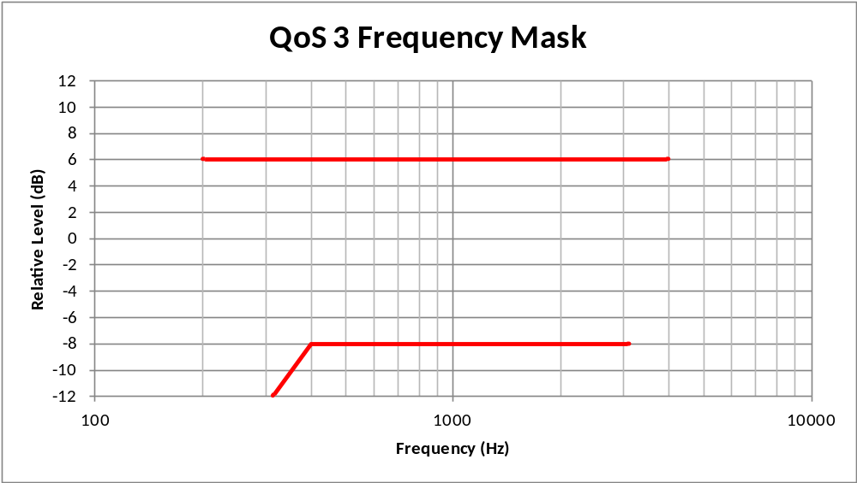
Table xx – Tolerance mask for the narrowband audio subsystem sensitivity frequency response for Performance class 4
Frequency [Hz] | Upper limit | Lower limit
200 | N/A | N/A
315 | N/A | N/A
1 000 | N/A | N/A
1 300 | N/A | N/A
1 600 | N/A | N/A
2 000 | N/A | N/A
3 100 | N/A | N/A
4 000 | N/A
NOTE – The limits for intermediate frequencies lie on a straight line drawn between the given values on a linear (dB) – logarithmic (Hz) scale. All sensitivity values are expressed in dB on an arbitrary scale.
T

Design guidance and root-cause analysis
Deviations from a flat frequency response characteristics may cause degradation of the listening speech quality in the receive direction or may result in insufficient listening speech quality. A flat frequency response mostly contributes to a good customer experience in the car.

Audio subsystem speech quality

Parameter description
The audio subsystem listening speech quality LQ_{AS} is measured from the test point (R2) to the test point (DRP). The measurement is conducted at nominal and at maximum volume control setting.
The test is intended to determine any impairment of the listening speech quality introduced by the unidirectional transport.

Test
The tests method to be used is ITU-T Recommendation P.863. NOTE: ITU-T Recommendation P.863 [xx] does not provide a wideband mode. Wideband systems are evaluated on a superwideband scale. Therefore the MOS Requirements are given in MOS-LQOsw. See P.863 for more information.

1) The test signals used are the English test sequences as specified in [ITU-T P.501] (2 male speakers, 2 female speakers, two sentences each). The test signal level is the nominal signal level, measured at the test point (R2), the test signal level is measured as "active speech level" according to [ITU-T P.56]. The speech activity should be between 30% and 70%.
The original speech signal is used as the reference signal for the determination of the speech quality.
Note: If the signal enhancement subsystem includes an equalization function for the receive path the equalization curve should be determined and applied to the test signal inserted. Such a pre-equalized signal is used for the measurements.
2) The test arrangement is according to clause 8.1. For wideband systems MOS-LQOsw is determined. For narrowband systems MOS-LQOn is determined
The calculation is made using the signal recorded at the test point (DRP).

Performance level classification based on values of this parameter
To claim compliance with a certain Performance class the listening speech quality has to meet the requirements for the applicable Performance classes as given in the table below:
Table xx –Limits for the audio subsystem listening speech quality at nominal volume control setting

Performance Class | MOS-LQOn | MOS-LQOsw
1 | > 4.2 | > 4.5
2 | > 3.8 | > 4.1
3 | > 3.4 | > 3.7
4 | ≤ 3.4 | ≤ 3.7

Table xx –Limits for the audio subsystem listening speech quality at maximum volume control setting

Performance Class | MOS-LQOn | MOS-LQOsw
1 | > 4.2 | > 4.5
2 | > 3.8 | > 4.1
3 | > 3.4 | > 3.7
4 | ≤ 3.4 | ≤ 3.7

Design guidance and root-cause analysis
No additional impairment on listening speech quality should be introduced by the audio subsystem. Any degradation of listening speech quality will deteriorate the overall listening speech quality for the user in the car and should be avoided. Therefore the listening speech quality under quiet conditions is checked.

Audio subsystem idle channel noise

Parameter description
The audio subsystem transport idle channel noise in N_{AS} is measured from the test point (R2) to the test point (DRP). The measurement is conducted at nominal and at maximum volume control setting.

Test
1) The British-English single talk sequence described in clause 7.3.2 of ITU-T Recommendation P.501 [xx] with the nominal average signal level [ITU-T P.50] is applied at the test point (R2). The test signal level is the average level of the complete test signal. The output level is measured using a speech level voltmeter according to ITU-T P.56. This level is the reference speech signal level.

2) For the noise measurement, no test signal is used. However, all sources which potentially contribute to noise at the output of the unidirectional transport as GSM noise, electrical noise introduced by the car must be considered. In order to ensure a reliable activation, an activation signal is inserted before the actual measurement. The activation signal consists of a sequence of 4 composite source signals according to [ITU-T P.501]. The level of the activation signal is –16 dBm0.
3) The test arrangement is according to clause 8.1.
The idle channel noise is measured at the output in the frequency range between 100 Hz and 8 kHz. The measurement requires a time window which starts exactly at the end of the activation signal. Any "ringing" of filters or receivers shall be taken into account, the time window must be shifted accordingly. The length of the time window is 1 second which is the averaging time for the idle channel noise. The test lab has to ensure the correct activation of the audio subsystem during the measurement. If the audio subsystem is deactivated during measurement, the measurement window has to be cut to the duration when the Audio subsystem remains activated.
The power density spectrum of the noise signal is determined using FFT (8 k samples/48 kHz sampling rate or equivalent). A Hann window is used.
If it is known that the audio subsystem stays activated without any activation signal, no activation signal is required. In this case, a simple noise measurement is conducted.
4) The idle channel noise is determined by A-weighting and referring to the reference speech signal level as determined with the British-English test sentence. Spectral peaks are measured in the frequency domain. The average noise spectrum used for determining the spectral peak should be calculated as the arithmetic mean of the noise spectrum values when stated in dBVP.

Performance level classification based on values of this parameter
To claim compliance with a certain Performance class the speech to idle noise ratio SINR has to meet the requirements for the applicable Performance classes for the SINR as defined in table xx:
Spectral peaks in the frequency domain shall not exceed the averaged spectrum by more than 10 dB.

Table xx –Limits for the idle channel noise re. reference speech signal level at nominal volume control setting

Performance Class | SINR
1 | > 70 dB
2 | > 60 dB
3 | > 40 dB
4 | ≤ 40 dB
Table xx –Limits for the idle channel noise re. reference speech signal level at maximum volume control setting

Performance Class | SINR
1 | > 70 dB
2 | > 60 dB
3 | > 40 dB
4 | ≤ 40 dB

Design guidance and root-cause analysis
Check shielding, connectors and cabling with respect to potentially induced interfering signals. Check quality of amplifiers used to insert signals and preamplifiers used to receive signals. Check power amplifiers. Verify that preamplifiers do not demodulate RF into NF, If upsampling is used check artefacts due to upsampling.

Audio subsystem output level at maximum level setting

Parameter description
The audio subsystem maximum output level OL_{ASmax} is measured from the test point (R2) to the test point (DRP). The measurement is conducted at maximum volume control setting.
The audio subsystem maximum output level is determined with nominal input signal level at R2 and maximum volume control setting.

Test
- The test setup is according to cause 8.1.
- The test signal used is the British-English single talk sequence described in clause 7.3.2of ITU-T Recommendation P.501 [xx] with the nominal average signal level applied at the test point (R2). The test signal level is the average level of the complete test signal.
- The maximum spectrum generated by the car audio system with maximum volume is recorded at the DRP.
- The A-weighted sound pressure level is determined at the DRP in the frequency range from 100 Hz to 7 kHz.

Performance level classification based on values of this parameter
To claim compliance with a certain Performance class the audio subsystem maximum output level has to meet the requirements for the applicable Performance classes for the audio subsystem maximum output level as defined in table xx:
Table xx –Limits for the audio subsystem maximum output level

Performance Class | OL_{ASmax}
1 | > 84 dB(A)
2 | >78 dB(A)
3 | >72 dB(A)
4 | <72 dB(A)

Design guidance and root-cause analysis
Insufficient output level will lead to poor speech intelligibility for the driver in the car. This may be especially problematic with high background noise e.g. at high driving speeds. In general luxury cars or cars with good, low noise acoustical design are less affected by this problem compared to cars with less acoustical treatment. The audio system design should ensure good speech intelligibility/comprehension with low listening effort at typical driving conditions.

Audio subsystem overload point

Parameter description
The audio subsystem overload point OVL_{AS} is measured from the test point (R2) to the test point (LSP). The measurement is conducted at level setting of 15 dB above nominal volume and maximum control setting.
The audio subsystem overload point is determined by the highest signal which is produced by the audio subsystem in the car without distorting.

Test
- The test setup is according to cause 8.1.
- The test signal used is the British-English single talk sequence described in clause 7.3.2 of ITU-T Recommendation P.501 [xx] with the nominal average signal level applied at the test point (R2). The test signal level is the average level of the complete test signal.
- The maximum spectrum generated by the car audio system with maximum volume is recorded with a reference microphone at the LSP.
- The coherence between the signal measured at the LSP and the signal inserted at R2 is determined as an average of the coherence function in the frequency range from 100 Hz to 7 kHz for wideband and 300 Hz to 3.5 kHz for narrowband system.

Note: In case of multiple loudspeaker s it is recommended to position the reference microphone close to a midrange speaker (for narrowband systems) or find a position as close as possible between the midrange and the high-frequency speaker (for wideband systems).

Performance level classification based on values of this parameter
To claim compliance with a certain Performance class the audio subsystem overload point has to meet the requirements for the applicable Performance classes for the audio subsystem overload point as defined in table xx:
Table xx –Limits for the audio subsystem overload point above 0.95 coherence

Performance Class | OVL re Lev_{max}
1 | 0 dB
2 | -3 dB
3 | -6 dB
4 | -9 dB
Note: This table is used for both volume control settings independently.

Design guidance and root-cause analysis
Distortion in the audio subsystem will mainly cause two problems: Audible distortion to the driver in the car and nonlinearities in the echopath. While the user may tolerate quite some distortion the impact on the echo canceller may be more severe. Any non-linearity in the echo path may impair the convergence performance of the echo canceller and may lead to intolerable echo or switching caused by the NLP in the echo canceller. In such case either the maximum output volume should be limited or a less distorting audio subsystem is required.

Audio subsystem delay between REF and LSP

Parameter description
The delay T_{REF-DRP} is measured from the test point (REF) to the test point (LSP). The delay T_{REF-LSP} should be minimized. The measurement is conducted at nominal volume control setting.

Test
1) For the measurements, a composite source signal (CSS) according to [ITU-T P.501] is used. The pseudo random noise (pn)-part of the CSS has to be longer than the maximum expected delay. It is recommended to use a pn sequence of 16 k samples (with 48 kHz sampling rate). The test signal is inserted at test point (R2) at a level according to clause 8.1.5.
The reference signal is the signal measured at REF.
The test set-up is according to clause 8.1.
2) The delay is determined by cross-correlation analysis between the measured signal at the LSP and the signal measured at REF. The measurement is corrected by delays which are caused by the test equipment. The measurement is corrected by delays which are caused by the test equipment.
3) The delay is measured in ms and the maximum of the cross-correlation function is used for the determination.

T_{measure} = T_{REF-LSP} + T_{System}

Performance level classification based on values of this parameter
To claim compliance with a certain Performance class the delay in the send direction has to meet the requirements for the applicable Performance classes for the delay T_{REF-LSP} as defined in table xx:
Table xx –Limits for the audio subsystem delay between REF and LSP

Performance Class | T_{REF-LSP}
1 | < ±3 ms
2 | < ±6 ms
3 | < ±10 ms
4 | ≥ ±10 ms

Design guidance and root-cause analysis
Low delay is for a proper functionalyity of teh echo canceller in the signal enhancement layer. Any delay between LSP and REF may impair the performance of the echo canceller and therefore should be avoided or minimized.

Audio Subsystem Linearity between reference output and LSP

Parameter description
The Audio Subsystem Linearity LIN_{REF-LSP} is measured from the test point (REF) to the test point (LSP).
The microphone linearity is determined by the measurement of the A-weighted output level between at LSP in the level range from -40 dB to +6 dB re. to the nominal input signal level and referring the measured level to the signal level measured at REF.
The measurement is conducted at nominal and at maximum volume control setting.

Test
- The test arrangement is according to clause 8.1.
- The test signal is inserted at (R2). The test signal used is the British-English single talk sequence described in clause 7.3.2 of ITU-T Recommendation P.501 [xx]. The correct activation of the measurement object during the measurement has to be ensured by the test lab. The test signal level shall be -40 dB, -30 dB, -20 dB, -10 dB, 0 dB and +6 dB re. to the nominal signal level. The test signal level is the average level of the complete test signal.
- The volume control is set to nominal.
- The signals are recorded simultaneously at the test points (LSP) and REF).
- The A-weighted output level is determined at the test point S2 and referred to the input signal level.
- The measurement is repeated for all input signal levels.
- The measurement is repeated for maximum volume control setting.

Performance level classification based on values of this parameter
To claim compliance with a certain Performance class the measured level difference between REF and LSP has to meet for all input signal levels the requirements for the applicable Performance classes as defined in table xx:
Table xx –Limits for the LIN_{REF-LSP}

Performance Class | LIN_{REF-LSP}
1 | < 0.2 dB
2 | Xx
3 | Xx
4 | Xx

Design guidance and root-cause analysis

Coherence between reference output and LSP

Parameter description
The REF – LSP coherence is measured from the test point (REF) to the test point (LSP).
The COH_{REF-LSP} is determined between (REF) and (LSP) output in the level range from -40 dB to +6 dB re. to the nominal input signal level.
The measurement is conducted at nominal and at maximum volume control setting.

Test
- The test arrangement is according to clause 8.1.
- The test signal is inserted at (R2). The test signal used is the British-English single talk sequence described in clause 7.3.2of ITU-T Recommendation P.501 [xx]. The correct activation of the measurement object during the measurement has to be ensured by the test lab. The test signal level shall be -40 dB, -30 dB, -20 dB, -10 dB, 0 dB and +6 dB re. to the nominal signal level. The test signal level is the average level of the complete test signal.
- The volume control is set to nominal.
- The signals are recorded simultaneously at the test points (LSP) and REF). The coherence between the LSP and REF is determined. The coherence is determined as an average of the coherence function in the frequency range from 100 Hz to 7 kHz.
- The measurement is repeated for all input signal levels.
- The measurement is repeated for maximum volume control setting.

Performance level classification based on values of this parameter
To claim compliance with a certain Performance class the COH_{REF-LSP} has to meet the requirements for the applicable Performance classes for the TBD as defined in table xx:
Table xx –Limits for the COH_{REF-LSP}

Performance Class | COH_{REF-LSP}
1 | X
2
3
4

Design guidance and root-cause analysis

Coupling between acoustical subsystems (echo path)
The focus of this test is to measure the electroacoustic coupling between loudspeaker and microphone. The test is targeted to optimize, positioning, packaging and type of microphone/speakers used by the hands-free system. The access points should be chosen as close as possible to the electro-acoustical components.
If speech enhancement is provided in the microphone subsystem, the measurement is conducted at S2.
Speech-to-Echo Ratio (SpER)
        - Echo Tail Delay (ETD)
        - Echo Tail coherence (ETco)
        - Check time invariance of processing (e.g. fixed beamformer…)

Signal Enhancement Subsystem
The Signal Enhancement subsystem attempts to improve signals captured and played at the acoustic interface. Network-side problems can also be reduced or eliminated. Figure xx shows how this subsystem fits into the overall telecommunications system. This subsystem could be physically located in either the terminal device or a network device. However, the terminal device is usually a better location for technical reasons. Common signal processing functions provided by this subsystem include:
- Send direction
  - Acoustic echo cancellation
  - Noise reduction
  - Equalization
  - Automatic Level Control
  - Fixed gain
  - Limiter
- Receive direction
  - Bandwidth Extension
  - Equalization
  - Automatic Level Control
  - Automatic Level Enhancement
  - Fixed gain
  - Limiter

The next sub-clause describes the test set-up for measuring performance of the Signal Enhancement subsystem. Subsequent sub-clauses provide information related to each of the measurement parameters. This information includes a parameter description, test method, requirements, design guidance, and root-cause analysis.

Test set-up
The test set-up for measuring performance of the Signal Enhancement subsystem consists of:
- Speech, noise test signals and impulse response traces including the effects of other subsystems involved
- A setup that enables simulation-based testing by:
  - Passing test signals to and from the signal enhancement layer
  - Simulating the dynamic effects introduced by other subsystems (e.g., acoustic interface)

Speech and noise test signals are processed to capture the effects of other subsystems involved in the end-to-end connection (e.g., vehicle microphones, speech coders, etc.).
In general the simulation can be made either file-based (pre-recorded test signals covering the effects of other subsystems) or simulation based (simulate the effects of other subsystems by impulse response traces).
The Signal Enhancement subsystem shall be tested with the set of signals acquired or simulated for the individual car under test. In case of Signal Enhancement Subsystem comparison e.g. for the purpose of system qualification for different cars a predefined set of test signals representative for the cars under consideration can be defined and used. An example and 3 subset of test signals are given in Annex XX.

The setup enables testing the signal enhancement layer in file-mode or by simulation. Test signals are passed to test points S2 and R3 which represent the inputs to the signal enhancement layer. The processed output from the signal enhancement layer is retrieved from test points S3 and R2a and analyzed.
The output at REF is also convolved with an impulse response simulating the acoustic echo path in the vehicle. The simulated acoustic echo is then mixed with the send test signal before being presented to test point S2. This allows any changes of the test signal in the receive direction (e.g., gain change due to the signal enhancement layer) to be dynamically reflected in the input test signal at S2—which is what happens in the real world.
If not stated otherwise all signal processing functions including equalization are active.
If pre-recorded signals are used information about the implementation for a framework can be found in Annex <X>.
If simulated signals are used information about the implementation for a framework can be found in Annex <X>.

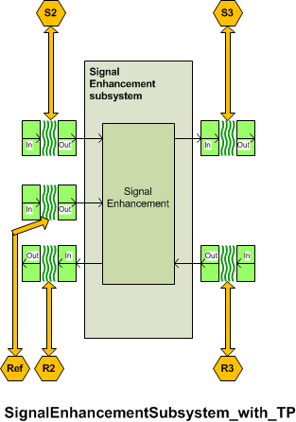
Fig. 8.2: Signal Enhancement subsystem and test points

Note 1: Some Signal Enhancement subsystems might not use test point R2b.
Note 2: Ideally the access to the signal enhancement subsystem is made using the S3/R3 interface. However, if these interfaces are not available the S4/R4 or S5/R5 interface can be used applying the same requirements.

Round-Trip Delay of Signal Enhancement
The round-trip delay of signal enhancement T_{SERTD} consists of the delay in send direction the T_{SES} plus the delay in receive direction T_{SER.}

Performance level classification based on values of this parameter (T_{SERTD)}
To claim compliance with a certain Performance class the delay in the send direction has to meet the requirements for the applicable Performance classes for the signal enhancement delay T_{SERTD} as defined in table xx:
Table xx –Limits for the round trip delay of signal enhancement for speech communication services

Performance Class | T_{SERTD}
1 | < 40 ms
2 | < 70 ms
3 | < 100 ms
4 | ≥ 100 ms

Design guidance and root-cause analysis
Low delay is essential for a seamless conversational performance especially for highly interactive conversations. Delay also contributes to echo perception: Higher delay low leads to higher impairment resulting even from low level echo components (see ITU-T Rec. G. 111 [xx]). Therefore any design providing as low delay in the connection as possible is preferable.

Signal enhancement delay in send direction (T_{SES})

Parameter description
The delay in send direction T_{SES} is measured from the test point (S2) to the test point (S3). The delay T_{SES} should be minimized.
The system delay t_{System} depends on the delay of the reference interface used. The delay t_{System} must be known and deducted from the test result.

Test
1) For the measurements, a composite source signal (CSS) according to [ITU-T P.501] is used. The pseudo random noise (pn)-part of the CSS has to be longer than the maximum expected delay. It is recommended to use a pn sequence of 16 k samples (with 48 kHz sampling rate). The test signal is inserted at test point (S2) at a level according to clause 8.1.5.
The reference signal is the original signal (test signal).
The test set-up is according to clause 8.3.
2) The delay is determined by cross-correlation analysis between the measured signal at the electrical access point (S3) and the original signal. The measurement is corrected by delays which are caused by the test equipment.
3) The delay is measured in ms and the maximum of the cross-correlation function is used for the determination.

T_{measure} = T_{SES} + T_{System}

Signal enhancement delay in receive direction (T_{SER})

Parameter description
The signal enhancement delay in receive direction T_{SER} is measured from the test point (R3) to the test point (R2).
The system delay t_{System} depends on the delay of the reference interface used. The delay t_{System} must be known and deducted from the test result.

Test
1) For the measurements, a composite source signal (CSS) according to [ITU-T P.501] is used. The pseudo random noise (pn)-part of the CSS has to be longer than the maximum expected delay. It is recommended to use a pn sequence of 16 k samples (with 48 kHz sampling rate). The test signal is applied at test point (R3) at a level according to clause 8.1.5.
The reference signal is the original signal (test signal).
2) The test arrangement is according to clause 8.3.
3) The delay is determined by cross-correlation analysis between the measured signal at the test point (R2) and the original signal. The measurement is corrected by delays which are caused by the test equipment.
4) The delay is measured in ms and the maximum of the cross-correlation function is used for the determination.
T_{measure} = T_{SER} + T_{System}

Signal enhancement send loudness ratings (SLR_{SES})

Parameter description
The send junction loudness rating SLR _{SES} is measured from the test point (S2) to the test point (S3).
The SLR describes any amplification or attenuation on the network transport layer using the prerecorded signal at the output of the microphone subsystem. The junction loudness rating SLR_{SES} should be 13 dB.

Test
1) The test signal used for the measurements shall be British-English single talk sequence described in clause 7.3.2 of ITU-T Recommendation P.501 [xx], recorded at the output of the microphone subsystem S2. The test signal level is the nominal signal level, the level is averaged over the complete test signal.
The measured power density spectrum at the MRP is used as the reference power-density spectrum for determining the send sensitivity.
2) The test arrangement is according to clause 8.3. For wideband the send sensitivity is calculated from each band of the 20 frequencies given in Table A.2 of [ITU-T P.79], bands 1-20. For narrowband bands 4-17 are used for calculation.
For the calculation, the average measured level at the electrical reference point for each frequency band is referred to the average test signal level measured in each frequency band at the reference interface.
3) The sensitivity is expressed in dBV/Pa, the send loudness rating SLR_{SES} shall be calculated according to [ITU-T P.79], Formula A-23b, bands 1-20, M = 0.175, and the weighting factors W_{J} for SLR according to Table A.2 of [ITU-T P.79]. For narrowband bands equation 5-1 of [ITU-T P.79], bands 4-17, m = 0.175 and the weighting factors in the send direction according to Table 1 of [ITU-T P.79] are used.

Performance level classification based on values of this parameter
To claim compliance with a certain Performance class the JLR in send has to meet the requirements for the applicable Performance classes for the signal enhancement JLR_{SES} as defined in table xx:
Table xx –Limits for the signal enhancement JLR in send

Performance Class | SLR_{SES}
1 | 13 ± 0.5 dB
2 | 13 ± 3 dB
3 | 13 ± 6 dB
4 | >13 ± 6 dB

Design guidance and root-cause analysis
Any deviation of the JLR_{SES} from 0 dB may result either in insufficient or too high speech levels and thus may deteriorate the performance of the interconnected devices and should be avoided.

Receive signal level L_{SER}

Parameter description
The receive signal level L_{SER} is measured from the test point (R3) to the test point (R2).
The receive signal level is system specific and describes the required output level needed to properly access the audio subsystem.

Test
1) The test signal used for the measurements shall be the British-English single talk sequence described in clause 7.3.2 of ITU-T Recommendation P.501 [xx], recorded at the output of the network transport subsystem R3. The test signal is the nominal signal level.

2) The test arrangement is according to clause 8.3. For the calculation, the averaged level at the test point (R2) is used. In wideband the receive level is determined from 100 Hz – 8 kHz, in narrowband from 100 Hz to 4 kHz measured as active speech level according to ITU-T Recommendation P.56 [xx].

3) The level is measured dBV and referenced to the nominal signal level required by the audio subsystem, measured as active speech level according to ITU-T Recommendation P.56 [xx].

Performance level classification based on values of this parameter
To claim compliance with a certain Performance class the receive signal level at nominal setting of the volume control has to meet the requirements for the applicable Performance classes for the signal enhancement L_{SER} as defined in table xx:
Table xx –Limits for the signal enhancement receive signal level referenced to the nominal signal level required by the audio subsystem

Performance Class | L_{SER}
1 | 0 ± 0.5 dB
2 | 0 ± 3 dB
3 | 0 ± 6 dB
4 | > ± 6 dB

Design guidance and root-cause analysis
Any deviation of the L_{SER} from 0 dB may result either in insufficient or too high speech levels and thus may deteriorate the performance of the interconnected devices and should be avoided. As a result overload or audible noise may occur in the audio subsystem.

Signal enhancement send sensitivity frequency response (FR_{SES})

Parameter description
The send frequency response FR_{SES} is measured from the test point (S2) to the test point (S3). This parameter measures the sensitivity frequency response of the signal enhancement subsystem in send.

Test
1) The test signal used for the measurements shall be the British-English single talk sequence described in clause 7.3.2 of ITU-T Recommendation P.501 [xx], recorded at the output of the microphone subsystem S2. The test signal level is the nominal signal level. The level is averaged over the complete test signal.
The measured power density spectrum at the MRP interface is used as the reference power density spectrum for determining the signal enhancement subsystem send sensitivity frequency response.
2) The test arrangement is according to clause 8.3. In wideband the send sensitivity frequency response is determined in third octave intervals, as given by [IEC 61260] for frequencies of 100 Hz and 8 kHz, inclusive. In narrowband it is determined for frequencies from 200 Hz to 4kHz. In each third octave band, the level of the measured signal is referred to the level of the reference signal averaged over the complete test sequence length.
3) The sensitivity is determined in dBV/Pa.

Performance level classification based on values of this parameter
To claim compliance with a certain Performance class the frequency response in send has to meet the requirements for the applicable Performance classes for the signal enhancement subsystem FR_{SES} as defined in the tables below:
The masks are drawn by straight lines between the breaking points in Table 9-xx to 9-xx on a logarithmic (frequency) – linear (dB sensitivity) scale.
Table xx – Tolerance mask for the wideband signal enhancement subsystem send sensitivity frequency response for Performance class 1
Frequency [Hz] | Upper limit | Lower limit
100 | 4 dB | –10 dB
125 | 4 dB | –5 dB
200 | 3 dB | –3 dB
1 000 | 3 dB | –3 dB
6 300 | 5 dB | –-3 dB
7 600 | 5 dB | -6 dB
8 000 | 5 dB | x
NOTE – The limits for intermediate frequencies lie on a straight line drawn between the given values on a linear (dB) – logarithmic (Hz) scale. All sensitivity values are expressed in dB on an arbitrary scale.
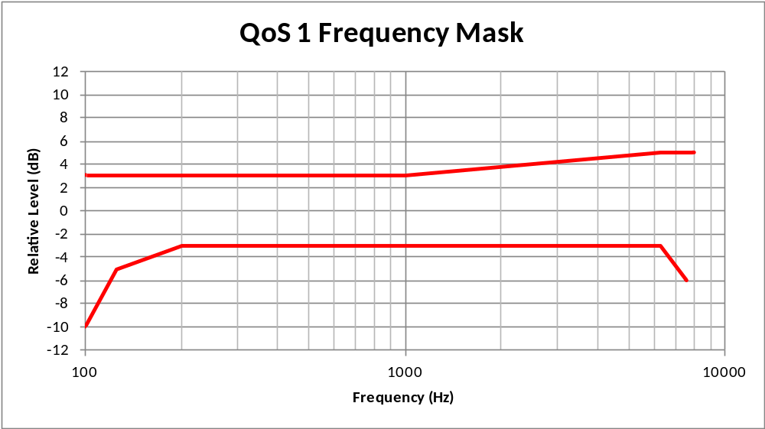
Table xx – Tolerance mask for the wideband signal enhancement subsystem send senTable xx – Tolerance mask for the wideband signal enhancement subsystem send sensitivity frequency response for Performance class 2
Frequency [Hz] | Upper limit | Lower limit
100 | 4 dB | –∞ dB
125 | 4 dB | –10 dB
200 | 4 dB | –4 dB
1 000 | 4 dB | –4 dB
5 000 | (Note) | –4 dB
6 300 | 9 dB | –7 dB
8 000 | 9 dB | –∞ dB
NOTE – The limits for intermediate frequencies lie on a straight line drawn between the given values on a linear (dB) – logarithmic (Hz) scale. All sensitivity values are expressed in dB on an arbitrary scale.
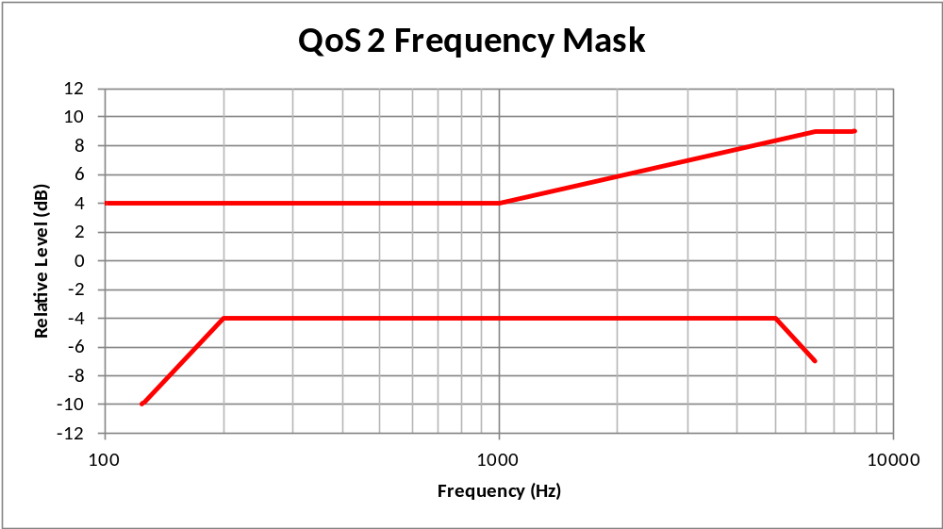
Table xx – Tolerance mask for the wideband signal enhancement subsystem send sensitivity frequency response for Performance class 3
Frequency [Hz] | Upper limit | Lower limit
100 | 6 dB | X
125 | 6 dB | –15 dB
200 | 6 dB | –6 dB
1 000 | 6 dB | –6 dB
5 000 | (Note) | –6 dB
6 300 | 9 dB | –8 dB
8 000 | X | X
NOTE – The limits for intermediate frequencies lie on a straight line drawn between the given values on a linear (dB) – logarithmic (Hz) scale. All sensitivity values are expressed in dB on an arbitrary scale.
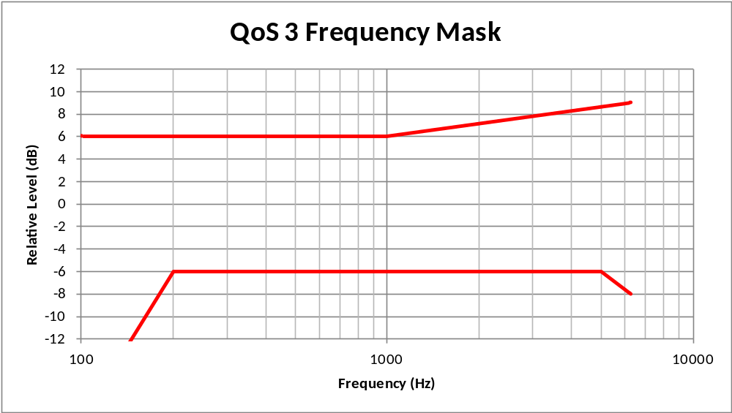
Table xx – Tolerance mask for the wideband signal enhancement subsystem send sensitivity frequency response for Performance class 4
Frequency [Hz] | Upper limit | Lower limit
100 | N/A | N/A
125 | N/A | N/A
200 | N/A | N/A
1 000 | N/A | N/A
5 000 | N/A | N/A
6 300 | N/A | N/A
8 000 | N/A | N/A
NOTE – The limits for intermediate frequencies lie on a straight line drawn between the given values on a linear (dB) – logarithmic (Hz) scale. All sensitivity values are expressed in dB on an arbitrary scale.
Table xx – Tolerance mask for the narrowband signal enhancement subsystem send sensitivity frequency response for Performance class 1
Frequency [Hz] | Upper limit | Lower limit
200 | 3 dB | –10 dB
315 | 3 dB | –3 dB
1 000 | 3 dB | –3 dB
1 300 | 5 dB | –3 dB
1 600 | 6 dB | –3 dB
2 000 | 6 dB | –3 dB
3 100 | 6 dB | –3 dB
3 400 | (Note) | -6 dB
4 000 | 3 dB | –∞ dB
NOTE – The limits for intermediate frequencies lie on a straight line drawn between the given values on a linear (dB) – logarithmic (Hz) scale. All sensitivity values are expressed in dB on an arbitrary scale.
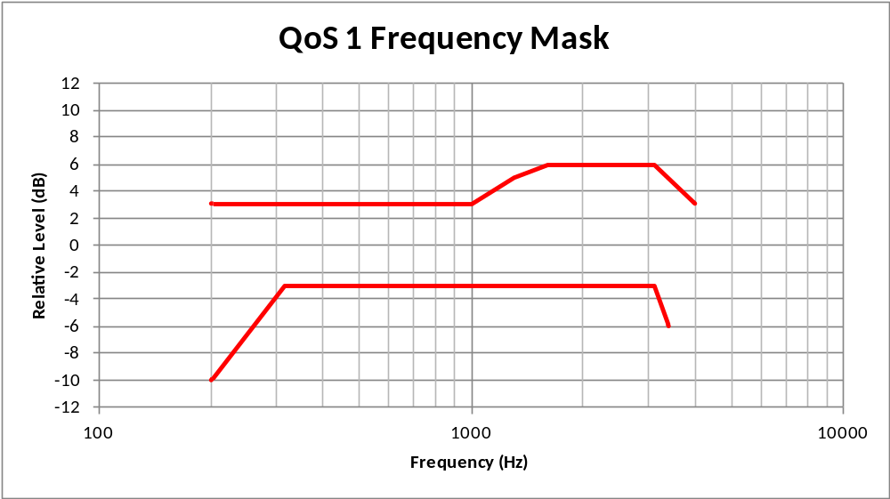
Table xx – Tolerance mask for the narrowband signal enhancement subsystem send sensitivity frequency response for Performance class 2
Frequency [Hz] | Upper limit | Lower limit
200 | 4 dB | –∞ dB
315 | 4 dB | –10 dB
1 000 | 4 dB | –4 dB
1 300 | 6 dB | –4 dB
1 600 | 7 dB | –4 dB
2 000 | 8 dB | –4 dB
3 100 | 8 dB | –4 dB
4 000 | 4dB | –∞ dB
NOTE – The limits for intermediate frequencies lie on a straight line drawn between the given values on a linear (dB) – logarithmic (Hz) scale. All sensitivity values are expressed in dB on an arbitrary scale.
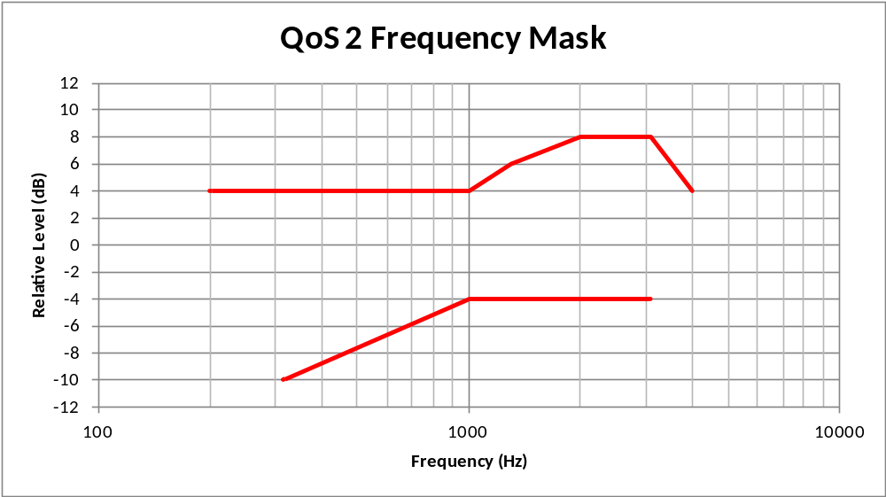
Table xx – Tolerance mask for the narrowband signal enhancement subsystem send sensitivity frequency response for Performance class 3
Frequency [Hz] | Upper limit | Lower limit
200 | 6 dB | X
315 | 6 dB | –10 dB
1 000 | 6 dB | –6 dB
1 300 | 6 dB | –6 dB
1 600 | (Note) | –6 dB
2 000 | 9 dB | –6 dB
3 100 | 9 dB | –10 dB
4 000 | X
NOTE – The limits for intermediate frequencies lie on a straight line drawn between the given values on a linear (dB) – logarithmic (Hz) scale. All sensitivity values are expressed in dB on an arbitrary scale.
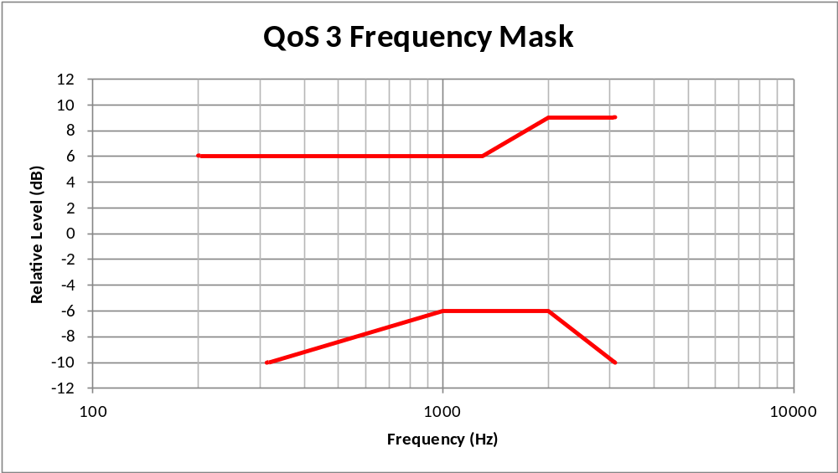
Table xx – Tolerance mask for the narrowband signal enhancement subsystem send sensitivity frequency response for Performance class 4
Frequency [Hz] | Upper limit | Lower limit
200 | N/A | N/A
315 | N/A | N/A
1 000 | N/A | N/A
1 300 | N/A | N/A
1 600 | N/A | N/A
2 000 | N/A | N/A
3 100 | N/A | N/A
4 000 | N/A
NOTE – The limits for intermediate frequencies lie on a straight line drawn between the given values on a linear (dB) – logarithmic (Hz) scale. All sensitivity values are expressed in dB on an arbitrary scale.
T

Design guidance and root-cause analysis
Deviations from the desired frequency response characteristic may cause degradation of the listening speech quality in the send direction or may result in insufficient listening speech quality in the presence of background noise which affects the listing speech quality perceived by the far end subscriber.

Signal enhancement receive sensitivity frequency response (FR_{SER})

Parameter description
The receive frequency response FR_{SER} is measured from the test point (R3) to the test point (R2). This parameter measures the sensitivity frequency response of the signal enhancement subsystem in receive.

Test
1) The test signal used for the measurements shall be the British-English single talk sequence described in clause 7.3.2 of ITU-T Recommendation P.501 [xx], recorded at the output of the network transport subsystem R3. The test signal level is the nominal signal level. The level is averaged over the complete test signal.
The measured power density spectrum at the test point (R3) interface is used as the reference power density spectrum for determining the signal enhancement subsystem receive sensitivity frequency response.
2) The test arrangement is according to clause 8.3. In wideband the send sensitivity frequency response is determined in third octave intervals, as given by [IEC 61260] for frequencies of 100 Hz and 8 kHz, inclusive. In narrowband it is determined for frequencies from 200 Hz to 4kHz. In each third octave band, the level of the measured signal is referred to the level of the reference signal averaged over the complete test sequence length.
3) The sensitivity is determined in dBV/V.

4) The measured result is corrected by the measured sensitivity frequency response characteristics of the audio subsystem in order to take into account any equalization potentially performed in the audio subsystem as well as the loudspeaker response characteristics. Alternatively a simulated R2 to DRP simulation could be used. In such a case the simulated output signal would be referred to the measured power density spectrum at the test point (R3) interface.

Performance level classification based on values of this parameter
To claim compliance with a certain Performance class the frequency response in receive has to meet the requirements for the applicable Performance classes for the signal enhancement subsystem FR_{SER} as defined in the tables below:
The masks are drawn by straight lines between the breaking points in Table 9-xx to 9-xx on a logarithmic (frequency) – linear (dB sensitivity) scale.
Table xx – Tolerance mask for the wideband receive enhancement subsystem receive sensitivity frequency response for Performance class 1
Frequency [Hz] | Upper limit | Lower limit
100 | 3 dB | -6 dB
200 | 3 dB | –3 dB
6 300 | 3 dB | –3 dB
7 600 | 3 dB | -6 dB
8 000 | 3 dB | –∞ dB
NOTE – The limits for intermediate frequencies lie on a straight line drawn between the given values on a linear (dB) – logarithmic (Hz) scale. All sensitivity values are expressed in dB on an arbitrary scale.
Table xx – Tolerance mask for the wideband signal enhancement subsystem receive Table xx – Tolerance mask for the wideband signal enhancement subsystem send sensitivity frequency response for Performance class 2
Frequency [Hz] | Upper limit | Lower limit
125 | 8 dB | –∞ dB
200 | 8 dB | –12 dB
250 | 8 dB | –9 dB
315 | 7 dB | –6 dB
400 | 6 dB | –6 dB
5 000 | 6 dB | –6 dB
6 300 | 6 dB | –9 dB
8 000 | 6 dB | –∞ dB
NOTE – The limits for intermediate frequencies lie on a straight line drawn between the given values on a linear (dB) – logarithmic (Hz) scale. All sensitivity values are expressed in dB on an arbitrary scale.
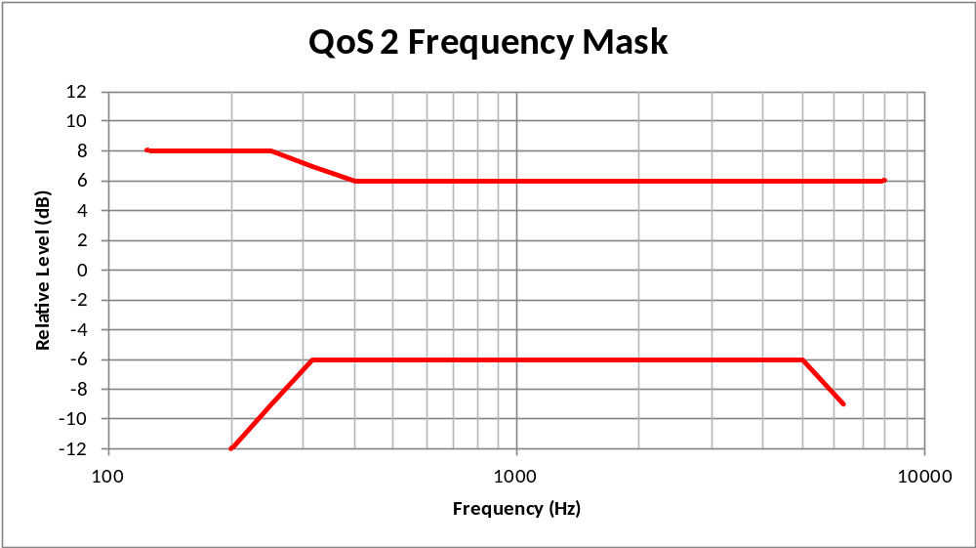
Table xx – Tolerance mask for the wideband signal enhancement subsystem receive sensitivity frequency response for Performance class 3
Frequency [Hz] | Upper limit | Lower limit
100 | 8 dB | X
200 | 8 dB | X
250 | 8 dB | X
315 | 8 dB | –9 dB
400 | 6 dB | –6 dB
5 000 | 6 dB | –9 dB
7 000 | 6 dB | –12 dB
8 000 | 6 dB | x
NOTE – The limits for intermediate frequencies lie on a straight line drawn between the given values on a linear (dB) – logarithmic (Hz) scale. All sensitivity values are expressed in dB on an arbitrary scale.
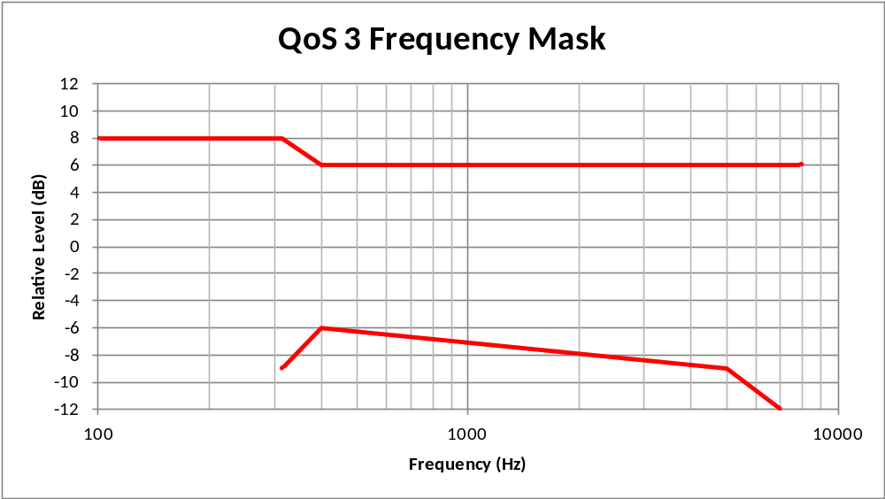
Table xx – Tolerance mask for the wideband signal enhancement subsystem receive sensitivity frequency response for Performance class 4
Frequency [Hz] | Upper limit | Lower limit
100 | N/A | N/A
125 | N/A | N/A
200 | N/A | N/A
1 000 | N/A | N/A
5 000 | N/A | N/A
6 300 | N/A | N/A
8 000 | N/A | N/A
NOTE – The limits for intermediate frequencies lie on a straight line drawn between the given values on a linear (dB) – logarithmic (Hz) scale. All sensitivity values are expressed in dB on an arbitrary scale.
Table xx – Tolerance mask for the narrowband signal enhancement subsystem receive sensitivity frequency response for Performance class 1
Frequency [Hz] | Upper limit | Lower limit
200 | 3 dB | -6 dB
250 | 3 dB | (Note)
315 | 3 dB | –3 dB
400 | 3 dB | –3 dB
3 100 | 3 dB | –3 dB
3 400 | 3 dB | -6 dB
4 000 | 3 dB | –∞ dB
NOTE – The limits for intermediate frequencies lie on a straight line drawn between the given values on a linear (dB) – logarithmic (Hz) scale. All sensitivity values are expressed in dB on an arbitrary scale.
Table xx – Tolerance mask for the narrowband signal enhancement subsystem receive sensitivity frequency response for Performance class 2
Frequency [Hz] | Upper limit | Lower limit
200 | 6 dB | –∞ dB
250 | 6 dB | –∞ dB
315 | 6 dB | –9 dB
400 | 6 dB | –6 dB
3 100 | 6 dB | –6 dB
4 000 | 6 dB | –∞ dB
NOTE – The limits for intermediate frequencies lie on a straight line drawn between the given values on a linear (dB) – logarithmic (Hz) scale. All sensitivity values are expressed in dB on an arbitrary scale.
Table xx – Tolerance mask for the narrowband signal enhancement subsystem receive sensitivity frequency response for Performance class 3
Frequency [Hz] | Upper limit | Lower limit
200 | 6 dB | –∞ dB
250 | 6 dB | –∞ dB
315 | 6 dB | –12 dB
400 | 6 dB | –8dB
3 100 | 6 dB | –8 dB
4 000 | 6 dB | –∞ dB
NOTE – The limits for intermediate frequencies lie on a straight line drawn between the given values on a linear (dB) – logarithmic (Hz) scale. All sensitivity values are expressed in dB on an arbitrary scale.
Table xx – Tolerance mask for the narrowband signal enhancement subsystem receive sensitivity frequency response for Performance class 4
Frequency [Hz] | Upper limit | Lower limit
200 | N/A | N/A
315 | N/A | N/A
1 000 | N/A | N/A
1 300 | N/A | N/A
1 600 | N/A | N/A
2 000 | N/A | N/A
3 100 | N/A | N/A
4 000 | N/A
NOTE – The limits for intermediate frequencies lie on a straight line drawn between the given values on a linear (dB) – logarithmic (Hz) scale. All sensitivity values are expressed in dB on an arbitrary scale.
T

Design guidance and root-cause analysis
Deviations from the desired frequency response characteristic may cause degradation of the listening speech quality for the subscriber in the car.

Careful design taking into account:
- Not too strong equalization in order to avoid overload at certain frequencies
- No counteraction equalization between audio subsystem and signal enhancement

Signal Enhancement Send Speech Quality (MOS-LQO_{SES})

Parameter description
This parameter predicts speech quality under quiet conditions in the Send direction after the Signal Enhancement subsystem. The signal enhancement speech quality in send direction MOS-LQO_{SES} is measured from the test point (S2) to the test point (S3)

Test
1) The test signal used is composed of eight sentences of two male and two female British English speakers according to Annex B.3.3 of ITU-T Recommendation P.501 [xx] and concatenated as described in ITU-T Recommendation P.863 [xx]. The test signal is recorded at the output of the microphone subsystem S2. The test signal level at the MRP is the nominal signal level. The test signal level is measured as "active speech level" according to [ITU-T P.56].
The original speech signal is used as the reference signal for the determination of the speech quality.
In wideband the superwideband mode of the model is used. In narrowband the superwideband mode is applied as well however applying a narrowband reference signal as described in [xx].
2) The test arrangement is according to clause xx.
The calculation is made using the signal recorded at S3.
3) The one-way speech quality is determined as MOS-LQON (narrowband) and MOS-LQOSW (wideband).

Performance level classification based on values of this parameter
To claim compliance with a certain Performance class the listening speech quality in send has to meet the requirements for the applicable Performance classes as given in the table below:
Table xx –Limits for the signal enhancement listening speech quality in send

Performance Class | MOS-LQOn | MOS-LQOsw
1 | > 4.2 | > 4.5
2 | > 3.8 | > 4.1
3 | > 3.4 | > 3.7
4 | ≤ 3.4 | ≤ 3.7

Design guidance and root-cause analysis
For further study.

Signal Enhancement Receive Speech Quality (MOS-LQO_{SER})

Parameter description
This parameter predicts speech quality in the Receive direction after the Signal Enhancement subsystem. The signal enhancement speech quality in receive direction MOS-LQO_{SER} is measured from the test point (R3) to the test point (R2)

Test
1) The test signal used is composed of eight sentences of two male and two female British English speakers according to Annex B.3.3 of ITU-T Recommendation P.501 [xx] and concatenated as described in ITU-T Recommendation P.863 [xx], recorded at the output of the network transport subsystem R3. The test signal level is the nominal signal level. The test signal level is measured as "active speech level" according to [ITU-T P.56].
The original speech signal is used as the reference signal for the determination of the speech quality.
In wideband the superwideband mode of the model is used. In narrowband the superwideband mode is applied as well however applying a narrowband reference signal as described in [xx].
2) The test arrangement is according to clause xx.
The calculation is made using the signal recorded at R2. The measured signal is corrected by the measured sensitivity frequency response characteristics of the audio subsystem in order to take into account any equalization potentially performed in the audio subsystem as well as the loudspeaker response characteristics. Alternatively a simulated R2 to DRP simulation could be used. In such a case the simulated output signal would be referred to the measured power density spectrum at the test point (R3) interface.
3) The one-way speech quality is determined as MOS-LQON (narrowband) and MOS-LQOSW (wideband).

Performance level classification based on values of this parameter
To claim compliance with a certain Performance class the listening speech quality in receive has to meet the requirements for the applicable Performance classes as given in the table below:
Table xx –Limits for the signal enhancement listening speech quality in receive

Performance Class | MOS-LQOn | MOS-LQOsw
1 | > 4.2 | > 4.5
2 | > 3.8 | > 4.1
3 | > 3.4 | > 3.7
4 | ≤ 3.4 | ≤ 3.7

Design guidance and root-cause analysis
For further study.

Signal Enhancement Send Intelligibility (SIE)

Parameter description
This parameter predicts speech intelligibility in the Send direction after the Signal Enhancement subsystem. A measure of intelligibility is desirable because some automotive speech services (e.g., eCall) should be optimized for speech intelligibility/comprehension.

Test method

Performance level classification based on values of this parameter
<To be determined based on test results>

Design guidance and root-cause analysis
For further study.

Signal Enhancement Receive Intelligibility (RIE)

Parameter description
This parameter predicts speech intelligibility in the Receive direction after the Signal Enhancement subsystem. A measure of intelligibility is desirable because some automotive speech services (e.g., eCall) should be optimized for speech intelligibility/comprehension.

Test

Performance level classification based on values of this parameter
<To be determined based on test results>

Design guidance and root-cause analysis
For further study.

Signal Enhancement Send Speech to Idle Channel Noise Ratio (SINR_{SES})

Parameter description
This parameter measures the idle channel noise, when no significant acoustic noise is present in the vehicle, in the Send direction after the Signal Enhancement subsystem. The signal enhancement idle channel noise in send N_{SES} is measured at the test point (S3).

Test
1) The British-English single talk sequence described in clause 7.3.2 of ITU-T Recommendation P.501 [xx] -recorded at the output of the microphone subsystem S2- is applied at the test point (S2). The test signal level is the nominal signal level. The level is averaged over the complete test signal.
The measured power density spectrum at the test point (S3) is used as the reference power density spectrum for determining the signal enhancement subsystem SINR. The test signal level is the average level of the complete test signal. The output level is measured using a speech level voltmeter according to ITU-T P.56. This level is the reference speech signal level.
2) For the measurement, no test signal is used. In order to ensure a reliable activation of the terminal, an activation signal is inserted before the actual measurement. The activation signal consists of the female speaker of the short conditioning sequence described in clause 7.3.7 of ITU-T Recommendation P.501 [xx],
3) The test arrangement is described in clause 8.3. If implemented any equalizer function is deactivated.
4) The idle channel noise is measured at the test point S3. In narrowband the frequency range between 100 Hz and 4 kHz is used. In Wideband the frequency range from 100 Hz to 8 kHz is used. The measurement requires a time window which starts exactly at the end of the activation signal. Any "ringing" of filters or receivers or reverberance influence shall be taken into account, the time window must be shifted accordingly. The length for the time window is 1 second, which is the averaging time for the idle channel noise. The test laboratory has to ensure that the terminal is activated during the measurement. If the subsystem is deactivated during the measurement, the measurement window has to be cut to the duration while the subsystem remains activated.
The power density spectrum of the noise signal is determined using FFT (8 k samples/48 kHz sampling rate or equivalent). A Hanning window is used.
5) In narrowband the idle channel noise is determined by psophometric weighting, in wideband A-weighting is applied. Spectral peaks are measured in the frequency domain. The average noise spectrum used for determining the spectral peak should be calculated as the arithmetic mean of the noise spectrum values when stated in dBm0(P), dBm0(A) respectively in wideband.
6) The weighted noise signal level is referenced to the speech signal level measured at S2.
7) The measurement is repeated with the subsystem equalizers activated.

Performance level classification based on values of this parameter
To claim compliance with a certain Performance class the speech to idle noise ratio SINR has to meet the requirements for the applicable Performance classes for the SINR as defined in table xx:
Spectral peaks in the frequency domain shall not exceed the averaged spectrum by more than 10 dB.
With the subsystem equalizer activated all values listed in table xx shall not decrease by more than 3 dB if the subsystem SINR is ≥ 70 dB .
Table xx –Limits for the idle channel noise re. reference speech signal level with equalizer function deactivated

Performance Class | SINR
1 | > 70 dB
2 | > 60 dB
3 | > 40 dB
4 | ≤ 40 dB

Design guidance and root-cause analysis
For further study.

Signal Enhancement Receive Speech to Idle Channel Noise Ratio (SINR_{SER})

Parameter description
This parameter measures the idle channel noise, when there is no significant noise coming from the network or far end terminal, in the Receive direction after the Signal Enhancement subsystem. The signal enhancement idle channel noise in receive N_{SER} is measured at the test point (R2).

Test
1) The British-English single talk sequence described in clause 7.3.2 of ITU-T Recommendation P.501 [xx] -recorded at the output of the network transport subsystem R3- is applied at the test point (R3). The test signal level is the nominal signal level. The level is averaged over the complete test signal.
The measured power density spectrum at the test point (R2) is used as the reference power density spectrum for determining the signal enhancement subsystem SINR. The test signal level is the average level of the complete test signal. The output level is measured using a speech level voltmeter according to ITU-T P.56. This level is the reference speech signal level.
2) For the measurement, no test signal is used. In order to ensure a reliable activation of the terminal, an activation signal is inserted before the actual measurement. The activation signal consists of the female speaker of the short conditioning sequence described in clause 7.3.7 of ITU-T Recommendation P.501 [xx],
3) The test arrangement is described in clause 8.3. If implemented any equalizer function is deactivated.
4) The idle channel noise is measured at the test point (R2). In narrowband the frequency range between 100 Hz and 4 kHz is used. In wideband the frequency range from 100 Hz to 8 kHz is used. The measurement requires a time window which starts exactly at the end of the activation signal. Any "ringing" of filters or receivers or reverberance influence shall be taken into account, the time window must be shifted accordingly. The length for the time window is 1 second, which is the averaging time for the idle channel noise. The test laboratory has to ensure that the terminal is activated during the measurement. If the subsystem is deactivated during the measurement, the measurement window has to be cut to the duration while the subsystem remains activated.
The power density spectrum of the noise signal is determined using FFT (8 k samples/48 kHz sampling rate or equivalent). A Hanning window is used.
5) The idle channel noise is A-weighted. Spectral peaks are measured in the frequency domain. The average noise spectrum used for determining the spectral peak should be calculated as the arithmetic mean of the noise spectrum values when stated in dBm0(A).
6) The weighted noise signal level is referenced to the speech signal level measured at S2.
7) The measurement is repeated with the subsystem equalizers activated.

Performance level classification based on values of this parameter
To claim compliance with a certain Performance class the speech to idle noise ratio SINR has to meet the requirements for the applicable Performance classes for the SINR as defined in table xx:
Spectral peaks in the frequency domain shall not exceed the averaged spectrum by more than 10 dB.
With the subsystem equalizer activated all values listed in table xx shall not decrease by more than 3 dB if the subsystem SINR is ≥ 70 dB .
Table xx –Limits for the idle channel noise re. reference speech signal level with equalizer function deactivated

Performance Class | SINR
1 | > 70 dB
2 | > 60 dB
3 | > 40 dB
4 | ≤ 40 dB

Design guidance and root-cause analysis
For further study.

Discrimination against out-of-band signals after Send Enhancement (DOOB_{SES})

Parameter description
This parameter measures the degree to which speech and noise signal frequencies, which are outside the transmission channel passband at the input to the Signal Enhancement subsystem, cause noise in the Send direction at the output of the Signal Enhancement subsystem. The discrimination against out-of-band signals in send DOOB_{SES} is measured at the test point (S3).

Test
1) The test arrangement is in accordance with clause 8.3.
2) The British-English single talk sequence described in clause 7.3.2 of ITU-T Recommendation P.501 [xx] -recorded at the output of the microphone subsystem S2- is applied at the test point (S2). The test signal level is the nominal signal level. The level is averaged over the complete test signal.
The measured power density spectrum at the test point (S3) is used as the reference power density spectrum for determining the signal enhancement subsystem DOOB.
3) In order to ensure a reliable activation of the subsystem, an activation signal is generated before the actual measurement starts. The activation signal consisting of the female speaker of the short conditioning sequence described in clause 7.3.7 of ITU-T Recommendation P.501 [xx] -recorded at the output of the microphone subsystem S2- is applied at the test point (S2). The activation level shall the nominal signal level. The level of the activation signal is averaged over the complete activation sequence signal.
4) Directly after the activation signal, the actual test signal is inserted. The test signal -recorded at the output of the microphone subsystem S2- is applied at the test point (S2). The test signal is inserted exactly after the activation signal. The duration of the test signal amounts to 200 ms.
5) The test signal is a white Gaussian noise, band-limited from 4.6 kHz to 8 kHz in narrowband and 8 kHz to 10 kHz in wideband with nominal signal level. The level of the test signal is averaged over the complete test signal sequence.
6) For the analysis, a rectangular window is used which is adapted to the test signal duration (200 ms). Any "ringing" of filters or receivers or reverberance influence shall be taken into account, the time window must be shifted accordingly. In narrowband the signal level is determined in the frequency range from 300 Hz to 3.4 kHz at the test point (S2). The level of the reference signal, band-limited from 300 Hz to 3.4 kHz is determined at the test point (S2) as well. In wideband for both signals 100 Hz to 8 kHz is used. The in-band reference signal level is determined using a speech level voltmeter according to ITU-T P.56.
7) The ratio (in dB) between the reference level and the measured signal level is determined.
NOTE – With low sensitivity in the send direction, the measured noise level may already exceed the required minimum out-of-band level.

Performance level classification based on values of this parameter
To claim compliance with a certain Performance class the discrimination against out-of-band signals after signall enhancement has to meet the requirements for the applicable Performance classes for the DOOB_{SES} as defined in table xx:

Table xx –Limits for the Discrimination against out-of-band signals after Send Enhancement

Performance Class | DOOB_{SES}
1 | > 40 dB
2 | > 35 dB
3 | > 30 dB
4 | ≤ 30 dB

Design guidance and root-cause analysis
For further study.

Spurious out-of-band signal after Receive Enhancement (SOOB_{SER})

Parameter description
This parameter measures the degree to which speech signal frequencies within the transmission channel passband cause spurious noise outside the passband at the output of the Signal Enhancement subsystem in the Receive direction. The signal enhancement spurious out-of-band signal in receive SOOB_{SER} is measured at the test point (R2).

Test
1) The test arrangement is in accordance with clause 8.3.
2) The test signal is the British-English single talk sequence described in clause 7.3.2 of ITU-T Recommendation P.501 [xx] -recorded at the output of the network transport subsystem R3- applied at the test point (R3). The test signal level is the nominal signal level. The level is averaged over the complete test signal.
The measured in-band power density spectrum at the test point (S3) is used as the reference power density spectrum for determining the signal enhancement subsystem DOOB.
3) In narrowband the level of the out-of-band signal is determined between 4.6 and 8 kHz. In wideband the level of the out-of-band signal is determined between 8.6 and 16 kHz. The in-band reference level is determined by measuring the in band signal level between 300 Hz and 3.4 kHz in narrowband and 100 Hz to 8 kHz in wideband. The in-band reference signal level is determined using a speech level voltmeter according to ITU-T P.56.
4) The ratio (in dB) between the reference level and the measured signal level is determined.

NOTE 1 – This measurement method does not apply to systems including artificial bandwidth extension.
NOTE 2 – In case of fluctuating noise levels, multiple reference noise measurements should be made and the worst case result should be used as a reference.
NOTE 3 – With low sensitivity in the receive direction, the measured noise level may already exceed the required minimum out-of-band level.

Performance level classification based on values of this parameter
To claim compliance with a certain Performance class the spurious out-of-band signals after signal enhancement has to meet the requirements for the applicable Performance classes for the SOOB_{SER} as defined in table xx:
Table xx –Limits for the Discrimination against out-of-band signals after Send Enhancement

Performance Class | SOOB_{SER}
1 | > 40 dB
2 | > 35 dB
3 | > 30 dB
4 | ≤ 30 dB

Design guidance and root-cause analysis
For further study.

Distortion in Send after Enhancement (D_{SES})

Parameter description
This parameter measures speech signal distortion in the Send direction after the Signal Enhancement subsystem. The signal enhancement distortion in send D_{SES} is measured at the test point (S3).

Test
1) The test signal is a sinusoidal signal with a frequency of 300 Hz, 500 Hz, 1 kHz and 2 kHz (for wideband only) is applied at the test point (S2). The test signal level is the nominal signal level. The level is averaged over the complete test signal.
2) In order to ensure a reliable activation of the subsystem, an activation signal is generated before the actual measurement starts. The activation signal consisting of the female speaker of the short conditioning sequence described in clause 7.3.7 of ITU-T Recommendation P.501 [xx] is applied at the test point (S2). The activation level shall the nominal signal level. The level of the activation signal is averaged over the complete activation sequence signal.
3) The test signal is inserted immediately after the activation sequence. The test signal duration is 200 ms.
4) For the analysis, a Hanning window is used which is adapted to the duration of the test signal (200 ms).
5) The harmonic distortion produced by the signal enhancement subsystem is measured at the test point (S3).

Performance level classification based on values of this parameter
To claim compliance with a certain Performance class the discrimination distortion after signal enhancement has to meet the requirements for the applicable Performance classes for the D_{SES} as defined in table xx:
Table xx –Limits for the signal enhancement subsystem distortion

Performance Class | D_{SES}
1 | < 0.1%
2 | < 0.5%
3 | < 1%
4 | > 1%

Design guidance and root-cause analysis
For further study.

Distortion in Receive after Enhancement (D_{SER)}

Parameter description
This parameter measures speech signal distortion in the Receive direction after the Signal Enhancement subsystem. The signal enhancement distortion in receive D_{SER} is measured at the test point (R2).

Test
1) The test signal is a sinusoidal signal with a frequency of 300 Hz, 500 Hz, 1 kHz and 2 kHz (for wideband only) is applied at the test point (R3). The test signal level is the nominal signal level. The level is averaged over the complete test signal.
2) In order to ensure a reliable activation of the subsystem, an activation signal is generated before the actual measurement starts. The activation signal consisting of the female speaker of the short conditioning sequence described in clause 7.3.7 of ITU-T Recommendation P.501 [xx] is applied at the test point (R3). The activation level shall the nominal signal level. The level of the activation signal is averaged over the complete activation sequence signal.
3) The test signal is inserted immediately after the activation sequence. The test signal duration is 200 ms.
4) For the analysis, a Hanning window is used which is adapted to the duration of the test signal (200 ms).
5) The harmonic distortion produced by the signal enhancement subsystem is measured at the test point (R2).

Performance level classification based on values of this parameter
To claim compliance with a certain Performance class the discrimination distortion after signal enhancement has to meet the requirements for the applicable Performance classes for the D_{SER} as defined in table xx:
Table xx –Limits for the signal enhancement subsystem distortion

Performance Class | D_{SER}
1 | < 0.1%
2 | < 0.5%
3 | < 1%
4 | > 1%

Design guidance and root-cause analysis
For further study.

Signal Enhancement Weighted Terminal Coupling Loss (TCLw_{SE}) and (TCL_{SE})

Parameter description
This parameter measures acoustic echo loss during Receive single-talk. Echo loss is measured from the input to the Signal Enhancement subsystem in the Receive direction (R3), to the output of the Signal Enhancement subsystem in the Send direction (S3). In narrowband TCLw is measured in wideband the unweighted TCL is measured.

Test
1) The test arrangement is in accordance with clause 8.3.
2) The noise level measured at the electrical access point (idle channel noise) shall be less than –63 dBm0. The attenuation between the input to the signal enhancement subsystem (R3) to the output of the signal enhancement subsystem is measured using the compressed speech test signal as described in ITU-T Recommendation P.501, clause 7.3.3, Amendment 1 [xx]. The test signal level is -10 dBm0.
3) The first 17,0 s of the test signal (6 sentences) are discarded from the analysis to allow for convergence of the acoustic echo canceller. The analysis is performed over the remaining length of the test sequence (last 6 sentences). For the calculation, the average measured echo level at each frequency band is referred to the average level of the test signal measured in each frequency band.
4) In narrowband TCL_{W} is calculated according to clause B.4 of [ITU-T G.122], (trapezoidal rule). In wideband TCL is calculated as unweighted echo loss from 100 Hz to 8 kHz.

Performance level classification based on values of this parameter
To claim compliance with a certain Performance class the echo loss after signal enhancement has to meet the requirements for the applicable Performance classes for the TCL_{SE} (wideband) and TCLw_{SE} as defined in table xx:
Table xx –Limits for the signal enhancement subsystem TCL

Performance Class | TCLw_{SE (narrowband)} | TCL_{SE (wideband)}
1 | > 50 dB | > 50 dB
2 | > 46 dB | > 46 dB
3 | > 40 dB | > 40 dB
4 | < 40 dB | < 40 dB

Design guidance and root-cause analysis
For further study.

Signal Enhancement Echo Level Versus Time (ELVT_{SE})

Parameter description
This parameter measures acoustic echo loss as a function of time during Receive single-talk. Echo loss is measured from the input to the Signal Enhancement subsystem in the Receive direction (R3), to the output of the Signal Enhancement subsystem in the Send direction (S3).

Test
1) The test arrangement is in accordance with clause 8.3.
2) The test signal consists of a periodically repeated composite source signal according to [ITU-T P.501] with an average level of –5 dBm0 as well as an average level of –25 dBm0. The echo signal is analysed during a period of at least 2.8 s, which represents 8 periods of the CS signal. The integration time for the level analysis shall be 35 ms, the analysis is referred to the level analysis of the reference signal.
3) The measurement result is displayed as attenuation versus time. The exact synchronization between input and output signal has to be guaranteed.
4) In addition, the test is repeated with the British-English single talk sequence described in clause 7.3.2 of ITU-T Recommendation P.501 [xx]. The average test signal level is –16 dBm0. The echo signal is analysed during the complete test signal. The integration time for the level analysis shall be 35 ms, the analysis is referred to the analysis of the same signal but using an integration time of 1 s.

NOTE – When testing using CSS, the analysis is conducted only during the active signal part, the pauses between the composite source signals are not analysed. The analysis time is reduced by the integration time of the level analysis (35 ms).

Performance level classification based on values of this parameter
To claim compliance with a certain Performance class of this parameter after signal enhancement has to meet the requirements for the applicable Performance classes for the ELVT_{SE} as defined in table xx:
Table xx –Limits for the signal enhancement subsystem echo level vs. time

Performance Class | ELVTw_{SE}
1 | ≤ 3 dB
2 | ≤ 6 dB
3 | ≤ 9 dB
4 | > 9 dB

Design guidance and root-cause analysis
For further study.

Signal Enhancement Spectral Echo Attenuation (SEA_{SE})

Parameter description
This set of parameters measures the frequency response of the acoustic echo path during Receive single-talk. The echo path frequency response is measured from the input to the Signal Enhancement subsystem in the Receive direction (R3), to the output of the Signal Enhancement subsystem in the Send direction (S3).

Test
1) The test arrangement is in accordance with clause 8.3. The noise level measured at the electrical access point (idle channel noise) shall be less than –63 dBm0.
2) The test signal is the compressed speech signal as described in ITU-T Recommendation P.501, clause 7.3.3, Amendment 1 [xx]. The test signal level is -10 dBm0.
3) The power density spectrum of the measured echo signal is referred to the power density spectrum of the original test signal. The analysis is conducted using FFT with 8 k points (48 kHz sampling rate or equivalent, Hann window).
4) The spectral echo attenuation is analysed in the frequency domain in dB.

Performance level classification based on values of this parameter
To claim compliance with a certain Performance class of this parameter after signal enhancement has to meet the requirements for the applicable Performance classes for the LVT_{SE} as defined in table xx:
Table xx –Limits for the signal enhancement subsystem spectral echo attenuation in narrowband
Frequency [Hz] | Performance Class 1 | Performance Class 2 | Performance Class 3 | Performance Class 4
100 | ≤ –20 dB
200 | ≤ –30 dB
300 | ≤ –38 dB
800 | ≤ –34 dB
1500 | ≤ –33 dB
2600 | ≤ –24 dB
4000 | ≤ –24 dB
NOTE 1 – All sensitivity values are expressed in dB on an arbitrary scale.
NOTE 2 – The limit at intermediate frequencies lies on a straight line drawn between the given values on a log (frequency) – linear (dB) scale.
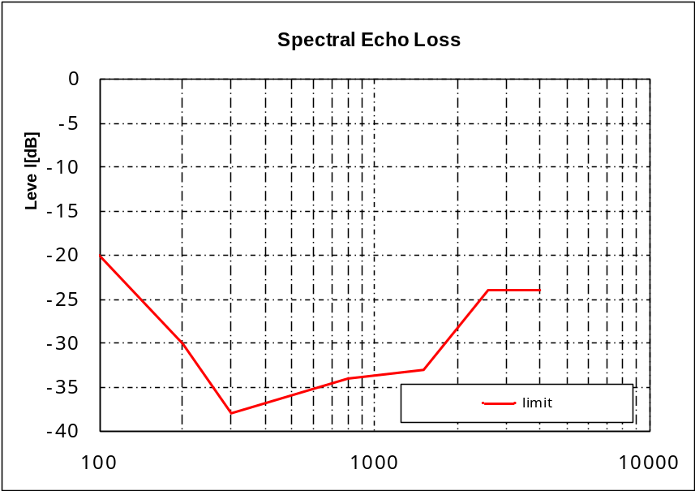
Figure xx – Spectral echo loss mask Performance Class 1 (Fig. is informative)
Table xx –Limits for the signal enhancement subsystem spectral echo attenuation in wideband
Frequency [Hz] | Performance Class 1 | Performance Class 2 | Performance Class 3 | Performance Class 4
100 | ≤ –41 dB
1 300 | ≤ –41 dB
3 450 | ≤ –46 dB
5 200 | ≤ –46 dB
7 500 | ≤ –37 dB
8 000 | ≤ –37 dB
NOTE 1 – All sensitivity values are expressed in dB on an arbitrary scale.
NOTE 2 – The limit at intermediate frequencies lies on a straight line drawn between the given values on a log (frequency) – linear (dB) scale.

Design guidance and root-cause analysis
For further study.

Signal Enhancement Initial Convergence without background noise (IC_{SE})

Parameter description
This parameter measures acoustic echo loss as a function of time immediately after call set-up when there is no background noise. Echo loss is measured from the input to the Signal Enhancement subsystem in the Receive direction (R3), to the output of the Signal Enhancement subsystem in the Send direction (S3).

Test
1) The test arrangement is in accordance with clause 8.3. The noise level measured at the electrical access point (idle channel noise) shall be less than –63 dBm0.
2) The test signal is applied immediately after setting up the call and setting the volume control to its maximum.
3) The test signal is a composite source signal according to [ITU-T P.501] repeated periodically. The average signal level is –16 dBm0. The echo signal is analysed over a period of at least 5 s. The analysis integration time is 35 ms, the analysis is referred to the level analysis of the reference signal. In addition, the test is repeated with artificial voice according to [ITU-T P.50]. One sequence of male voice and a second one consisting of a female voice are used. The starting point of each signal is as defined by the start of the sequence provided by [ITU-T P.50]. The average test signal level is –16 dBm0.
4) In addition, the test is repeated with the British-English single talk sequence described in clause 7.3.2 of ITU-T Recommendation P.501 [xx]. The average test signal level is –16 dBm0. The echo signal is analysed over a period of at least 5 s. The analysis integration time is 35 ms, the analysis is referred to the level analysis of the reference signal.
5) The measurement is displayed as echo attenuation vs time, measured signal and reference signal have to be synchronized in time.
NOTE 1 – The analysis of the CSS is performed only on the active signal parts, the pauses between the bursts of the composite source signal are not analysed. The analysis time is reduced by the time constant of the level analysis due to the integration time of 35 ms.
NOTE 2 – The required performance for speech signal should be achieved for different starting points of the speech signal.

Performance level classification based on values of this parameter
To claim compliance with a certain Performance class of this parameter after signal enhancement has to meet the requirements for the applicable Performance classes for the IC_{SE} as defined in table xx:

Table xx –Limits for the signal enhancement subsystem initial convergence
time [ms] | Performance Class 1 | Performance Class 2 | Performance Class 3 | Performance Class 4
200 | ≥ 6 dB
1 000 | ≥ 20 dB
1 200 | ≥ 40 dB

Design guidance and root-cause analysis
For further study.

Signal Enhancement Initial Convergence With Background Noise (ICBNE)

Parameter description
This parameter measures acoustic echo loss as a function of time immediately after call set-up when background noise is present. Echo loss is measured from the input to the Signal Enhancement subsystem in the Receive direction, to the output of the Signal Enhancement subsystem in the Send direction.

Test method
<Adapt from ITU-T P.1100/1110>

Performance level classification based on values of this parameter

<To be determined based on test results>

Design guidance and root-cause analysis
For further study.

Signal Enhancement Echo Performance with Time Variant Echo Path (TVEPE)

Parameter description
This parameter measures acoustic echo loss when the echo path changes during the measurement. Echo loss is measured from the input to the Signal Enhancement subsystem in the Receive direction, to the output of the Signal Enhancement subsystem in the Send direction.

Test
<Adapt from ITU-T P.1100/1110>

Performance level classification based on values of this parameter

<To be determined based on test results>

Design guidance and root-cause analysis
For further study.

Signal Enahncement Echo Performance with Time Variant Echo Path and Artificial Voice (TVEPE-AV)

Parameter description
This parameter measures acoustic echo loss when the echo path changes during the measurement and the ITU-T P.50 artificial voice is used as the test signal. Echo loss is measured from the input to the Signal Enhancement subsystem in the Receive direction, to the output of the Signal Enhancement subsystem in the Send direction.

Test
<Adapt from ITU-T P.1100/1110>

Performance level classification based on values of this parameter
<To be determined based on test results>

Design guidance and root-cause analysis
For further study.

Signal Enhancement Send Activation (SAE)

Parameter description
This parameter measures the minimum speech signal level required to activate the Send transmission path up to the output of the Signal Enhancement subsystem in the Send direction.

Test
<Adapt from ITU-T P.1100/1110>

Performance level classification based on values of this parameter
<To be determined based on test results>

Design guidance and root-cause analysis
For further study.

Signal Enhancement Receive Activation (RAE)

Parameter description
This parameter measures the minimum speech signal level required to activate the Receive transmission path up to the output of the Signal Enhancement subsystem in the Receive direction.

Test
<Adapt from ITU-T P.1100/1110>

Performance level classification based on values of this parameter
<To be determined based on test results>

Design guidance and root-cause analysis
For further study.

Signal Enhancement Send Attenuation Range (SARE)

Parameter description
This parameter measures the range of attenuation in the Send direction during single-talk due to the Signal Enhancement subsystem.

Test
<Adapt from ITU-T P.1100/1110>

Performance level classification based on values of this parameter
<To be determined based on test results>

Design guidance and root-cause analysis
For further study.

Signal Enhancement Receive Attenuation Range (RARE)

Parameter description
This parameter measures the range of attenuation in the Receive direction during single-talk due to the Signal Enhancement subsystem.

Test
<Adapt from ITU-T P.1100/1110>

Performance level classification based on values of this parameter
<To be determined based on test results>

Design guidance and root-cause analysis
For further study.

Signal Enhancement Attenuation Range in Send during Double-Talk (ASDTE)

Parameter description
This parameter measures the range of attenuation in the Send direction during double-talk due to the Signal Enhancement subsystem.

Test
<Adapt from ITU-T P.1100/1110>

Performance level classification based on values of this parameter
<To be determined based on test results>

Design guidance and root-cause analysis
For further study.

Signal Enhancement Attenuation Range in Receive during Double-Talk (ARDTE)

Parameter description
This parameter measures the range of attenuation in the Receive direction during double-talk due to the Signal Enhancement subsystem.

Test
<Adapt from ITU-T P.1100/1110>

Performance level classification based on values of this parameter
<To be determined based on test results>

Design guidance and root-cause analysis
For further study.

Detection of Echo Components during Double-Talk after Enhancement (DECDTE)

Parameter description
This parameter measures acoustic echo loss during double-talk. Echo loss is measured from the input to the Signal Enhancement subsystem in the Receive direction, to the output of the Signal Enhancement subsystem in the Send direction.

Test
<Adapt from ITU-T P.1100/1110>

Performance level classification based on values of this parameter
<To be determined based on test results>

Design guidance and root-cause analysis
For further study.

Signal Enhancement Sent Speech Attenuation during Double-Talk (SSADTE)

Parameter description
This parameter measures the range of attenuation in the Send direction immediately after the onset double-talk due to the Signal Enhancement subsystem. It is intended to complement the “Enhanced Attenuation Range in Send during Double-Talk” measurement parameter by verifying the attenuation range at the onset of double-talk is consistent with that measured during double-talk.

Test
<Adapt from ITU-T P.1100/1110>

Performance level classification based on values of this parameter
<To be determined based on test results>

Design guidance and root-cause analysis
For further study.

Signal Enhancement Speech-to-Echo Ratio (SpERE)

Parameter description
This parameter provides a measurement of the Send speech level relative to the echo level at the output of the Signal Enhancement subsystem.

Test
<Need to identify best test method. Could use temporally-weighted terminal coupling loss w/ varying echo path to calculate echo portion.>

Performance level classification based on values of this parameter
<To be determined based on test results>

Design guidance and root-cause analysis
For further study.

SNR Improvement after Enhancement (SNRIE)

Parameter description
This parameter provides a measurement of the Send speech level relative to the noise level at the output of the Signal Enhancement subsystem.

Test
<This measurement parameter is listed for further study in P.1100. Could potentially use measures from G.160 Appendix II.>

Performance level classification based on values of this parameter
<To be determined based on test results>

Design guidance and root-cause analysis
For further study.

Signal Enhancement Background Noise Transmission After Call Set-up (BGNTACSE)

Parameter description
This parameter predicts the transmitted noise quality after call set-up at the output of the Signal Enhancement subsystem.

Test
<Adapt from ITU-T P.1100/1110>

Performance level classification based on values of this parameter
<To be determined based on test results>

8.3.3.4 Design guidance and root-cause analysis
For further study.

Enhanced Speech Quality in the Presence of Background Noise (SQPBGNE)

Parameter description
This parameter predicts speech quality under noisy conditions in the Send direction after the Signal Enhancement subsystem.

Test
<Adapt from ITU-T P.1100/1110. Need to decide on objective model (e.g., ETSI, P.863, etc.). Note caveats and more relaxed requirements because of using perceptual-based model to measure signal intended for input of speech encoder.>

Performance level classification based on values of this parameter
<To be determined based on test results>

Design guidance and root-cause analysis
For further study.

Enhanced Quality of Background Noise Transmission with Far End Speech (QBGNTFSE)

Parameter description
This parameter measures the variation in noise level at the output of the Signal Enhancement subsystem in the Send direction due to the presence/absence of speech in the Receive direction.

Test
<Adapt from ITU-T P.1100/1110>

Performance level classification based on values of this parameter
<To be determined based on test results>

Design guidance and root-cause analysis
For further study.

Enhanced Quality of Background Noise Transmission with Near End Speech (QBGNTNSE)

Parameter description
This parameter measures the variation in noise level at the output of the Signal Enhancement subsystem in the Send direction due to the presence/absence of speech in the Send direction.

Test
<Adapt from ITU-T P.1100/1110>

Performance level classification based on values of this parameter
<To be determined based on test results>

Design guidance and root-cause analysis
For further study.

Background Noise Distortion Measure (xxx )

Parameter description
The noise distortion caused by background noise reduction algorithms of the signal enhancement subsystem can be measured by an objective noise distortion measure, which can be found in Annex E. This method can be used in addition to measurement of the enhanced speech quality in the presence of background noise (see xx) for investigating the root causes of background noise impairments in more detail and optimizing noise reduction algorithms.

Test
Some text has to be added -
See Annex E

Performance level classification based on values of this parameter
The performance classes are defined in Annex E.

Design guidance and root-cause analysis
Background noise attenuation achieved by the signal enhancement subsystem will lead to enhanced speech-to-noise ratio. In addition to that, background noise distortion may occur due to different factors like applying different noise reduction algorithms and different parameterizations inside a noise reduction algorithm. An objective noise distortion measure can be found in Annex E, which objectively measures the background noise distortion based only on the input background noise and the filtered background noise after the noise reduction algorithm. Such a noise distortion measure can be applied to optimize the parameterization of the noise reduction algorithm under test in the sense of background noise quality.

Comfort Noise Injection after Enhancement (CNIE)

Parameter description
This set of parameters measures the difference in noise spectrum due to comfort noise injection at the output of the Signal Enhancement subsystem

Test
<Adapt from ITU-T P.1100/1110>

Performance level classification based on values of this parameter
<To be determined based on test results>

Design guidance and root-cause analysis
For further study.

Speech Recognition Accuracy Indicator after Enhancement (SRAIE)

Parameter description
This parameter predicts Speech Recognition (SR) accuracy at the output of the Signal Enhancement subsystem.

Test
<Need to identify test method. Both signal-based (e.g., weighted SNR, AI, etc.) and reference speech recognizer-based (e.g., % correct, % confusions, etc.) measures should be considered.>

Performance level classification based on values of this parameter
<To be determined based on test results>

Design guidance and root-cause analysis
For further study.

Send path
        - Enhanced Send Speech Level (SSLE)
        - Enhanced Speech-to-Noise Ratio (SpNRE)
        - Equalized Send Frequency Response (SFRE)
        - Enhanced Send ReVerberation (SRVE)
        - Enhanced Send Distortion + Noise (SDNE)

Echo path
        - Enhanced Speech-to-Echo Ratio (SpERE)
        - Enhancement layer Round-Trip Delay (RTDE)

Receive path
        - Enhanced Receive Speech Level (RSLE)
        - Enhanced Receive speech quality (MOS-LQOE)
        - Enhanced Receive Intelligibility (RIE)

Network Access Subsystem

Send path
        - Enhanced Send Speech Level (SSLE)
        - Enhanced Speech-to-Noise Ratio (SpNRE)
        - Equalized Send Frequency Response (SFRE)
        - Enhanced Send ReVerberation (SRVE)
        - Enhanced Send Distortion + Noise (SDNE)

Echo path
        - Enhanced Speech-to-Echo Ratio (SpERE)
        - Enhancement layer Round-Trip Delay (RTDE)

Receive path
        - Enhanced Receive Speech Level (RSLE)
        - Enhanced Receive speech quality (MOS-LQOE)
        - Enhanced Receive Intelligibility (RIE)

Send-receive path coupling

      - See section in P.1100

- Acoustic interface
  - For each measurement parameter:
    - Parameter description
    - Test method
    - Single Pass/Fail or multiple thresholds of degradation for measured value
- Speech enhancement layer
  - For each measurement parameter:
    - Parameter description
    - Test method
    - Performance level classification based on values of this parameter
    - Design guidance and root-cause analysis
- Local transport
  - For each measurement parameter:
    - Parameter description
    - Test method
    - Performance level classification based on values of this parameter
    - Design guidance and root-cause analysis
- Network transport
  - For each measurement parameter:
    - Parameter description
    - Test method
    - Performance level classification based on values of this parameter
    - Design guidance and root-cause analysis

Bidirectional Signal Transport: Wired and Short range Wireless Transmission
The purpose of this section is to ensure linearity (as far as possible) and time invariance of a bidirectional signal transport over a wired or a short range wireless transmission system. Any bidirectional signal transport system including the network transport system in conjunction with the devices it is integrated in should not introduce any additional signal processing. Any other function than pure speech data transmission should be avoided.
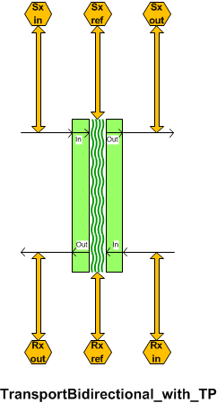
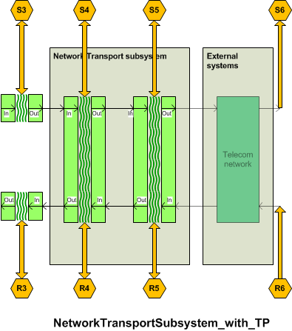

The DUT is connected to the reference interfaces. The reference interfaces are calibrated as specified in clause 8.1.

Bidirectional transport delay in send direction

Parameter description
The delay in send direction T_{BDS} is measured from the test point (S3) to the test point (S4) or to the POI (input of the reference speech coder of the system simulators) test point(S5). The test point (S3) may be the SRWAP. The delay T_{BDS} should be minimized.
The system delay t_{System} depends on the transmission method used, the delay of the reference interface and the network simulator. The delay t_{System} must be known and deducted from the test result.

Test
1) For the measurements, a composite source signal (CSS) according to [ITU-T P.501] is used. The pseudo random noise (pn)-part of the CSS has to be longer than the maximum expected delay. It is recommended to use a pn sequence of 16 k samples (with 48 kHz sampling rate). The test signal is inserted at test point (S3) at a level according to clause 8.1.5.
The reference signal is the original signal (test signal).
The test set-up is according to clause 9.1.
2) The delay is determined by cross-correlation analysis between the measured signal at the electrical access point and the original signal. The measurement is corrected by delays which are caused by the test equipment.
3) The delay is measured in ms and the maximum of the cross-correlation function is used for the determination.

T_{measure} = T_{BDS} + T_{System}

Performance level classification based on values of this parameter
To claim compliance with a certain Performance class the delay in the send direction has to meet the requirements for the applicable Performance classes for the bidirectional transport delay T_{BDS} as defined in table xx:
Table xx –Limits for the bidirectional transport delay in send direction for speech communication services

Performance Class | T_{BDS}
1 | < 2 ms
2 | < 10 ms
3 | < 30 ms
4 | ≥ 30 ms

Design guidance and root-cause analysis
Low delay is essential for a seamless conversational performance especially for highly interactive conversations. Delay also contributes to echo perception: Higher delay low leads to higher impairment resulting even from low level echo components (see ITU-T Rec. G. 111 [xx]). Therefore any design providing as low delay in the connection as possible is preferable.

Bidirectional transport delay in receive direction

Parameter description
The delay in receive direction T_{BDR} is measured from the test point (R4) or the POI (input of the reference speech coder of the system simulators) (R5) to the test point (R3) which may be the SRWAP (R3).
The system delay t_{System} depends on the transmission system, the delay of the reference interface and on the network simulator used. The delay t_{System} must be known and deducted from the test result.

Test
1) For the measurements, a composite source signal (CSS) according to [ITU-T P.501] is used. The pseudo random noise (pn)-part of the CSS has to be longer than the maximum expected delay. It is recommended to use a pn sequence of 16 k samples (with 48 kHz sampling rate). The test signal is applied at test point (R4) or the test point (R5) at a level according to clause 8.1.5.
The reference signal is the original signal (test signal).
2) The test arrangement is according to clause 9.1.
3) The delay is determined by cross-correlation analysis between the measured signal at the SRWR and the original signal. The measurement is corrected by delays which are caused by the test equipment.
4) The delay is measured in ms and the maximum of the cross-correlation function is used for the determination.
T_{measure} = T_{BDR} + T_{System}

Performance level classification based on values of this parameter
To claim compliance with a certain Performance class the delay in the receive direction has to meet the requirements for the applicable Performance classes for the bidirectional transport delay T_{BDR} as defined in table xx:
Table xx –Limits for the bidirectional transport delay in receive direction for speech communication services

Performance Class | T_{BDR}
1 | < 2 ms
2 | < 10 ms
3 | < 30 ms
4 | ≥ 30 ms

Design guidance and root-cause analysis
Low delay is essential for a seamless conversational performance especially for highly interactive conversations. Delay also contributes to echo perception: Higher delay low leads to higher impairment resulting even from low level echo components (see ITU-T Rec. G. 111 [xx]). Therefore any design providing as low delay in the connection as possible is preferable.

Bidirectional transport send junction loudness ratings

Parameter description
The send junction loudness rating JLR_{BDS} is measured from the test point (S3) to the test point (S4) or to the POI (input of the reference speech coder of the system simulators) (S5). The test point (S3) may be the SRWAP.
The JLR describes any amplification or attenuation on the network transport layer. The send junction loudness rating JLR_{BDS} should be 0 dB.

Test
1) The test signal used for the measurements shall be CSS according to [ITU-T P.501]. The test signal level is the nominal signal level, the level is averaged over the complete test signal.
The measured power density spectrum at the test point interface (S3)is used as the reference power-density spectrum for determining the bidirectional transport send sensitivity.
2) The test arrangement is according to clause 9.1. For wideband the bidirectional send sensitivity is calculated from each band of the 20 frequencies given in Table A.2 of [ITU-T P.79], bands 1-20. For narrowband bands 4-17 are used for calculation.
For the calculation, the average measured level at the electrical reference point for each frequency band is referred to the average test signal level measured in each frequency band at the reference interface.
3) The sensitivity is expressed in dBV/V, the junction loudness rating JLR_{BDS} shall be calculated according to [ITU-T P.79], Formula A-23d, bands 1-20, M = 0.175, and the weighting factors W_{J} for JLR according to Table A.2 of [ITU-T P.79]. For narrowband bands 4-17 are used for the calculation.

Performance level classification based on values of this parameter
To claim compliance with a certain Performance class the JLR in send has to meet the requirements for the applicable Performance classes for the bidirectional transport JLR_{BDS} as defined in table xx:
Table xx –Limits for the bidirectional transport JLR in send

Performance Class | JLR_{BDS}
1 | 0 ± 0.5 dB
2 | 0 ± 3 dB
3 | 0 ± 6 dB
4 | > ± 6 dB

Design guidance and root-cause analysis
Any deviation of the JLR_{BDS} from 0 dB may result either in insufficient or too high speech levels and thus may deteriorate the performance of the interconnected devices. and should be avoided.
However, it is recognized that different SRW implementations deviate significantly (±6 dB) from this level. In order to maintain a good system performance, appropriate corrections have to be integrated in the hands-free implementation to ensure a good system performance. Based on these tests, appropriate level corrections can be inserted.

Bidirectional transport receive loudness ratings

Parameter description
The receive junction loudness rating JLR_{BDR} is measured from the test point (R4) or the POI (input of the reference speech coder of the system simulators) (R5) to the test point (R3). The test point (R3) may be the SRWAP.
The JLR describes any amplification or attenuation on the network transport layer. The send junction loudness rating JLR_{BDR} should be 0 dB.

Test
1) The test signal used for the measurements shall be CSS according to [ITU-T P.501]. The test signal is the nominal signal level.
2) The test arrangement is according to clause 9.1. For the calculation, the averaged level at the test point (R4) (alternatively R5) interface is used. In wideband the test point receive sensitivity is determined by the bands 1-20 according to Table A.2 of [ITU-T P.79]. For narrowband systems bands 4-17 are used.
For the calculation, the average signal level of each frequency band is referred to the signal level of the reference signal measured in each frequency band.
3) The sensitivity is expressed in dBV/V, the test pointjunction loudness rating in receive JLR_{BDRv} shall be calculated according to [ITU-T P.79], Formula A-23d, bands 1-20, M = 0.175, and the weighting factors W_{J} for JLR according to Table A.2 of [ITU-T P.79]. For narrowband systems bands 4-17 are used for the calculation.

Performance level classification based on values of this parameter
To claim compliance with a certain Performance class the JLR in receive has to meet the requirements for the applicable Performance classes for the bidirectional transport JLR_{BDR} as defined in table xx:
Table xx –Limits for the bidirectional transport JLR in receive

Performance Class | JLR_{BDR}
1 | 0 ± 0.5 dB
2 | 0 ± 3 dB
3 | 0 ± 6 dB
4 | > ± 6 dB

Design guidance and root-cause analysis
Any deviation of the JLR_{BDR} from 0 dB may result either in insufficient or too high speech levels and thus may deteriorate the performance of the interconnected devices. and should be avoided.
However, it is recognized that different SRW implementations deviate significantly (±6 dB) from this level. In order to maintain a good system performance, appropriate corrections have to be integrated in the hands-free implementation to ensure a good system performance. Based on these tests, appropriate level corrections can be inserted.

Bidirectional transport linearity in send direction

Parameter description
The linearity of the send junction loudness rating JLR_{BDS} is measured from the test point (S3) to the test point (S4) or to the POI (input of the reference speech coder of the system simulators) (S5). The test point (S3) may be the SRWAP.
The test is aimed to detect any amplitude non-linearities including AGC or companding.

Test
1) The test signal used for the measurements shall be CSS according to [ITU-T P.501]. The test signals are in the range of –40 dBV to 5 dBV in steps of 5 dB relative to the nominal signal level, measured at the test point (S3). The test signal level is the average level of the complete test signal.
The measured power density spectrum at the test point (S3) is used as the reference power-density spectrum for determining the send sensitivity.
2) The test arrangement is according to clause 9.1. In wideband the test point send sensitivity is calculated from each band of the 20 frequencies given in Table A.2 of [ITU-T P.79], bands 1-20. For narrowband systems bands 4-17 are used.
For the calculation, the average measured level at the electrical reference point for each frequency band is referred to the average test signal level measured in each frequency band at the test point (S3) reference interface.
3) In wideband the sensitivity is expressed in dBV/V, the bidirectional junction loudness rating JLR_{BDS} shall be calculated according to [ITU-T P.79], Formula A-23d, bands 1-20, M = 0.175, and the weighting factors in send direction according to Table A.2 of [ITU-T P.79]. For narrowband systems bands 4-17 are used for the calculation.

Performance level classification based on values of this parameter
To claim compliance with a certain Performance class the JLR in send has to meet the requirements for the applicable Performance classes as defined in table xx. The bidirectional transport JLR_{BDS} deviation is measured relative to the measured JLR_{BDSnom} measured with nominal signal level:
Table xx –Limits for the bidirectional transport linearity in the send direction

Performance Class | Input signal level range | JLR_{BDS} re JLR_{BDSnom}
1 | –40 dB/+5 dB | 0 ± 0.5 dB
2 | –40 dB/+5 dB | 0 ± 3 dB
3 | –40 dB/+5 dB | 0 ± 6 dB
4 | –40 dB/+5 dB | > ± 6 dB

Design guidance and root-cause analysis
Any AGC or companding on the network transport should be avoided. Additional non-linearities of this type may counteract algorithms implemented in the signal processing subsystem and deteriorate it’s performance.

Bidirectional transport linearity in receive direction

Parameter description
The linearity of receive junction loudness rating JLR_{BDR} is measured from the test point (R4) or the POI (input of the reference speech coder of the system simulators) (R5) to the test point (R3). The test point (R3) may be the SRWAP.
The test is aimed to detect any amplitude non-linearities including AGC or companding.

Test
1) The test signal used for the measurements shall be CSS according to [ITU-T P.501]. The test signals are in the range of –40 dBV to 5 dBV in steps of 5 dB relative to the nominal signal level measured at test point (R4) (alternatively R5) . The test signal level is the average level of the complete test signal.
The measured power density spectrum at the test point (R4) (alternatively R5) is used as the reference power-density spectrum for determining the receive sensitivity.
2) In wideband the test arrangement is according to clause 9.1. The test point receive sensitivity is calculated from each band of the 20 frequencies given in Table A.2 of [ITU-T P.79], bands 1-20. For narrowband bands 4-17 are used.
For the calculation, the average measured level at the test point for each frequency band is referred to the average test signal level measured in each frequency band at the electrical reference interface.
3) The sensitivity is expressed in dBV/V, the bidirectional transport junction loudness rating JLR_{BDS} shall be calculated according to [ITU-T P.79], Formula A-23d, bands 1-20, M = 0.175, and the weighting factors in send direction according to Table A.2 of [ITU-T P.79]. For narrowband bands 4-17 are used for the calculation.

Performance level classification based on values of this parameter
To claim compliance with a certain Performance class the JLR in receive has to meet the requirements for the applicable Performance classes as defined in table xx. The bidirectional transport JLR_{BDR} deviation is measured relative to the measured JLR_{BDRnom} measured with nominal signal level:
Table xx –Limits for the bidirectional transport linearity in the receive direction

Performance Class | Input signal level range | JLR_{BDR} re JLR_{BDRnom}
1 | –40 dB/+5 dB | 0 ± 0.5 dB
2 | –40 dB/+5 dB | 0 ± 3 dB
3 | –40 dB/+5 dB | 0 ± 6 dB
4 | –40 dB/+5 dB | > ± 6 dB

Design guidance and root-cause analysis
Any AGC or companding on the network transport should be avoided. Additional non-linearities of this type may counteract algorithms implemented in the signal processing subsystem and deteriorate it’s performance.

Bidirectional transport send sensitivity frequency response

Parameter description
The send frequency response FR_{BDS} is measured from the test point (S3) to the test point (S4) or to the POI (input of the reference speech coder of the system simulators) (S5). The test point (S3) may be the SRWAP.The send sensitivity response on the network transport should be mostly flat in the entire frequency range in order not to interfere with any (wanted) response characteristic in the signal processing subsystem or the acoustical frontend.

Test
1) The test signal used for the measurements shall be the British-English single talk sequence described in clause 7.3.2of ITU-T Recommendation P.501 [xx] . The test signal level is the nominal signal level , the level is averaged over the complete test signal.
The measured power density spectrum at the test point (S3) interface is used as the reference power density spectrum for determining the bidirectional transport send sensitivity.
2) The test arrangement is according to clause 9.1. In wideband the bidirectional send sensitivity is determined in third octave intervals, as given by [IEC 61260] for frequencies of 100 Hz and 8 kHz, inclusive. In narrowband it is determined for frequencies from 200 Hz to 4kHz. In each third octave band, the level of the measured signal is referred to the level of the reference signal averaged over the complete test sequence length.
3) The sensitivity is determined in dBV/V.

Performance level classification based on values of this parameter
To claim compliance with a certain Performance class the frequency response in send has to meet the requirements for the applicable Performance classes for the bidirectional transport FR_{BDS} as defined in the tables below:
The masks are drawn by straight lines between the breaking points in Table 9-xx to 9-xx on a logarithmic (frequency) – linear (dB sensitivity) scale.
Table xx – Tolerance mask for the bidirectional transport wideband send sensitivity frequency response for Performance class 1
Frequency (Hz) | Upper limit | Lower limit
50 | 0.5 | –0.5
6 200 | 0.5 | –0.5
7 000 | 0.5 | –3
NOTE – All sensitivity values are expressed in dB on an arbitrary scale.

Table xx – Tolerance mask for the bidirectional transport wideband send sensitivity frequency response for Performance class 2
Frequency (Hz) | Upper limit | Lower limit
100 | 2 | –2
6 200 | 2 | –2
7 000 | 2 | –5
NOTE – All sensitivity values are expressed in dB on an arbitrary scale.

Table xx – Tolerance mask for the bidirectional transport wideband send sensitivity frequency response for Performance class 3
Frequency (Hz) | Upper limit | Lower limit
100 | 4 | –4
6 200 | 4 | –4
7 000 | 4 | –9
NOTE – All sensitivity values are expressed in dB on an arbitrary scale.
Table xx – Tolerance mask for the bidirectional transport wideband send sensitivity frequency response for Performance class 4
Frequency (Hz) | Upper limit | Lower limit
100 | NA | NA
6 200 | NA | NA
7 000 | NA | NA
NOTE – There is no frequency tolerance mask requirement for class 4.
Table xx – Tolerance mask for the bidirectional transport narrowband send sensitivity frequency response for Performance class 1
Frequency (Hz) | Upper limit | Lower limit
50 | 0.5 | –0.5
3 100 | 0.5 | –0.5
3 500 | 0.5 | –3
NOTE – All sensitivity values are expressed in dB on an arbitrary scale.

Table xx – Tolerance mask for the bidirectional transport narrowband send sensitivity frequency response for Performance class 2
Frequency (Hz) | Upper limit | Lower limit
100 | 2 | –2
3 100 | 2 | –2
3 500 | 2 | –5
NOTE – All sensitivity values are expressed in dB on an arbitrary scale.

Table xx – Tolerance mask for the bidirectional transport narrowband send sensitivity frequency response for Performance class 3
Frequency (Hz) | Upper limit | Lower limit
100 | 4 | –4
3 100 | 4 | –4
3 500 | 4 | –9
NOTE – All sensitivity values are expressed in dB on an arbitrary scale.
Table xx – Tolerance mask for the bidirectional transport narrowband send sensitivity frequency response for Performance class 4
Frequency (Hz) | Upper limit | Lower limit
100 | NA | NA
3 100 | NA | NA
3 500 | NA | NA
NOTE – There is no frequency tolerance mask requirement for class 4.

Design guidance and root-cause analysis
Deviations from a flat frequency response characteristics may cause degradation of the listening speech quality in the send direction or may result in insufficient listening speech quality in the presence of background noise which affects the listing speech quality perceived by the far end subscriber.

Bidirectional transport receive sensitivity frequency response

Parameter description
The receive frequency response FR_{BDR} is measured from the test point (R4) or the POI (input of the reference speech coder of the system simulators) (R5) to the test point (R3). The test point (R3) may be the SRWAP.

Test
1) The test signal used for the measurements shall be the British-English single talk sequence described in clause 7.3.2of ITU-T Recommendation P.501 [xx] . The test signal is the nominal signal level, measured at the test point (R4) (alternatively R5) and averaged over the complete test signal sequence.
2) The test arrangement is according to clause 9.1. For wideband the bidirectional transport receive sensitivity is determined in third octave intervals as given by [IEC 61260] for frequencies of 100 Hz and 8 kHz, inclusive. In narrowband it is determined for frequencies from 200 Hz to 4kHz. In each third octave band, the level of the measured signal is referred to the level of the reference signal, averaged over the complete test sequence length.
3) The sensitivity is determined in dBV/V.

Performance level classification based on values of this parameter
To claim compliance with a certain Performance class the frequency response in send has to meet the requirements for the applicable Performance classes for the bidirectional transport FR_{BDR} as defined in the tables below:
The masks are drawn by straight lines between the breaking points in Table 9-xx to 9-xx on a logarithmic (frequency) – linear (dB sensitivity) scale.
Table xx – Tolerance mask for the bidirectional transport wideband receive sensitivity frequency response for Performance class 1
Frequency (Hz) | Upper limit | Lower limit
50 | 0.5 | –0.5
6 200 | 0.5 | –0.5
7 000 | 0.5 | –3
NOTE – All sensitivity values are expressed in dB on an arbitrary scale.

Table xx – Tolerance mask for the bidirectional transport wideband receive sensitivity frequency response for Performance class 2
Frequency (Hz) | Upper limit | Lower limit
100 | 2 | –2
6 200 | 2 | –2
7 000 | 2 | –5
NOTE – All sensitivity values are expressed in dB on an arbitrary scale.

Table xx – Tolerance mask for the bidirectional transport wideband receive sensitivity frequency response for Performance class 3
Frequency (Hz) | Upper limit | Lower limit
100 | 4 | –4
6 200 | 4 | –4
7 000 | 4 | –9
NOTE – All sensitivity values are expressed in dB on an arbitrary scale.
Table xx – Tolerance mask for the bidirectional transport wideband receive sensitivity frequency response for Performance class 4
Frequency (Hz) | Upper limit | Lower limit
100 | NA | NA
6 200 | NA | NA
7 000 | NA | NA
NOTE – There is no frequency tolerance mask requirement for class 4.

Table xx – Tolerance mask for the bidirectional transport narrowband receive sensitivity frequency response for Performance class 1
Frequency (Hz) | Upper limit | Lower limit
50 | 0.5 | –0.5
3 100 | 0.5 | –0.5
3 500 | 0.5 | –3
NOTE – All sensitivity values are expressed in dB on an arbitrary scale.

Table xx – Tolerance mask for the bidirectional transport wideband receive sensitivity frequency response for Performance class 2
Frequency (Hz) | Upper limit | Lower limit
100 | 2 | –2
3 100 | 2 | –2
3 500 | 2 | –5
NOTE – All sensitivity values are expressed in dB on an arbitrary scale.

Table xx – Tolerance mask for the bidirectional transport wideband receive sensitivity frequency response for Performance class 3
Frequency (Hz) | Upper limit | Lower limit
100 | 4 | –4
3 100 | 4 | –4
3 500 | 4 | –9
NOTE – All sensitivity values are expressed in dB on an arbitrary scale.
Table xx – Tolerance mask for the bidirectional transport narrowband receive sensitivity frequency response for Performance class 4
Frequency (Hz) | Upper limit | Lower limit
100 | NA | NA
3 100 | NA | NA
3 500 | NA | NA
NOTE – There is no frequency tolerance mask requirement for class 4.

Design guidance and root-cause analysis
Deviations from a flat frequency response characteristics may cause degradation of the listening speech quality in the receive direction or may result in insufficient listening speech quality in the presence of background noise which affects the listing speech quality perceived by the subscriber in the car.

Bidirectional transport idle channel noise in send

Parameter description
The bidirectional transport idle channel noise in send N_{BDS} is measured from the test point (S3) to the test point (S4) or to the POI (input of the reference speech coder of the system simulators) (S5). The test point (S3) may be the SRWAP.

Test
1) The British-English single talk sequence described in clause 7.3.2of ITU-T Recommendation P.501 [xx] with nominal signal level is applied at the test point (S3). The test signal level is the average level of the complete test signal. The output level is measured using a speech level voltmeter according to ITU-T P.56. This level is the reference speech signal level.

2) For the noise measurement, no test signal is used. However, all sources which potentially contribute to noise at the output of the bidirectional transport as GSM noise, electrical noise introduced by the car must be considered. In order to ensure a reliable activation, an activation signal is inserted before the actual measurement. The activation signal consists of a sequence of 4 composite source signals according to [ITU-T P.501]. The level of the activation signal is –16 dBm0.
3) The test arrangement is according to clause 9.1.
The idle channel noise is measured at the output in the frequency range between 100 Hz and 8 kHz. The measurement requires a time window which starts exactly at the end of the activation signal. Any "ringing" of filters or receivers shall be taken into account, the time window must be shifted accordingly. The length of the time window is 1 second which is the averaging time for the idle channel noise. The test lab has to ensure the correct activation of the bidirectional transport during the measurement. If the bidirectional transport is deactivated during measurement, the measurement window has to be cut to the duration when the transport system remains activated.
The power density spectrum of the noise signal is determined using FFT (8 k samples/48 kHz sampling rate or equivalent). A Hann window is used.
If it is known that the bidirectional transport stays activated without any activation signal, no activation signal is required. In this case, a simple noise measurement is conducted.
4) The idle channel noise is determined by A-weighting and referring to the reference speech signal level as determined with speech sequence. Spectral peaks are measured in the frequency domain. The average noise spectrum used for determining the spectral peak should be calculated as the arithmetic mean of the noise spectrum values when stated in dBVP.

Performance level classification based on values of this parameter
To claim compliance with a certain Performance class the speech to idle noise ratio SINR has to meet the requirements for the applicable Performance classes for the SINR as defined in table xx:
Spectral peaks in the frequency domain shall not exceed the averaged spectrum by more than 10 dB.

Table xx –Limits for the idle channel noise re. reference speech signal level

Performance Class | SINR
1 | > 70 dB
2 | > 60 dB
3 | > 40 dB
4 | ≤ 40 dB

Design guidance and root-cause analysis
Check shielding, connectors and cabling with respect to potentially induced interfering signals. Check quality of amplifiers used to insert signals and preamplifiers used to receive signals. Verify that preamplifiers do not demodulate RF into NF,

Bidirectional transport idle channel noise in receive

Parameter description
The bidirectional transport idle channel noise in send N_{BDR} is measured from the test point (R4) or the POI (input of the reference speech coder of the system simulators) (R5) to the test point (R3). The test point (R3) may be the SRWAP.

Test
1) The British-English single talk sequence described in clause 7.3.2of ITU-T Recommendation P.501 [xx] with nominal signal level is applied at the test point (R4). The test signal level is the average level of the complete test signal. The output level is measured using a speech level voltmeter according to ITU-T P.56. This level is the reference speech signal level.

2) For the noise measurement, no test signal is used. However, all sources which potentially contribute to noise at the output of the bidirectional transport as GSM noise, electrical noise introduced by the car must be considered. In order to ensure a reliable activation, an activation signal is inserted before the actual measurement. The activation signal consists of a sequence of 4 composite source signals according to [ITU-T P.501]. The level of the activation signal is –16 dBm0.
3) The test arrangement is according to clause 9.1.
The idle channel noise is measured at the output in the frequency range between 100 Hz and 8 kHz. The measurement requires a time window which starts exactly at the end of the activation signal. Any "ringing" of filters or receivers shall be taken into account, the time window must be shifted accordingly. The length of the time window is 1 second which is the averaging time for the idle channel noise. The test lab has to ensure the correct activation of the bidirectional transport during the measurement. If the bidirectional transport is deactivated during measurement, the measurement window has to be cut to the duration when the transport system remains activated.
The power density spectrum of the noise signal is determined using FFT (8 k samples/48 kHz sampling rate or equivalent). A Hann window is used.
If it is known that the bidirectional transport stays activated without any activation signal, no activation signal is required. In this case, a simple noise measurement is conducted.
4) The idle channel noise is determined by A-weighting and referring to the reference speech signal level as determined with speech sequence. Spectral peaks are measured in the frequency domain. The average noise spectrum used for determining the spectral peak should be calculated as the arithmetic mean of the noise spectrum values when stated in dBVP.

Performance level classification based on values of this parameter
To claim compliance with a certain Performance class the speech to idle noise ratio SINR has to meet the requirements for the applicable Performance classes for the SINR as defined in table xx:
Spectral peaks in the frequency domain shall not exceed the averaged spectrum by more than 10 dB.

Table xx –Limits for the idle channel noise re. reference speech signal level

Performance Class | SINR
1 | > 70 dB
2 | > 60 dB
3 | > 40 dB
4 | ≤ 40 dB

Design guidance and root-cause analysis
Check shielding, connectors and cabling with respect to potentially induced interfering signals. Check quality of amplifiers used to insert signals and preamplifiers used to receive signals. Verify that preamplifiers do not demodulate RF into NF,

Bidirectional transport noise cancellation test in send direction

Parameter description
The send noise cancellation NC_{BDS} is measured from the test point (S3) to the test point (S4) or to the POI (input of the reference speech coder of the system simulators) (S5). The test point (S3) may be the SRWAP.
The objective of this test is to check whether no noise cancellation is active in send direction of the bidirectional transport.

Test
1) The test arrangement is according to clause 9.1.
2) The test signal used for the measurements shall be pink noise with a duration of 5 s followed by a pause of 3 s, both repeated 3 times. The test signal during the active parts of the signal isthe nominal signal level, the level is averaged over the active parts of the test signal.
3) The level of the transmitted signal is measured at the test point(S4) (alternatively S5) . The measured signal level is referred to the test signal level measured at test point (S3) and displayed vs time. The levels are calculated from the time domain using an integration time of 5 ms.
4) The attenuation vs time is determined for each pink noise section.
–

Performance level classification based on values of this parameter
To claim compliance with a certain Performance class the NC in send has to meet the requirements for the applicable Performance classes for the bidirectional transport NC_{BDS} as defined in table xx. The attenuation of the simulated background noise test signal (BGN) shall not deviate more than the given value in the relevant Performance class for all periods of the test signal.
Table xx – Tolerance for the bidirectional transport background noise attenuation

Performance Class | BGN attenuation
1 | <± 1 dB
2 | < ± 2 dB
3 | < ± 6 dB

Design guidance and root-cause analysis
Any activated (tandemed) noise cancellation would interfere with the noise cancellation in the signal processing subsystem and will lead to significant listening speech degradation in the send direction.
If a non-linear or time variant behaviour of the is observed, the tests, as described in ITU-T P.1100 [xx] clause 11.13 (for narrowband systems) or P.1110 [xx] clause 11.13 (for wideband systems), can be applied to determine the behaviour of the bidirectional transport in more detail. Instead of inserting the tests signals acoustically, they have to be inserted electrically.

Bidirectional transport one-way speech quality in send direction

Parameter description
The bidirectional transport listening speech quality in send LQ_{BDS} is measured from the test point (S3) to the test point (S4) or to the POI (input of the reference speech coder of the system simulators) (S5). The test point (S3) may be the SRWAP.
The test is intended to determine any impairment of the listening speech quality introduced by the bidirectional transport.

Test
The tests method to be used is ITU-T Recommendation P.863. NOTE: ITU-T Recommendation P.863 [xx] does not provide a wideband mode. Wideband systems are evaluated on a superwideband scale. Therefore the MOS Requirements are given in MOS-LQOsw. See P.863 for more information.

1) The test signals used are the English test sequences as specified in [ITU-T P.501] (2 male speakers, 2 female speakers, two sentences each). The test signal level is the nominal signal level, measured at thetest point (S3), the test signal level is measured as "active speech level" according to [ITU-T P.56]. The speech activity should be between 30% and 70%.
The original speech signal is used as the reference signal for the determination of the speech quality.
2) The test arrangement is according to clause 9.1. For wideband systems MOS-LQOsw is determined. For narrowband systems MOS-LQOn is determined
The calculation is made using the signal recorded at the test point (S4) (alternatively test point S5).

Performance level classification based on values of this parameter
To claim compliance with a certain Performance class the listening speech quality in send has to meet the requirements for the applicable Performance classes as given in the table below:
Table xx –Limits for the bidirectional transport listening speech quality in send

Performance Class | MOS-LQOn | MOS-LQOsw
1 | > 4.2 | > 4.5
2 | > 3.8 | > 4.1
3 | > 3.4 | > 3.7
4 | ≤ 3.4 | ≤ 3.7

Design guidance and root-cause analysis
No additional impairment on listening speech quality should be introduced by the network transport. Any degradation of listening speech quality will deteriorate the overall listening speech quality and should be avoided. Therefore the listening speech quality under quiet conditions is checked.

Bidirectional transport speech quality stability in send direction

Parameter description
The bidirectional transport listening speech quality stability in send LQS_{BDS} is measured from the test point (S3) to the test point (S4) or to the POI (input of the reference speech coder of the system simulators) (S5). The test point (S3) may be the SRWAP.
This test is intended to detect speech quality instabilities due to unreliable connection (speech frame loss....). This test should be repeated in different representative test configurations, e.g. positions of the phone within the vehicle, different SRW links active and different WIFI links active.

Test
Several measurements of MOS-LQOsw (for wideband systems) and MOS-LQOn (for narrowband systems) according to Section xx are performed in series within the same call or for different calls, within the test arrangement defined below. Typically, for the same call, a measurement each 20 s issufficient. The results are reported in terms of statistics.
The procedure is identical for narrowband and wideband systems. In narrowband systems MOS-LQOn ist used, in wideband systems MOS-LQOsw.
The assessment of Listening Speech Quality Stability is preformed in 5 steps:
- To measure the MOS-LQO periodically over the duration of one communication. N measurements provide N MOS-LQO values.
- For each MOS-LQO (i) value i from 2 to N, MOS-LQO_GAP(i) is calculated as the absolute difference with the previous value MOS-LQO (i-1):

MOS-LQO_GAP (i) =| MOS-LQO (i)- MOS-LQO (i-1)|

- In order to take into account the subjective perception and measurement accuracy, MOS-LQO_GAP (i) is set to 0 when the difference is equal or lower to THRESHOLD1:

- if MOS-LQO_GAP (i)> (2*THRESHOLD1), then MOS-LQO_GAP (i)= MOS-LQO_GAP (i)
- if THRESHOLD1 < MOS-LQO_GAP (i) ≦ 2*THRESHOLD1, then MOS-LQO_GAP (i)= [MOS-LQO_GAP (i) * 2] – (2*THRESHOLD1)
- if MOS-LQO_GAP (i)≦ THRESHOLD1, then MOS-LQO_GAP (i)=0

- The instability (INS_MOS-LQO) associated to the MOS-LQO over the whole N measurements is defined by mean value of MOS-LQO_GAP (i).
INS_MOS-LQO=1/(N-1)Σ MOS-LQO_GAP (i) with i=[2:N]

- A linear weighting function is applied in order to express Stability ST-MOS-LQO on a 0 to 100 scale.

This formulation used to determine the Listening Quality Stability (ST-MOS) as

ST-MOS=100-(250* INS_MOS)
and
ST-MOS= 0 if [100-(250* INS_MOS)] < 0

When ST-MOS is calculated within a single call, the call should be longer than 3 minutes (Recommended duration being between 3 and 5 minutes). The duration of each measurement depends on the length of the speech samples used for the test as described in xx
(As an example, if a sample is 15s length and the analysis is done every 20 s a minimum of 10 values will be measured).

Performance level classification based on values of this parameter
For the stability indicator about Listening Speech Quality, THRESHOLD1 = 0.1 and the linear weighting function applies in order to express Stability (ST-MOS) on a 0 to 100 scale. By definition Stability equals 100 when no variations occur and Stability ST-MOS equals 0 when MOS-LQO variation is equal or more than 0.4.
To claim compliance with a certain Performance class the listening speech quality stability in send has to meet the requirements for the applicable Performance classes as given in the table below:
Table xx –Limits for the bidirectional transport listening speech quality stability in send

Performance Class | ST-MOSn | ST-MOSsw
1 | > 95 | > 95
2 | > 80 | > 80
3 | > 50 | > 50
4 | ≤ 50 | ≤ 50

Design guidance and root-cause analysis
Listening quality stability during a call (if the position or transmission characteristics change during the call (or during several different calls) takes into account degradations generated on the signal by the transmission link impairment and the phone position.
In case of systems using SRW transmission it is the purpose to verify the integration of SRW radio network by evaluating change of speech quality over time. This will help in detect problems with RF coverage inside the car cabin and verify the error concealment (packet loss, bit errors) caused by weak RF link or interference with other radio.
A guidance to proceed is
1 - Check RF coverage from SRW unit to possible mobile positions (Protocol analyzer)
2 – Identify weak and bad reception areas inside the vehicle. (Protocol analyzer)
Check bit error rate, rate of packet loss …
3 – Use the speech quality measurement to rate the quality of error concealment in the weak areas identified in step 2 above and compare with measurements from areas with good coverage.
4 – Identify possible issues from interference with parallel SRW links or other networks. This will check how the SRW can handle interference and change to undisturbed channels. Speech quality measurements can be used to see the performance of handling these problems.
It’s recommended to use to a known link as reference.

Bidirectional transport one-way speech quality in receive direction

Parameter description
The bidirectional transport listening speech quality in receive LQ_{BDR} is measured from the test point (R4) or the POI (input of the reference speech coder of the system simulators) (R5) to the test point (R3). The test point (R3) may be the SRWAP.
The test is intended to determine any impairment of the listening speech quality introduced by the bidirectional transport.

Test
The tests method to be used is ITU-T Recommendation P.863.
NOTE: ITU-T Recommendation P.863 [xx] does not provide a wideband mode. Wideband systems are evaluated on a superwideband scale. Therefore the MOS Requirements are given in MOS-LQOsw. See P.863 for more information.
1) The test signals used are the English test sequences as specified in [ITU-T P.501] (2 male speakers, 2 female speakers, two sentences each). The test signal level ist the nominal signal level measured at test point (R4), alternatively (R5), the test signal level is measured as "active speech level" according to [ITU-T P.56]. The speech activity should be between 30% and 70%.
The original speech signal is used as the reference signal for the determination of the speech quality.
2) The test arrangement is according to clause 9.1. For wideband systems MOS-LQOsw is determined, for narrowband systems MOS-LQOn. The signal measured at the test point (R3) is used for the calculation

Performance level classification based on values of this parameter
To claim compliance with a certain Performance class the listening speech quality in send has to meet the requirements for the applicable Performance classes as given in the table below:
Table xx –Limits for the bidirectional transport listening speech quality in receive

Performance Class | MOS-LQOn | MOS-LQOsw
1 | > 4.2 | > 4.5
2 | > 3.8 | > 4.1
3 | > 3.4 | > 3.7
4 | ≤ 3.4 | ≤ 3.7

Design guidance and root-cause analysis
No additional impairment on listening speech quality should be introduced by the network transport. Any degradation of listening speech quality will deteriorate the overall listening speech quality and should be avoided. Therefore the listening speech quality under quiet conditions is checked.

Bidirectional transport speech quality stability in receive direction

Parameter description
The bidirectional transport listening speech quality in receive LQ_{BDR} is measured from the test point (R4) or the POI (input of the reference speech coder of the system simulators) (R5) to the test point (R3). The test point (R3) may be the SRWAP.
This test is intended to detect speech quality instabilities due to unreliable SRW connection (speech frame loss....). This test should be repeated in different representative positions of the phone within the vehicle, different SRW links active and different WIFI links active.

Test
The test procedure is described in Sectionxx.

Performance level classification based on values of this parameter
For the stability indicator about Listening Speech Quality, THRESHOLD1 = 0.1 and the linear weighting function applies in order to express Stability (ST-MOS) on a 0 to 100 scale. By definition Stability equals 100 when no variations occur and Stability ST-MOS equals 0 when MOS-LQO variation is equal or more than 0.4.
To claim compliance with a certain Performance class the listening speech quality stability in send has to meet the requirements for the applicable Performance classes as given in the table below:
Table xx –Limits for the bidirectional transport listening speech quality stability in receive

Performance Class | ST-MOSn | ST-MOSsw
1 | > 95 | > 95
2 | > 80 | > 80
3 | > 50 | > 50
4 | ≤ 50 | ≤ 50

Design guidance and root-cause analysis
Listening quality stability during a call (if the position or transmission characteristics change during the call (or during several different calls) takes into account degradations generated on the signal by the transmission link impairment and the phone position.
In case of systems using SRW transmission it is the purpose to verify the integration of SRW radio network by evaluating change of speech quality over time. This will help in detect problems with RF coverage inside the car cabin and verify the error concealment (packet loss, bit errors) caused by weak RF link or interference with other radio.
A guidance to proceed is
1 - Check RF coverage from SRW unit to possible mobile positions (Protocol analyzer)
2 – Identify weak and bad reception areas inside the vehicle. (Protocol analyzer)
Check bit error rate, rate of packet loss …
3 – Use the speech quality measurement to rate the quality of error concealment in the weak areas identified in step 2 above and compare with measurements from areas with good coverage.
4 – Identify possible issues from interference with parallel SRW links or other networks. This will check how the SRW can handle interference and change to undisturbed channels. Speech quality measurements can be used to see the performance of handling these problems.
It’s recommended to use to a known link as reference.

Verification of bidirectional transport disabled echo control

Parameter description
The bidirectional transport echo control EC_{BD} is measured from the test point (R4) or the POI (input of the reference speech coder of the system simulators) (R5) to the test point (S4) or the POI (input of the reference speech coder of the system simulators) (S5).
No acoustic echo control shall be active in the mobile phone.

Test
1) For the test, an artificial echo path is inserted at thetest point (R4), alternatively (R5). The artificial echo path consists of an attenuation of 20 dB/40 dB and a delay of 20 ms is inserted at the test point (S3/R3) interface. The test set-up is shown in Figure xx:
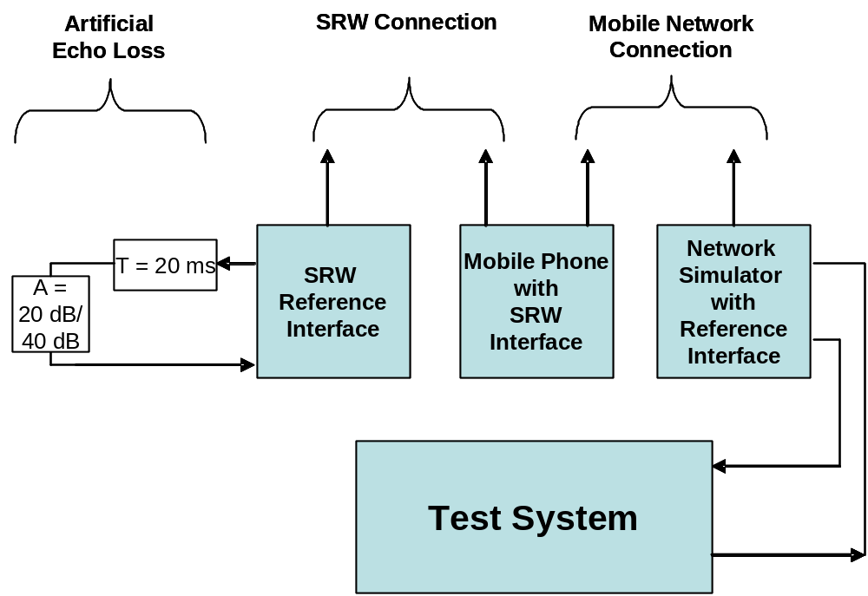
Figure 12-3 – Test set-up with artificial echo loss
2) The attenuation between the input of the test point (R4) to the output of the test point (R4) is measured using a speech-like test signal. Alternatively the measurement is conducted from the input of test point (R5) to the output of test point (S5).
3) Before the actual measurement, a training sequence consisting of the British-English single talk sequence described in clause 7.3.2of ITU-T Recommendation P.501 [xx] is inserted. The training sequence level is the nominal signal level.
4) The test signal is a pn sequence, according to [ITU-T P.501], with a length of 4 096 points (48 kHz sampling rate) and a crest factor of 6 dB. The duration of the test signal is 250 ms, the test signal level is -6 dBov as applicable to the individual interface. The low crest factor is achieved by random alternation of the phase between –180° and +180°.
5) TCL_{W} is calculated according to clause B.4 of [ITU-T G.122] (trapezoidal pseudo rule). For the calculation, the average measured echo level at each frequency band is referred to the average level of the test signal measured in each frequency band. For the measurement, a time window has to be applied which is adapted to the duration of the actual test signal (250 ms).
6) The difference between the echo loss measured with 20 dB echo loss and 40 dB echo loss is determined.

Performance level classification based on values of this parameter
The difference between the echo loss ELD_{BD} measured with 20 dB echo loss and 40 dB echo loss is measured. To claim compliance with a certain Performance class the listening speech quality stability in send has to meet the requirements for the applicable Performance classes as given in the table below:
Table xx –Limits for the bidirectional transport echo loss difference

Performance Class | ELD_{BDmin} | ELD_{BDmax}
1 | 19.8 dB | 20.2 dB
2 | N.A. | N.A.
3 | N.A. | N.A.
4 | ≤ 19.8 dB | ≥ 20.2 dB

Design guidance and root-cause analysis
Any additional echo cancellation would impair the performance of the acoustic echo cancellation integrated in the signal processing subsystem. As a result additional impairments on speech quality and double talk performance will occur.

Unidirectional Signal Transport: Wired and Short range Wireless Transmission
The purpose of this section is to ensure linearity (as far as possible) and time invariance of the signal transport over wired or a short range wireless transmission system. Any unidirectional transport system in conjunction with the devices it is integrated in should not introduce any additional signal processing. Any other functions than pure speech data transmission should be avoided.

Test setup
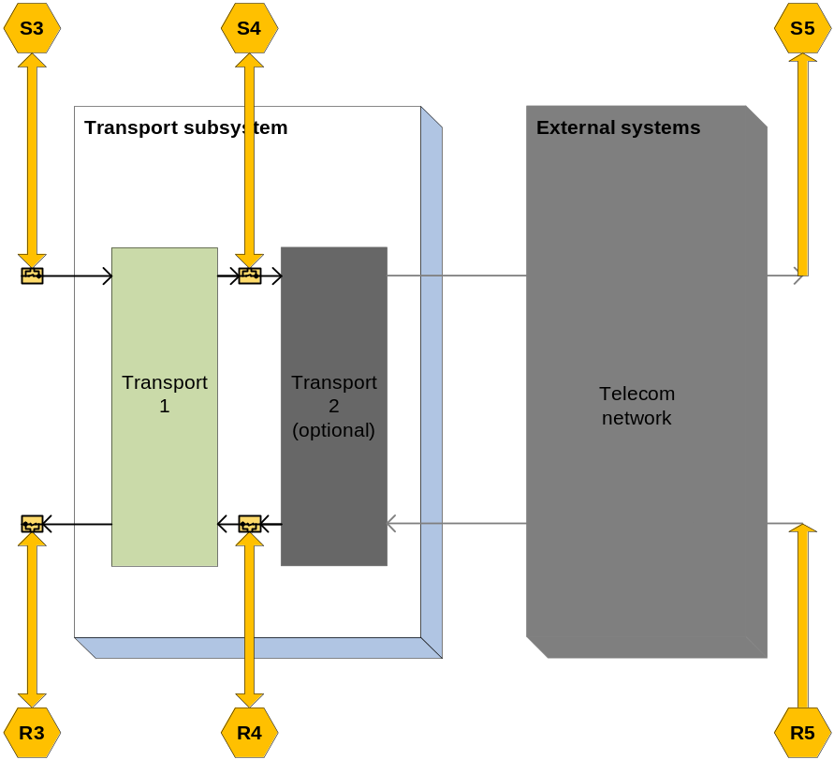

The DUT is connected to the reference interfaces. The reference interfaces are calibrated as specified in clause 8.1.

Unidirectional transport delay

Parameter description
The delay T_{UD} is measured from the test point (xx) to the test point (xy). The delay T_{UD} should be minimized.
The system delay t_{System} depends on the transmission method used, the delay of the reference interface and the network simulator. The delay t_{System} must be known and deducted from the test result.

Test
1) For the measurements, a composite source signal (CSS) according to [ITU-T P.501] is used. The pseudo random noise (pn)-part of the CSS has to be longer than the maximum expected delay. It is recommended to use a pn sequence of 16 k samples (with 48 kHz sampling rate). The test signal is inserted at test point (S3) at a level according to clause 8.1.5.
The reference signal is the original signal (test signal).
The test set-up is according to clause 9.1.
2) The delay is determined by cross-correlation analysis between the measured signal at the electrical access point and the original signal. The measurement is corrected by delays which are caused by the test equipment.
3) The delay is measured in ms and the maximum of the cross-correlation function is used for the determination.

T_{measure} = T_{UD} + T_{System}

Performance level classification based on values of this parameter
To claim compliance with a certain Performance class the delay in the send direction has to meet the requirements for the applicable Performance classes for the bidirectional transport delay T_{UD} as defined in table xx:
Table xx –Limits for the unidirectional transport delay for speech communication services

Performance Class | T_{UD}
1 | < 2 ms
2 | < 10 ms
3 | < 30 ms
4 | ≥ 30 ms

Design guidance and root-cause analysis
Low delay is essential for a seamless conversational performance especially for highly interactive conversations. Delay also contributes to echo perception: Higher delay low leads to higher impairment resulting even from low level echo components (see ITU-T Rec. G. 111 [xx]). Therefore any design providing as low delay in the connection as possible is preferable.

Unidirectional transport junction loudness ratings

Parameter description
The junction loudness rating JLR_{UD} is measured from the test point (xx) to the test point (xy).
The JLR describes any amplification or attenuation on the transport layer. The junction loudness rating JLR_{UD} should be 0 dB.

Test
1) The test signal used for the measurements shall be CSS according to [ITU-T P.501]. The test signal level is the nominal signal level, the level is averaged over the complete test signal.
The measured power density spectrum at the test point interface (S3)is used as the reference power-density spectrum for determining the unidirectional transport send sensitivity.
2) The test arrangement is according to clause 9.1. For wideband the unidirectional sensitivity is calculated from each band of the 20 frequencies given in Table A.2 of [ITU-T P.79], bands 1-20. For narrowband bands 4-17 are used for calculation.
For the calculation, the average measured level at the electrical reference point for each frequency band is referred to the average test signal level measured in each frequency band at the reference interface.
3) The sensitivity is expressed in dBV/V, the junction loudness rating JLR_{UD} shall be calculated according to [ITU-T P.79], Formula A-23d, bands 1-20, M = 0.175, and the weighting factors W_{J} for JLR according to Table A.2 of [ITU-T P.79]. For narrowband bands 4-17 are used for the calculation.

Performance level classification based on values of this parameter
To claim compliance with a certain Performance class the JLR has to meet the requirements for the applicable Performance classes for the bidirectional transport JLR_{UD} as defined in table xx:
Table xx –Limits for the unidirectional transport JLR

Performance Class | JLR_{UD}
1 | 0 ± 0.5 dB
2 | 0 ± 3 dB
3 | 0 ± 6 dB
4 | > ± 6 dB

Design guidance and root-cause analysis
Any deviation of the JLR_{BDS} from 0 dB may result either in insufficient or too high speech levels and thus may deteriorate the performance of the interconnected devices. and should be avoided.
However, it is recognized that different SRW implementations deviate significantly (±6 dB) from this level. In order to maintain a good system performance, appropriate corrections have to be integrated in the hands-free implementation to ensure a good system performance. Based on these tests, appropriate level corrections can be inserted.

Unidirectional transport linearity

Parameter description
The linearity of the junction loudness rating JLR_{UD} is measured from the test point (xx) to the test point (xy)
The test is aimed to detect any amplitude non-linearities including AGC or companding.

Test
1) The test signal used for the measurements shall be CSS according to [ITU-T P.501]. The test signals are in the range of –40 dBV to 5 dBV in steps of 5 dB relative to the nominal signal level, measured at the test point (xx). The test signal level is the average level of the complete test signal.
The measured power density spectrum at the test point (xx) is used as the reference power-density spectrum for determining the send sensitivity.
2) The test arrangement is according to clause 9.1. In wideband the sensitivity is calculated from each band of the 20 frequencies given in Table A.2 of [ITU-T P.79], bands 1-20. For narrowband systems bands 4-17 are used.
For the calculation, the average measured level at the electrical reference point for each frequency band is referred to the average test signal level measured in each frequency band at the test point (xx) reference interface.
3) In wideband the sensitivity is expressed in dBV/V, the bidirectional junction loudness rating JLR_{UD} shall be calculated according to [ITU-T P.79], Formula A-23d, bands 1-20, M = 0.175, and the weighting factors in send direction according to Table A.2 of [ITU-T P.79]. For narrowband systems bands 4-17 are used for the calculation.

Performance level classification based on values of this parameter
To claim compliance with a certain Performance class the JLR has to meet the requirements for the applicable Performance classes as defined in table xx. The bidirectional transport JLR_{UD} deviation is measured relative to the measured JLR_{UDnom} measured with nominal signal level:
Table xx –Limits for the bidirectional transport linearity

Performance Class | Input signal level range | JLR_{UD} re JLR_{UDnom}
1 | –40 dB/+5 dB | 0 ± 0.5 dB
2 | –40 dB/+5 dB | 0 ± 3 dB
3 | –40 dB/+5 dB | 0 ± 6 dB
4 | –40 dB/+5 dB | > ± 6 dB

Design guidance and root-cause analysis
Any AGC or companding on the network transport should be avoided. Additional non-linearities of this type may counteract algorithms implemented in the signal processing subsystem and deteriorate its performance.

Unidirectional transport sensitivity frequency response

Parameter description
The frequency response FR_{UD} is measured from the test point (xx) to the test point (xy)
The sensitivity response on the network transport should be mostly flat in the entire frequency range in order not to interfere with any (wanted) response characteristic in the signal processing subsystem or the acoustical frontend.

Test
1) The test signal used for the measurements shall be the British-English single talk sequence described in clause 7.3.2of ITU-T Recommendation P.501 [xx] . The test signal level is the nominal signal level , the level is averaged over the complete test signal.
The measured power density spectrum at the test point (xx) interface is used as the reference power density spectrum for determining the unidirectional transport send sensitivity.
2) The test arrangement is according to clause 9.1. In wideband the unidirectional send sensitivity is determined in third octave intervals, as given by [IEC 61260] for frequencies of 100 Hz and 8 kHz, inclusive. In narrowband it is determined for frequencies from 200 Hz to 4kHz. In each third octave band, the level of the measured signal is referred to the level of the reference signal averaged over the complete test sequence length.
3) The sensitivity is determined in dBV/V.

Performance level classification based on values of this parameter
To claim compliance with a certain Performance class the frequency response has to meet the requirements for the applicable Performance classes for the unidirectional transport FR_{UD} as defined in the tables below:
The masks are drawn by straight lines between the breaking points in Table 9-xx to 9-xx on a logarithmic (frequency) – linear (dB sensitivity) scale.
Table xx – Tolerance mask for the unidirectional transport wideband sensitivity frequency response for Performance class 1
Frequency (Hz) | Upper limit | Lower limit
50 | 0.5 | –0.5
6 200 | 0.5 | –0.5
7 000 | 0.5 | –3
NOTE – All sensitivity values are expressed in dB on an arbitrary scale.

Table xx – Tolerance mask for the unidirectional transport wideband sensitivity frequency response for Performance class 2
Frequency (Hz) | Upper limit | Lower limit
100 | 2 | –2
6 200 | 2 | –2
7 000 | 2 | –5
NOTE – All sensitivity values are expressed in dB on an arbitrary scale.

Table xx – Tolerance mask for the unidirectional transport wideband sensitivity frequency response for Performance class 3
Frequency (Hz) | Upper limit | Lower limit
100 | 4 | –4
6 200 | 4 | –4
7 000 | 4 | –9
NOTE – All sensitivity values are expressed in dB on an arbitrary scale.
Table xx – Tolerance mask for the unidirectional transport wideband sensitivity frequency response for Performance class 4
Frequency (Hz) | Upper limit | Lower limit
100 | NA | NA
6 200 | NA | NA
7 000 | NA | NA
NOTE – There is no frequency tolerance mask requirement for class 4.
Table xx – Tolerance mask for the unidirectional transport narrowband sensitivity frequency response for Performance class 1
Frequency (Hz) | Upper limit | Lower limit
50 | 0.5 | –0.5
3 100 | 0.5 | –0.5
3 500 | 0.5 | –3
NOTE – All sensitivity values are expressed in dB on an arbitrary scale.

Table xx – Tolerance mask for the unidirectional transport narrowband sensitivity frequency response for Performance class 2
Frequency (Hz) | Upper limit | Lower limit
100 | 2 | –2
3 100 | 2 | –2
3 500 | 2 | –5
NOTE – All sensitivity values are expressed in dB on an arbitrary scale.

Table xx – Tolerance mask for the unidirectional transport narrowband sensitivity frequency response for Performance class 3
Frequency (Hz) | Upper limit | Lower limit
100 | 4 | –4
3 100 | 4 | –4
3 500 | 4 | –9
NOTE – All sensitivity values are expressed in dB on an arbitrary scale.
Table xx – Tolerance mask for the unidirectional transport narrowband sensitivity frequency response for Performance class 4
Frequency (Hz) | Upper limit | Lower limit
100 | NA | NA
3 100 | NA | NA
3 500 | NA | NA
NOTE – There is no frequency tolerance mask requirement for class 4.

Design guidance and root-cause analysis
Deviations from a flat frequency response characteristics may cause degradation of the listening speech quality in the send direction or may result in insufficient listening speech quality in the presence of background noise which affects the listing speech quality perceived by the far end subscriber.

Unidirectional transport idle channel noise

Parameter description
The unidirectional transport idle channel noise in N_{UD} is measured from the test point (Sxx) to the test point (Sxy).

Test
1) The British-English single talk sequence described in clause 7.3.2of ITU-T Recommendation P.501 [xx] with nominal signal level is applied at the test point (S3). The test signal level is the average level of the complete test signal. The output level is measured using a speech level voltmeter according to ITU-T P.56. This level is the reference speech signal level.

2) For the noise measurement, no test signal is used. However, all sources which potentially contribute to noise at the output of the unidirectional transport as GSM noise, electrical noise introduced by the car must be considered. In order to ensure a reliable activation, an activation signal is inserted before the actual measurement. The activation signal consists of a sequence of 4 composite source signals according to [ITU-T P.501]. The level of the activation signal is –16 dBm0.
3) The test arrangement is according to clause 9.1.
The idle channel noise is measured at the output in the frequency range between 100 Hz and 8 kHz. The measurement requires a time window which starts exactly at the end of the activation signal. Any "ringing" of filters or receivers shall be taken into account, the time window must be shifted accordingly. The length of the time window is 1 second which is the averaging time for the idle channel noise. The test lab has to ensure the correct activation of the unidirectional transport during the measurement. If the unidirectional transport is deactivated during measurement, the measurement window has to be cut to the duration when the transport system remains activated.
The power density spectrum of the noise signal is determined using FFT (8 k samples/48 kHz sampling rate or equivalent). A Hann window is used.
If it is known that the unidirectional transport stays activated without any activation signal, no activation signal is required. In this case, a simple noise measurement is conducted.
4) The idle channel noise is determined by A-weighting and referring to the reference speech signal level as determined with speech sequence. Spectral peaks are measured in the frequency domain. The average noise spectrum used for determining the spectral peak should be calculated as the arithmetic mean of the noise spectrum values when stated in dBVP.

Performance level classification based on values of this parameter
To claim compliance with a certain Performance class the speech to idle noise ratio SINR has to meet the requirements for the applicable Performance classes for the SINR as defined in table xx:
Spectral peaks in the frequency domain shall not exceed the averaged spectrum by more than 10 dB.

Table xx –Limits for the idle channel noise re. reference speech signal level

Performance Class | SINR
1 | > 70 dB
2 | > 60 dB
3 | > 40 dB
4 | ≤ 40 dB

Design guidance and root-cause analysis
Check shielding, connectors and cabling with respect to potentially induced interfering signals. Check quality of amplifiers used to insert signals and preamplifiers used to receive signals. Verify that preamplifiers do not demodulate RF into NF,

Unidirectional transport noise cancellation test

Parameter description
The send noise cancellation NC_{UD} is measured from the test point (xx) to the test point (xy)
The objective of this test is to check whether no noise cancellation is active in the unidirectional transport.

Test
1) The test arrangement is according to clause 9.1.
2) The test signal used for the measurements shall be pink noise with a duration of 5 s followed by a pause of 3 s, both repeated 3 times. The test signal during the active parts of the signal isthe nominal signal level, the level is averaged over the active parts of the test signal.
3) The level of the transmitted signal is measured at the test point(xy) . The measured signal level is referred to the test signal level measured at test point (xx) and displayed vs time. The levels are calculated from the time domain using an integration time of 5 ms.
4) The attenuation vs time is determined for each pink noise section.
–

Performance level classification based on values of this parameter
To claim compliance with a certain Performance class the NC in send has to meet the requirements for the applicable Performance classes for the unidirectional transport NC_{UD} as defined in table xx. The attenuation of the simulated background noise test signal (BGN) shall not deviate more than the given value in the relevant Performance class for all periods of the test signal.
Table xx – Tolerance for the unidirectional transport background noise attenuation

Performance Class | BGN attenuation
1 | <± 1 dB
2 | < ± 2 dB
3 | < ± 6 dB

Design guidance and root-cause analysis
Any activated (tandemed) noise cancellation would interfere with the noise cancellation in the signal processing subsystem and will lead to significant listening speech degradation in the send direction.
If a non-linear or time variant behaviour of the is observed, the tests, as described in ITU-T P.1100 [xx] clause 11.13 (for narrowband systems) or P.1110 [xx] clause 11.13 (for wideband systems), can be applied to determine the behaviour of the unidirectional transport in more detail. Instead of inserting the tests signals acoustically, they have to be inserted electrically.

Unidirectional transport speech quality

Parameter description
The unirectional transport listening speech quality LQ_{UD} is measured from the test point (xx) to the test point (xy).
The test is intended to determine any impairment of the listening speech quality introduced by the unidirectional transport.

Test
The tests method to be used is ITU-T Recommendation P.863. NOTE: ITU-T Recommendation P.863 [xx] does not provide a wideband mode. Wideband systems are evaluated on a superwideband scale. Therefore the MOS Requirements are given in MOS-LQOsw. See P.863 for more information.

1) The test signals used are the English test sequences as specified in [ITU-T P.501] (2 male speakers, 2 female speakers, two sentences each). The test signal level is the nominal signal level, measured at thetest point (S3), the test signal level is measured as "active speech level" according to [ITU-T P.56]. The speech activity should be between 30% and 70%.
The original speech signal is used as the reference signal for the determination of the speech quality.
2) The test arrangement is according to clause 9.1. For wideband systems MOS-LQOsw is determined. For narrowband systems MOS-LQOn is determined
The calculation is made using the signal recorded at the test point (xy).

Performance level classification based on values of this parameter
To claim compliance with a certain Performance class the listening speech quality has to meet the requirements for the applicable Performance classes as given in the table below:
Table xx –Limits for the unidirectional transport listening speech quality

Performance Class | MOS-LQOn | MOS-LQOsw
1 | > 4.2 | > 4.5
2 | > 3.8 | > 4.1
3 | > 3.4 | > 3.7
4 | ≤ 3.4 | ≤ 3.7

Design guidance and root-cause analysis
No additional impairment on listening speech quality should be introduced by the signal transport. Any degradation of listening speech quality will deteriorate the overall listening speech quality and should be avoided. Therefore the listening speech quality under quiet conditions is checked.

Unidirectional transport speech quality stability

Parameter description
The uidirectional transport listening speech quality stability LQS_{UD} is measured from the test point (xx) to the test point (xy).
This test is intended to detect speech quality instabilities due to unreliable connection (speech frame loss....). This test should be repeated in different representative test configurations, e.g. positions of the phone within the vehicle, different SRW links active and different WIFI links active.

Test
Several measurements of MOS-LQOsw (for wideband systems) and MOS-LQOn (for narrowband systems) according to Section xx are performed in series within the same call or for different calls, within the test arrangement defined below. Typically, for the same call, a measurement each 20 s issufficient. The results are reported in terms of statistics.
The procedure is identical for narrowband and wideband systems. In narrowband systems MOS-LQOn ist used, in wideband systems MOS-LQOsw.
The assessment of Listening Speech Quality Stability is preformed in 5 steps:
- To measure the MOS-LQO periodically over the duration of one communication. N measurements provide N MOS-LQO values.
- For each MOS-LQO (i) value i from 2 to N, MOS-LQO_GAP(i) is calculated as the absolute difference with the previous value MOS-LQO (i-1):

MOS-LQO_GAP (i) =| MOS-LQO (i)- MOS-LQO (i-1)|

- In order to take into account the subjective perception and measurement accuracy, MOS-LQO_GAP (i) is set to 0 when the difference is equal or lower to THRESHOLD1:

- if MOS-LQO_GAP (i)> (2*THRESHOLD1), then MOS-LQO_GAP (i)= MOS-LQO_GAP (i)
- if THRESHOLD1 < MOS-LQO_GAP (i) ≦ 2*THRESHOLD1, then MOS-LQO_GAP (i)= [MOS-LQO_GAP (i) * 2] – (2*THRESHOLD1)
- if MOS-LQO_GAP (i)≦ THRESHOLD1, then MOS-LQO_GAP (i)=0

- The instability (INS_MOS-LQO) associated to the MOS-LQO over the whole N measurements is defined by mean value of MOS-LQO_GAP (i).
INS_MOS-LQO=1/(N-1)Σ MOS-LQO_GAP (i) with i=[2:N]

- A linear weighting function is applied in order to express Stability ST-MOS-LQO on a 0 to 100 scale.

This formulation used to determine the Listening Quality Stability (ST-MOS) as

ST-MOS=100-(250* INS_MOS)
and
ST-MOS= 0 if [100-(250* INS_MOS)] < 0

When ST-MOS is calculated within a single call, the call should be longer than 3 minutes (Recommended duration being between 3 and 5 minutes). The duration of each measurement depends on the length of the speech samples used for the test as described in xx
(As an example, if a sample is 15s length and the analysis is done every 20 s a minimum of 10 values will be measured).

Performance level classification based on values of this parameter
For the stability indicator about Listening Speech Quality, THRESHOLD1 = 0.1 and the linear weighting function applies in order to express Stability (ST-MOS) on a 0 to 100 scale. By definition Stability equals 100 when no variations occur and Stability ST-MOS equals 0 when MOS-LQO variation is equal or more than 0.4.
To claim compliance with a certain Performance class the listening speech quality stability has to meet the requirements for the applicable Performance classes as given in the table below:
Table xx –Limits for the unidirectional transport listening speech quality stability

Performance Class | ST-MOSn | ST-MOSsw
1 | > 95 | > 95
2 | > 80 | > 80
3 | > 50 | > 50
4 | ≤ 50 | ≤ 50

Design guidance and root-cause analysis
Listening quality stability during a call (if the position or transmission characteristics change during the call (or during several different calls) takes into account degradations generated on the signal by the transmission link impairment and the phone position.
In case of systems using SRW transmission it is the purpose to verify the integration of SRW radio network by evaluating change of speech quality over time. This will help in detect problems with RF coverage inside the car cabin and verify the error concealment (packet loss, bit errors) caused by weak RF link or interference with other radio.
A guidance to proceed is
1 - Check RF coverage from SRW unit to possible mobile positions (Protocol analyzer)
2 – Identify weak and bad reception areas inside the vehicle. (Protocol analyzer)
Check bit error rate, rate of packet loss …
3 – Use the speech quality measurement to rate the quality of error concealment in the weak areas identified in step 2 above and compare with measurements from areas with good coverage.
4 – Identify possible issues from interference with parallel SRW links or other networks. This will check how the SRW can handle interference and change to undisturbed channels. Speech quality measurements can be used to see the performance of handling these problems.
It’s recommended to use to a known link as reference.

- Speech Recognition
- Prompts

- Appendix I-Design Guidance and Root-Cause Analysis

System with integrated microphone and speaker
The system is tested as described in ITU-T Rec. P.1100 (for narrowband systems) or in ITU-T Rec. P.1110 (for wideband systems). If no network access is provided by the system the system is connected to a reference interface replacing the network access system. The requirements as given in ITU-T Recs. P.1100 and P.1110 apply.
Annex A
Microphone measurements in anechoic conditions

The scope of these measurements is the verification of microphone parameters in a defined acoustic environment. The influence of integration such as mounting, orientation and in car acoustics is quite important for the overall performance and therefore it is recommended to integrate the microphone in a surrogate environment as close as possible to the production environment. In case wind noise may have a major influence on the microphone performance it is recommended to also simulate the wind noise in the anechoic environment.

Microphone sensitivity (in anechoic conditions)

Parameter description
Microphone sensitivity has to be measured in the free sound field. The sensitivity refers to the sound pressure of the undisturbed free sound field (in the absence of the microphone). The sensitivity is measured at the output of the test circuit according to Figure 7-2.
Microphone sensitivity at 1 kHz shall be measured in the direction of its maximum sensitivity.

Test
1) The test signal is a sine wave of 1 kHz at a level of 0 dBPa at the microphone position in the undisturbed free sound field.
2) The microphone is positioned in a distance of 1 m in the acoustic centre line of the loudspeaker.
3) The microphone is oriented toward the loudspeaker with its direction of maximum sensitivity.
4) The sensitivity is determined in mV/Pa.
Further information can be found in [b-IEC 60268-4].

Performance level classification based on values of this parameter
To claim compliance with a certain Performance class the Microphone Sensitivity has to meet the requirements for the applicable Performance classes for the Microphone Sensitivity as defined in table xx:
Table xx –Limits for the Microphone Sensitivity (in anechoic conditions)

Performance Class | Sensitivity
1 | 300 mV/Pa +/- 3 dB
2 | TBD
3 | TBD
4 | NA

Design guidance and root-cause analysis
With a nominal sensitivity of 300 mV/Pa there is a good balance between detecting speech accurately without causing clipping due to high audio level in the car (providing a Voltage supply of 8V).

Microphone frequency response (in anechoic conditions)
        - Send Frequency Response (SFR)

Parameter description
The microphone frequency response has to be measured in the free sound field. The frequency response refers to the sound pressure of the undisturbed free sound field (in the absence of the microphone). The frequency response is measured at the output of the test circuit according to Figure 7-2.

Test
1) The test signals are sine waves at a level of 0 dBPa at the microphone position in the undisturbed free sound field covering at least the defined frequency range.
2) The microphone is positioned in a distance of 1 m in the acoustic centre line of the loudspeaker.
3) The microphone is oriented toward the loudspeaker with its direction of maximum sensitivity.
4) The sensitivity for each frequency is determined in mV/Pa.
Further information can be found in [b-IEC 60268-4].

Performance level classification based on values of this parameter
To claim compliance with a certain Performance class the frequency response has to meet the requirements for the applicable Performance classes for the microphone send sensitivity as defined in the tables below:
The masks are drawn by straight lines between the breaking points in Table 9-xx to 9-xx on a logarithmic (frequency) – linear (dB sensitivity) scale.
Table xx – Tolerance mask for the microphone send sensitivity frequency response for Performance class 1
Frequency (Hz) | Upper limit | Lower limit
100 | N
125 | 0
200 | 0 | –14
315 | 0 | –13
400 | 0 | –12
500 | 0 | –11
630 | 0 | –10
1 000 | 0 | –8
1 300 | 2 | –8
1 600 | 3 | –8
2 000 | 4 | –8
3 100 | 4 | –8
4 000 | 4 | –8
8 000 | 4
NOTE – All sensitivity values are expressed in dB on an arbitrary scale.

Table xx – Tolerance mask for the microphone send sensitivity frequency response for Performance class 2
Frequency (Hz) | Upper limit | Lower limit
100
125
200
315
400
500
630
1 000
1 300
1 600
2 000
3 100
4 000
8 000
NOTE – All sensitivity values are expressed in dB on an arbitrary scale.

Table xx – Tolerance mask for the microphone send sensitivity frequency response for Performance class 3
Frequency (Hz) | Upper limit | Lower limit
100
125
200
315
400
500
630
1 000
1 300
1 600
2 000
3 100
4 000
8 000
NOTE – All sensitivity values are expressed in dB on an arbitrary scale.

Table xx – Tolerance mask for the microphone send sensitivity frequency response for Performance class 4
Frequency (Hz) | Upper limit | Lower limit
100 | NA | NA
125 | NA | NA
200 | NA | NA
315 | NA | NA
400 | NA | NA
500 | NA | NA
630 | NA | NA
1 000 | NA | NA
1 300 | NA | NA
1 600 | NA | NA
2 000 | NA | NA
3 100 | NA | NA
4 000 | NA | NA
8 000 | NA | NA
NOTE – All sensitivity values are expressed in dB on an arbitrary scale.

Design guidance and root-cause analysis
NOTE 1 – Depending on customer demands, other tolerance schemes than those described in Table 10-1. may be applied and have to be defined in an equivalent format.
NOTE 2 – Ideally the response characteristics of the microphone should be flat in the frequency range of wideband transmission (100 Hz – 7 kHz). However, especially in the presence of background noise, a bandwidth limitation may be desirable. No explicit recommendation can be given here since such limitation would depend on level and spectral content of the background noise and ideally should be adaptive. If, however, a bandwidth limitation is introduced, it should be made at both, the high and low frequencies.
NOTE 3 – Table 10-1 applies wider tolerances than Table 10-2 to achieve the freedom of adapting the microphones frequency response to the needs in the car.

Microphone directional characteristics (in anechoic conditions)

Parameter description
The directional characteristic of a microphone is described by different sensitivities at different angels of sound incidence.
The front to back ratio is the ratio between the sensitivity in direction of highest sensitivity and the sensitivity at the angle of lowest sensitivity expressed in dB at 1 kHz. The front to back ratio is measured at the output of the test circuit according to Figure 7-2.

Test
1) The test signal is a sine wave of 1 kHz at a level of 0 dBPa at the microphone position in the undisturbed free sound field.
2) The microphone is positioned in a distance of 1 m in the acoustic centre line of the loudspeaker.
3) The first measurement is done with the microphone oriented to the loudspeaker with its direction of maximum sensitivity. The second measurement is done with the microphone oriented toward the loudspeaker with its direction of minimum sensitivity. If the direction of minimum sensitivity is not known, it has to be determined by rotating the microphone until the minimum is found.
4) The front to back ratio is determined in dB.
Further information can be found in [b-IEC 60268-4].

Performance level classification based on values of this parameter
To claim compliance with a certain Performance class the Microphone directionality has to meet the requirements for the applicable Performance classes for the Microphone directional characteristics as defined in table xx:
Table xx –Limits for the Microphone directional characteristics

Performance Class | Front to Back Ratio
1 | >= 10 dB
2 | TBD
3 | TBD
4 | < TBD

Design guidance and root-cause analysis
To achieve appropriate noise reduction a high front to back ratio is desired.
NOTE – Depending on mounting and orientation, also lower front to back ratios can be an advantage.

Microphone distortion (in anechoic conditions)
        - Send Distortion + Noise (SDN)

Parameter description
The microphone distortion refers to the sound pressure of the undisturbed free field. The distortion is measured at the output of the test circuit according to Figure 7-2.
The harmonic distortion with a sound pressure level of 0 dBPa (94 dBSPL) at the position of the microphone shall be measured in the narrow-band frequency range.

Test
1) The test signal is a sine wave with a frequency of 300 Hz, 500 Hz, 1 kHz, 2 kHz at a level of 0 dBPa.
2) The microphone is positioned in an acoustic centre line of the loudspeaker.
3) The microphone is oriented toward the loudspeaker with its direction of maximum sensitivity.
4) The total harmonic distortion is expressed in %.
Care has to be taken that the loudspeaker is able to produce the required sound pressure level with a lower distortion than the microphone under test.
Further information can be found in [b-IEC 60268-4].

Performance level classification based on values of this parameter
To claim compliance with a certain Performance class the Microphone distortion has to meet the requirements for the applicable Performance classes for the Microphone distortion as defined in table xx:
Table xx –Limits for the Microphone distortion

Performance Class | SDN
1 | < 1%
2 | TBD
3 | TBD
4 | > TBD

Design guidance and root-cause analysis
TBD

Microphone maximum sound pressure level (in anechoic conditions)

Parameter description
The maximum sound pressure is defined by the sound pressure level where the total harmonic distortion of the microphone at 1 kHz is 3% in the narrow-band frequency range. The total harmonic distortion is measured at the output of the test circuit according to Figure 7-2.

Test
1) The test signal is a sine wave with a frequency of 1 kHz and an increasing level to determine the level of 3% total harmonic distortion.
2) The microphone is positioned in an acoustic centre line of the loudspeaker.
3) The microphone is oriented toward the loudspeaker with its direction of maximum sensitivity.
4) The maximum sound pressure level is expressed in dBSPL or dBPa.
Care has to be taken that the loudspeaker is able to produce the required sound pressure level with a lower distortion as the microphone under test.

Performance level classification based on values of this parameter
To claim compliance with a certain Performance class the Microphone sound pressure level has to meet the requirements for the applicable Performance classes for the Microphone maximum sound pressure level as defined in table xx:
Table xx –Limits for the Microphone maximum sound pressure level

Performance Class
1 | >= 106 dB SPL
2
3
4

Design guidance and root-cause analysis
The maximum sound pressure level should be higher than 106 dBSPL for a microphone with a typical sensitivity of 300 mV/Pa.
NOTE – With a good microphone design, the maximum sound pressure level is electrically limited by the supply circuit referred to in Figure 7-2. A microphone with higher sensitivity will reach the electrical output limits at a lower sound pressure level compared to another microphone with lower sensitivity.

Microphone self-noise (in anechoic conditions)

Parameter description
The maximum self-noise shall be measured at the output of the test circuit according to Figure 7-2 in quiet conditions.

Test
1) For the measurement, no test signal is used.
2) The microphone has to be powered with a low noise voltage supply.
3) The self-noise is measured at the output of the test circuit according to Figure 7-2 in the frequency range between 100 Hz and 8 kHz, A-weighting has to applied.
4) The self-noise is expressed in dBV(A).
Care has to be taken that the environmental noise is below the equivalent self-noise of the microphone.

Performance level classification based on values of this parameter
To claim compliance with a certain Performance class the TBD has to meet the requirements for the applicable Performance classes for the Microphone self-noise as defined in table xx:
Table xx –Limits for the Microphone self-noise

Performance Class
1 | < 72 dBV(A).
2 | TBD
3 | TBD
4 | > TBD

Design guidance and root-cause analysis
TBD

Annex D
Standard set of user scenarios.
Table D.1: Standard set of user scenarios used to collect noise recordings.

 |  | Vehicle settings |  |  |  |  |  | Environmental conditions
User scenario | Description | Vehicle speed | HVAC settings | Windows | Wipers | Turn signal | Back-ground talkers | Road surface (see Note 3) | Wind speed | Precipitation | Temp.
1 | Stationary vehicle with low HVAC noise | 0 km/h (at idle) | FAN=Lowest setting | Up | Off | Off | None | N/A | < 5 m/s (12mph) | None | > -20C and  < 40C
2 | City driving with high HVAC noise | 60 km/h (37mph) | FAN= Setting closest to 6 dB(A) above driving noise with FAN =lowest setting; AIRFLOW=Directed to windows | Up | Off | Off | None | Dry; Rough road | < 5 m/s (12mph) | None | > -20C and < 40C
3 | Highway driving with low HVAC noise | 120 km/h (75mph) | FAN=Lowest setting | Up | Off | Off | None | Dry; Rough road | < 5 m/s (12mph) | None | > -20C and < 40C
4 | Highway driving with high HVAC noise | 120 km/h (75mph) | FAN=Setting closest to 6 dB(A) above driving noise as in condition 3; AIRFLOW=Directed to windows | Up | Off | Off | None | Dry; Rough road | < 5 m/s (12mph) | None | > -20C and < 40C
5  see note 1 | Highway driving with high HVAC noise | ≥160 km/h (≥100 mph) | FAN=Lowest Setting AIRFLOW=Directed to windows | Up | Off | Off | None | Dry; Rough road | < 5 m/s (12mph) | None | > -20C and < 40C
6  see note 2 | Stationary vehicle with high HVAC noise | 0 km/h (at idle) | FAN=Highest setting, AIRFLOW= Directed to microphone if possible | Up | Off | Off | None | N/A | < 5 m/s (12mph) | None | > -20C and  < 40C
7  see note 3 | Highway driving with low HVAC noise; windows down and open roof (if possible) | 120 km/h (75mph) | FAN=Lowest settings | Up | Off | Off | None | Dry; Rough road | < 5 m/s (12mph) | None | > -20C and < 40C
Note 1: Optional test: If the hands-free system is to be deployed in countries where higher driving speeds are allowed, then testing at 160 k.p.h. or more should be performed in addition to the standard set of user scenarios.
Note 2: Required test if the airflow can be directed towards the microphone. (This may result in wind buffeting.)
Note 3: Optional test: This test is applicable if the hands-free system is required to work with windows down, roof open or convertibles.
Note 4: Smooth road surfaces that generate very little tire noise shall not be used. Also, road surfaces with bumps that cause significant impulse noises shall not be used either. If available, concrete surfaces are preferred because they often result in worst case conditions that cause impairments not seen on other road surfaces.
Note 5: AIRFLOW refers to the HVAC mode settings related to how air is directed into the cabin. For example, in North American vehicles there is typically a “Defrost” setting that will direct the flow of air onto the windows.
Annex E
Testing for Noise Distortion
This Annex describes a test using an objective noise distortion measure specifically designed to quantify the amount of musical tones. The system under test is the noise reduction functionality in the signal enhancement subsystem as described in section 8.3. If comfort noise generation is part of the system, it should be switched off. The purpose of the measure described in this Annex is to help to optimize the signal enhancement subsystem during the development and optimization process. The described test is recommended, although not mandatory.
  - Parameter description
The noise distortion is measured in send direction with the weighted log-average kurtosis ratio WLAKR of the signals at test point (S2) and at test point (S3) of the signal enhancement subsystem as shown in Fig. <SignalEnhancementSubsystem_with_TP>. The weighted log-average kurtosis ratio WLAKR describes the amount of musical tones by measuring the average change of the weighted kurtosis of the unprocessed background noise signals and the processed background noise signals using the signal enhancement subsystem.

  - Test
In principle, the test could be carried out using noise signals acquired by the hands-free microphone in the car. A number of not less than 18 noise samples of length 8 seconds taken from typical stationary driving conditions should then be recorded and taken for the subsequent measurement. An even more relevant problem to solve may be to allow comparison to tests carried out for other signal enhancement subsystems in other labs. Therefore, as the recommended alternative, the noise data shall be taken from the inside-car background noise signals in section 8.2 (“Stereophonic Signals”) of [ETSI EG 202 396-1]. The left channel of all 9 signals including fullsize car1, midsize car1 and midsize car2 with 80 km/h, 100 km/h and 130 km/h are selected, respectively. Each signal is downsampled from 48 kHz to 16 kHz, the first 16 seconds are taken and segmented into 2 noise signals with a length of 8 seconds each. This leads to altogether 18 reference background noise signals. For the test of a wideband subsystem the ITU-T P.341 weighting filter [ITU-T P.341] for wideband signals (50 … 7000 Hz) is applied. For the test of a narrowband subsystem the modified IRS (MIRS) weighting filter according to ITU-T Recommendation P.830 [ITU-T P.830] (300 … 3400 Hz) is applied and subsequently downsampled to 8 kHz. The mean weighted log-average kurtosis ratio WLAKR is then computed from all 18 weighted log-average kurtosis ratios. For each of the 18 background noise signals, one weighted log-average kurtosis ratio WLAKR is calculated as follows:
- The long-term rms level of the 16 kHz/8 kHz sampled background noise signal of length 8 seconds is adjusted to -26 dBov according to ITU-T Recommendation P.56 [13]. Then the signal is digitally stored as the reference signal, and fed into test point (S2) as an input to the signal enhancement subsystem.
- The background noise signal processed by the signal enhancement subsystem is taken from test point (S3) and also digitally stored.
- Now the signals are transformed into the Fourier domain. To accomplish this, a square root Hann window of length 512 (or 256 for narrowband signals) is applied, followed by a discrete Fourier transform (DFT) of the same length and a frame shift of 50%. These operations are separately performed for the stored reference signal and the processed noise signal with being the time index, respectively.
- Based on the DFT coefficients of the reference signal and the processed background noise signal, the weighted log-average kurtosis ratio WLAKR =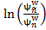 is computed, where is the natural logarithm, and are the average weighted kurtosis of the reference signal and the processed noise signal, respectively. is calculated by averaging the instantaneous kurtosis of the weighted squared amplitude reference signal DFT coefficientsover all frames
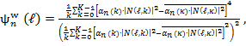 (1)
with 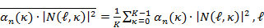 and being the frame index and frequency bin, respectively, and K being the DFT length. The weighting factor 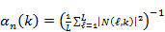 is being calculated for each frequency bin as the inverse mean value of across all L frames. The average weighted kurtosis can be calculated in the same way by using 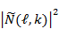 and instead of and in equation (1), respectively. The noise distortion, i.e., the amount of musical tones produced by the signal enhancement subsystem, shall be evaluated in terms of the mean of the weighted log-average kurtosis ratio WLAKR. More details are described in [YU-KURTOSIS-WB] and [YU-KURTOSIS-NB].
  - Classification of QoS level based on values of this parameter
To claim compliance with a certain QoS class the WLAKR of the signal enhancement subsystem in send direction has to meet the requirement for the applicable QoS classes as defined in Table YYY for wideband subsystems, and in Table ZZZ for narrowband subsystems. The audibility of musical tones is rated with seven categories on a mean opinion score (MOS) scale: (1) intolerably audible, (2) loudly audible, (3) rather loudly audible, (4) moderately audible, (5) slightly audible, (6) just audible, and (7) inaudible.
Table YYY –Limits for the mean of the weighted log-average kurtosis ratio WLAKR of the signal enhancement subsystem in send direction (wideband)
Performance Class | WLAKR | Interpretation
Performance Class | WLAKR | Mean Opinion Score (MOS) | Audibility of Musical Tones
1 | WLAKR<0.72 | 5.5<MOS | Just audible or inaudible
2 | 0.72≤WLAKR<1.16 | 4.5<MOS≤5.5 | Slightly audible
3 | 1.16≤WLAKR<1.56 | 3.5<MOS≤4.5 | Moderately audible
4 | 1.56≤WLAKR | MOS≤3.5 | Intolerably audible or loudly audible or rather loudly audible
Table ZZZ –Limits for the mean of the weighted log-average kurtosis ratio WLAKR of the signal enhancement subsystem in send direction (narrowband)
Performance  Class | WLAKR | Interpretation
Performance  Class | WLAKR | Mean Opinion Score (MOS) | Audibility of Musical Tones
1 | WLAKR<0.30 | 5.5<MOS | Just audible or inaudible
2 | 0.30≤WLAKR<0.67 | 4.5<MOS≤5.5 | Slightly audible
3 | 0.67≤WLAKR<1.00 | 3.5<MOS≤4.5 | Moderately audible
4 | 1.00≤WLAKR | MOS≤3.5 | Intolerably audible or loudly audible or rather loudly audible

  - Design guidance and root-cause analysis
Noise distortion introduced by the signal enhancement subsystem may lead to a high degradation of the overall perceived speech quality. Therefore, the described noise distortion measure should be evaluated during the optimization of the signal enhancement subsystem, and judged along with speech signal-related quality measures. A high noise distortion may indicate a too low spectral gain floor in spectral noise reduction, or a too low noise overestimation factor in spectral noise power estimation, or a too low SNR floor and/or a too weak temporal smoothing in SNR estimation.

References:
[ETSI EG 202 396-1]: Speech Processing, Transmission and Quality Aspects (STQ), Speech Quality Performance in the Presence of Background Noise; Part 1: Background Noise Simulation technique and Background Noise Database, ETSI, 2008
[ITU-T P.341]: ITU-T Recommendation P.341, Characteristics of Wideband Terminals, ITU, Geneva, 1994.
[ITU-T P.830] ITU-T Recommendation P.830, Subjective Performance Assessment of Telephone-band and Wideband Digital Codecs, Annex D, ITU, Geneva, 1996
[YU-KURTOSIS-WB]: H. Yu and T. Fingscheidt, A Weighted Log Kurtosis Ratio Measure for Instrumental Musical Tones Assessment in Wideband Speech, 10th ITG Fachtagung Sprachkommunikation, accepted for publication, Braunschweig, Germany, Sep. 2012
[YU-KURTOSIS-NB]: H. Yu and T. Fingscheidt, Instrumental Musical Tones Measurement of Arbitrary Noise Reduction Systems, in Proc. of DAGA’12, pp. 255-256, Darmstadt, Germany, Mar. 2012

Annex F
Reference-free SNR Measurement

Introduction
This annex describes an approach to measure the SNR of a speech signal distorted by car noise as close as possible to the reference SNR from ITU-T Recommendation P.56 [2], but without using any reference signals based on [1]. This “reference-free” nature allows for a wide flexibility; the proposed method just has to be applied to the noisy speech signal. Moreover, it offers low complexity, and can be applied both to narrowband and wideband signals.
To measure the SNR of the noisy speech signal in this approach, first the speech and noise power have to be estimated. Because of the additive nature of the noise, the speech power is approximated by the difference between the noisy speech power and the noise power. The noise power is estimated by a noise variance tracking algorithm. To estimate the P.56 active speech level only speech active frames are taken for the speech power estimation. Therefore, a voice activity detection (VAD) is needed. The power of the noise component is estimated by means of the noise tracking algorithm and—in order to ensure a robust estimation—a speech pause detection (SPD). Then, the measured SNR is the ratio of the speech and noise power estimates. Since the effectiveness of the employed algorithms (such as noise variance tracking, VAD, and SPD) decreases at low reference SNR values, the raw SNR measurement leads to systematical measurement errors in this region. Therefore, the resulting raw SNR values will be corrected by a mapping curve.

Signal-to-Noise Ratio Measurement
The input signal of the measurement system is assumed to consist of the clean speech signal and an additive noise signal , with n being the discrete time index. After segmentation, windowing, and the discrete Fourier transform (DFT), the input signal can be rewritten as with , , , as well as , and being the short-time spectra of the noisy speech, the clean speech, the noise component, as well as the analysis frame index, and the frequency bin index, respectively. We define the signal-to-noise ratio (SNR) as
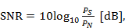 (1)
with , , being the logarithm to the base 10, the speech and the noise power, respectively.
Since and are not accessible in practice, they have to be estimated. Exploiting the additive nature of the noise, the numerator is estimated with contributions 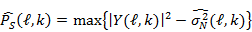, where and are the power spectral density (PSD) of the noisy speech signal and the estimated noise variance (see Section 3), respectively. The maximum operator ensures a non-negative speech power estimate. Conforming to the definition of the active speech level [2], for the estimation of in (1) only speech active frames are taken as
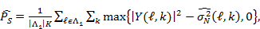 (2)
with , , and being the set of active speech frames detected by a VAD as a part of the noise tracking algorithm (see Section 3), the number of elements in , and the number of all frequency bins, respectively.
The precise estimation of the noise power is essential for the SNR estimation. However, the accuracy of the noise variance tracking algorithm is affected especially at low SNRs. In order to increase the robustness of the approach, for the estimation of in (1), the estimated noise variance is averaged over all frequency bins and those frames belonging to speech pause
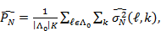 (3)
with and being the set of speech pause frames detected by a separate conservative SPD described in Section 4, and the number of elements in , respectively.

Noise Variance Tracking and Voice Activity Detection
The estimation of the noise variance in (2) is performed utilizing a 3–state classifier specific to this estimator. Based on the smoothed periodogram of the noisy speech signal
(4)
and a dynamic threshold , one hypothesis out of three is chosen:
: Speech presence is assumed if
: Speech absence is assumed if .
: Speech transition is assumed if .
The noise variance estimate is updated as
(5)
where the initial value is and the time-varying smoothing factor depends on the hypothesis of the current frame :
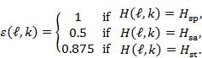 (6)
The update of the dynamic threshold is performed as follows
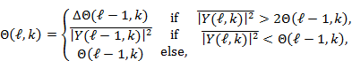 (7)
where the multiplication by the step-size constant =1.07 for narrowband signals (=1.2 for wideband signals) slowly but steadily decreases the probability of selecting the speech presence hypothesis. The unsmoothed update to the last periodogram value allows for rapid threshold adaptation in speech pauses. The control parameter is initialized as .
The frame-wise VAD is based on the hypotheses of the noise variance tracking algorithm as introduced above. Therefore, it was integrated into the noise variance tracking algorithm. Frame is detected as voice active and becomes element of set , if at least 90 % of its frequency bins from the range [500 Hz 2500 Hz] containing relevant speech information are classified as speech active or transient by the 3–state classifier.

Speech Pause Detection
This section describes the algorithm which is employed to detect frames with speech pause . Please note that different to the VAD, this is a separate algorithm which is independent from the noise power tracking. The SPD is based on the frame energy of the noisy speech spectrum calculated by means of (4) as follows
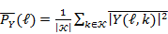 (8)
with and being the set of frequency bins between 500 Hz and 2500 Hz and the number of elements in this set, respectively. This frequency range excludes low frequencies where most of the car noise power is concentrated. Based on an adaptive threshold, the SPD delivers a hypothesis based on the following 3 states:
: Speech presence is assumed if
: Speech transition state follows every decision with a duration of frames, unless threshold has been exceeded again.
: Speech pause is assumed in all other situations.
Frame is considered as speech absent and becomes element of , if . The adaptive threshold is calculated as
, (9)
with the additive term . The SPD floor signal is updated recursively as follows (cf. (5))
, (10)
where the initial value is and the time-varying smoothing factor is defined as follows (cf. (6))
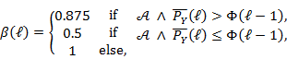 (11)
with ensuring a more conservative floor signal update in speech pauses than just conditioning on .
The SPD control parameter is increased slightly in speech presence and updated strongly during speech absence as (cf. (7))
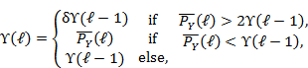 (12)
with the control update constant . The control parameter is initialized as .
The SPD parameters which differ for the narrowband and the wideband implementation are summarized in Tab 1.
Parameter
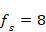 kHz | 6 |  | 1.085
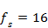 kHz | 7 |  | 1.055
Tab 1 Parameters of the SPD

Measurement Setup
At a sampling frequency of 8 kHz (16 kHz), the noisy speech signal has to be segmented by a Hann window, an analysis frame length of 256 (512) samples, and an analysis frame shift of 50% (50%) to obtain . The raw SNR value can be calculated as follows
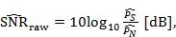 (13)
using (2), the noise variance tracker, and the VAD as described in Section 3, as well as (3), the noise variance tracker from Section 2, and the SPD as introduced in Section 4. This raw SNR value has to be corrected by the following mapping function in order to obtain an unbiased SNR measurement
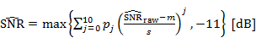, (14)
with the scaling parameters and , as well as the polynomial coefficients as shown in Tab 2.
8 kHz | 16.043 | 11.252 | -2.1312 | 6.4129 | 2.0957 | -19.199 | 5.0992 | 19.709 | -7.7268 | -6.6348 | 2.0857 | 13.066 | 11.555
16 kHz | 15.461 | 11.798 | -0.8082 | 2.8537 | -0.3609 | -7.5337 | 4.3304 | 7.2828 | -5.0623 | -1.8734 | 0.8842 | 13.06 | 11.48
Tab 2 Scaling parameters and as well as the polynomial coefficients of the mapping function
The approach is summarized by means of a pseudocode in Tab 3.
... % parameter initialization for signal segmentation, FFT, VAD, SPD, etc.
for l=1:L, % main loop over all frames
... % signal analysis: segmentation, windowing, FFT, absolute square
(4), (7), (6), (5) % 3-state noise variance tracking, VAD
(4), (8), (9), (12), (11), (10) % SPD
end
(2) % speech power estimation
(3) % noise power estimation
(13) % raw SNR
(14) % corrected SNR
Tab 3 Overview of the approach by means of pseudocode

References
[1] Fodor, B.; Fingscheidt, T., “Reference-free SNR Measurement for Narrowband and Wideband Speech Signals in Car Noise”, In Proc. 10th ITG Conference on Speech Communication, Braunschweig, Germany, Sep. 26-28, 2012, available online at IEEE Xplore
[2] ITU-T, “Objective Measurement of Active Speech Level”, ITU-T Recommendation P.56, Mar. 1993
Annex G
Frame process and Delay

General
This Annex provides definition and handling of delay for frame process subsystems.
Typical speech enhancement subsystems have spectral analysis/synthesis processes to realize good noise reduction or echo cancellation. Time domain input signal in a fixed length of window is applied, analyzed, enhanced, then synthesized by overlap-add method. The windowing period is often called “frame shift”.
Typical data transport subsystems also take frame processes for efficient data compression or error correction. A unit of the data transferred is called a “packet”.
When two subsystems, sender and receiver, having different frame data interval interfaces to each other, a special data buffer must be inserted to arbitrate the difference of intervals. Several definitions about delay and framing process should be given to such processing. This Annex provides the definitions for such parameters.

Frame interval
Frame interval is defined as a logical time interval of input or output frame data. Frame interval of time domain data is regarded as 1 sample period. Subsystem having framed input or output signals shall specify the frame interval.
Frame rate is the reciprocal of frame interval.

Delay
Subsystem having framed input or output signals may have two types of delays, buffer delay and input/output delay. If the subsystem is composed of software, algorithmic delay is defined, and computational delay is also defined after the software implementation. Table X.1 provides the definition of these delays. A subsystem supplier shall specify the correspondent delay time.
Table X.1 – Definition of delays
Category |  | Definition
Buffer delay |  | Additional delay time when a buffer is introduced at interface to arbitrate frame size difference.
Input/output delay |  | Subsystem’s physical delay time from data input to output.
Software | Algorithmic delay | Subsystem’s logical delay time in case the subsystem is realized by software.
Software | Computational delay | Additional computational delay time from data input to output caused by a processor. It is applied in case the software subsystem is implemented onto the processor.

Figure X.1 shows a system integrating two framed software subsystems on a processor. Input buffer A is placed before subsystem A to convert input sampled data to framed data. If Subsystems A and B has the same frame interval, a buffer between these subsystems should not be necessary. After subsystem B, the output framed data is converted to sampled data by output buffer B which can be regarded as no delay.
The overall delay of this system is calculated by summing buffer delay A, algorithmic delay A, algorithmic delay B and computational delay.
Overall system delay =
(Buffer delay A) + (Algorithmic delay A) + (Algorithmic delay B) + (Computational delay)
[Processor]
[Software]
Subsystem A
[Software]
Subsystem B
Buffer
delay A

No buffer here

Sampled data
Framed
data
No buffer
delay

Input buffer A
Algorithmic
delay A

Output buffer B
Algorithmic
delay B

Framed
data
Framed
data
Sampled data
Computational
delay

Figure X.1: Framing and Delays

Arbitration between two subsystems having different frame intervals
When a receiver subsystem interfaces with sender subsystem having different frame interval, a data buffer shall be shall be categorized into following cases.

Sender’s and receiver’s frame intervals are identical
No additional delay is to be inserted.

Sender’s frame interval is a multiple of receiver’s frame interval
No delay will be added at the receiver. The total delay equals to the sender’s delay. Figure X.2 shows an example that sender’s frame interval is 15 msec and receiver’s is 5 msec. Algorithmic delay and computational delay are omitted. In Figure X.1, subsystem A can be regarded as the sender, subsystem B as the receiver, buffer A as the sender’s input buffer, and buffer B as the receiver’s output buffer.
Sender:
Receiver:
Buffer delay = 15 ms
Buffer delay = 0 ms
Total delay = 15 ms
0 .......... 5 .......... 10 ..........14ms
0 ... 4ms
5 ... 9ms
15 ... 19ms
10 ... 14ms
15 ........ 20 ........ 25 ........ 29ms
30 ........ 35 ....
Sender’s input buffer:
Receiver’s output buffer:
0 ... 14ms

15 ... 29ms

0 ... 4ms

5 ... 9ms

10...14ms

15...19ms

20...24ms

Figure X.2: Example of Case 2

Receiver’s frame interval is a multiple of sender’s frame interval
Receiver’s delay buffer size is equal to its frame interval minus sender’s frame interval. However, the total buffer delay is equal to the receiver’s frame interval. Figure X.3 shows an example that sender’s frame interval is 5 msec and receiver’s frame interval is 15 msec.
Buffer delay = 5 ms
Sender:
Receiver:
Buffer delay = 10 ms
Total delay = 15 ms
0 ........ 5 ........ 10 ........ 14ms
15 .......
0 ... 4ms
5 ... 9ms
15 ... 19ms
20 ... 24ms
25 ... 29ms
30 ... 34ms
10 ... 14ms
Sender’s input buffer:
Receiver’s output buffer:
0 ... 14ms

15 ... 29ms

0 ... 4ms

5 ... 9ms

10...14ms

15...19ms

20...24ms

25...29ms

30...34ms

Figure X.3: Example of Case 3

Other cases
In general case, an arbitration buffer is inserted between two subsystems. Receiver has to read the buffer with the delay equal to its frame interval. It coincides with the case that the data is transferred with time domain signal. The resultant buffering delay is equal to the sum of frame intervals of two subsystems. Figure X.4 shows an example that sender’s frame interval is 5 msec and receiver’s is 8 msec.
Figure X.4: Example of Case 4
Sender:
Receiver:
Buffer delay = 8 ms
Total delay = 13 ms
0 ... 4ms
5 ... 9ms
15 ... 19ms
20 ... 24ms
25 ... 29ms
30 ... 34ms
10 ... 14ms
Sender’s input buffer:
Receiver’s output buffer:
0
Buffer delay = 5 ms
0 ... 7ms
8 ... 15ms
16 ... 23ms
Arbitration buffer:
1
2
3
4
-5
-4
-3
-2
-1
5
6
7
8
9
10
11
12
13
14
15
16
17
18
19
20
21
22
23
24
25
26
27
28
29
0 ... 4ms

5 ... 9ms

10...14ms

15...19ms

20...24ms

25...29ms

30...34ms

0 ... 7ms

30
8 ... 15ms

16 ... 23ms

In special cases where two subsystems are operating on asynchronous clocks, a drop/insert buffer with a unit or the multiples of frame size should be used to arbitrate them.

Example
An example of wideband mode SRW/hands-free system is shown. Examples of frame process are shown in Table X.2.
Table X.2 –Frame intervals of subsystems
Subsystem | Frame interval
Signal enhancement | 15 ms (to meet SRW frame interval)
SRW | 1.25, 2.5, 3.75 ms (CVSD) for Narrow band  7.5, 15 ms (mSBC) for Wideband
Cell phone | 20 ms (Speech codec)

An example of subsystems composing of an automotive hands-free send system is shown in Figure X.5. The upper boxes specify frame intervals and delays of each subsystem. The total send delay is calculated by summing all delays surrounded by red circles excepted for cell phone factors which are out of send delay specified by P.1100 or P.1110. According to Case 2 in clause X.4, buffer delay at input of SRW is omitted.
2 + 0.5 + 15 + 25 + 7.5 + 15? = 65 msec

Cell phone
Frame interval: 1 sample period
Delay:0.5 ms
Frame interval: 15ms
Delay:25 ms
Frame interval:7.5ms
Delay:15? ms

Processor
MIC
Signal enhancement
SRW
Speech CODEC
Buffer delay: 15 ms

Buffer delay: 20 ms
Acoustic delay: 2 ms

MRP
Frame interval: 20ms
Delay:don’t care
Computational delay: 7.5 ms

Figure X.5: An example of automotive hands-free send system
In the same way, the subsystems composing of the receive system is shown in Figure X.6. The total receive delay is calculated by summing all delays surrounded by red circles excepted for cell phone factors. According to Case 3 in clause X.4, buffer delay at input of SRW is omitted.
15? + 15 +15 + 7.5 + 0.5 + 2 = 55 msec
Cell phone
Frame interval: 1 sample period
Delay:0.5 ms
Frame interval: 15ms
Delay:15 ms
Frame interval:7.5ms
Delay:15? ms
Processor
Audio
Signal enhancement
SRW
Speech CODEC
Buffer delay: 7.5 ms
Frame interval: 15ms
Delay:25 ms
SRW
Speech CODEC
Buffer delay: 15 ms

Computational delay: 7.5 ms
Acoustic delay: 2 ms
Frame interval: 20ms
Delay:don’t care
DRP
Frame interval: 20ms
Delay:don’t care
Buffer delay: 15 ms
Figure X.6: An example of automotive hands-free receive system
In this scenario, the round trip delay is equal to 120 msec, which meets P.1110.

The next examples are the typical cases that the signal enhancement subsystems of automotive hands-free send system and receive system are implemented without special care for delay or realized as an independant chip from SRW and having 16 msec frame interval. Since the interval is not simple multiple of SRW frame interval, those processes are implemented as asynchronous tasks. Figure X.7 shows the send system. The total delay of the send system is calculated as below. According to Case 4 in clause X.4, buffer delay at input of SRW is also added.
2 + 0.5 + 16 + 16 + 26 + 7.5 + 7.5 + 15? = 90.5 msec

Cell phone
Frame interval: 1 sample period
Delay:0.5 ms
Frame interval: 16ms
Delay:26 ms
Frame interval:7.5ms
Delay:15? ms
Processor
MIC
Signal enhancement
SRW
Speech CODEC
Buffer delay: 16 ms

Buffer delay: 20 ms
Computational delay: 7.5 ms

Acoustic delay: 2 ms

MRP
Frame interval: 20ms
Delay:don’t care
Buffer delay: 7.5 ms

Computational delay: 16 ms

Figure X.7: A bad example of automotive hands-free send system
The receive system is shown in Figure X.8. The total receive delay is calculated as below. According to Case 4 in clause X.4, buffer delay at input of SRW is also added.
7.5 + 15? + 7.5 + 16 + 16 + 16 + 0.5 + 2 = 80.5 msec
Cell phone
Frame interval: 1 sample period
Delay:0.5 ms
Frame interval: 16ms
Delay:16 ms
Frame interval:7.5ms
Delay:15? ms
Processor
Audio
Signal enhancement
SRW
Speech CODEC
Buffer delay: 7.5 ms
Frame interval: 15ms
Delay:25 ms
SRW
Speech CODEC
Buffer delay: 15 ms

Computational delay: 16 ms
Acoustic delay: 2 ms
Frame interval: 20ms
Delay:don’t care
DRP
Frame interval: 20ms
Delay:don’t care
Buffer delay: 16 ms
Computational delay: 7.5 ms
Figure X.8: A bad example of automotive hands-free receive system
In this scenario, the round trip delay is equal to 171 msec, which cannot meet P.1110.

________________

The near field is characterized by the distance (measured from the sound source) where the direct sound and the reflected sound are of equal intensity. In acoustics, this distance is often referred to as critical distance.

