Geneva, 19 September 2011

Telecommunication Standardization
Bureau
Ref:  Tel:  Fax: | Corrigendum 1 to  TSB Circular 231  COM 15/GJ  +41 22 730 6356  +41 22 730 5853 | - To Administrations of Member States of the Union
E-mail: | tsbsg15@itu.int | Copy:  - To ITU-T Sector Members;  - To ITU-T Associates;  - To ITU-T Academia;  - To the Chairman and Vice-Chairmen of Study Group 15;  - To the Director of the Telecommunication Development Bureau;  - To the Director of the Radiocommunication Bureau

Subject: | Meeting of Study Group 15 with a view to approving draft new Recommendation ITU-T G.9964 in accordance with the provisions of Resolution 1, Section 9, of WTSA (Johannesburg, 2008)  Geneva, 16 December 2011

Dear Sir/Madam,
Further to the English version of TSB Circular 231 of 16 September 2011, please note that the correct title of draft new Recommendation ITU-T G.9964 is "Unified high-speed wire-line based home networking transceivers – Specification of spectrum related components".
Yours faithfully,
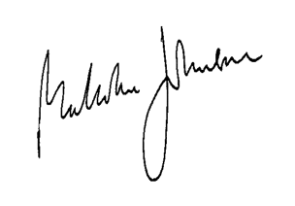
Malcolm Johnson
Director of the Telecommunication
Standardization Bureau

