|  |  |
| --- | --- |
| **Oficina de Normalización de las Telecomunicaciones** | **logo_S_** |
|  |  |

Ginebra, 13 de julio de 2011

|  |  |  |
| --- | --- | --- |
| Ref.:  Tel.: Fax: | **Circular TSB** **204**  +41 22 730 6301 +41 22 730 5853 | - A las Administraciones de los Estados Miembros de la Unión;  - A los Miembros del Sector UIT-T;  - A los Asociados del UIT‑T;  - A las Instituciones Académicas del UIT-T |
| Correo-e: | [cristina.bueti@itu.int](mailto:cristina.bueti@itu.int) | **Copia**:  - Al Presidente y a los Vicepresidentes de la Comisión de Estudio 5 del UIT-T;  - Al Director de la Oficina de Desarrollo de las Telecomunicaciones;  - Al Director de la Oficina de Radiocomunicaciones |

|  |  |
| --- | --- |
| Asunto: | **Simposio "Avanzar el programa de trabajo sobre el clima a través de las normas de las TIC verdes", Seúl, Corea – 19 de septiembre de 2011** |

Muy Señora mía/Muy Señor mío:

1 Me complace informarle de que el simposio "*Avanzar el programa de trabajo sobre el clima a través de las normas de las TIC verdes*"tendrá lugar en el Palacio Internacional de Conferencias del Centro de Prensa de Corea, Seúl, Corea, el 19 de septiembre de 2011 a las 18.00 horas.

El simposio se celebrará inmediatamente antes de la reunión de la Comisión de Estudio 5 del UIT-T (*Medio ambiente y cambio climático*) en Seúl, Corea, del 20 al 28 de septiembre de 2011, ambos inclusive (véase la Carta Colectiva TSB 8/5).

2 El taller se celebrará únicamente en inglés.

3 La participación está abierta a los Estados Miembros, a los Miembros de Sector, a los Asociados y a las Instituciones Académicas de la UIT, y a cualquier persona de un país que sea miembro de la UIT y desee contribuir a los trabajos. Esto incluye a las personas que también sean miembros de organizaciones nacionales, regionales e internacionales. La participación en el simposio es gratuita.

4 En el **Anexo 1** adjunto figura un proyecto de programa de trabajo del simposio.

5 El **Anexo 2** contiene información práctica sobre la reunión proporcionada por la organización anfitriona.

6 Se encontrará información relativa al simposio en la dirección web del UIT-T siguiente: <http://www.itu.int/ITU-T/worksem/climatechange/201109/index.html>.

7 Para que la TSB pueda tomar las disposiciones necesarias sobre la organización del simposio, le agradecería que se inscribiese a la mayor brevedad posible a través del formulario en línea <http://www.itu.int/cgi-bin/htsh/edrs/ITU-T/workshop/edrs.registration.form?_eventid=3000286>, y **a más tardar el 10 de septiembre de 2011. Le ruego que tome nota de que la preinscripción de los participantes en el simposio se lleva a cabo exclusivamente *en línea*.**

8 El UIT-T ofrecerá un número limitado de becas parciales a **un participante por cada país elegible de la región Asia-Pacífico únicamente** *y* en función del presupuesto disponible. Los participantes deben estar debidamente autorizados por las respectivas Administraciones de la UIT de los países menos adelantados y de los países en desarrollo con unos ingresos per cápita inferiores a 2.000 US$. Si bien la concesión de las becas se limita a un participante por país, el número de delegados de un país no está limitado siempre que los gastos en que incurran los delegados adicionales corran a cargo del país en cuestión.

Los participantes que soliciten una beca deben rellenar en su totalidad el **Formulario de Solicitud de Beca** que figura en el **Anexo 4** y remitirlo a la UIT por **correo-e**: [bdtfellowships@itu.int](mailto:bdtfellowships@itu.int) **o por** fax +41 22 730 5778 a más tardar el **19 de agosto de 2011**.

9 Le recordamos que los ciudadanos procedentes de ciertos países necesitan visado para entrar y permanecer en la República de Corea. **Ese visado debe solicitarse al menos cuatro (4) semanas antes de la fecha de inicio de la reunión** en la oficina (embajada o consulado) que representa a la República de Corea en su país o, en su defecto, en la más próxima a su país de partida.

Los participantes que requieran una carta de invitación y/o una carta para adjuntar a la solicitud de visado de acceso a la República de Corea deberán ponerse en comunicación con la persona de contacto en la República de Corea:

**Sra. Hye Young (Grace) Hwang**

Tel.: +82 2 338 1082

Fax: +82 2 338 1083

Correo-e: [sg5\_visa@kcc.go.kr](mailto:sg5_visa@kcc.go.kr)

10 Para su comodidad, en el **Anexo 3** adjuntamos un formulario de reserva de hotel.

Atentamente.

Malcolm Johnson  
Director de la Oficina de Normalización  
de las Telecomunicaciones

**Anexos: 4**

ANNEX 1  
(to TSB Circular 204)

**Draft programme for the Symposium on progressing the Climate Agenda  
through Green ICT Standards  
(Seoul, 19 September 2011)**

|  |  |
| --- | --- |
| **Monday, 19 September 2011** | |
| **13:30 - 13:45** | **Opening Session**  **Moderator:** Dr. Hye Joo Yoon, KCC   * **Dr. Yong-Sup Shin,** Standing Committee Commissioner, KCC (Republic of Korea) * **Ms. Judit Katona Kiss,** Counsellor, Study Group 5 (on behalf of Malcolm Johnson, Director, Telecommunication and Standardization Bureau, ITU) * **Mr. Ahmed Zeddam,** ITU-T SG5 Chairman |
| **13:45 -14:00** | **Keynote Speaker: Ms. Cristina Bueti,** Programme Coordinator, ITU activities on ICTs, the Environment and Climate Change |
| **14:00 - 15:30** | **Session I : Roadmap: “ICTs and Environmental Sustainability”**  This session will provide an overview of ongoing activities and efforts to reduce GHG emissions and energy consumption through the use of ICTs and will shed light on national and regional policies and best practices on how ICTs can help to address climate change. |
| **15:30 - 16:00** | **Coffee Break** |
| **16:00 - 17:30** | **Session II : Can the ICT Sector Save the Planet and Humanity?**  It is estimated that the ICT sector produces directly some 2-2.5 per cent of total emissions of greenhouse gases, and this share will increase as ICTs make a larger contribution to the global economy. What ICT manufactures and service providers have done so far to reduce their own carbon footprint and energy consumption? |
| **17:30 - 18:00** | **Questions & Answers, Review and Wrap-up**  This session will provide an opportunity for participants and speakers to share their views which will be summarized in the outcome of the symposium.  The outcome of the symposium will be a set of recommendations and actions which will be submitted for consideration to the upcoming UNFCCC conference of parties-17 which will be held in Durban, South Africa in December 2011 as well as to the next TSAG (ITU Telecommunication Standardization Advisory Group which will be held in Geneva in January 2012. |
|  |  |
|  | |

ANNEX 2  
(to TSB Circular 204)

**Practical Information  
(Republic of Korea, 19-28 September 2011)**

## INFORMATION ABOUT THE MEETING AND SYMPOSIUM

1. **Venue**

## ITU-T SG5 Meeting

The ITU-T SG5 will be held from 20th of September to 28th of September 2011 at ‘Sapphire Ballroom’(3F) and meeting rooms on the 36th floor of Lotte Hotel, Seoul, Korea.

|  |  |
| --- | --- |
| Address | 1, Sogong-Dong, Jung-Gu, Seoul, Korea 100-721 |
| Facilities | Club Floor, Fitness Club, Business Center, Duty Free Shop |
| Telephone | +82-2-771-1000 |
| Fax | +82-2-752-3758 |
| Website | [www.lottehotelseoul.com](http://www.lottehotelseoul.com) |

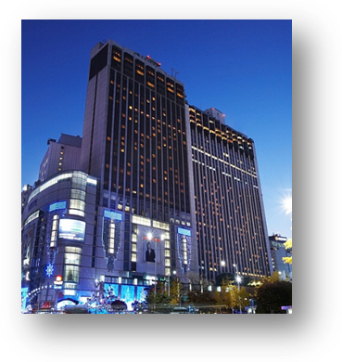

## Symposium on “Progressing the climate agenda through green ICT standards”

|  |  |
| --- | --- |
| Address | 33, Taepyeongro, Jung-Gu, Seoul, Korea 100-721 |
| Facilities | VIP Room, Press Room |
| Telephone | +82-2-2001-7114 |
| Fax | +82-2-2001-7770 |
| Website | [www.kpf.or.kr](http://www.kpf.or.kr) |

The Symposium will be held on 19th of September 2011 at ‘International Conference Hall’(20F) in Korea Press Center, Seoul, Korea.

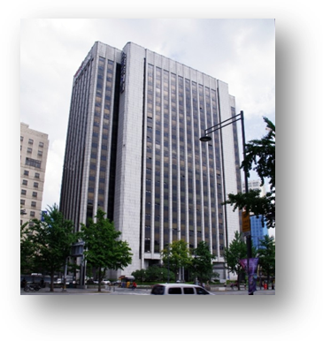

## How to get from Lotte Hotel to Press Center

It takes 10 minutes by walk and 5 minutes by taxi as below map.

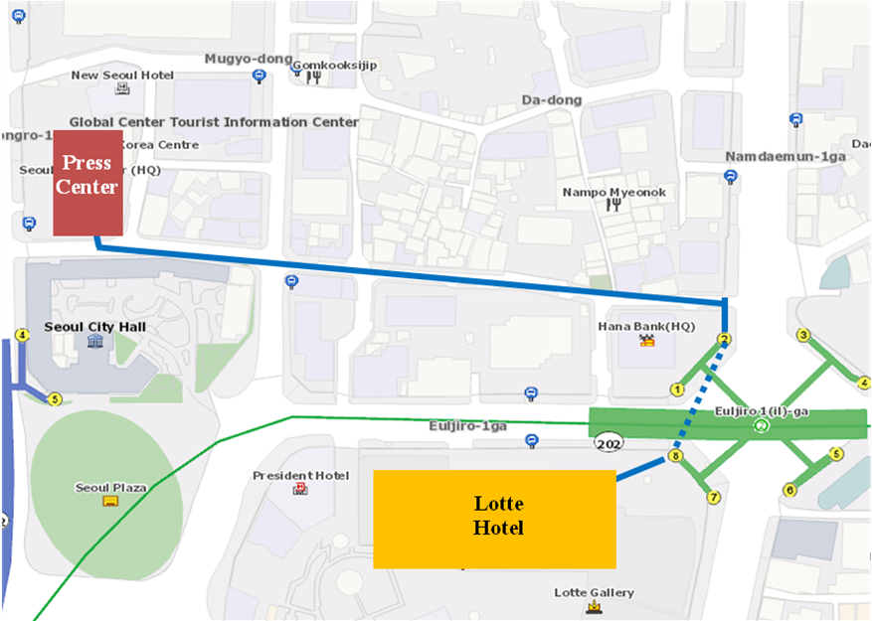

1. **National Coordinator**

**Dr. Sam Young CHUNG**

Tel: +82 2 710 6595

Fax: +82 2 710 6639

E-mail: [sychung@kcc.go.kr](mailto:sychung@kcc.go.kr)

**Ms. Hye Young (Grace) Hwang**

Tel: +82 2 338 1082

Fax: +82 2 338 1083

E-mail: [sg5\_general@kcc.go.kr](mailto:sg5_general@kcc.go.kr)

1. **Accommodation and hotel reservations**

The Korea Administration has obtained special rates in different downtown hotels. Next page shows a map indicating each hotel’s proximity to the meeting venue together with a chart including the corresponding hotel rates.

Delegates are kindly requested to fill out the corresponding reservation form, send it directly to the hotel, copy to Ms. Grace at: [sg5\_general@kcc.go.kr](mailto:sg5_general@kcc.go.kr) or fax. +82 2 338 1083.

It is important to make your reservation as soon as possible**. All reservations must include a credit card number**. You shall receive a confirmation message once your reservation has been accepted by the hotel. In case of failure to attend the meeting, all reservations must be cancelled well in advance.

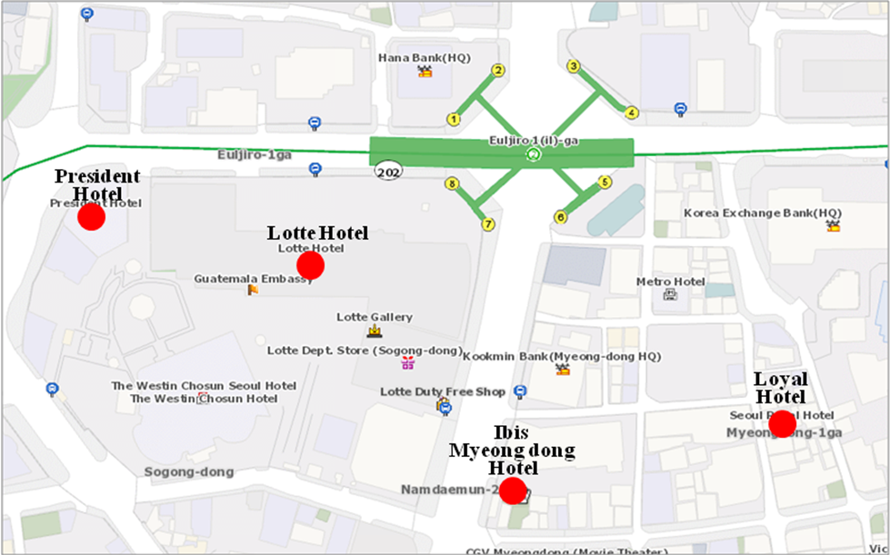

|  |  |  |  |  |
| --- | --- | --- | --- | --- |
| **HOTEL** | **CATEG.** | **ROOM** | **RATE** | **NOTES** |
| **(1) Lotte Hotel (Venue)**  1 Sogong-dong Jung-gu Seoul  Tel: +82. 2-759-7311~6 Fax: +82. 2-773-4910 Check-In: 2:00 PM Check-Out: 12:00 PM reservation@hotellotte.co.kr www.lottehotelseoul.com/index.asp | Standard  (Basis on Single Occupancy) | Superior  Deluxe | KRW 254,100 (≒USD 234)  KRW 278,300 (≒USD 257) | Included Taxes  buffet breakfast  : KRW 30,250 (≒USD 29)  Double occupancy charge will be added KRW 24,200 (≒USD 25) |
| Deadline of Reservation | | 1st of August | |
| Cancelation Policy | | Inform to the hotel of any cancellations by 6:00 pm on the date of arrival or be charged for one night. | |
| **(2) Ibis-Myeongdong Hotel**  59-5 Myeongdong 1ga Jung-gu Seoul Tel: +82. 2-6361-8888 Fax: +82. 2-6361-8050 Check-In: 2:00 PM  Check-Out: 12:00 PM [ibismres@ambatel.com](mailto:ibismres@ambatel.com) ibis.ambatel.com/FrontSite/ibis/myeongdong/Default.aspx | Standard | Double  Twin | KRW 172,480 (≒USD 159)  KRW 188,650 (≒USD 174) | Included Taxes  buffet breakfast  : KRW 16,500 (≒USD 15) |
| Deadline of Reservation | | 29th of August | |
| Cancelation Policy | | 50% penalty fee from 14days prior to check in date.  100% penalty fee from 7days prior to check in date. | |
| **(3) Hotel President**  188-3 Euljiro 1ga Jung-gu Seoul Tel: +82. 2-753-3131 Fax: +82. 2-752-7417 Check-In: 2:00 PM  Check-Out: 12:00 PM [marketing@hotelpresident.co.kr](mailto:marketing@hotelpresident.co.kr) www.hotelpresident.co.kr/english | Standard | Twin or Double | KRW 165,000 (≒USD 152) | Included Taxes  buffet breakfast  : KRW 22,000 (≒USD 20) |
| Deadline of Reservation | | 19th of August | |
| Cancelation Policy | | 100% penalty fee from 7days prior to check in date. | |
| **(4) Royal Hotel**  6 Myeongdong 1ga Jung-gu Seoul Tel: +82. 2-2129-5754~7 Fax: +82. 2-2129-5880 Check-In: 2:00 PM  Check-Out: 12:00 PM reser@royal.co.kr www.royal.co.kr | Standard | Double  Twin | KRW 187,000 (≒USD 173)  KRW 203,500 (≒USD 188) | Included Taxes  buffet breakfast  : KRW 15,400 (≒USD 14) |
| Deadline of Reservation | | 19th of August | |
| Cancelation Policy | | 50% penalty fee from 28th of August  75% penalty fee from 5th of September  100% penalty fee from 12nd of September | |

Participants are requested to reserve a hotel on a first-come-first-served basis through E-mail or Fax. Please note that there is a limit of the number of available rooms of Hotels. Therefore, if the reservations are full, it will be shifted to nearby Hotel and the reservation counter of the hotel will inform the corresponding participants about the situation

1. **Flights and transportation**

Incheon International Airport handles all international air traffic and is 60 minutes away from the Seoul. Delegates have several transfer options from the airport to their hotel in the city of Seoul:

**ITU-T SG5 and Symposium on “Progressing the climate agenda through green ICT standards” Information desk:** Korea Secretariat will open the Information desk for participants’ convenience at arrivals (see below map). It will be opened from 18th of September to 19th of September at 7:00AM to 7:00PM. (Operating hours can be changed to depend on the participant's schedule) If you need to help to go to Seoul, drop by the information desk and get information.

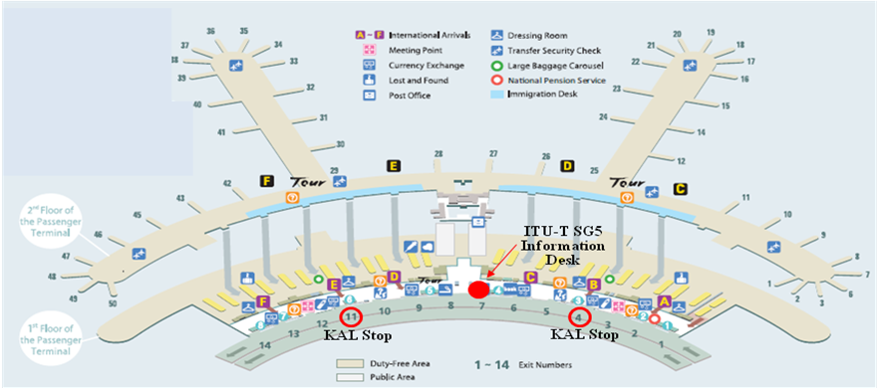

**Car services and private taxis:** taxi is recommended if you arrive late at night and buses are no longer operating or if you have heavy baggage or there are many members in your party. If you go to Myeong-dong (near the main venue) by a deluxe taxi late at night, you need to pay about 100,000 won. The fare varies depending on distance (meters).

**Airport Bus:** Airport buses run from Incheon Int'l Airport to various parts of Seoul. You can buy a ticket for your destination at the ticket desk on the arrival floor (1st floor). You can get information on bus routes and bus stops at the Airport Information Desk. Also Korea Secretariat will be operating the ITU-T SG5 and Symposium Information desk for participants’ convenience. If you would like to go from Incheon International Airport to the Lotte Hotel (main venue) you can use a KAL limousine bus.

**Airport Railroad Express and Seoul Metro:** Incheon International Airport Station of AREX is located on the first underground level of the Transportation Center at Incheon International Airport. You can get to Seoul and Lotte Hotel (main venue) using Airport Railroad Express and Seoul Metro.

How to get from Incheon Int’l Airport to Lotte Hotel :

* Get on the Airport Railroad Express on 1st floor of Incheon International Airport
* Transfer to line number 2 (green line) at the Hongik University station
* Get off the train at the Uljiro1(il)-ga station

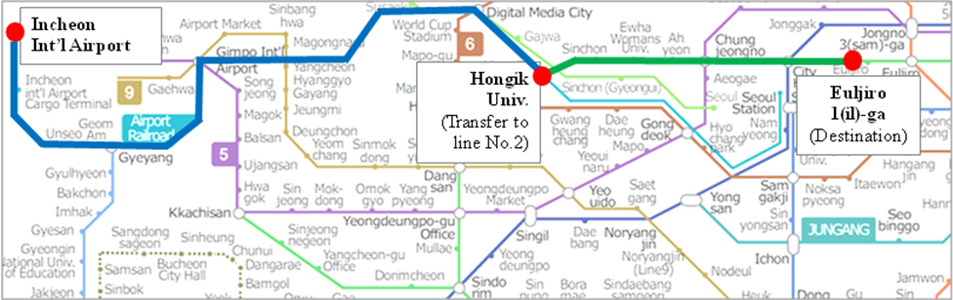

If you want to further information, please visit below website :

Airport Railroad Express : <http://www.airport.kr/iiacms/pageWork.iia?_scode=C1203020000&fake=1308136787130>

Seoul Metro :

http://www.seoulmetro.co.kr/eng/

## Information for KAL limousine bus from Incheon Int’l Airport to the Lotte Hotel

- Course Time : About 1 hour and 20 min / Adult(15,000won), Child(10,000won)

- Boarding : KAL Stop - 4B or 11A

* Ticket Office : ITU-T SG 5 and Symposium Information desk at Incheon International Airport

(Ticket for the Bus departure from the entrance of the Hotel is sold at Front desk of Main building and New Wing)

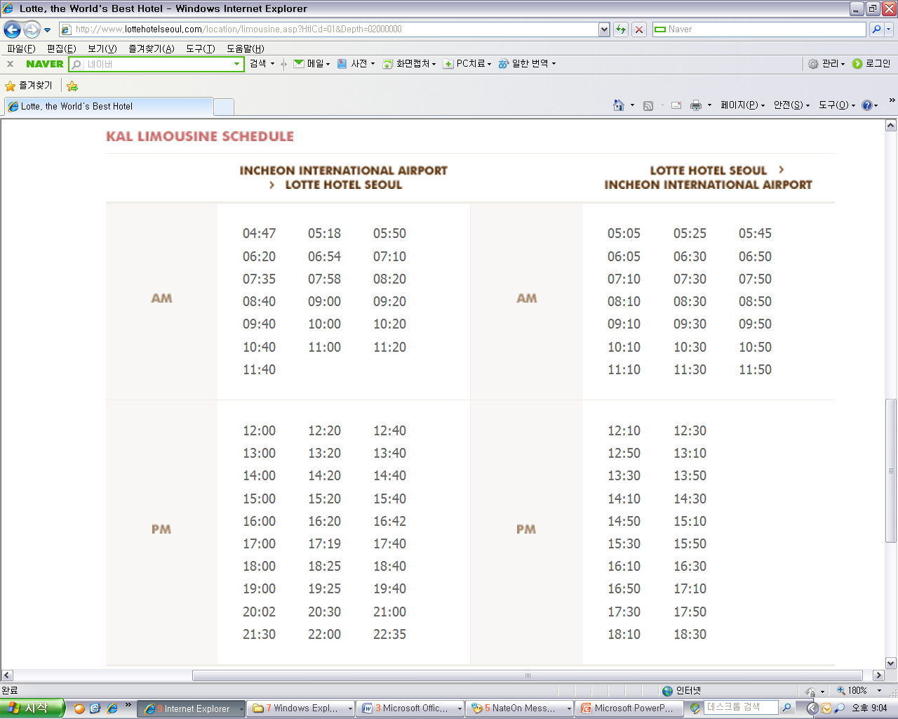

For further information, please visit the following web page: <http://english.visitkorea.or.kr/enu/GK/GK_EN_2_2_2_3.jsp>

1. **GENERAL INFORMATION**

Introduction

The Korean Peninsula is located in North-East Asia and roughly 1,030 km (612 miles) long and 175 km (105 miles) wide at its narrowest point. Korea's total land area is 100,140 sq km, and it has a population of 48.7 million people (2009). Korea is a culturally diverse and economically advanced country full of dynamism. Building upon incredible post-war economic growth, Korea is the 12th largest economy in the world, and is becoming a powerful focal point of the Asian economic block. With a history tracing back more than 5,000 years, Korea is also rightly proud of its dazzling culture. It possesses 8 UNESCO cultural heritage sites, which compares favourably with any other nation in the world.

1. **The City of Seoul**

Seoul is the capital and largest city of the Republic of Korea (South Korea). With a population of over 10 million, it is one of the world's largest cities and is by far the most densely populated city among OECD nations. The Seoul National Capital Area, which includes the Incheon metropolis and most of Gyeonggi province, has 24.5 million inhabitants, and is the world's second largest metropolitan area. Almost half of South Korea's population lives in the Seoul National Capital Area, and nearly a quarter in Seoul itself, making it the country's foremost economic, political, and cultural center

1. **Visa**

Most delegates do not require a visa to enter Korea. You can check all visa requirements at http://www.mofat.go.kr/english/visa/apply/[index](http://www.mofat.go.kr/english/visa/apply/index.jsp).jsp. However, for more certainty we recommend you consult your embassy or consulate.

Those who require a visa to enter Korea should contact Ms. Ellva or Grace at [sg5\_visa@kcc.go.kr](mailto:sg5_visa@kcc.go.kr) in order to request a personalized letter of invitation addressed to the petitioner via e-mail. This letter shall then be delivered to the petitioning country’s Korea Embassy in order to get the visa.

1. **Language**

Korean is the official language (English, Japanese and Chinese are also spoken).

1. **Power**

Supply voltage is 220V, 50Hz~60Hz. Participants are requested to bring the A-type adapter which is two parallel pronged and requested to bring the electric transformer, if necessary, for your equipments

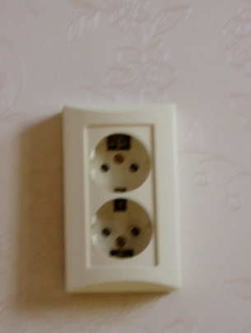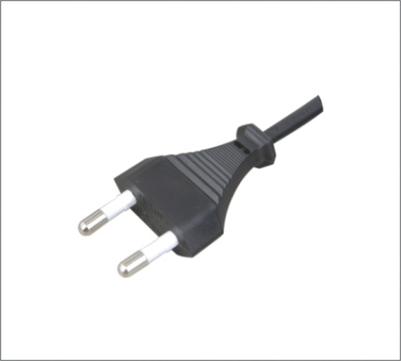

**Electrical Outlet**

1. **Climate**

The month of September is autumn that is well and truly in Seoul. In the mid September, Korea will be hot but less humid than August. Temperature is between 17 °C ~ 25°C.

1. **Currency**

The unit of Korean currency is Korean Won (KRW). Also the most widely accepted credit cards are American Express, VISA and Master card.

Examples of exchange rates as of 10 June, 2011 is US$1= 1083.00 KRW

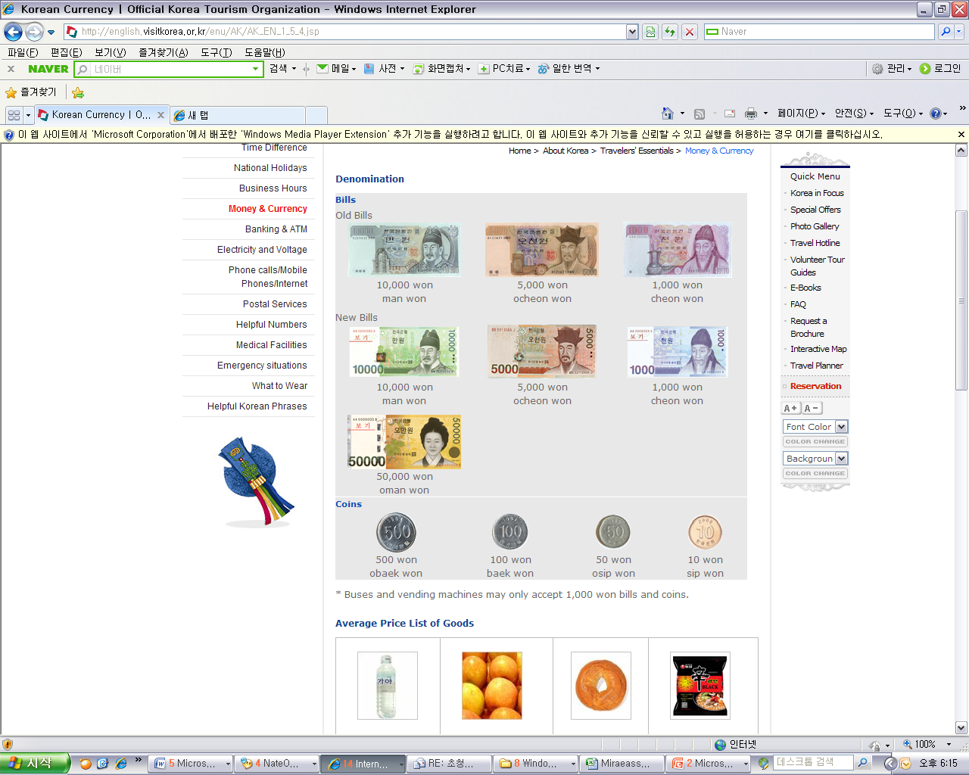

1. **Tax Refund**

At the airport, passengers can get a 10% refund of the amount paid for Value Added Tax (VAT), if they have bought national products for amounts over $ 30 (per purchase slip) at the shops and within 3 months of departure from Korea adhered to the “Global Refund” system.

For further information, please visit: <http://english.visitkorea.or.kr/enu/SH/SH_EN_7_1_4.jsp>

1. **Business hours**

Banks, post offices, and public offices generally open from 09:30 to 16:00 on weekdays but are closed on Saturdays and Sundays. Most of the shops are open from 10:00 to 22:00 through the entire week. However, some shops in Itaewon and Dongdaemon Shopping Mall are opened all night.

1. **Customary Tip**

It is not customary tip in Korea. However, a 10% service charge and 10% taxes is added to your bill at all tourist hotels and some larger restaurants.

1. **Useful Information**

For further information on the city of Seoul, please visit the following web page: http://english.seoul.go.kr

1. **Attire**

Formal attire is recommended for officials attending the Meeting of Study Group 5 and the Symposium, on “Progressing the climate agenda through green ICT Standards”throughout the event.

1. **Invitation to the Welcome Dinner**

*The Communications Secretary of the Republic of Korea are pleased to invite the officials attending the meeting to the Welcome Dinner to be celebrated on Tuesday 20 September 2011 at 6.30 pm at the Sapphire Ballroom of the venue.*

*Suggested attire: Formal*

ANNEX 3  
(to TSB Circular 204)

**ITU-T Study Group 5 meeting and Symposium**

**Seoul, Republic of Korea, 19-28 September 2011**

**\*\*\*\*\***

## HOTEL RESERVATION

Please type or print clearly. Retain a copy for your records. **Please send this form to the Hotel and one copy to Grace**, e-mail address: [sg5\_general@kcc.go.kr](mailto:sg5_general@kcc.go.kr) Tel: (+82 2) 338-1082, Fax: (+82 2) 338-1083

|  |  |  |  |  |  |  |  |  |  |  |  |  |  |
| --- | --- | --- | --- | --- | --- | --- | --- | --- | --- | --- | --- | --- | --- |
| **Last Name**: | |  | | | | | | **First Name**: | | | |  | |
| **Organization-Company:** | |  | | | | | | | | | | | |
| **Address**: | |  | | | | | | | | | | **Country** |  |
| Tel.: |  | | | Fax: | |  | | | | E-mail: |  | | |
| **Hotel Information** | | | | | **Please choose type of room** | | | | | | | | **Remarks** |
| **Hotel Name** | | | **Number** | | **Room Type** | | | | | **Breakfast** | | | **Remarks** |
|  | | |  | | **Double** | | | |  | Included |  | | *e.g. Smoking or*  *Non-Smoking* |
| **Twin** | | | |  | Excluded |  | |
| **Shared with**: | | | | | | |  | | | | | | |
| **Arrival date and time**: | | | | | | |  | | | | | | |
| **Airline and flight No.:** | | | | | | |  | | | | | | |
| **Departure date and time**: | | | | | | |  | | | | | | |

***I authorize the use of the following credit card to guarantee my hotel reservation:***

|  |  |  |  |
| --- | --- | --- | --- |
| **Type of Card**: |  | **Number:** |  |
| **Name on Card**: |  | **Expiration Date:** |  |

ANNEX 4  
(to TSB Circular 204)

|  |  |  |  |  |  |  |  |
| --- | --- | --- | --- | --- | --- | --- | --- |
|  | **Symposium on Progressing the Climate Agenda Through Green ICT Standards**  **Seoul, Republic of Korea, 19 September 2011** | | | | | |  |
| **Please return to:** | | | **ITU/BDT**  **Geneva (Switzerland)** | | **E-mail :** [**bdtfellowships@itu.int**](mailto:bdtfellowships@itu.int)  **Tel: +41 22 730 5487**  **Fax: +41 22 730 5778** | | | |
| **Request for a partial fellowship to be submitted before 19 August 2011** | | | | | | | |
|  | | | | Participation of women is encouraged | | |  | |
| **Country: \_\_\_\_\_\_\_\_\_\_\_\_\_\_\_\_\_\_\_\_\_\_\_\_\_\_\_\_\_\_\_\_\_\_\_\_\_\_\_\_\_\_\_\_\_\_\_\_\_\_\_\_\_\_\_\_\_\_\_\_\_\_\_\_\_\_\_\_\_\_\_\_\_\_\_\_\_\_\_\_\_\_\_\_\_\_\_\_\_\_\_\_\_\_\_\_\_\_\_\_\_**  **Name of the Administration or Organization: \_\_\_\_\_\_\_\_\_\_\_\_\_\_\_\_\_\_\_\_\_\_\_\_\_\_\_\_\_\_\_\_\_\_\_\_\_\_\_\_\_\_\_\_\_\_\_\_\_\_\_\_\_\_\_\_\_\_\_\_\_\_\_\_\_\_\_\_\_\_**  **Mr. / Ms. \_\_\_\_\_\_\_\_\_\_\_\_\_\_\_\_\_\_\_\_\_\_\_\_\_\_\_\_\_\_\_\_\_\_\_\_\_\_\_(family name) \_\_\_\_\_\_\_\_\_\_\_\_\_\_\_\_\_\_\_\_\_\_\_\_\_\_\_\_\_\_\_\_\_\_\_\_\_\_(given name)**  **Title: \_\_\_\_\_\_\_\_\_\_\_\_\_\_\_\_\_\_\_\_\_\_\_\_\_\_\_\_\_\_\_\_\_\_\_\_\_\_\_\_\_\_\_\_\_\_\_\_\_\_\_\_\_\_\_\_\_\_\_\_\_\_\_\_\_\_\_\_\_\_\_\_\_\_\_\_\_\_\_\_\_\_\_\_\_\_\_\_\_\_\_\_\_\_\_\_\_\_\_\_** | | | | | | | | |
| **Address: \_\_\_\_\_\_\_\_\_\_\_\_\_\_\_\_\_\_\_\_\_\_\_\_\_\_\_\_\_\_\_\_\_\_\_\_\_\_\_\_\_\_\_\_\_\_\_\_\_\_\_\_\_\_\_\_\_\_\_\_\_\_\_\_\_\_\_\_\_\_\_\_\_\_\_\_\_\_\_\_\_\_\_\_\_\_\_\_\_\_\_\_\_\_\_\_\_\_\_\_**  **\_\_\_\_\_\_\_\_\_\_\_\_\_\_\_\_\_\_\_\_\_\_\_\_\_\_\_\_\_\_\_\_\_\_\_\_\_\_\_\_\_\_\_\_\_\_\_\_\_\_\_\_\_\_\_\_\_\_\_\_\_\_\_\_\_\_\_\_\_\_\_\_\_\_\_\_\_\_\_\_\_\_\_\_\_\_\_\_\_\_\_\_\_\_\_\_\_\_\_\_\_\_\_\_\_\_\_\_\_\_**  **Tel.: \_\_\_\_\_\_\_\_\_\_\_\_\_\_\_\_\_\_\_\_\_\_\_\_\_\_\_\_ Fax: \_\_\_\_\_\_\_\_\_\_\_\_\_\_\_\_\_\_\_\_\_\_\_\_\_\_\_\_ E-Mail:\_\_\_\_\_\_\_\_\_\_\_\_\_\_\_\_\_\_\_\_\_\_\_\_\_\_\_\_\_\_\_\_\_**  **PASSPORT INFORMATION :**  **Date of birth: \_\_\_\_\_\_\_\_\_\_\_\_\_\_\_\_\_\_\_\_\_\_\_\_\_\_\_\_\_\_\_\_\_\_\_\_\_\_\_\_\_\_\_\_\_\_\_\_\_\_\_\_\_\_\_\_\_\_\_\_\_\_\_\_\_\_\_\_\_\_\_\_\_\_\_\_\_\_\_\_\_\_\_\_\_\_\_\_\_\_\_\_\_\_\_**  **Nationality: \_\_\_\_\_\_\_\_\_\_\_\_\_\_\_\_\_\_\_\_\_\_\_\_\_\_\_\_\_\_\_\_\_\_\_\_\_\_\_\_\_\_ Passport number: \_\_\_\_\_\_\_\_\_\_\_\_\_\_\_\_\_\_\_\_\_\_\_\_\_\_\_\_\_\_\_\_\_\_\_\_\_\_\_\_**  **Date of issue: \_\_\_\_\_\_\_\_\_\_\_\_\_\_\_\_\_\_\_ In (place) : \_\_\_\_\_\_\_\_\_\_\_\_\_\_\_\_\_\_\_\_\_\_\_\_\_\_\_\_\_Valid until (date): \_\_\_\_\_\_\_\_\_\_\_\_\_\_\_\_\_\_\_\_\_\_\_** | | | | | | | | |
| CONDITIONS **(Please select your preference in “condition” 2 below)** | | | | | | | | |
| 1. One **partial** fellowship per eligible country. | | | | | | | | |
| 1. ITU will cover either one of the following: | | | | | | | | |
| □ **Economy class air ticket (duty station / Seoul / duty station).** | | | | | | | | |
| **□ Daily subsistence allowance intended to cover accommodation, meals & misc. expenses.**   1. It is imperative that fellows be present from the first day to the end of the meeting. | | | | | | | | |
| **Signature of fellowship candidate:** | | | | | | **Date:** | | |
| **TO VALIDATE FELLOWSHIP REQUEST, NAME, TITLE AND SIGNATURE OF CERTIFYING OFFICIAL DESIGNATING PARTICIPANT MUST BE COMPLETED BELOW WITH OFFICIAL STAMP.** | | | | | | | | |
| **Signature** | | | | | | **Date** | | |