Geneva, 10 November 2006
INTERNATIONAL TELECOMMUNICATION UNION  Telecommunication  Standardization Bureau | 

Ref:  Tel:  Fax: | TSB Circular 123  NGN-GSI/TK  +41 22 730 5994  +41 22 730 5853 | - To Administrations of Member States of  the Union;
E-mail: | tsbngngsi@itu.int | Copy:  - To ITU-T Sector Members;  - To ITU-T Associates;  - To the Chairmen and Vice-Chairmen of all ITU-T Study Groups;  - To the Director of the Telecommunication Development Bureau;  - To the Director of the Radiocommunication Bureau

Subject: | NGN-GSI event  Beijing, P.R. China, 8-12 January 2007

Dear Sir/Madam,
1 Further to the NGN-GSI events that have taken place during 2006 in Geneva and Kobe, Japan, and according to the agreement reached at the last two NGN-GSI events in Geneva in July and October - November 2006, I have the pleasure to inform you that the next NGN-GSI event will take place at the Beijing Friendship Hotel, Beijing, People’s Republic of China, from 8 to 12 January 2007 inclusive, at the kind invitation of China Communications Standards Association (CCSA).
2 The joint Rapporteur Groups meeting comprised in the NGN-GSI event will open at 0930 hours on the first day with Technical and Strategic Review meeting. Participant registration will begin at 0830 hours on the same day. Detailed information concerning the meeting rooms will be displayed on NGN-GSI website and on the pointers at the entrance to the hotel and at the entrance to each meeting room.
3 Meetings and discussion will be held in English.
4 A draft timetable for this event along with some logistical arrangements for this set of meetings as agreed to by the Rapporteurs and Chairmen concerned, is set out in Annex 1 hereto.
5 Updated information relating to this event will be available on the ITU-T NGN-GSI website at the following address: http://www.itu.int/ITU-T/ngn/events/index.asp.
6 The proposed agenda of Rapporteur Groups will be posted on the webpage, created for these groups of meetings: http://www.itu.int/ITU-T/ngn/events/index.asp.
7 Contributions should be sent to TSB secretariat for NGN-GSI tsbngngsi@itu.int. Taking into account seasons holidays break for many people and on an exceptional basis the deadline for the submission of contributions is set at 3 January 2007.
8 Annex 2 provides practical information on the meeting, venue, and country, as provided by the host organization.
9 For your convenience, a hotel reservation form is enclosed in Annex 3.
10 Please note that the meeting will be run paperless. Wireless LAN facilities would be made available for delegates. Please bring your wireless card with you. If you do not have one, you may rent it from secretariat on the spot.
11 In order to enable the host organization and TSB to make the necessary arrangements concerning the running of the event, we should be grateful if you would pre-register by sending the registration form in Annex 4 duly completed (one per participant) by fax (+86-10-82053019) or by e-mail (NGNGSI_meeting@ccsa.org.cn) to the host by 22 December 2006.
12 We would remind you that citizens of some countries are required to obtain a visa in order to enter and spend time in P.R. China. The visa must be requested and obtained from the office (embassy or consulate) representing China in your country or, if there is no such office in your country, from the one that is closest to the country of departure. Please be aware that visa approval might take time so kindly make your request for the invitation letter as soon as possible.
Participants who need an invitation letter and/or a visa supporting letter for entering China are advised to get in touch with the NGN-GSI event contact person in this country whose detailed information is as follows:

Ms. Duo Liu
CATR, MII of China
Tel: +86 10 68094158
Mobile: +86 13601275317
Email: liuduo@mail.ritt.com.cn

Yours faithfully,
H. Zhao
Director of the Telecommunication
Standardization Bureau

Annexes: 4

ANNEX 1
(to TSB Circular 123)
NGN-GSI time plan
Beijing, China, 8-12 January 2007

Monday | 08/01 | Tuesday | 09/01 | Wednesday | 10/01 | Thursday | 11/01 | Friday | 12/01
AM | PM | AM | PM | AM | PM | AM | PM | AM | PM

TSR | 2/13 | 2/13 | 2/13 | 2/13 | 2/13 | 2/13 | 2/13 | 2/13 | 2/13 | 2/13 | 2/13 | 2/13 | 2/13 | 2/13 | 2/13 | 2/13 | 2/13 | 2/13 | TSR
TSR | 3/13 | 3/13 | 3/13 | 3/13 | 3/13 | 3/13 | 3/13 | 3/13 | 3/13 | 3/13 | 3/13 | 3/13 | 3/13 | 3/13 | 3/13 | 3/13 | 3/13 | 3/13 | TSR
TSR | 4/13 | 4/13 | 4/13 | 4/13 | 4/13 | 4/13 | 4/13 | 4/13 | 4/13 | 4/13 | 4/13 | 4/13 | 4/13 | 4/13 | 4/13 | 4/13 | 4/13 | 4/13 | TSR
TSR | 15/13 | 15/13 | 15/13 | 15/13 | 15/13 | 15/13 | 15/13 | 15/13 | 15/13 | 15/13 | 15/13 | 15/13 | 15/13 | 15/13 | 15/13 | 15/13 | 15/13 | 15/13 | TSR
TSR | 8/13 | 8/13 | 8/13 | 8/13 | 8/13 | 5/11 | 8/13 |  |  | 8/13 |  | 8/13 | 8/13 |  |  | 8/13 | 8/13 | 8/13 | TSR
TSR | 13/13 | 13/13 | 13/13 | 9/13 | 9/13 | 9/13 | 13/13 | 9/13 | 9/13 | 9/13 | 9/13 | 9/13 |  | 9/13 | 9/13 |  |  |  | TSR
TSR | 2/11 | 2/11 | 2/11 | 7/13 | 5/11 | 7/13 | 7/13 | 7/13 | 7/13 |  | 5/11 |  | 7/13 | 7/13 |  |  |  |  | TSR
TSR | 1/13 | 7/13 | 1/13 | 1/13 | 1/13 | 3/11 | 3/11 | 1/13 | 3/11 | 3/11 | 3/11 | 3/11 | 3/11 | 3/11 | 3/11 | 3/11 | 3/11 | 3/11 | TSR
TSR | 8/11 | 5/11 | 8/11 | 7/11 | 7/11 | 7/11 | 1) | 5/11 | 5/11 | 5/11 | 1/13 | 5/11 | 5/11 | 5/11 | 5/11 | 5/11 | 5/11 | 5/11 | TSR

Legend:
TSR: NGN-GSI Technical and Strategy Review Activity
Note 1: Joint Qs.5 & 7/11 meeting

Some arrangements for the NGN-GSI meeting

- The meetings will be run paperless: no paper copies of the documents will be distributed. Meeting documents will be available on http://www.itu.int/ITU-T/ngn/events/index.asp. This page is accessible from the main NGN-GSI webpage http://www.itu.int/ITU-T/ngn/index.phtml.
- Similar to the previous NGN-GSI event in Geneva, the document handling for the NGN-GSI events held as co-located Rapporteur groups meetings (beyond Study Group structure) will be carried out by TSB. Therefore, contributions to this meeting should be sent to the TSB secretariat for NGN-GSI (tsbngngsi@itu.int), with copy to the Rapporteur concerned. Please use the template for the documents available from http://www.itu.int/ITU-T/ngn/events/index.asp.
- The deadline for the submission of contributions is set at 3 January 2007, midnight, Geneva time.
- For this NGN-GSI event a website has been created to give access to the input and output documents via the regular ITU document management system (DMS). As for the previous event, all input and output documents from the various Rapporteur groups for this event will be processed by the TSB, loaded onto the DMS and mirrored onto the FTP area established for this meeting. Mr. Georges Sebek, TSB acting coordinator for the NGN-GSI, is the focal point to carry out this task. His contact details are as follows:
Georges Sebek
TSB/ITU
Place des Nations
CH-1211 Geneva 20
Switzerland
Tel : +41 22 730 5994
Fax : +41 22 730 5853
E-mails : tsbngngsi@itu.int
georges.sebek@itu.int
- Meeting logistics will also be coordinated by TSB. Please contact TSB secretariat for this event at tsbngngsi@itu.int.
- Any requests for information on meetings should be sent to Georges Sebek, TSB acting coordinator for NGN-GSI.
ANNEX 2
(to TSB Circular 123)

Practical Information

- Venue
The Beijing Friendship Hotel (****) Tel: +86-10-68498888
1 Zhongguancun Nandajie, Haidian District, Fax: +86-10-68498866
Beijing, China
For detailed information about Beijing Friendship Hotel, please see:
http://www.bjfriendshiphotel.com/enew.htm
  - How to get there
There are 2 ways to get from the airport to the hotel:
First, a Shuttle Bus from Beijing Capital International Airport to Beijing Friendship Hotel goes every 30 minutes (from 8:00-23:00); the fare is 16 RMB.
Second, you may wish to take a taxi from airport to hotel. Average fare from the airport to the hotel is approximately 120 RMB for a regular taxi but it may cost more depending on traffic during rush hours.
- Entry Notes
Visa requirements
Please contact Ms Duo Liu (liuduo@mail.ritt.com.cn) should you require an individual invitation letter while obtaining your visa. Your email must include the following information in order to be processed:
- Family name (last name)
- Forename (first name)
- Birth date (month, day, year)
- Passport number, issuing country, issuing date and expiry date
- Gender
- Occupation
- Company name
- Company’s mailing address
- Postal Code
- Country
- Telephone number
- Fax number
- Name of meeting (ITU-T NGN-GSI event)
Letters will only be sent via Express mail upon request. Letters will be sent via fax unless otherwise indicated on the request.
Letters will be processed within 14 days of receiving an email request. If you have not received your letter within 14 days or wish to make changes after receiving a faxed copy, please contact Ms. Duo Liu at liuduo@mail.ritt.com.cn.
In addition, you may be asked for specific documentation showing strong social, economic, and other ties to your home country.
Customs Regulations and Vaccination Requirements

See the above attachment for reference or check this website:
http://www.hlraohe.gov.cn/kajm/crj/xz.htm
Hotel Reservation Procedure
A total of about 100 rooms in the Beijing Friendship Hotel Building NO.4 have been blocked for the participants at preferential rates. The preferential rates will start when the participants arrive at the hotel and be cut off when the meeting closed.
The hotel is pleased to offer you a standard room (single/twin) and a suite (single/twin) in the Building NO.4. The fare for stay in the standard room (single/twin) is US$72 per night (including breakfast), and the fare for the suit (single/twin) is US$127 per night (including breakfast). The fare for the lunch is US$12, and the fare for the lunch and supper will be US$24.
Participants wishing to make reservations should fulfil the reservation form in Annex 3 and send it to the following address: NGNGSI_meeting@ccsa.org.cn (hosting organization focal point for this meeting).
We should be grateful if you would send your reservation as soon as possible, but not later than 20 December 2006.
3. Map directions
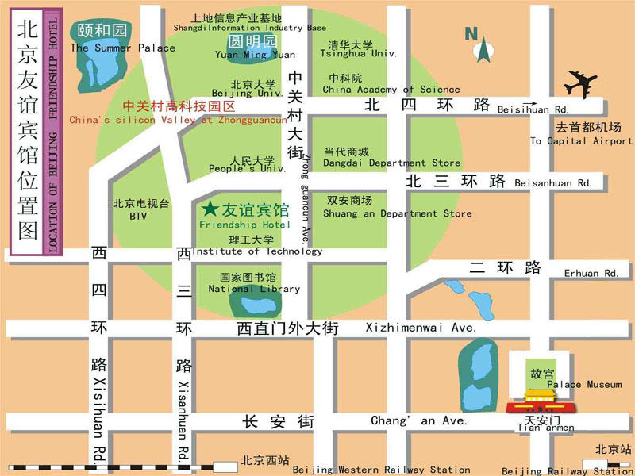
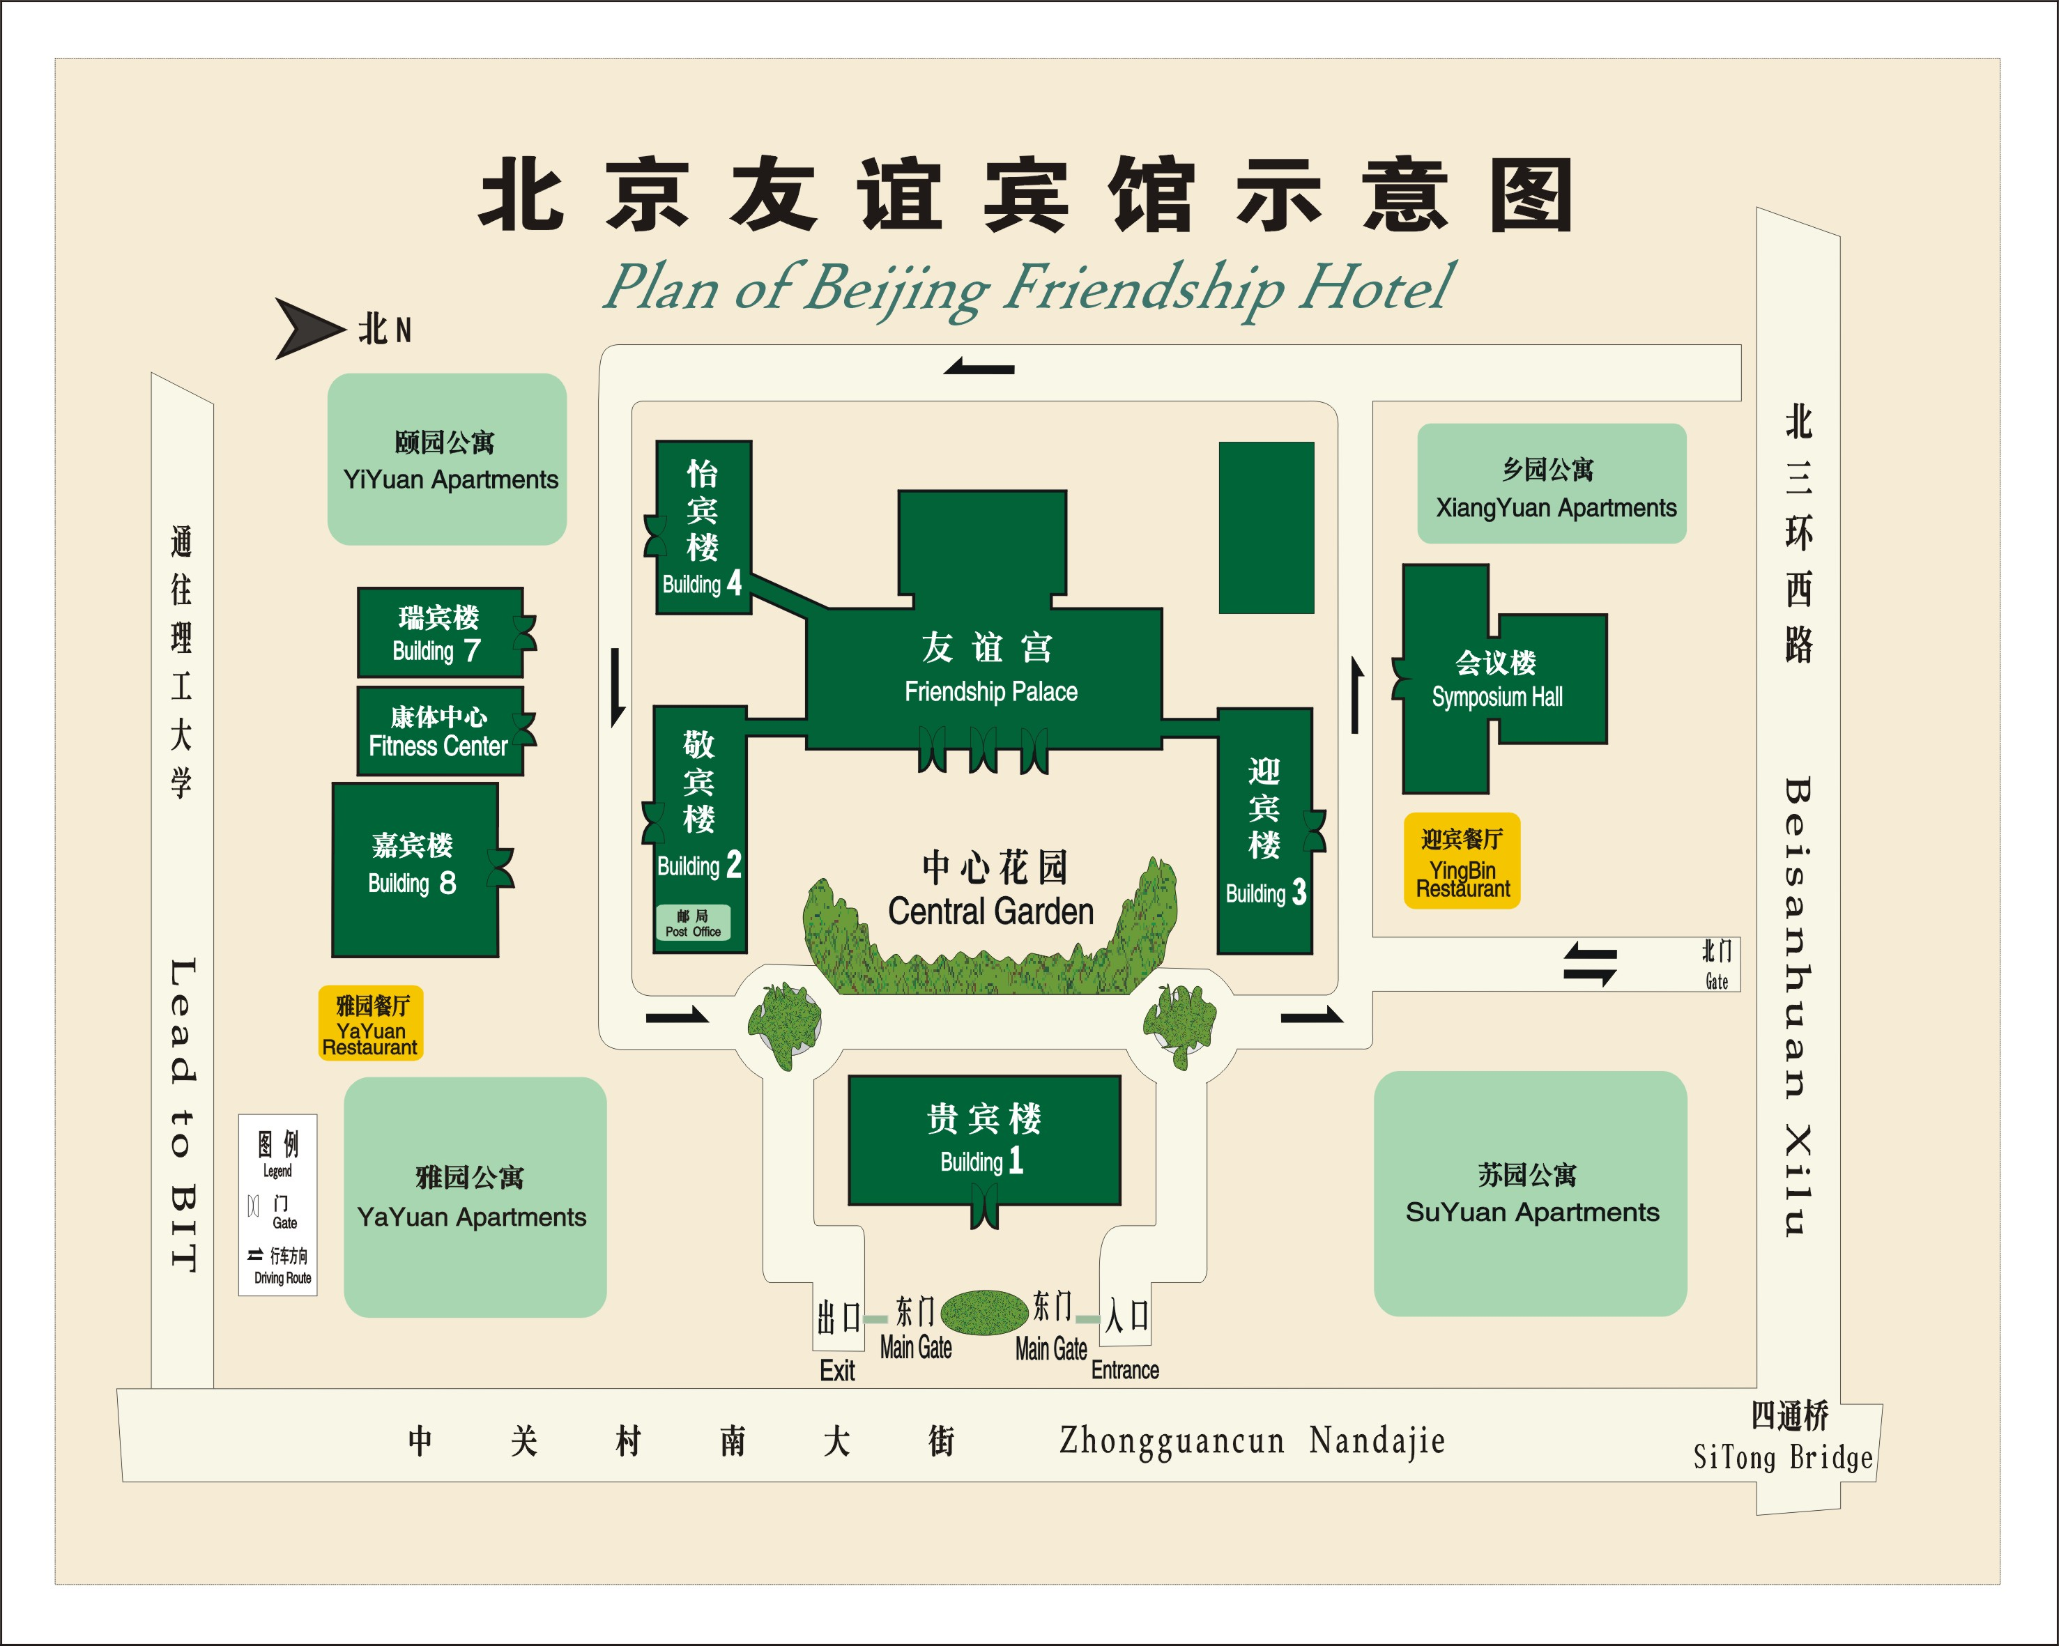
Medical services around the hotel
For medical emergencies, there are two major hospitals around the Beijing Friendship Hotel. They are Peking University Third Hospital and Beijing Haidian Hospital.
Bank services around the hotel
Around the Beijing Friendship Hotel, there are branches of China CITIC Bank and Bank of Beijing. You can go to these for financial business.
4. Miscellaneous
GSM and ACDMA Coverage
There are GSM and CDMA 95/1X coverage in Beijing.
Currency
Local currency RMB Yuan ( ¥ ). The bank and hotel can provide multi-currency service. The currency exchange desk is situated on the 1st floor of Building NO.4, Beijing Friendship Hotel.
Exchange rates
Online spot exchange rates are shown at: http://www.china.org.cn/english/BAT/31.htm
Exchange rate as of 6 November 2006.
US Dollar 100 | 779.42 RMB
Euro 100 | 976.21 RMB

Tipping

Tipping is not necessary.
Time Zone
Central Time Zone (GMT +8 hours, Beijing, Hong Kong).
Climate
Beijing's climate is defined as "continental monsoon". The four seasons are distinctly recognizable. The climate of Beijing in winter is cold and snowy. Average temperature during the January is: -4.6C. Although winter is technically longer, that should not keep you from travelling to Beijing as indoor heating is widely available. Nevertheless, as the indoor/outdoor temperature difference is rather large, travellers should be prepared with warm clothing and a thick coat is recommended for the colder months of the year.
Phone charges
Each delegate is responsible for verifying any toll charges that may be incurred by placing local, long distance and toll-free calls from a guest room.
In-town transport
Taxi rate: Typical minimum charge is RMB ¥10 (covering preliminary 3 kilometers), and extra RMB ¥ 2.0 per additional kilometre.
Subway and City Rail: There are 2 subway lines and 1 city rail in Beijing, as presented in the map below.
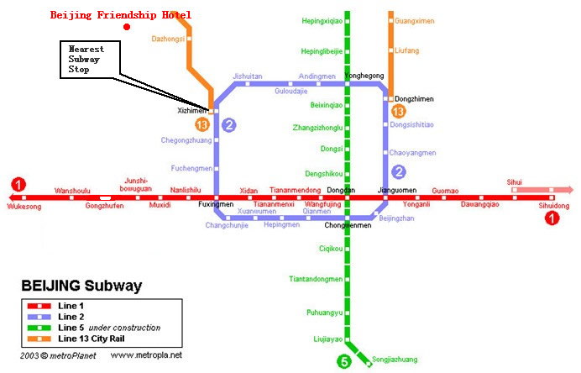
Subway System in Beijing
Currently there are three subway (or city railway) lines running in Beijing, which are line 1, 2, 13.
Line 1: line-style subway; the nearest subway stop to Beijing Friendship Hotel is Xizhimen stop;
Line 2: ring-style subway; running around the Beijing downtown area;
Line 13: sector-style city railway; running at the suburb area in the northern part of Beijing.
Electricity
220 Volt. Please be sure you have the correct adapter. Voltage converters will NOT be provided at the meeting.
The type of electrical socket at the venue of the meeting is type B.

Type B – Oblique flat blades (inverted V-shape) with ground
About Beijing
You are welcome to visit http://www.ebeijing.gov.cn, the official website of Beijing City as well as the 2008 Olympics.
Network
There will be Wireless LAN (802.11) Service in meeting rooms. Please bring your WLAN card, if you have it. WLAN cards can also be rented at the meeting secretariat (there will be a total of 50 WLAN cards available for rent).
Wired Broadband Access to Internet is available in guest rooms, which is charged 50 RMB per day.

ANNEX 3
(to TSB Circular 123)
HOTEL RESERVATION FORM
for NGN-GSI event
(Beijing, 8– 12 January, 2007)
Please complete and return this form to: NGNGSI_meeting@ccsa.org.cn
by 20 December 2006

(Please type or print in block letters and check appropriate items.)
NAME: □ Mr □ Ms.
Last name First name

ORGANIZATION:

ADDRESS: □ Office □ Home _________________

Postal code_ Country
Phone: Fax:

Name of Accompanying Person(s), if any:
□ Mr □ Ms. Last name First name
Flight Schedule: Arriving at (airport) on (date) by (flight number)

HOTEL ACCOMMODATION
Hotel Name | Room Type |  | Period of stay
Beijing Friendship Hotel  (Building NO.4) | Standard Room | Single | Check In:
Beijing Friendship Hotel  (Building NO.4) | Standard Room | Twin | Check In:
Beijing Friendship Hotel  (Building NO.4) | Suite | Single | Check Out:
Beijing Friendship Hotel  (Building NO.4) | Suite | Twin | Nights:

REMITTANCE
- Cash
- □ Credit card: □ VISA □ MasterCard □ Diners Club □ AMEX □ Other ( )
Card number:
Name of card holder: Expiration date: / /
Authorized signature:

ANNEX 4
(to TSB Circular 123)

Registration Form
ITU-T NGN-GSI event
8-12 January 2007, Beijing, P.R. China

Please fill in this form and send it by  22 December 2006 to:  (beyond this date you will be registered on site) | E-Mail: NGNGSI_meeting@ccsa.org.cn  Fax: +86-10-82053019

Title: | Ms. Mr
Last Name:
First Name:
Company:
Mailing address:
Country:
Telephone:
Fax:
Email Address:

_____________

