INTERNATIONAL TELECOMMUNICATION UNION |  |  |  | Focus Group On IPTV
TELECOMMUNICATION  STANDARDIZATION SECTOR  STUDY PERIOD 2005-2008 |  |  | FG IPTV-DOC-0093
 |  |  | English only
WG(s): 5 |  | 4th FG IPTV meeting:  Bled, Slovenia, 7-11 May 2007
OUTPUT DOCUMENT
Source: | Acting Editors
Title: | Working Document: Aspects of IPTV End System – Terminal Device

CONTENTS
1. Scope 4
2. Reference 4
3. Definitions 6
3.1 Terms Defined Elsewhere 6
3.2 Terms Defined within this document 6
4. Abbreviations and Acronyms 7
5. Conventions 8
6. Services supported by the IPTV TD 8
7. IPTV Terminal Device 8
7.1 Functional architecture 8
7.1.1 General functional architecture block diagram 8
7.1.2 Management functions 11
7.1.3 Protocol functions 11
7.1.4 Application functions 11
7.1.5 Service functions 11
7.2 Software architecture 11
7.2.1 IPTV terminal software architecture 11
7.2.2 OS/Driver layer 12
7.2.3 Protocol/Control layer 12
7.2.4 Middleware layer (API, optional) 12
7.2.5 Application layer 12
7.2.6 Service layer 12
7.3 Hardware architecture 12
7.4 Interfaces between IPTV terminal device and other media 12
7.4.1 BC-TD interface 13
7.4.2 NW-TD interface 13
7.4.3 TD-DD interface 14
7.4.4 TD-HN interface 14
7.4.5 TD-SM 15
7.4.6 TD-PD 15
7.5 User Interface 15
7.6 Consideration for accessibility of IPTV Terminal Device 16
7.7 Protocols 16
7.8 Codec 18
7.8.1 Video/Audio format supported by IPTV Terminal Device 18
7.8.2 Video/Audio decoders supported by IPTV Terminal Device 18
7.9 Terminal management 19
7.10 Security 19
7.11 Privacy 19
7.12 Quality Monitoring. 19
7.12.1 No-reference methods [J.mm-noref] 20
7.12.2 Reduced-reference methods [J.mm-redref] 20
7.12.3 Quality monitoring using transmission error information at the head-end [J.242] 21

Aspects of IPTV End Systems – Terminal Devices

1. Scope
[[Editor’s Note: This Scope needs to be re-examined based on the fact that this document is dedicated to the terminal device alone]]
This working document identifies functions needed for the IPTV end systems to support IPTV services. It further provides procedures and sets criteria to verify compliance of terminal devices to the identified rules and requirements.

2. Reference
The following ITU-T Recommendations and other references contain provisions, which, through reference in this text, constitute provisions of this working document. At the time of publication, the editions indicated were valid. All Recommendations and other references are subject to revision; all users of this working document are therefore encouraged to investigate the possibility of applying the most recent edition of the Recommendations and other references listed below. A list of the currently valid ITU-T Recommendations is regularly published. The reference to a document within this working document does not give it, as a stand-alone document, the status of a Recommendation.
[ITU-T E.118] ITU-T Recommendation E.118 (2006), The international telecommunication charge card.
[ITU-T E.164] ITU-T Recommendation E.164 (2005), The international public telecommunication numbering plan.
[ITU-T F.902] ITU-T Recommendation F.902 (1995), Interactive services design guidelines
[ITU-T J.190] ITU-T Recommendation J.190 (2002), Architecture of MediaHomeNet that supports cable-based services.
[ITU-T J.242] ITU-T Draft new ITU-T Recommendation J.242 (2006), A method to reconstruct the received video sequence seen at the receiver using transmission error information to monitor the perceptual video quality at the receiver in digital cable television and video telephony.
[ITU-T T.50] ITU-T Recommendation T.50. International Reference Alphabet (IRA) (Formerly International Alphabet No. 5 or IA5) - Information technology - 7-bit coded character set for information interchange.
[ITU-R BT.1700] ITU-R Recommendation BT.1700 (2005), Characteristics of composite video signals for conventional analogue television systems
[ITU-R BT.2052] ITU-R Report BT.2052 (2006), Protection of end-users’ privacy in interactive broadcasting systems.
[ITU-R BT.2070] ITU-R Report BT.2070 (2006), Broadcasting of content protection signalling for television
[ITU-R BT.709] ITU-R Recommendation BT.709 (2002), Parameter values for the HDTV standards for production and international programme exchange.
[ITU-R BT.1543] ITU-R Recommendation BT.1543 (2001), 1 1280 × 720, 16 × 9 progressively-captured image format for production and international programme exchange in the 60 Hz environment.
[ITU-R BT.601] ITU-R Recommendation BT.601 (2007), Studio encoding parameters of digital television for standard 4:3 and wide-screen 16:9 aspect ratios.
[ITU-R BT.1358] ITU-R Recommendation BT.1358 (1998), Studio parameters of 625 and 525 line progressive scan television systems.
[DSL-F TR069] DSL Forum TR069 (2004), CPE WAN Management Protocol.
[IEC62360] IEC 62360 (2004-03), Baseline specifications of satellite and terrestrial receivers for ISDB (Integrated Service for Digital Broadcast)
[IEEE1394] IEEE Std. 1394 (1995), IEEE Standard for a High Performance Serial Bus.
[ISO7816-1] ISO7816-1 (1998), Identification cards – Integrated circuit(s) cards with
contacts – Part 1: Physical characteristics
[ISO7816-2] ISO7816-2 (1999), Identification cards – Integrated circuit cards – Part 2: Cards with contacts – Dimensions and location of the contacts
[ISO7816-3] ISO7816-3 (1997), Information technology – Identification cards – Integrated circuit(s) cards with contacts – Part 3: Electronic signals and transmission protocols
[ISO/IEC 13818-2] ISO/IEC 13818-2 (2006), Information technology -- Generic coding of moving pictures and associated audio information: Part 2: Video
[ISO/IEC 13818-3] ISO/IEC 13818-3 (2006), Information technology -- Generic coding of moving pictures and associated audio information: Part 3: Systems
[ISO/IEC13818-7] ISO/IEC13818-7 (2006), Information technology – Generic coding of moving pictures and associated audio information – Part 7: Advanced Audio Coding (AAC).
[ISO/IEC14496-3] ISO/IEC14496-3 (2005), Information technology – Coding of audio-visual objects – Part3: Audio
[RFC768] IETF RFC 768 (1980), User Datagram Protocol (UDP).
[RFC791] IETF RFC 791(1981), Internet Protocol
[RFC792] IETF RFC 792(1981), Internet Control Message Protocol (ICMP)
[RFC793] IETF RFC 793(1981), Transmission Control Protocol (TCP)
[RFC1034] IETF RFC 1034(1987), Domain names - concepts and facilities (DNS)
[RFC1035] IETF RFC 1035(1987), Domain names - implementation and specification
[RFC1323] IETF RFC 1323(1992), TCP Extensions for High Performance
[RFC2018] IETF RFC 2018(1996), TCP Selective Acknowledgement Options
[RFC2030] IETF RFC 2030(1997), Simple Network Time Protocol (SNTP) Version 4 for IPv4, IPv6 and OSI
[RFC2131] IETF RFC 2131(1997), Dynamic Host Configuration Protocol
[RFC2236] IETF RFC 2236 (1997), Internet Group Management Protocol, Version 2
[RFC2246] IETF RFC 2246 (1999), The TLS Protocol Version 1.0
[RFC2250] IETF RFC 2250(1998), RTP Payload Format for MPEG1/MPEG2 Video
[RFC2326] IETF RFC 2326(1998), Real Time Streaming Protocol (RTSP)
[RFC2373] IETF RFC 2373(1998), IP Version 6 Addressing Architecture
[RFC2460] IETF RFC 2460(1998), Internet Protocol, Version 6 (IPv6) Specification
[RFC2461] IETF RFC 2461(1998), Neighbor Discovery for IP Version 6 (IPv6).
[RFC2462] IETF RFC 2462(1998), IPv6 Stateless Address Autoconfiguration
[RFC2463] IETF RFC 2463 (1998), Internet Control Message Protocol (ICMPv6) for the Internet Protocol Version 6 (IPv6) Specification
[RFC2616] IETF RFC 2616(1999), Hypertext Transfer Protocol -- HTTP/1.0
[RFC2617] IETF RFC 2617(1999), HTTP Authentication: Basic and Digest Access Authentication
[RFC3228] IETF RFC 3228(2002), IANA Considerations for IPv4 Internet Group Management Protocol (IGMP)
[RFC3315] IETF RFC 3315 (2003), Dynamic Host Configuration Protocol for IPv6 (DHCPv6).
[RFC3513] IETF RFC 3513 (2003), Internet Protocol Version 6 (IPv6) Addressing Architecture
[RFC3550] IETF RFC 3550 (2003), RTP: A Transport protocol for Real-Time Applications
[RFC3596] IETF RFC 3596 (2003), DNS Extensions to Support IP Version 6
[RFC3633] IETF RFC 3633 (2003), IPv6 Prefix Options for Dynamic Host Configuration Protocol (DHCP) version 6
[RFC3646] IETF RFC 3646 (2003), DNS Configuration options for Dynamic Host Configuration Protocol for IPv6 (DHCPv6)
[RFC3736] IETF RFC 3736 (2003), Stateless Dynamic Host Configuration Protocol (DHCP) Service for IPv6
[RFC3810] IETF RFC 3810 (2004), Multicast Listener Discovery Version 2 (MLDv2) for IPv6

3. Definitions

3.1 Terms Defined Elsewhere
This working document uses the following terms defined elsewhere:
3.1.1 Home Network (HN) [J.190]: A short-range communication system designed for the residential environment, in which two or more devices exchange information under some sort of standard control.

3.2 Terms Defined within this document
This working document defines the following terms:
3.2.1 HN capable IPTV TD: An IPTV TD which has HN capability. This is typically a server and/or a client to HN devices.
3.2.2 HN capable TD: A TD which has HN capability. This is typically a server and/or a client to HN devices.
3.2.3 Hybrid terminal device: A terminal device that has both broadcast and broadband interfaces and is capable of handling broadcast terrestrial/satellite/cable and broadband IPTV services synchronously.
3. 2.4 IPTV End System (IES): A single or set of consumer devices that support IPTV Services (i.e. everything from Gateway to Display).
3.2.5 IPTV TD: An IPTV service enabled terminal device such as an IPTV set-top box, an IPTV service enabled TV set, or an IPTV mobile device which can support IPTV services.,.
3.2.6 Residential Gateway (RG): A logical element that acts as a bridge between the access network and the home network, providing in premise and aggregated security management, provisioning and addressing services for logical elements within a compliant IPTV Network.
3.2.7 Terminal Device (TD) : A device such as a personal computer, a computer peripheral, a set-top box, a network appliance, a mobile device, a TV set, a monitor , a VoIP Terminal, or an audio-visual media player that is connected to a network and which typically terminates the IP based information service.
[[Editor’s Note: discussion needed with WG1]]

4. Abbreviations and Acronyms
This working document uses the following abbreviations and acronyms.
API Application Program Interface
BC Broadcasting
CAS Conditional Access System
DD Display Device
DEMUX Demultiplexing
DRM Digital Rights Management
ECG Electronic Contents Guide
EPG Electronic Program Guide
GUI Graphical User Interface
HN Home Network
IES IPTV End System
IP Internet Protocol
MPEG Moving Picture Experts Group
NTSC National Television System Committee
NW Network
OS Operating System
PC Personal Computer
PD Peripheral Device
QoE Quality of Experience
QoS Quality of Service
RG Residential Gateway
SM Security Module
STB Set-Top Box
TD Terminal Device
VoD Video on Demand
VoIP Voice over IP

5. Conventions
<TBD>

6. Services supported by the IPTV TD
IPTV services supported by the IPTV terminal device (IPTV TD) may include:
- IP broadcasting
- Video on demand (VoD)
- Electronic program guide (EPG)
- Electronic contents guide (ECG)
- Web browsing
- Emergency Alert System (EAS)
[[Editor’s Note: Need further study]]

7. IPTV Terminal Device

7.1 Functional architecture

7.1.1 General functional architecture block diagram

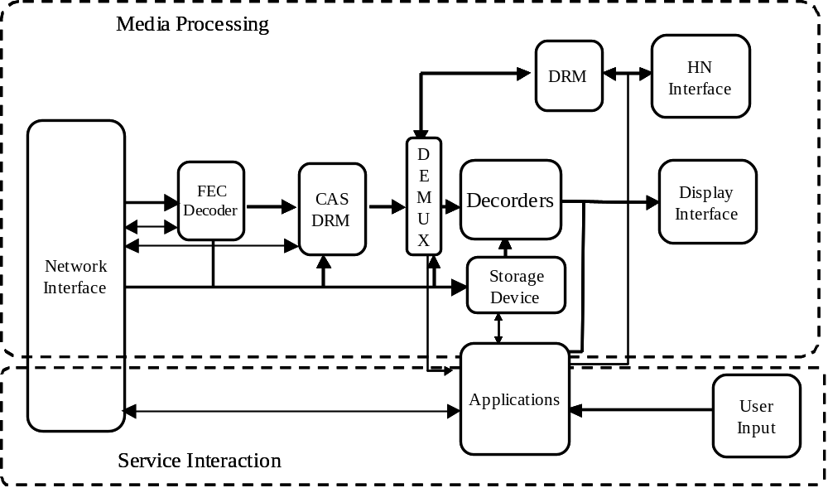
[[Editor’s note: This diagram will be brought into alignment with the determination of WG1]]
Figure 7-1: Functional Architecture Block diagram of IPTV Terminal Device

[[Editor’s Note: The term “Applications” should be modified]]
Note: “Applications” include user interfaces such as EPG, browsers to access to the IPTV services, etc…
Note: “Network Interface” is used for the interconnection with outside Network (NW) such as NGN.
Note: “DEMUX” can include multiplexing functionality.
Note: “Display interface” may not be necessary in the IPTV Terminal Device if it is integrated with a display device.
The brief explanations of each components presented in Figure 7-1 are described below.
Network Interface:
The Network Interface functional entity includes the following functions:
- Send and Receive signals.
- Processing of Layer 2 functions.
- Processing of IP Packets.
- Processing of TCP/UDP Packets.
- Handling of the control flows
- Network Attachment Function
[[Editor: Refer to result of WG4 for detailed description of Network Attachment Function]]
CAS/DRM:
The CAS/DRM functional entity includes the following functions:
1) Handling of authentication mechanisms (CAS) including key exchange and processing.
- Processing of DRM entitlement issues.
3) Descrambling of input stream.
DEMUX:
The DEMUX functional entity is responsible for the following functions:
1) De-multiplexing of video, audio, and data streams.
2) May include Re-multiplexing functionality.
Decoders:
The Decoder functional entity is responsible for:
1) Decoding the compressed video and audio streams.
2) Decoding textual data, i.e. closed caption.
Display Interface:
- The Display Interface functional entity is responsible for the interface which is described in Section 7.4.3.
- If the IPTV Terminal Device includes display functionality, the interface for an external display device is optional.
DRM (HN):
- The DRM (HN) functional entity is responsible for transferring applicable DRM rights/privileges throughout the Home Network.
- DRM (HN) is optional.
HN Interface:
- The HN Interface entity is responsible for the functionality described in Section 7.4.4.
- The HN Interface is optional.
Storage Device:
- The Storage Device is responsible for the storage of content. [[Editor’s Note: Further Contributions are needed]]
- The Storage Device is optional.
Applications:
- Applications include the mechanic (SW or HW) components enabling functional and observable behavior.
[[Editor’s Note: What are “mechanic components”????]]
User Input:
- The User Input, as a functional entity is responsible for interaction between user and the appropriate Application.
Contributor’s note: Sub-clauses 7.1.2 to 7.1.5 are descriptions of functions related to the functional entities which appear to have been defined above. However, unless the diagram in Figure 7-1 is clearly defined the followings have no meaning and should be removed.

7.1.2 Management functions
Management functions consist of Applications, CAS/DRM and DRM (HN).
Management functions are responsible for basic management of the IPTV terminal, including but not limited to Applications, CAS/DRM, DRM (HN), system management, power management and event management.

7.1.3 Protocol functions
Protocol functions consist of Network Interface, DEMUX, a part of Applications and HN Interface.
Protocol functions are responsible for network communication and support most of the network protocols that IPTV services need, including but not limited to authentication protocols, streaming protocols, communication protocols and management protocols.

7.1.4 Application functions
Application functions consist of Applications, Storage Device (if exists), a part of CAS/DRM and a part of DRM.
Application functions are responsible for elements supporting services, including but not limited to DRM applications, plug-in applications, browser applications, media player applications and graphical user interface (GUI) applications.

7.1.5 Service functions
Service functions consist of Decoders and Applications.
Service functions are directly responsible for IPTV Services.

7.2 Software architecture

7.2.1 IPTV terminal software architecture
[[Editor’s Note: Contributions requested to provide brief overview of each section 7.2.2-7.2.6]]
[[Editor’s Note: WG6 should be consulted]]
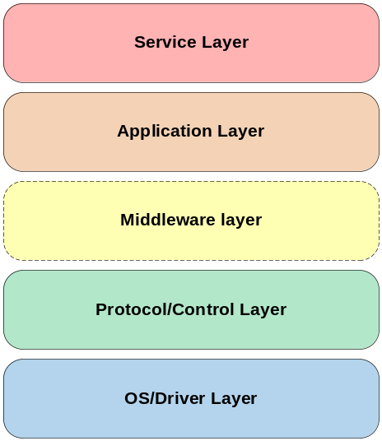
Figure 7-2 Software Architecture Layered Relationship

7.2.2 OS/Driver layer

7.2.3 Protocol/Control layer

7.2.4 Middleware layer (API, optional)

7.2.5 Application layer

7.2.6 Service layer

7.3 Hardware architecture
TBD

7.4 Interfaces between IPTV terminal device and other media
Figure 7-3 identifies possible interfaces between the IPTV terminal device and other media. These interfaces, physical or logical, may not all be present simultaneously and their existence depends on the configuration and the use of IPTV terminal device. Following sub-clauses provide descriptions of these interfaces.
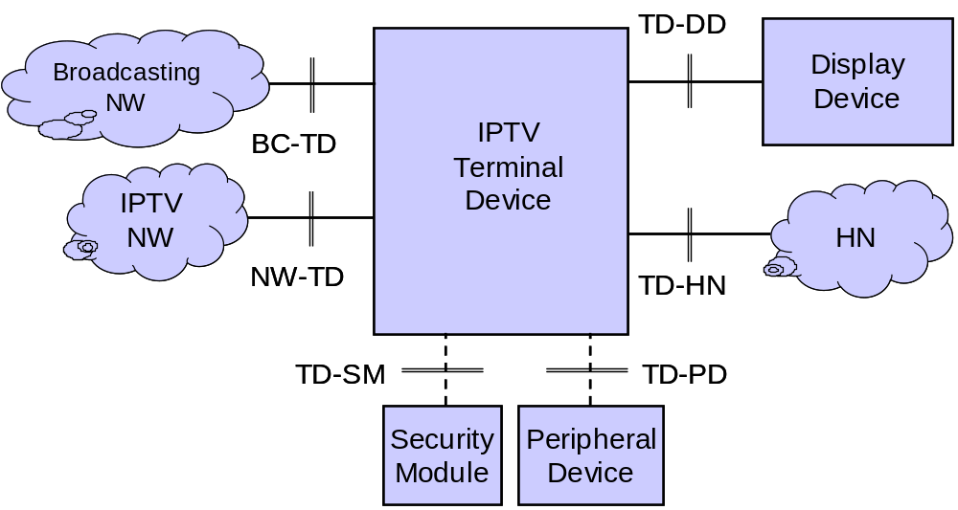

Figure 7-3: Interfaces between IPTV Terminal Device and other media
[[Editor’s Note: IPTV NW in above figure is a temporary definition and may be modified following the discussion of WG1]]

TD-HN | An interface that outputs audio and video signal to the home network. TD-HN is used for the connection between IPTV Terminal Device and other in-home device such as video recorder and is not used for the connection with IPTV network. (Note2)  TD-HN is an optional interface.
TD-SM | An interface between IPTV Terminal Device and removable security functions such as IC card.
[[Editor’s Note: Shouldn’t we provide definitions for each of the interfaces here…contributions requested]]
Note2: Relationship between TD-HN and NW-TD requires further study. There is a technical possibility to use a single Ethernet interface for the connection with both IPTV NW and HN

7.4.1 BC-TD interface
This interface is between non-IPTV broadcasting network such as satellite, terrestrial and cable network and the IPTV Terminal Device. This interface facilitates transfer of content and related information by way of e.g. radio signals.

NW-TD interface
This interface is between an IPTV Terminal Device and IPTV network. The interface facilitates content and metadata transfer by multicast or unicast operation. If home network is the only network then the interface is between two IPTV terminal devices
An IPTV Terminal Device shall be capable of at least supporting one of the following:
    - 10/100BASE-TX (as defined in [xxx])
    - 1000BASE-T (as defined in [xxx])
    - IEEE 802.16x (WiMAX, WiBro, x: a and e) (as defined in [xxx])
    - IEEE802.11x (x: a, b, g and n) (as defined in [xxx])

7.4.3 TD-DD interface
This interface is between display device and IPTV terminal device and facilitates transfer of audio and video signals from IPTV terminal device (when the terminal device has no display functionality) to the Display Device. It can be between audio visual (AV) devices such as an external storage devices and the IPTV terminal device.
An IPTV Terminal Device shall be capable of at least supporting one of the following:
    - support of analogue video signal output interface;
    - D connector as per [IEC 62360] or a combination of three RCA pins
      - For 1080p/1080i/720p/480p/480i component output
    - RCA pins as per [xxx]
      - For NTSC/PAL/SECAM composite output (as defined in [ITU-R BT.1700])
    - S or S2 Connector as per [xxx]
      - For NTSC/PAL/SECAM Y/C output (as defined in [xxx])

    - support of digital video signal output interface:
      - DVI (Digital Video Interface) as per [xxx]
      - HDMI (High-Definition Multimedia Interface) as per [xxx]
Contributor’s note: It is not clear what two following bullets are asking for
[[Editor’s Note: Clarify these two bullet points]]
  - TD-DD shall be equipped with an appropriate copy guard management system.

7.4.4 TD-HN interface
Refer to section 6.1 of the Home Network Document.
The followings are the specification for TD-HN.
  - An IPTV Terminal Device should be equipped with one of the interfaces listed below for TD-HN.
    - Non-IP interface
    - IP interface
  - If a non-IP interface is used for TD-HN, the IPTV Terminal Device should be equipped with at least one of the interfaces listed below:
    - IEEE 1394 [IEEE 1394]
    - USB
    - PLC
[[Editor’s note: More contributions on this issue are expected.]]
[[Editor’s note: Protocols for non-IP interface is for further study.]]
  - If an IP interface is used for TD-HN, the IPTV Terminal Device should be equipped with at least one of the interfaces listed below:
    - 100BASE-TX
    - 1000BASE-T
    - IEEE802.11a/b/g/n

7.4.5 TD-SM
Contributor’s note: In the above table this interface is described as: “An interface between IPTV Terminal Device and removable security functions such as IC card”. Question being asked is: has the security function been implemented in a card? If so where this card is being inserted? After these questions are satisfactorily answered then attempt should be made to describe the interface.
The followings are the specification for TD-SM.
  - An IPTV Terminal Device should be equipped with one interface for TD-SM.
  - The interface for TD-SM should be a smart card interface defined in ISO 7816-1 [ISO7816-1], ISO 7816-2 [ISO7816-2] and ISO 7816-3 [ISO7816-3].
  - The IPTV smart card should follow a common uniform format similar to SIM.
  - The IPTV smart card should have the ability to support prepay and postpay mode by enough information.
  - The IPTV smart card should support ITU-T Recommendation E.118, ITU-T Recommendation E.164, and ITU-T Recommendation T.50, according to charging and numbering needs.
[[Editor: Check for more smart card ETSI specifications…contributions requested]]
[[Editor: WG3 review and feedback requested]]

7.4.6 TD-PD
This interface is between a peripheral device and the IPTV terminal device. It allows transfer of information such as Bluetooth protocol or those dealing with infrared to facilitate communication between the IPTV terminal device and, for example, a Bluetooth universal serial bus (USB) adaptor or mobile phone headset.

7.5 User Interface
A User interface is a combination of software and hardware components through which a user can interact with a system [ITU-T Recommendation F.902]. It can manifest itself in such forms as:
- A remote control (e.g. for TV)
- A keyboard

7.6 Consideration for accessibility of IPTV Terminal Device
To facilitate the concerns of people with needs outside the majority population, the following requirements should be implemented.
- The ability to transmit the captions through an external interface on the terminal.
- The ability to select and receive two (related) video sources. (E.g. one with sign language translation.)
- The methods for activating and deactivating captioning, extra video source and extra audio source should be easy to use and should not incur an excessive delay.
- Result of the use of the controls should be available in the form of voice output.
- Any on Screen Display facilities for control of the terminal and the programs should be easy to read and not difficult to understand.
- Any On Screen Display facilities should also be available via external interfaces and also be able to control the capability to transmit captions and information provided by On Screen Display facilities to conform to the assigned content protection.
- The ITU-T accessibility checklist should be applied to the work on IPTV.
[[Editor’s Note: Contribution is expected]]

7.7 Protocols
Contributor’s note: Protocols are used at the interfaces between two entities (logical or physical). In clause 3 of the working document, IPTV terminal device is not defined to be a unique entity and can be in different forms such as a TV set, a set-top box and etc. So, each one of the following protocols should be clearly stated for which type of IPTV terminal device is applicable to.
IPTV Terminal Device shall support a set of protocol for IPv4.
IPTV Terminal Device may support a set of protocol for IPv6.
The possible protocols for the IPv4 capable IPTV Terminal Device are listed below.
- User Datagram Protocol (UDP) [RFC768].
- Internet Protocol [RFC791].
- Internet Control Message Protocol (ICMP) [RFC792].
- Transmission Control Protocol (TCP) [RFC793].
- Domain names - concepts and facilities (DNS) [RFC1034].
- Domain names - implementation and specification (DNS) [RFC1035].
- TCP Extensions for High Performance [RFC1323].
- TCP Selective Acknowledgement Options [RFC2018].
- Simple Network Time Protocol (SNTP) Version 4 for IPv4, IPv6 and OSI [RFC2030].
- Dynamic Host Configuration Protocol (DHCPv4) [RFC2131].
- Internet Group Management Protocol, Version 2 [RFC2236].
- The TLS Protocol Version 1.0 (SSL/TLS) [RFC2246].
- RTP Payload Format for MPEG1/MPEG2 Video [RFC2250].
- Real Time Streaming Protocol (RTSP) [RFC2326].
- Hypertext Transfer Protocol -- HTTP/1.1 [RFC2616].
- HTTP Authentication: Basic and Digest Access Authentication [RFC2617].
- IANA Considerations for IPv4 Internet Group Management Protocol (IGMP) [RFC3228].
- RTP: A Transport protocol for Real-Time Applications [RFC3550].
The possible protocols for the IPv6 capable IPTV Terminal Device are listed below.
- User Datagram Protocol (UDP) [RFC768].
- Transmission Control Protocol (TCP) [RFC793].
- Domain names - concepts and facilities (DNS) [RFC1034].
- Domain names - implementation and specification (DNS) [RFC1035].
- TCP Extensions for High Performance [RFC1323].
- TCP Selective Acknowledgement Options [RFC2018].
- Simple Network Time Protocol (SNTP) Version 4 for IPv4, IPv6 and OSI [RFC2030].
- The TLS Protocol Version 1.0 (SSL/TLS) [RFC2246].
- RTP Payload Format for MPEG1/MPEG2 Video [RFC2250].
- Real Time Streaming Protocol (RTSP) [RFC2326].
- IP Version 6 Addressing Architecture [RFC2373].
- Internet Protocol, Version 6 (IPv6) Specification [RFC2460].
- Neighbor Discovery for IP Version 6 (IPv6) [RFC2461].
- IPv6 Stateless Address Autoconfiguration [RFC2462].
- Internet Control Message Protocol (ICMPv6) for the Internet Protocol Version 6 (IPv6) Specification [RFC2463].
- Hypertext Transfer Protocol -- HTTP/1.1 [RFC2616].
- HTTP Authentication: Basic and Digest Access Authentication [RFC2617].
- Dynamic Host Configuration Protocol for IPv6 (DHCPv6) [RFC3315].
- Internet Protocol Version 6 (IPv6) Addressing Architecture [RFC3513].
- RTP: A Transport protocol for Real-Time Applications [RFC3550].
- DNS Extensions to Support IP Version 6 [RFC3596].
- IPv6 Prefix Options for Dynamic Host Configuration Protocol (DHCP) version 6 [RFC3633].
- DNS Configuration options for Dynamic Host Configuration Protocol for IPv6 (DHCPv6) [RFC3646].
- Stateless Dynamic Host Configuration Protocol (DHCP) Service for IPv6 [RFC3736].
- Multicast Listener Discovery Version 2 (MLDv2) for IPv6 [RFC3810].
[[Editor’s Note: Usage of these protocols will be defined…contributions requested]]

7.8 Codec

7.8.1 Video/Audio format supported by IPTV Terminal Device
An IPTV Terminal Device should support the existing video formats that are already in use in video industries, including broadcasting industries. The following video formats, which have been used in broadcasting industries, are recommended as appropriate video formats. This is by no means an exhaustive list of possible video formats.
- 1920x1080 [ITU-R BT.709]
- 1280x720p [ITU-R BT.1543] (Note 1)
- 720x483 [ITU-R BT.601]
- 720x576 [ITU-R BT.1358]
[[Editor’s Note: Whether 1920x1080 and 1280x720 are optional or mandatory is TBD]]
Colorimetry of video signals shall be in compliance with [ITU-R BT.1361] in all video formats.
Note 1: Under a certain condition, translating high resolution video such as 1920x1080 to lower resolution format such as 720x483 may be restricted or prohibited.

[[Editor’s Note: Audio format is for further study]]
At least one of the following audio formats should be supported by the IPTV Terminal Device:
- 5.1 channel audio
- 2 channel audio

[[Editor’s Note: Video format for mobile device is for further study.]]

7.8.2 Video/Audio decoders supported by IPTV Terminal Device
The IPTV terminal is required to handle at least one of the following digital transport streams in accordance with the associated requirements:
- H.264 AVC/ MPEG4 part 10
- MPEG2 [ISO/IEC 13818-2]
Editor’s Note: Decoder supported by IPTV Terminal Device may be modified according to the result of WG6.
At least one of the following audio codec is required to be supported by IPTV Terminal Device.
- AC3 [Digital Audio Compression (AC-3) ATSC A/52MPEG-2 AAC [ISO/IEC13818-7]
- MPEG-4 AAC [ISO/IEC14496-3]
- MPEG-2 Audio BC [ISO/IEC 13818-3]
- MP3 file
[[Editor’s Note: The above audio codec may become mandatory or optional according to future discussion. Contributions are expected]]

7.9 Terminal management
SNMPv2/v3 [xx] and DSL-F TR069 may be used for IPTV Terminal Device management.
[[Editor’s Note: Management by the user is for further study]]

7.10 Security
Editor’s Note: The following issues should be considered in the discussion of the security mechanism for IPTV Terminal Device.
  - The IPTV Terminal Device may have a renewable security system to perform the functions of Conditional Access, including decryption, authorization, authentication, entitlement, and key generation.
  - The IPTV Terminal Device shall include copy protection and redistribution control.
  - The IPTV Terminal Device should implement a secure software download mechanism from the network.
  - The IPTV Terminal Device should secure the communication channel used to support billing.
  - The IPTV Terminal Device should support content protection mechanisms currently in use in the broadcasting industry, such as ITU-R Report BT.2070.

7.11 Privacy
[[Editor: Contributions to clarify privacy protection issues should be addressed…possibly refer to ITU-R BT.2052]]
An IPTV Terminal Device can be a major source of private information in an interactive broadcast systems. Following information are examples of items that should be kept in a secure device and/or storage, or created by a processor as a result of user interaction:
– Viewing history
– Return/interaction channel usage
– History of interactive operation
– Personal profiles and preferences
– ID number.
In some interactive broadcast systems, the ID number is used for the purpose of content copy control even in free-to-air services. [ITU-R BT.2052]

7.12 Quality Monitoring.
The following methods can be used, if video quality monitoring is required.
      - no reference methods
      - reduced reference methods
      - quality monitoring using transmission errors [ITU-T J.242]
[[WG2 Review the following:]]

As an optional functionality, the IPTV terminal may have quality monitoring capability. IPTV services are different from traditional TV services such as satellite TV or cable TV. If satellite or cable TVs are properly installed, video quality will be consistently good. This is not true for IPTV. If demands exceed the bandwidth or there are transmission errors, video quality will deteriorate. For this reason, quality monitoring is more important in IPTV, particularly for some applications such as PPV or VOD.
For video quality monitoring in IPTV applications, there are three possibilities: reduced-reference (RR) models, no-reference (NR) models and the quality monitoring method using transmission errors [ITU-T J.242].

7.12.1 No-reference methods [J.mm-noref]
In the no-reference method (Figure 7-4), perceptual video quality evaluation is made based solely on the processed video sequence (PVS) without using the source video sequence (SRC). Although the performance of no-reference methods is inferior to that of full-reference and reduced-reference methods, it is expected that upcoming bit-stream NR methods will provide improved performance [J.bitvqm].

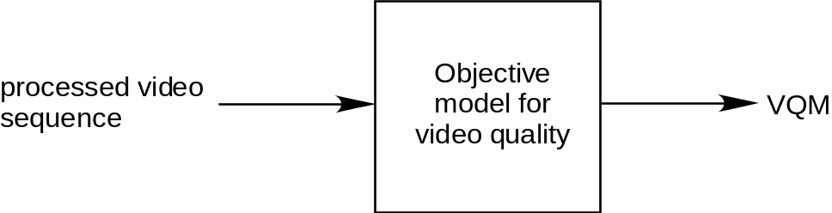
7-4: A no-reference model

7.12.2 Reduced-reference methods [J.mm-redref]

In the reduced-reference method, features are extracted from the source video sequence and the processed video sequence (Figure 7-5). From these features, perceptual objective measurements of video quality are computed. If a reduced-reference method is used at the terminal, the head-end needs to transmit feature data for video quality measurement in addition to video data (Figure 7-6). It is desirable that the feature data should be available at the terminal in a timely manner. It is preferred that the feature data is sent with a time advance and the terminal stores the feature data in a local storage. Thus, the terminal should have adequate computing power and storage. It is also expected that upcoming bit-stream RR methods will provide improved performance [J.bitvqm].

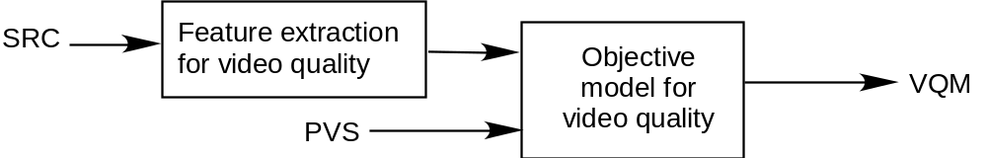
Figure 7-5: A reduced-reference model (SRC: source video sequence, PVS: processed video sequence)

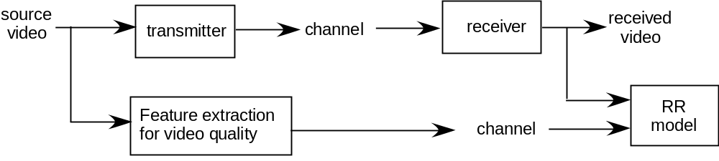
Figure 7-6: A block diagram of video quality monitoring using an RR model

7.12.3 Quality monitoring using transmission error information at the head-end [ITU-T J.242]

In digital communications, transmission errors include packet loss and packet delay and their effects can be exactly identified when video data is transmitted using packets. Furthermore, if there is no transmission error, the video quality at the receiver will be identical to the video quality of the video sent by the transmitter. Therefore, if the receiver sends transmission error information which includes information on packet loss and delay in packetized video transmission, the head-end (service provider) can exactly reconstruct the received video seen at the receiver (Figure 7-7). Finally, the head-end may use a FR or RR method to evaluate the video quality of the received video seen at the receiver. Table 7-1 describes messages for sending transmission error information to the service provider.

Table 7-2 shows an example of error message format capable to send information on transmission errors. Thus, the terminal (e.g., set top box, or mobile terminals) is designed to send transmission error information (e.g., Table 7-2), quality monitoring can be efficiently done at the head-end using the transmission error information.

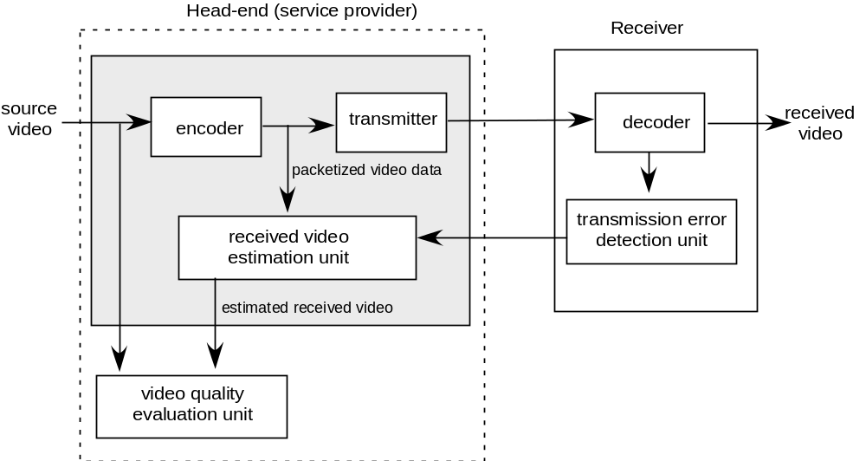
Figure 7-7: A method for a head-end to monitor video quality at the terminal using transmission error information
Table 7-1: Message description

Type of transmission errors | Message descriptions
Information on the terminal | A model identification message
Source Identifier | A source identification message
Information on a lost packet | A lost packet index
Information on lost packets | A starting packet index and an ending packet index of the lost packets
Information on a delayed frame | A delayed frame index and the amount of delayed time
Information on a skipped frame | A skipped frame index
Information on skipped frames | A starting frame index and an ending frame index of the skipped frames

Table 7-2: Error Message Formats [ITU-T J.242]

Type of transmission errors | Transmission error messages in hexadecimal | Descriptions
Information on a lost packet  (5 bytes) | 6C XX XX XX XX | ‘l’ + packet index in long integer
Information on lost packets  (9 bytes) | 4C XX XX XX XX XX XX XX XX | ‘L’ + starting packet index in long integer + ending packet index in long integer
Information of a delayed frame  (7 bytes) | 64 XX XX XX XX XX XX | ‘d’ + frame index in long integer + delay time in short integer
Information on a skipped frame  (5 bytes) | 73 XX XX XX XX | ‘s’ + frame index in long integer
Information of skipped frames  (9 bytes) | 53 XX XX XX XX XX XX XX XX | ‘S’ + starting frame index in long integer + ending frame index in long integer
Information of the receiver  (32 bytes) | 6D + 31-byte string | ‘m’+31 byte string
Source Identifier  (5 bytes) | 69 XX XX XX XX | ‘i’ + 4 bytes (32 bits)

______________

