Plenipotentiary Conference (PP-14)
Busan, 20 October – 7 November 2014
PLENARY MEETING | Document 35-E
 | 11 March 2014
 | Original: English
Note by the Secretary-General
CANDIDACY FOR THE POST OF MEMBER OF
THE RADIO REGULATIONS BOARD
Further to the information published in Document 3, I have pleasure in transmitting to the Conference, in annex, the candidacy of:
Dr Yasuhiko ITO (Japan)
for the post of member of the Radio Regulations Board.

Dr Hamadoun I. TOURÉ
Secretary-General

Annex: 1

ANNEX 1
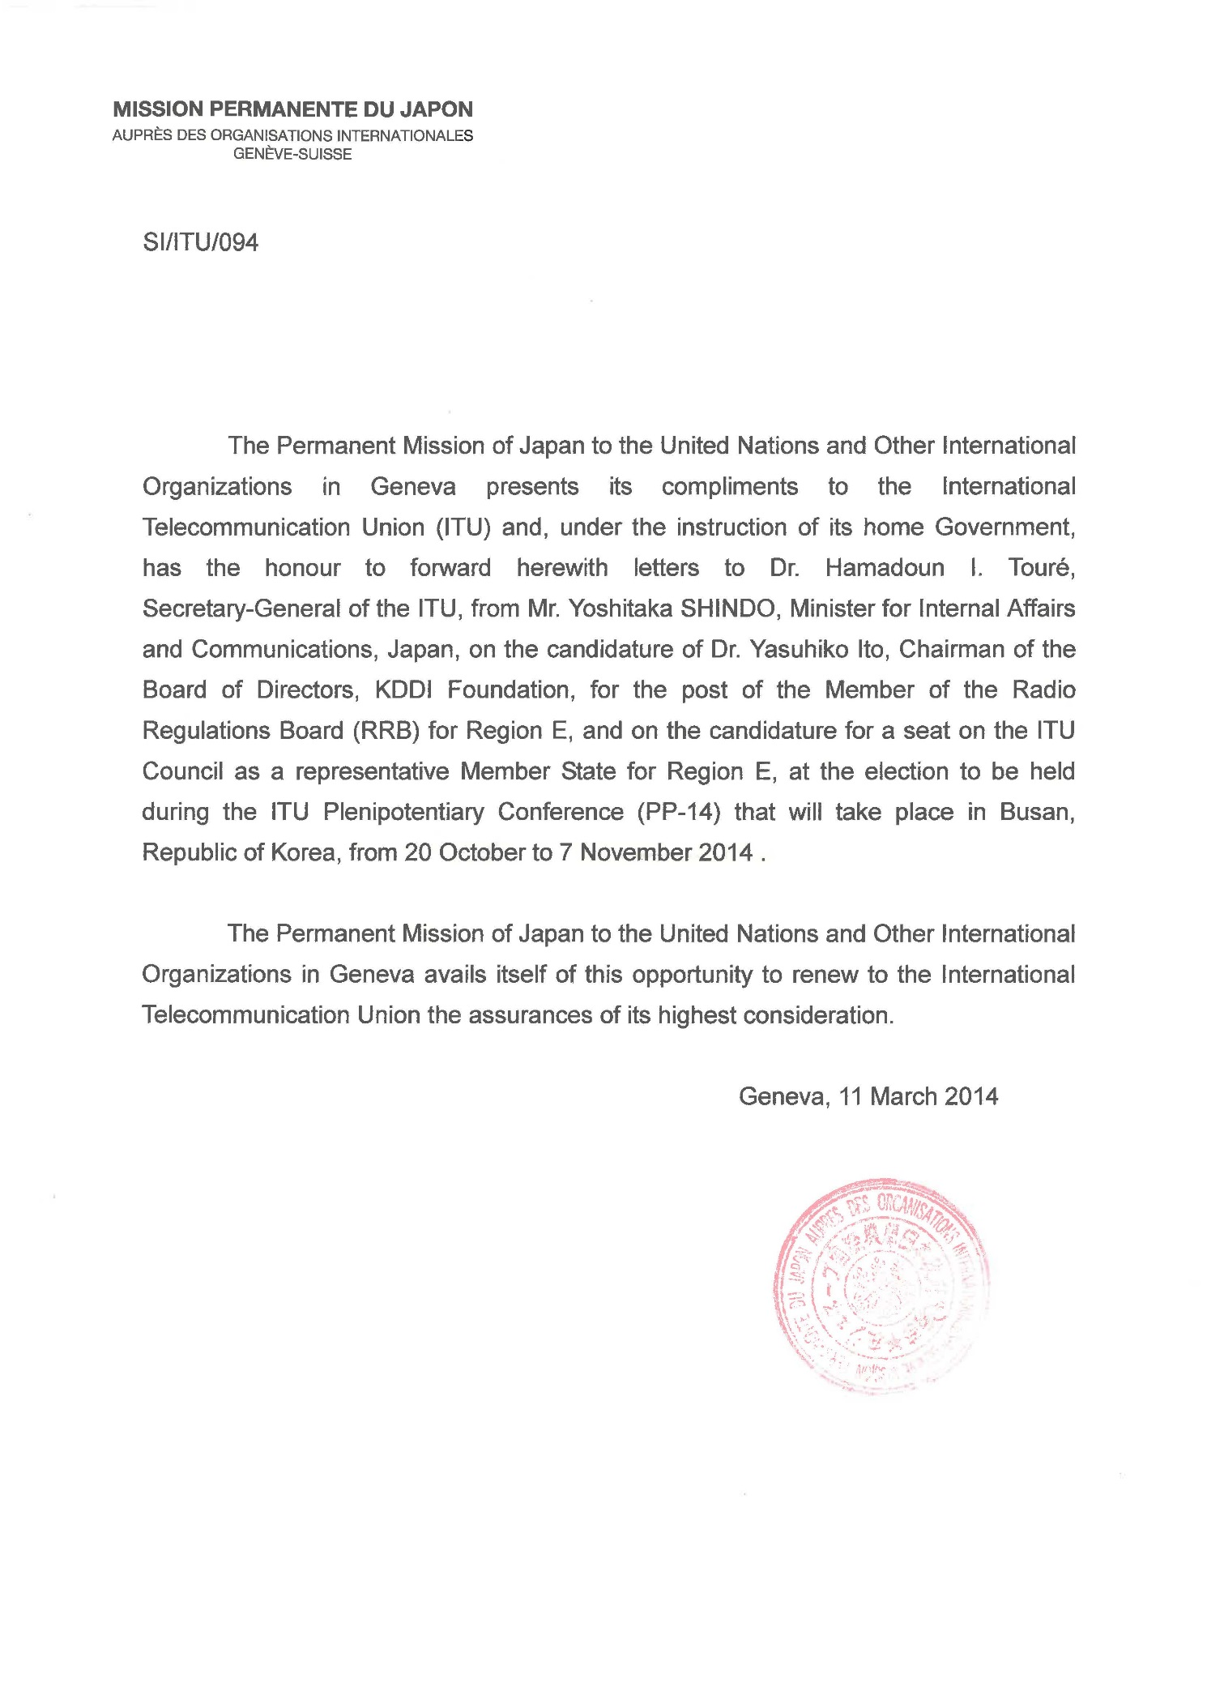
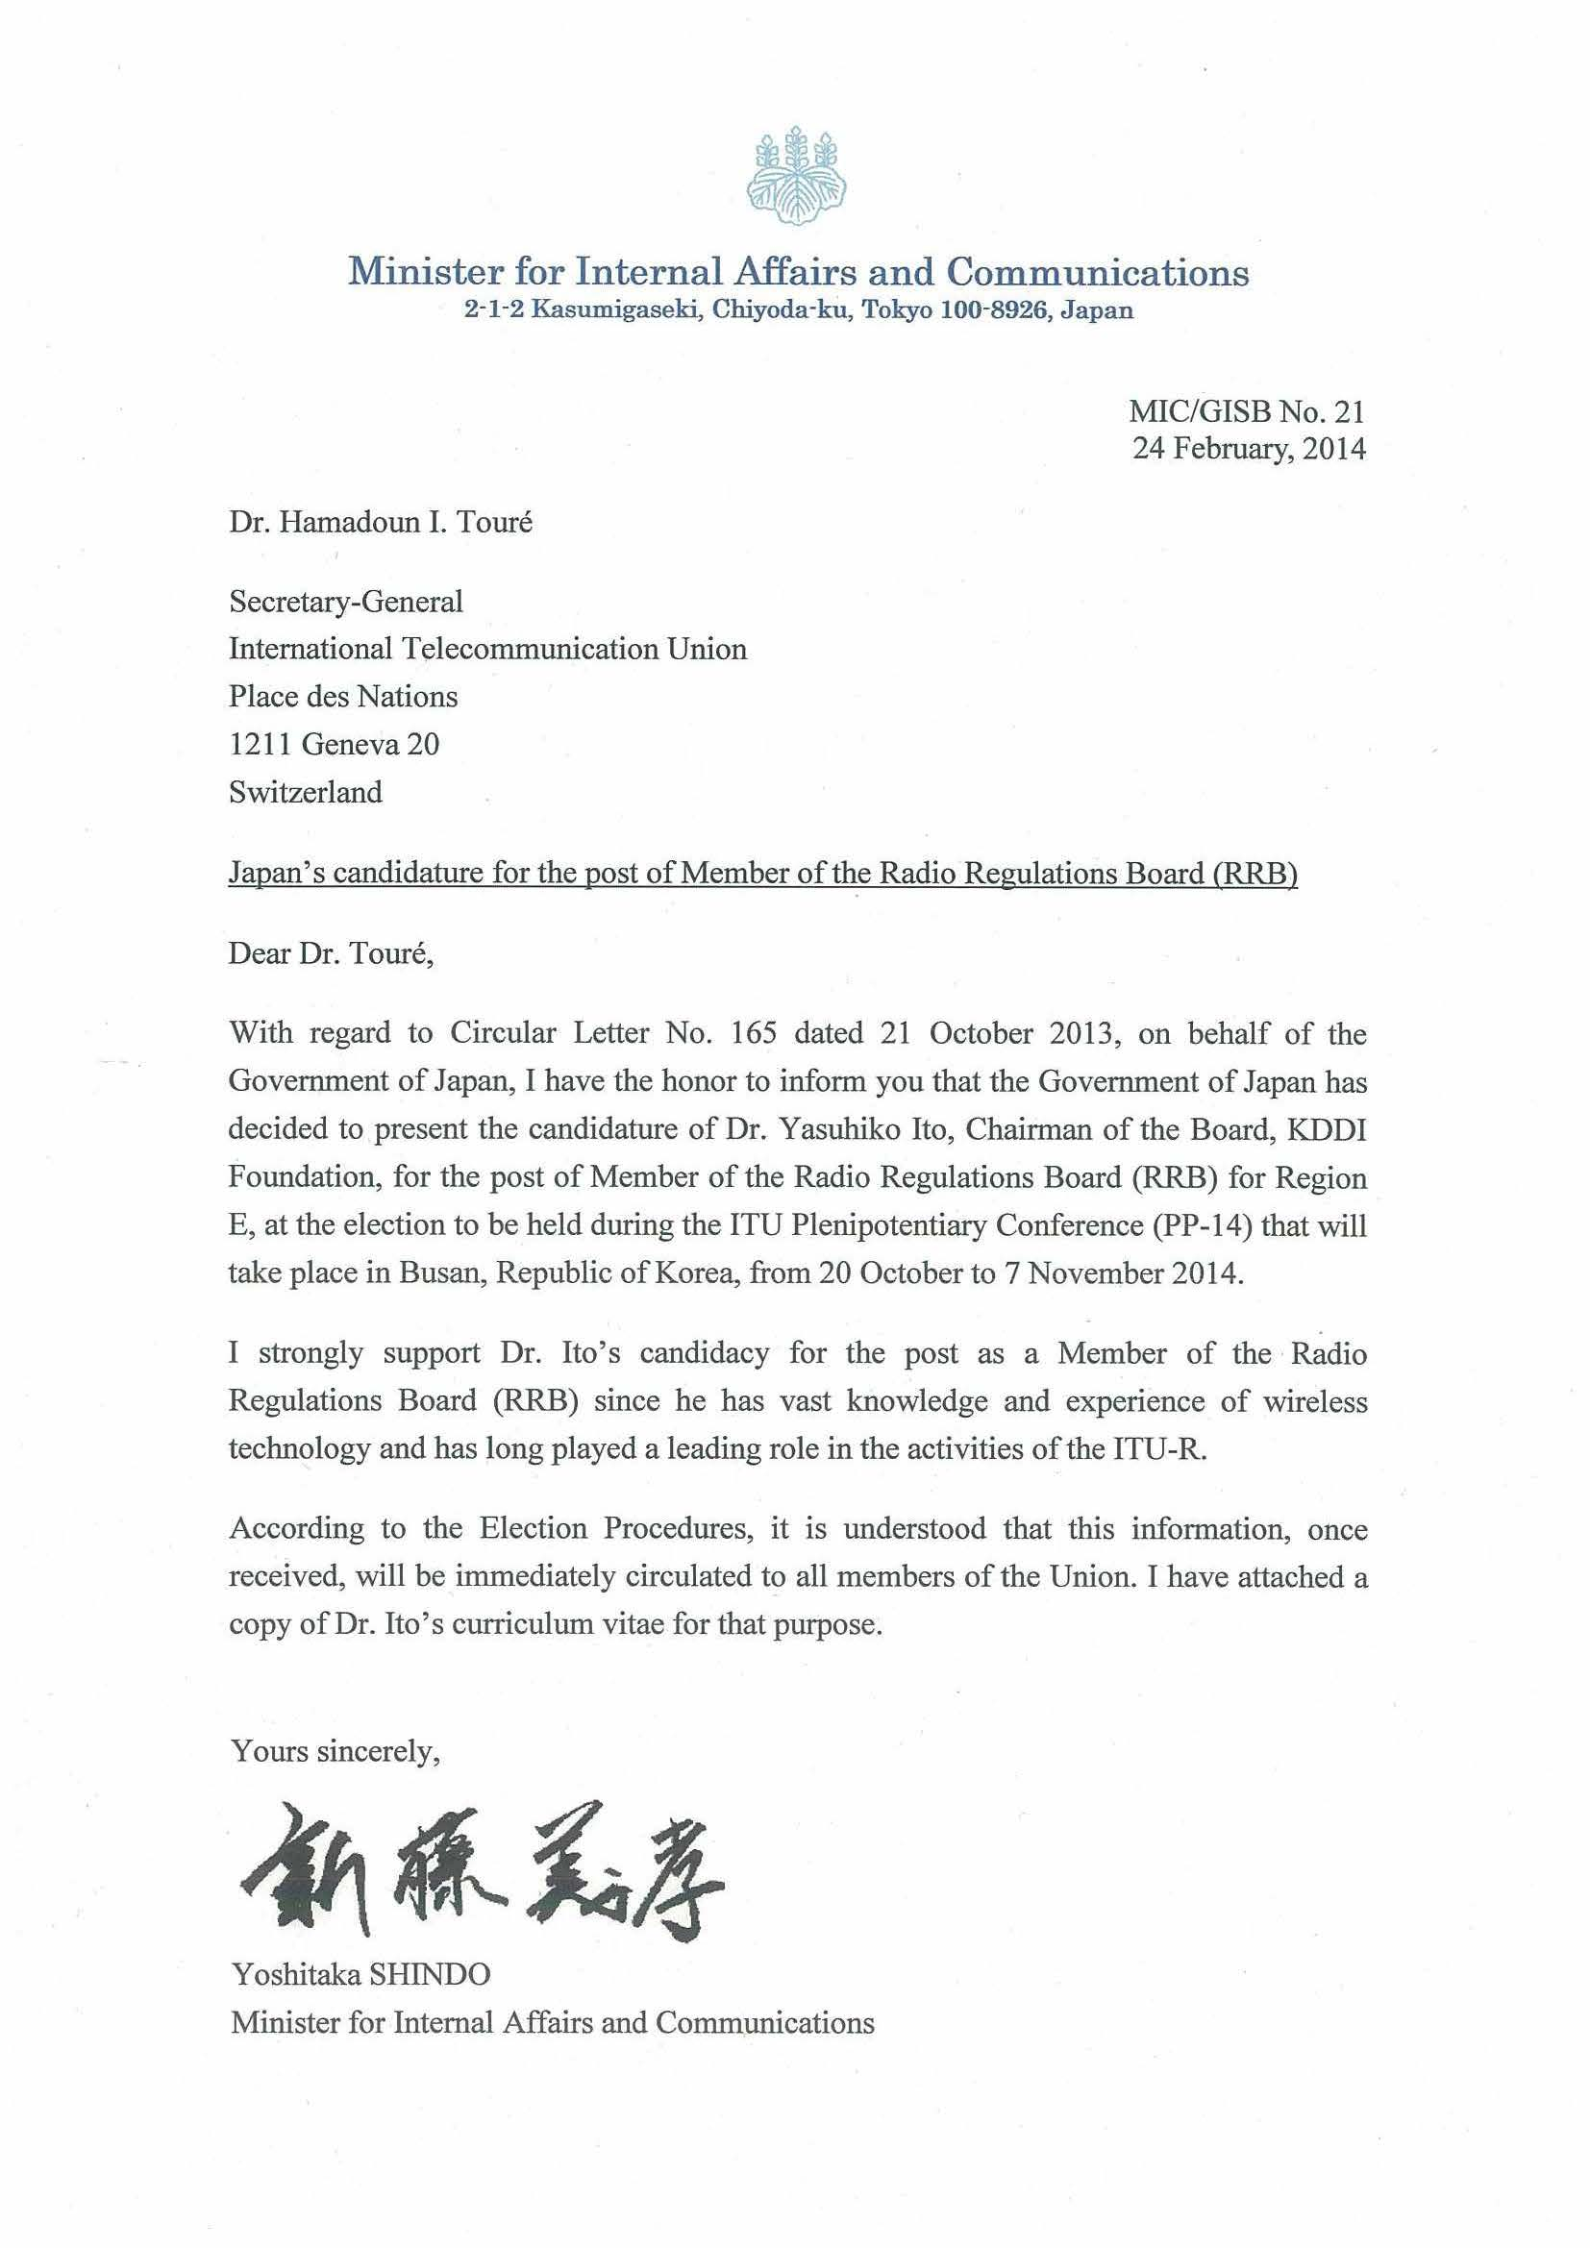

Curriculum Vitae
Name: Yasuhiko Ito
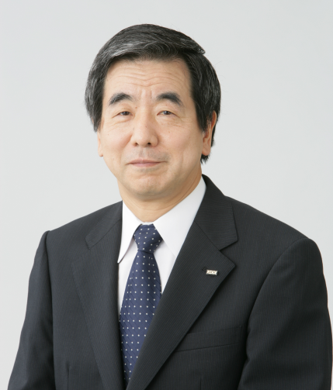
Present Title: Chairman of the Board of Directors,
KDDI Foundation
Birth: 21 December 1945 in Tokyo, Japan
Nationality: Japanese
Marital Status: Married, one son and one daughter
Education and Academic Achievements:
1969 | Bachelor of Engineering, Waseda University, Japan
1971 | Master of Engineering, Waseda University, Japan
1976 | Master of Electric Engineering, Princeton University, U.S.A.
1981 | Ph. D. from Waseda University, Japan
Professional Experience:
1998 | General Manager, Wireless Business, KDD
2000 | Managing Director, Mobile Business Sector, KDDI Corporation
2002 | Chief Operating Officer, Solution Business Sector, KDDI
2005 | Executive Vice President and CTO, KDDI
2009 | Chairman of the Board of Directors, KDDI R&D Laboratories, Inc.
2010 | Chairman of the Board of Directors, KDDI Foundation
ITU Experience:
1988 | Chairman, WG 4A WARC-ORB88
1993 | Vice-Chair, SG4, ITU-R (through 1997)
1995 | Chairman, WG 5C, WRC-95
1997 | Chairman, WG 5B, WRC-97
1997 | Chairman, SG4, ITU-R (through 2003)
2003 | Chairman, Radiocommunication Assembly, ITU-R
2011- | Radio Regulation Board
Books and Awards:
International Telecommunication Networks, The Institute of Electronics, Information and Communication Engineers (IEICE), Japan, 1994;
Basics and Applications in Satellite Telecommunications, Baifukan, Japan, 1996;
Low Earth Orbit Satellite Telecommunication Systems, IEICE, Japan, 1999;

Awarded Medal of Honour with Purple Ribbon in 2004 for his achievements and contributions.

Background to Dr Yasuhiko Ito’s candidacy to become member of RRB
Dr Yasuhiko Ito has 30 years of experience in R&D laboratories and in real business, and has a vast knowledge of wireless technologies including satellite, fixed and mobile technologies. He served as Executive Vice President & CTO of KDDI from 2005 to 2009 and steered the company’s entire engineering operations. In addition to managing these engineering groups with KDDI, Dr Ito has also been very active internationally and has played a leading role in the activities of the ITU-R.
Probably best known for his long tenure as Chairman of ITU-R Study Group 4 from 1997 to 2003. He earned wide respect for being one of the most impartial chairpersons, Dr Ito has also played a leading role in many important ITU conferences such as World Radiocommunication Conference (WRC), Radiocommunication Assemblies (RA) and Study Group (SG) meetings. Especially, he chaired the RA in 2003. In every case he was always positive and influential, offering very constructive ideas.
Dr Ito is a strong proponent of technology and yet he is also fascinated by the potential and power of the human spirit. His favourite quotation is one by Charles Darwin: “It is not the strongest of the species that survives, nor the most intelligent that survives. It is the one that is the most adaptable to change.” Currently he is a Chairman of KDDI Foundation where he is helping developing countries to build their telecommunication infrastructure. He is also helping education of children in these countries.
Japan believes Dr Ito’s exceptional and significant accomplishments in the ITU-R make him an ideal candidate to become an RRB member.
SUMMARY OF DR YASUHIKO ITO’S CAREER
1. ITU-R ACTIVITIES AND CONTRIBUTIONS
- Dr Ito has made significant contributions to the incorporation of new concepts in the essential provisions of the Radio Regulations through his chairmanships of World Radio Conferences. In addition, in his capacity as Study Group 4 Chairman, Dr Ito succeeded in establishing the technical background in a number of newly approved Recommendations supporting the provisions developed under his strong leadership.
Chairman of Working Group 4A, WARC-ORB88
- During WARC-ORB88 (World Administrative Radio Conference on the Use of the Geostationary-Satellite Orbit and Planning of Space Service Utilizing It), Dr Ito was nominated as Chairman of Working Group 4A the mandate of which was to prepare basic satellite parameters to be used in planning the allotment of satellite positions in geostationary orbit. Dr Ito played a key role in establishing the consensus for finalizing those basic satellite parameters. He also proposed the concept of the service arc indicating a possible range of satellite positions to increase the flexibility in planning. WARC-ORB88 decided to use the ORBIT computer program that Dr Ito originally developed as an official tool to analyze mutual interference and develop orbital plans which can assign appropriate satellite positions to all of the world’s countries. As the result of these efforts, plans were successfully developed to guarantee the positions of satellites for 154 countries.
Chairman and Vice Chairman of Study Group 4, ITU-R
- Dr Ito served as Vice Chairman of Study Group 4 for fixed satellite service (FSS) in ITU-R from 1993 to 1997. During this period, he chaired Task Group 4/5 to develop a list of candidate frequency bands for feeder links of non-geostationary orbit mobile satellite service (NGSO/MSS) in preparation for WRC-95. He then served as Chairman of Study Group 4 from 1997 to 2003
Chairman of Working Group 5C, WRC-95
- At WRC-95, Dr Ito was nominated as Chairman of Working Group 5C which was responsible for agenda items on feeder-links of NGSO/MSS. Frequency bands were successfully allocated for feeder-links of NGSO/MSS in 5/7GHz bands and 19/29GHz bands, and associated provisions were also developed with regard to frequency coordination and power flux density (PFD) limits.
Chairman of Working Group 5B, WRC-97
- Dr Ito served again as Chairman of Working Group 5B at WRC-97. Under agenda item 1.9.1, important decisions were made for the frequency allocation of MSS and FSS as well as associated provisions. Particularly for NGSO/FSS, new provisions were successfully developed by introducing the concept of equivalent PFD and aggregate PFD.
Chairman of RA2003
- Dr Ito chaired the plenary meeting of Radiocommunication Assembly 2003. ITU-R Resolutions were successfully revised mainly in the area of working methods and study programs. Important recommendations were newly approved not only for relevant subjects for WRC-03 preparations but also regarding the framework of the future development of International Mobile Telecommunication 2000 (IMT-2000). At the closure of RA-03, a silver medal was awarded to Dr Ito for his great contribution to ITU-R by the Secretary General of the ITU.
2. ACTIVITIES IN JAPAN
- Throughout his career, he has gained a broad range of professional experience in both the public and private spheres. Several examples are provided below:
- Dr Ito has performed public responsibilities as an associate member of the Information and Communications Technology sub-Council, Advisory Board to the Minister of Internal Affairs and Communications, since 2001. The majority of Japan’s domestic and international frequency issues on radio matters including the sharing scheme and WRC matters are addressed comprehensively in this sub-Council. He continues to lead the discussion and has resolved many controversial issues such as NGSO systems, Earth Stations on board Vessels (ESV) issues and sharing between mobile and space services.
- He served as Chairman of the FSS Committee under the Information and Communications Technology sub-Council until 2003, exercising leadership to coordinate and to propose many policy drafts to be reviewed at this Committee.
- He was also an Executive Vice President and CTO of KDDI and piloted the company’s entire engineering activities. He led the company to build 3G mobile system and long term evolution (LTE) systems.
________________________

