Plenipotentiary Conference (PP-14)
Busan, 20 October – 7 November 2014
PLENARY MEETING | Document 24-E
 | 13 January 2014
 | Original: English
Note by the Secretary-General
CANDIDACY FOR THE POST OF MEMBER OF
THE RADIO REGULATIONS BOARD
Further to the information published in Document 3, I have pleasure in transmitting to the Conference, in annex, the candidacy of:
Mr Stanley Kaige KIBE (Republic of Kenya)
for the post of member of the Radio Regulations Board.

Dr Hamadoun I. TOURÉ
Secretary-General

Annex: 1

ANNEX
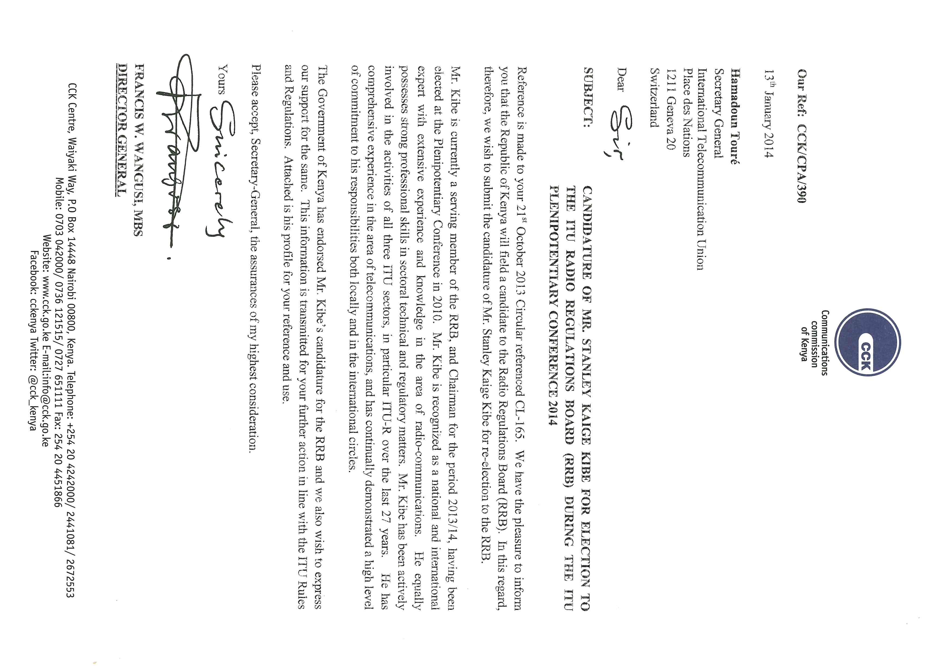

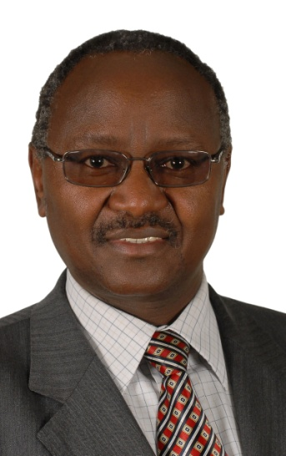
Plenipotentiary Conference of the
International Telecommunications Union

Busan, Korea, 20 Oct – 7 Nov 2014

Candidate of the Republic of Kenya
for re-election to the
ITU Radio Regulations Board

STANLEY KAIGE KIBE
PERSONAL DETAILS
Name: | KIBE, Stanley K.
Contact: | P.O. Box 24443,  Karen 00502,  Nairobi. KENYA  Telephone: Office: +254-20-4242245, 4242445  Cellular: +254-722-510013, +41-79-104 6536  Email: kibe@cck.go.ke
Date of Birth | 17th May 1955.
Nationality: | Kenyan.
Marital status: | Married, three children.
PROFESSIONAL CARRER TRACK
August 2005 to date: |  | Director, Frequency spectrum Management,  Communications Commission of Kenya,
2005 |  | Director, Licensing Compliance and Standards,  Communications Commission of Kenya
1999 – 2005 |  | Assistant Director, Standards, type approval and numbering  Communications Commission of Kenya
1986 – 1999 |  | Senior Executive Engineer, Frequency Spectrum Management  Kenya Posts and Telecommunications Corporation  Communications Commission of Kenya
1984 – 1986 |  | Senior Executive Engineer, Projects Engineering, Transmission and Radio  Kenya Posts and Telecommunications Corporation
1982 – 1984 |  | Executive Engineer, Major Works Construction/Transmission and Radio, Kenya Posts and Telecommunications Corporation
1979 – 1982 |  | Pupil Engineer, Kenya Posts and Telecommunications Corporation
EDUCATION
1976 – 1979: |  | University education. B.Sc. (Hons) (Electrical Engineering, Telecommunications & Microwaves). University of Nairobi.
Other Studies |  | Courses in radio communications, frequency management, telecommunications regulations, leadership, and management.
MAJOR ITU CONFERENCES AND MEETINGS
1986: |  | First Session of the ITU Regional Administrative Radio Conference for the planning of VHF/UHF Television Broadcasting in the African Broadcasting Area and the Neighbouring Countries (AFBC) (Nairobi).
1987: |  | World Administrative Radio Conference for Mobile Services  (WARC- MOB-87) (Geneva).
1988: |  | World Administrative Radio Conference of the Geostationary Satellite Orbit and the planning of the frequency bands utilising it (WARC-ORB-88) (Geneva). Vice-chairman of the Regulatory Committee (Geneva).
1992: |  | World Administrative Radio Conference (WARC-92), (Malaga - Torremolinos, Spain).
1995: |  | Two meetings of the 1995 World Radio Conference (WRC-95) Conference Preparatory Meeting (CPM-95) and the 1995 World Radiocommunication Conference (WRC-95) as a Kenyan delegate, (Geneva)
1996: |  | ITU-R SG1 meeting in Santa Rosa (California, U.S.A.)
1997: |  | ITU-R SG1 (Geneva).
1999: |  | - ITU-R SG1 meeting in Assen, Netherlands.  - Biennial meeting of the Radio Africa Conference (RA-99) (Gaborone, Botswana) and presented a paper on frequency management and utilisation.
2000: |  | ITU Council (Geneva) and the World Telecommunication Standardization Assembly (WTSA-2000) (Montreal, Canada).
2001 – 2004: |  | ITU-T Study Group meetings on IMT-2000 and systems beyond  IMT-2000.
2004: |  | Head of delegation to the ITU World Telecommunication Standardization Assembly (WTSA-04) (Florianopolis, Brazil).
2005: |  | ITU Telecommunication Standardization Advisory Group (TSAG) meeting.
2006: |  | Deputy head of delegation to the ITU-R Regional Radiocommunication Conference for planning of terrestrial digital television broadcasting in Region 1 and parts of Region 3 (RRC-06). Chairman of Committee 4 of Regional Radiocommunication Conference for the revision of the Geneva 1989 Agreement (RRC-06-Rev.GE89)
2007: |  | Radiocommunication Advisory Group (RAG) meeting (Geneva).
 |  | Elected vice-chairmen of the ITU-R Study Group 1 at the ITU Radiocommunication Assembly (RA-07). Head of delegation to the 2007 ITU World Radio Conference (WRC-07) (Geneva).
2010: |  | Elected as a member of the ITU Radio Regulations Board.
2012: |  | Attended World Radio Conference in the Capacity as an elected member of the RRB
2013: |  | Vice-Chairman ITU Radio Regulations Board.
2014: |  | Chairman ITU Radio Regulations Board.
ITU ASSIGNMENTS
1991 – 1994: |  | Participated in the ITU project of the development of the ITU master plan for the development of maritime radiocommunication in Africa.
2006 – 2007 |  | Contracted by the ITU under Special service Agreement No. 9RAF/01/056.1150 C6 for assistance in reconstruction of the nation of Somalia after 13 years of civil war. The terms of references of this contract included, inter alia:  - Preparation of policy and regulatory framework for spectrum management in Somalia.  - Preparation of frequency allocation and coordination procedures in Somalia.  - Development of the first draft of Somalia’s National Table of Frequency Allocations  - Give proposals on methodologies of licence fees payable for various Radiocommunication services.  - Development of an action plan for computerisation of frequency management.  - Design the frequency licences as well as the structure of the national frequency register.  - Definition of the organisational structure and job descriptions of Somalia’s frequency management agency.
SUMMARY PROFILE
Mr Stanley K. KIBE has 34 years of experience in the field of telecommunications, of which 28 years have been in the field of spectrum management. Since 2005, he has served as the Director/ Frequency Spectrum Management in the Communications Commission of Kenya, the ICT regulatory agency in Kenya. He has been the key person in Kenya’s preparation for the ITU World and Regional Radiocommunication Conferences, and has attended and actively participated in these ITU meetings as radiocommunication meetings within the East African Community.
Mr Kibe has attended meetings of the ITU Radiocommunication Advisory Group (RAG) as well as the Telecommunication Standardisation Advisory Group (TSAG). In 1990, he participated in the then CCIR group of administrations and organisations participating in the work of CCIR, on the future working methods and organisations of CCIR. He participated in the work of the Voluntary Group of Experts (VGE) who studied and recommended the simplification of the Radio Regulations, and has attended various ITU seminars and meetings.
Mr Kibe was instrumental in the development of the Kenya National table of Frequency Allocations, as well as the modernisation of the country’s radiomonitoring and direction finding facilities from 1996 to date.
He has on many occasions resourced on matters of spectrum management and as well as been a panellist and presented papers in many engineering and industry forums.
Mr Kibe has in the past consistently followed the work of ITU-R Study Group 1, and was the vice-chairman of this Study Group from 2007 to 2010.
Mr Kibe is member of the ITU Radio Regulations Board following his election to the position in the Plenipotentiary Conference of 2010 (PP-10). Currently he is a Chairman of the RRB.

____________________

