Plenipotentiary Conference (PP-14)
Busan, 20 October – 7 November 2014
PLENARY MEETING | Document 9-E
 | 6 September 2013
 | Original: English
Note by the Secretary-General
CANDIDACY FOR THE POST OF DEPUTY SECRETARY-GENERAL

Further to the information contained in Document 3, I have pleasure in transmitting to the conference, in annex, the candidacy of:
Dr Amr BADAWI (Arab Republic of Egypt)
for the post of Deputy Secretary-General of the International Telecommunication Union.

Dr Hamadoun I. TOURE
Secretary-General

Annex: 1

ANNEX
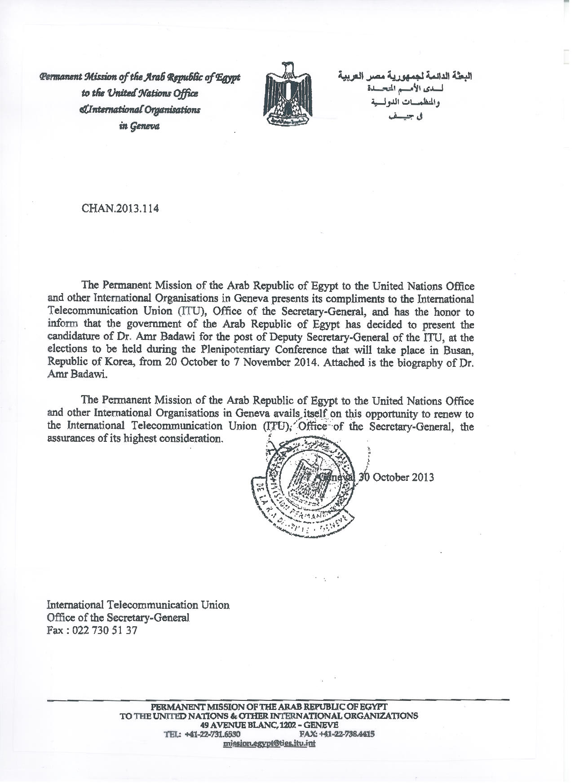

AMR BADAWI,PH.D.  Address: National Telecommunications Regulatory Authority  Building B4 Smart Village,  Abu Rawash, Giza, Egypt  Tel: +20 2 35344238 (office) +20 122 2172277 (mobile)  Email: abadawi@tra.gov.eg | 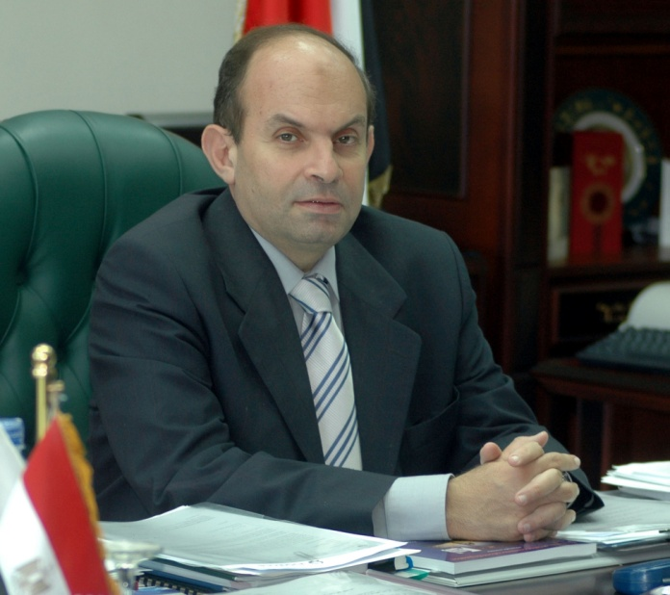

Experience:
Board Member, the National Telecom Regulatory Authority (NTRA), Egypt, July 2013- present
Executive President, the National Telecom Regulatory Authority (NTRA), Egypt, March 2006 – July 2013
Led NTRA in:
- Drafting Egypt’s National Broadband Plan.
- Drafting the Free Competition Framework in conjunction with the liberalization of Fixed Networks Services.
- Drafting the Universal Service framework and its executive plan.
- Issuing the third national mobile operator’s license via a public tender auction, which was awarded to Etisalat consortium in 2006 for royalties of 3.0 Billion USD.
- Issuing the third generation mobile Licenses to Mobinil (Orange) and Vodafone Egypt in 2007 for royalties of 600 Million USD each.
- Issuing licenses to TE data, Vodafone Data, Link and Egyptian Network of Universities for TLD Registrars (Top level Domain name) (.مصر) as the first internationalized domain name (IDN) in Arabic.
- Authorizing GSM services (1800 MHz) on aircrafts within the Egyptian airspace.
- Issuing the license for Middle East and North Africa (MENA) consortium to install, operate and lease international submarine cables networks besides international telecommunication services infrastructure as a main step for the liberalization of the international services in the Egyptian market.
- The ruling on the interconnection dispute between Etisalat Misr on one hand and Mobinil and Vodafone on the other.
- Issuing and implementing the new national numbering plan for Egypt in 2006.
- Introducing the Mobile Number Portability System and National Mobile Roaming Services, and site sharing for mobile operators.
- Drafting the regulatory framework of Research and Development projects at NTRA, and launching the digital broadcasting project that was introduced by the Fraunhofer Institute.
- Establishing a 24-hour QoS monitoring system for mobile networks, and applying judicial seizures for telecommunication devices unapproved by NTRA.
- Signing and implementing the Institutional Twinning Agreement with AGCOM (Italy) and BnetzA (Germany) in 2008.
International and regional events hosted
- ITU Telecom Africa 2008
- 33rd meeting of ICANN
- 4th meeting of the Internet Governance Forum (IGF)
Chairmanship of Regional Associations
- Chairman of the Arab Regulators Network (AREGNET) and the Euro-Mediterranean Regulators Group (EMERG) for the year 2012.
- Vice-Chairman of the World Conference on International Telecommunications (WCIT) 2012
Headed the Egyptian delegation in the following ITU events
- ITU Plenipotentiary Conferences 2006 and 2010
- ITU WTSA 2008
- The World Radiocommunication Conferences (WRC) 2007 and 2012
- The World Conference on International Telecommunications (WCIT) 2012
Panelist/presenter
- Global Symposium for Regulators (GSR) 2009, 2011, and 2012
- ITU Telecom World 2006 and 2012
- ITU Telecom Africa 2008
- GSMA World Congress 2007 through 2012
Associate Professor, Cairo University, Cairo, Egypt, 1987 – present
- Started as an Assistant Professor in 1987.
- Taught various courses in electronics and telecommunications.
- Consultant to the University VP and President for all technical matters related to the telecommunications systems in the university and in government authorities requesting the aid of the university in areas of telecommunications, security and surveillance systems.
Senior Technical Advisor to the Minister, Ministry of Communications and Information Technology, Cairo, Egypt, Jan 2005 - Feb 2006
- Handled the development of Egypt's telecommunication sector, including the policy development and providing support to telecommunication entities such as the carries, ISPs, vendors.
- Interfaced with NTRA regarding regulatory issues affecting the industry.
- Oversaw the activities of Telecom Egypt and its privatization process by leading the team that selected the Investment advisor and conducted the successful Initial Public Offering of 20% Telecom Egypt shares.
Senior Technical Advisor, ICT and TSS Programs Egypt, General Dynamics, Chantilly, VA, May 2003-Dec 2004
- Responsible for providing technical advice to the USAID – funded program.
- Led the technical study group responsible for the procurement of the ATM network for TE
Chief of Party, ICT Program Egypt, General Dynamics, Chantilly, VA, March 2002- May 2003
- Responsible for providing technical advice to the USAID – funded program.
- Worked on solving the program's technical problems.
- Represented General Dynamics (GD) in the Ministry of Communications and Information Technology (MCIT) in the form of advice and aid to the Minister.
- Coordinated and headed MCIT’s E-Access efforts aimed at improving access to ICT in Egypt.
- Assisted in promoting GD within MCIT ensuring smooth and clear communication with MCIT's top management.
- Provided technical advice and assistance to the telecommunication sector Support Program (TSS) General Dynamics team in implementing USAID funded telecommunications projects in Egypt.
- Program Manager for the Information and Communication Technology Program- a USAID funded program in Egypt.
Deputy Program Manager, TSSDPM Engineering, General Dynamics, Chantilly, VA., March 2000-March 2002
- Responsible for the engineering aspects of the USAID-funded program (NOC, DSS III, and OSP II).
- Worked on solving the program’s technical problems.
- Coordinated and headed the MCIT technology assessment and planning efforts that resulted in the three-year plan for telecommunications in Egypt (presented in July 2000).
- Assisted in promoting General Dynamics within Telecom Egypt (TE) – Egypt’s incumbent operator - ensuring smooth and clear communications with Telecom Egypt’s top management.
NOC Project Manager, GTE/General Dynamics, Chantilly, VA., June 1997-March 2000
- Responsible for the evaluation of technical bids for the Telecom Egypt NOC project.
- Produced a shortlist of technically qualified bidders to provide commercial bids and provided engineering cost estimates for the NOC project. Selected the successful bidder and proceeded with all steps towards the signing of the contract.
- Directed the supervision team during the installation period and system testing until NOC Integrated System Provisional Acceptance.
Senior Member, Technical Staff, GTE, Chantilly, VA., October 1996-June 1997
- Reviewed the scope of work for the Arab Republic of Egypt National Telecommunications Organization (ARENTO) NOC project in their tendering process.
- Helped in formulating the pre-qualification criteria for prospective bidders.
- Performed a complete evaluation of the technical specifications of the NOC and introduced modifications to suit the new situation in ARENTO and to make use of newer technology. Was involved in selecting the pre-qualified bidders for the NOC project.
- Provided technical support to all bidders during the technical bid preparation.
Consultant, GTE, Chantilly, VA, December 1995- October 1996
- Technical consultant under a subcontract to GTE for the ARENTO NOC Project which was funded by USAID.
- Helped review and evaluate the technical bid, and provided engineering estimates and reviewed the commercial bid.
President, Technical Director, Telecomp International, 1987-1995
- Provided technical consultancy on telecommunications equipment and systems business.
Consulting Engineer, Transtech International, Mountain View, CA, January 1987- October 1987
- Consulting Engineer for the design of telecom equipment.
System Engineer, Aydin Corporation, San Jose, CA, January 1984-January 1987
- Engineer for the design of voice and data communication networks and systems.
- Involved in the following proposal efforts: Egyptian Army Backbone Strategic Network; Royal Thai Air Defense Network; Airborne Command, Control and Communications (ABCCC) for U.S. DOD; Data and Voice Network for U.S Naval Base in Jacksonville, Florida; Pakistan Army Telecommunication Network, and Voice of America transmissions stations for Latin America region.
Research Assistant, Stanford University, 1980-1986
- Assisted with research projects under the guidance of Professor Bruce Lusignan while pursuing Ph.D. degree.
Graduate Assistant, Virginia Tech, Blacksburg, VA, 1979-1980
- Teaching assistant for computer and communications class.
Graduate Assistant, Cairo University, Cairo, Egypt, 1977-1979
- Teaching and research assistant for electronics and computer engineering courses.
Education:
Ph.D.-Electrical Engineering, 1986, Stanford University
Master of Science-Electrical Engineering, 1979, Cairo University
Bachelor of Science-Electrical Engineering, 1977, Cairo University
Honors:
- Egyptian Government Fellowship during all undergraduate studies.
- Stanford University Research Assistantship during years of study towards my Ph.D.
Activities:
Coordinator and Head of the Telecommunications Technology Workgroup formed by the Minister of Communications & Information Technology in Egypt. (2000-2004)
- The group was engaged in promoting the telecommunications field in Egypt by providing independent recommendations to the Minister to improve the services and promote the telecommunications industry in Egypt.
Member of IEEE and the Egyptian Syndicate for Engineers.
Languages
- Fluent in spoken and written Arabic and English
- Fair knowledge of French
Personal Data
- Date of Birth: 24 May 1955 in Egypt
- Marital Status: married with two children and one grandchild

