ANNEX 10H

First Response Radio in Tacloban City - Typhoon Haiyan (Yolanda)

Following the catastrophic Indonesian Tsunami in 2004, it took a month for First Response Radio (FRR) to get a radio station up and running. While that was a great achievement in difficult conditions, it was not fast enough, and so the present aim is to set up a radio station within 72 hours of a disaster happening.
While this goal was not achieved with Typhoon Haiyan (Yolanda), it was accomplished in six days, with only 72 hours from the time it was decided to deploy to having a complete radio system established and broadcasting to the affected populations around Tacloban City.
The strategy of FRR has improved dramatically since the Indonesian Tsunami. FRR now buys equipment, trains teams and practices in disaster prone countries before disaster strikes. The equipment is ready on the ground and relationships have been built up with local communities, officials and aid agencies. Emergency radio training is also provided to some of these teams. It is vital to build teams where different types of organisations and people are connected. FRRs local partner is the Far East Broadcasting Company (FEBC) who have been working in the Philippines since 1946.
While the training FRR provides is important, the work really happens in 3-day field trials - putting things into practice in a former disaster zone under realistic field conditions. When people work hard in the field together their relationship becomes stronger and when disaster strikes they will do anything for their team. FRR seeks to build this kind of team in disaster prone countries before the disaster happens and has been taking this approach since 2007.
The Aftermath
FRR had carried out a training event previously in the Philippines and completed exercises with local teams, but that had been several years ago. After the 2007 training event in Manila, the portable broadcasting kit was taken away when the training exercises were completed. Since then, it was realised that each country needs its own equipment and FRR has now changed its strategy to always leave broadcasting kit behind. However, some of the necessary equipment was missing when FRR arrived in the Philippines, two days before the Typhoon hit. Thankfully, FRRs local partner, FEBC had been putting together a community radio station, so they had a transmitter which was compatible with the FRR system that was delivered the very day of the typhoon. FEBC was also able to provide a number of volunteers to operate the equipment.
After the storm hit, all communications were down and it was impossible to work out what was going on, and where. It took more than three days to confirm there was a need for the FRR teams help. Typically, the humanitarian system carries out rapid "needs assessments" - this is a large task and was made more difficult in the Philippines due to it being composed of many islands. Normally, the assessments confirm that power and communications are down, but in this case it was not clear whether there was still radio broadcasting on the air. It’s a real paradox - people need the most help when communications are down, but no one knows what is going on. Finally, an article in a Manila newspaper quoted Interior Secretary, Mar Roxas saying: "…all systems, all vestiges of modern living - communications, power, water - all are down. Media is down, so there is no way to communicate with the people in a mass sort of way." After reading this, FRR knew that its help was required.

The Response
As FEBC had been operating in the Philippines since 1946, and had long standing links with the government and the National Telecommunications Commission (NTC), it only took a short phone call to get verbal authorisation for FRR to go to Tacloban City. When FRR had been in the Philippines in 2007, the emergency licensing protocol had already been established with NTC, so this also helped FRR to gain its license very quickly.
FRR operates a "radio in a suitcase" broadcast station, which is small enough to carry on any standard flight as checked luggage. It’s a complete radio system and generally only needs a four to five person team to operate it.
Going into a disaster zone is always a challenge and travelling to Tacloban City was no exception. Even with tickets and boarding passes in hand, the team were initially unable to board a flight and had to fight hard to keep their seats, even after they finally boarded the aircraft. Landing in Tacloban airport thirty minutes before dark, the team were met by representatives of the United Nations Office for the Coordination of Humanitarian Affairs (OCHA) who were staffing the "Reception Centre". After signing in and getting a short briefing, the FRR team were taken to the City Hall on a relief truck.
FRR linked up with some of the Emergency Telecommunications Cluster (ETC) staff that were already located at the City Hall, which was very helpful as ETC were able to help with setting up the equipment and providing fuel for the generator. After arriving, the equipment was set up very quickly, and the radio station was on the air by 0900 the following morning. The antenna was erected using materials found on site, including bamboo poles, pipes and duct tape.
When on air, FRR were broadcasting emergency messages to local communities, so the people would know what to do if a particular situation affected them, for example relating to shelter, hygiene or sanitation. The local Mayor went live on air, issuing an inspiring challenge to all people to go back to work on Monday, about 10 days after the storm. He invoked the Filipino spirit of pulling together or Bayanihan, and he said if this was done the people would pull through together.
The number of people listening to the FRR station was boosted by the Public Information Agency (PIA), who installed mobile loudspeaker units on trucks, recommending that people tune into the FRR broadcasts. On advice from the Mayor, 120 radios were placed in Barangay halls and evacuation centres, so that a larger number of people could listen to the FRR programmes. The FRR broadcasts received very positive feedback from the affected communities.
What was learned?
The value of the personal relationships FRR had built up in its previous operations in the Philippines was extremely valuable. Having these relationships enabled FRR to obtain the necessary licence to commence broadcasting very quickly, and meant that FRR were able to assist the affected communities in a way that would help them.
FRR also learned that even if the radio teams were fully prepared, there were still other factors that made it difficult to establish the broadcast station as quickly as FRR would like. Firstly, awkward geography made both logistics and communications extremely challenging. In the Philippines there are many sparsely populated islands that are extremely difficult to reach in times of crisis. Secondly, simply working out what is going on immediately after the disaster strikes enables the humanitarian response to be activated sooner. This requires needs assessments to be made more quickly than have been carried out previously - preferably within 24 hours. Both of these elements rely on greater coordination, not only between responders, but with communities on the ground. New strategies are required to enable needs assessments to be completed more quickly, and the community plays a big role in this. Using the Communicating with Disaster Affected Communities (CDAC) Network can assist humanitarian agencies to work together to make the changes necessary to ensure affected communities come first in any disaster response.
Mike Adams First Response Radio

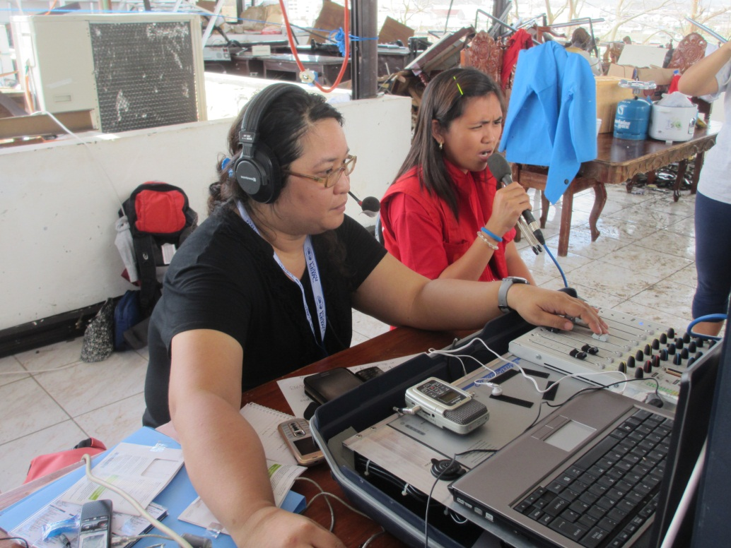

First Response Radio begins emergency broadcasts from the roof of Tacloban City Hall on the 6th day following Typhoon Haiyan.

