ANNEX 10C
First Response Radio India deploys to Uttarakhand Floods

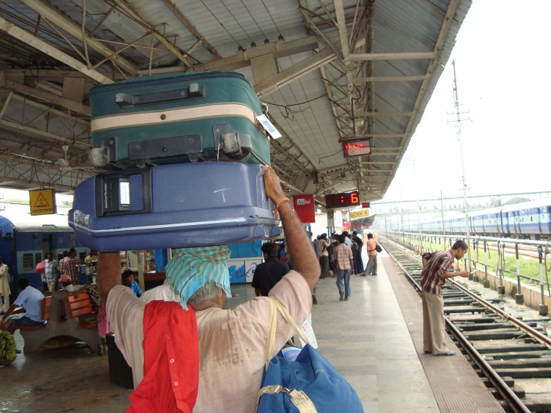
First Response Radio (FRR) India began emergency broadcasts within 72 hours of the onset of flash floods and landslides in the Northern state of Uttarakhand in the Himalayas. According to Uttrakhand Chief Minister the floods were a "Himalayan Tsunami".
The special broadcasts began going out on 19th June 2013 via SW radio for 30 minutes a day towards the affected region to provide critical information to those affected by the flooding including the many pilgrims who are not from that state.
Even before full assessments were available, FRR began preparing broadcasts from Delhi based on the news, government and NGO information. In the early days of the special broadcasts the floods were still increasing and programs warned listeners of the increased danger of floods.
On 21st June FRR India deployed a team of 4 people into Uttarakhand state. Most of the team members had already completed FRR training in 2011 where they learned how to use the suitcase studio to produce emergency radio programs.
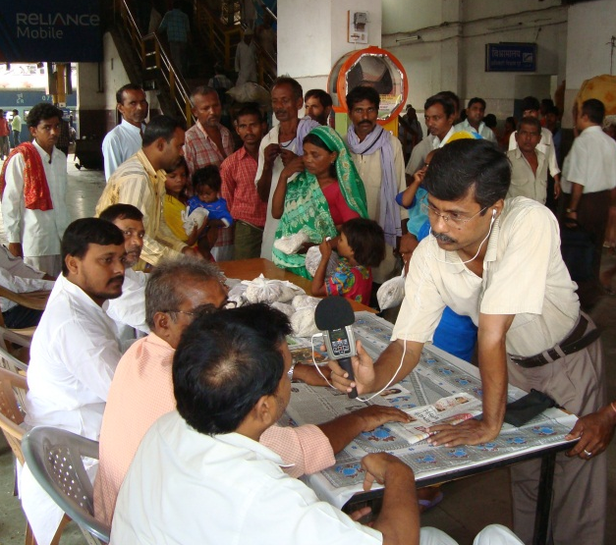
Team leader, Firoz Faridi is an FRR veteran having responded to previous disasters in Bihar (2008), Ley (2009) and lasts summer's Assam floods.
Once in the affected area they began interviewing the affected community, Government and NGOs. Every day they produced a 30 minute program of useful information using the suitcase and upload the programs over the (slow) internet for broadcast that night.
On the 22nd Firoz took his team to the most affected town of Uttarkashi. The road in was still in very bad shape but by traveling behind Indian Army and government bulldozers, they arrived in Uttarkashi.
When FRR INTL coordinator, Mike Adams called Firoz he asked "What was the most important information that the programs were providing for those affected by the flash floods?" Firoz replied: "On our emergency radio programs we were passing information about rescue operations, health tips, weather information and information about relief camps and health camps".
Broadcasts could be heard on Shortwave Radio (SW) on 9 500 KHz on the 31 Meter Band from 8:00 to 8:30 pm local time, nightly (1430 UTC).

