ANNEX 5F

Emergency Warning Systems Limited

Technical overview

Emergency Warning Systems Limited’s (EWS) patented technology broadcasts an alert message on all radios to people who are at risk in an emergency or disaster to allow them to make informed decisions about the appropriate action to take to save lives and property. The system over‑broadcasts existing radio stations operating in the target area and only that target area, not the entire broadcast zone of the radio station. Because most people have access to a radio and the reliability of radio, EWS’s technology can arguably reach more people than any other single system.

Unlike other alert systems, our technology can provide targeted, comprehensive and clear advice and instructions to different people simultaneously according to where they are and what risk they are facing. In other words, the technology can deliver different messages to people in different target zones simultaneously on the same radio stations.

The technology can be deployed in different ways as detailed below.

The Mobile Emergency Warning System (MOBILE EWS)

The MOBILE EWS is a product which, when installed in an emergency service vehicle, has the operational capability to:

– Monitor commercial and public radio frequencies within a controlled range; and

– When required, interrupt and override the broadcast with an emergency warning message over a pre-determined distance.

The yellow shaded area in the diagram below represents the classic MOBILE EWS broadcast pattern from a moving emergency vehicle and the number of cars in the surrounding area that are within range of the warning message.

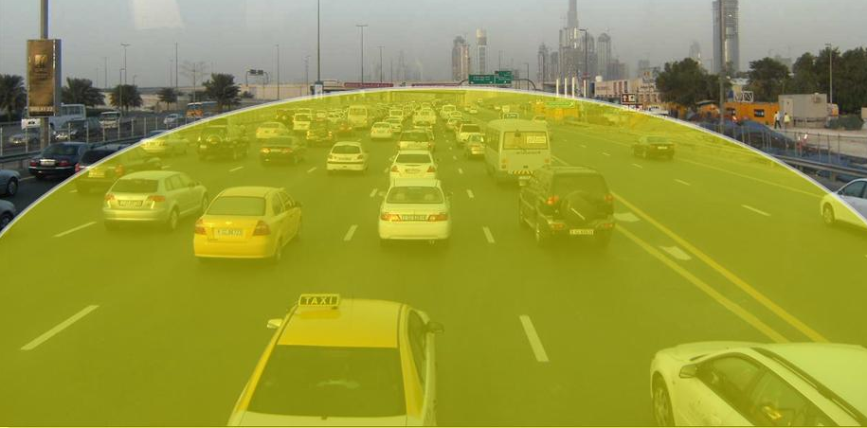

The warning system comprises the following components:

– A microprocessor based subsystem for controlling the way that the system operates.

– Multiple transmitters each with their own frequency synthesizer for transmitting the audio warning messages – currently FM and RDS transmission with AM and UHF as current work-in-progress developments.

– Broadcast receiver for measuring ambient signal strengths.

– Appropriate antennae for the transmitter unit.

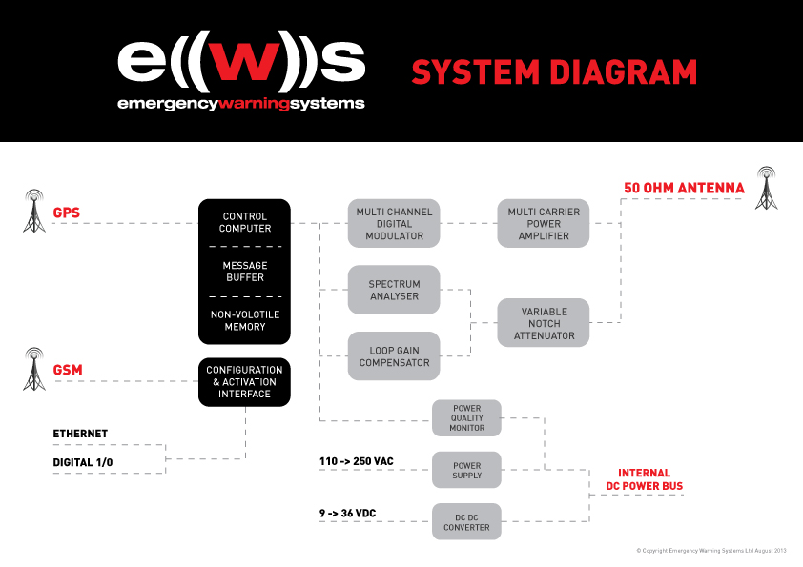

Production Ready Works

EWS has incorporated new technology into the MOBILE EWS so that a final production unit is compact for ease of installation into an emergency vehicle.

The Fixed Emergency Warning System (FIXED EWS)

Whilst similar in concept to the mobile device, the FIXED EWS is designed for emergency broadcasting from a fixed location, with a higher broadcasting coverage area. The core concepts of the EWS technology such as measuring signal strengths, combining multiple signals, and containing broadcast radiation to a set range have already been extensively researched and developed for the mobile application. The fixed solution will adopt all such proven concepts, but will require extended features such as higher power, central control capabilities (with integration into a customer network management centre or central command centre) and power redundancies.

This product would be best suited for:

– Roadside warnings and incident alerts.

– Catastrophic events such as natural disasters (bushfires, tsunamis, cyclones, floods), major crime scenes (terrorist attacks, bomb threats, hostage siege, prison escapees) and any other situation where the local public is under threat and must be immediately alerted to act in a prescribed manner by an emergency authority

– Weather alerts in areas at risk of storms, high seas or fog

– Covert and humanitarian military operation use to reach target areas and zones.

The technology will enable notification of the public (residents, workers and road users) of an emergency, danger or incident, through fast, localised messages on standard vehicle or household radios. In newer vehicles that are fitted with RDS (Radio Data System) radios, the technology can interrupt other devices being used such as a CD player or iPod/MP3 player. The messages would be prepared to empower people at risk to make informed decisions and respond in the appropriate manner.

The following diagrams show examples of the FIXED EWS in operation as a roadside broadcast for traffic and incident response and as a regional emergency broadcast for the wider community. Victoria Police in Australia wishes to deploy the technology on a rural freeway at various points where driver fatigue is responsible for deaths, injury and major blockages.

FIXED EWS activation for Road Traffic and Incident Response

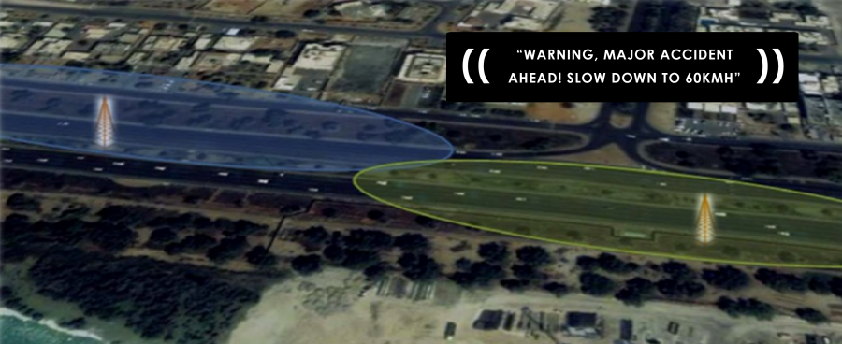

FIXED EWS activation for longer range community and public broadcast

*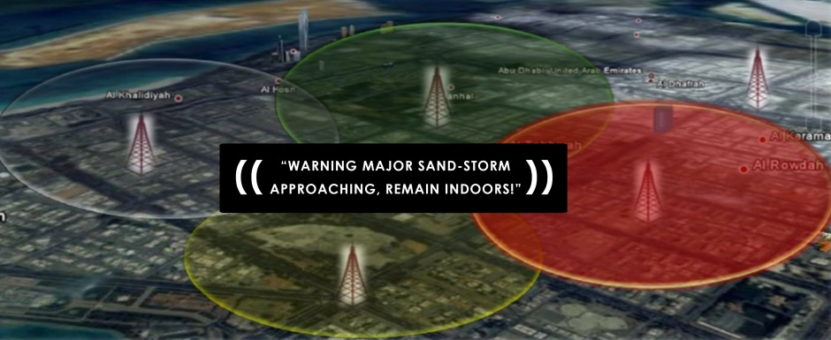*

Community-based warnings for regional larger scale emergencies such as bushfires have proven to be ineffective due to inability of multiple warning dissemination mediums to be implemented. Also lacking is the ability to target different areas with specific warnings. The compelling need for multiple methods of warning dissemination during natural disasters is clearly evident from different emergency authorities responsible for people management when an incident occurs.

All members of the community who have a standard radio or the Personal Emergency Warning System (PERSONAL EWS - as we describe in the next section) will be able to receive key safety and emergency information.

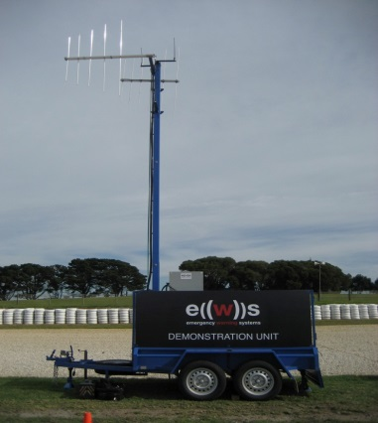

The FIXED EWS above, mounted on an optional trailer platform, was deployed by Victoria Police during the Easter long weekend in April 2011 for incident management and road safety initiatives due to the closure of the Princes Freeway in Morwell, Victoria. Successful deployment was confirmed in the police media release “Emergency warning system to be used to update Morwell motorists” issued on Thurs 21 April 2011

Key capabilities of the FIXED EWS will include:

– Can be activated from a central point (Network Operation Centre)

– Configurable to provide tailored information and messaging to the public

– Wide area of broadcast coverage option

– Localised area broadcasting for specific and tailored messaging

– Assist authorities with catastrophic event management.

– Rapid dissemination of information

– Low maintenance, easy to use, robust

– Uses existing public radios and the PERSONAL EWS (below) to warn the public

– Automatically identifies active radio stations

– Ability to nominate and exclude frequencies from broadcast

– Accurately control transmission power per carrier frequency

– Broadband antenna (fixed solution)

– Ability to incorporate variable transmission coverage based on user configuration

– Multiple message storage capability

– FM and RDS transmission capability (upgrade for AM as a current work-in-progress)

– Software controlled and easily upgraded.

Personal Emergency Warning System (PERSONAL EWS)

The third product in the EWS suite of warning solutions is the Personal Emergency Warning Systems (PERSONAL EWS). The PERSONAL EWS can be purchased by the public and fitted to any public vehicle or room within a building. Anytime a warning message is activated by a central command body such as police, road or government authority, it will be received by the PERSONAL EWS and the warning message will be heard by anybody within the broadcast reach of the unit through its own speaker system. The unit will also feature its own dedicated frequency (it is not an over-ride device) and include a strobe light to alert people with hearing difficulties that an emergency is present. The Personal EWS can be supplied with frequency options to allow alerts in different languages to be delivered.

Radio Data Systems (RDS) Capability

EWS has incorporated RDS functionality into the company’s technology. RDS enables the EWS to not only cut into radio listening but also interrupt CD players, where in-car radio receivers have RDS functionality present. It is envisaged that RDS functionality will become standard for all new vehicles as is already the case in the whole of Europe. The RDS feature allows increased penetration of the warning message to drivers targeting radio listeners and those listening to CD players or iPods.

Future Development

EWS has developed the framework for a SmartPhone Application that will link to a FIXED EWS allowing the same message to be broadcast over SmartPhones in the area of the radio broadcast.

A feature will allow Smart Phone users to log into target zones to enable them to receive alerts even though they may not be in the target zone. That way people will be able to monitor activity in an area where they have an interest in family or property.