ANNEX 5A
Digital Radio Mondiale - Emergency Warning Functionality
Overview
The Digital Radio Mondiale (DRM) system incorporates support for a fully integrated disaster and early warning service called Early Warning Functionality (EWF). This is one of the core functions of the DRM system specification, as set out in Recommendation ITU-R BS.1114-7 and the European Telecommunications Standards Institute (ETSI) standard ES 201 980.
Task
The task of any early warning system is to inform the general public (and relevant authorities) about the impending disaster, with maximum reach and as quickly as possible, giving all relevant information.
Requirements
A typical early warning system has the following requirements:
– Send notification to maximum number of people in the affected areas as promptly as possible.
– Must cover large areas with very high reliability.
– Must work when common information services and local services fail.
– Make warnings available on devices that people use on a daily basis.
– Reach devices that are still operational if electricity fails (for example, radio sets and other devices with independent energy source).
– Be as un-intrusive as possible for daily use.
– Must be available and continuously on-air for the duration of the emergency.
– Control of emergency notification and immediate access by authorities.
– Make emergency message available to widest possible audience, including the visually or hearing impaired.
Summary
With EWF support included as one of the mandatory elements of the DRM system specification, DRM technology already provides an ideal platform for delivering emergency warning services, without the need for special chipsets or other adaptations. Everything needed for EWF is already in the receivers built according to the above specifications issued by the DRM Consortium. The DRM technology should be the major building block of a national emergency warning policy, providing full and continuous services as a last resort. Additional features, such as text display and activation from remotely located transmitter sites can also be included in policy requirements.
DRM building blocks - how EWF works
Broadcast functionality
The DRM system employs Alternative Frequency Signalling (AFS) which can point the receiver to the emergency broadcast (even if the receiver is tuned to a different service ID or on a different frequency). It also employs emergency announcement signalling, where the receiver has general support for the emergency announcement feature and the current activation status of the tuned programme (can be sent in DRM signalling channel along with any audio or data transmission).
Receivers may check regularly for announcement activity even if turned off, as announcement information is carried in the signalling channel (no need to decode full DRM signal for checking; for battery-operated receivers proper engineering solutions are needed to make this feature available). If emergency announcement is active, DRM receivers switch automatically to the emergency broadcast. Emergency content is provided automatically in the form of audio and text information (see below for details).
Listener experience
A DRM broadcasting network can be configured so as to provide listeners with information on emergencies in the following formats:
– Audio programme (provided in one language at a time).
– DRM text messages (short text lines appearing on screen, updated automatically every few seconds).
– Journaline advanced text service (providing detailed instructions in multiple languages simultaneously).
When the alarm signal is triggered by the authorities
In compliance with the DRM specification, the emergency broadcast reception features of any DRM receiver already switched on will be activated by the emergency alarm signal sent over the DRM service to which it is already tuned. The DRM receiver will then switch over to the emergency broadcast audio content and, if fitted with a text screen, display any associated text. The options for the associated emergency broadcast text include headlines (via DRM text messages) plus detailed, multilingual information and instructions (Journaline) for instant and interactive look-up by the user. A further option that national administrations/regulators may wish to consider is to require that DRM receivers sold domestically incorporate an automatic switch-on feature.
The ability of receivers to check on emergency warning signals being active should be a general requirement for receiver manufacturers. Deploying DRM's multimedia capabilities (text messages, Journaline) allows additional facilities for audio impaired listeners and allows listeners to be addressed in their own language.
As a result, target listeners of the EWF can receive detailed text information through Journaline, supporting multiple languages and scripts simultaneously in one single broadcast (see Figure 1), such as:
– The reason for the emergency warning.
– Instructions on what to do.
– Contact details for further information.
– List of affected areas.
– List of affected people/population (search messages etc.).
FIGURE 1
Examples of screen renderings and emergency content (Journaline)
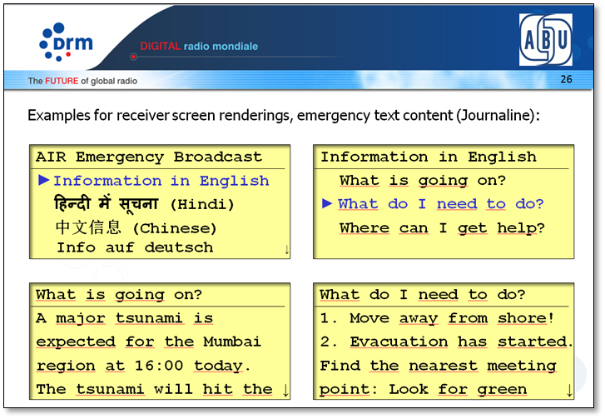

Implementation
DRM broadcast chain
A DRM broadcast chain consists of:
Studio (content) - DRM Content Server(s) - DRM Modulator(s)/Transmitter(s).
If authorities trigger the emergency signal, it must automatically be provided to the studios, which in turn activate it at the DRM Content Server(s) (or grant authorities direct access to an appropriate interface). The emergency warning signal must be activated for all DRM on-air services (even if they do not carry the emergency program themselves, but simply point receivers to it, for example a public broadcast).
During implementation, DRM configuration(s) may need to be dynamically reconfigured to make room for the emergency programme and additional content. Typical interfaces to trigger/activate the DRM emergency signal on a Content Server may include web interface access (for manually activating a trigger) or UECP (international standard for automated announcement distribution within studio environments). See Figure 2.
FIGURE 2
DRM broadcast chain
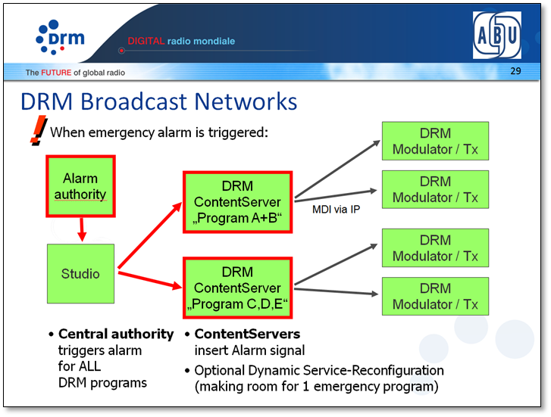

Implementation considerations for the DRM broadcast chain
The following are implementation considerations for the DRM broadcast chain:
- Enable emergency alarm signalling for all DRM broadcasts (+ AFS links to emergency programme).
- Establish alarm trigger signal path from central authorities to all stations
- The content to be put on-air (audio + text) must be prepared in advance for each possible emergency scenario, to be available and placed on-air immediately when required, and easily accessible by broadcasters.
- If required, prepare DRM broadcast configurations for emergency program scenario to quickly switch configurations in case of emergency. For example, to add the emergency service with audio and text content into a regular DRM broadcast (optionally replacing existing content and programmes in the broadcast).
Activation of emergency alert
When the emergency alert is required to be activated, the following steps should be taken:
- Activate trigger chain from authorities through studios to DRM Content Servers and ultimately the DRM receivers, to switch all receivers automatically to the emergency programme (see Figure 3).
- Broadcast (at least) one emergency programme covering at least the region of the emergency with audio + text information.
FIGURE 3
Announcement management screen
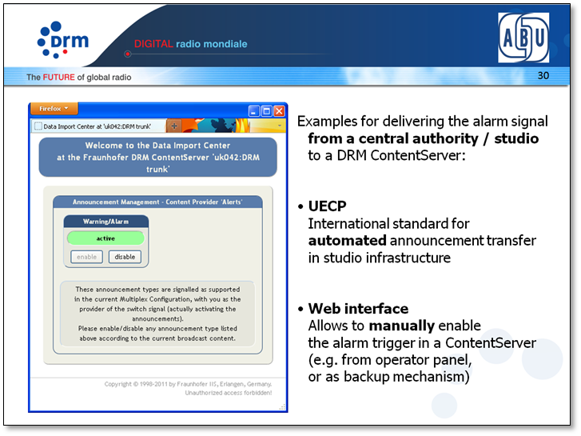

Conclusion
The DRM audio broadcasting system has all required tools built in - and supported - by available chipsets for a quick and complete notification of entire populations when disasters/catastrophes occur:
- Providing DRM receivers with switch signals and alternative frequencies to receive emergency programmes.
- Providing listeners (including impaired users) with complete and detailed information by audio and multilingual on-demand text (Journaline).
Preparation in advance is key in three major areas:
- Alarm trigger routing (from central authority to DRM receivers).
- Content preparation for immediate availability (text information, audio loops/feeds).
- Full receiver functionality to be implemented (including EWF and automatic wake-up).
The global DRM standard fully supports the emergency warning facility, and on the transmitter side this functionality is available in systems currently in operation, while it is being implemented in some receivers.

As set forth in the DRM minimum receiver requirements and the second level receiver profile (see www.drm.org)
See ETSI Standard TS 102 979.
See Recommendation ITU-R BS.1894.

