How to use ITU-R SG 4 electronic facilities
(March 2021)

1 Introduction
To make full use of the ITU-R electronic facilities you need an ITU User Account with a user-id and a password and also you need TIES access.
If you do not have an ITU User Account and/or a TIES access, please read the information on the ITU TIES services and follow the relevant instructions given at:
www.itu.int/en/ties-services/Pages/default.aspx
The electronic facilities used by ITU-R SG 4 are as follows:
– Mailing lists: Used to send messages to all those that have subscribed to the list.
Large file attachments are discouraged.
– Share Point Sites: For file exchange and other purposes.

2 Mailing lists
TIES mailing lists are used by the various working parties and their subordinate groups to facilitate work by correspondence between meetings. The following SG 4 mailing lists have now been set up. As there is no automatic subscription to the lists, you will need to request subscription to the lists yourself.

2.1 General Working Party mailing lists
Used for general announcements to members of a Working Party (WP)
(e.g. announcement of the creation of a new correspondence group):

WP 4A: rwp4a@itu.int | WP 4B: rwp4b@itu.int | WP 4C: rwp4c@itu.int

2.2 Other mailing lists for the SG 4 or Working Party sub-groups
Sub-groups (e.g. Correspondence Groups) can be established by SG 4 or each WP.
Information about the groups currently established in each WP is available by following the link to “Mailing lists” under the tab “Electronic working” on the SG 4 web page, WP 4A web page, WP 4B web page or WP 4C web page.
Additional information on the established Correspondence Groups can be found on the following links for SG 4, WP 4A, WP 4B and WP 4C.

2.3 How to use, subscribe to and unsubscribe from a mailing list
When you send an email to one of the mailing list addresses, your message is automatically forwarded to all the members of that mailing list.
However, you first have to subscribe to a mailing list in order to be able to send messages to it.
To manage your mailing list subscriptions, open the TIES Services home page at: http://www.itu.int/TIES/
You will then see the following webpage:

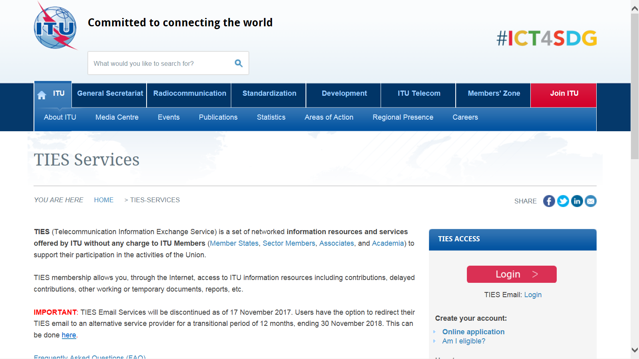

Click on “ Login > ” to see the following webpage and enter your ITU user account/TIES login and password:
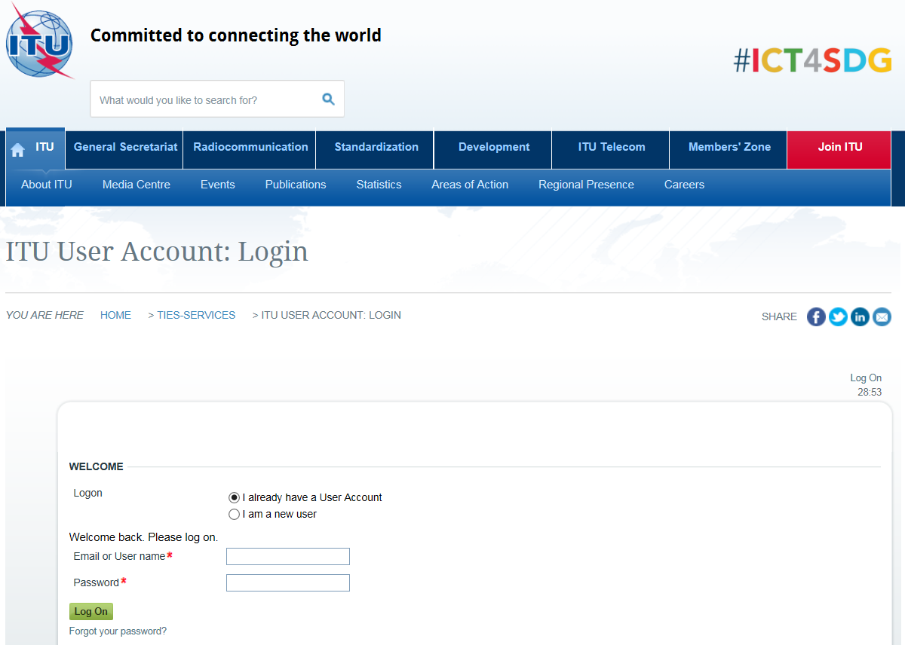

After entering your username and password, you will see the following web page:
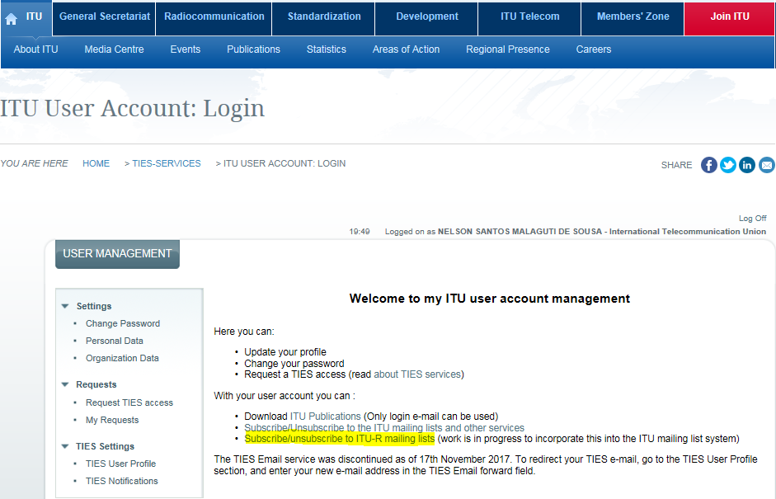
Click on the text highlighted in yellow above, to see a page showing which mailing lists you have already subscribed to, and below that, which mailing lists you can request subscription to.
To subscribe to a mailing list, scroll down the page to find “Mailing lists for itu-r:sg4”.
Click on the box(es) next to the list(s) that you want to subscribe to.
Scroll back up to “Request Subscription to mailing lists”, to see the following information, where your email address should be indicated instead of the one used in the example below:
If you want to use a different email address for sending/receiving emails to/from the mailing list, fill in the second box on the right, as appropriate. Then click on the “Subscribe” button on the right.
Allow a day or two for your request to be processed. You will receive an email advising you once your request is approved.
Once subscribed, in the part of the web page showing which mailing lists you are subscribed to, you will also be able to see who else is subscribed to each list (“Members”).
To unsubscribe from mailing list(s), simply click the check-box(es) corresponding to the list(s) that you want to unsubscribe from, then click the “Unsubscribe” button.

3 Share Point sites
It is preferable that large files (>1-2 Mbytes) be placed on the Share Point sites, rather than including them as attachments to messages sent to the mailing lists. Many subscribers' mailboxes apply file size limits, which prevent emails with large attachments being received. A better approach is to include a link to the file on the Share Point site in the message that you send to the mailing list. To be able to access the SG 4 Share Point site, you need to have a TIES ID and password.
The webpage of the main SG 4 Share Point site can be accessed at:
https://extranet.itu.int/rsg-meetings/sg4/default.aspx
The webpages of the Share Point sites of the SG 4 Working Parties can be accessed directly at:
– For WP 4A: https://extranet.itu.int/rsg-meetings/sg4/wp4a/default.aspx
– For WP 4B: https://extranet.itu.int/rsg-meetings/sg4/wp4b/default.aspx
– For WP 4C: https://extranet.itu.int/rsg-meetings/sg4/wp4c/default.aspx
The Share Point sites of the relevant sub-groups (e.g. Correspondence Groups) are available from the quick links on the left-hand side of the above-mentioned webpages.
For further information about the ITU-R electronic facilities, please consult:
http://www.itu.int/ITU-R/index.asp?category=information&link=e-facilities&lang=en

______________

