|  |  |
| --- | --- |
| **Radiocommunication Study Groups** |  |
| **INTERNATIONAL TELECOMMUNICATION UNION** |  |
|  |  |
| Source: Document 3M/183, Annex 10 | **Document 3M/FAS/7-E** |
| **15 May 2015** |
| **English only** |
| Working Party 3M | |
| FASCICLE | |
| the prediction method of the probability of rain attenuation proposed in recommendation ITU-R P.618 | |

# 1 Introduction

Recommendation ITU-R [P.837-6](http://www.itu.int/rec/R-REC-P.837/en) predicts the rainfall rate exceeded for a given probability of the average year and at a given location. In particular, the percentage probability of rain in an average year, *P0*, is defined in step 4 from worldwide ERA40 maps. The objective of this fascicle is to provide information on the basic principles of the method to predict the probability of rain attenuation on Earth-space links specified in Rec. ITU-R P.618.

# 2 Modelling of the probability of rain attenuation on Earth-space link

Knowing *N* equally distributed points on the ground projection of the path of length *L* and under the rain height *Hr* as illustrated in Figure 1, the probability to have non-zero rain attenuation on the path, *P(AR>0)*, is equal to the complementary probability to not have rain on each point of the path:

 (1)

with:  and .

Figure 1

Geometry of the link

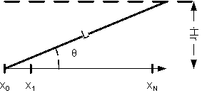

## 2.1 Expression of the probability of rain attenuation from the spatial correlation of rain rate fields

The joint probability  can be expressed from the correlation between the random variables *R(x1)*, *R(x2)*,…, *R(xN)*. [Jeannin et al., 2011] showed that the rainfall rate field *R(x*) can be modelled from locally stationary Gaussian random fields *G(x)* whose correlation *cG(x)* is:

 (2)

The rainfall rate field is then obtained by: *R(x)=f(G(x))*

where *f* is a function that depends on the local cumulative distribution function of rainfall rate.

Consequently,

 (3)

with: $α=Q^{-1}(P_{0})$ (4)

where: $Q\left(x\right)= \frac{1}{\sqrt{2π}}\int_{x}^{∞}{e^{-\frac{t^{2}}{2}}dt}$ (5)

So:  (6)

and therefore:

 (7)

## 2.2 Resolution of the integral giving the probability of rain attenuation

The analytical solution of integral (7) is not known and the numerical computation could be inaccurate and even time consuming, particularly for high values of the correlation. Instead, it is proposed to use the Markov hypothesis on the rain/non-rain states. Therefore, a 2-states Markov chain *Ui* can be defined as illustrated in Figure 2 and so:

 (8)

where ** is the transition probability from the state of no-rain attenuation to the state of rain attenuation and ** is the transition probability from the state of rain attenuation to the state of no-rain attenuation.

Figure 2

2-states Markov chain (state 0: no rain, state 1: rain)

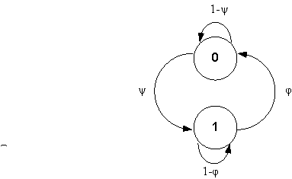

P(Ui=1) = P0 which imposes the following constraint:  (9)

and so:  (10)

then:  (11)

In order to relate the Gaussian correlation of the rain field and the transition probabilities of the Markov chain, the covariance of both processes will be assumed to be equal.

On the one hand, the covariance *cB* of the random process *G(xi)> α* is:

 (12)

where $c_{B}\left(α,ρ\right)=\frac{1}{2π\sqrt{1-ρ^{2}}}\int_{α}^{∞}{\int_{α}^{∞}{e^{-\frac{x^{2}-2ρxy+y^{2}}{2(1-ρ^{2})}}}}dxdy$ is the bivariate normal integral (13)

On the other hand, the covariance of the random process *U* is given by . So the product *U0U1* is not equal to zero only if *U0*and *U1*are simultaneously equal to 1, which occurs with a probability of:

 (14)

The probability  can be obtained thanks to the transition matrix of the Markov chain:

 (15)

and so:  (16)

as:  (17)

then:  (18)

and,  (19)

Finally, the equality of the covariances of the processes *Ui* in (18) and *G(xi)>α* in (11) leads to:

 (20)

and so:  (21)

Eventually from (11), the probability to have rain attenuation on the link becomes:

 (22)

# 3 Conclusion

Figure 3 illustrates the probability to have rain attenuation on the link in function of the probability of rain and the ground projection of the link.

Figure 3

Probability to have rain attenuation on the link in function of the probability of rain and   
the ground projection of the link

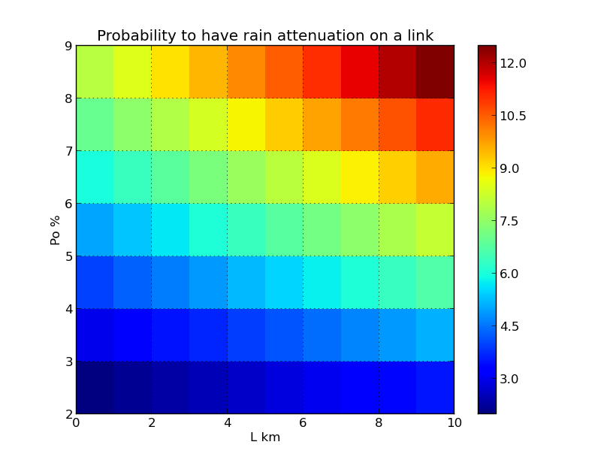

This contribution has presented a model of the probability to have rain attenuation of an Earth-space link. This type of prediction method can be useful to improve the rain attenuation prediction method given in Recommendation ITU-R [P.618-11](http://www.itu.int/rec/R-REC-P.618/en) and can be used to feed time series synthesisers such as the one given in Recommendation ITU-R [P.1853-1](http://www.itu.int/rec/R-REC-P.1853/en).

# 4 References

[Jeannin et al., 2012] Jeannin N., Féral L., Sauvageot H., Castanet L., F. Lacoste : "A large scale space-time stochastic simulation tool of rain attenuation for the design and optimization of adaptive satellite communication systems operating between 10 and 50 GHz", International Journal of Antennas and Propagation, Volume 2012 (2012), Article ID 749829, 16 pages, doi:10.1155/2012/749829.

______________