|  |  |
| --- | --- |
| **Radiocommunication Study Groups** |  |
|  |  |
|  |  |
| Source: Documents [3J/59](http://www.itu.int/md/R12-WP3J-C-0059/en) and [3J/82](http://www.itu.int/md/R12-WP3J-C-0082/en)  Subject: Information on Rec. ITU-R P.678-2 | **Document 3J/FAS/4-E** |
| **16 October 2014** |
| **English only** |
| Working Party 3J | |
| Fascicle | |
| the use of Recommendation itu-R p.678 | |

# 1 Introduction and goal

Statistics of rain rate and rain attenuation exhibit a high inter-annual variability as already shown by [‎1]-[‎7]. The knowledge of this inter-annual variability of rain attenuation Empirical Complementary Cumulative Distribution Functions (ECCDFs) could be extremely useful for system designers or for satellite operators. This variability has been studied in [8] and [9]. An empirical model, inferred from a limited collection of yearly experimental ECCDFs, has been proposed to predict the risk associated with propagation margins [9].

Recommendation ITU-R P.678 (from version 2) provides a generic worldwide model for the inter-annual variability of Earth-space propagation statistics and for the inherent risk. The complete methodology is available in [11]-[‎24]. It is parameterized with respect to data collected over Europe and Canada [‎12]. This recommendation answers to Question ITU-R 209-1-3.

# 2 Model of inter-annual variability

Assuming that the inter-annual fluctuations of rain attenuation *A* are asymptotically normal around the long term probability *p=P(A>A*)* [‎10] [‎11] it is proposed to model the yearly variance  of ECCDFs so that [‎11]:

 (1)

where:

 is the variance of estimation,

 is the inter-annual climatic variance.

## 2.1 Parameterization of the variance of estimation of the yearly rain attenuation ECCDFs

The Complementary Cumulative Distribution Function (CCDF) of rain attenuation can be estimated at the level *A\** by the ECCDF  given by [‎10] [‎11]:

 (2)

where *I* is the indicator function equal to 1 when the rain attenuation samples *Ai* are over the rain attenuation threshold *A\** and equals to 0 otherwise. This is a random variable -as it is a sum of random variables- and so has a variance. The ECCDF variance of estimation  is given by [‎10] [‎11]:

 (3)

where Δt is the time between two consecutive samples (sampling time), N the total number of samples,  the correlation function of the underlying Bernoulli (or binary) process  and  is the CCDF. Importantly, note in (3) that  and if yearly fluctuations are considered, then NΔt=1 year.

Several databases of rain attenuation collected over Europe (France, Italy, Germany) and Canada between 12 and 50 GHz have been used to compute the experimental correlation functions of the binary processes  [‎12]. A stretched decaying exponential function is fitted on the mean experimental correlation function of the binary processes [‎12]. So,  can be modelled by:

 (4a)

with:

 (4b)

and where the coefficients a, b1 and b2 are regressed on the mean experimental correlation function of the binary processes:

a = 0.0265 s-1, b1 = -0.0396, b2 = 0.286 (4c)

Due to the poor reliability of propagation measurements for very low attenuation thresholds (difficult calibration of the 0 dB level) and for very high attenuation thresholds (low number of observations) used to derive the model, Equations (4) are expected to be valid at least for probabilities of exceedance between 0.01% and 2%.

## 2.2 Parameterization of the inter-annual climatic variance of estimation of the yearly rain attenuation ECCDFs

The variance  quantified in section 2.1. is related to the properties of the statistical estimator and to the correlation of rain attenuation time series for some hours. Nevertheless, it is not able to explain alone the total variance that is observed on yearly ECCDFs. Another major source of fluctuation has to be taken into account: the inter-annual climatic variability of rain [‎24]. Indeed, the latter is likely to introduce variability around the “long-term” probability  of rain attenuation. In such conditions, in (3) becomes the yearly probability  to exceed *A\** and has now to be considered as a realization of the random variable  whose climatological average   
(i.e. computed over an infinite duration) is  and which variance  quantifies the CCDF fluctuations related to the inter-annual climatic variability.

It is then useful to assume that the inter-annual climatic variability comes only from the yearly occurrence of rain rate or rain attenuation . This assumption leads to consider that the conditional CCDF  of rain attenuation or  of rainfall rate are invariant from one year to another [‎13] to [‎18]. In such conditions, a yearly CCDF  can be decomposed into the general form:

 (5)

In (4),  is a realization of the random variable , that refers to the yearly occurrence of rain attenuation on the link (reasonably equal to the probability of rain at least for high elevation angles >30° [‎19] [‎20]). Particularly, for rainfall rate *R*, then it follows from (5) that the yearly rain amount *MT* *[mm]* is given by:

 (6)

where  *[mm.h-1]* is the conditional average rainfall rate (i.e. when it is raining) and  *[h]* is the integration duration (here equals to one year). As the conditional distribution  is assumed to be invariant from one year to another, it follows that  is constant and (6) leads in terms of variance to:

 (7)

Considering (6), (7) leads to:

 (8)

So the “climatic ratio” *rc* can be defined as the following:

 (9)

In order to compute *c* from Equation (9), meteorological databases giving the annual total rain amount collected over a large number of years (several tens of years) can be used in order to produce a map of *rc*.

## 2.3 Map of the climatic ratio *rc*

In the Second version of the recommendation (Rec. ITU-R P.678-2), the GPCC database [‎21] [‎22] that provides 50 years of monthly rain amounts collected worldwide with a dense network of rain gauges over the lands (spatial resolution of 0.5° in latitude and longitude) and only over the lands, has been used to derive the climatic ratio as shown on Figure 1.

Figure 1

Climatic ratio  computed worldwide from the GPCC database [‎21] [‎22]

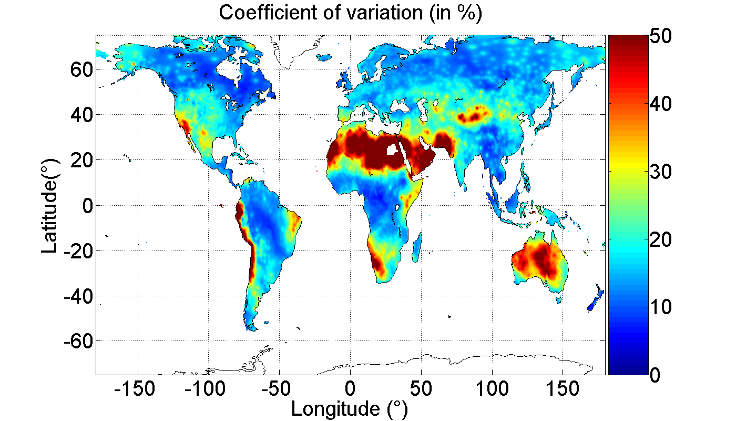

To complete the map over the oceans, the Global Precipitation Climatology Project (GPCP) database [‎23] that combines observations and satellite precipitation data into 2.5°x2.5° global grids for 34 years of monthly precipitation dataset from 1979 to 2012 has been used to derive the new climatic ratio  over the oceans.

The values of over the lands have been kept and the values over the oceans have been bi-linearly interpolated to reach 0.5° of resolution. The new climatic ratio  is shown on Figure 2.

Figure 2

New climatic ratio  computed worldwide from the GPCC and GPCP databases

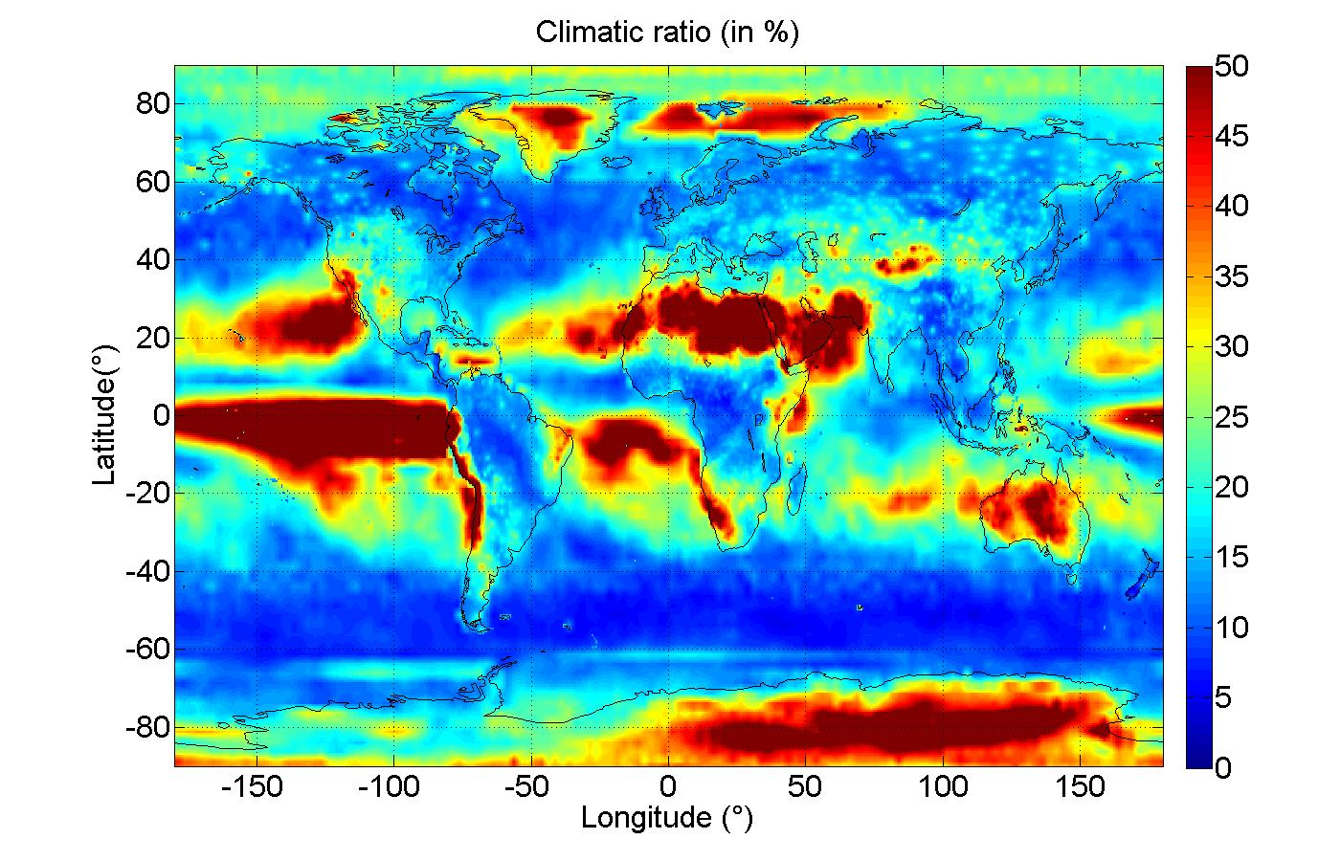

# 3 Risk estimation

Starting from a link budget with a fixed propagation margin *AM* derived from a rain attenuation CCDF  supposed to be at disposal,the problem is now to estimate the risk  that the yearly exceedance exceeds the value . Recalling from Section 2 that the inter-annual fluctuations are asymptotically normal with variance  given by (1), it follows that  satisfies:

, (10a)

or equivalently:

. (10b)

Importantly, note that = in (10) leads, as expected, to =50%.

An illustration of the risk predicted on a yearly exceedance is illustrated on Figure 3 for a radio link at 20 GHz between an earth station located in Toulouse (43.57°N, 1.47°E, France) and a geostationary satellite whose longitude is defined so that the radio link elevation is 38.6°. The CCDF is supposed to be the one predicted by Recommendation [ITU-R P.618](http://www.itu.int/rec/R-REC-P.618/en)-10. Figure 3 is very interesting for system designers for two reasons:

– Starting from an available margin of 6.2 dB,

• the availability of 99.9% is guaranteed with a risk =50% (initial prediction),

• the availability of 99.83% is guaranteed with a risk =1%,

• the availability of 99.79% is guaranteed with a risk =0.01%.

– Reciprocally, to guarantee a targeted yearly availability of 99.9%,

• with a risk =50%, a margin of 6.2 dB is needed (initial design),

• with a risk =1%, a margin of 8.4 dB is needed,

• with a risk =0.01%, a margin of 9.5 dB is needed.

Figure 3

Risk  on the yearly availability for a fictitious radio link at 20 GHz. The CCDF is supposed to be  
 the one given by Recommendation ITU-R P. 618-10

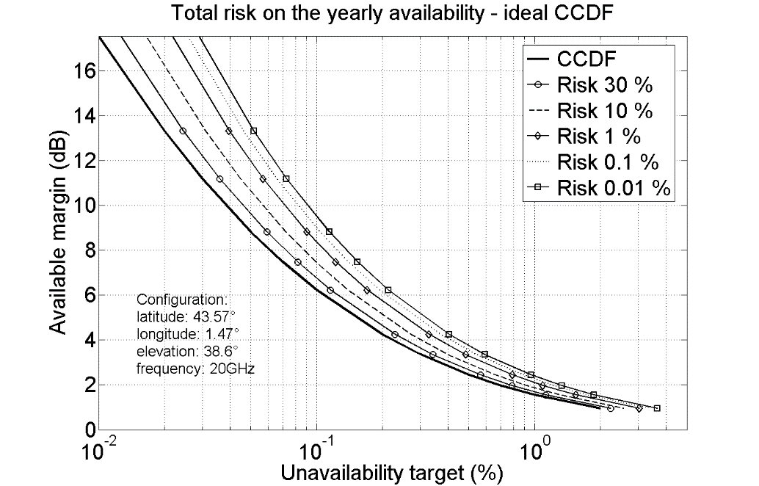

Up to now, the prediction model of the CCDF of rain attenuation was supposed ideal. However, in practice, CCDF models of rain attenuation such as Recommendation ITU-R P. 618-10 or rainfall rate such as Recommendation [ITU-R P. 837-6](http://www.itu.int/rec/R-REC-P.837/en) do not perfectly fit the experimental CCDF worldwide and are associated with an error variance . If the error of the CCDF model is assumed to be normally distributed, with mean  and variance , so that  in (10a) becomes:

 (11)

Figure 4 illustrates the risk on a yearly exceedance from (11) for the same fictitious radio link used in Figure 3. The CCDF is still supposed to be the one given by Recommendation ITU-R P.618-10 but now with an error =35%.

– Starting from an available margin of 6.2 dB:

• the availability of 99.9% is guaranteed with a risk =50% (initial prediction),

• the availability of 99.79% is guaranteed with a risk =1%,

• the availability of 99.73% is guaranteed with a risk =0.01%.

– Reciprocally, to guarantee a targeted yearly availability of 99.9%:

• with a risk =50%, a margin of 6.2 dB is needed (initial design),

• with a risk =1%, a margin of 9.2 dB is needed,

• with a risk =0.01%, a margin of 10.5 dB is needed.

Figure 4

Risk  on the yearly availability for a fictitious radio link at 20 GHz. The CCDF is supposed to be the one given by Recommendation ITU-R P. 618-10 but now with an error =35%

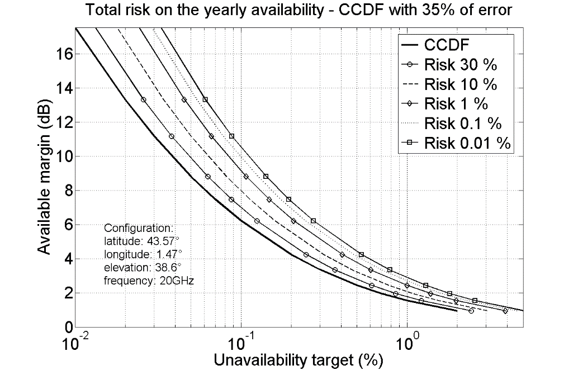

# 4 Bibliography

1. H. Fukuchi and P.A. Watson, “Statistical stability of cumulative distribution of rainfall rate in the UK”, *IEE Proceedings*, vol. 136, no 2, 1989.

2. O. Fiser and V. Kveton, “Stability of rain rate distribution how many years to measure?”, *Electron. Lett*. , vol. 42, no. 10, pp. 567569, 2006.

3. J. P. V. Poiares Baptista, Z. W. Zhang and N. J. McEwan, “Stability of rain rate cumulative distributions”, *Electron. Lett*., vol. 22, no. 7, pp. 350-352, Mar 1986.

4. E. Vilar, A. Burgueño, “Statistical properties of 49 years of rainfall rate events.” *Theoretical and applied climatology,* vol. 50, no 3-4, pp. 213-225 , 1995.

5. J. P. V. Poiares Baptista, Davies PG (general eds), “OPEX Reference Book on attenuation Measurement and Prediction”, ESA WPP-083, Noordwijk, 1994

6. B. Giannone, E. Saggese, E. Matricciani, and A. Paraboni, “The ITALSAT propagation experiment”, *Space Com. Broadcasting*, vol.3, pp. 221231, 1985.

7. R. K. Crane, “*Propagation Handbook for Wireless Communication System Design”*, CRC Press LLC, 2003.

8. R. K. Crane, “Rain attenuation measurements: variability and data quality”, *Radio Sci.*, vol. 25, no. 4, pp. 455-473, 1990.

9. R. K. Crane, “Estimating Risk for Earth-Satellite Attenuation Prediction”, *Proceedings of the IEEE*, vol. 81, no. 6, pp. 906- 913, 1993.

10. France : “Variability associated with experimental statistic of propagation parameters”, Input document 3J/181-3M/207, Geneva, October 2011.

11. N. Jeannin, X. Boulanger, L. Féral L. Castanet and F. Lacoste, “Inter-Annual Variability, Risk and Confidence Intervals Associated with Propagation Statistics. Part I: Theory of Estimation”, *International Journal of Satellite Communications and Networking*, Published online in Wiley Online Library (wileyonlinelibrary.com). DOI: 10.1002/sat.1060, 2013.

12. X. Boulanger, N. Jeannin, L. Féral, L. Castanet, F. Lacoste, F. Carvalho, “Inter-Annual Variability, Risk and Confidence Intervals Associated with Propagation Statistics. Part II: Parameterization and Applications”, *International Journal of Satellite Communications and Networking*, Published online in Wiley Online Library (wileyonlinelibrary.com). DOI: 10.1002/sat.1059, 2013.

13. D. Rosenfeld, D. Atlas and D. A. Short, “The estimation of convective rainfall by area integrals: 2. The Height-Area Rainfall Threshold (HART) method”, *J. Geophys. Res.*, 95(D3), 2161–2176, doi:10.1029/JD095iD03p02161, 1990.

14. B. Kedem, L. S. Chiu and G. R. North, “Estimation of mean rain rate: Application to satellite observations", *J. Geophys. Res.*, 95(D2), 1965–1972, 1990. doi:10.1029/JD095iD02p01965.

15. P. Xie and P. A. Arkin, "Analyses of Global Monthly Precipitation Using Gauge Observations, Satellite Estimates, and Numerical Model Predictions”, *J. Climate*, 9, 840‑858, 1996. doi: http://dx.doi.org/10.1175/1520-0442(1996)009<0840:AOGMPU>2.0.CO;2

16. H. Sauvageot, “The probability density function of rain rate and the estimation of rainfall by area integrals,” *Journal of Applied Meteorology*, vol. 33, no. 11, pp. 1255‑1262, 1994.

17. E. A. B. Eltahir and R. L. Bras, “Estimation of the fractional coverage of rainfall in climate models”, Journal of Climate, vol. 6, no. 4, pp. 639–656, 1993.

18. A. Nzeukou and H. Sauvageot, “Distribution of rainfall parameters near the coasts of France and Senegal”, Journal of Applied Meteorology, vol. 41, no. 1, pp. 69–82, 2002.

19. X. Boulanger, L. Féral, L. Castanet , N. Jeannin , G. Carrie and F. Lacoste, “A Rain Attenuation Time Series Synthesizer Based on a Dirac and Lognormal Distribution”, *IEEE Transactions on Antennas and Propagation*, vol. 61, no. 03, 2013. doi: 10.1109/TAP.2012.2230237.

20. ITU-R Recommendation P.1853-1, *Tropospheric attenuation time series synthesis*, Geneva, 2012.

21. U. Schneider, A. Becker, A. Meyer-Christoffer, M. Ziese and B. Rudolf, “Global Precipitation Analysis Products of the GPCC", *Global Precipitation Climatology Centre (GPCC)*, Deutscher Wetterdienst, Offenbach a. M., Germany, Internet publication, 2011.

22. L. Castanet, G. Blarzino, N. Jeannin, A. Testoni, C. Capsoni, D. Ferraro, L. Luini, D. Rogers, C. Amaya, P. Bouchard, M. Pontes, L. Silva Mello: “Assessment of radiowave propagation for satellite communication and navigation systems in tropical and sub‑tropical areas”, Final report for the European Space Agency under ESTEC Contract No. 18278/04/NL/US, ONERA Doc. RF 4/09521 DEMR, June 2007.

23. Adler, R.F., G.J. Huffman, A. Chang, R. Ferraro, P. Xie, J. Janowiak, B. Rudolf, U. Schneider, S. Curtis, D. Bolvin, A. Gruber, J. Susskind, and P. Arkin, 2003: The Version 2 Global Precipitation Climatology Project (GPCP) Monthly Precipitation Analysis (1979-Present). J. Hydrometeor., 4, 1147-1167.

24. Boulanger X., Jeannin N., Castanet L., Feral L., Carvalho F., Lacoste F., Bousquet M.: "On the Modelling of Statistical and Climatic Uncertainties Associated with Propagation Measurements", Joint 18th Ka and Broadband Communications, Navigation and Earth Observation Conference - 30th AIAA International Communications Satellite System Conference (ICSSC), Ottawa, September 2012.

______________